BeagleConnect Torque
Features and description

1. Product description
BeagleConnect Torque is a small processor module for motor control, motion control, and CAN-based sensing, actuating, controlling, or display embedded designs. It features a Texas Instruments (TI) AM13E23019 Arm Cortex-M33 running at 200 MHz, 512 KB flash, 128 KB SRAM, a TinyEngine edge-AI accelerator (NPU) for application-specific local inference, a trigonometric math unit (TMU), and hardware security features. BeagleConnect Torque serves as the central controller inside BeagleConnect QuadESC (a 4-in-1 brushless DC motor electronic speed controller) and is intended as a standalone solder-down module for high-volume production, rapid prototyping, and custom carrier board development. Hardware schematics, layout, and firmware are open source.
Designed in the USA and assembled in Michigan. Final production origin and compliance claims require a production BOM and supplier audit.

2. Applications
- Drone electronic speed controllers, including BeagleConnect QuadESC as a four-channel carrier.
- Robot joints and wheel drives, gimbals, actuators, positioning stages, pumps and fans.
- Field-oriented control (FOC), sensorless control and custom motion algorithms with suitable application firmware and external power stages.
- Local neural-network inference for motor fault and anomaly detection with application-specific models and firmware.
- CAN-FD sensor, actuator, indicator, power and protocol-bridge nodes; DroneCAN requires application firmware.
- Education and research in motor control, embedded communications and edge AI.

3. Development and production
Firmware sources are available in BeagleConnect QuadESC repository. Load custom firmware through Serial Wire Debug (SWD) or the TI ROM bootstrap loader (BSL) over CAN, I²C or UART. J2 provides SWDIO, SWCLK, UART, reset and boot-invoke signals.
Support targets community-aligned mainline Zephyr and OpenOCD. Board support and tool compatibility must be validated for the release. The module ships with TI ROM BSL only; motor control, DroneCAN and neural-network applications require suitable firmware.
Use BeagleConnect Torque as a solder-down module on your own custom carrier boards.
Editable KiCad schematics and layout, bill-of-materials (BOM) files, and firmware sources are available. Open source hardware certification and its identifier require confirmation before release.
Supported engagement through BeagleBoard.org Foundation and network of professional hardware and software consultants; free public support through active community forums and chat services, with issue escalation.

4. Key features and specifications
A reusable controller for four BeagleConnect QuadESC motor channels, with onboard CAN hardware, expansion connections and a solder-down carrier interface. Motor gate drivers and power transistors are on the carrier.
Item | Value
MCU | TI AM13E23019, Arm Cortex-M33, 200 MHz; PCB U1: XAM13E23019GTPZ, 100-pin package
Flash | 512 KB
SRAM | 128 KB
AI accelerator | NPU for edge AI
Math accelerator | Trigonometric math unit (TMU)
Security | MCU secure boot, secure debug, secure firmware update and cryptographic acceleration; application provisioning required
Motor control | Controller for up to four three-phase motor channels on BeagleConnect QuadESC; external power stages and application firmware required
CAN | Onboard TCAN844DRBRQ1; J5 four-pin JST-GH (+5V, CANH, CANL, GND); switched 120 Ω termination via PC0 / J1.B9
Expansion | J4 Qwiic I²C; J3/J6 two 12-pin rows with UART, SPI, analog, PWM and control signals; check module pinout
Debug | J2 eight-pin row: SWDIO/SWCLK, UART TX/RX, reset, boot invoke, GND and 3.3 V input
Supply voltage | Nominal regulated 5 V carrier input at +VDC; separate 3.3 V debug input. External VAA required for ADC; CAN requires 5 V. Qualified range/current: [VERIFY]
Mounting | 100-pad underside LGA, 1.27 mm pitch, 0.6 mm pads; solder-down carrier mounting
PCB | 4-layer FR-4, 0.035 mm copper per layer (nominal 1 oz), 1.6 mm PCB thickness
Dimensions | 25.4 mm width × 38.1 mm length, southwest outline relief; assembled height [TBD]
Firmware | TI ROM BSL at shipment; application programming over CAN, I²C, UART or SWD. Zephyr/OpenOCD support targets require release validation.
Connector supply rails share capacity with onboard loads. U5 TPS22950 switches the carrier input, U6 TPS7A2633 regulates to 3.3 V, and U4 TPS2116 selects regulated or debug power. Do not connect raw battery voltage to +VDC.

5. Physical and compliance data
Field | Value
Product Name | BeagleConnect Torque
Net weight (g) | [TBD — weigh production unit]
Length (mm) | 38.1 (PCB outline)
Width (mm) | 25.4 (PCB outline)
Height (mm) | [TBD — measure assembled unit; PCB thickness is 1.6 mm]
Country of origin | USA design; Michigan assembly stated. [VERIFY — final production origin audit]
NDAA | [VERIFY — production BOM and supplier compliance audit]
RoHS | Planned [VERIFY]
REACH | Planned [VERIFY]
Open source hardware certification and its identifier require confirmation. The current MCU ordering code is XAM13E23019GTPZ; confirm the production-qualified part before volume release.

6. Packaging and integration
Standalone package: one BeagleConnect Torque module. Static-shielding bag and final packaging: [TBD]. Product configurations are a standalone module or a controller integrated into BeagleConnect QuadESC; release ordering details require confirmation.
The 100-pad underside LGA uses a 1.27 mm grid with 0.6 mm pads. Allow clearance for components and cables, preserve the southwest outline relief, and keep debug, reset and boot access available after carrier assembly. Use the actual pinout for the two 12-pin expansion rows; mikroBUS-related signals do not alone establish accessory compatibility.

7. Design and release references
Hardware basis: embedconsult/quadesc commit 1fe0bbf0fa20e1aa848fa81a7b839ce0438ad440; som/som.kicad_pcb and the MCU, power, CAN and connector schematic sheets. MCU capabilities: TI AM13E23019 product page and AM13E230x datasheet (https://www.ti.com/product/AM13E23019).
Electrical detail: som/som.kicad_pcb, som/mcu-core.kicad_sch, som/power.kicad_sch, som/can-transceiver.kicad_sch and som/io-connectors.kicad_sch. Hardware manual: https://github.com/embedconsult/quadesc/tree/main/documentation/source/som
The current PCB and schematic references differ from som/som_bom_with_mpns.csv. Reconcile the production BOM before procurement, certification or country-of-origin signoff. Confirm unit weight, assembled height, packaging, production MCU ordering code, qualified supply/current/temperature ratings, and released firmware/tool support.
[TBD] = decision or measurement needed. [VERIFY] = formal check required before release. Component capabilities and ratings do not establish a released application or finished-module qualification.

8. Board renders
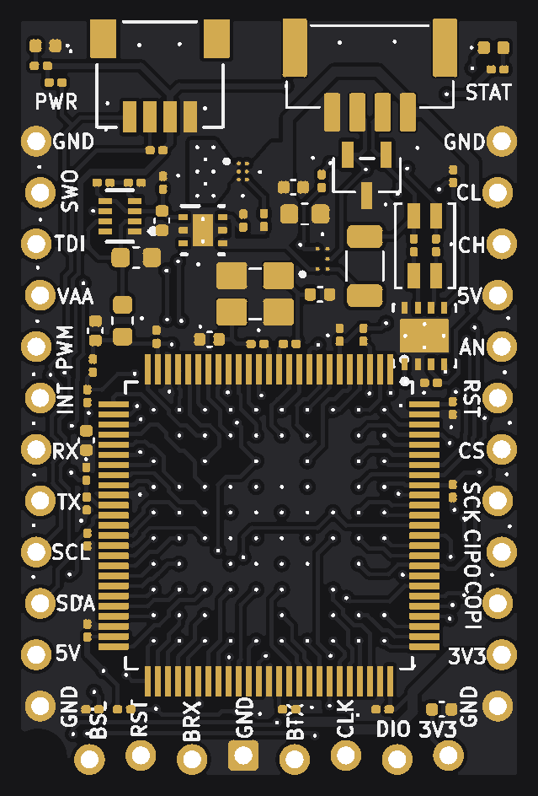
BeagleConnect Torque Rev A1 — front (component side)
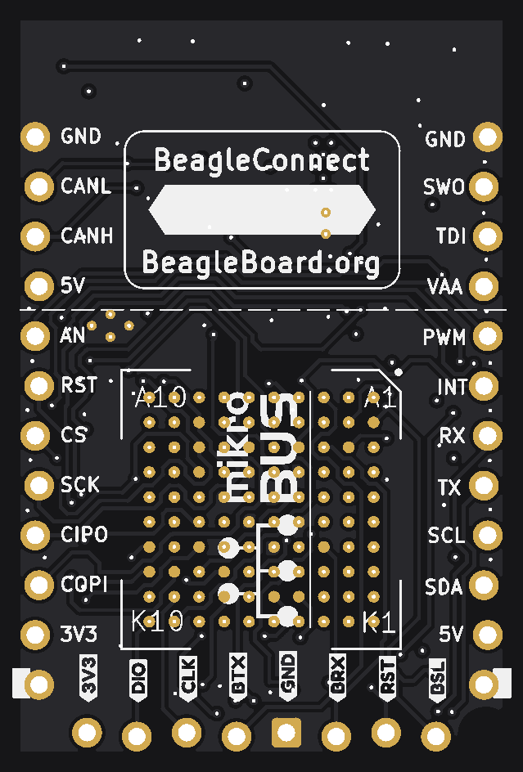
BeagleConnect Torque Rev A1 — back (LGA side)
Renders are not photos. Component bodies use placement data and typical package sizes. Use the editable KiCad outline and mating footprint for manufacturing. PCB thickness is not assembled module height.

