SOFTWARE HARDWARE 

GUIDE

### PREPARED FOR

Future collaborators

Users

### PREPARED BY

Gajendra S Kushwah

SYSTEM BLOCK DIAGRAM

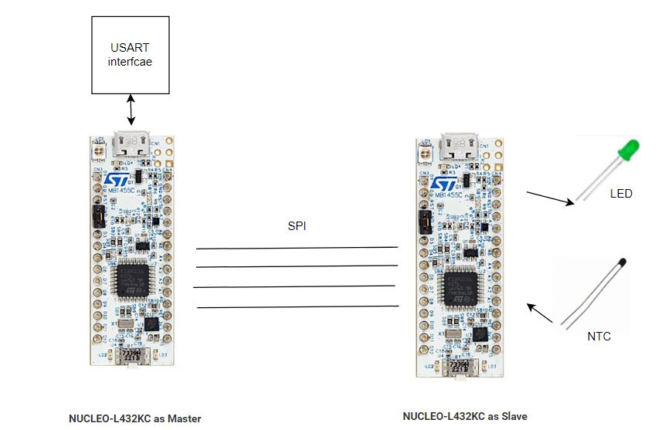

# 1. Project Overview

Master will take commands over serial and Transfer it to Slave over SPI

The slave processes the commands and replies back to the master. Slaves have two sensors led and temperature. The project has a provision of extending to various sensors on slave and master.

# Peripheral used

|  |  |
| --- | --- |
| **Mater** | **Slave** |
| Usart with Interrupt | ADC |
| IO for led | IO for led |
| SPI with interrupt in a master mode without NCC | SPI with interrupt in Slave mode without NSS |
| Timer | Timer |

# Sensor Type

|  |  |  |
| --- | --- | --- |
| **Sensor** | **Read** | **Write** |
| **LED** | **Y** | **Y** |
| **Temperature** | **Y** | **N** |

# 

# Frame structure

### USART

|  |  |  |  |  |  |  |
| --- | --- | --- | --- | --- | --- | --- |
| SYNC_B1 | SYNC_B2 | CMD | SENSOR | DATA | CRC_H | CRC_l |

*crc for future development

### SPI

|  |  |  |  |  |  |  |
| --- | --- | --- | --- | --- | --- | --- |
| SLAVE_ADD | R | CMD | SENSOR | DATA | DATE_2 | R |

# 2. State Machine

# 

# Master

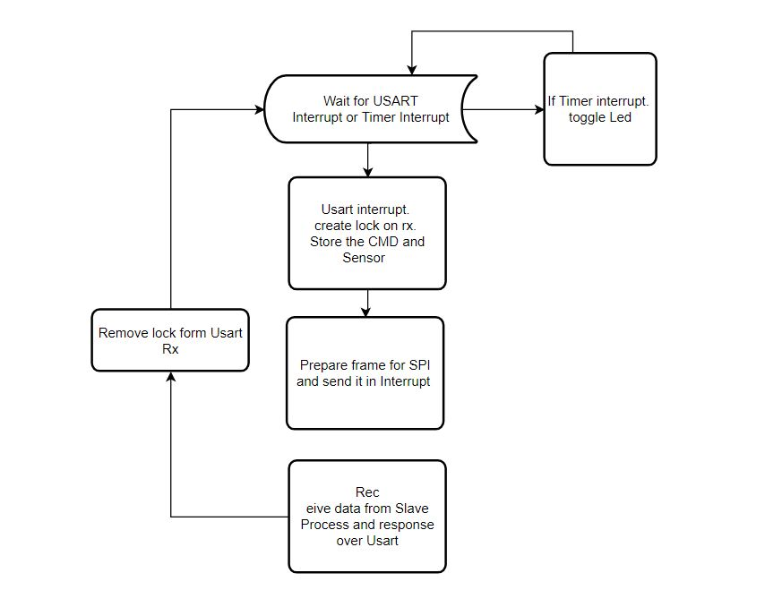

# 

# Slave

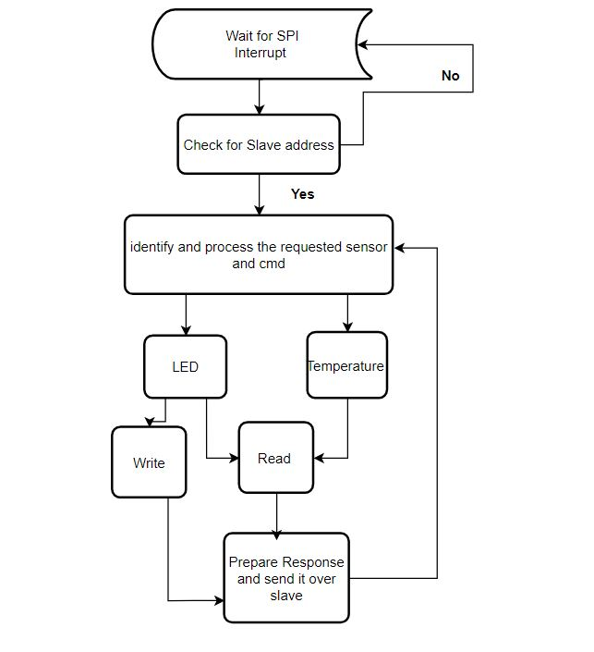

# 

# 3. Software

## Prerequisite

STM32 CubeIDE. STM32CubeMX, ARM GCC compiler. STM32L4 libraries.

### 