Day 1

Tiny4412 Hardware

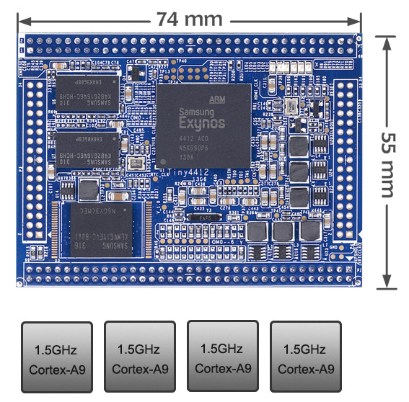

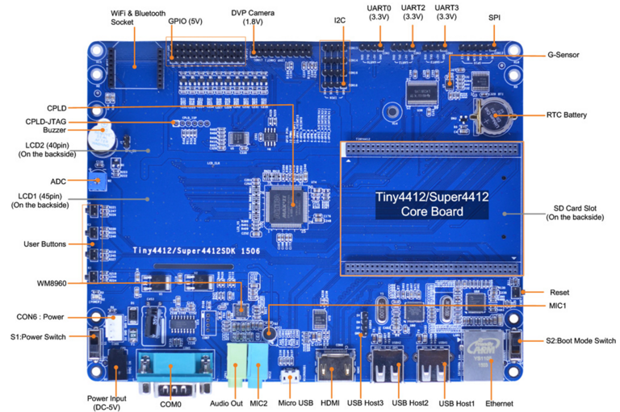

Boot Select
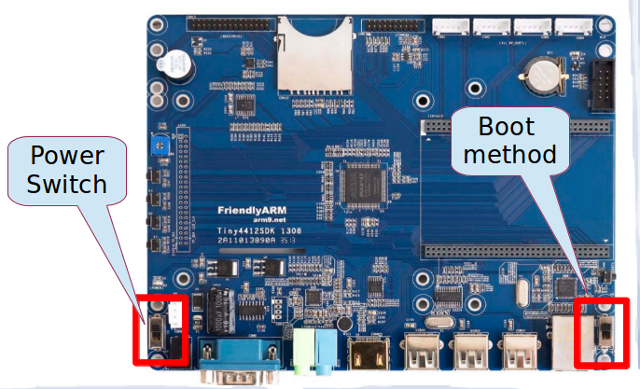

Boot Medthod :

- SD Boot
- eMMC boot (板子上面寫 NAND)

Network setting on your [ Host PC ]

1.
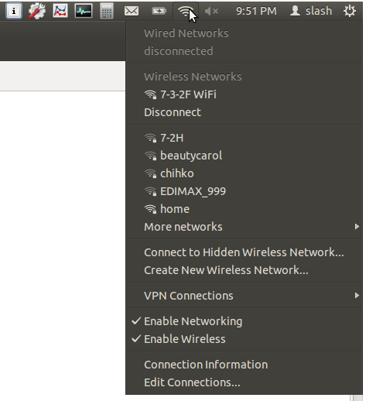

2.
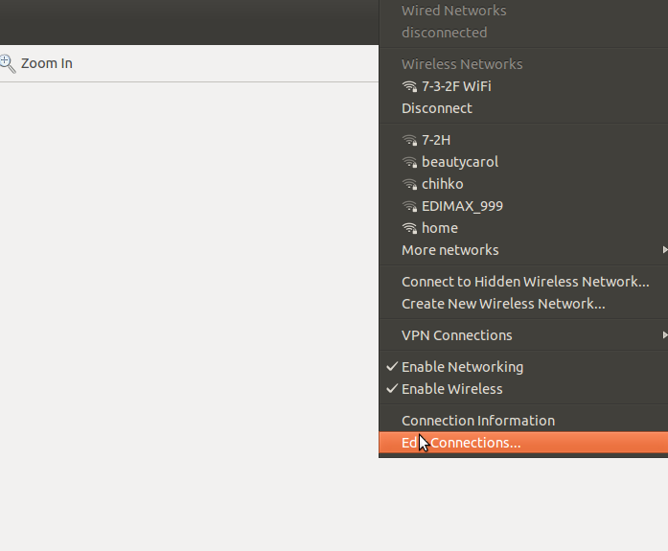

3.
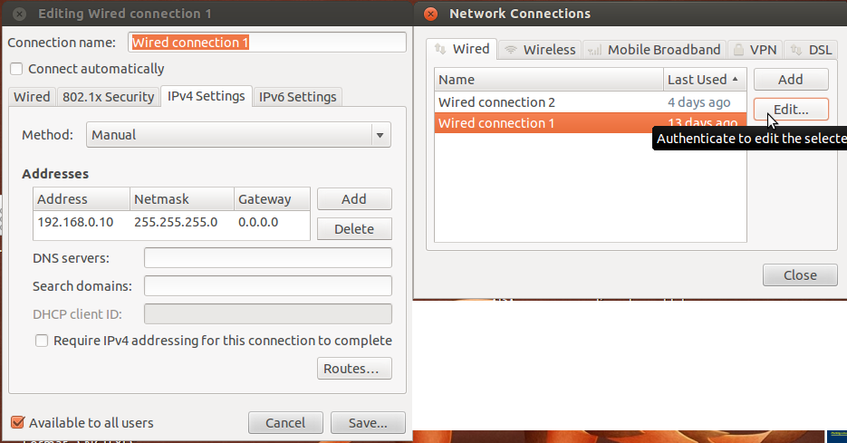

======================================================
Develop Environment Setting
======================================================

1. install gtkterm
#sudo apt-get install gtkterm

install geany
#sudo add-apt-repository ppa:geany-dev/ppa
#sudo apt-get update
#sudo apt-get install geany

2. install toolchan
# cd ~/tiny4412/experiment/
# tar -xvf toolchain/arm-linux-gcc-4.5.1-v6-vfp-20120301.tgz

3. setting toolchain
#source set_arm_4412_toolchain_path.sh

4. install library
#sudo apt-get install autoconf automake libtool libexpat1-dev \
libncurses5-dev bison flex patch curl cvs texinfo git bc \
build-essential subversion gawk python-dev gperf unzip \
pkg-config wget

======================================================
set_arm_4412_toolchain_path.sh
======================================================

1. #geany set_arm_4412_toolchain_path.sh

2. We can found below Linux shell code ...

#######################
#!/bin/sh
PATH=$PATH:/home/cadtc/tiny4412/experiment/opt/FriendlyARM/toolschain/4.5.1/bin

export CROSS_COMPILE=arm-none-linux-gnueabi-
export ARCH=arm
########################

- #arm-none-linux-gnueabi-gcc -v
======================================================
Setting and Test Tool chain
======================================================

1. # source ~/tiny4412/experiment/set_arm_4412_toolchain_path.sh.sh

2. check toolchain : #arm-none-linux-gnueabi-gcc -v

3. test tool chain : build example application (hello_word.c)
# cd ~/tiny4412/experiment/day1
# arm-none-linux-gnueabi-gcc hello.c ‐o hello

======================================================
Build DNW Transmit Application ( Host )
======================================================

0. Install library
sudo apt-get install libusb-dev

1. Build DNW module
a) cd ~/tiny4412/experiment/tool/dnw
b) gcc dnw_new.c -o dnw -lusb
c) sudo cp -a ./dnw /usr/bin

2. Test DNW – Download file to EVB
a) u-boot side
# dnw [address] (default is 0xc00000000)
b) Host side
# cd ~/tiny4412/experiment/init_boot
# sudo ./dnw zImage

======================================================
SD boot - Make SD boot card
======================================================

1. find pre-build binary file (~/tiny4412/experiment/init_boot)

2. Check pre-build binary file
# ls ~/tiny4412/experiment/init_boot_v2/sd_fuse/tiny4412/E4412_N.bl1.bin
# ls ~/tiny4412/experiment/init_boot_v2 /sd_fuse/tiny4412/mkbl2.bin
# ls ~/tiny4412/experiment/init_boot_v2 /sd_fuse/tiny4412/E4412_tzsw.bin
# ls ~/tiny4412/experiment/init_boot_v2 /u-boot-v2.bin

3. Format SD card
#~/tiny4412/experiment/init_boot_v2/sd_fuse/sd_fdisk /dev/sdb

4. Run image install script
#~/tiny4412/experiment/init_boot_v2/sd_fuse/tiny4412/sd_fusing.sh

======================================================
eMMC boot
======================================================

[ Target ] u-boot 環境
0.
a ) use sd boot (SD 卡 開機) → # setenv mmc_device 1
b ) use emmc boot (eMMC 開機) → # setenv mmc_device 0

[Host]

8. sudo dnw ~/tiny4412/experiment/init_boot_v2/E4412_N.bl1.bin
11. sudo dnw ~/tiny4412/experiment/init_boot_v2/bl2.bin
14. sudo dnw ~/tiny4412/experiment/init_boot_v2/u-boot.bin
17. sudo dnw ~/tiny4412/experiment/init_boot_v2/E4412_tzsw.bin

[if you have done below command process before, you can bypass below ]
1. fdisk -c $mmc_device 600 2048 220
2. fatformat mmc $(mmc_device):1
3. ext3format mmc $(mmc_device):2
4. ext3format mmc $(mmc_device):3
5. ext3format mmc $(mmc_device):4

[ Target ]
6. emmc open $(mmc_device)

(download and write E4412_N.bl1.bin)
7. dnw
9. mmc write $(mmc_device) 0xc0000000 0 0x10
(0x10 = 十進位16, 16個block, 一個block是512B, 16*512=8*1024=8KB)

“(download and write bl2.bin)”
10. dnw
12. mmc write $(mmc_device) 0xc0000000 0x10 0x1C

“(download and write u-boot.bin)”
13. dnw
15. mmc write $(mmc_device) 0xc0000000 0x30 0x21D
(u-boot.bin size 270K，space is 328K. So 48th block start，write 541 blocks, 541*512B=270.5*1024 :=270K)

(download and write E4412_tzsw.bin)
16. dnw
18. mmc write $(mmc_device) 0xc0000000 0x2c0 0xB8
(tzsw.bin size about 92K，space is 160K. So, 704 block start，write 184 blocks, 184*512=92*1024=92K)

19. emmc close $(mmc_device)

========================================
Extract rootfs
========================================

[Host]
1. # cd ~/tiny4412/experiment
2. # sudo tar -xvjf root_mkfs.tar.bz2

===========================================
Download and Booting kernel Image
===========================================

Please insert microUSB first

[Host]
2. sudo dnw ~/tiny4412/experiment/init_boot_v2/Image
6. ifconfig ethx (x = 0, 1, 2, 3 ….)192.168.0.10

[ Target ]
1. dnw 0xc0008000
3. setenv serverip 192.168.0.10
4. setenv ipaddr 192.168.0.20
5. set bootargs noinitrd init=/linuxrc root=/dev/nfs ip=192.168.0.20:192.168.0.10:192.168.0.1:255.255.255.0::eth0:on nfsroot=192.168.0.10:/home/cadtc/tiny4412/experiment/root_mkfs, console=ttySAC0 lcd=S70

6. savenv
7. bootm 0xc00080000

========================================
write kernel Image to eMMC
========================================

[ Hots ]
2. sudo dnw ~/tiny4412/experiment/init_boot/Image

[ Target ]
1. dnw
3. movi write kernel $mmc_device 0xc0000000

[ boot kernel ]
4.
movi read kernel $mmc_device C0008000
bootm c0008000

========================================
Build NFS environment
========================================

1. sudo apt-get install nfs-kernel-server nfs-common portmap

2. configure portmap
a. sudo vim /etc/default/portmap
b. del 127.0.0.1

3. comfigure exports
a. sudo geany /etc/exports
b. add your share file folder

example :
/home/cadtc/tiny4412/experiment/root_mkfs *(rw,sync,no_root_squash)

*: any ip can entry this

4. restart
a. sudo /etc/init.d/portmap restart
b. sudo /etc/init.d/nfs-kernel-server restart

5. Host :
ifconfig ethx 192.168.0.10

6. sudo tar -xvjf root_mkfs.tar.bz2

7. local test
a.
# sudo mount -t nfs 192.168.0.10:/home/cadtc/tiny4412/experiment/root_mkfs /mnt/

b. # ls -l /mnt
c. # sudo umount /mnt

Day 2

GNU C Compiler

=============================
exercise 1 :
=============================

-S :
Compile only; do not assemble or link
#gcc -S main.c

-c :
Compile and assemble, but do not link
#gcc -c main.c

=============================
exercise 2 :
=============================

-o <file> : Place the output into <file>
a)
# gcc -o main main.o
# ./main

b)
# ls
# rm main.o main
# ls
# gcc -o main main.c
# ./main

=============================
exercise 3 :
=============================

-D : defines a macro to be used by the preprocessor
# rm main
# gcc -DD_FLAG -o main main.c
# ./main

=============================
exercise 4 :
=============================

-I : adds include directory of header files
#rm main.o
#gcc -DI_FLAG -Itest_inc -o main main.c func_1.c
#./main

=============================
exercise 5 :
=============================

-l : links with a library file
#rm main
gcc -lm -DL_FLAG -Itest_inc -o main main.c

Exercise Makefile

===============================================
hello_world_ex1 : Signal source file
===============================================
1. # cd hello_world_ex1
2. # make

===============================================
hello_world_ex2 : Multi source file
===============================================
1. # make
2. # ./main

===============================================
hello_world_ex4 : Double colon rule
===============================================
1. # make
2. # ls -l main

3. # touch debug
4. # make
5. # ls -l main

===============================================
hello_world_ex5 : Automatic Variables
===============================================
1. # make
2. # ./hello_world

Binutils Tool

================================================
exercise ar:
================================================
a) static library
1. cd create_static_lib
2. make
b) share library
1. cd create_dymamic_lib
2. make

================================================
exercise nm:
================================================
x86-PC
1. #make
2. #nm -help
3. #nm main.o
4. #nm -a -l main.o
5. #nm -a -A main.o

ARM
1. #make
2. #arm-none-linux-gnueabi-nm -help
3. #arm-none-linux-gnueabi-nm main.o
4. #arm-none-linux-gnueabi-nm -a -l main.o
5. #arm-none-linux-gnueabi-nm -a -A main.o

================================================
objdump:
================================================
x86-PC
1. #make
2. #objdump -help
3. #objdump -d main.o
4. #objdump -t main.o

ARM
1. #make
2. #arm-none-linux-gnueabi-objdump -help
3. #arm-none-linux-gnueabi-objdump -d main.o
4. #arm-none-linux-gnueabi-objdump -t main.o
================================================
strip:
================================================
x86-PC
#ls -l
#arm-none-linux-gnueabi-strip exerise
#ls -l

ARM
#ls -l
#arm-none-linux-gnueabi-strip exerise
#ls -l

Patch file Exercise

1) create patch file
#cd /home/cadtc/tiny4412/experiment/day2/6-patch_exerise/exercise_1
#diff -Naur hello_1.c hello_2.c > hello.patch

2) add patch file
#../cd exercise_2/
#cp ../exercise_1/hello.patch ./
#patch -p0 < hello.patch

3) remove patch file
patch -R -p0 < hello.patch

Library Exercise
ar:
A) static library
a) x86-PC
1. #cd ~/tiny4412/experiment/create_static_lib
2. #make

b) ARM
1. #source ~/tiny4412/experiment/tool/set_arm_4412_toolchain_path.sh
2. #cd create_static_lib
3. #make
4. #./test

b) share library
a) x86-PC
1 #cd create_dymamic_lib
2 #export CC=gcc
3 #export DIR=$('pwd')
4 #make
5 #export LD_LIBRARY_PATH=$LD_LIBRARY_PATH:/home/cadtc/tiny4412/experiment/day2/3-build_library/create_dymamic_lib

b) ARM
1 #cd create_dymamic_lib
2 #make
3
export LD_LIBRARY_PATH=$LD_LIBRARY_PATH:/home/cadtc/tiny4412/experiment/day2/3-build_library/create_dymamic_lib
Day3 U-Boot

BASIC Command

http://www.denx.de/wiki/view/DULG/UBoot

1 help

2 mtest - simple RAM test

example :
#mtest 40000000 400000010 0xffff 0x20

3 printenv - printenv - print environment variables

example :
#printenv

4 setenv - setenv - set environment variables
savenv - saveenv - save environment variables to persistent storage
-
example :
#printenv
#setenv bootdealy 10
#printenv
#saveenv

5 mm - memory modify (auto-incrementing address)

example
TINY4412 # mm
40000000: ffffffff ? ffffffff
40000004: 12345678 ? 12345678
40000008: 00000002 ? 76543210
4000000c: 00000003 ? 23456754

6 md - memory display

example
TINY4412 # md.l 40000000
40000000: ffffffff 12345678 76543210 23456754 ....xV4..2TvTgE#
40000010: 00000004 00000005 00000006 00000007 ................
40000020: 00000008 00000009 0000000a 0000000b ................

7 macro

example
#setenv test 'md.l 40000000;md.l 50000000'
#run test

8 saveenv - save environment variables to persistent storage

example
#setenv test 'md.l 40000000;md.l 50000000'
#saveenv

Build u-boot

1. source ~/tiny4412/experiment/set_arm_4412_toolchain_path.sh

2 cd ~/tiny4412/experiment/day3

3 tar -xvjf uboot_tiny4412_v2.tar.bz2 -C ~/tiny4412/experiment/

4 cd ~/tiny4412/experiment/uboot_tiny4412_v2

5 make distclean

6 make tiny4412_config

7 make -j4

8 Then we can check “u-boot.bin” with “ls” command
# ls ./u-boot.bin

Update u-boot/kernel for SD card

for u-boot

SD boot - Make SD boot card

1. find pre-build binary file

2. Below is pre-build binary file
ls ~/tiny4412/experiment/init_boot_v2/sd_fuse/tiny4412/E4412_N.bl1.bin
ls ~/tiny4412/experiment/init_boot_v2/sd_fuse/tiny4412/mkbl2.bin
ls ~/tiny4412/experiment/init_boot_v2/sd_fuse/tiny4412/E4412_tzsw.bin
ls ~/tiny4412/experimentinit_boot_v2/u-boot-v2.bin

3. Format SD card

PC-Linux# sudo ~/tiny4412/experiment/uboot_tiny4412_v2/sd_fuse/sd_fdisk /dev/sdb

4. Run image install script
PC-Linux# sudo ~/tiny4412/experiment/uboot_tiny4412_v2/sd_fuse/tiny4412/sd_fusing.sh

Update u-boot for eMMC

binary compare tool : vbindiff ( sudo apt-get install vbindiff )

*Please copy “/home/cadtc/tiny4412/experiment/day3/combine_bl2_uboot.sh” to
U-BOOT source directory first

[Host]
0. update bl2.bin
# mkbl2 u-boot.bin bl2.bin 14336

1. combin bl2.bin and u-boot.bin
# cat ./bl2.bin ../u-boot.bin > bl2_uboot.bin

4. sudo dnw ./bl2_uboot.bin

[Target]
================================================
if you use sd 開機 boot "mmc_device" = 1
if you use emmc 開機 boot "mmc_device" = 0
================================================
sd boot -> #setenv mmc_device 1
eMMC -> #setenv mmc_device 0

2. #emmc open $mmc_device

(download and write bl2_uboot.bin)
3. #dnw

(write bl2)
5. #mmc write $mmc_device 0xc0000000 0x10 0x1C

(write uboot)
6. #mmc write $mmc_device 0xc0003800 0x30 0x21D
(u-boot.bin size 270K，space is 328K. So 48th block start，write 541 blocks, 541*512B=270.5*1024 :=270K)

7. #emmc close $mmc_device

Customer command

0. cd ~/tiny4412/experiment/day3/3-create_cmd_exerise/cmd_helloworld

1. geany ~/tiny4412/experiment/uboot_tiny4412_v2/common/Makefile

add below

============================ start ====================================
@@ -170,6 +170,7 @@ COBJS-$(CONFIG_LYNXKDI) += lynxkdi.o
COBJS-$(CONFIG_MODEM_SUPPORT) += modem.o
COBJS-$(CONFIG_UPDATE_TFTP) += update.o
COBJS-$(CONFIG_USB_KEYBOARD) += usb_kbd.o
+COBJS-$(CONFIG_HELLOWORLD) += cmd_helloworld.o

COBJS := $(sort $(COBJS-y))
XCOBJS := $(sort $(XCOBJS-y))
============================ end ====================================

2. cp ./cmdhello.c ~/tiny4412/experiment/uboot_tiny4412_v2/common

3. make -j4

4. update u-boot to SD card

5. Target : #help hello

6. Target : #hello

Modify Prompt

1. gedit include/configs/tiny4412.h

2. search "CONFIG_SYS_PROMPT"

3. change "TINY4412 # " to "QEDWWCW #"

4. make (please reference above <Build u-boot>)

5. update u-boot (please reference above <update u-boot for SD card or update u-boot for eMMC>)

Standalone application

1 [Host ] :
geany ~/tiny4412/experiment/uboot_tiny4412_v2/arch/arm/config.mk

ifeq ($(BOARD),omap2420h4)
STANDALONE_LOAD_ADDR = 0x80300000
else
ifeq ($(SOC),omap3)
STANDALONE_LOAD_ADDR = 0x80300000
else
STANDALONE_LOAD_ADDR = 0xc0000000
endif
endif

2 [Host ] :
cd ~/tiny4412/experiment/uboot_tiny4412_v2&& make

3 [Target ]:
dnw c0000000

4 [Host ]:

sudo sudo dnw ~/tiny4412/experiment/uboot_tiny4412_v2/examples/standalone/hello_world.bin

5 [Target ]:
go c0000000

Boot Linux Kernel

A)

1 [Target] :
dnw 40008000 (c0008000)

2 [Host ]:
sudo dnw $(KERNEL_PATH)arch/arm/boot/zImage

3 [Target] :
bootm 40008000 (c0008000)

B)

1 [Target ]:
movi read kernel 0 40008000 (c0008000)

2 [Target ]:
bootm 40008000 (c0008000)

Day 4 Linux Kernel

Building Linux kerne

0. # source /home/cadtc/tiny4412/experiment/set_arm_4412_toolchain_path.sh

1.
# cd /home/cadtc/tiny4412/experiment/day4
# tar -xvjf /home/cadtc/tiny4412/experiment/day4 -C ../
# cd ../linux_3.5.0_tiny4412/

2. # make distclean

3. # make tiny4412_linux_defconfig

4. # make -j4

5. # check output kernel image : arch/arm/boot/zImage

=====================================================================
MAKE HELP
=====================================================================

1. # make help

Cleaning targets:
clean - Remove most generated files but keep the config and
enough build support to build external modules
mrproper - Remove all generated files + config + various backup files
distclean - mrproper + remove editor backup and patch files

Configuration targets:
config - Update current config utilising a line-oriented program
nconfig - Update current config utilising a ncurses menu based program
menuconfig - Update current config utilising a menu based program
xconfig - Update current config utilising a QT based front-end
gconfig - Update current config utilising a GTK based front-end
oldconfig - Update current config utilising a provided .config as base
localmodconfig - Update current config disabling modules not loaded
localyesconfig - Update current config converting local mods to core
silentoldconfig - Same as oldconfig, but quietly, additionally update deps
defconfig - New config with default from ARCH supplied defconfig
savedefconfig - Save current config as ./defconfig (minimal config)
allnoconfig - New config where all options are answered with no
allyesconfig - New config where all options are accepted with yes
allmodconfig - New config selecting modules when possible
alldefconfig - New config with all symbols set to default
randconfig - New config with random answer to all options
listnewconfig - List new options
oldnoconfig - Same as silentoldconfig but set new symbols to n (unset)

Other generic targets:
all - Build all targets marked with [*]
* vmlinux - Build the bare kernel
* modules - Build all modules
modules_install - Install all modules to INSTALL_MOD_PATH (default: /)
firmware_install- Install all firmware to INSTALL_FW_PATH
(default: $(INSTALL_MOD_PATH)/lib/firmware)
dir/ - Build all files in dir and below
dir/file.[oisS] - Build specified target only
dir/file.lst - Build specified mixed source/assembly target only
(requires a recent binutils and recent build (System.map))
dir/file.ko - Build module including final link
modules_prepare - Set up for building external modules
tags/TAGS - Generate tags file for editors
cscope - Generate cscope index
gtags - Generate GNU GLOBAL index
kernelrelease - Output the release version string
kernelversion - Output the version stored in Makefile
headers_install - Install sanitised kernel headers to INSTALL_HDR_PATH
(default: /home/slash/work/exynos4412/build/linux_3.5.0_tiny4412/usr)

Static analysers
checkstack - Generate a list of stack hogs
namespacecheck - Name space analysis on compiled kernel
versioncheck - Sanity check on version.h usage
includecheck - Check for duplicate included header files
export_report - List the usages of all exported symbols
headers_check - Sanity check on exported headers
headerdep - Detect inclusion cycles in headers
coccicheck - Check with Coccinelle.

Kernel packaging:
rpm-pkg - Build both source and binary RPM kernel packages
binrpm-pkg - Build only the binary kernel package
deb-pkg - Build the kernel as a deb package
tar-pkg - Build the kernel as an uncompressed tarball
targz-pkg - Build the kernel as a gzip compressed tarball
tarbz2-pkg - Build the kernel as a bzip2 compressed tarball
tarxz-pkg - Build the kernel as a xz compressed tarball
perf-tar-src-pkg - Build perf-3.5.0.tar source tarball
perf-targz-src-pkg - Build perf-3.5.0.tar.gz source tarball
perf-tarbz2-src-pkg - Build perf-3.5.0.tar.bz2 source tarball
perf-tarxz-src-pkg - Build perf-3.5.0.tar.xz source tarball

Documentation targets:
Linux kernel internal documentation in different formats:
htmldocs - HTML
pdfdocs - PDF
psdocs - Postscript
xmldocs - XML DocBook
mandocs - man pages
installmandocs - install man pages generated by mandocs
cleandocs - clean all generated DocBook files

Architecture specific targets (arm):
* zImage - Compressed kernel image (arch/arm/boot/zImage)
Image - Uncompressed kernel image (arch/arm/boot/Image)
* xipImage - XIP kernel image, if configured (arch/arm/boot/xipImage)
uImage - U-Boot wrapped zImage
bootpImage - Combined zImage and initial RAM disk
(supply initrd image via make variable INITRD=<path>)
dtbs - Build device tree blobs for enabled boards
install - Install uncompressed kernel
zinstall - Install compressed kernel
uinstall - Install U-Boot wrapped compressed kernel
Install using (your) ~/bin/installkernel or
(distribution) /sbin/installkernel or
install to $(INSTALL_PATH) and run lilo

acs5k_defconfig - Build for acs5k
acs5k_tiny_defconfig - Build for acs5k_tiny
afeb9260_defconfig - Build for afeb9260
ag5evm_defconfig - Build for ag5evm
am200epdkit_defconfig - Build for am200epdkit
lart_defconfig - Build for lart
lpc32xx_defconfig - Build for lpc32xx
lpd270_defconfig - Build for lpd270
lubbock_defconfig - Build for lubbock
sam9_l9260_defconfig - Build for sam9_l9260
shannon_defconfig - Build for shannon
shark_defconfig - Build for shark
simpad_defconfig - Build for simpad
spear13xx_defconfig - Build for spear13xx
spear3xx_defconfig - Build for spear3xx
spear6xx_defconfig - Build for spear6xx
spitz_defconfig - Build for spitz
stamp9g20_defconfig - Build for stamp9g20
tct_hammer_defconfig - Build for tct_hammer
tegra_defconfig - Build for tegra
tiny4412_linux_defconfig - Build for tiny4412_linux
tiny4412_ubuntu_defconfig - Build for tiny4412_ubuntu
trizeps4_defconfig - Build for trizeps4
u300_defconfig - Build for u300
u8500_defconfig - Build for u8500
usb-a9260_defconfig - Build for usb-a9260
versatile_defconfig - Build for versatile
vexpress_defconfig - Build for vexpress
viper_defconfig - Build for viper
xcep_defconfig - Build for xcep
zeus_defconfig - Build for zeus

make V=0|1 [targets] 0 => quiet build (default), 1 => verbose build
make V=2 [targets] 2 => give reason for rebuild of target
make O=dir [targets] Locate all output files in "dir", including .config
make C=1 [targets] Check all c source with $CHECK (sparse by default)
make C=2 [targets] Force check of all c source with $CHECK
make RECORDMCOUNT_WARN=1 [targets] Warn about ignored mcount sections
make W=n [targets] Enable extra gcc checks, n=1,2,3 where
1: warnings which may be relevant and do not occur too often
2: warnings which occur quite often but may still be relevant
3: more obscure warnings, can most likely be ignored
Multiple levels can be combined with W=12 or W=123

Execute "make" or "make all" to build all targets marked with [*]
For further info see the ./README file

=====================================================================
Building and install modules
=====================================================================
0. # cd ~/tint4412/experiment/linux_3.5.0_tiny4412

1. # make modules

2. # make kernelrelease

3. # INSTALL_MOD_PATH=${PRJROOT}/modules-KERNEL-VERSION

4. # make modules_install

=====================================================================
Modify ourself kernel version name
=====================================================================

1. # make kernelrelease

2 # make menuconfig

3 # General setup → () Local version

=====================================================================
Configure kernel (use menuconfig for configuration)
=====================================================================

1 make menuconfig
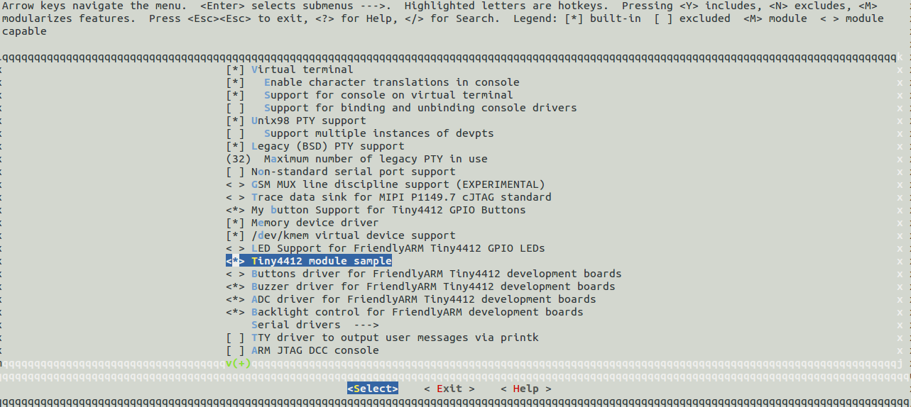
2 add/delete driver

add – build-in

add – build module
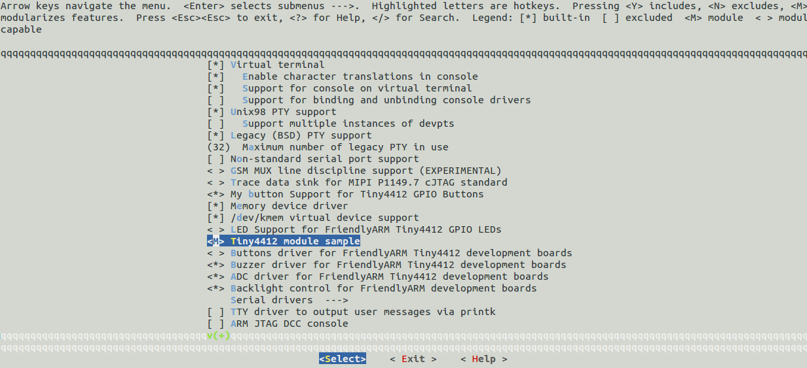

delete
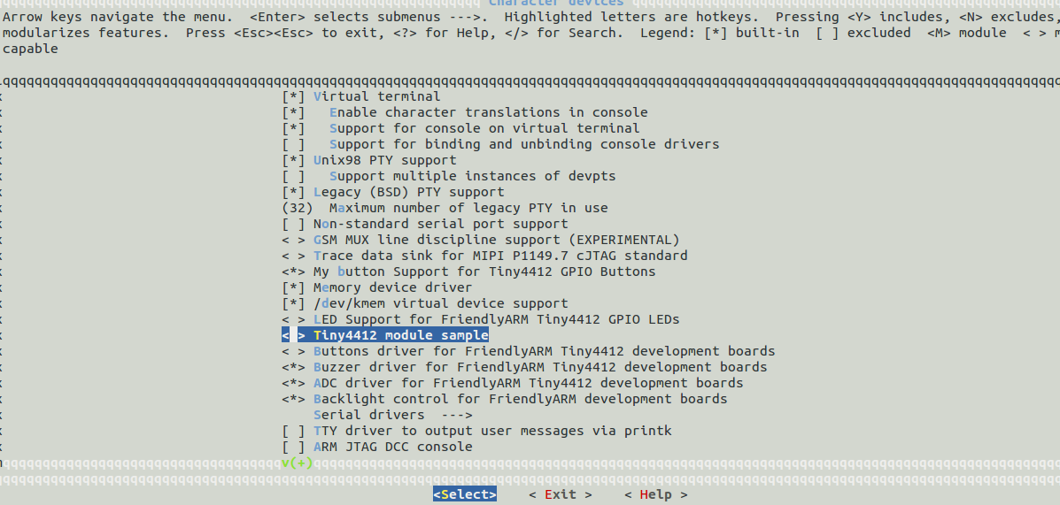

=====================================================================
Create kernel configure file
=====================================================================

1. We will get defconfig in local currently directory
# make savedefconfig

2. rename defconfig to hello_defconfig
# mv defconfig hello_defconfig

3. put hello_deconfig to arch/arm/configs
# mv hello_deconfig arch/arm/configs

4. confirm our configure
# make help | grep hello

=====================================================================
Change Linux boot screen
=====================================================================

1. [ HOST PC ] # sudo apt-get install netpbm

2. [ HOST PC ] # pngtopnm ~/tiny4412/experiment/day4/2-Change_Linux_boot_screen-exerise/larry.png | ppmquant -fs 223 | pnmtoplainpnm > logo_larry_clut224.ppm

3. copy the created .ppm file into ~/tiny4412//experiment/day4/linux_3.5.0_tiny4412/drivers/video/logo folder

[ HOST PC ]
# cp -a logo_larry_clut224.ppm ~/tiny4412/experiment/day4/linux_3.5.0_tiny4412/drivers/video/logo

4. Add the entry in the Kconfig (drivers/video/logo/Kconfig)
[ HOST PC ]
# geany ~/tiny4412/experiment/day4/linux_3.5.0_tiny4412/drivers/video/logo/Kconfig

add below to "drivers/video/logo/Kconfig"

========================================================================
#if LOGO

+ config LOGO_LARRY_CLUT224
+ bool "Test 224-colour logo"
+ depends on FB=y
========================================================================

5. Add the code in
a ) logo.c
# geany ~/tiny4412/Day4/linux_3.5.0_tiny4412/drivers/video/logo/logo.c

========================================================================
+ #ifdef CONFIG_LOGO_LARRY_CLUT224;
+ logo = &logo_larry_clut224;
+ #endif

}
return logo;
}
EXPORT_SYMBOL_GPL(fb_find_logo);
========================================================================

b ) include/linux/linux_logo.h
# geany ~/tiny4412/Day4/linux_3.5.0_tiny4412/include/linux/linux_logo.h

========================================================================
extern const struct linux_logo logo_m32r_clut224;
extern const struct linux_logo logo_spe_clut224;
+ extern const struct linux_logo logo_larry_clut224;
========================================================================

6. Add an entry in the Makefile(drivers/video/logo/Makefile)

[ HOST PC ]
# geany ~/tiny4412/experiment/day4/linux_3.5.0_tiny4412/drivers/video/logo/Makefile

========================================================================
add below to "drivers/video/logo/Makefile"
obj-$(CONFIG_LOGO_SUPERH_CLUT224) += logo_superh_clut224.o
obj-$(CONFIG_LOGO_M32R_CLUT224) += logo_m32r_clut224.o
+ obj-$(CONFIG_LOGO_LARRY_CLUT224) += logo_larry_clut224.o
========================================================================

7. [ HOST PC ]

# make menuconfig
Device Drivers --->
Graphics support --->
[*] Bootup logo --->
--- Bootup logo
[*] Test 224-colour logo
[ ] Standard black and white Linux logo
[ ] Standard 16-color Linux logo
[ ] Standard 224-color Linux logo

# make -j4

8. Download Kernel Image and boot it
Please check “Download and Booting kernel Image” in ~/tiny4412/note/boot/day1_Exerise.txt

========================================================================
Download kernel Image
=========================================================================

[ Host ]
2. sudo dnw ~/tiny4412/experiment/day4/linux_3.5.0_tiny4412/arch/arm/boot/zImage

6. ifconfig ethx 192.168.0.10

[ Target ] (u-boot)
1. dnw 0xc0008000
3. setenv serverip 192.168.0.10
4. setenv ipaddr 192.168.0.20
5. set bootargs noinitrd init=/linuxrc root=/dev/nfs ip=192.168.0.20:192.168.0.10:192.168.0.1:255.255.255.0::eth0:on nfsroot=192.168.0.10:/home/cadtc/tiny4412/experiment/root_mkfs, console=ttySAC0 lcd=S70

6. savenv
7. bootm 0xc00080000

============================================================
Please make sure ARM toolchain setting finish first !!!!!
============================================================

A. adc-test
[ Host ]
0. # cd ~/tiny4412/day4/linux_3.5.0_tiny4412/
1. # make menuconfig
Device Drivers --->
Character devices --->
<*> ADC driver for FriendlyARM Tiny4412 development boards
2. # cd adc-test/
3. # make
4. # cp -a ./adc-test ~/tiny4412/experiment/root_mkfs

[ Target ]
5. # ./adc-test

-------------------------------------------------------------
-------------------------------------------------------------

B. buttons
[ Host ]
0. # cd ~/tiny4412/day4/linux_3.5.0_tiny4412/
1. # make menuconfig
Device Drivers --->
Character devices --->
<*> Buttons driver for FriendlyARM Tiny4412 development boards
2. # cd buttons/
3. # make
4. # cp -a ./buttons ~/tiny4412/experiment/root_mkfs

[ Target ]
5. # ./buttons

-------------------------------------------------------------
-------------------------------------------------------------

C. I2C
[ Host ]
0. # cd ~/tiny4412/day4/linux_3.5.0_tiny4412/
1. # make menuconfig
Device Drivers --->
<*> I2C support --->
I2C Hardware Bus support --->
<*> S3C2410 I2C Driver
2. # cd i2c/
3. # make
4. # cp -a ./i2c ~/tiny4412/experiment/root_mkfs

[ Target ]
5. # ./i2c

-------------------------------------------------------------
-------------------------------------------------------------

D. led-payer
[ Host ]
0. # cd ~/tiny4412/day4/linux_3.5.0_tiny4412/
1. # make menuconfig
Device Drivers --->
Character devices --->
<*> LED Support for FriendlyARM Tiny4412 GPIO LEDs
2. # cd led-payer/
3. # make
4. # cp -a ./led-payer ~/tiny4412/experiment/root_mkfs

[ Target ]
5. # ./led-payer

-------------------------------------------------------------
-------------------------------------------------------------

E. led
[ Host ]
0. # cd ~/tiny4412/day4/linux_3.5.0_tiny4412/
1. # make menuconfig
Device Drivers --->
Character devices --->
<*> LED Support for FriendlyARM Tiny4412 GPIO LEDs
2. # cd led
3. # make
4. # cp -a ./led ~/tiny4412/experiment/root_mkfs

[ Target ]
5. # ./led

-------------------------------------------------------------
-------------------------------------------------------------

F. pwm
[ Host ]
0. # cd ~/tiny4412/day4/linux_3.5.0_tiny4412/
1. # make menuconfig
Device Drivers --->
Character devices --->
<*> Buzzer driver for FriendlyARM Tiny4412 development boards
2. # cd pwm/
3. # make
4. # cp -a ./pwm ~/tiny4412/experiment/root_mkfs

[ Target ]
        - # ./pwm

Application Exercise

FFMPEG

1 source ~/tiny4412/experiment/set_arm_4412_toolchain_path.sh
2 cd ~/tiny4412/experiment/day4/3-application-exerise/ffmpeg
3 wget http://ffmpeg.org/releases/ffmpeg-2.8.3.tar.bz2
4 tar -xvjf ffmpeg-2.8.3.tar.bz2
5 cd ffmpeg-2.8.3

========================================================================
Configure ffmpeg
========================================================================

6.
./configure --cross-prefix=arm-none-linux-gnueabi- --enable-cross-compile --target-os=linux --cc=arm-linux-gcc --arch=arm --cpu=armv5te --prefix=/home/cadtc/tiny4412/experiment/root_mkfs/usr/local/ffmpeg --enable-shared --disable-static --enable-gpl --enable-ffmpeg --disable-ffplay --disable-ffserver --enable-swscale --enable-pthreads --disable-armv5te --disable-yasm --disable-stripping --enable-gpl --disable-network --enable-avfilter

========================================================================
Build source
========================================================================

7.
a ) make -j4

* [ Target ]
b ) mkdir usr/local/bin/ffmpeg

========================================================================
install and test
========================================================================
8. [ Host ]
make install

9.
[ Target ]
a)
export PATH=$PATH:/usr/local/bin/ffmpeg/bin
export LD_LIBRARY_PATH=$LD_LIBRARY_PATH:/usr/local/bin/ffmpeg/lib

b ) TEST
record video
ffmpeg -f video4linux2 -s 320x240 -r 50 -i /dev/video15 /slash.mpeg

libjpeg

[ Host ]

********************************************************
* please check arm tool chain if setting or not *
********************************************************

========================================================
libtool
========================================================

- Get Source code -
0. # wget ftp://ftp.gnu.org/gnu/libtool/libtool-2.4.tar.gz
1. # tar -xvzf libtool-2.4.tar.gz && cd libtool-2.4

- Configure -
2. # ./configure --host=arm-linux CC=arm-linux-gcc –prefix=/home/cadtc/tiny4412/experiment/day4/3-application-exerise/libjpeg/libtool-2.4/install

- Build -
3. # make -j4
4. # ls -l ./libtool

========================================================
libjpeg_build
========================================================

- Get Source code -
0. wget http://www.ijg.org/files/jpegsrc.v6b.tar.gz && tar -xvzf jpegsrc.v6b.tar.gz

- Configure -
1. # cd jpeg-6b

2. # ./configure --help

3. # cp ../libtool-2.4/libtool ./

4. # ./configure --host=arm-none-linux-gnueabi CC=arm-none-linux-gnueabi-gcc –prefix=/home/cadtc/tiny4412/experiment/day4/3-application-exerise/libjpeg/jpeg-6b/install --enable-shared

5. # geany ./Makefile

please search "LIBTOOL"

***********************************************************************
# If using GNU libtool, LIBTOOL references it; if not, LIBTOOL is empty.
LIBTOOL=./libtool --tag=arm-none-linux-gnueabi-gcc
# $(O) expands to "lo" if using libtool, plain "o" if not.
# Similarly, $(A) expands to "la" or "a".
***********************************************************************

- Build Source -
6. make -j4

- Install -
5.
a. make -n install
b. mkdir -p ./install/bin && mkdir -p ./install/man/man1 && mkdir -p ./install/lib && mkdir -p ./install/include
c. make install

7.
sudo cp -a ./install/bin/* ~/tiny4412/experiment/root_mkfs/usr/bin
sudo cp -a ./install/lib/* ~/tiny4412/experiment/root_mkfs/usr/lib

8. sudo cp ./testimg.jpg ~/tiny4412/experiment/root_mkfs

- Test in Target -

[ Target ]

0.
export PATH:$PATH:/usr/lib
export LD_LIBRARY_PATH=$LD_LIBRARY_PATH:/usr/lib

1. djpeg -grayscale -bmp ./testimg.jpg > testimg.bmp

2. check slash.bmp from host pc tool

madpaly

=======================================================================
Get Source code
=======================================================================

1. wget http://www.mirrorservice.org/sites/downloads.sourceforge.net/m/ma/mad/madplay/0.15.2b/madplay-0.15.2b.tar.gz

=======================================================================
Get Source code
=======================================================================

2. tar -xvzf madplay-0.15.2b.tar.gz

=======================================================================
Enter source code
=======================================================================

3. cd madplay-0.15.2b/

=======================================================================
Configure Source code
=======================================================================

4. # ./configure --host=arm-linux CC=arm-none-linux-gnueabi-gcc \
--prefix=/home/cadtc/tiny4412/experiment/day4/3-application-exerise/madplay/madplay-0.15.2b/install

=======================================================================
Build Source code
=======================================================================

- # make -j4

=======================================================================
Install
=======================================================================

6. # make -n install
# make install
# cp -a install/bin/maplay ~/tiny4412/experiment/root_mkfs/usr/bin

=======================================================================
TEST in target
=======================================================================

7. [ Target ]
# madplay sample.mp3

mplayer

=====================================================================
1. Introduction
=====================================================================

http://www.mplayerhq.hu/design7/news.html
http://en.wikipedia.org/wiki/MPlayer

=====================================================================
2. decompress MPlayer-1.0rc4.tar.bz2
=====================================================================

# tar -jxvf MPlayer-1.0rc4.tar.bz2 && cd MPlayer-1.0rc4/

=====================================================================
3. ./configure ,make and copy to Tiny4412
=====================================================================

a )
# ./configure --host-cc=gcc --cc=arm-none-linux-gnueabi-gcc \
--target=arm-linux --enable-fbdev --disable-dvdread --disable-live \
--disable-mp3lib --enable-mad --disable-win32dll --disable-mencoder \
--disable-ivtv --disable-dvdnav --disable-dvdread-internal \
--disable-libdvdcss-internal --enable-libavcodec_a --prefix=./install

b ) # make -j8

c )
************************************************************
install: strip process terminated abnormally
将config.mak中 INSTALLSTRIP=-s，-s去掉即可
************************************************************
make -n install
make install

d ) sudo cp -a ./install/bin ~/tiny4412/experiment/root_mkfs/usr/bin
sudo cp -a ./install/lib ~/tiny4412/experiment/root_mkfs/usr/lib

=====================================================================
4. plug webcam
(sonix chip idVendor=0c45, idProduct=6340) into Tiny4412 and run "mplayer"
=====================================================================

[root@Tiny4412 /]#mplayer -vo fbdev -fps 15 tv:// -tv driver=v4l2:device=/dev/video15 -vf scale=800:480

*There should be frames on the screen

=====================================================================
5. play mpg file
=====================================================================
[root@Tiny4412 /]# ./mplayer -vo fbdev MELT.MPG -fs
[root@Tiny4412 /]# ./mplayer -vo fbdev bugs.avi

=====================================================================
6. play raw file
(you can catch RAW file with luvcview pleaser refer to NOTE_luvcview)
=====================================================================

[root@Tiny4412 /]# ./mplayer -vo fbdev -demuxer rawvideo -rawvideo w=320:h=240:format=yuy2 stream.raw -loop 0

*for furthre user guide refer to http://www.mplayerhq.hu/design7/documentation.html
*Here are the webcam qualified that be able to capture Image/Video with this mplayer
->logitech UVC Camera (046d:080f),UVC
->sonix USB 2.0 Camera (0c45:6340),UVC

FBV

=======================================================================
0. Introduction
=======================================================================

A graphic file viewer for the Linux framebuffer device

=======================================================================
1. decompress "fbv-0.99.tar.gz"
=======================================================================

# tar xvf fbv-1.0b.tar.gz

=======================================================================
3. Configure and build source code
=======================================================================

# cd fbv-1.0b
# ./configure --without-libungif --without-libpng
# cp -a ../../libjpeg/jpeg-6b/install/lib/* ./

=======================================================================
4. Modify Makefile
=======================================================================

# geany ./Makefile

a ) add below in Makefile
CFLAGS = -O2 -Wall -D_GNU_SOURCE -I/home/cadtc/tiny4412/experiment/day4/3-application-exerise/panel_screen/fbv-1.0b/

b ) add below in Makefile
LIBS = -ljpeg

c ) build code
# make

d ) Copy execute file to target
cp -a ./fbv ~/tiny4412/experiment/root_mkfs

???????????????????????????????????????????????????????????????????????
5. download, compile, make
libpng-1.4.1.tar.bz2 and libungif-4.1.4.tar.gz
???????????????????????????????????????????????????????????????????????

$ tar xvf libpng-1.4.1.tar.bz2
$ cd ~/libpng-1.4.1
$ ./configure --host=arm-linux CC=arm-linux-gcc --prefix=./install
$ make -j4
$ make install

$ tar xvf libungif-4.1.4.tar.gz
$ cd ~/libungif-4.1.4
$ ./configure --host=arm-linux CC=arm-linux-gcc --prefix=./install
$ make -j4
$ make install

Include png/gif library by modifying this in " fbv Makefile "
LIBS = -ljpeg -lpng -lungif

$ cd ~/fbv-0.99
$ make

then "fbv" is generated in current directory and copy it/JPEG picture to ~/tiny4412/Day1/root_mkfs

=======================================================================
6 run ./fbv demo.jpg and bmp on Target
=======================================================================
# ./fbv testimg.jpg
# ./fbv testimg.bmp

Step 1 – Creation of the actual EXT4.img
# dd if=/dev/zero of=rootfs_ext4.img bs=512k count=60
Translation of the terms,
bs =blocksize,
count=60, the number of block`s, in our case will result an image of 30 Mb.
To get the exact size of the image that you create use simple maths.
60 * 512K = 31457280 byte = 30M bytes

Step 2 Formating the rootfs_ext4.img with EXT4
# mkfs.ext4 rootfs_ext4.img
It will be a question where you will select yes (Y)

Step 3 mount the directories that we previous created.
# mkdir rootfs_ext4 && mount -o loop rootfs_ext4.img rootfs_ext4/

Step 4 copy the content from the old system.img in the system_new.img
# cp -v -r -p /home/cadtc/tiny4412/experiment/root_mkfs/* ./rootfs_ext4

Step 5 sync the files
# sync

Step 6 Unmounting the partitons.
# umount rootfs_ext4/

Step 7 reboot EVB and into Linux console with NFS

Step 8 dd rootfs_ext4.img to /dev/mmcblk0p2
# dd if=/tmp/rootfs_ext4.img of=/dev/mmcblk0p2

Step 9 Modify u-boot args then reboot
# setenv bootargs 'noinitrd init=/linuxrc root=/dev/mmcblk0p2 rw noinitrd rootfstype=ext4 console=ttySAC0 lcd=S70'

Day 5 Build Basic rootfs

1. create necessary directgory
a ) mkdir my_rootfs

b ) mkdir -p bin dev etc home lib proc root sbin sys tmp usr var etc/init.d

c ) copy rootfs_sample/* my_rootfs/etc
(fstab hostname inittab mdev.conf modules.conf mtab passwd profile init.d/rcS)

2. build busybox

a ) wget http://www.busybox.net/downloads/busybox-1.23.0.tar.bz2

b ) tar -xvjf busybox-1.23.0.tar.bz2

c ) source set_arm_4412_toolchain_path.sh

d ) make menuconfig

e ) make -j4

f ) make install (intsall ./_install)

3. copy C library to rootfs

a ) cp -a FriendlyARM/toolschain/4.5.1/arm-none-linux-gnueabi/sys-root/lib my_rootfs

4. change u-boot parameters about rootfs

a ) setenv bootargs noinitrd init=/linuxrc root=/dev/nfs
ip=192.168.0.20:192.168.0.10:192.168.0.1:255.255.255.0::eth0:on
nfsroot=192.168.0.10:/home/xlloss/work/tiny-
4412/build/my_rootfs, ip=192.168.0.20 console=ttySAC0 lcd=S70

5. create device note

a ) sudo mknod console c 5 1

b ) sudo mknod null c 1 3

Use Buildroot to create rootfs

a ) wget http://buildroot.uclibc.org/downloads/buildroot-2015.08.tar.gz

b ) tar -xvzf buildroot-2015.08.tar.gz && cd buildroot-2015.08

c ) make mini2440_defconfig

d ) make menuconfig

e ) cancel build kernel

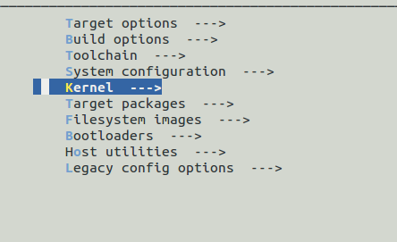

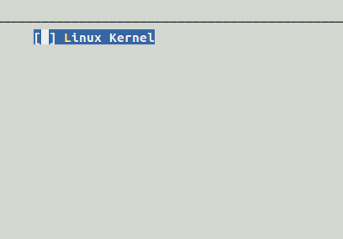

f ) cancel buid bootloader

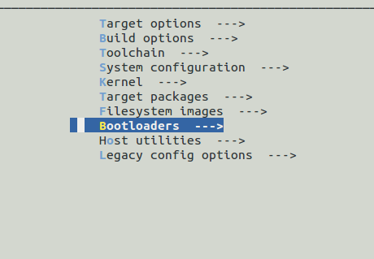

g ) Toolchain setting

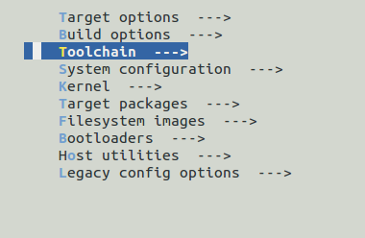

select toolchain type : External toolchain

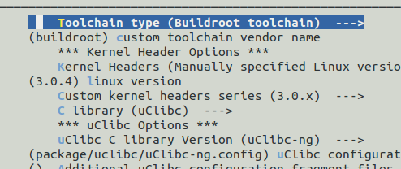

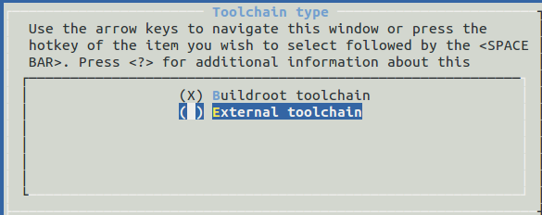

set toolchain path
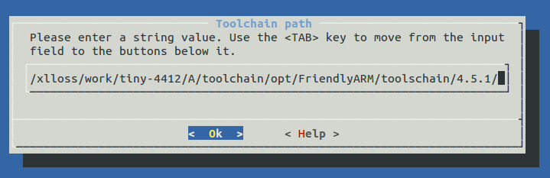

h ) set Toolchain has RPC support

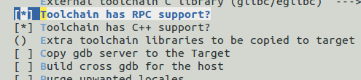

i ) build buildroot
#make

j ) make finish, we enter output directory
cd output/images

k ) extract rootfs.tar
mkdir my_rootfs && tar -xvf rootfs.tar -C my_rootfs/

l ) modify etc/passwd file
sudo vim etc/passwd
-root:x:0:0:root:/root:/bin/sh
+root::0:0:root:/root:/bin/sh

m ) add init process in etc/init.d
cd etc/init.d
sudo vim S00init, paste below :

##################### Start ############################

#!/bin/sh
#
# Start init
#

start() {
echo -n "Starting init: "
/bin/hostname -F /etc/hostname

/bin/mount -n -t proc none /proc
/bin/mount -n -t sysfs none /sys
/bin/mount -t ramfs none /dev

echo /sbin/mdev > /proc/sys/kernel/hotplug
/sbin/mdev -s
/bin/hotplug
# mounting file system specified in /etc/fstab
mkdir -p /dev/pts
mkdir -p /dev/shm
/bin/mount -n -t devpts none /dev/pts -o mode=0622
/bin/mount -n -t tmpfs tmpfs /dev/shm
/bin/mount -n -t ramfs none /tmp
/bin/mount -n -t ramfs none /var
mkdir -p /var/empty
mkdir -p /var/log
mkdir -p /var/lock
mkdir -p /var/run
mkdir -p /var/tmp

/bin/sh /etc/modules.conf

/sbin/getty -L ttySAC0 115200 vt100

echo "OK"
}

stop() {
echo -n "Stopping logging: "
start-stop-daemon -K -q -p /var/run/syslogd.pid
start-stop-daemon -K -q -p /var/run/klogd.pid
echo "OK"
}

case "$1" in
start)
start
;;
stop)
stop
;;
restart|reload)
stop
start
;;
*)
echo "Usage: $0 {start|stop|restart}"
exit 1
esac
exit $?

##################### End ############################

n ) # sudo 777 chmod S00init

[ 'n and o ' option, please check NTFS_Setting]

o ) update build_root rootfs to /etc/exports

p ) restart nfs server

Day6 Linux driver module

[ Host ]

1. Setting build module
# cd ~/tiny4412/experiment/linux_3.5.0_tiny4412
# make menuconfig
Device Drivers --->
Character devices --->
<M> Tiny4412 module sample

2. build module
# cd ~/tiny4412/experiment/linux_3.5.0_tiny4412
# make modules

3. set install path
# make help | grep modules_install
# export INSTALL_MOD_PATH=../
# make modules_install
# ls ../lib

4 Copy module to roofs
# sudo cp -a ../lib/modules/ ~/tiny4412/experiment/root_mkfs/lib/

[ Target ]

5. # ls lib/modules/3.5.0-FriendlyARM/kernel/drivers/char/

6. # insmod lib/modules/3.5.0-FriendlyARM/kernel/drivers/char/tiny4412_hello_module.ko
# lsmod

7. # rmmod tiny4412_hello_module
# lsmod

8. # modprobe tiny4412_hello_module
# lsmod

9. #modprobe -r tiny4412_hello_module
# lsmod

example_char_dev

a.
[ Host ]
1. cd ~/tiny4412/experiment/day6/module/example_char_dev/led_driver
2. cp ./leds-tiny4412-char.c ~/tiny4412/experiment/linux_3.5.0_tiny4412/drivers/char/
3. cd ~/tiny4412/experiment/linux_3.5.0_tiny4412/drivers/char/
4. geany Kconfig

config SLASH_LED
tristate "My LED Support for Tiny4412 LED"

5. geany Makefile

obj-$(CONFIG_SLASH_LED) += leds-tiny4412-char.o

6.
a. cd $(KERNEL_PATH)
b. #make menuconfig
c. #make modules

7. cp -a drivers/char/leds-tiny4412-char.ko ~/tiny4412/experiment/root_mkfs/lib/modules/3.5.0-FriendlyARM/kernel/drivers/char/

[ Target ]

8. depmod

9. modprobe leds-tiny4412-char

Application program

1. # cd ~/tiny4412/experiment/day6/module/example_char_dev/example_app/leds
2. # make
3. # sudo cp -a ./led ~/tiny4412/experiment/root_mkfs
4. # depmod -n
# depmod

5. # modprobe leds-tiny4412-char

6. # led

example_build_out_of_kernel

[ Host ]
1. # cd ~/tiny4412/experiment/day6/module/example_build_out_of_kernel

2. # make

3. # cp ./leds-tiny4412_out_of_kernel.ko ~/tiny4412/experiment/root_mkfs/lib/modules/3.5.0-FriendlyARM/kernel/drivers/char/

[ Target ]

6. # depmod -n
# depmod

7. # modprobe leds-tiny4412_out_of_kernel [install module ]

8. # modprobe -r leds-tiny4412_out_of_kernel [remove module ]

