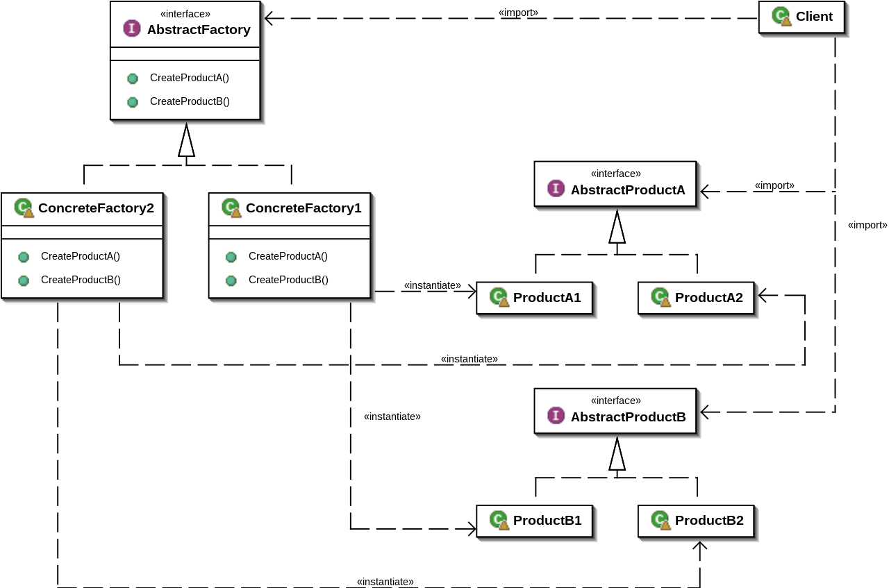
- It provides an interface or an abstract class for creating families of related objects without exposing their concrete implementations.
- This pattern is useful when there is a need to create multiple related objects that belong to a common family or share a common theme.
Abstract Factory patterns work around a super-factory which creates other factories.
This factory is also called as factory of factories. This type of design pattern comes
under creational pattern as this pattern provides one of the best ways to create an object.
Key Features of the Abstract Factory Design Pattern:
Abstract Factory: The Abstract Factory defines an interface or an abstract class with methods for creating the family of related objects.
Concrete Factories: Concrete factories implement the Abstract Factory interface and provide the concrete implementation for creating objects of the related family.
Abstract Products: Abstract products are interfaces or abstract classes that define the common methods to be implemented by the family of related objects.
Concrete Products: Concrete products are the actual implementations of abstract products, representing specific objects within the related family

