Real-time Handwritten Digit Recognition on FPGA Using Vitis HLS - Tutorial

INSTRUCTION MANUAL

Design of Handwritten Digit Recognition Implemented on FPGA Using Vitis High-Level Synthesis (HLS)

Table of Contents
1. IMPLEMENTATION PROCESS 2
2. TRAIN MODEL 2
2.1. Prepare Code 2
2.2. Use Google Colab 2
3. PY2C 6
3.1. Tool to Convert Python to C 6
3.2. Result After Running Py2C 6
3.3. Prepare X.txt and Y.txt Files 7
4. AXI WRAPPER 8
5. C-TO-RTL WITH VITIS HLS 2022.2 9
6. Run C Simulation 16
7. C Synthesis 19
8. C/RTL Cosimulation 21
9. INTEGRATE IP INTO SOC SYSTEM 25
10. Create SoC System 27
11. INSTALL PETALINUX 41
12. Datatest Recognition (Code C) 44
The entire code is in the link below, copy it to the Linux account on the KV260 FPGA: https://github.com/AISeQLab/Real-time_Handwritten_Digit_Recognition_on_FPGA/tree/main/Embedded_Software/Datatest_Recognition 44
13. Real-time Recognition (Code C + Nodejs to host Webserver) 50
The entire code is in the link below, copy it to the Linux account on the KV260 FPGA: https://github.com/AISeQLab/Real-time_Handwritten_Digit_Recognition_on_FPGA/tree/main/Embedded_Software/Real-time_Recognition 50

1. IMPLEMENTATION PROCESS

Train Model → Convert from Python to C → AXI Wrapper → Convert from C to RTL
→ Integrate IP into SoC System → Write Control C Code → Load Kit

2. TRAIN MODEL
Link Github: https://github.com/TuanSuyTu/Lenet-5-HLS

2.1. Prepare Code

Python (Keras/TensorFlow) to train the model (file - lenet.py at the GitHub link).

2.2. Use Google Colab

Switch to GPU to train faster. Go to the settings as shown in Figure 1 to change to GPU.

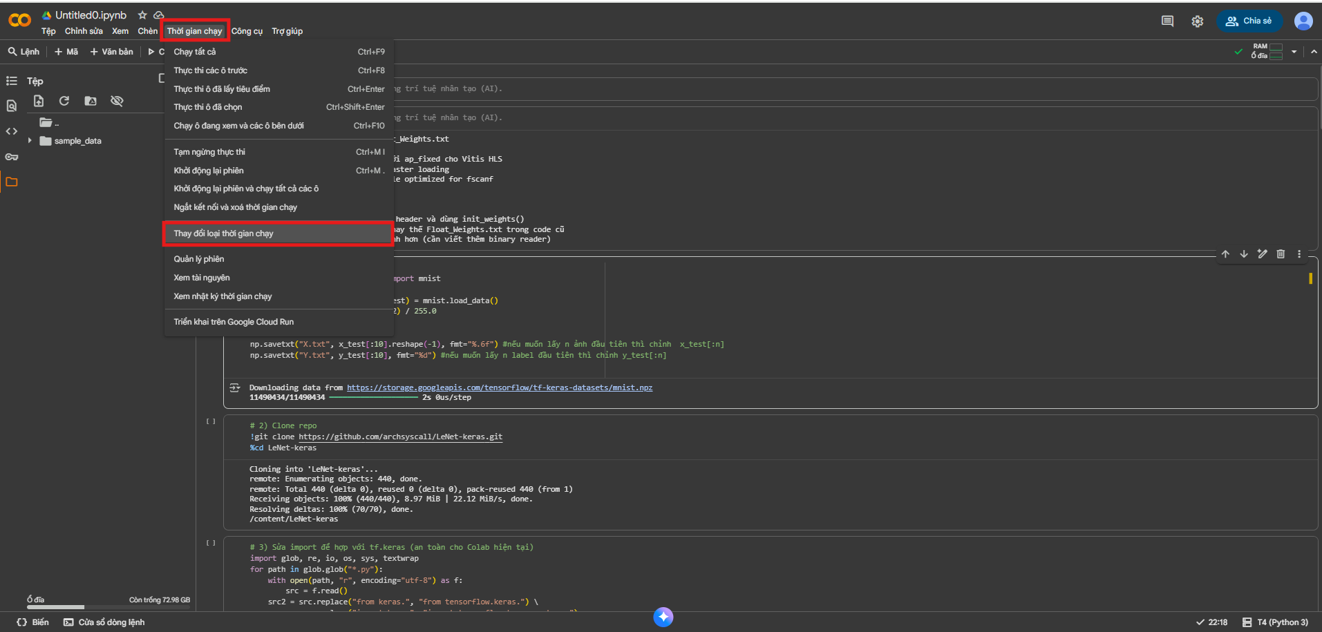

Figure 1: Switch to GPU - Google Colab runtime settings showing GPU selection.
Runtime → Change runtime type

Run Python code to train the model
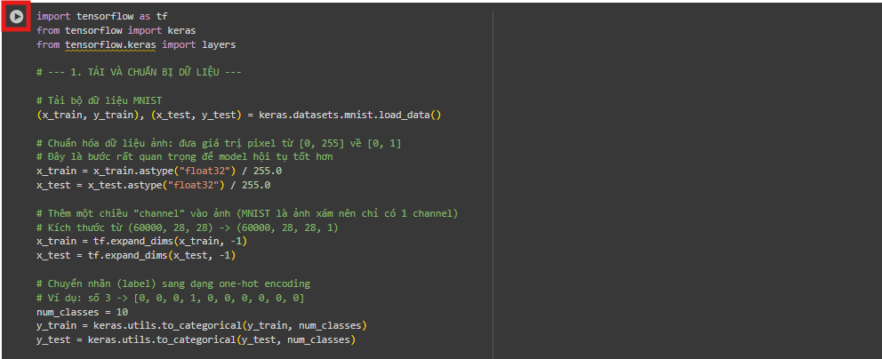
Figure 2: - Run Python Code - Python code for loading MNIST dataset, normalizing data, adding channel dimension, and one-hot encoding labels.

After running successfully:

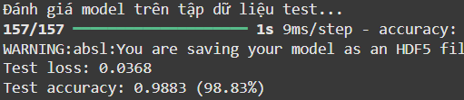
Figure 3: Result After Running - Screenshot showing test accuracy of 98.83%.

Note: If Dropout is used, run the file `remove_dropout.py` to create a `.h5` file without Dropout.

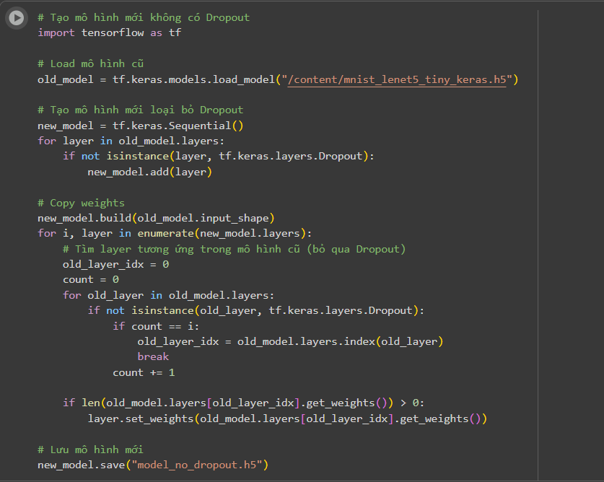

Figure 4: Code to Remove Dropout - Python code that loads the old model, creates a new Sequential model without Dropout layers, copies weights, and saves as “model_no_dropout.h5”.

Download .h5 File:

Go to the Folder icon on the left sidebar. If you don't see it, press refresh, then download the file `model_no_dropout.h5` to your computer.

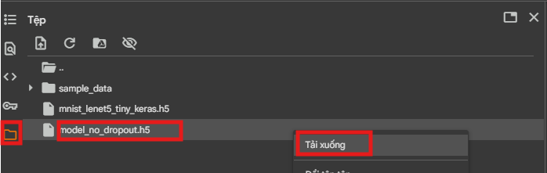

Figure 5: Download .h5 File - File browser in Google Colab with `model_no_dropout.h5` selected and a "Download" button.

3. PY2C

3.1. Tool to Convert Python to C

Go to: https://github.com/WangNe2207/Py2C_new?tab=readme-ov-file

Follow the instructions to convert from Python code to C code.

The main.py file for LeNet-5 will be selected as follows:

- Change model_path according to the actual path
- Change type = "fxp"
- Torch = False (if using Keras/TensorFlow)
- If using Visual Studio, set ide = "vs", otherwise leave as in the image

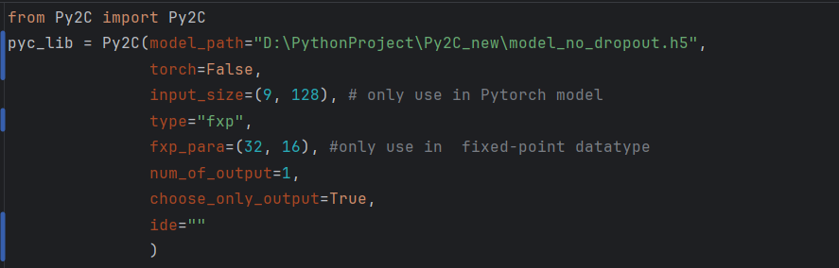

Figure 6 - File main.py - Python code initializing Py2C with `model_path`, `torch=False`, `type="fxp"`, `fxp_para=(32, 16)`.

3.2. Result After Running Py2C

After running, the following files will be created:

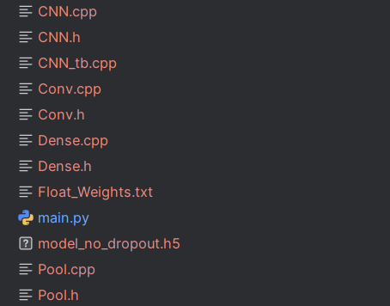

Figure 7: Files Created After Running main.py

File list showing:
- CNN.cpp, CNN.h
- CNN_tb.cpp
- Conv.cpp, Conv.h
- Dense.cpp, Dense.h
- Float_Weights.txt
- main.py
- model_no_dropout.h5
- Pool.cpp, Pool.h

3.3. Prepare X.txt and Y.txt Files

- X.txt is the file containing input images for testing
- Y.txt is the expected output

Use the following Python code (file creat_x_y.py). Run the code on Colab, then download the 2 files X.txt and Y.txt.

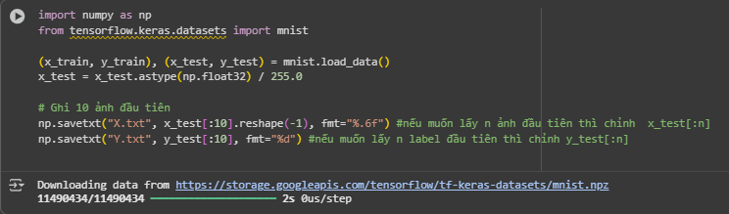
Figure 8: Create X.txt and Y.txt Files for CNN_tb.cpp - Python code that loads MNIST data, normalizes, and saves the first 10 images to `X.txt` and their labels to `Y.txt`.

4. AXI WRAPPER

In the CNN.cpp file, add #pragma directives to create the AXI wrapper.

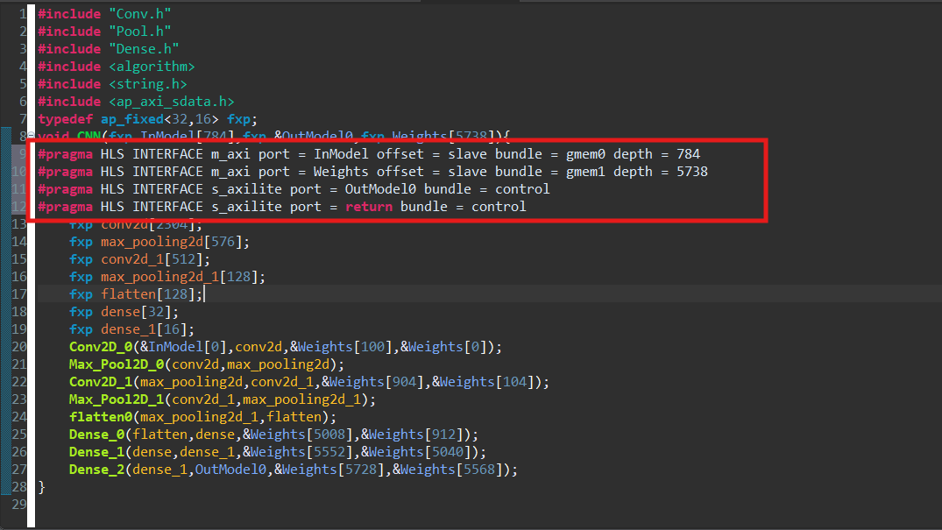

Figure 9: File CNN.cpp After Adding #pragma

- CNN.cpp file with AXI interface pragmas added for `InModel`, `Weights`, `OutModel0`, and `return`.

Explanation of Pragmas

1. #pragma HLS INTERFACE m_axi port = InModel offset = slave bundle=gmem0 depth = 784

- “m_axi” creates an AXI Master port so the IP can read from BRAM (or DDR) itself

- “offset = slave” means HLS will create an AXI-Lite to store the base address of “InModel”. The CPU will write to this address before running the IP, and the IP will use this address to communicate directly with the BRAM storing “InModel”

- “bundle=gmem0” names the bus for the m_axi port as “gmem0” to separate it from Weights and allow parallel reading

- “depth = 784” announces the maximum size of the array since this is a 28×28 = 784 element image

2.#pragma HLS INTERFACE m_axi port = Weights offset = slave bundle = gmem1 depth = 5738

- Similar to above

3.#pragma HLS INTERFACE s_axilite port = OutModel0 bundle = control

- Creates an AXI-Lite
- Maps “OutModel0” as an AXI-Lite register for the CPU to read results

4.#pragma HLS INTERFACE s_axilite port = return bundle = control

- Creates AP_CTRL register (“ap_start”, “ap_done”, ...) for controlling the CNN IP

#pragma HLS INTERFACE m_axi port = InModel offset = slave bundle = gmem0 depth = 784
#pragma HLS INTERFACE m_axi port = Weights offset = slave bundle = gmem1 depth = 5738
#pragma HLS INTERFACE s_axilite port = OutModel0 bundle = control
#pragma HLS INTERFACE s_axilite port = return bundle = control

5. C-TO-RTL WITH VITIS HLS 2022.2

1. Create Project

Select “Create Project”

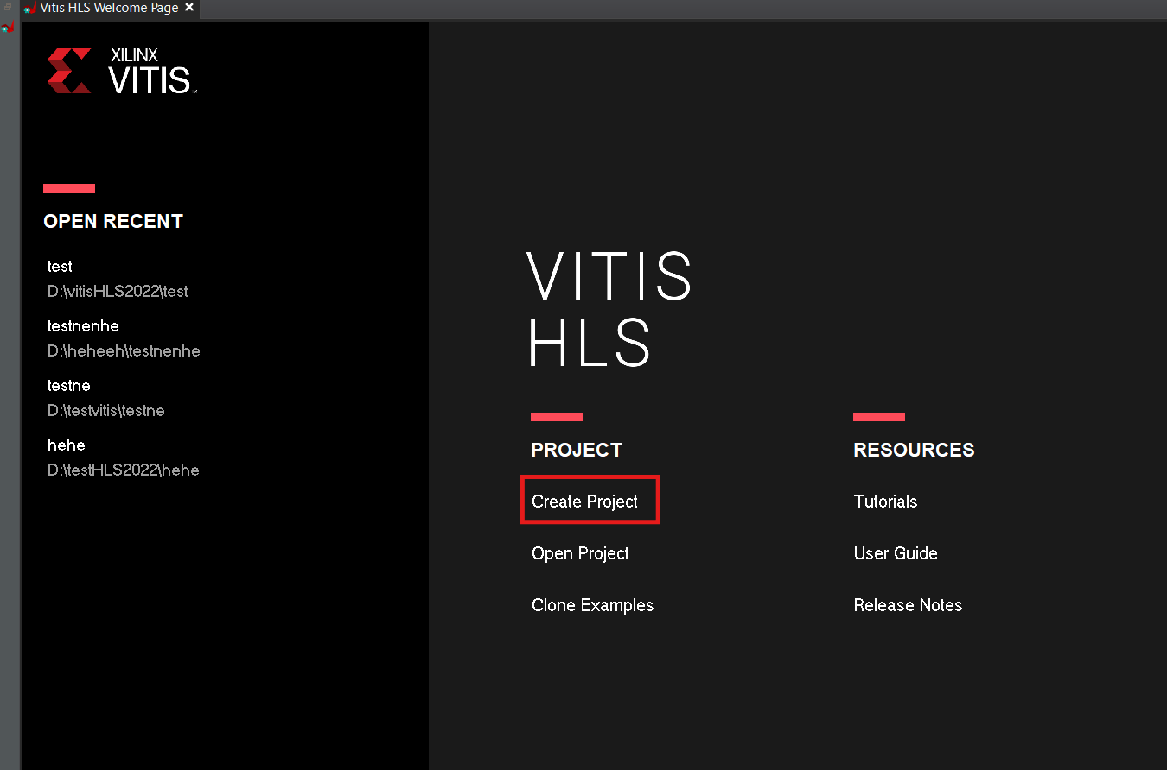

Figure 10: Create Project - Vitis HLS welcome screen with "Create Project" button highlighted.

Name it, choose project folder, press Next.

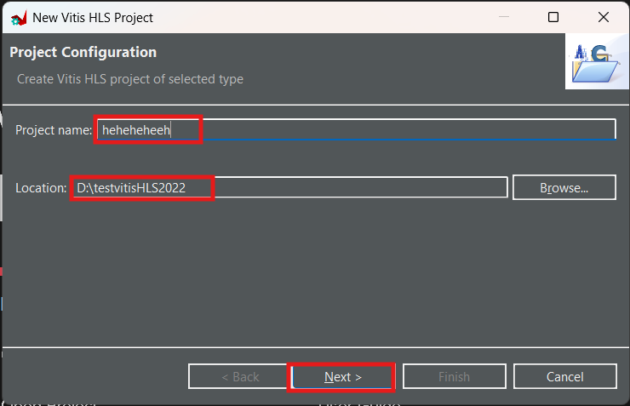
Figure 11: Name Project - New Vitis HLS Project dialog with project name and location fields.

Add/Remove Design file: Add the files created from the Py2C step.

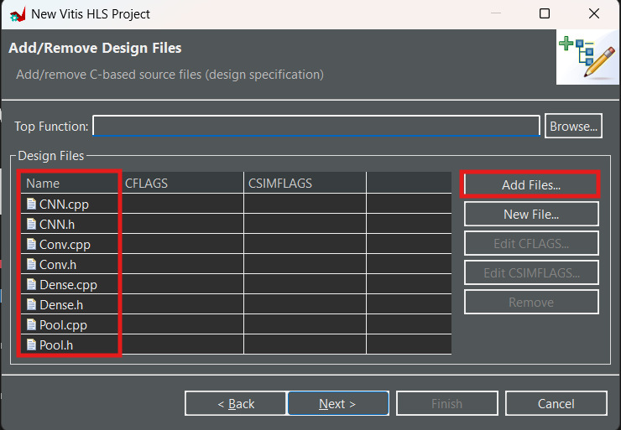

Figure 12: Add Design Files - Dialog showing CNN.cpp, CNN.h, Conv.cpp, Conv.h, Dense.cpp, Dense.h, Pool.cpp, Pool.h added as design files.

Select “Top function” as the CNN.cpp file, then select Next.
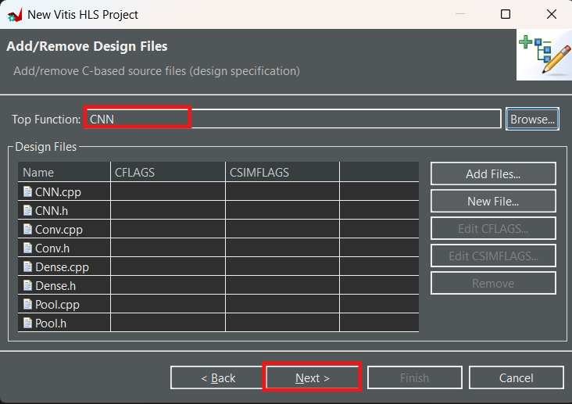

Figure 13: Select Top Function - Top Function field set to "CNN".

Add/Remove Testbench file: Add the files as shown, then select “Next”.

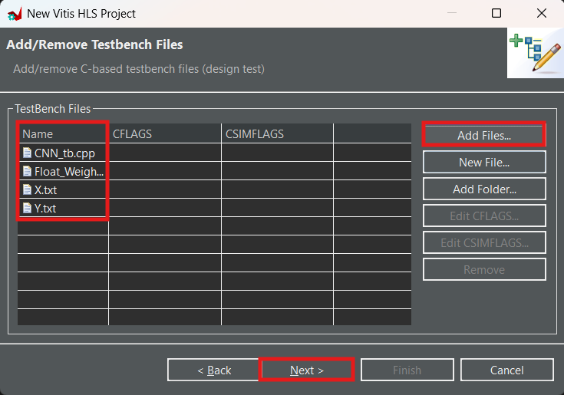
Figure 14: Select Testbench File - Dialog showing CNN_tb.cpp, Float_Weights.txt, X.txt, Y.txt added as testbench files.

Solution Configuration: Select the three dots in the Part Selection section to choose the kit code to load. If you want to use KV260, use code “xck26-sfvc784-2LV-c”.

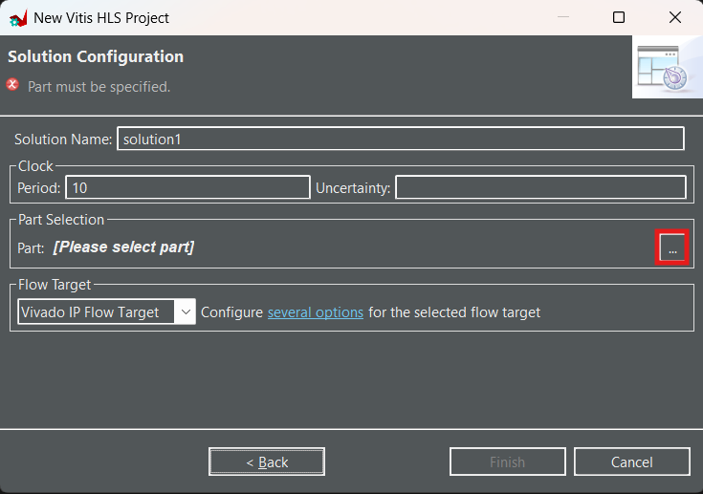

Figure 15: Select Kit Code - Solution Configuration dialog with Part Selection field empty and "..." button highlighted.

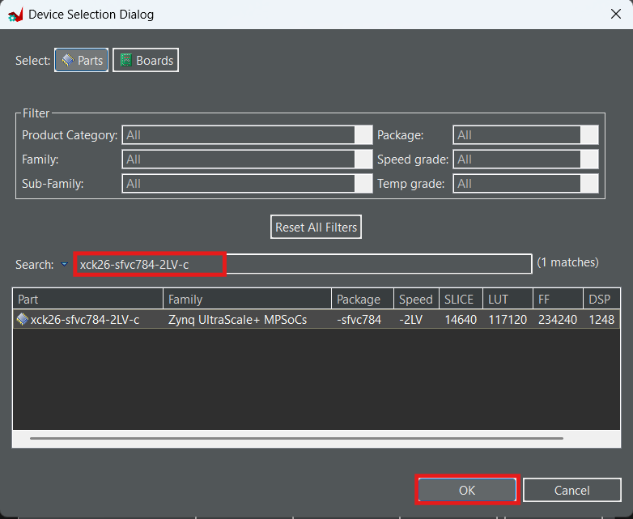
Figure 16: Enter Kit Code - Device Selection Dialog with search for "xck26-sfvc784-2LV-c" showing 1 match.

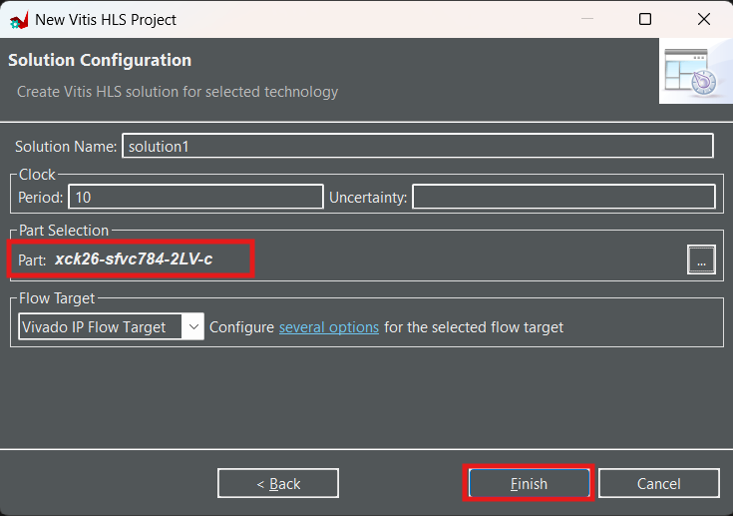
Figure 17: Finish - Solution Configuration dialog with Part field filled with "xck26-sfvc784-2LV-c" and Finish button highlighted.

After successful creation:

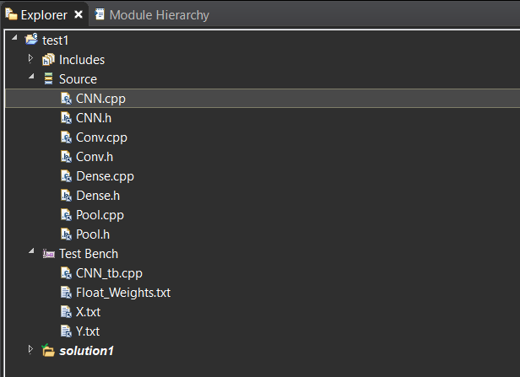
Figure 18: Files After Successfully Creating Project - Explorer panel showing Source files and Test Bench files.

6. Run C Simulation

In the file “CNN_tb.cpp”:

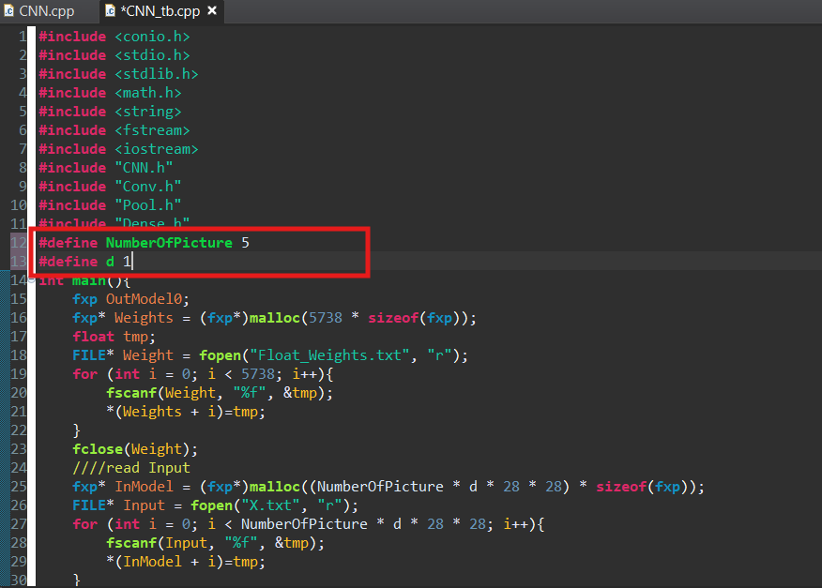
Figure 19: Select Number of Images to Test - Code snippet from “CNN_tb.cpp” showing #define NumberOfPicture 5 and #define d 1.

- If you want to test on `n` images, define `NumberOfPicture` as `n`. For example, here it's 5 images. If set too large in the Cosimulation step, you will have to wait a long time and may time out. Choose `dump trace = all` (in Figure 28).
- Since here it's a black and white image with only 1 input channel (28×28×1), if using color images you can set `define d` to 3.

Note: There may be code at the last line of the `Dense.cpp` file missing an underscore like this:

output_Dense0 = maxindex_2;

Correct it as follows:

output_Dense_0 = maxindex_2;

Select “Run C simulation”.

Note - Comment “#include <conio.h>” from CNN_tb.cpp.
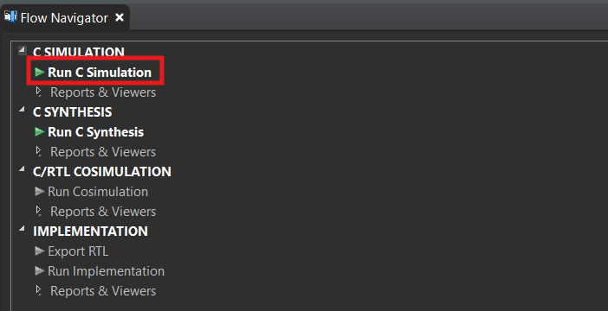
Figure 20: Run C Simulation - Flow Navigator showing C SIMULATION with "Run C Simulation" highlighted.

Next, press “OK”.

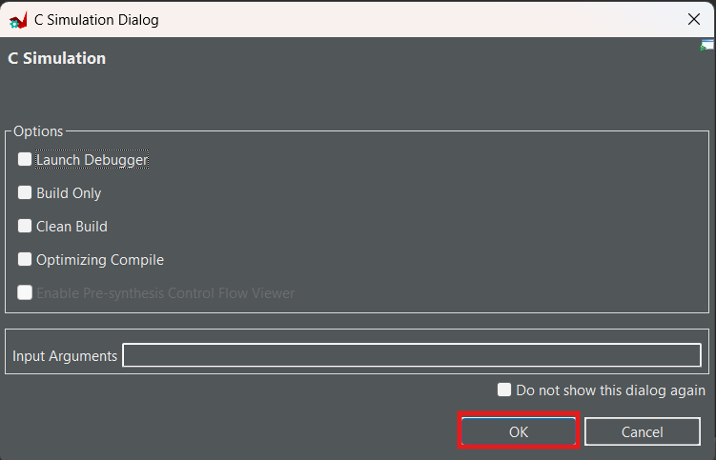
Figure 21: Select C Simulation Dialog - C Simulation Dialog with OK button highlighted.

After running, note the accuracy of Model section:

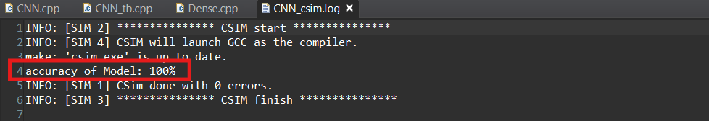
Figure 22: Result After Running C Simulation - Console log showing "accuracy of Model: 100%" and "Csim done with 0 errors".

If accuracy is too low, the C code may be wrong and needs checking and correction.

7. C Synthesis

Select “Run C synthesis”

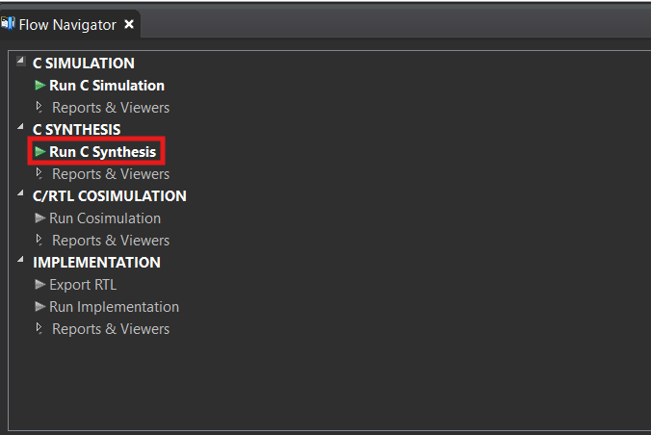
Figure 23: Run C Synthesis - Flow Navigator showing C SYNTHESIS with "Run C Synthesis" highlighted.

Next, press “OK”.

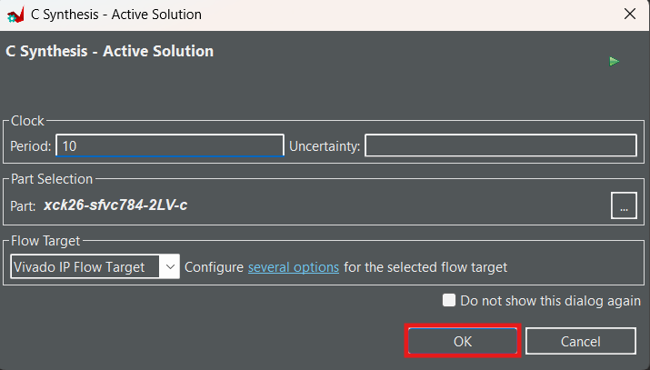
Figure 24: Set Clock - C Synthesis - Active Solution dialog with Period 10 and Part “xck26-sfvc784-2LV-c”.

View the “Performance & Resource Estimate” section to see the IP resource report.

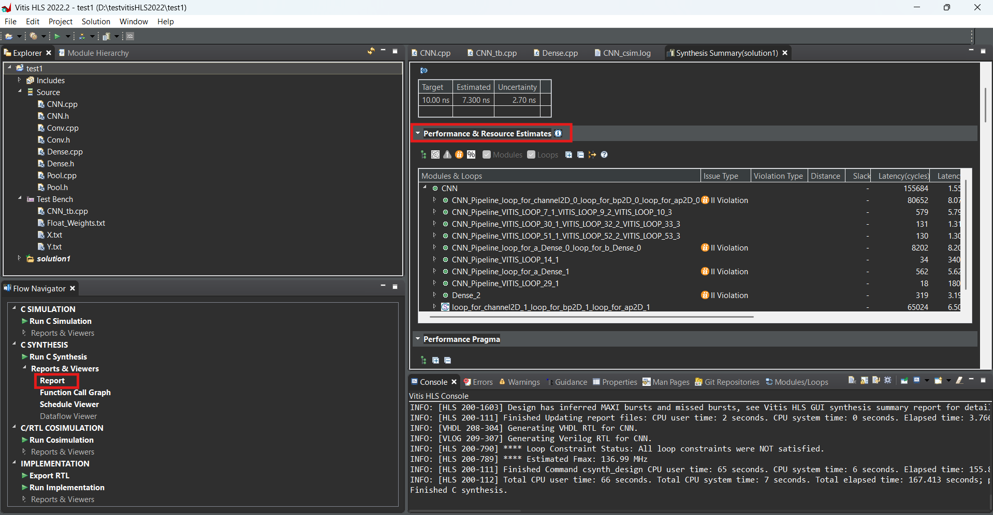
Figure 25: View Resource Report - Vitis HLS interface showing Performance & Resource Estimate with timing and resource utilization.

Note the “HW Interfaces” section to be able to write control C code later.

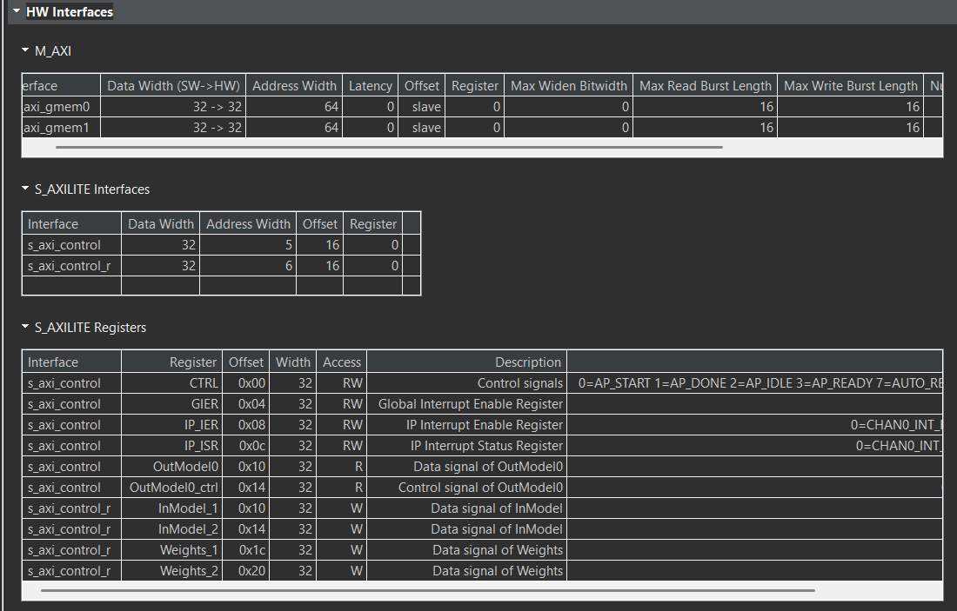
Figure 26: Configuration of AXI Wrapper - HW Interfaces panel showing M_AXI interfaces (`gmem0`, `gmem1`) and S_AXILITE interfaces (`s_axi_control`, `s_axi_control_r`) with registers like `AP_CTRL`, `OutModel0`, `InModel_1`, `Weights_1`, etc.

8. C/RTL Cosimulation

This is the step to compare the results of the RTL just generated in the Synthesis part with the C code to check the correctness of the generated RTL.

Select “Run Cosimulation”.

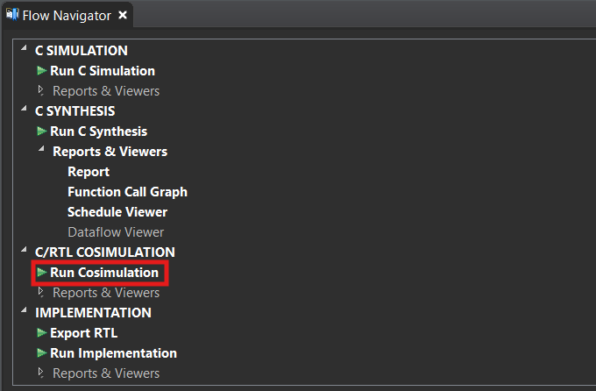
Figure 27: Run Cosimulation - Flow Navigator showing C/RTL COSIMULATION with "Run Cosimulation" highlighted.

Select settings as shown to view waveform. If you don't want to view waveform, you can turn off Wave Debug and select `Dump Trace = none` to run this step faster.

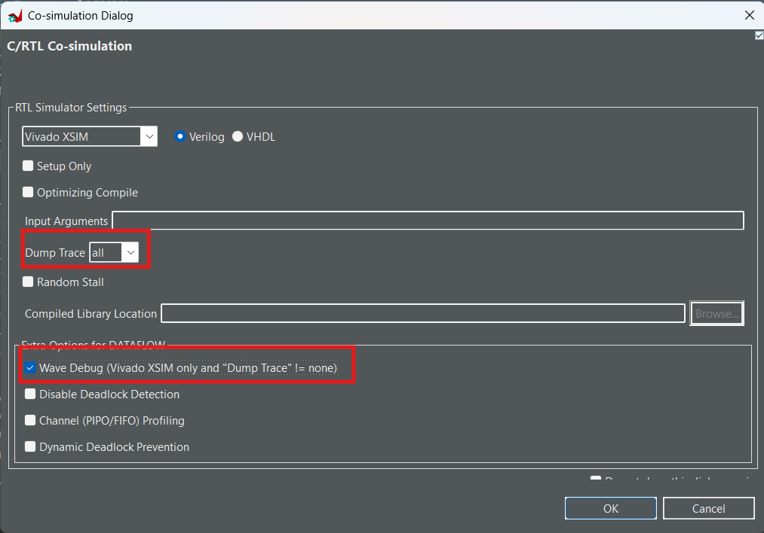
Figure 28: Configure to View Waveform - Co-simulation Dialog with Dump Trace set to "all" and Wave Debug checkbox checked.

While running, Vivado will open. Wait until it finishes running, then select `CNN.wcfg` to view waveform.

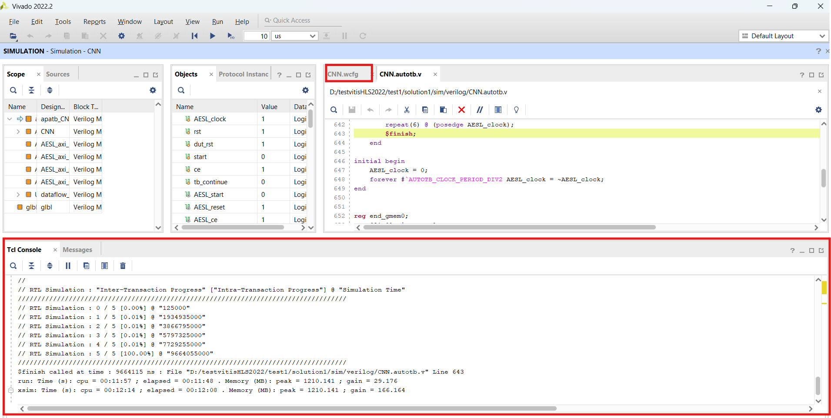
Figure 29: Vivado Simulation Running Interface - Vivado window showing simulation running with Tcl Console output.

In the waveform, select “Design Top Signals” to view signals.

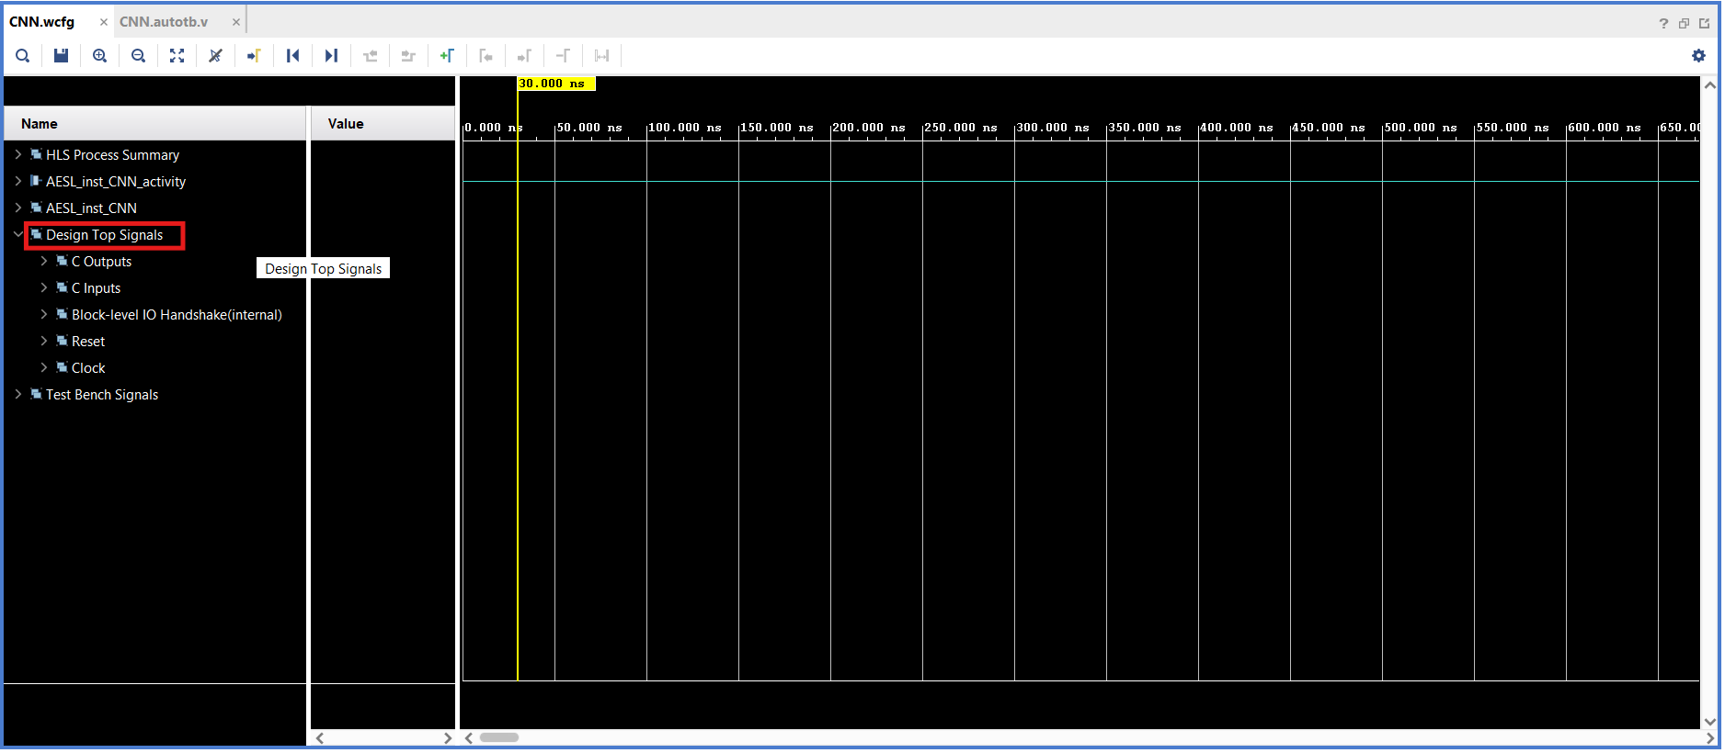
Figure 30: Waveform - Vivado waveform viewer showing signals like `ap_clk`, `ap_rst_n`, `s_axi_control`, `m_axi_gmem0`.

If you want to see the output data, select “C outputs → OutModel0” and select “RDATA” to see the Model output.

Note: The Address in Figure 25, `OutModel0` has offset `0x10`, so when `ARADDR = 10`, `RDATA` at that time will be the model output.

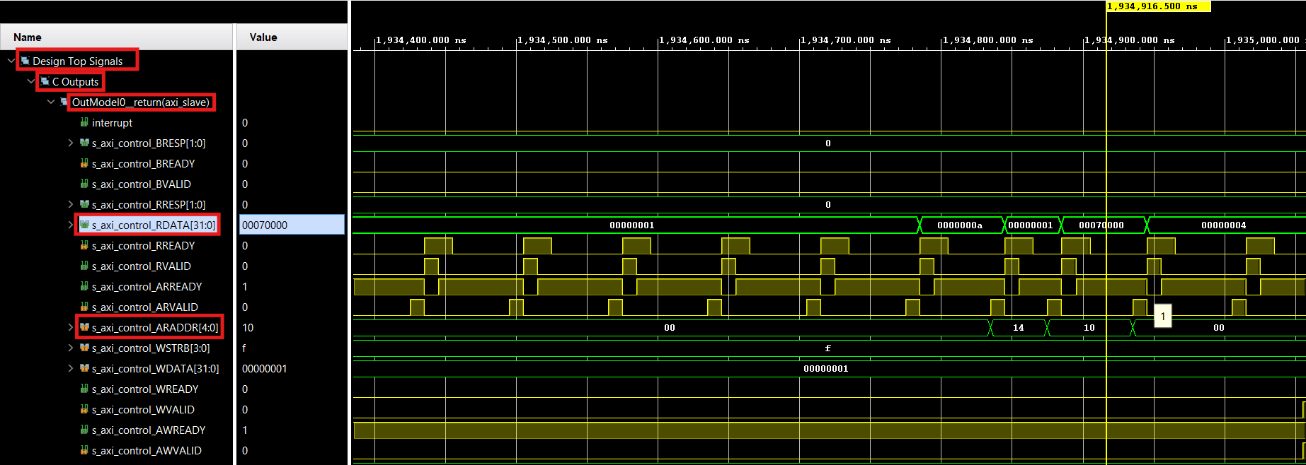

Figure 31: Read Output Data - Waveform showing RDATA with value `0x00070000` and `ARADDR = 10`.

Since fixed point Q16.16 is used here, the number 7 will be represented as `0x00070000`.

If you have finished viewing, exit Vivado, then return to Vitis to complete running C cosimulation.

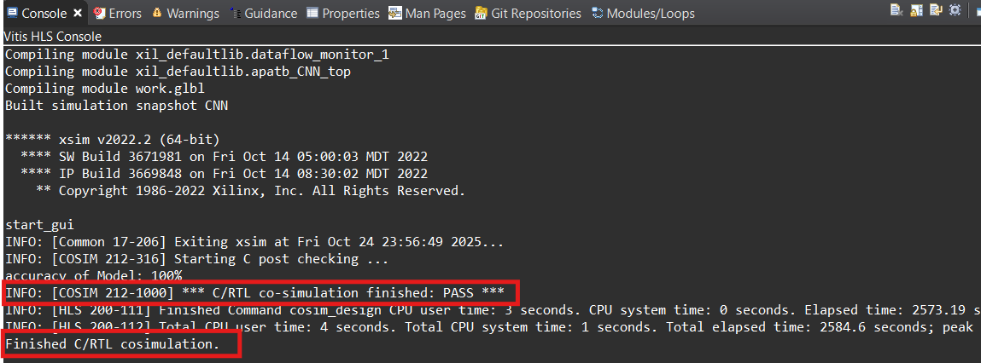
Figure 32: Complete Running Cosimulation - Console showing "C/RTL co-simulation finished: PASS".

After running, click “Export RTL” in Implement to create IP.

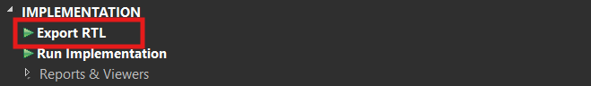
Figure 33: Export RTL - Flow Navigator showing IMPLEMENTATION with "Export RTL" highlighted.

9. INTEGRATE IP INTO SOC SYSTEM

1. Download Vivado 2022.2

2. Create Project

Name it, choose project folder → Next.

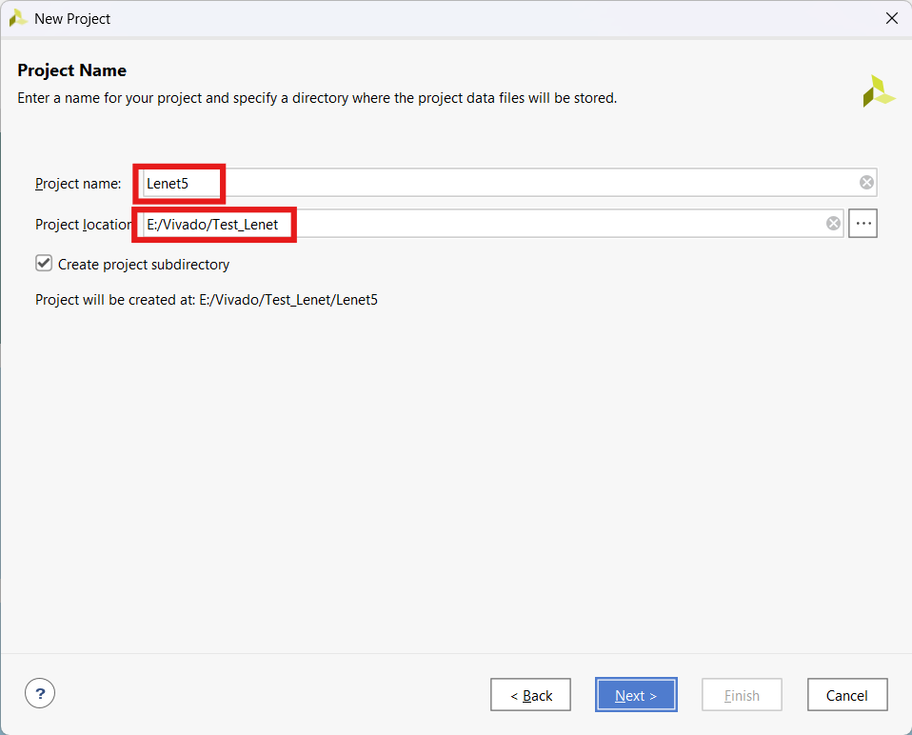
Figure 34: Create Name, Project Folder - New Project dialog with project name "Lenet5" and location.

Project type select “RTL” → Next.

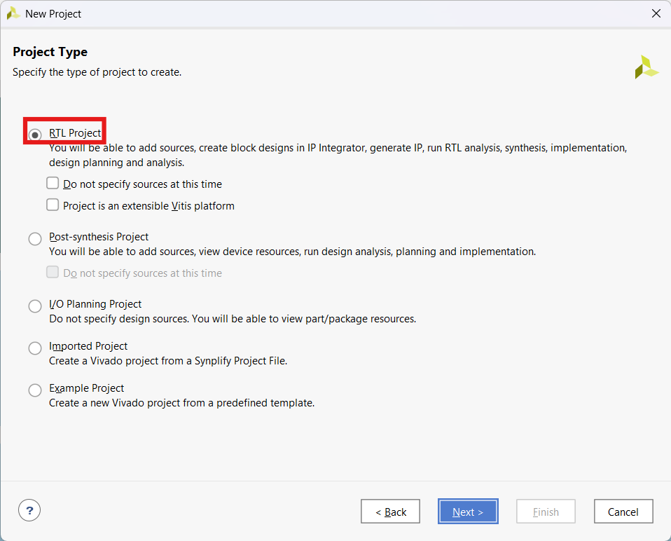
Figure 35: Select RTL Project - New Project dialog with RTL Project selected.

- Add Source: Don't add → **Next**
- Add Constraint: Don't add → **Next**
- Default Part: Select the part or board in use. In this project, KV260 is used. Switch to “Board”, select “KV260”.

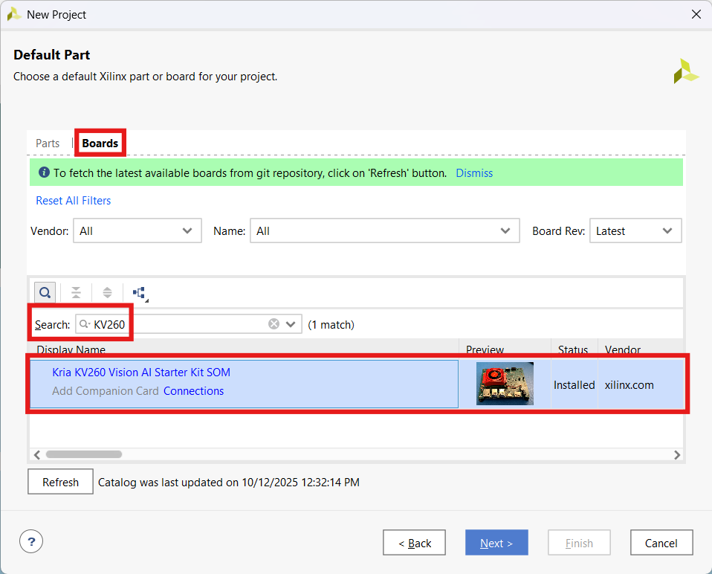
Figure 36: Select Board KV260 - Default Part dialog showing Boards tab with KV260 selected.

Note: If you don't see the board, press “Refresh” to update.

- Finish

10. Create SoC System

Add IP CNN:

Go to Tools → Settings → IP → Repository.

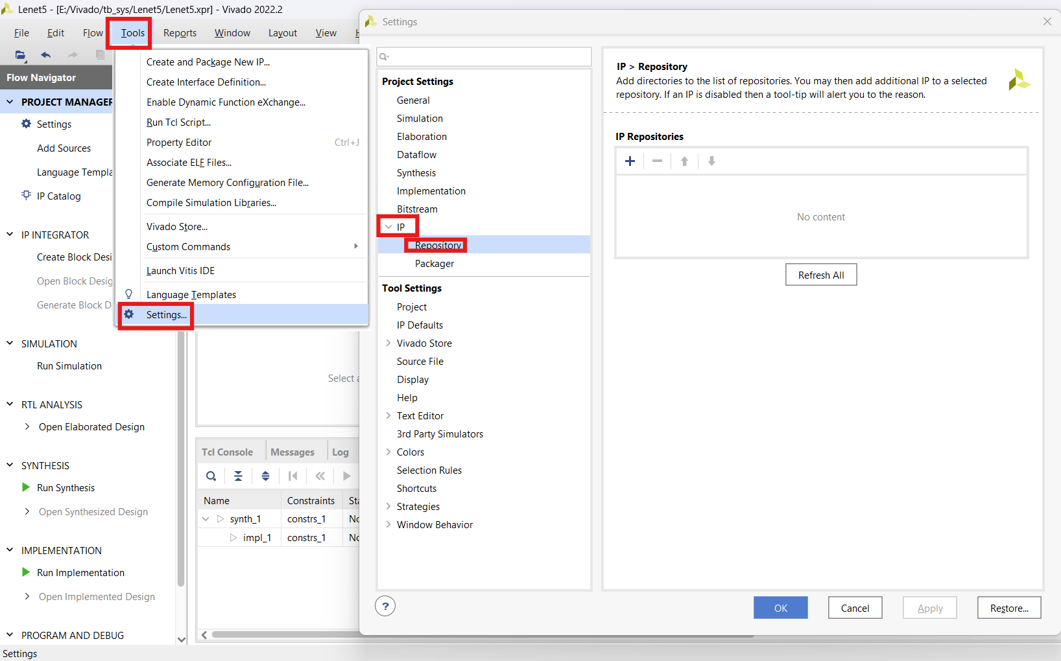
Figure 37: Open IP Repository - Vivado Settings dialog showing IP Repository tab.

Go to the VitisHLS project made earlier. Select “.../impl/ip”.

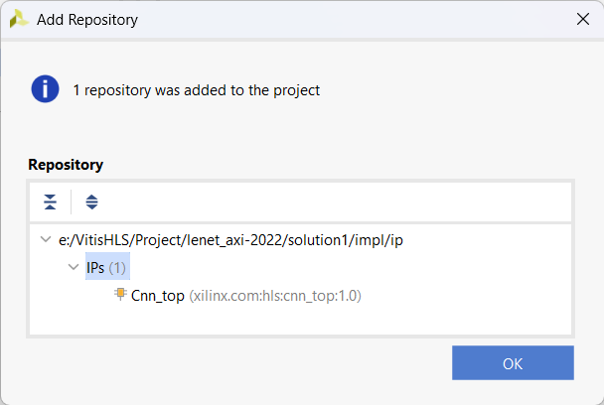
Figure 38: Select CNN IP Path - Add Repository dialog showing the IP path and “Cnn_top” IP found.

Found IP → OK → OK.

Create Block Design → OK.

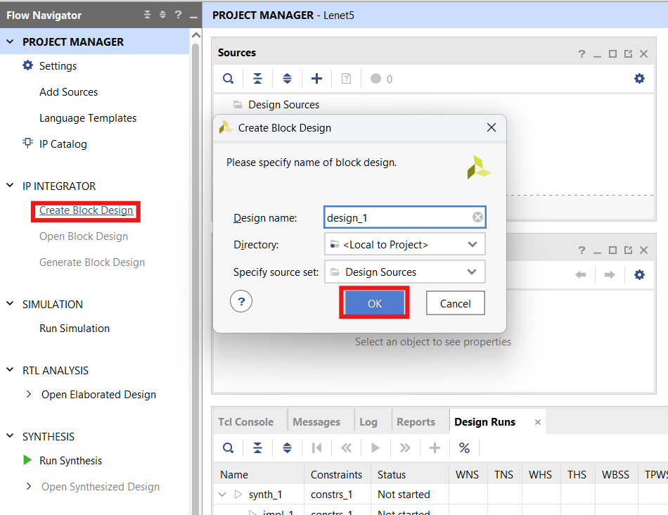
Figure 39: Create Block Design - Create Block Design dialog with design name “design_1”.

After creating Block Design, press “+” to add IP.

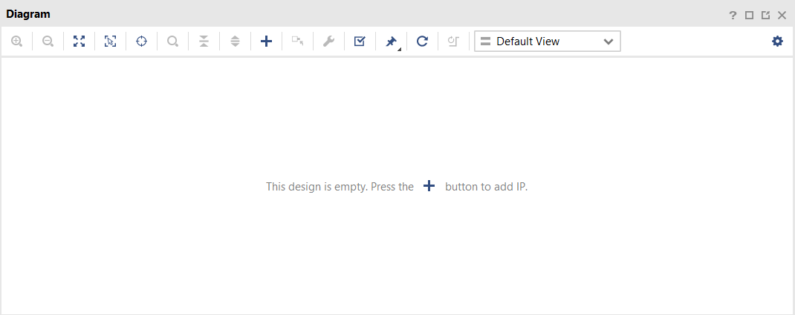
Figure 40: Add IP - Empty Diagram window with + button highlighted.

Add Zynq UltraScale+ MPSoC → Run Block Automation.

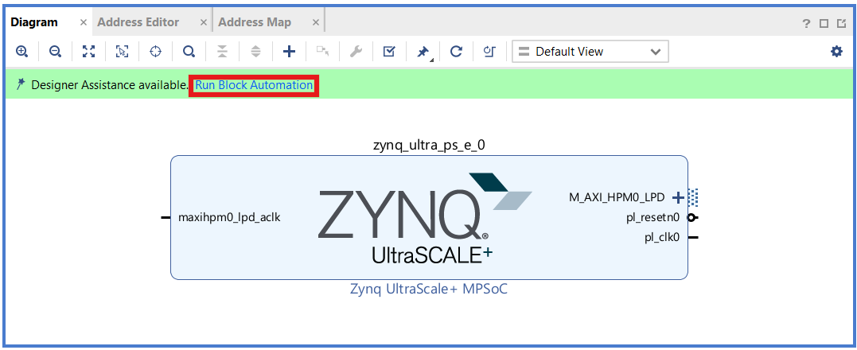
Figure 41: Add Zynq UltraScale+ MPSoC - Block Design showing `zynq_ultra_ps_e_0` with Run Block Automation highlighted.

Add CNN IP.

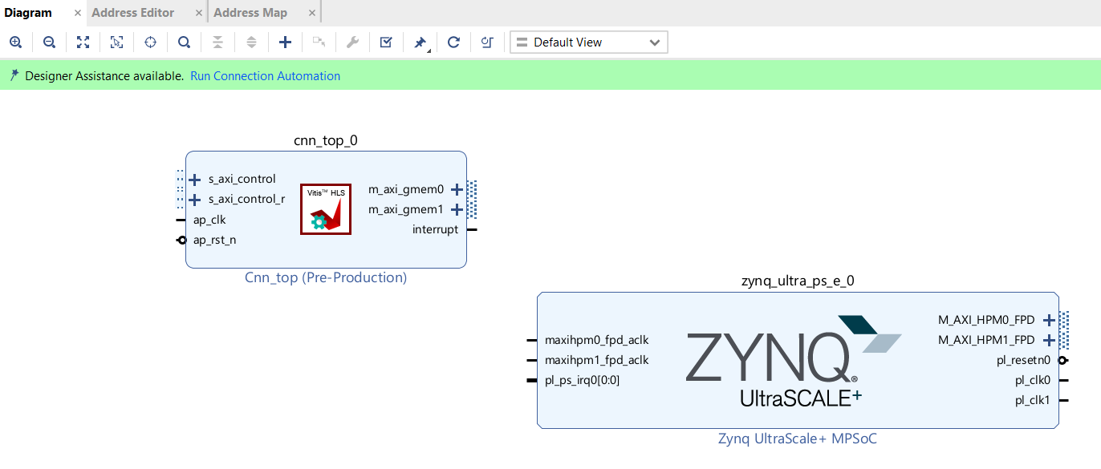
Figure 42: Add CNN IP - Block Design showing `cnn_top_0` and `zynq_ultra_ps_e_0`.

Add “2 Block Memory Generator”. In Block Properties, rename to “immodel_bram” and `weights_bram`. Click on each IP to change Memory Type to “True Dual Port RAM”.

- 2 Ports A/B to support reading/writing at 2 different addresses simultaneously, helping to increase processing speed. Data can be shared by one port for CPU access, the other port for the accelerator (CNN IP) to use.

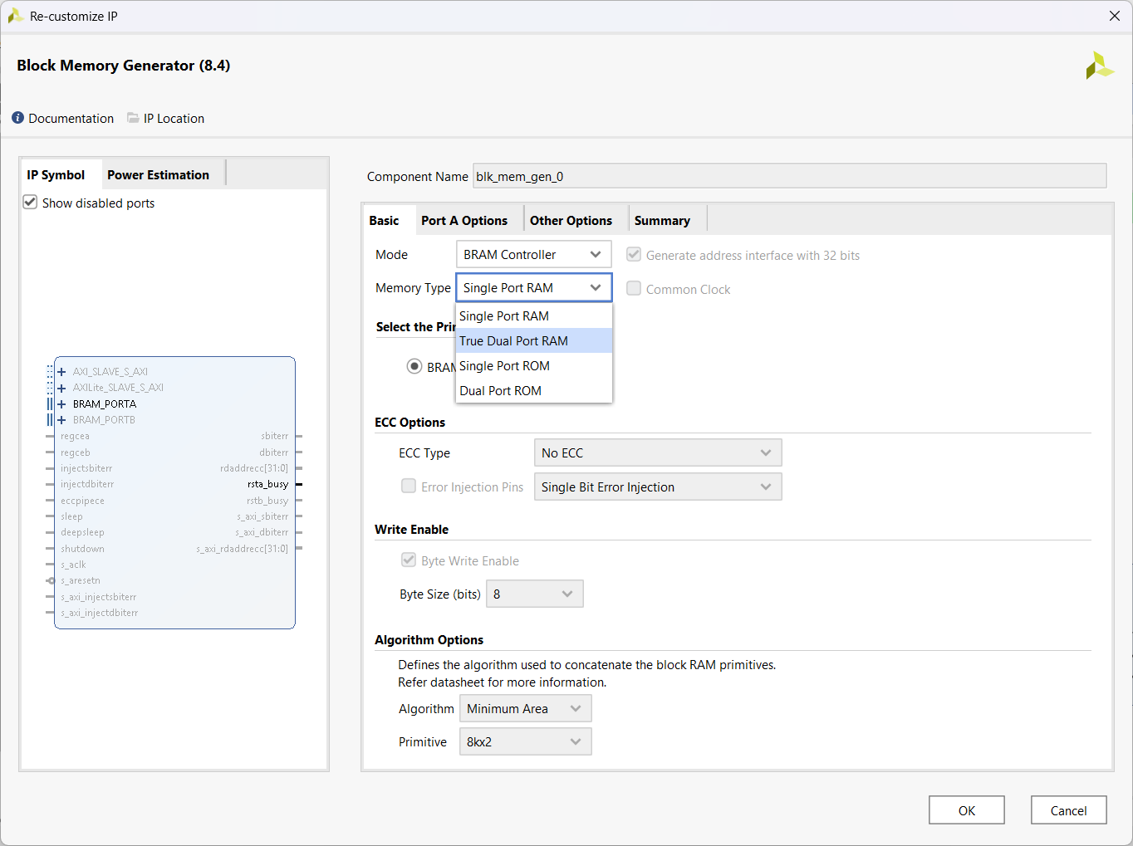
Figure 43: Select Memory Type - Re-customize IP dialog for Block Memory Generator with Memory Type set to "True Dual Port RAM".

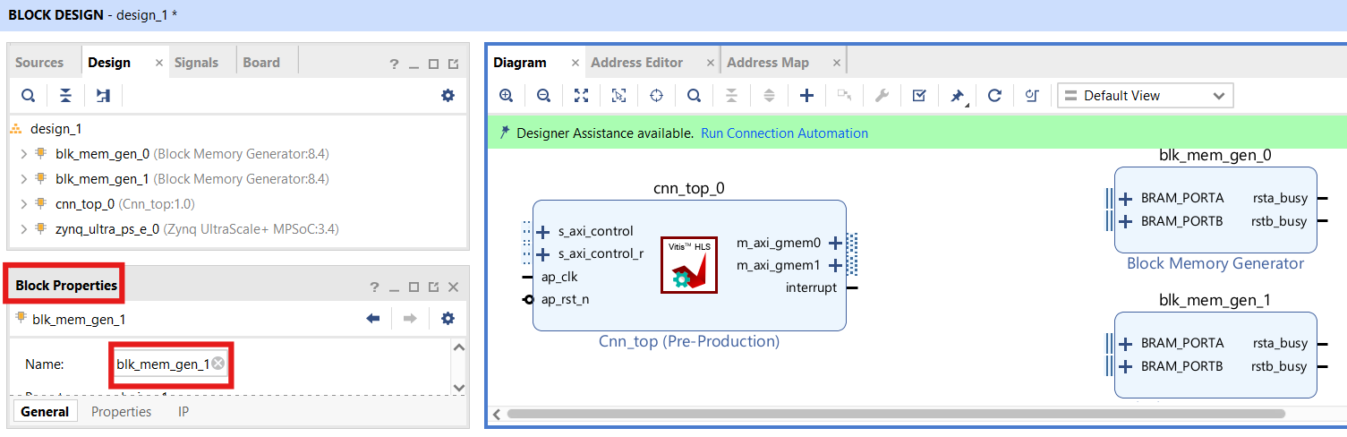
Figure 44: Rename BRAM - Block Properties panel showing Name field with `blk_mem_gen_1` and block diagram showing `cnn_top_0` and two Block Memory Generators.

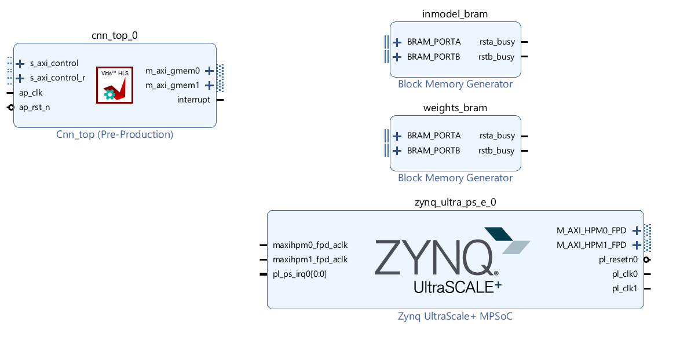
Figure 45: After Adding 2 BRAMs - Block Design showing “cnn_top_0”, “immodel_bram”, “weights_bram”, and “zynq_ultra_ps_e_0”.

Add “2 IP AXI BRAM Controller”. Rename to “immodel_bram_ctrl” and “weights_bram_ctrl”. Connect Port A, B of the 2 BRAM Controllers to Port A, B of the 2 Block Mems respectively.

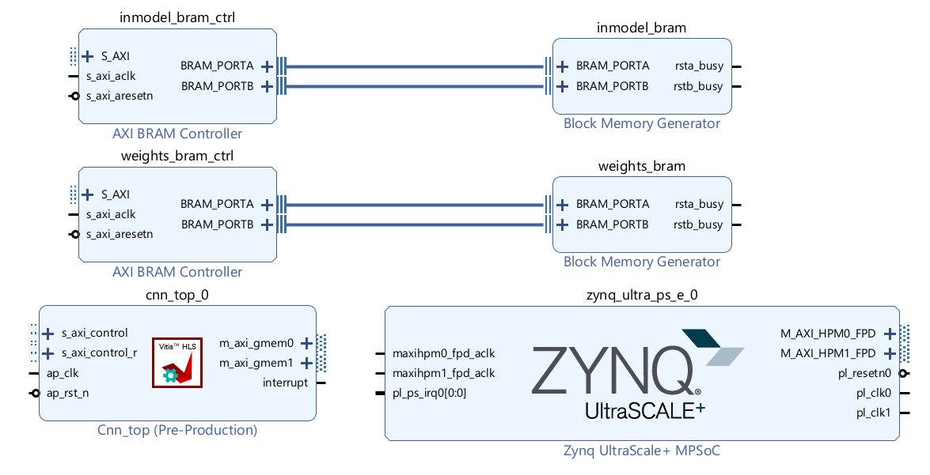
Figure 46: Connect BRAM CTRL with BRAM - Block Design showing AXI BRAM Controllers connected to Block Memory Generators.

“Run Connection Automation” until you have a complete system, no more Run Connection Automation notifications appear.

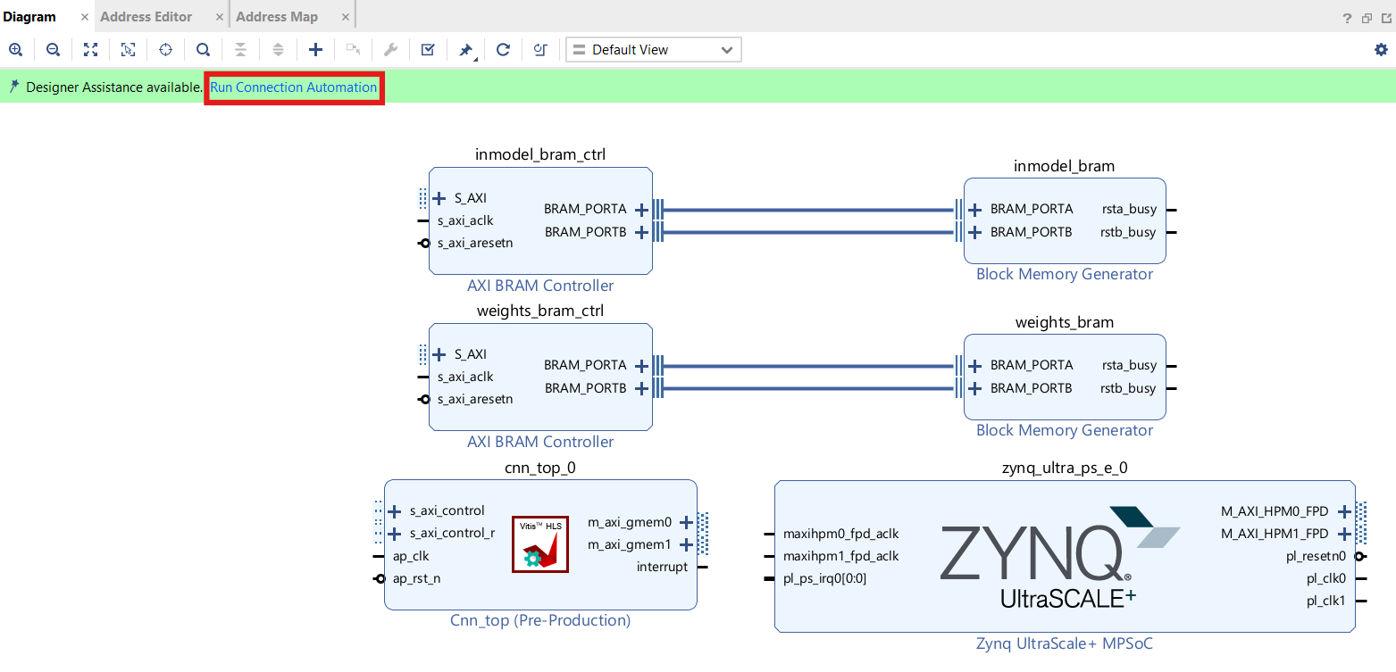
Figure 47: Run Connection Automation - Block Design showing Run Connection Automation highlighted.

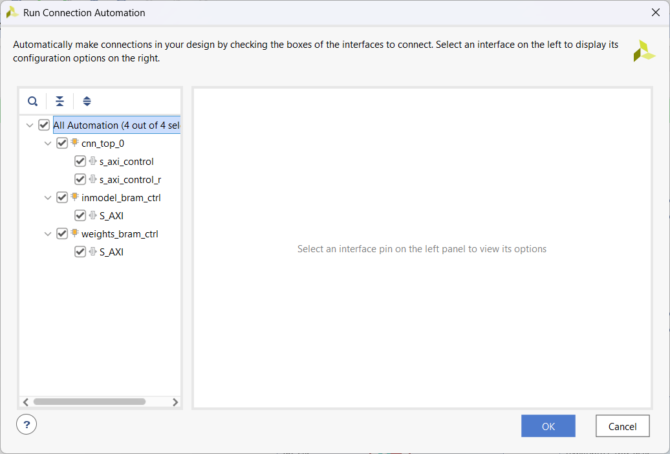
Figure 48: Setting Run Connection Automation - Run Connection Automation dialog showing All Automation with `cnn_top_0`, `immodel_bram_ctrl`, `weights_bram_ctrl`.

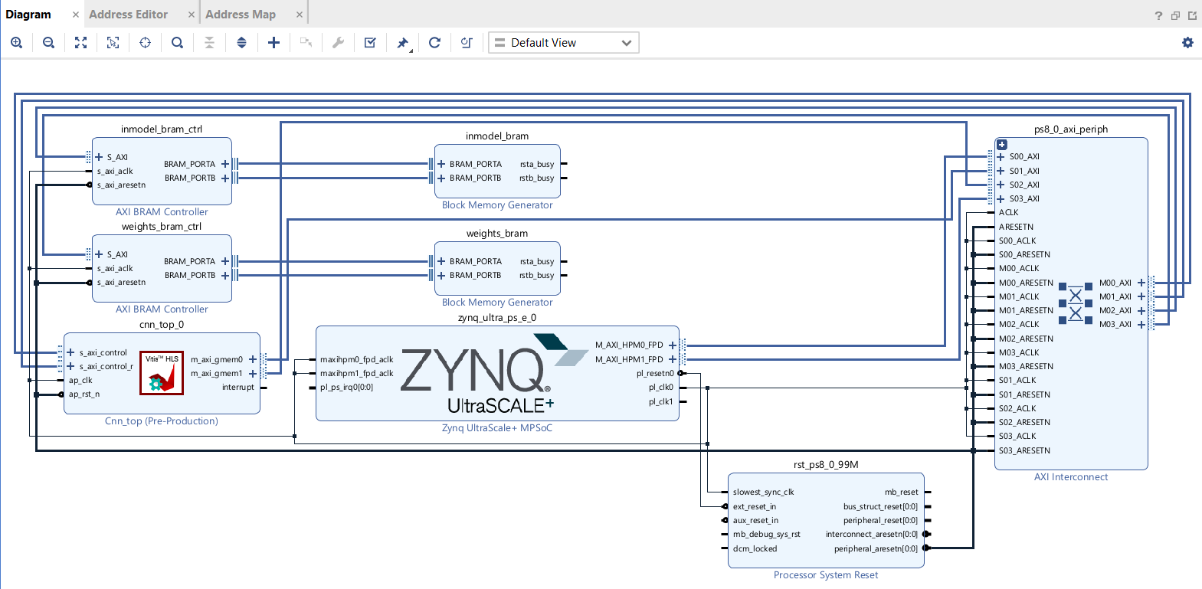
Figure 49: Complete SoC - Block Design showing complete SoC with Zynq UltraScale+ MPSoC, CNN IP, BRAMs, AXI BRAM Controllers, and AXI Interconnect.

Switch to “Address Editor” tab. Adjust Base Address and Range of each BRAM appropriately. When adjusting Range, you may encounter errors. Must adjust Base Address according to the notification.

- Here Weights has 5738 elements, each element is 1 word, so BRAM needs about 22KB → adjust to 32KB.

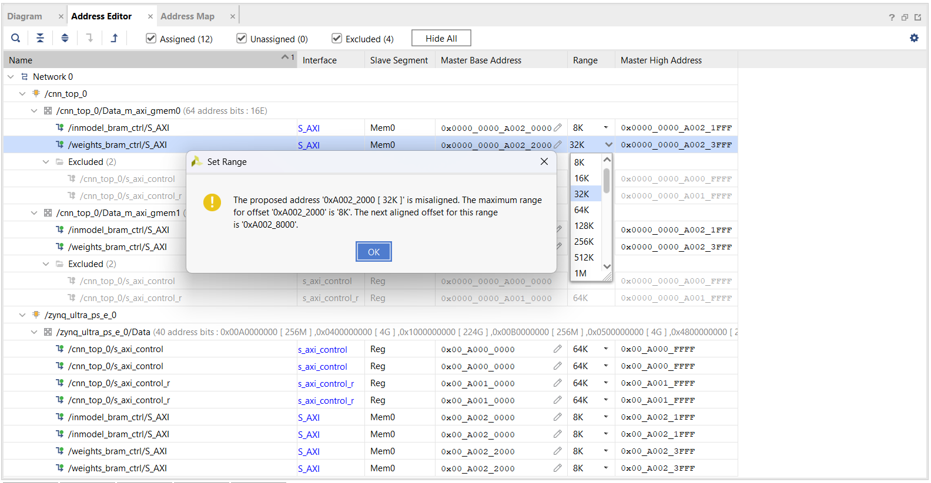
Figure 50: Error When Adjusting BRAM Range - Set Range dialog showing error message about misaligned address.

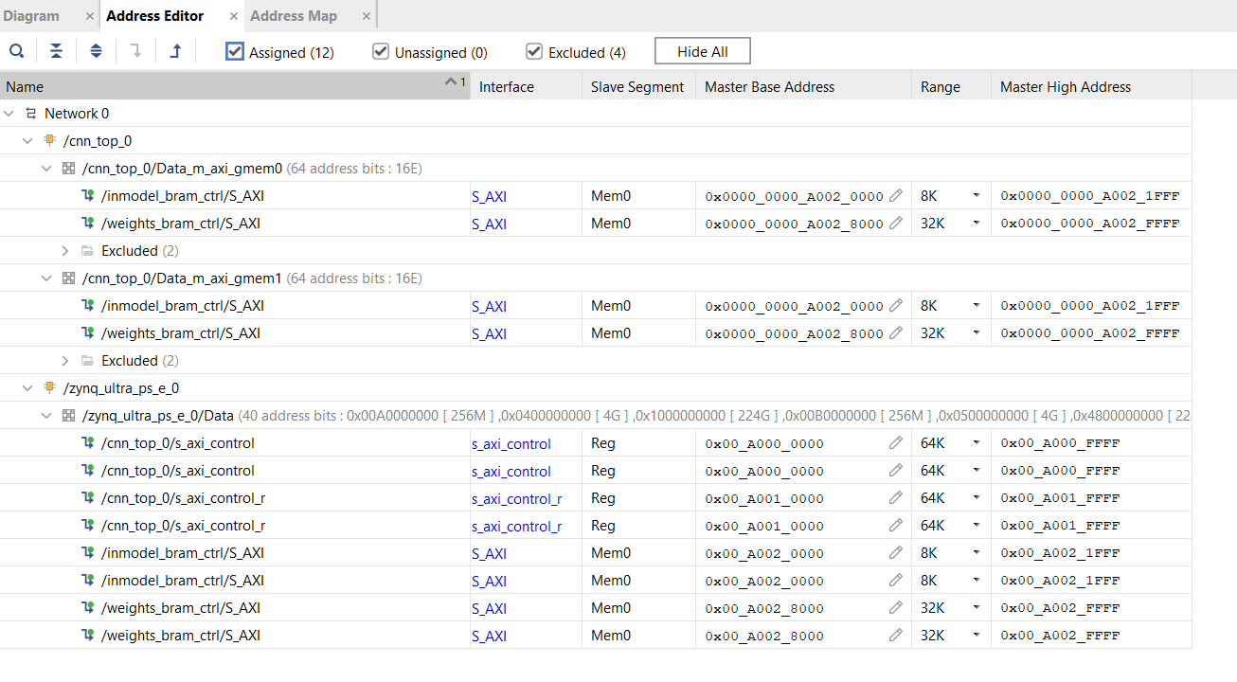
Figure 51: After Adjusting Range and Base Address Completed - Address Editor showing assigned addresses for `immodel_bram_ctrl` and `weights_bram_ctrl`.

Switch back to “Diagram” tab. Press “Valid Design (F6)”.

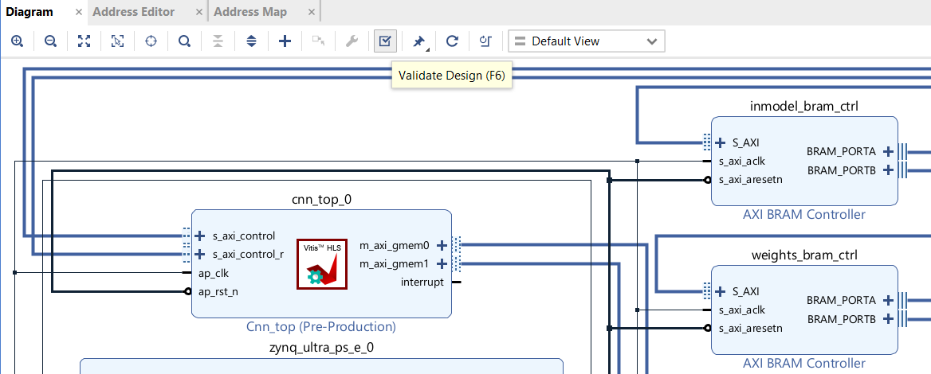
Figure 52: Valid Design - Block Design with Validate Design button highlighted.

Press “Generate Block Design” → “Generate”.

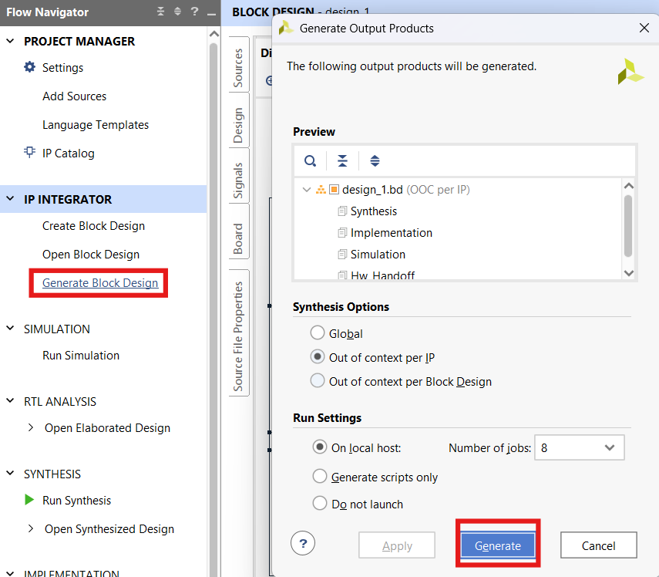
Figure 53: Generate Block Design - Generate Output Products dialog with Generate button highlighted.

Why “Generate Block Design”?
The Generate Block Design option (often labeled Generate Output Products when you right-click the block design) is the bridge that turns your visual block diagram into actual, synthesizable hardware files that Vivado can implement.
Think of it as compiling your schematic into the actual RTL (Register-Transfer Level) code, constraints, and netlists needed for the next steps.

In the “Source” tab, right-click on `design.bd` → Create HDL wrapper → OK.

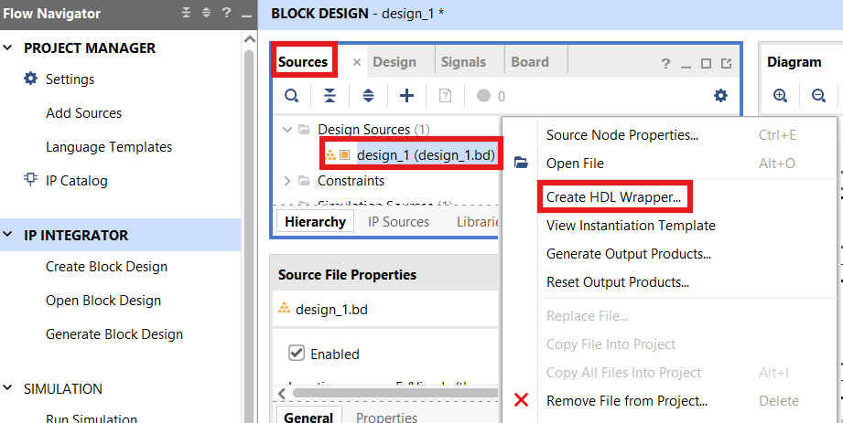
Figure 54: Create HDL Wrapper - Right-click menu on `design_1.bd` showing "Create HDL Wrapper" highlighted.

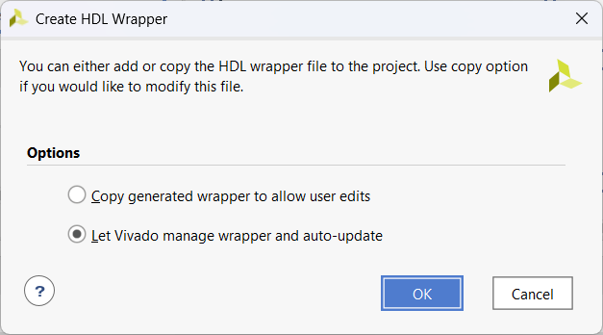
Figure 55: Setting HDL Wrapper - Create HDL Wrapper dialog with "Let Vivado manage wrapper and auto-update" option.

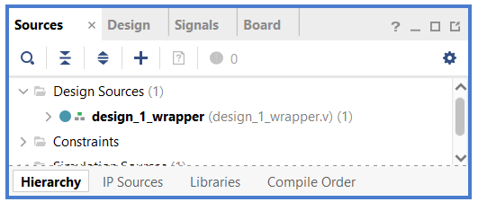
Figure 56: After Creating Wrapper - Sources panel showing `design_1_wrapper.v`.

Run Synthesis → OK.

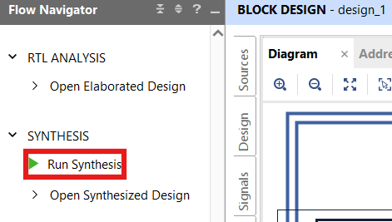
Figure 57: Run Synthesis - Flow Navigator showing SYNTHESIS with "Run Synthesis" highlighted.

“Run Implementation” → OK. When done, you can check reports “Utilization”, “Timing”, etc. to check parameters.

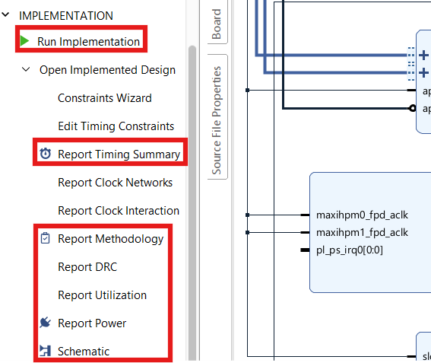
Figure 58: Run Implementation - Flow Navigator showing IMPLEMENTATION with "Run Implementation", "Report Timing Summary", "Report Methodology", "Report DRC", "Report Utilization", "Report Power", "Schematic" highlighted.

Generate Bitstream → OK to create .bit file.

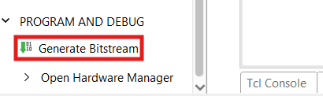
Figure 59: Create Bitstream File - Flow Navigator showing PROGRAM AND DEBUG with "Generate Bitstream" highlighted.

File → Export → Hardware to create “.xsa” file. In the Output tab, must include bitstream.

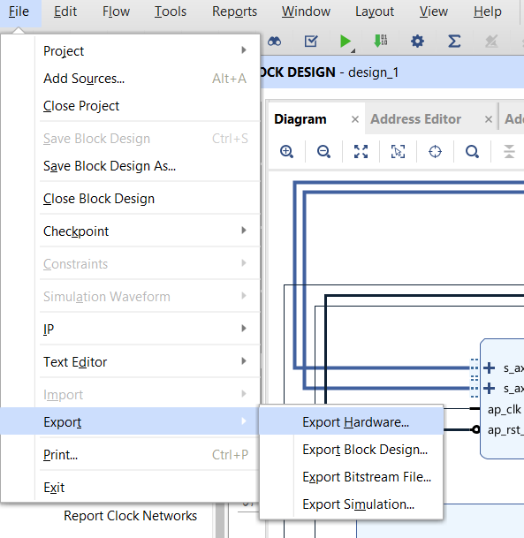
Figure 60: Create .xsa File - File menu showing Export → Export Hardware.

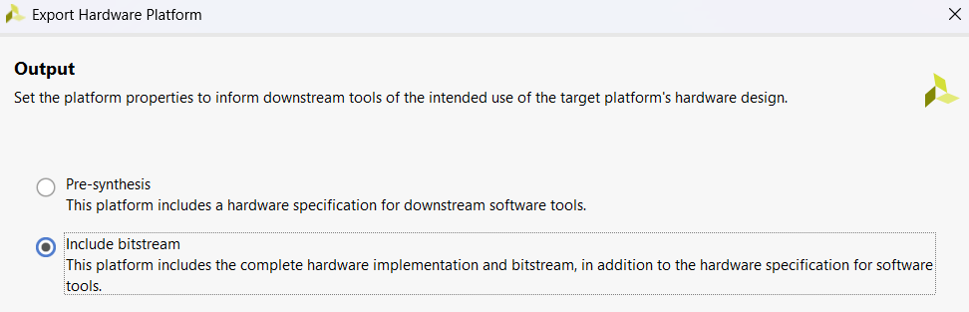
Figure 61: Include Bitstream for .xsa File - Export Hardware dialog with "Include bitstream" checkbox.

What is .xsa file?
The .xsa file is a container (like a .zip archive) that packages our entire hardware design so that software development tools like Vitis can understand and program it. It's the official handoff file from the hardware world (Vivado) to the software world (Vitis).

What's Inside an .xsa File?
An .xsa file is a comprehensive package that includes everything Vitis needs to build software for our specific hardware. Its contents include:
- The Bitstream (BIT file): The actual configuration data for the FPGA.
- Hardware Handoff (.hwh) Files: XML files describing the hardware—the IP blocks used, their memory map, interrupts, and clocking.
- Tool & Board Info: The version of Vivado used and the target part/board.
- IP Metadata: Details on each IP instance and its parameters.
- Driver Files: Software drivers for the IP in your design.
- Other Metadata: Device tree files, BMM/MMI files, and more.

11. INSTALL PETALINUX

Option 1: You can download the pre-built image at the link below:
https://drive.google.com/file/d/1XiKV12dBukXk6_hllGrsGoc6sPSUN5GH/view?usp=sharing

Option 2: Build the Linux file for KV260 FPGA yourself following the flow below:

Watch the entire video at the link below and follow along:
https://youtu.be/F1vxzkd7_DI

Detailed Steps

1. Download PetaLinux 2022.2 installer from the official Xilinx page:
https://www.xilinx.com/support/download/index.html/content/xilinx/en/downloadNav/embedded-design-tools/archive.html

2. Install dependencies (Ubuntu/Debian):

sudo apt-get install tofrodos gawk xvfb git libncurses5-dev tftpd zlib1g-dev zlib1g-dev:i386 \
libssl-dev flex bison chrpath socat autoconf libtool texinfo gcc-multilib \
libsdl1.2-dev libglib2.0-dev screen pax libtinfo5 xterm build-essential net-tools

3. Grant execute permission to the .run file:

chmod +x petalinux-v2022.2-*.run

4. Run the installer:

./petalinux-v2022.2-*.run

During installation, the installer will display license agreements:
- Use PgUp/PgDn to read
- Press `q` to exit the display
- Press `y` to agree and continue

5. Set up Petalinux working environment:

Source the Petalinux installation directory to use `petalinux-*` commands:

source <petalinux_installation_path>/2022.2/settings.sh

Example: -
source /opt/PetaLinux_SDK/settings.sh

6. Download BSP for KV260 FPGA from the official Xilinx page:
https://www.xilinx.com/support/download/index.html/content/xilinx/en/downloadNav/embedded-design-tools/archive.html

VVI URL:-
https://xilinx-wiki.atlassian.net/wiki/spaces/A/pages/2950595219/2024.1+Release

BSP file link: -
https://account.amd.com/en/forms/downloads/xef.html?filename=xilinx-kv260-starterkit-v2024.1-05230256.bsp

7. Create PetaLinux project from BSP:

petalinux-create -t project -s <path_to_BSP_file>.bsp --name KV260_Linux
cd KV260_Linux

8. Import hardware (.xsa) into project:

After exporting the `.xsa` file from Vivado (containing bitstream), use the following command to integrate hardware into the project:

petalinux-config –get-hw-description=<path_to_the_hw_description_file>

Example -

9. Manually configure kernel bootargs:

After running `petalinux-config`, the system will open a curses interface for deeper configuration.

In the configuration window, perform the following steps:

Subsystem AUTO Hardware Settings --->
DTG Settings --->
Kernel Bootargs --->
[ ] generate boot args automatically
(user-defined) user set kernel bootargs

Paste the following bootargs into the user set kernel bootargs:

earlycon console=ttyPS1,115200 root=/dev/mmcblk1p2 rw rootwait cpuidle.off=1 uio_pdrv_genirq.of_id=generic-uio clk_ignore_unused init_fatal_sh=1 cma=256M

This configuration helps boot the correct device, enable UIO driver, allocate CMA memory region, and keep clock for custom IPs in PL.

10. Edit Device Tree (system-user.dtsi):

To allow the Linux operating system to use custom IP in PL through the uio driver, you need to edit the Device Tree Overlay file.

In the file at path:

KV260_Linux/project-spec/meta-user/recipes-bsp/device-tree/files/system-user.dtsi

Edit the file to:

dts
/include/ "system-conf.dtsi"
/ {
amba_pl@0 {
MY_IP@a00000000 {
compatible = "generic-uio";
;
;
;
};
};
};

Sample “system-user.dtsi” file is saved in the `KV260_Linux` folder on GitHub.

11. Then proceed to build the project:

petalinux-build

12. Create boot image and rootfs for Linux on SoC FPGA:

After successfully building the project, type this command to package the `BOOT.BIN` boot file along with the appropriate U-Boot for the system.

petalinux-package --boot --force --u-boot

Then insert the SD card into the PC, proceed to partition and format the SD card. You can follow the detailed instructions in the video tutorial above from minute 53:40 to 1:03:18 at the link below:

https://youtu.be/F1vxzkd7_DI

This rootfs file contains a Debian operating system pre-configured for ARM64 architecture, supporting XFCE interface and easy installation of additional applications via apt.

https://drive.google.com/file/d/1ZcJYuVHpn8ER11nLCjwCUjfc5ykqP0tM/view

12. Datatest Recognition (Code C)

The entire code is in the link below, copy it to the Linux account on the KV260 FPGA:
https://github.com/AISeQLab/Real-time_Handwritten_Digit_Recognition_on_FPGA/tree/main/Embedded_Software/Datatest_Recognition
1. Preparation
- Download the Fpga_Driver.c file
Note in Fpga_Driver.c:
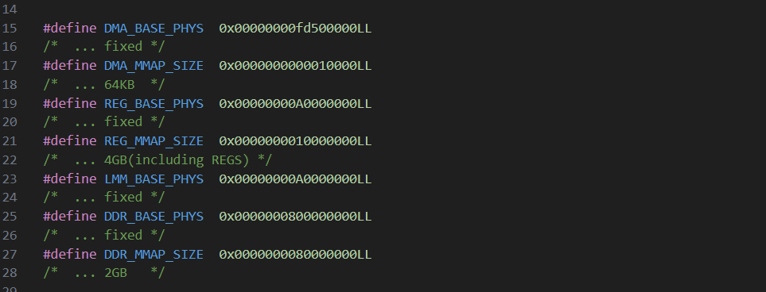
Figure 63. Address in Fpga_Driver.c

- The base physical address of the control register region (REG_BASE_PHYS) is defined as 0x00000000A0000000, so when writing the control C code, you don't need to write 0x00_Axxx_xxxx like the registers in Figure 50, but only need to write the numbers after A (e.g., s_axi_control_r 0x00_A001_0000 → 0x10000)

- Similarly, the base physical address of the internal memory region (LLM_BASE_PHYS) is defined as 0x00000000A0000000, so when writing the control C code, you don't need to write 0x00_Axxx_xxxx like the memory addresses in Figure 50, but only need to write the numbers after A (e.g., InModel_Bram_ctrl/S_AXI 0x00_A002_0000 → 0x20000)
See the following section for more clarity

- Download the CRGA.h file
- Download or create the 2 files weights_array.c and test_images_1000 yourself by running the create_files_c file in the Github link at the beginning. This script will perform the following:
  - Download the MNIST data, normalize and write the normalized images and labels to the files X.txt, Y.txt
  - Read from X.txt and Y.txt to generate test_images_1000.c: array of labels and fixed-point images
  - Read weights from Float_Weights.txt, convert from float to fixed-point, and write to the file weight_array.c

2. Write control C code
Note:
Xil_Out(A, B) means the CPU writes value B to address A
Xil_In(A) means the CPU will read the value from address A
- Include libraries
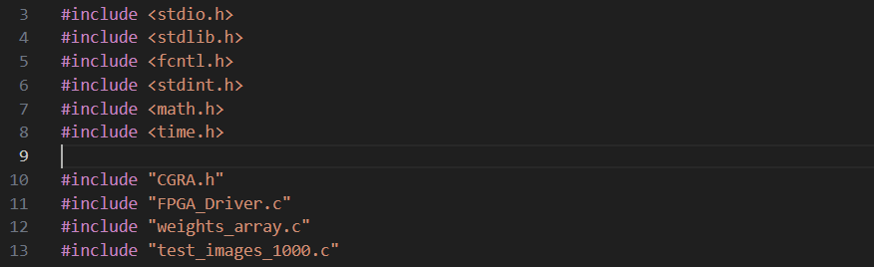
Figure 64. Include libraries

- Define the addresses for operation (see baseaddr in Figure 50 and offsets in Figure 25)

- Control C code flowchart

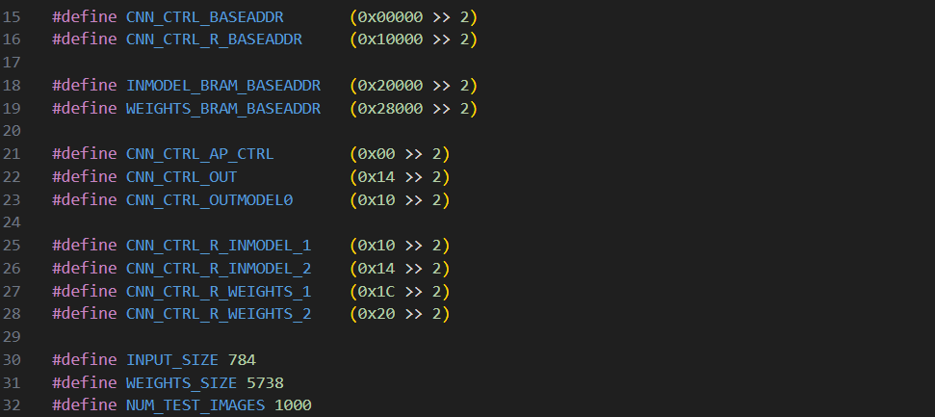
Figure 65. Offset addresses
Note:
- Addresses are defined in bytes, but the Xil_In and Xil_Out functions accept values in words (defined in the FPGA_Driver.c file), so you need to shift 2 bits to convert from byte to word
- INPUT_SIZE is defined as 784 because it processes 1 image at a time (28x28 = 784)
- WEIGHTS_SIZE will be the number of weights
- NUM_TEST_IMAGES will be the number of images to run
- Flowchart for the control C code (cnn_petalinux.c)

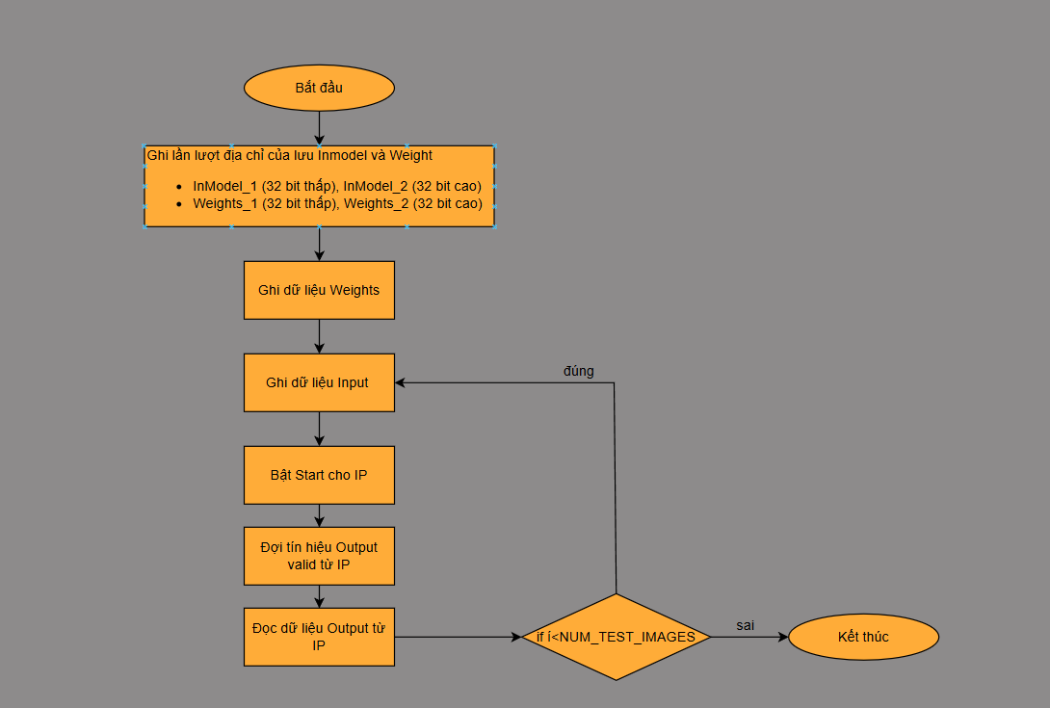
Figure 66. Control C code flowchart

- Function to write InModel and Weight addresses to the Ctrl_r register for the IP
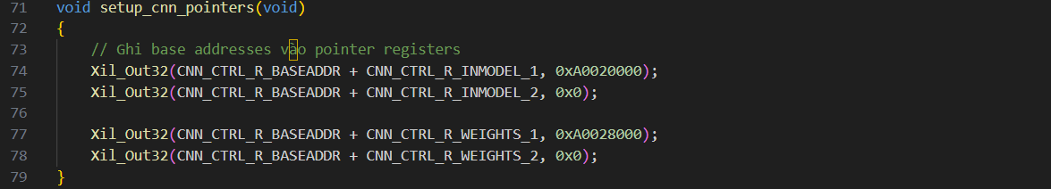
Figure 67. Function setup_cnn_pointer
Explanation:
- Since the address is only 32 bits, you only need to write to the "_1" register, and the "_2" register is 0
- Write the address of the BRAM Block storing INMODEL (0xA0020000) (see in Figure 50) to the CTRL_R_INMODEL_1 register so the IP can communicate directly with the BRAM
- Write the address of the BRAM Block storing Weights (0xA0028000) (see in Figure 50) to the CTRL_R_WEIGHTS_1 register

- Function to write Weights to BRAM

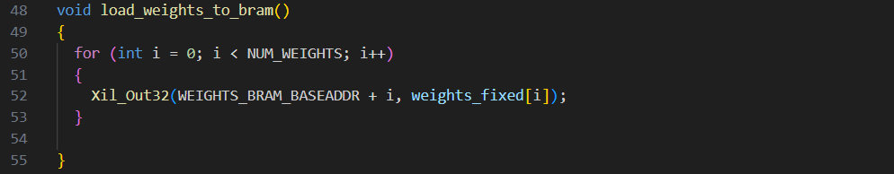
Figure 68. Function load_weights_to_bram

- Sequentially write Weights data to BRAM
- Function to write Image to BRAM

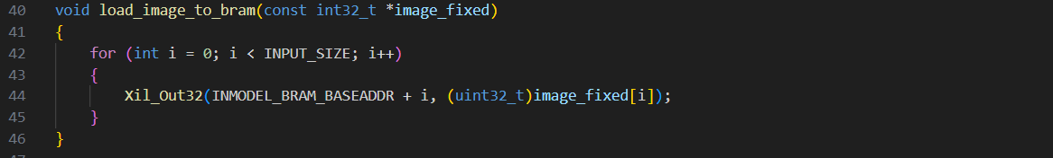
Figure 69. Function load_image_to_bram
- Sequentially write the value of each pixel in the image to BRAM

- Function to enable start for the IP

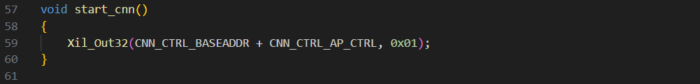
Figure 70. Function start_cnn
- Write 0x01 to the AP_CTRL register because bit 1 is for AP_START (Figure 25)

- Function to wait for the Outvalid signal from the IP
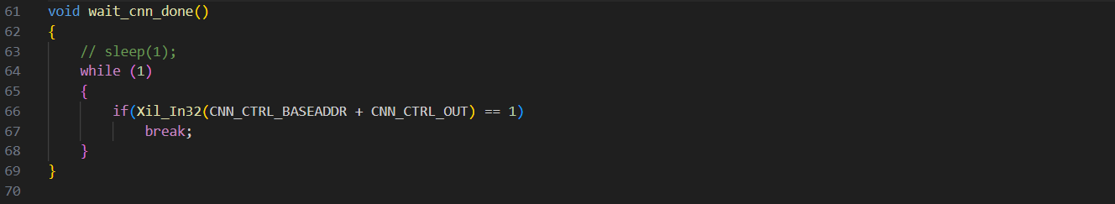
Figure 71. Function wait_cnn_done

- Wait until Output valid goes to 1, the CPU will stop waiting and move on to reading the Output of the Model

- Function to read the Output of the Model

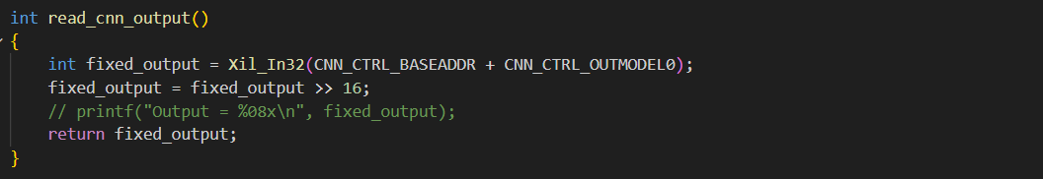
Figure 72. Function read_cnn_output
  - Read Output data from the OutModel0 register (in Figure 25)
  - Since the output data is in fixed point Q16.16 format as in Figure 30, you need to shift 16 bits to read the integer part

- Function run_inference

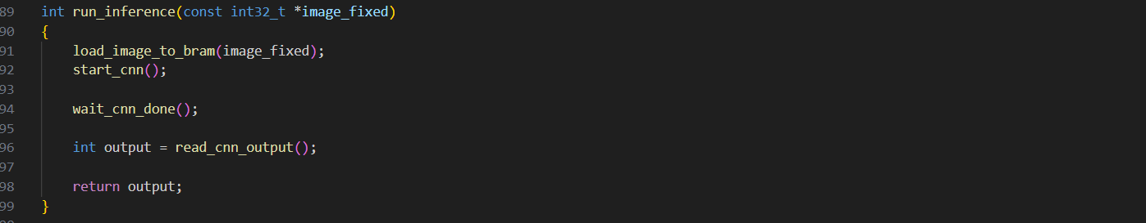
Figure 73. Function run_inference

- Function main
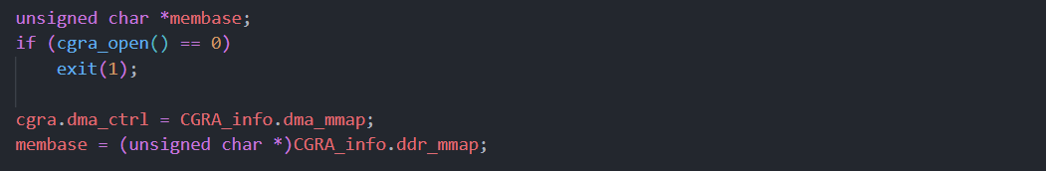
Figure 74. Initialize and set up hardware communication
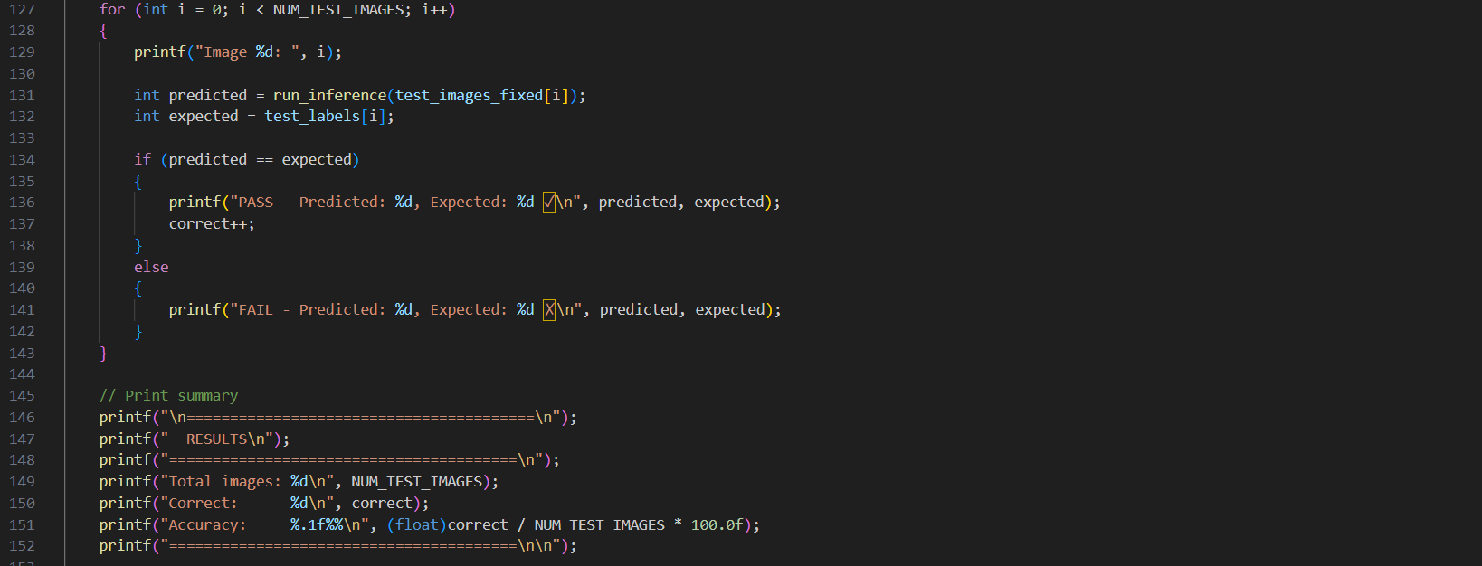
Figure 75. Inference loop
  - The for loop will sequentially load each image into BRAM for processing, then check the result returned from the IP against the test_label (saved in test_images.c)
To compile the C code and run it, type:
gcc cnn_petalinux.c -o main
./main

13. Real-time Recognition (Code C + Nodejs to host Webserver)

The entire code is in the link below, copy it to the Linux account on the KV260 FPGA:
https://github.com/AISeQLab/Real-time_Handwritten_Digit_Recognition_on_FPGA/tree/main/Embedded_Software/Real-time_Recognition

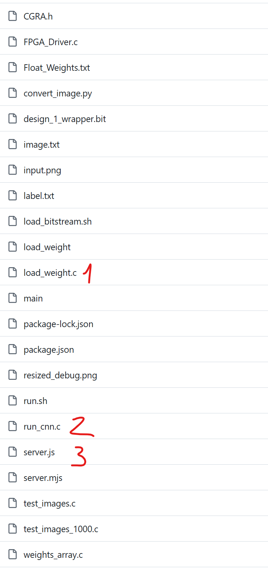
First, we divide the cnn_petalinux.c file into 2 smaller files named "load_weight.c" and "run_cnn.c" to separate the task of transferring the pre-trained parameters (weights) into BRAM first. After that, "run_cnn.c" will only run for 1 input received from the number you draw on the webserver (run using the "server.js" file).
First, compile the 2 files "load_weight.c" and "run_cnn.c" as follows:
gcc load_weight.c -o load_weight
gcc run_cnn.c -o main
After that, we can run the webserver using the command below:
sh run.sh

