Electronic components divided in to two types

1) Passive Components
2) Active Components

Passive Components
Passive components are those that do not require electrical power to operate (e.g., not capable of power gain).

Examples

1) Resistors
2) Capacitors
3) Inductors

Those are discussed in below

Resistor

Resistor it opposes the flow of electrons (current). A resistor has two terminals across which electricity must pass, and is designed to drop the voltage of the current as it flows from one terminal to the next. The symbols are shown below.

Symbols
Units
Resistance is measured in “Ohm” (symbol is Ω); an Ohm is equivalent to a volt per ampere.

Example 1KOhm=1000 Ohm=10³ Ohm

Resistor marking

The resistance value is calculated by using color code. Those colors are available on resistor in the form of colored bars/the colored stripes

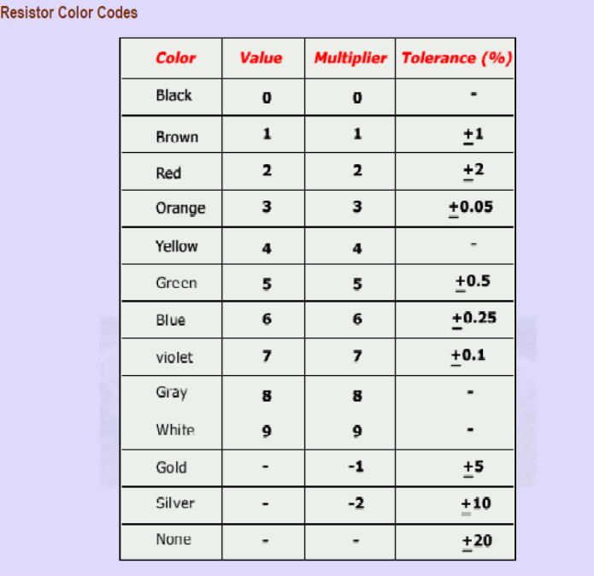

Examples

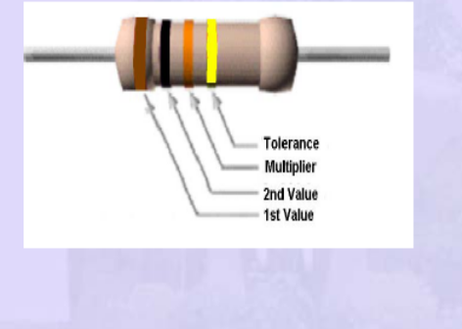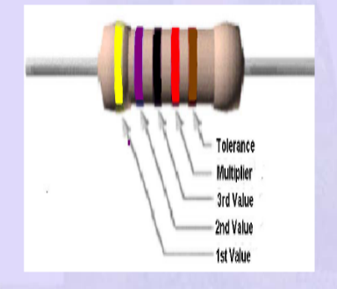

Fig: 1 Fig: 2

Fig: 1) (Brown=1),(Black=0),(Orange=3)10 x 10³= 10k ohm; Tolerance (Gold) = ±5%

Fig: 2) (Yellow=4),(Violet=7),(Black=0),(Red=2) 470 x 102= 47k ohm;
Tolerance (Brown) = ±1%

OHM’S LAW

The current (I) flowing through a conductor is proportional to the voltage (V) applied across its ends. i.e.,
V=IR Where R is the proportionality constant and R is called Resistance
Ohm's law can be stated
Current | Resistance | Voltage | Power | Power w.r.to I | Power with V (or)E
I=E/R | R=E/I | E=I.R | P=E.I | P=I².R | P=E²/R
Example: (Ohm’s Law Ckt)
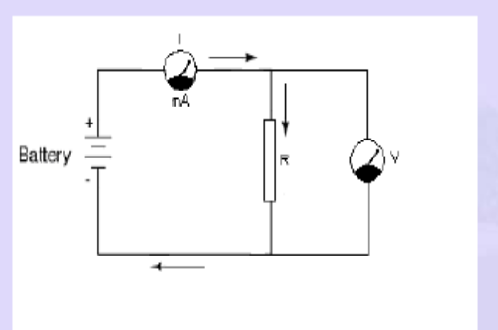
- Find out the current where R=300 ohm, V=12volts across the terminals?
Ans: V=IR => I=V/R =>I=12/300=0.04amperes (A) =>40 mA
Like we can calculate voltage and resistance values by using Ohm’s law
Series and parallel Connections of Resistor
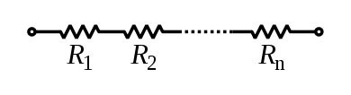
In a series configuration, the current through all of the resistors is the same, but the voltage across each resistor will be in proportion to its resistance.
Note: The resistance of N resistors connected in series, each of the same resistance R is given by NR.
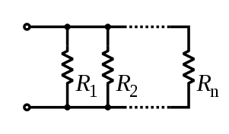
Resistors in a parallel configuration are each subject to the same potential difference (voltage). If two different resistors are used the current will still split, but not evenly. More current will take the path of least resistance and less current will take the path of higher resistance.
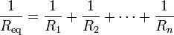
The parallel equivalent resistance can be represented in equations by two vertical lines "||". For the case of two resistors in parallel, this can be calculated using:
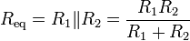

Use: Whenever required resistor is not available we are using more than one resistor for getting the required value. Those resistors we can connect either series or parallel based on our result

Resistors can be broadly of two types

- Fixed Resistors
- Variable Resistors
Fixed Resistors
The value of its resistance is specified and cannot be varied in “Fixed Resistors”

Variable Resistors

There are two general ways in which variable resistors are used. One is the variable resistor whose value is easily changed, like the volume adjustment of Radio. The other is semi-fixed resistor that is not meant to be adjusted by anyone but a technician.

Examples of Semi-fixed Resistors

- Potentiometers
- Trimmer Potentiometers
- Presets

Voltage Dividers
Resistors can also be used to determine voltages, in a configuration called a voltage divider.
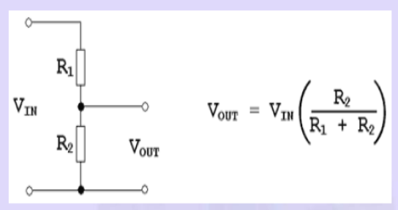

Applications

- A resistor is primarily used to create and maintain a known safe current within an electrical component.
- Resistors can be used to provide a specific voltage for an active device such as a transistor.
- Easily to calculate Power, Voltage, Resistance and Current values

Capacitor
Capacitor is an electronic (Passive) component that stores electric charge. The capacitor is made of 2 close conductors (usually plates) that are separated by a dielectric material. The plates accumulate electric charge when connected to power source. One plate accumulates positive charge and the other plate accumulates negative charge. The capacitance is the amount of electric charge that is stored in the capacitor at voltage of 1 Volt.

Capacitance
The capacitance (C) of the capacitor is equal to the electric charge (Q) divided by the voltage (V):
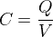
C is the capacitance in Farad [F].
Q is the electric charge that is stored on the capacitor, in Coulomb [C].
V is the voltage between the capacitor's plates in volts [V].
Capacitor pictures

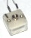

Capacitor symbols
Capacitor | 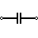 | 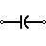
Polarized Capacitor | 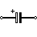 | 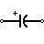
Variable Capacitor | 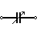

Capacitor will give fewer ripples. The capacitor value must be doubled when smoothing half-wave DC.

Smoothing capacitor for 10% ripple, C = | 5 × Io
Smoothing capacitor for 10% ripple, C = | Vs × f
C = smoothing capacitance in farads (F)
Io = output current from the supply in amps (A)
Vs = supply voltage in volts (V), this is the peak value of the unsmoothed DC
f = frequency of the AC supply in hertz (Hz), 50Hz in the UK
Series and Parallel Connections of Capacitor
The total capacitance of capacitors in series is equal to the reciprocal of the sum of the reciprocals of their individual capacitances
Series Ckt
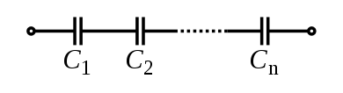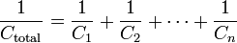
Parallel Ckt
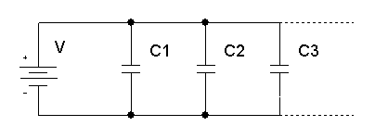 C_{Total} = C₁+C₂+C₃+...
Capacitors in a parallel configuration each have the same applied voltage.
Capacitor Types
Variable Capacitor | Variable capacitor has changeable capacitance
Electrolytic Capacitor | Electrolytic capacitors are used when high capacitance is needed. Most of the electrolytic capacitors are polarized
Power Capacitors | Power capacitors are used in high voltage power systems.
Ceramic Capacitors | Ceramic capacitor has ceramic dielectric material. Has high voltage functionality.
Tantalum Capacitor | Tantalum oxide dielectric material. Has high capacitance
Mica Capacitor | High accuracy capacitors
Paper Capacitor | Paper dielectric material

Applications

- They are used for filtering power supply lines, tuning resonant circuits, and for blocking DC voltages while passing AC signals.

- Capacitors are widely used as parts of electrical circuits in many common electrical devices.

Inductor

An inductor (also choke, coil or reactor) is a passive two-terminal electrical component that stores energy in its magnetic field. For comparison, capacitor stores energy in an electric field and a resistor does not store energy but rather dissipates energy as heat. According to Faraday's law of electromagnetic induction, opposes the change in current that created it.

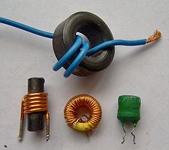 Symbol: L Units: Henry’s

Series and Parallel Connections of Inductor
Inductors in a parallel configuration each have the same potential difference (voltage). To find their total equivalent inductance (L_{eq}):

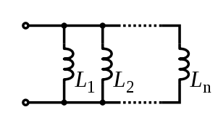
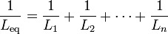

The current through inductors in series stays the same, but the voltage across each inductor can be different. The sum of the potential differences (voltage) is equal to the total voltage. To find their total inductance:
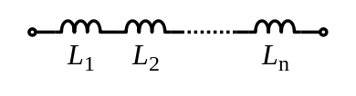
These simple relationships hold true only when there is no mutual coupling of magnetic fields between individual inductors.

Relationship b/w Energy, Current and Inductance
The energy (measured in joules, in SI) stored by an inductor is equal to the amount of work required to establish the current through the inductor, and therefore the magnetic field. This is given by:
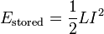
Where L is inductance and I is the current through the inductor.
This relationship is only valid for linear (non-saturated) regions of the magnetic flux linkage and current relationship.
Q factor
The Q factor of an inductor can be found through the following formula, where R is its internal (Series Model) electrical resistance and is the inductive reactance at resonance:
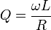
Applications
- Filters
- Electromagnets
- Automotive Ignition Coils
- Transformers
- Loudspeaker crossover networks
- Induction motors

Active Components
Active components are those that require electrical power to operate.
Examples

1) Diodes
2) Transistors etc

Those are discussed in below

Diodes

A diode is a two terminal device, having two active electrodes, between which it allows the transfer of current in one direction only. Most diodes are made with semiconductor materials such as silicon, germanium, or selenium.

The forward break over voltage is approximately six tenths of a volt (0.7V) for silicon devices, 0.3 V for germanium devices, and 1 V for selenium devices.

Types of Diodes

There are many different types of diodes that are available for use in electronics design. Different semiconductor diode types can be used to perform different functions as a result of the properties of these different diode types.

Those are

- PN junction diode
- Gunn diode
- IMPATT diode
- Laser diode
- Photo diode
- PIN diode
- Schottky barrier diode
- Step recovery diode
- Tunnel diode
- Varactor diode
- Zener diode
- Light emitting diode(LED)

In that some diodes are discussed in below

PN Junction Diode

This one is Normal (General) and standard diode. These diodes are used to rectify alternating power inputs in power supplies. They can rectify current levels that range from an amp upwards.
Eg: Rectifier Diodes

Zener Diode

The Zener diode is a very useful type of diode as it provides a stable reference voltage. As a result it is used in vast quantities. It is run under reverse bias conditions and it is found that when a certain voltage is reached it breaks down. If the current is limited through a resistor, it enables a stable voltage to be produced.

Light Emitting Diode (LED)

The light emitting diode or LED is one of the most popular types of diode. When forward biased with current flowing through the junction, light is produced. The diodes use component semiconductors, and can produce a variety of colors, although the original color was red. There are also very many new LED developments that are changing the way displays can be used and manufactured. High output LEDs and OLEDs are two examples.
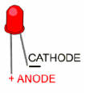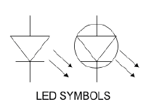

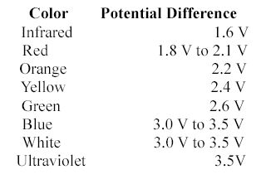

Symbols of Diodes
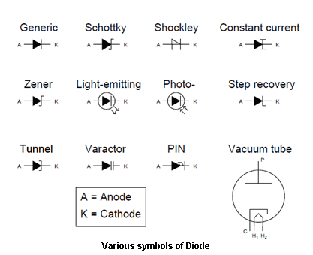

Applications

- Rectifiers
- Signal Limiters
- Voltage Regulators
- Switches
- Signal Modulators & Demodulators
- Signal Mixers
- Oscillators

Semiconductor diodes can be designed to produce direct current (DC) when visible light, infrared transmission (IR) or ultraviolet (UV) energy strikes them. These diodes are known as photovoltaic cells and are the basis for solar electric energy systems and photo sensors. Yet another form of diode, commonly used in electronic and computer equipment, emits visible light or IR energy when current passes through it. Such a device is the familiar light-emitting diode (LED).

Transistors

A transistor is a semiconductor device used to amplify and switch electronic signals and electrical power. Transistors are manufactured in different shapes but they have three leads (legs).
BASE - it leads responsible for activating the transistor.
COLLECTOR – This one is positive lead.
EMITTER – This one is negative lead.

Types of Transistors

There are two types of standard transistors, NPN and PNP, with different circuit symbols. The letters refer to the layers of semiconductor material used to make the transistor. Most transistors used today are NPN because this is the easiest type to make from silicon. If you are new to electronics it is best to start by learning how to use NPN transistors. In addition to standard (bipolar junction) transistors, there are field-effect transistors which are usually referred to as FETs.

Below diagrams shows the symbol of an NPN & PNP transistors

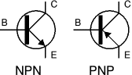
Functionality of a Transistor

Transistors amplify current, for example they can be used to amplify the small output current from a logic IC so that it can operate a lamp, relay or other high current device. In many circuits a resistor is used to convert the changing current to a changing voltage, so the transistor is being used to amplify voltage.
A transistor may be used as a switch (either fully on with maximum current, or fully off with no current) and as an amplifier (always partly on).
Functionality of a PNP Transistor
It is purely opposite to NPN. In this PNP transistor by passing high voltage to base it will switch “OFF” the device and by passing 0v to base it will switch “ON” the device means it will pass the current.
Functionality of a NPN Transistor
If you want to control the flow of current in NPN Transistor from emitter to collector or from collector to emitter by using base voltage only. So, first we have to give high voltage to the base will pass the current from collector to emitter or from emitter to collector means it will switch “ON” the device. If we will give the low voltage to base it stops the flow of current means it will switch “off” the device. In this way it works as a switch.
- The base-emitter junction behaves like a diode.
- A base current I_{B} flows only when the voltage V_{BE} across the base-emitter junction is 0.7V or more.
- The small base current I_{B} controls the large collector current Ic.
- Ic = h_{FE} × I_{B} (unless the transistor is full on and saturated)
h_{FE} is the current gain (strictly the DC current gain), a typical value for h_{FE} is 100 (it has no units because it is a ratio)
- The collector-emitter resistance R_{CE} is controlled by the base current I_{B}:
  - I_{B} = 0 R_{CE} = infinity transistor off
  - I_{B} small R_{CE} reduced transistor partly on
  - I_{B} increased R_{CE} = 0 transistor full on ('saturated')
The amount of current amplification is called the current gain, symbol h_{FE}. The standard equation for currents flowing in a transistor is given as: I_{E} = I_{B} + I_{C}
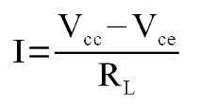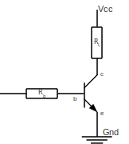
The ratio of collector current available when a certain amount of base current is injected into the transistor is called the current gain. It is denoted with the Greek letter Beta: 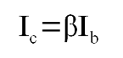 => 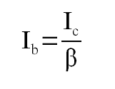
To provide the appropriate size resistor we use the following formula.
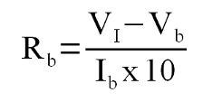
Where V_{I} is the voltage input to the base resistor.
The power developed in a switching transistor is very small:
- In the OFF state: power = Ic × V_{CE}, but Ic = 0, so the power is zero.
- In the full ON state: power = Ic × V_{CE}, but V_{CE} = 0 (almost), so the power is very small.

Uses

- Relays
- Solenoids
- LEDs
- Motors

When to use a relay

Transistors cannot switch AC or high voltages (such as mains electricity) and they are not usually a good choice for switching large currents (> 5A). In these cases a relay will be needed, but note that a low power transistor may still be needed to switch the current for the relay's coil.

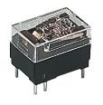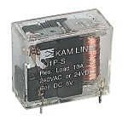
Advantages of relays:
- Relays can switch AC and DC, transistors can only switch DC.
- Relays can switch high voltages, transistors cannot.
- Relays are a better choice for switching large currents (> 5A).
- Relays can switch many contacts at once.
Disadvantages of relays:
- Relays are bulkier than transistors for switching small currents.
- Relays cannot switch rapidly; transistors can switch many times per second.
- Relays use more power due to the current flowing through their coil.
- Relays require more current than many ICs can provide, so a low power transistor may be needed to switch the current for the relay's coil.

Protection diode

If the load is a motor, relay or solenoid (or any other device with a coil) a diode must be connected across the load to protect the transistor from the brief high voltage produced when the load is switched off. The diagram shows how a protection diode is connected 'backwards' across the load, in this case a relay coil.
Current flowing through a coil creates a magnetic field which collapses suddenly when the current is switched off. The sudden collapse of the magnetic field induces a brief high voltage across the coil which is very likely to damage transistors and ICs. The protection diode allows the induced voltage to drive a brief current through the coil (and diode) so the magnetic field dies away quickly rather than instantly. This prevents the induced voltage becoming high enough to cause damage to transistors and ICs.
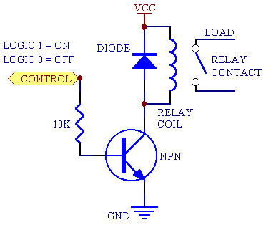

Frequency

For an oscillating or varying current, frequency is the number of complete cycles per second in alternating current direction. If a current completes one cycle per second, then the frequency is 1 Hz; 60 cycles per second equals 60 Hz

Units: Hertz (Hz)

Relation Ship b/w Frequency (f), Time period (t) &Wavelength (λ)

f=1/t (or) f=1/ λ

Applications

- Wireless Communications
- To calculate the wave length and Time period

POWER SUPPLIES

TYPES OF POWER SUPPLY:
There are many types of power supplies. Most are designed to convert high voltage AC mains electricity to a suitable low voltage supply for electronics circuits and other devices. A power supply section can be broken into a series of blocks, each block having its own individual functionality.
For example a 5V regulated supply:
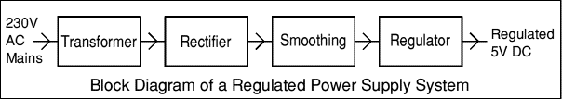
Each of the block description is given below:
- Transformer - steps down high voltage AC mains to low voltage AC.
- Rectifier - converts AC to DC, but the DC output is varying.
- Smoothing - smoothes the DC from varying greatly to a small ripple.
- Regulator - eliminates ripple by setting DC output to a fixed voltage.
Power supplies made from these blocks are described below with a circuit diagram and a graph of their output:
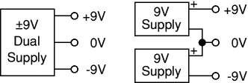
- Transformer

DUAL SUPPLIES:
Some electronic circuits require a power supply with positive and negative outputs as well as zero volts (0V). This is called a 'dual supply' because it is like two ordinary supplies connected together as shown in the diagram.
Dual supplies have three outputs, for example a ±9V supply has +9V, 0V and -9V outputs.
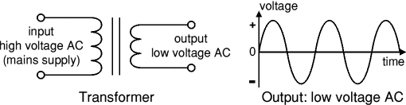
The low voltage AC output is suitable for lamps, heaters and special AC motors. It is not suitable for electronic circuits unless they include a rectifier and a smoothing capacitor.

TRANSFORMER + RECTIFIER:
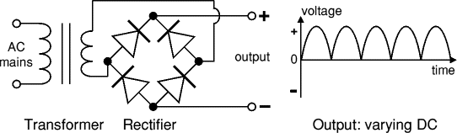
The varying DC output is suitable for lamps, heaters and standard motors. It is not suitable for electronic circuits unless they include a smoothing capacitor.

TRANSFORMER + RECTIFIER + SMOOTHING:
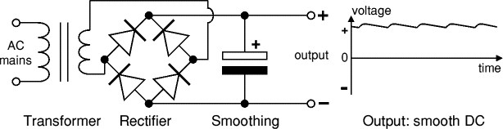
The smooth DC output has a small ripple. It is suitable for most electronic circuits.

TRANSFORMER + RECTIFIER + SMOOTHING + REGULATOR:
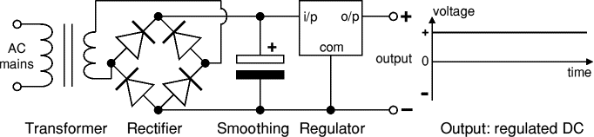
The regulated DC output is very smooth with no ripple. It is suitable for all electronic circuits.

TRANSFORMER:
Transformers convert AC electricity from one voltage to another with little loss of power. Transformers work only with AC
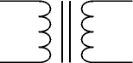
Transformer
circuit symbol
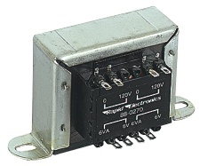

Step-up transformers increase voltage, step-down transformers reduce voltage. Most power supplies use a step-down transformer to reduce the dangerously high mains voltage (230V in UK) to a safer low voltage.
The input coil is called the primary and the output coil is called the secondary. There is no electrical connection between the two coils; instead they are linked by an alternating magnetic field created in the soft-iron core of the transformer. The two lines in the middle of the circuit symbol represent the core.
Transformers waste very little power so the power out is (almost) equal to the power in. Note that as voltage is stepped down current is stepped up.
The ratio of the number of turns on each coil, called the turns ratio, determines the ratio of the voltages. A step-down transformer has a large number of turns on its primary (input) coil which is connected to the high voltage mains supply, and a small number of turns on its secondary (output) coil to give a low output voltage.
turns ratio = | Vp | = | Np | and | power out = power in
turns ratio = | Vs | = | Ns | and | Vs × Is = Vp × Ip

Vp = primary (input) voltage  Np = number of turns on primary coil  Ip = primary (input) current |  | Vs = secondary (output) voltage  Ns = number of turns on secondary coil  Is = secondary (output) current

RECTIFIER:
There are several ways of connecting diodes to make a rectifier to convert AC to DC. The bridge rectifier is the most important and it produces full-wave varying DC. A full-wave rectifier can also be made from just two diodes if a centre-tap transformer is used, but this method is rarely used now that diodes are cheaper. A single diode can be used as a rectifier but it only uses the positive (+) parts of the AC wave to produce half-wave varying DC.

BRIDGE RECTIFIER:
A bridge rectifier can be made using four individual diodes, but it is also available in special packages containing the four diodes required. It is called a full-wave rectifier because it uses the entire AC wave (both positive and negative sections). 1.4V is used up in the bridge rectifier because each diode uses 0.7V when conducting and there are always two diodes conducting, as shown in the diagram below. Bridge rectifiers are rated by the maximum current they can pass and the maximum reverse voltage they can withstand (this must be at least three times the supply RMS voltage so the rectifier can withstand the peak voltages). Please see the Diodes page for more details, including pictures of bridge rectifiers.
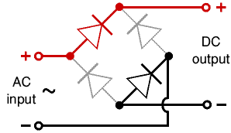 | 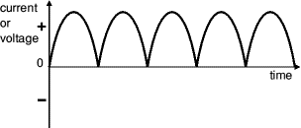
Bridge rectifier  Alternate pairs of diodes conduct, changing over the connections. So, the alternating directions of AC are converted to the one direction of DC. | Output: full-wave varying DC  (using all the AC wave)

SINGLE DIODE RECTIFIER:
A single diode can be used as a rectifier but this produces half-wave varying DC which has gaps when the AC is negative. It is hard to smooth this sufficiently well to supply electronic circuits unless they require a very small current so the smoothing capacitor does not significantly discharge during the gaps. Please see the Diodes page for some examples of rectifier diodes.

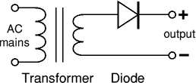 | 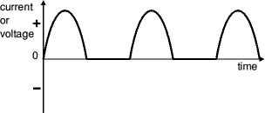
Single diode rectifier | Output: half-wave varying DC  (using only half the AC wave)

SMOOTHING:

Smoothing is performed by a large value electrolytic capacitor connected across the DC supply to act as a reservoir, supplying current to the output when the varying DC voltage from the rectifier is falling. The diagram shows the unsmoothed varying DC (dotted line) and the smoothed DC (solid line). The capacitor charges quickly near the peak of the varying DC, and then discharges as it supplies current to the output.
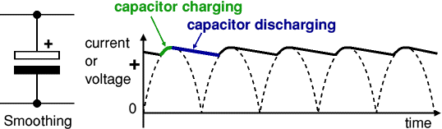
Note that smoothing significantly increases the average DC voltage to almost the peak value (1.4 × RMS value). For example 6V RMS AC is rectified to full wave DC of about 4.6V RMS (1.4V is lost in the bridge rectifier), with smoothing this increases to almost the peak value giving 1.4 × 4.6 = 6.4V smooth DC.
Smoothing is not perfect due to the capacitor voltage falls a little as it discharges, giving a small ripple voltage. For many circuits a ripple which is 10% of the supply voltage is satisfactory and the equation below gives the required value for the smoothing capacitor. A larger capacitor will give fewer ripples. The capacitor value must be doubled when smoothing half-wave DC.
Smoothing capacitor for 10% ripple, C = | 5 × Io
Smoothing capacitor for 10% ripple, C = | Vs × f
C = smoothing capacitance in farads (F)
Io = output current from the supply in amps (A)
Vs = supply voltage in volts (V), this is the peak value of the unsmoothed DC
f = frequency of the AC supply in hertz (Hz), 50Hz in the UK

REGULATOR:
Voltage regulator ICs are available with fixed (typically 5, 12 and 15V) or variable output voltages. They are also rated by the maximum current they can pass. Negative voltage regulators are available, mainly for use in dual supplies. Most regulators include some automatic protection from excessive current ('overload protection') and overheating ('thermal protection').
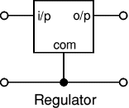 | 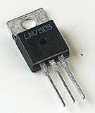
Circuit diagram of 7805 | 7805 regulator
REGULATORS | VOLTAGES
7805 | 5V
7809 | 9V
7812 | 12V
7815 | 15V
LM 117 | 3.3V
LM 317 | Variable

Many of the fixed voltage regulator ICs has 3 leads and look like power transistors, such as the 7805 +5V 1A regulator shown on the right. They include a hole for attaching a heat sink if necessary. Like if we want negative voltages then we have to use 79 series instead of positive voltages of 78 series.
A smaller capacitor (0.1uF) will help suppress higher frequency noise and shorter power dips (noise in the 1us to 100us range). Therefore, 0.1uF caps are located near the IC’s (7805, microcontroller…) to help with short bursts, where 100uF and 10uF capacitors are used on the power rails.
SENSORS

A Sensor is a device that detects(senses) changes in the ambient conditions or in the state of another device or a system, and conveys or records this information in a certain manner. A transducer is a device that transfers power from one system to another in the same or in the different form.

Figure 1 shows the sensing process in terms of energy conversion. The form of the output signal will often be a voltage analogous to the input signal, though sometimes it may be a wave form whose frequency is proportional to the input or a pulse train containing the information in some other form.

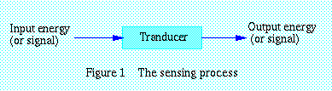
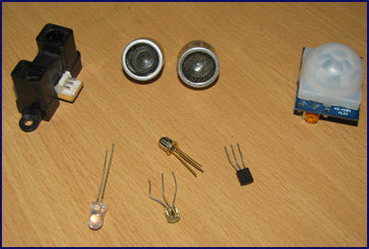

Sensors are sophisticated devices that are frequently used to detect and respond to electrical or optical signals. A Sensor converts the physical parameter (for example: temperature, blood pressure, humidity, speed, etc.) into a signal which can be measured electrically. Let’s explain the example of temperature. The mercury in the glass thermometer expands and contracts the liquid to convert the measured temperature which can be read by a viewer on the calibrated glass tube.

Criteria to choose a Sensor

There are certain features which have to be considered when we choose a sensor. They are as given below:
1. Accuracy
2. Environmental condition - usually has limits for temperature/ humidity
3. Range - Measurement limit of sensor
4. Calibration - Essential for most of the measuring devices as the readings changes with
Time
5. Resolution - Smallest increment detected by the sensor
6. Cost
7. Repeatability - The reading that varies is repeatedly measured under the same
Environment

Some commonly used sensors along with their principle and applications are explained as follows:

Temperature Sensor

This device collects information about temperature from a source and converts into a form that is understandable by other device or person. The best illustration of a temperature sensor is mercury in glass thermometer. The mercury in the glass expands and contracts depending on the alterations in temperature. The outside temperature is the source element for the temperature measurement. The position of the mercury is observed by the viewer to measure the temperature. There are two basic types of temperature sensors:

- Contact Sensors – This type of sensor requires direct physical contact with the object or media that is being sensed. They supervise the temperature of solids, liquids and gases over a wide range of temperatures.

- Non contact Sensors – This type of sensor does not require any physical contact with the object or media that is being sensed. They supervise non-reflective solids and liquids but are not useful for gases due to natural transparency. These sensors use Plank’s Law to measure temperature. This law deals with the heat radiated from the source of heat to measure the temperature.

Example

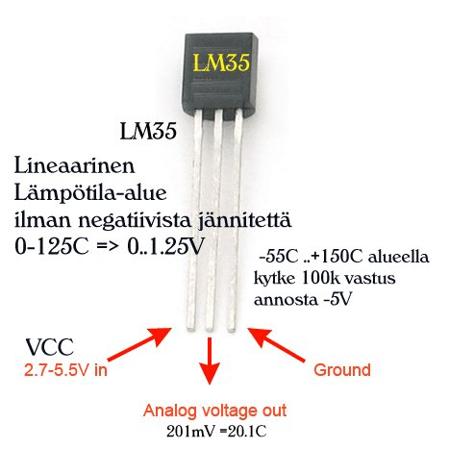
IR Sensor
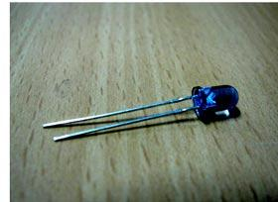
This device emits and/or detects infrared radiation to sense a particular phase in the environment. Generally, thermal radiation is emitted by all the objects in the infrared spectrum. The infrared sensor detects this type of radiation which is not visible to human eye.

Advantages

- Easy for interfacing
- Readily available in market

Disadvantages

It disturbed by noise in the surroundings such as radiations, ambient light etc.

Working

The basic idea is to make use of IR LEDs to send the infrared waves to the object. Another IR diode of the same type is to be used to detect the reflected wave from the object. The diagram is shown below.

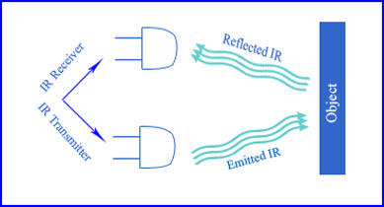
When IR receiver is subjected to infrared light, a voltage difference is produced across the leads. Less voltage which is produced can be hardly detected and hence operational amplifiers (Op-amps) are used to detect the low voltages accurately to measure the distance of the object from the receiver sensor. The electrical property of IR sensor components can be used to measure the distance of an object. The fact when IR receiver is subjected to light, a potential difference is produced across the leads.

Applications

- Thermography
- Heating
- Spectroscopy
- Meteorology
- Photobiomodulation
- Climatology
- Communications

UV Sensor

These sensors measure the intensity or power of the incident ultraviolet radiation. This form of electromagnetic radiation has wavelengths longer than x-rays but is still shorter than visible radiation. An active material known as polycrystalline diamond is being used for reliable ultraviolet sensing. UV sensors can discover the exposure of environment to ultraviolet radiation.

Criteria to select a UV Sensor

- Wavelength ranges in nanometers (nm) that can be detected by the UV sensors.
- Operating temperature
- Accuracy
- Weight
- Power range

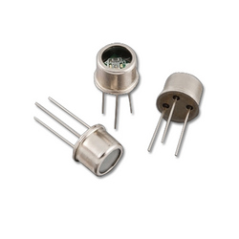
Working

The UV sensor accepts one type of energy signal and transmits different type of energy signals. To observe and record these output signals they are directed to an electrical meter. To create graphs and reports, the output signals are transmitted to an analog-to-digital converter (ADC), and then to a computer with software.

Examples include

- UV phototubes are radiation-sensitive sensors supervise UV air treatments, UV water treatments, and solar irradiance.
- Light sensors measure the intensity of incident light.
- UV spectrum sensors are charged coupled devices (CCD) utilized in scientific photography.

  - Ultraviolet light detectors
  - Germicidal UV detectors
  - Photo stability sensors

Applications

- Measures the portion of the UV spectrum which sunburns human skin
- Pharmacy
- Automobiles
- Robotics
- Printing industry for solvent handling and dyeing processes
- Chemical industry for the production, storage, and transportation of chemicals

