CISC | RISC
Complex instruction set computing | Reduced instruction set computing
More number of instructions | Less number of instructions comparitively
Complex instructions are made available by the cpu designer | It is programmers responsibility to design complex operations through software
Decoder unit size is large | Decoder unit size is small comparitively
Power consumption is more | Power consumption is less
Internal registers are less | Internal registers are more
Memory intensive processing,  Frequent access of memory is slow access | Register intensive processing,  Frequent access of registers is fast access
Instruction sizes and machine cycles required for  execution are varied. | Mostly single cycled instructions with fixed length
More number of addressing modes | Less number of addressing modes comparitively
CPU Design Architectures:
- Based on Instruction Set:
- CISC
- RISC
- Based on Memory Organisation:
- Harvard
- Von Neuman

ex:8086,8051… ex:ARM,AVR…….

ROM
RAM
Von-Neuman:

CPU

- Common pair of address bus and data bus are available to access RAM and ROM
Ex: 8086,ARM7……

Harvard:

ROM
RAM
CPU

- separate pair of address bus and data bus are available to access the ROM and RAM.
- maximize the throughput.
- Ex: 8051,ARM9…..

8051 ARCHITECTURE
Features:
- Employs CISC, Harvard architecture
- 8 bit CPU
- 40 pin DIP(40(physical)=32_I/O+8,64(logical)=(24*2)+16)
- 4KB on chip ROM
- 128 bytes of on chip RAM
- 128 bytes address space reserved for SFRs, available ONLY 21 bytes/sfr’s
- 4 ,8-bit parallel port peripherals
- Two 16 bit timers/counters peripheral
- Full Duplex UART serial peripheral
- On-chip clock oscillator requires ext crystal
- Interrupt Control logic which supports 6 sources,5 vectored interrupts
- Can support up to max 64KB of ROM
- Can support up to addition max 64KB ex-RAM

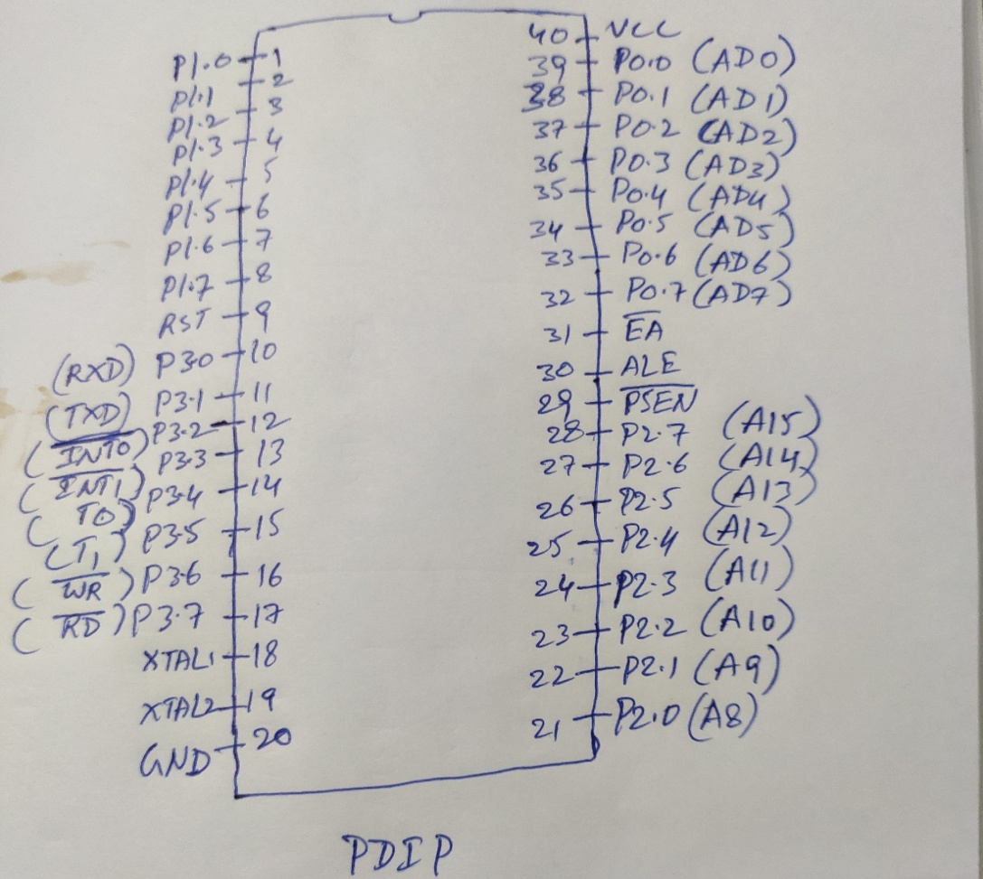
Figure: 8051 pin diagram
Alternate functionalities of Port3 are as follows:
RXD Serial data receive pin
TXD Serial data transmit pin
INT0 External interrupt0 pin
INT1 External interrupt1 pin
T0 Timer0 input pin(used in counter functionality)
T1 Timer1 input pin(used in counter functionality)
WR write signal to the external RAM
RD Read signal to the external RAM

- EA pin:External Access pin
- If EA pin is connected to Vcc then 8051 CPU fetches the opcodes from On-chip ROM.
- If EA pin is connected to GND then 8051 CPU fetches the opcodes from External ROM.

Note:1) In 8051 EA pin need to be connected to Vcc.
Note:2) 8031 is a ROMless version of microcontroller ;In 8031 EA pin need to be connected to GND

- ALE Pin:Address latch enable
- To de-multiplex the address bus and data bus in Port0.

- PSENpin: Program store enable pin
- It is a read control signal to the external ROM.

Power on reset circuit with switch for run time reset

- Reset in 8051 is active-high reset.
- To reset 8051 ,supply logic 1(Vcc) for minimum two machine cycles.

CRYSTAL CKT

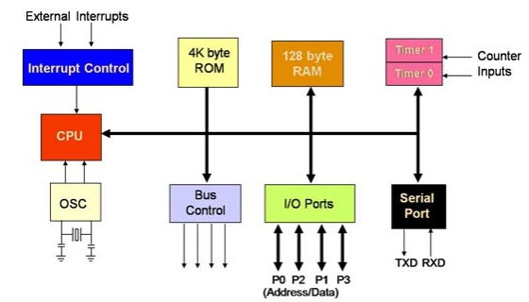
Figure: 8051 Block diagram

