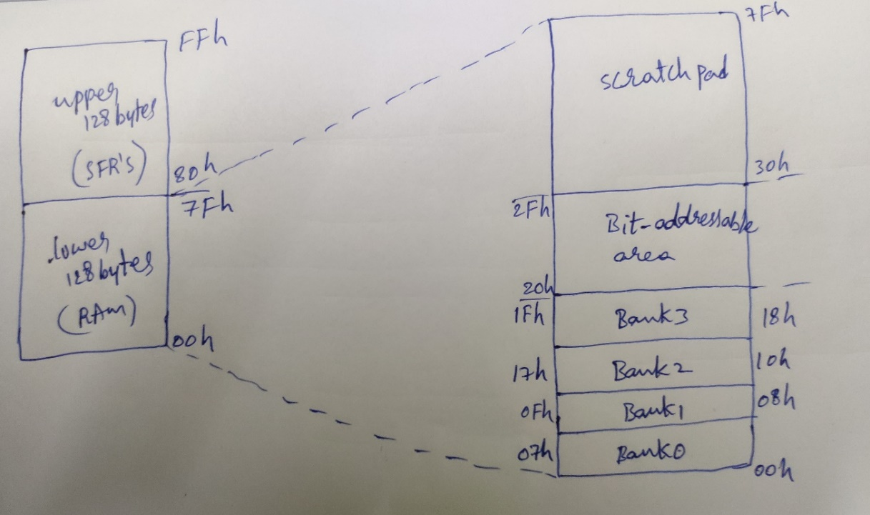

Figure: 8051 data memory
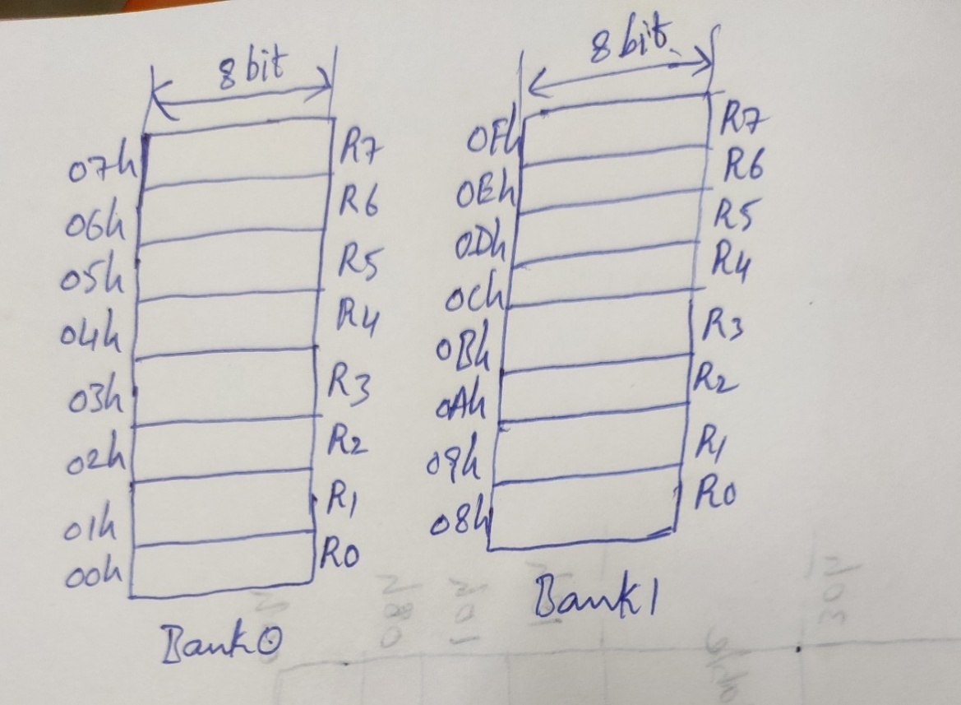
Figure: Banked registers

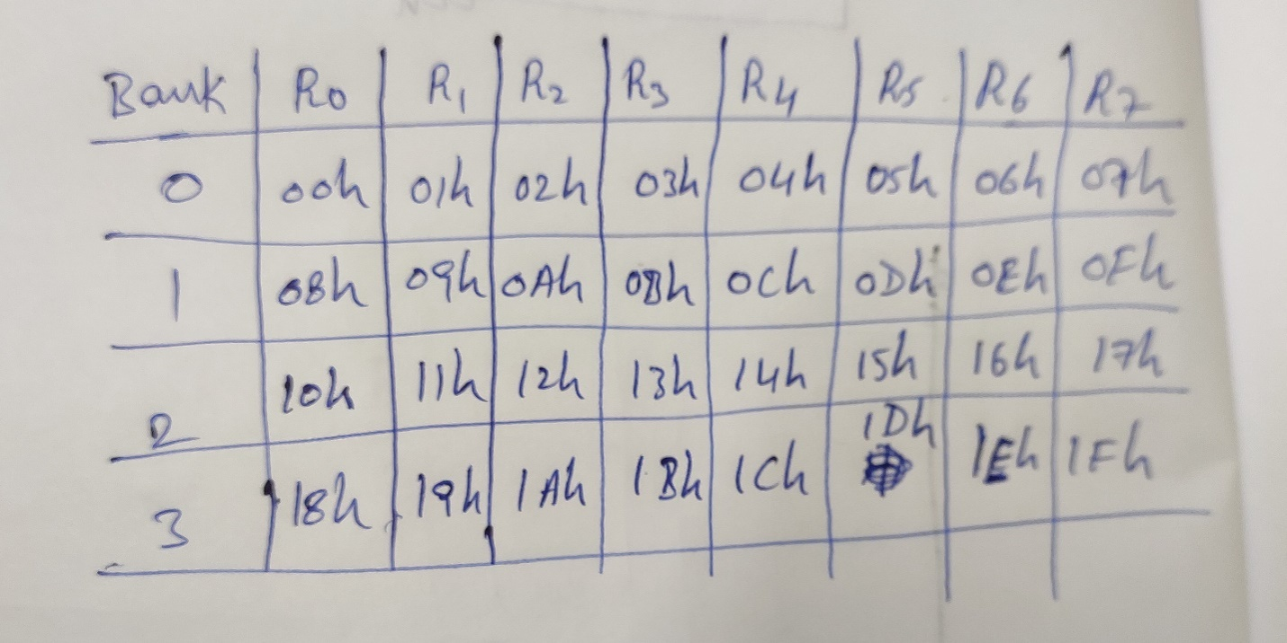
Figure: Bank registers and address of registers
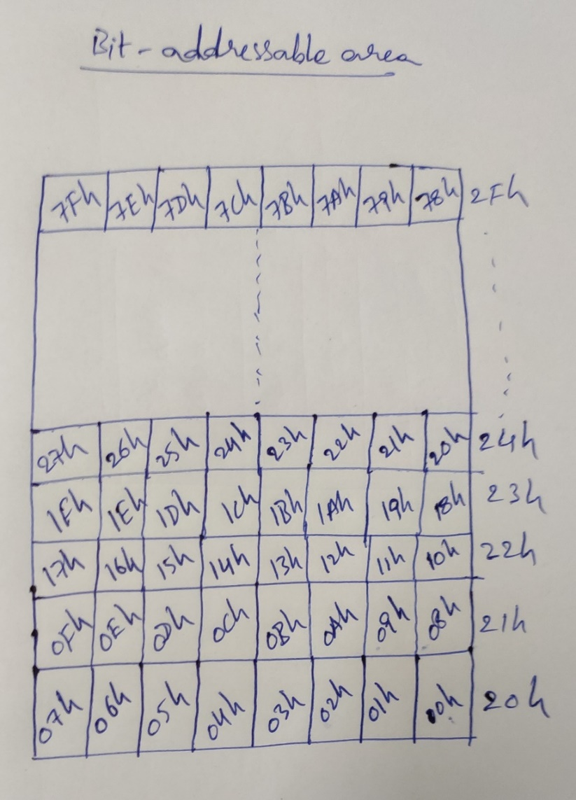
Figure: Bit-addressable memory
Bit-addressable area(20h to 2Fh):
- The bit addresses from 00h to 7fh are assigned to byte-addresses 20h to 2Fh.
- Bit-addressable area is accessed both bit and byte-wise.
- Used to store temporary flag status .
- 128 bit addresses are available in internal ram(lower 128 bytes).
Scratchpad area(30h to 7fh):
- The size of scratchpad area is 80bytes.
- Used to store the temporary byte values or results.
- It can be accessed only byte-wise.

