After completing this lab, you should be able to:
- Debug an existing Verilog design using Verilog system task calls.
- Debug an existing Verilog design using VCS UCLI features

VCS Debugging Basics

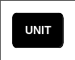
45 minutes
Unit 2
Learning Objectives
2

Getting Started
You will once again be using the following carry-select 8-bit adder:
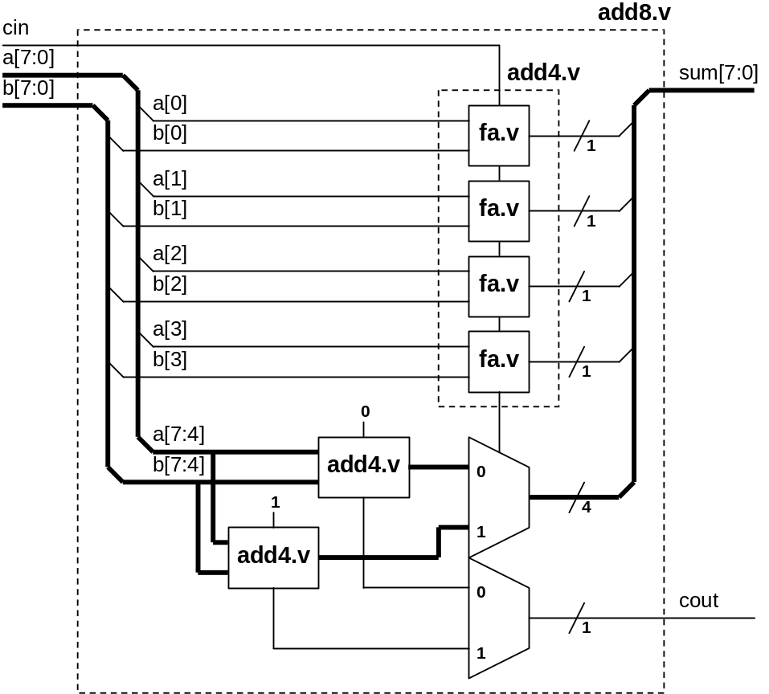
Figure 2-1: 8-bit Carry Select Adder Block Diagram
We have embedded errors in the lab files. The goal is to use the debugging techniques presented during lecture to locate and fix the errors. The block diagram that you will see is what the Verilog code intended to implement.
This lab is divided into two parts. Each part has its own associated tasks.
Here's a preview:
- Compile & simulate the adder to note what the errors are.
- In Part A, you will insert Verilog system task calls into the design files then compile, simulate and interpret the Verilog system task call outputs to try to pin point the error. You will repeat this process until the error is located and corrected.
- In Part B, you will compile with UCLI debugger enabled. You will use the UCLI interactive simulation control to step through the execution of the code and locate the source of the error. You will correct the error and simulate to confirm that the correction works.
Figure 2-2: Flow Diagram of Lab Exercise
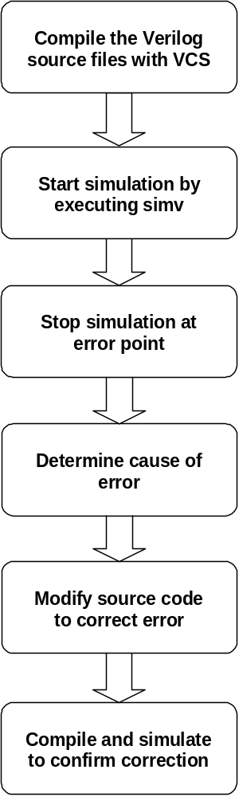

Part A: Debugging with Verilog System Task Calls
- A useful VCS Switch
Go into the lab2 Part A directory.
- shell> cd ../../lab2/parta
Starting this lab, you will use an assortment of compile and run-time switches. In case, you forgot what these switches are, here’s a quick way to get a reminder:
- shell> vcs -h
This command will give you a list of commonly used VCS compile-time and run-time switches, along with a brief explanation of their function.
- Compile and Run First-Pass Verification
Compile and simulate the carry select adder.
- shell> vcs –f adder.f -R
An error is reported:
***ERROR at time = 25750 ***
a = 01, b = 01, sum = 00; cin = 0, cout =0
With inputs a = 1, b = 1 and cin = 0, the sum is 0 rather than 2. The error could be in any one of the rtl modules. We will examine the operation of each.
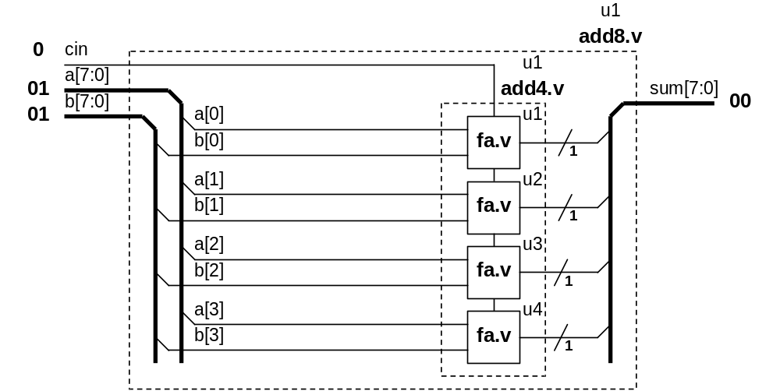
Should be “02”
- Debugging the Error
In debugging, you must be able to trace the errors through the design. If you chose to debug using only the Verilog system task calls, there are generally two ways of tracing the errors. You can insert the Verilog system task calls in the rtl modules directly, or you can add the Verilog system task calls in the testbench.
It is better to add debugging statements in the testbench. There are two reasons for this: One, the testbench is typically where you are doing results checking. Using Verilog system task calls along with the result checking routines can effectively give you a breakpoint capability. Two, for performance reasons, you want to avoid re-compilation. By placing debugging statements in only the testbench, you can restrict the re-compilation to just the testbench file.
You will modify the testbench to follow the error through the design hierarchy. First, you will look at the testbench to see where you should place the Verilog system task call. Enter the following UNIX command:
- shell> more addertb.v
Design Under Test (DUT) instantiation
module addertb;
reg [7:0] a_test, b_test;
wire [7:0] sum_test;
reg cin_test;
wire cout_test;
Useful Verilog system task call for monitoring all activities of an operation
reg [17:0] test;

add8 u1(a_test, b_test, cin_test, sum_test, cout_test);
Input stimulus
(We will see a better method of managing input stimulus in lab3)
initial
if (!$test$plusargs(“monitoroff”))
$monitor ($time, " %h + %h = %h; cin = %h, cout = %h",
a_test, b_test, sum_test, cin_test, cout_test);

initial
begin
Result checking.
This is where insertion of $display system task calls will help the debugging process the most
for (test = 0; test <= 18'h1ffff; test = test +1) begin
cin_test = test[16];
a_test = test[15:8];
b_test = test[7:0];
#100;
if ({cout_test, sum_test} !== (a_test + b_test + cin_test)) begin
$display("***ERROR at time = %0d ***", $time);
$display("a = %h, b = %h, sum = %h; cin = %h, cout = %h",
The $finish is used to terminate the simulation after an error is detected. If you change this to $stop you created a breakpoint at the error state.
a_test, b_test, sum_test, cin_test, cout_test);
$finish;
end
end
$display("*** Testbench Successfully completed! ***");
$finish;
You should always have a message to tell you that the simulation has completed. If you don’t see this message, your simulation may be caught in an infinite loop
Usage of $time to display the simulation time can be very helpful in debugging
end
endmodule

The best insertion point is right after the detection of the error. Insert more $display system task calls here to follow the error through the design hierarchy. First take a look at what is happening in the add8 module.
- Add the following three lines into addertb.v
$display(“\nIn add8(u1)”);
$display(“a = %b, b = %b, sum = %b; cin = %b, cout = %b”,
u1.a, u1.b, u1.sum, u1.cin, u1.cout);
…
if ({cout_test, sum_test} !== (a_test + b_test + cin_test)) begin
$display("***ERROR at time = %0d ***", $time);
$display("a = %b, b = %b, sum = %b; cin = %b, cout = %b",
a_test, b_test, sum_test, cin_test, cout_test);

$finish;
end
…
Compile and simulate the adder again to see the results in the add8 module level.
- shell> vcs –f adder.f -R
The result from this insertion of $display is as follows:
In add8(u1)
a = 00000001, b = 00000001, sum = 00000000, cin = 0, cout = 0
Bit[1] of the output of add4(u1) should have been a 1. Instead, it is erroneously calculated as 0. Go into add4(u1) to see what’s happening.
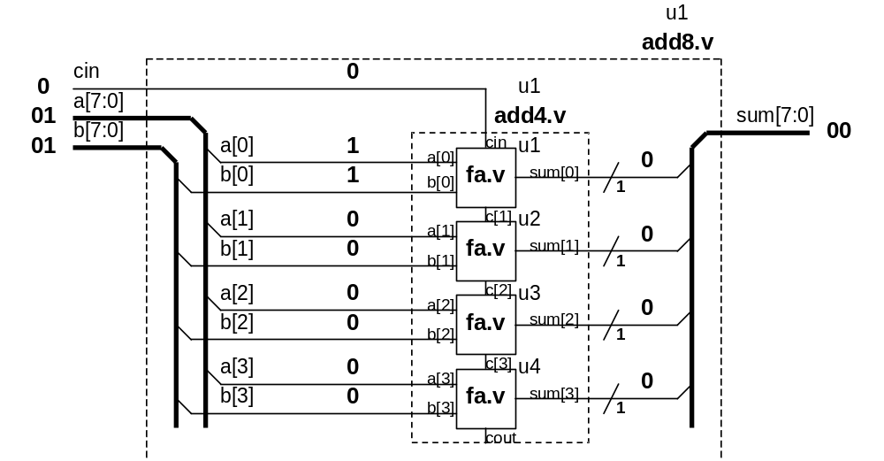
Should be “1”
- Insert the following in addertb.v.
$display(“\nIn add4(u1)”);
$display(“a = %b, b = %b, sum = %b; cin = %b, c = %b, cout = %b”,
u1.u1.a, u1.u1.b, u1.u1.sum, u1.u1.cin, u1.u1.c, u1.u1.cout);
…
$display("\nIn add8(u1)");
$display("a = %b, b = %b, sum = %b; cin = %b, cout = %b",
u1.a, u1.b, u1.sum, u1.cin, u1.cout);

$finish;
end
…
Create a breakpoint here by changing the $finish system task call to $stop.
- Change this $finish to $stop.
With this modification, every time an error is detected, the results listed in the $display will be printed and the testbench will be halted at this time step.
Compile and run the testbench again.
- shell> vcs –f adder.f -R
When VCS encounters the $stop system task call we embedded, it puts you into the CLI debugger. You will see the CLI prompt C1>.
Take a look at the $display message first:
In add4(u1)
a = 0001, b = 0001, sum = 0000, cin = 0, c = 001, cout =0
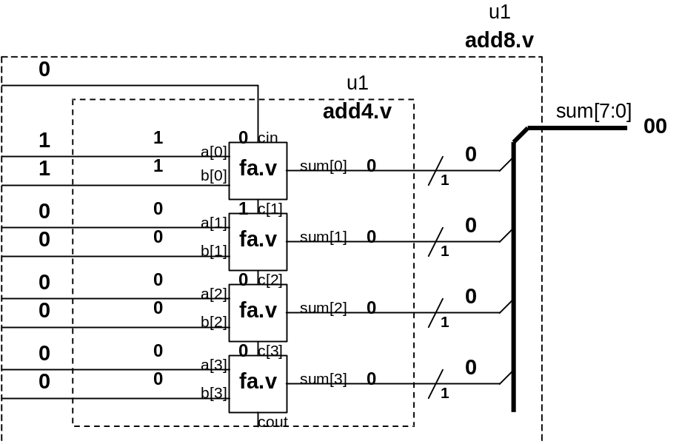
Should be “1”
The lsb operation looks okay, however, the second lsb has a problem. It looks like the carry-in is not being added.
Continue the simulation to the next error point and see if you can deduce this really is a problem. Please continue the simulation with “.”. Before continuing, try some other CLI commands to see if they work.
Type the following at the CLI prompt:
- C1> .
The simulation should continue to the next error point and stop. You should see:
In add4(u1)
a = 0001, b = 0011, sum = 0010, cin = 0, c = 001, cout =0
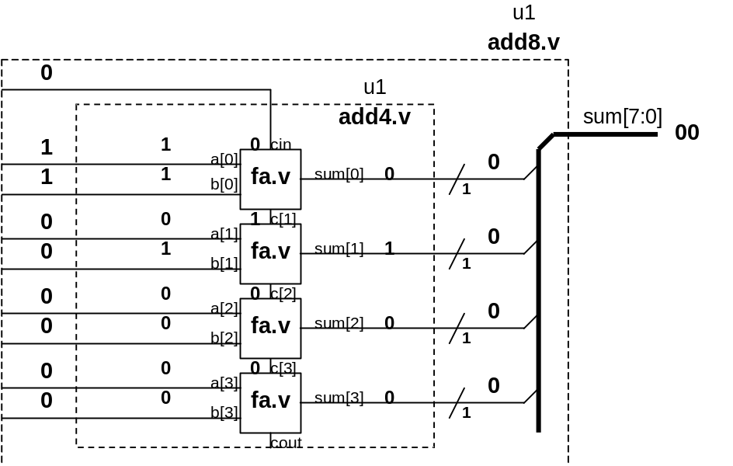
Should be “0”
Should be “1”
Try the “.” MINI CLI command two more times and record the results. You will begin to notice that the problem appears to be in how the fa module handles the carry-in.
Exit the MINI CLI command mode.
- C1> quit
Display the content of the fa.v file on the console.
- shell> more fa.v
module fa(a, b, cin, cout);
input a, b, cin;
output sum, cout;
assign {cout, sum} = a + b;
endmodule
Do you see the problem? Edit fa.v to fix the problem then re-compile and simulate to verify that your correction works.
Did the simulation take a while to complete? Why?
Re-simulate with the “monitoroff” plus argument. This will tell VCS to skip the $monitor lines in the testbench.
…
add8 u1(a_test, b_test, cin_test, sum_test, cout_test);

initial
if (!$test$plusargs(“monitoroff”))
$monitor ($time, “ %h + %h = %h; cin = %h, cout = %h”,
a_test, b_test, sum_test, cin_test, cout_test);

initial
…
- shell> simv +monitoroff
Is there a difference in the simulation speed?
Excessive use of message passing will slow down simulation. When you need faster simulation speed, the first thing to do is to remove the unnecessary message passing statements.

Part B: Debugging with VCS UCLI Debugger
- Compile and Run First-Pass Verification
One thing you might have noticed in part A, is that debugging by using Verilog system task call insertions is a lot of work. You are constantly executing the complete modify-compile-simulate-verify loop. Not only is the data entry time consuming, every other step in this debugging loop is also time consuming. In part B, we will use the UCLI command set to simplify the debugging process.
In part A, you needed to use pen & paper to help you to diagnose the problem. UCLI simplifies, but does not eliminate the need for pen & paper.
Go to the lab2 Part B directory.
- shell> cd ../partb
Once again, compile and simulate the adder to see if it’s working properly.
- shell> vcs –f adder.f –R
Notice there is an error at time 50.
***ERROR at time = 50 ***
a = 00, b = 00, sum = 10; cin = 0, cout =0
$finish at simulation time 50
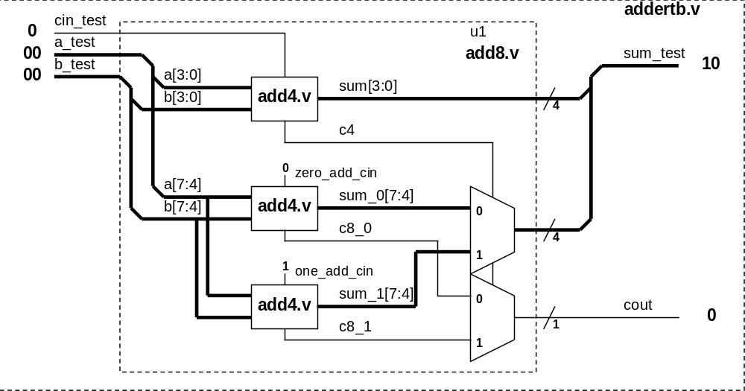
Should be “00”
- Compile with UCLI Debugger Switch Enabled
Re-compile, this time, enable the UCLI debugger.
- First, add a hard breakpoint in addertb.v by modifying the file as follows:
…
if ({cout_test, sum_test} != {a_test + b_test + cin_test)) begin
Change to $stop
$display(“***ERROR at time = %0d ***”, $time);
$display("a = %h, b = %h, sum = %h; cin = %b, cout = %b",
a_test, b_test, sum_test, cin_test, cout_test);
$finish;
…
Compile & simulate with UCLI enabled.
2. shell> vcs –f adder.f –R –debug_all -ucli
When VCS encounters the $stop system task call we embedded, it puts you into the UCLI debugger. You will see the UCLI prompt ucli%.
- Debugging with UCLI Debugger
When the UCLI debugger is invoked, you are placed at simulation time 0.
$stop at time 0
ucli%
If you forget what UCLI commands are available, try the following to get a quick summary of the UCLI commands:
- ucli% help
To find out where we are in the design hierarchy enter:
- ucli% scope
The scope is testbench module addertb.

To get to the problem area enter:
- ucli% run
***ERROR at time = 50 ***
a = 00, b = 00, sum = 10; cin = 0, cout =0
$stop at time 50 Scope: addertb File: addertb.v Line: 25
Take a look at what signals are defined in addertb.
- ucli% show
sum_test
cout_test
a_test
b_test
cin_test
test
u1
List all the signals/ports/scopes, and so on. To see value of signal that are of interest, use the get command.
- ucli% get sum_test -radix hex
'h10
The sum_test bus is incorrect. Trace the sum_test signal to locate the problem. Move into the u1(add8) module using the scope command.
- ucli% scope u1
addertb.u1
- ucli% show -ports -value -radix hex
a 'h00
b 'h00
cin 'h00
sum 'h10
cout 'h00
In debugging, you often need to print out the values of the same set of variables multiple times. Creating an alias for this commonly executed task will make things much easier. Once we have created the alias, executing it is as simple as just typing in the alias name.
- ucli% alias vars show -value -radix hex a b sum sum_0 sum_1 cin c4
- ucli% vars
a 'h00
b 'h00
sum 'h10
sum_0 'h0
sum_1 'h1
cin 'h00
c4 'h0
You can see the details of the error here. The 2:1 mux should select the sum_0 value of “0” but it selected the sum_1 value of “1”. This may be the problem.
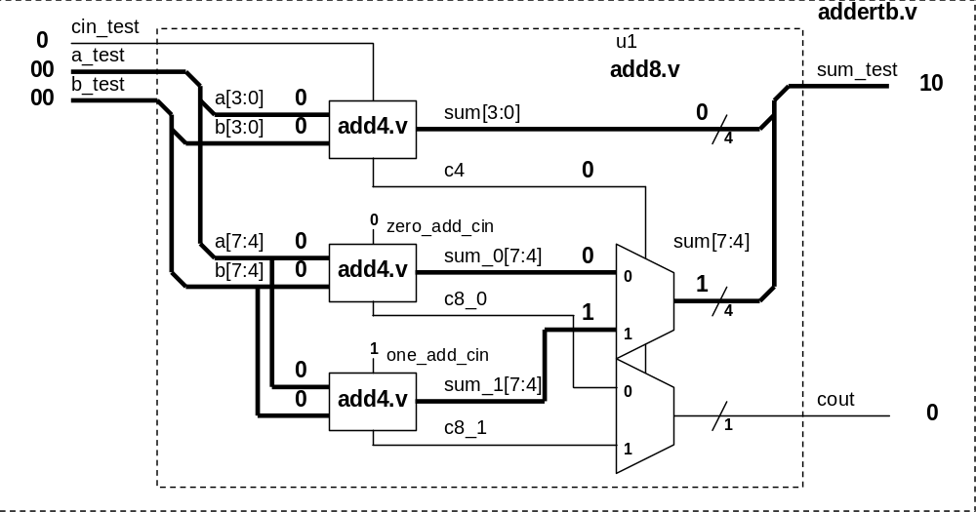
Should be “0”
Leave the UCLI window as is (DO NOT exit UCLI). Open a new UNIX window and take a look at the add8.v file.
- shell> more add8.v
Take a look at the mux code. The inputs to the mux are reversed. In fact, both the sum and the carry mux have the same error.
Assign sum[7:4] = c4?sum_0:sum_1;
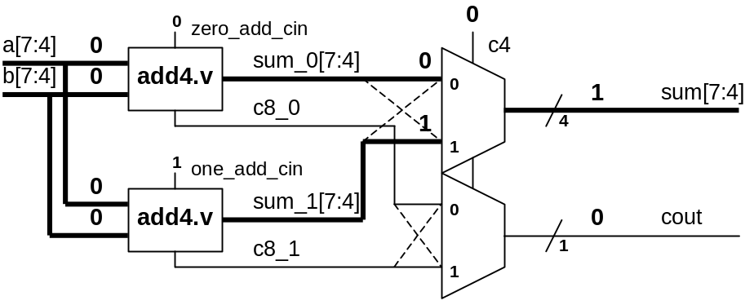
Assign cout = c4?c8_0:c8_1;
The dotted line shows what the source code implemented. The intended implementation is the solid line.
DO NOT fix the error yet. Go back into the UCLI debugger window.
connection reversed
Fortunately, you can emulate a correction without leaving the UCLI environment. If you change carry-in of the sum_0 adder to “1” and change carry-in of the sum_1 adder to “0”, you will have effectively corrected the problem.
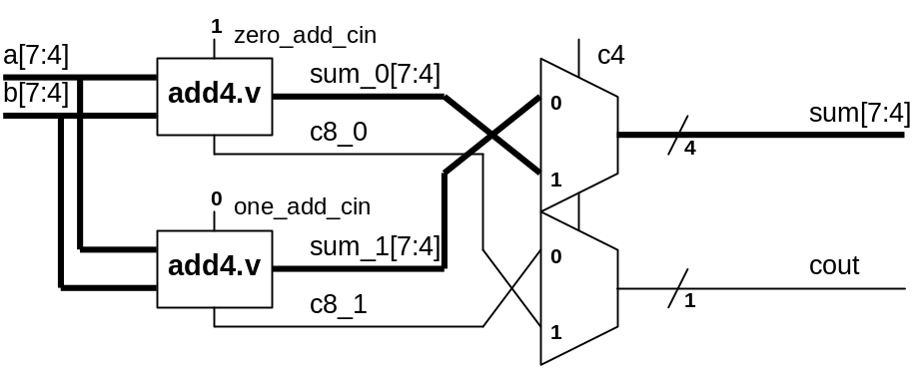
Notice what the current value of the zero_add_cin and one_add_cin signals are.
- ucli% show zero_add_cin one_add_cin -value
zero_add_cin 0
one_add_cin 1
Force the zero_add_cin signal to a “1” and the one_add_cin signal to a “0”.
- ucli% force zero_add_cin 1
- ucli% force one_add_cin 0
To take a look at all the values, use the “prvars” alias that you created. You have not, however, included zero_add_cin and one_add_cin when you created the alias. Because they are needed to view all values, you will need to add them to the command line.
- ucli% vars zero_add_cin one_add_cin
a 'h00
b 'h00
sum 'h10
sum_0 'h0
sum_1 'h1
cin 'h00
c4 'h0
zero_add_cin 'h1
one_add_cin 'h0
The carry-in values have changed, sum[7:4] remains the same. This is because we have not advanced the simulation time to allow for the execution of the new values. You are going to advance the simulation time by 10 time increments.
- ucli% run 10s
60 s
Take a look at the values now.
- ucli% vars
Now, all values should be correct. Return to the testbench level and verify that the adder is working properly.
- ucli% scope -up
- ucli% show a_test b_test cin_test cout_test sum_test –value
a_test 0
b_test 0
cin_test 0
cout_test 0
sum_test 0
These are the correct results. Set a breakpoint where c4 in module add8 changes from ‘0’ to ‘1’ and see if this works.
- ucli% stop -posedge u1.c4
1
- ucli% run
Stop point #1 @ 26400 s;
You have advanced the simulation from 60 to 26400 without encountering an error. Take a look at the values.
- ucli% show a_test b_test cin_test cout_test sum_test –value
a_test 1
b_test 8
cin_test 0
cout_test 0
sum_test 8
Is this right?
VCS encountered the transition of c4 from ‘0’ to ‘1’ and stopped the simulation at that point. There may, however, still be other events in addition to these that have not yet been encountered. In this specific case, the 4-bit MSB (sum_1 in addertb.u1) addition takes place after the transition of the u1.c4 signal. The current value for sum_test, therefore, has not been updated yet. What you are seeing is the previous value of sum_test.
You need to advance the simulation to at least the next time step to see the full effect of all events in the current time step.
- ucli% run 1
26401 s
- ucli% show a_test b_test cin_test cout_test sum_test –value
a_test 1
b_test 8
cin_test 0
cout_test 0
sum_test 9
Now this looks right.
Remove the breakpoint and continue the simulation.
- ucli% stop
1: -posedge addertb.u1.c4
Breakpoint number
We can remove a breakpoint by deleting its breakpoint number.
- ucli% stop -delete 1
1
Resume the simulation.
- ucli% run
*** Testbench successfully completed! ***
addertb.v, 30 : $stop;
You have successfully detected the error and worked around it in the simulation.
If you get tired of re-typing the same commands over and over again, use the log file as a reference to generate a script file. This will simplify your debugging command entries.
We have already generated a script file for you. In this script file, the commonly used aliases are defined and the emulated carry-in fix commands are executed.
Remember this is not a real fix! It is used only to allow simulation to continue without leaving the UCLI environment.
Restart the simulation.
- shell> simv –ucli –i test.s
You can see that zero_add_cin and one_add_cin have been set to the emulated values. Try the alias tb.
- ucli% tb
This alias works! Let’s simulate.
- ucli% run
Congratulations! Exit UCLI and take a look at the simulation log file. The log file should show you everything that you’ve done during the simulation session.
- shell> more ucli.key
Does the content look familiar? Use the content of this file as a reference to generate your script files.
You are done with part B. Continue to part C.

Part C: Getting Help
- Submitting Files for Help
If you ever need to get help from the VCS support team, there are two switches that will make working with the support staff go a lot smoother. They are –ID and –Xman=4. Let’s see what these switches generate.
You do not need to change the directory.
Enter the following at the UNIX prompt:
- shell> vcs –ID > id.txt; more id.txt
You should see a summary of the VCS version being used and workstation OS information. This will help the support staff to quickly focus on issues relevant to the specific VCS version and workstation OS.
When phone support does not resolve your issue, your next plan of action should be to submit a testcase for the Synopsys engineers to play with, use the –Xman=4 switch for this purpose.
Enter the following at the UNIX prompt: (to simplify the command typing, the file script is already written for you)
- shell> vcs –f adder.f –Xman=4; ls
You should see that the file tokens.v has been generated. Take a look at it.
- shell> more tokens.v
Do you see all the modules of the design in this file?
PLI files are not included in tokens.v. You will need to submit them separately.

