After completing this lab, you should be able to:
- Debug an existing Verilog design using DVE GUI.

Debugging with DVE


30 minutes
Unit 3
Learning Objectives
3

Getting Started
- You are handed this design, told there's a bug in it, and to fix it. The usual.
- This is a FIFO written in Verilog with a Verilog testbench. The testbench detects bugs with checkers.
- It prints output and terminates simulation upon failures which we will debug with DVE.
- The FIFO uses count to determine how many entries are in the FIFO and to determine empty and full. There is a head and tail pointer that shows where to write and read from, respectively.
- If you ever get lost and need to back up to the beginning, the original .v and .f files are in the ./start_over directory. Copy them to ".", then go back to the COMPILE AND RUN step. (can use cleanup script)

FIFO REQUIREMENTS
The testbench has its own counter, count_checker, to determine how many entries are in the FIFO and to determine empty and full.
The checkers implemented in the testbench cover the following requirements:
- FIFO count always equals TB count_checker
- If count_checker is empty, empty flag must be asserted.
- Never allow underflow
- Never allow overflow

COMPILE AND RUN
The first thing you decide to do is compile and run this design in VCS.
Since you will debug in DVE, you compile with the "-debug" flag and have $vcdpluson; in your testbench code.
% vcs -debug -f run1.f (can use run_debug script)
% simv
You notice the message:
FAILURE: Empty flag missed at time 250000000000.000 ps. Exiting test.
...
$finish at simulation time 261000000000.000 ps
This is what we will debug.

DEBUG THE EMPTY FLAG BUG
We'll start up DVE and open the vcdplus.vpd simulation result file.
% dve &
File -> Open Database... In the dialog, select vcdplus.vpd. Click Open.
The hierarchy pane shows test_fifo.
The Design dropdown menu shows the name of the displayed file, V1=vcdplus.vpd
Expand test_fifo, and you can see components of this design.

Display the testbench signals in a Wave window.
Select New -> Wave Window from the Window menu. A new wave window opens.
In Hierarchy pane, select test_fifo. Notice its signals are displayed in the Variable pane.

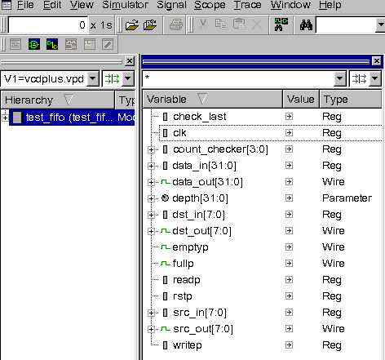

Right click on test_fifo to view the Hierarchy context menu.
Select Add to Waves.
All signals in test_fifo are added to the Wave window.
Notice at the bottom of the main DVE window is the Console pane. In the console pane, you see a Log, History and Errors/Warnings tab. Each action that you have done in DVE has been logged to this pane as a Tcl command. You can enter Tcl commands at the command prompt. The content of these tabs are also saved in history logs in the current directory.
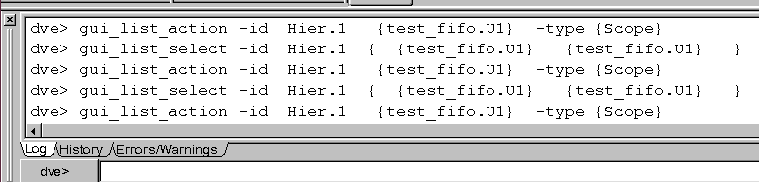
Back to figuring out that empty flag bug...
As you can see in the Time field units at the top of the windows, the timescale is currently 1s, and our simulation was in 100ps. This could be modified via View -> Set Time Scale... But, we'll just leave it.
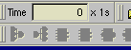

Zoom around in Wave window.
In the Wave window, we see a timescale bar at the top of the wave window and one at the bottom.
The bottom one always shows all time available in the open database.
The top one shows you the portion that is currently visible in the wave window.
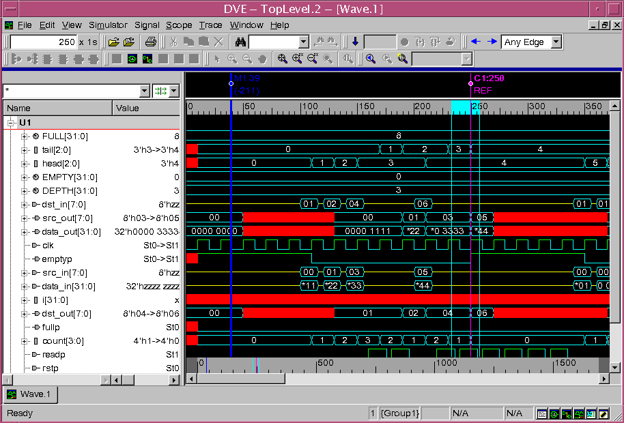
Since our bug was at time 250, let's zoom over there using the bottom timescale.
On the bottom timescale, click down at about time 240 and drag through 250 and let go.

The top timescale and waveform now shows about 240 to 260. This is much quicker than scrolling.

Put a marker at the time of failure.
Let's put a marker at our problem time. In waveform area, right click and select "Create Marker" from the context menu.
You get a moving cursor that you can place at time 250 by left clicking a transition at time 250 on a waveform (ex: data_out[31:0]).
It will snap the marker to the nearest transition.
Notice the bottom timescale has a white vertical line through time 250. This denotes the marker we just created.
Notice also that there is a pink line at time 0 in the bottom timescale. Zoom into that pink line using the bottom timescale click and drag technique.
The top timescale now displays from time 0 and you see cursor C1=0 in the marker pane.
C1 is the application time, it is displayed in the Time field at the top of the windows.
You can move C1 by entering a time in the Time field, likewise, you can change the time in the time field by moving C1.
Why is this interesting? This C1 application time is the time attached to the values when you annotate values in source, or schematics.
We'll use these features soon.
Let's move the application time, C1, to 250 where our marker is.
Zoom back over to the white M1 marker using the bottom timescale. In the Waveform pane, left click on a transition at time 250.
Left clicks in the waveform pane snap C1 to the nearest transition.
Now the Time field shows 250. The time our empty flag bug showed up.
We can see that signal emptyp in the wave window is indeed 0 at time 250 and the checker says it should be 1.

Show connections of emptyp in path schematic window.
In main window Variable pane, select emptyp. Click the Show Path Schematic Window button in the toolbar buttons, or select New -> Show Path Schematic from the Window menu. A path schematic window opens with the connections of emptyp in the testbench.
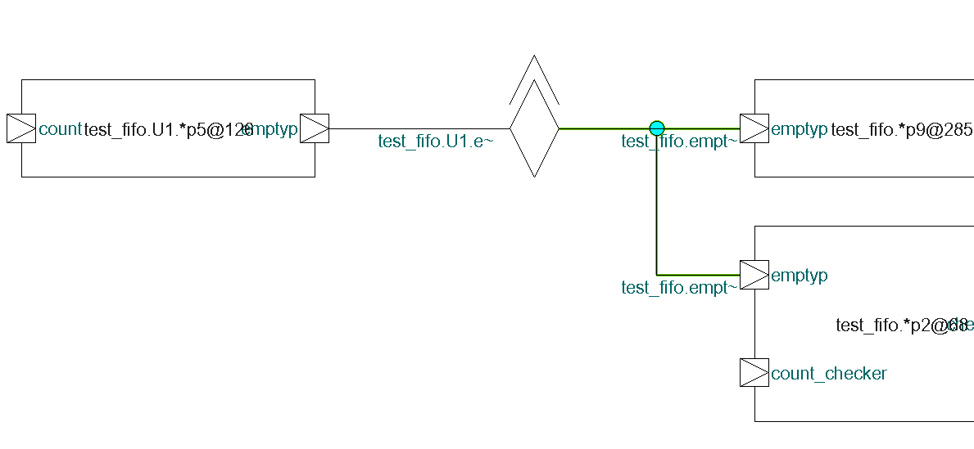
What do we have here?
- The cyan line shows emptyp connections with solder points in the testbench.
- The green components labelled "*p9@285" and "*p2@68" show process 9 at line 285 and process 2 at line 68, respectively. These represent blocks of source code.
- The orange component shows connections that cross a level of hierarchy.
Since emptyp comes out the top, we can tell it represents connection to a child component.
Hold your mouse over the hierarchy transition component to see the tooltip.
It shows that it connects with test_fifo.U1.emtpyp.
We need to see where emptyp comes from, so double click on the orange hierarchy transition.
Now we are looking at 2 levels of hierarchy, the processes in the testbench AND a process in test_fifo_U1.
Zoom in a little using the Zoom In 2x toolbar button.
Click the Pan Tool button and grab and drag the schematic with the pan tool so you can see the process in test_fifo.U1, called *p5@126.
(Or use the window scroll bars)
Change back to the Selection Tool.

Annotate pin values in schematic and expand path.
Select Scope -> Annotate Values, now we see the St0 value for emptyp.

To get the value for count, we will need to expand the path schematic. Click to select the count port on the process.
Right click and select Expand Path from the menu. Zoom in.
Now we see the source code component connected to count, in addition to its value, 4'h0. The FIFO is empty.

Show source code from schematic.
In the path schematic window, select the source code block with count as input and empty as output, that is, the one called *p5@126.
It is now highlighted in white. Now right click and select Show Source from the menu.

DVE source window pops forward highlighting text on line 126.
The source code is an always block. Let's annotate values here (if they are not already present).
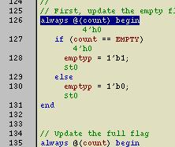
Select Source -> Annotate Values. Values are annotated in green, below the signals.
We see count is empty and based on this code, it should have gone through the if, not the else.
The "if" condition, count == EMPTY, must have failed. Let's verify that.
Searching text in source code. Double click the word EMPTY so that it is highlighted.
Now click the Find... toolbar button. (Looks like binoculars)
It opens the Find tool. Select Match case, so that we don't stop on emptyp and click Find Next.
We have a match on line 24. We see that EMPTY = (1<<3), the same as the FULL parameter.
Here's our bug.
It should be EMPTY = 0. Close the Find dialog.

Edit source to fix the bug.
Select Scope -> Edit Source.
DVE chose the editor based on your EDITOR environment variable.
Change to EMPTY = 0; and save it.

Recompile and simulate in DVE to verify bug fix.
Recompile the design outside of the GUI - the same as you did in Compile and Run. (run_debug)
Back in DVE, Select Simulator - Setup. A new window opens, select OK which will run simv in interactive mode.
The current design is Sim=inter.vpd, and V1=vcdplus.vpd is still there in the menu.
Let's drag test_fifo from Hierachy Window to the Wave Window over "New Group".
Click on test_fifo with the middle mouse button and drag it to the wave window.
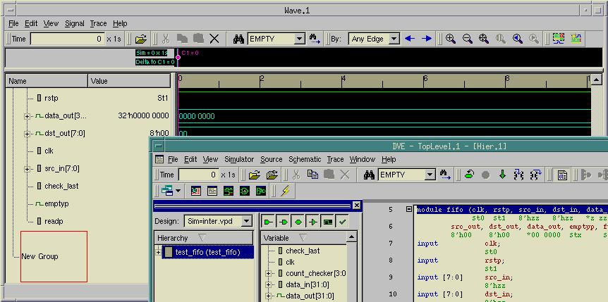
(Now we have one group with the vcdplus.vpd signals in it and another with the interactive signals in it.
Notice that the signals in Group2 are all gray since we have not yet run the simulation)
Our C1 cursor is now hooked up to Sim time and is back to 0.
Let's run it to 260 to see if it fixed that empty flag bug.
Enter 260 in the Time field and hit Enter. Sim runs to time 260, C1 and app time are 260.
Scroll the waveform display to find our interacitve "emptyp" signal in the Group2 signal group.
Verify its value is 1 at the time of our marker, time 250. The bug is fixed.

Close the buggy simulation results.
Let's close the post-processing, vcdplus.vpd database.
File -> Close Database. Select V1 .../vcdplus.vpd. Click OK.
Leave the interactive one open, inter.vpd.

RUN SIMULATION IN DVE
Let's look for more bugs.
To run the simulation forward, click the Continue button in the main window toolbar.
Another FAILURE!
You see the VCS simulation output in the Log tab of the Console pane when you are running simulations in DVE.
This time, is prints and exits simulation:
FAILURE: Counter mismatch at time 16800000000000.000 ps! Exiting test.
...
$finish at simulation time 16900000000000.000 ps

DEBUG THE COUNTER MISMATCH BUG

Find the checker that printed the error message.
In Hierarchy pane, double click the test_fifo testbench to populate the source window.
Click the Find toolbar button at the top of the window.
Enter "Counter mismatch" and click Find Next to take us to the checker.

We see that the comparison that failed was the tb counter not equal the FIFO counter and it was detected at the negedge of clk.
In Wave window, zoom full with Zoom Full toolbar button.. Locate the count_checker signal in the wave window.
Middle mouse click on that signal to place the red insertion bar below it.
Any signals added to the Wave window, will be added at this point.
In Source window, select the text of the checker from the if to the end.
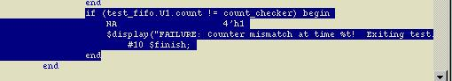
Right click and select Add to Waves from the context menu.
Now we have count and count_checker (our mismatched counters in the Wave Window.)

Compare count signals to find the mismatch.
Select the count and count_checker in the Wave window, so that both are highlighted (use Ctrl or Shift for multiple selection).
Select Signal -> Compare Signals... The compare tool is automatically populated with the signals you selected.
The top shows the database and signals to compare (you can also compare instances, not just signals). The middle shows the options for comparison, and the bottom is a summary.
Just click OK.
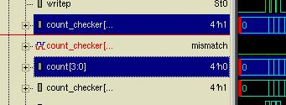
The comparison result is added in red to the Wave window at the insertion point.

Search forward to get to mismatch.
Select the compare result signal in the wave window.
Move your C1 cursor to time 0 and then click the Search Forward toolbar button in the Wave window. (blue, right arrow)

The Search is controlled by the "By:" dropdown menu, which is Any Edge, by default.
The C1 cursor moves to time 1670, the time of the first mismatch. Zoom in around that C1 cursor using the top timescale.
We see that the FIFO count is 0 and the testbench counter is 1 at this time.

Get drivers of the count signal.
Double click the waveform transition of the count signal at time 1670, when it transitioned to 0.
This opens the Drivers and Loads window. It shows that there are four drivers in one source file.
The Source window pops forward with driver icons on the lines that drive count.

Annotate values and step through drivers to find the active one.
In the main window, click the Annotate Values toolbar button, or select Source -> Annotate Values. (may already be shown)
These values are tied to C1 cursor, now 1670 s, since we searched to the first mismatch.
Our first driver "count <= 0;" We see that the "if" condition is "rstp == 1'b1", and the annotated value shows rstp is 0 now. So that's not it.
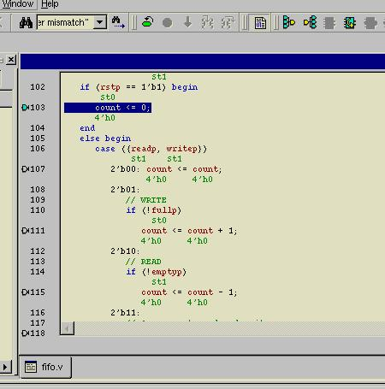
Lets' try the next. Select Trace -> Drivers/Loads -> Next In This Instance, or select the Next In This Instance toolbar button.
Now we're in the "case" statement. Looking at the case condition ({readp, writep}), we see from the annotated values (St1 and St1) that the "2'b11" case applies.
Click the Next In This Instance toolbar button until the cyan current driver icon is on the source line that is inside the 2'b11 case.
That is, count <= count -1;, the concurrent read and write. (line 117)
When writing and reading, we should not be changing the counter.
This is our bug.
It should be count <= count;.

Edit source to fix the bug.
Select Scope -> Edit Source.
Fix the source code as described above, and save it.

Recompile and simulate in DVE to verify bug fix.
Again, you will need to re-compile the design outside of the GUI. This time however, you will need to use the following:
vcs -debug_all -f run1.f (can use run_debug_all script)
Back in DVE, Select Simulator -> Setup. A new window opens, select OK which will run simv in interactive mode.
The signals (including the signal compare) are still availalbe in the Wave window so we can verifiy the fix.

Set a breakpoint on the line we just fixed to verify it.
Click on the + in front of test_fifo in the Hierarchy to expand it.
Double click the test_fifo.U1 in Hierarchy to populate the source window.
Scroll down to the line we edited (or use Find to jump to it.) (line 117)
Green dots to the left of the line number denote breakable lines during an interactive simulation.
Set a breakpoint by clicking the green breakable line on the source line we just edited (count <= count;)
It turns red to show that we have a breakpoint set here.
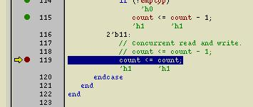
Now click the Continue toolbar button to run the simulation.
The simulation stops at the breakpoint, we see from annotated values that count is now 1. Fixed.

Disable the breakpoint and continue running.
Click on the breakpoint (red dot) so that it becomes a hollow red dot, denoting that it has been disabled.
Now click the Continue toolbar button to run the simulation.
It runs to completion without anymore checker errors. You're done.
File -> Exit to exit DVE.

DEBUG THE COUNTER MISMATCH BUG using SVA

Setup design, compile and setup simulation
We want to use SVA to debug the simulation for the counter mismatch, so we need to remove the fix and recompile.
This has been automated in the a script, so simply run run_debug_sva.
After the compile completes, start DVE with: dve &
Back in DVE, Select Simulator - Setup. A new window opens, select OK which will run simv in interactive mode.
You will notice that another window, Assertions, also opens. We will be using this window in this session.
Simply click the continue (blue down arrow) in the banner to run the simulation to find the error.
In the log window you will see the same Counter mismatch error as well as the SVA assertion error at time 1680.
emptyp = 1
FAILURE: Counter mismatch at time 1680000000000.000 ps! Exiting test.
time = 1680000000000.000 ps
"fifo.sva", 18: test_fifo.mychk.a3: started at 1680s failed at 1680s
Offending '(count == count_checker)'
$finish at simulation time 1690000000000.000 ps

Follow the checker that printed the error message.
Fi the Assertion window is not visible, click Window -> Panes -> Assertion to see the assertion debug information.
In Assertion window, double click the a3 assertion to populate the wave window.
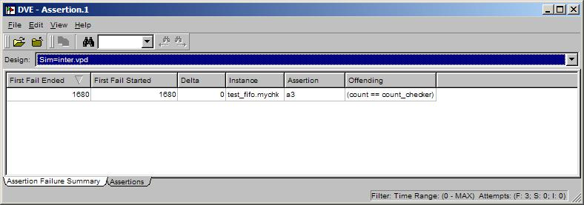
In the Wave window you will see the a3 assertion with the green up arrows.
You should see the first assertion failure (red arrow) at time 1680.

To see why this assertion is failing, we'll look at the parts of the assertion.
We have count and count_checker (our mismatched counters) in the Wave Window.
Since we are checking this assertion on the negative edge of clk, the previous values (time 1670) are the ones that show the failure.
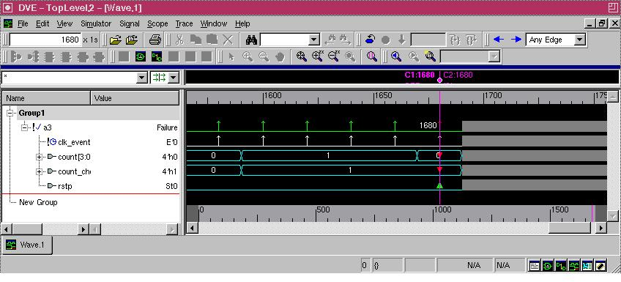
Double click on the transition of count.
This will open the Drviers and Loads window, but since all of the drivers are in the same source file we'll look at that file. Select Close.
Now in the sourcecode window we see the first driver for count.
This is exactly where we were in the previous debug session, so we could continue in the exact same manner.
Using SVA reaches the same problem with with fewer/simpler steps, even for this simple example.

SUMMARY

We detected, found, fixed, and verified 2 bugs in this Verilog FIFO using the following features of DVE.
- Hierarchy, Wave, Source, Path Schematic, Console windows
- Post and interactive debugging.
- Quick Timescale zooming in Wave window
- Cursors and Markers and application time.
- Connectivity across hierarchy in path schematic window
- Expand paths in path schematic
- Annotated values and zooming in schematics
- Cross linking of schematic to source code
- Cross linking of wave to source code
- Cross linking of hierarchy to source code
- Searching text in source
- Edit source and recompile sim
- Multiple databases
- Waveform comparison
- Edge searching in waveforms
- Get drivers in waveforms
- Annotated values in source code
- Step through drivers in source code
- Interactive simulations with breakpoints and disabled breakpoints.
- SVA assertion reports
- Cross linking of assertions to wave and source code

