After completing this lab, you should be able to:
- Locate race condition in an existing Verilog design using the race checker utility in VCS
- Locate a simulation mismatch in an existing Verilog design

Debugging simulation mismatches


30 minutes
Unit 5
Learning Objectives
5

Getting Started
You will continue to use the Select Adder for this lab.
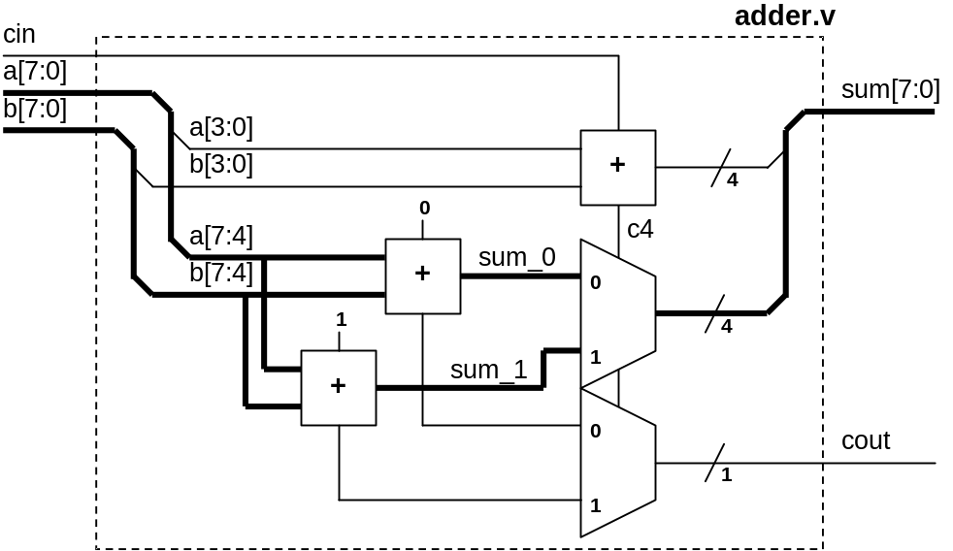
In the lab files, there are errors caused by race conditions. The goal is to use VCS to identify and locate the cause of the race conditions. Once, corrected, you will re-compile and re-simulate to verify the functionality of our corrections.
Here's a preview of what you'll do:
- In part A, you will compile and simulate to see if the adder is operating correctly. Then, we will use the +race compile-time switch and re-compile and re-simulate the adder. By examining the race.out file and locating the race condition in the source code, you will be able to make the proper correction.
- In part B, you will compile with $vcdpluson to generate a VPD dump file. Examining the differences in DVE, you will locate the race condition. The source code will be modified. Finally you will re-compile and re-simulate to verify the correctness of the adder operation.
Figure 5-1: Flow Diagram of Lab Exercise
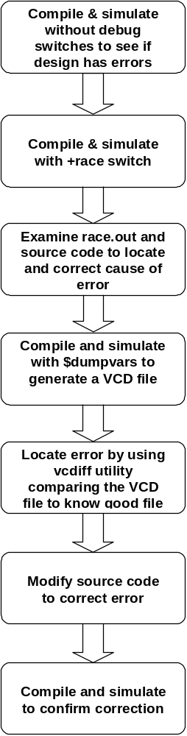
Figure 5-1: Flow Diagram of Lab Exercise
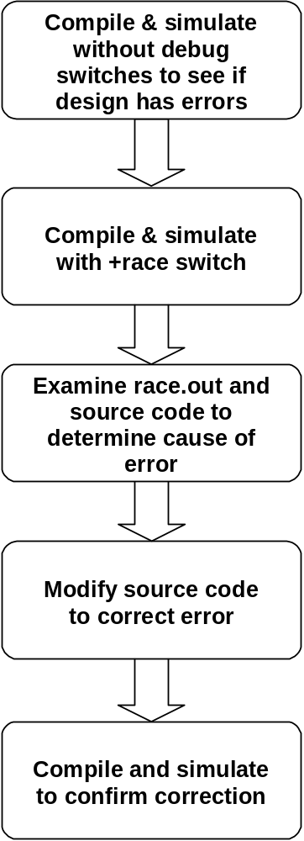

Part A: Debugging with +race Switch
- Verify Adder Functionality
The first step of any debugging process is to compile and simulate the design without using the debugging switches to see if there are any errors.
Go into lab5 part A directory.
- shell> cd ../lab5/parta
- shell> vcs –f adder.f –R
There are errors being reported.
***ERROR at time = 0 ***
a = 00, b = 00, sum = xx; cin = 0, cout =x
…
…
- Re-Compile and Re-Simulate with +race Switch
With race conditions, it is generally difficult to see from the error message that the cause is Verilog race condition. When things don’t look quite right, you might want to quickly check to see if the error is caused by race condition.
- shell> vcs –f adder.f –R +race
This will generate a race.out file.
Take a look at the race.out file after the simulation has completed.
- shell> more race.out
At time 0, three signals are reported being written and read at the same time.
0 "error_count": read addertb (addertb.v: 32) && write addertb (addertb.v:21)
0 "sum_test": write addertb.u1 (add8.v: 14) && read addertb (addertb.v:35)
0 "cout_test": write addertb (add8.v: 15) && read addertb (addertb.v:35)

Where is the race condition in each of these cases?
- Correct the race condition in the source code, repeat step 1 & 2 to make sure the race condition is resolved. (Hint: The race condition is in the testbench)

Part B: Debugging with $vcdplustraceon Task
- Verify Adder Functionality
Again, you want to verify the operation of the design first.
Go into lab5 part B directory.
- shell> cd ../partb
- shell> vcs –f adder.f –R
There are errors being reported.
***ERROR at time = 50 ***
a = 00, b = 00, sum = xx; cin = 0, cout =0
***ERROR at time = 150 ***
a = 00, b = 01, sum = 00; cin = 0, cout =0
…
…
- Re-Compile and Re-Simulate with +race Switch
Check the possibilities for race conditions by running a race report.
- shell> vcs –f adder.f –R +race
Take a look at the race.out file after the simulation has completed.
- shell> more race.out
At time 0, four signals are reported being written and read at the same time.
0 "sum_0": read addertb.u1 (adder.v: 21) && write addertb.u1 (adder.v:15)
0 "sum_1": read addertb.u1 (adder.v: 22) && write addertb.u1 (adder.v:16)
0 "sum_temp": write addertb.u1 (adder.v: 14) && read addertb.u1 (adder.v:23)
0 "c4": write addertb.u1 (adder.v: 13) && read addertb.u1 (adder.v:25)

Let’s keep these in mind and dump a VCD+ file.
- Generate VPD dump file
In the testbench, sections of the code are already written for dumping VPD file. Take a look at it.
The relevant sections are as follows:
initial
begin
…
…
`ifdef vcdplusdump
$display("\n*** VCD+ file dump is turned on ***\n");
$vcdpluson;
#1000;
$vcdplusoff;
`endif
…
end

initial
begin
…
if (error_count == 10) begin
…
`ifdef vcdplusdump
$vcdplusoff;
`endif
…
end

The $vcdpluson task can be enabled with a +define+vcdplusdump compile-time switch.
The #1000 and $vcdplusoff are used in the first section of the code to control the size of the reference file. This was done so that the size of the file generated is manageable for download from the Synopsys web site.
In the second section, VPD dumpping is turned off after ten error counts are detected. Again, this is done to manage the VPD file size.
In your own debugging, you might want to consider using similar mechanisms for controlling VPD file size.
Compile and generate the VPD file.
- shell> vcs –f adder.f –debug_all –R +define+vcdplusdump
You will got error message and vcdplus.vpd in current directory.
- Compare VCD File with Reference File
There is a reference VCD file already generated called “reference.dump”. You will compare this reference file with the VCD file that you generated.
- conver VPD to VCD
shell> vpd2vcd vcdplus.vpd vcdplus.vcd
- shell> vcdiff reference.dump vcdplus.vcd
vcdiff - Version X-2005.06-SP2
Copyright (c) 1991-2003 by Synopsys Inc.
ALL RIGHTS RESERVED

vcdiff reference.dump vcdplus.vcd
< reference.dump: scopes:3 signals:18
> vcdplus.vcd: scopes:3 signals:18

--- addertb.sum_test --- 0 ---
< 0 00000000
---
> 0 xxxxxxxx

--- addertb.u1.sum --- 0 ---
< 0 00000000
---
> 0 xxxxxxxx

--- vcdiff summary ---
--- compares: 70
--- diffs: 2

At time 0, the adder.v generated a sum value of xxxxxxxx instead of 00000000 as was expected in the reference file.
Recall that the race.out file reported sum_0 and sum_1 had potential race conditions. The problem is likely to be in how we generated the sum.
- Examine File Differences in DVE
Look at the differences graphically.
Invoke DVE in post-processing mode.
- shell> dve&
- Select File -> Open Database…
An Open Database Dialog window will open up.
- In the Files pane, select “reference.dump” then click on Open
As soon as you do this, DVE will translate VCD to VPD file. (the translated file name is “reference.dump.vpd”)
Let’s also open the VCD file for the DUT.
- In the Open Database Dialog window select “vcdplus.vpd” then click on Open
Do you see that the new opened file is given the designator “V2=vcdplus.vpd” in the Open File pane near the top of the dialog window?
Look at the signals in Waveform window.
- Click + before “addertb” in Hierarchy pane.
The modules and the signals now displayed in the Hierarchy pane and Variable pane are the signals captured in the last file that you opened – vcdplus.vpd. You can see this by looking at the title bar at the top of the Hierarchy pane.
- Show all signals in u1 module into the Waveform window, left click select “u1” in Hierarchy pane and select “Add To Waves” in right click menu.
Each signal in the Waveform window should have the V2 designator (leave mouse point on signals for one second), indicating that these are the vcdplus.vpd signals.
Look at the DUT signals.
- In Hierarchy pane, select “V1=reference.dump”
Look at the same set of signals from u1 module.
- Drag and drop the u1 module onto the “New Group” in the Waveform window
This create another group u1_1 for new group signal, you can edit group name to ref_u1.
All the signals are identical with the exception of the sum signal. Use Zoom features to view the appropriate amount of data.
- Examine Source File to Locate Error
- Double click sum[7:0] signal from the Waveform window(if you forget which is from V2, just put your pointer on it for one second), The adder.v module is opened in the source code pane.
Recall what the race.out file reported. Where is the error?
(Hint: this is a form of the Continuous Assignment Evaluation race condition)
- Correct the error then re-compile and re-simulate to verify that the error is removed.

