Class04.R
embell
2026-01-16
x <- 1:50
# command return to get the script onto the console
plot(x)
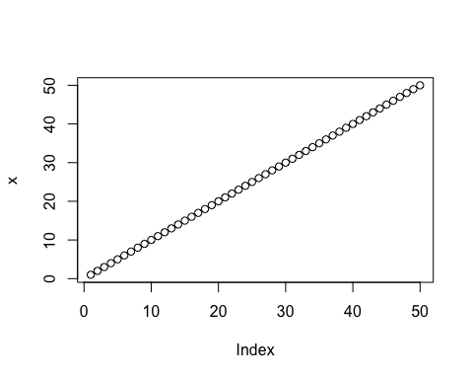
plot(x, sin(x))
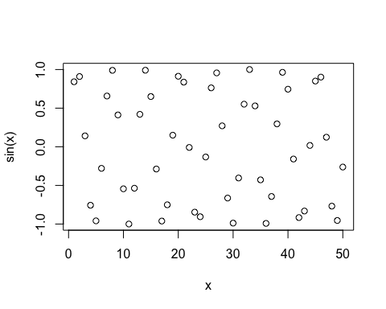
plot(x, sin(x), typ="b")
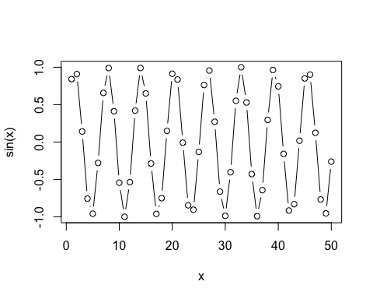
plot(x, sin(x), typ="l", col="blue", lwd=3, xlab="is it lunchtime yet?")
