How H-MAP Forecasts Cases with Prophet
How the forecast works, how the CESU should read it, and how accurate it has been on Parañaque data

Abbreviations used
Abbreviation | Meaning
MAPE | Mean Absolute Percentage Error (average miss per week, in percent)
RMSE | Root Mean Square Error (typical miss per week, in cases)
MAE | Mean Absolute Error (average miss per week, in cases)
ILI | Influenza-like illness
HFMD | Hand, foot and mouth disease
TYP / LEP | Typhoid / Leptospirosis
CESU | City Epidemiology and Surveillance Unit

1. In one paragraph
H-MAP uses a forecasting method called Prophet (Taylor & Letham, 2018) to estimate the number of Confirmed + Probable cases for the next four weeks. It learns two things from the city's weekly counts since 2010: the long-run level of the disease and its usual pattern through the year (for dengue, the rise in the rainy months). The forecast is a likely direction and range, not an exact count. It is shown only for diseases where it has proven better than simply repeating last year's numbers, and it is one input to the CESU's judgment, never a replacement for it.

2. How the forecast is made
- Weekly counts. Confirmed and Probable cases are added up per morbidity week, from 2010 to the latest training data (the same case definition as the thresholds). Weeks with no cases count as 0.
- Trend. Prophet fits a slowly changing line through the years: is the disease generally becoming more or less common?
- Yearly pattern. Prophet learns how each part of the year compares with the trend, for example that the rainy months are usually much higher than the dry months for dengue. The pattern is multiplied by the trend, so in a high year the rainy-season peak is higher too.
- Forecast. Trend times yearly pattern, carried forward four weeks, gives the predicted cases for each week.
- Range. Prophet also gives an 80% range (lower and upper bound). In principle, about 4 out of 5 future weeks should fall inside it. Section 5 shows how well that held on Parañaque data.
What the model does not know: floods and typhoons, clean-up drives, school calendars, outbreaks in nearby cities, changes in reporting, or anything that has not happened in a regular yearly pattern before. These are exactly the things the CESU knows and the model does not.

3. When H-MAP shows a forecast and when it does not
Before a forecast is shown, H-MAP tests it. The model is trained on 2010 to 2023 only, asked to predict 2024 and 2025, and compared with what actually happened. The same test is given to the simplest possible guess: the same week last year. If Prophet does not beat that guess, the forecast is withheld and the dashboard says so.
Disease (city-wide) | Prophet error (MAPE) | Last-year error (MAPE) | Prophet RMSE | Last-year RMSE | On the dashboard
Dengue | 50.1% | 69.6% | 20.24 | 27.60 | Shown
Influenza-like illness | 101.1% | 90.0% | 3.28 | 2.75 | Withheld
Measles | 25.1% | 5.5% | 0.57 | 0.42 | Withheld
Typhoid | 35.4% | 43.9% | 1.51 | 1.63 | Shown
Leptospirosis | 19.7% | 35.0% | 2.74 | 2.30 | Shown
Hand, foot and mouth disease | 149.8% | 10.1% | 3.02 | 0.51 | Withheld

What the columns mean:
- MAPE (Mean Absolute Percentage Error): the average miss per week, as a percentage of the actual count. H-MAP adds 1 to the actual count before dividing, so weeks with 0 cases do not make the percentage infinite. Example: 40 actual cases and a forecast of 30 is a miss of 10 / (40 + 1) = 24.4%.
- RMSE (Root Mean Square Error): the typical miss in number of cases per week. Each week's miss is squared, averaged, then square-rooted, so one large miss counts more than several small ones. Example: misses of 2 and 4 cases give the square root of (4 + 16) / 2 = 3.16 cases.
- Prophet error: how far the H-MAP forecast was from the actual weekly counts in 2024 and 2025.
- Last-year error: how far the simple guess "same week last year" (also called the seasonal-naive forecast) was from the same actual counts.
- On the dashboard: "Shown" when Prophet's MAPE is lower than the last-year MAPE, otherwise "Withheld". For both measures, lower is better.
- ILI: Influenza-like illness.
- HFMD: Hand, foot and mouth disease.
- City-wide: all 16 barangays counted together.
Why three diseases are withheld: Measles and HFMD have mostly zero weeks with occasional bursts, and influenza-like illness depends on which strains circulate in a given year. None of them follows a regular yearly pattern that Prophet can learn, so for these the CESU should rely on the thresholds and the single-case rule.

4. How the CESU should read the forecast
- Read the direction first. Is the line going up, flat or down over the four weeks? H-MAP calls a barangay's forecast "rising" when the fourth week is at least 10% and at least one case higher than the first. A rising forecast alone puts a barangay at Moderate risk.
- Then read the range, not the single number. "About 50 to 80 cases next week" is the honest message; "63 cases" is not.
- Compare the range with the thresholds. If the upper bound reaches the alert threshold for the coming weeks, prepare (supplies, information drives, search-and-destroy scheduling). If the forecast itself is above the epidemic threshold, treat it as an early warning and verify with the latest reports.
- Check the latest weeks. The last one or two reported weeks are usually incomplete because of late reports, so actual counts often look low at first. Do not conclude that the forecast is too high until those weeks have filled in.
- Add what the model cannot see. After heavy rains or flooding, expect leptospirosis and dengue to run above the forecast. After a strong vector control campaign, expect dengue below it.
- Note the model's freshness. The forecast is anchored to the current week, but the model only knows the data it was trained on (currently up to December 2025). Retrain it whenever a newer PIDSR workbook is loaded (python ml/train_prophet.py), ideally monthly, so the forecast starts from recent weeks.
What the forecast shows | Suggested reading
Flat or falling, well below the alert line | Routine surveillance.
Rising, upper bound near or above the alert line | Prepare and watch the next reports closely.
Forecast above the epidemic line | Early warning. Verify with current case reports and hotspots.
Forecast withheld | Use thresholds, the single-case rule and hotspots only.

5. How accurate it has been on Parañaque data

5.1 Two-year test (the display check)
Figure 1 shows the test from Section 3 for dengue: one forecast made at the end of 2023 for every week of 2024 and 2025. Prophet caught the timing of both rainy seasons and missed less than the same-week-last-year guess (RMSE 20.2 against 27.6 cases per week). It did not foresee the size of the 2024 season: actual cases reached about 91 a week while the forecast peaked near 33. A forecast made far ahead knows when the season comes, not how big it will be. 71% of the actual weeks fell inside the 80% range, so the range is somewhat narrower than it claims: treat it as the typical range, not a guarantee.
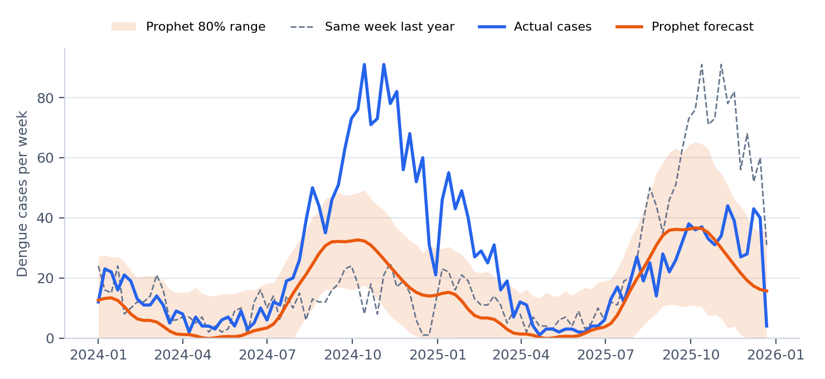
Figure 1. Dengue, city-wide: actual weekly cases in 2024-2025 against a forecast made at the end of 2023.

5.2 Four-week test (how the dashboard is used)
The dashboard shows only the next four weeks, from a model that has seen all earlier data. To test exactly that, the model was retrained every four weeks through 2024 and 2025, each time forecasting the next four weeks only, and compared with what happened.
Disease | Avg miss, Prophet (cases/wk) | Avg miss, last year (cases/wk) | Prophet MAPE | Last-year MAPE | Weeks inside 80% range | Direction correct
Dengue | 14.2 | 19.4 | 57.6% | 69.7% | 66% | 22 of 26
Typhoid | 0.9 | 1.0 | 37.3% | 43.9% | 77% | 13 of 22
Leptospirosis | 1.2 | 0.9 | 56.4% | 35.0% | 68% | 11 of 23

Dengue. Over 2024-2025 the city averaged 26 dengue cases a week (lowest 1, highest 91). The four-week forecast missed by 14.2 cases a week on average, against 19.4 for the last-year guess, and it called the direction of the next four weeks (up or down from the previous four) correctly 22 times out of 26. The one-week-ahead forecast was the most accurate (MAPE 48%, against 64% four weeks ahead). This is the strongest result and the main use of the forecast. Figure 2 also shows its typical mistake: in 2024 it followed the rise but stayed below the peak, and in 2025, having just seen a large season, it expected another one and ran above the actual counts. The forecast tends to repeat the size of recent seasons; the threshold lines and the current reports show whether this season is different.
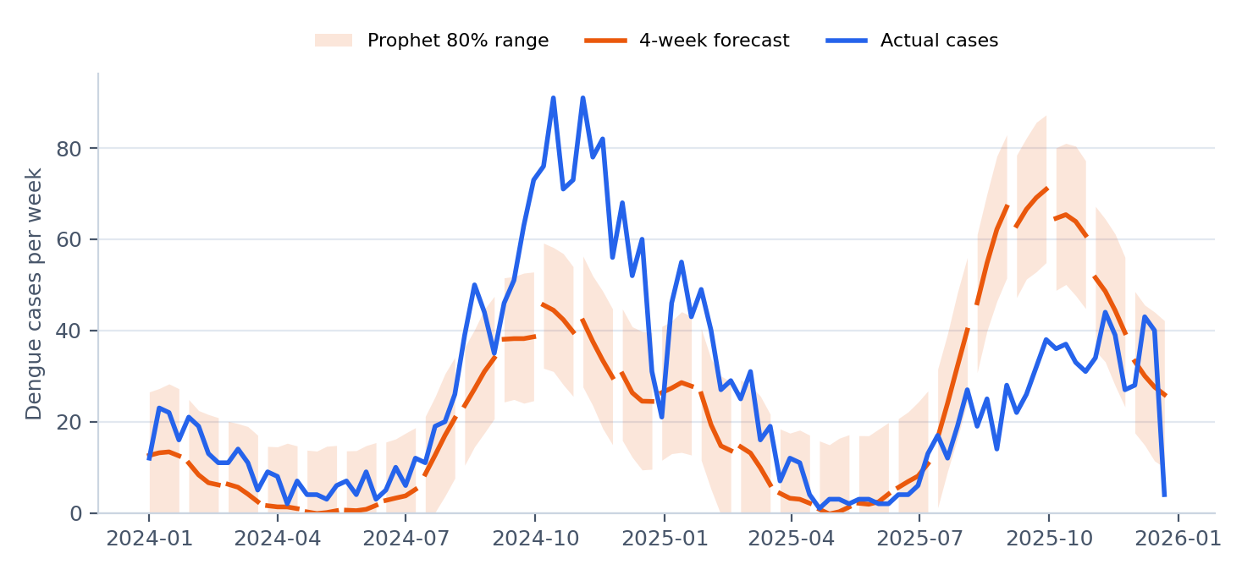
Figure 2. Dengue, city-wide: each orange segment is a 4-week forecast made with the data available at the time.
Typhoid. Small but consistent gain over the last-year guess (average miss 0.9 against 1.0 cases a week). With only one or two cases a week, the direction is often a matter of a single case, so read typhoid forecasts as "low and steady" or "higher than usual" only.
Leptospirosis: read with caution. Leptospirosis passes the two-year check, but in the four-week test it did worse than the last-year guess (average miss 1.15 against 0.95 cases a week) and called the direction correctly only 11 times out of 23, about as often as a coin toss. Leptospirosis follows floods, which a yearly pattern cannot predict. Until the display check also uses the four-week test, the CESU should treat the leptospirosis forecast as background information and act on rainfall, flooding and case reports instead.

5.3 Barangay-level dengue forecasts
Barangay | Prophet MAPE | Last-year MAPE | Prophet RMSE | Last-year RMSE
Don Galo | 22.9% | 42.2% | 1.01 | 1.29
La Huerta | 30.5% | 51.1% | 1.68 | 2.05
Merville | 31.2% | 46.9% | 1.18 | 1.22
San Martin de Porres | 32.6% | 50.8% | 1.23 | 1.60
Baclaran | 33.1% | 62.2% | 2.49 | 3.03
Tambo | 38.5% | 47.4% | 1.96 | 1.97
Marcelo Green Village | 38.8% | 62.6% | 1.95 | 2.30
San Antonio | 40.8% | 78.3% | 2.68 | 3.15
Santo Niño | 44.1% | 55.2% | 2.36 | 2.01
Sun Valley | 46.4% | 66.2% | 1.59 | 1.94
B.F. Homes | 49.1% | 71.4% | 3.32 | 3.31
San Dionisio | 51.1% | 58.5% | 4.13 | 3.77
Don Bosco | 56.0% | 145.4% | 3.36 | 4.53
San Isidro | 57.8% | 70.3% | 4.69 | 4.38
Moonwalk | 60.9% | 97.3% | 2.02 | 2.79

All 15 barangays with enough dengue cases beat the last-year guess on MAPE, so their forecasts are shown. In the highlighted barangays, Prophet's RMSE is slightly worse: it misses the occasional large week by more, even though it is closer on ordinary weeks. Barangay forecasts work with a few cases a week, so they are best read for direction.

6. Summary for the CESU
- The forecast is reliable enough to watch the direction of dengue over the next four weeks, and it is closest one week ahead.
- Read the range and the direction, and compare them with the alert and epidemic thresholds; do not quote the single predicted number.
- Typhoid forecasts are modestly useful; leptospirosis forecasts should not drive decisions on their own.
- Measles, ILI and HFMD forecasts are withheld on purpose; use the thresholds and the single-case rule.
- Retrain the model whenever new workbook data is loaded, and always add local knowledge (weather, campaigns, reporting delays) that the model cannot see.
Notes on the figures. The display-check figures in Section 3 come from the stored evaluation (ml/reports/prophet_eval_latest.csv). The four-week test and Figures 1 and 2 were rerun on the current database for this guide; the dengue two-year error there is 51.0% (stored value 50.1%). The small difference comes from the reloaded case data.
Reference: Taylor, S. J., & Letham, B. (2018). Forecasting at scale. The American Statistician, 72(1), 37-45. https://doi.org/10.1080/00031305.2017.1380080

