How H-MAP Computes the Alert and Epidemic Thresholds
A worked example using Parañaque City PIDSR data · For the City Epidemiology and Surveillance Unit (CESU)

Abbreviations used
Abbreviation | Meaning
PIDSR | Philippine Integrated Disease Surveillance and Response
CESU | City Epidemiology and Surveillance Unit
DOH | Department of Health
MW | Morbidity week (the PIDSR reporting week, MW1 to MW52 or MW53)
SD | Standard deviation (how spread out the five baseline counts are)
AFP | Acute flaccid paralysis
5YrAve | The five-year average sheet in the CESU PIDSR workbook

1. What the thresholds are for
H-MAP marks a disease week as unusual when its case count is higher than what the same week normally looks like in Parañaque. "Normal" is measured from the city's own records of the five previous years. Two lines are drawn from those records, following the PIDSR Manual of Procedures (Department of Health, 2014, pp. 57-58):
- Alert threshold = mean + 1 standard deviation. Crossing it means the week is higher than usual and should be watched.
- Epidemic threshold = mean + 2 standard deviations. Crossing it means the week is well above the usual range and may need a response.
- Single-case diseases (Measles, AFP). One case is already an alert, whatever the baseline says.

2. The rule, step by step
- Pick the disease and the morbidity week (MW) to check, for example Dengue, MW1 of 2026.
- Count the Confirmed and Probable cases for that same MW in each of the 5 previous years (2021 to 2025). Suspect, Discarded and other classifications are not counted. A year with no cases counts as 0.
- Compute the mean (average) of the 5 counts.
- Compute the standard deviation (SD) of the 5 counts using the sample formula (divide by 4, that is n - 1). This is Excel's STDEV.S.
- Alert threshold = mean + SD. Epidemic threshold = mean + 2 x SD.
- Compare the current week's Confirmed + Probable count. A count greater than the epidemic threshold is an epidemic-level week; greater than the alert threshold (but not the epidemic one) is an alert-level week.
The baseline moves every year: for weeks of 2026 it is 2021 to 2025, for weeks of 2027 it will be 2022 to 2026. Each morbidity week has its own pair of thresholds, so a rainy-season week is compared with past rainy-season weeks, not with the dry months.

3. Worked example: Dengue, city-wide, MW1 of 2026
Confirmed + Probable dengue cases in MW1 of each baseline year:
Year | Cases in MW1 | Difference from mean | Difference squared
2021 | 23 | +5.8 | 33.64
2022 | 6 | -11.2 | 125.44
2023 | 24 | +6.8 | 46.24
2024 | 12 | -5.2 | 27.04
2025 | 21 | +3.8 | 14.44
Total | 86 | 0.0 | 246.80

Mean = 86 / 5 = 17.2
Variance = 246.80 / (5 - 1) = 61.70
SD = square root of 61.70 = 7.85
Alert = 17.2 + 7.85 = 25.05
Epidemic = 17.2 + 2 x 7.85 = 32.91
Result. MW1 of 2026 had 43 Confirmed + Probable dengue cases. 43 is greater than 32.91, so the week is at the epidemic level and H-MAP shows it in red.
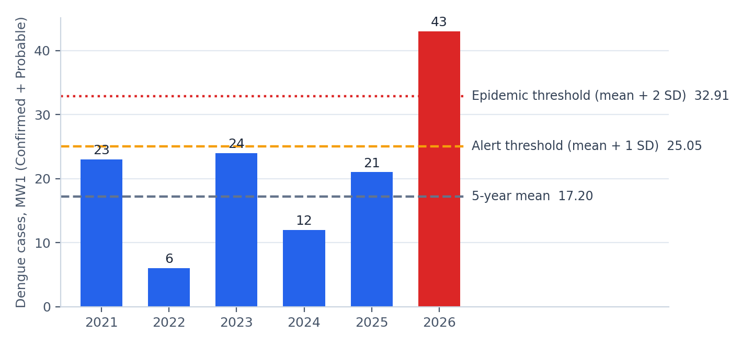
Figure 1. MW1 dengue counts for the five baseline years (blue) and 2026 (red), with the lines they produce.
These are the same numbers H-MAP stores in its thresholds table: mean 17.2000, SD 7.8549, epidemic threshold 32.9099, baseline years 2021 to 2025. The hand computation and the system agree to four decimal places for every week shown in the next section.

4. The first five weeks of 2026
The same steps repeated for MW1 to MW5 give three different outcomes:
Week | 2021-2025 counts | Mean | SD | Alert | Epidemic | 2026 | Level
MW1 | 23, 6, 24, 12, 21 | 17.2 | 7.85 | 25.05 | 32.91 | 43 | Epidemic
MW2 | 11, 4, 16, 23, 46 | 20.0 | 16.11 | 36.11 | 52.22 | 32 | Below alert
MW3 | 16, 4, 15, 22, 55 | 22.4 | 19.35 | 41.75 | 61.09 | 28 | Below alert
MW4 | 19, 3, 24, 16, 43 | 21.0 | 14.54 | 35.54 | 50.09 | 38 | Alert
MW5 | 13, 1, 8, 21, 49 | 18.4 | 18.60 | 37.00 | 55.59 | 5 | Below alert

- MW1 (43 cases): epidemic level. Far above a baseline that was mostly in the teens and twenties.
- MW4 (38 cases): alert level. Above 35.54 but below 50.09.
- MW2 (32 cases): below alert, even though 32 is a lot of cases. The 2025 baseline year had 46 cases in MW2 and 55 in MW3, which raised both the mean and the SD. An outbreak year in the baseline makes the thresholds higher for the next five years. The CESU should keep this in mind when 2025 is in the baseline.
- MW5 (5 cases): below alert, but probably incomplete. MW5 is the latest week in the workbook, and late reports are still arriving. The most recent one or two weeks always look lower than they will end up.

5. Barangay example: San Isidro, MW1 of 2026
H-MAP repeats the same computation for each barangay, using only that barangay's cases. This is what drives the "above epidemic threshold" reason in the barangay risk tiers on the dashboard.
Baseline (2021-2025) = 2, 1, 1, 2, 2
Mean = 8 / 5 = 1.6
Variance = 1.20 / 4 = 0.30
SD = 0.5477
Alert = 2.15
Epidemic = 2.70
Result. San Isidro had 7 cases in MW1 of 2026, well above 2.70: epidemic level.
All 16 barangays for the same week (the 2026 counts add up to the city total of 43):
Barangay | 2021-2025 | Mean | Alert | Epidemic | 2026 | Level
B.F. Homes | 5, 0, 1, 1, 2 | 1.8 | 3.72 | 5.65 | 7 | Epidemic
Baclaran | 0, 0, 1, 1, 0 | 0.4 | 0.95 | 1.50 | 1 | Alert
Don Bosco | 1, 3, 4, 2, 3 | 2.6 | 3.74 | 4.88 | 1 | Below alert
Don Galo | 1, 0, 0, 0, 0 | 0.2 | 0.65 | 1.09 | 3 | Epidemic
La Huerta | 0, 0, 2, 0, 0 | 0.4 | 1.29 | 2.19 | 0 | Below alert
Marcelo Green Village | 1, 0, 0, 0, 1 | 0.4 | 0.95 | 1.50 | 2 | Epidemic
Merville | 1, 1, 0, 0, 1 | 0.6 | 1.15 | 1.70 | 1 | Below alert
Moonwalk | 3, 0, 5, 0, 1 | 1.8 | 3.97 | 6.14 | 2 | Below alert
San Antonio | 3, 0, 3, 2, 2 | 2.0 | 3.22 | 4.45 | 5 | Epidemic
San Dionisio | 2, 0, 3, 2, 6 | 2.6 | 4.79 | 6.98 | 5 | Alert
San Isidro | 2, 1, 1, 2, 2 | 1.6 | 2.15 | 2.70 | 7 | Epidemic
San Martin de Porres | 0, 0, 0, 1, 0 | 0.2 | 0.65 | 1.09 | 0 | Below alert
Santo Niño | 1, 0, 2, 1, 0 | 0.8 | 1.64 | 2.47 | 2 | Alert
Sun Valley | 3, 1, 2, 0, 0 | 1.2 | 2.50 | 3.81 | 4 | Epidemic
Tambo | 0, 0, 0, 0, 3 | 0.6 | 1.94 | 3.28 | 2 | Alert
Vitalez | 0, 0, 0, 0, 0 | 0.0 | 0.00 | 0.00 | 1 | Epidemic

Small numbers need judgment. When a barangay's baseline is very small the thresholds are very low. Vitalez had no MW1 dengue cases in any baseline year, so its thresholds are 0 and its single case puts it at the epidemic level. Don Galo (baseline 1, 0, 0, 0, 0) reaches the epidemic level with 3 cases. These flags are correct by the rule, but one or two cases in a small barangay are weaker evidence than seven cases in San Isidro. H-MAP requires at least one case before it flags a barangay, and it raises a barangay to High risk only when an active hotspot (200 m, 3 or more cases, 4 weeks) is also present.

6. Single-case diseases: Measles and AFP
For Measles and Acute Flaccid Paralysis, the PIDSR rule is that one case is already an alert (DOH, 2014, p. 58). The mean + SD lines are hidden for these diseases on the dashboard. The example below shows why the formula alone would not work.
Measles, MW3 baseline (2021-2025) = 0, 0, 0, 1, 0
Mean = 0.2 SD = 0.447 Epidemic threshold = 1.09
Suppose one measles case is reported in MW3. By the formula, 1 is below 1.09, so it would not be flagged. By the single-case rule it is flagged at once, which is what H-MAP does. (This is an illustration: there were no Confirmed or Probable measles or AFP cases in MW1 to MW5 of 2026.)

7. How this differs from the 5YrAve sheet in the PIDSR workbook
The CESU workbook's 5YrAve sheet answers a different question, so its numbers will not match the H-MAP thresholds:
 | 5YrAve sheet (workbook) | H-MAP PIDSR thresholds
Period | Cumulative, MW1 up to the selected week | One morbidity week
Classifications | All (including Suspect) | Confirmed + Probable only
Statistic | Average and median | Mean, SD, mean + 1 SD, mean + 2 SD
Purpose | Reference value for the memo | Alert and epidemic signal

Example, dengue up to MW5: the cumulative MW1-5 totals for 2021 to 2025 (all classifications) are 107, 32, 126, 105, 246. Their average is 123.2, which is the value in the 5YrAve sheet. The 2026 cumulative total is 151 (146 Confirmed + Probable). H-MAP shows the 5YrAve reference on the Weekly Report and uses the PIDSR thresholds for alerts.

8. Checking a threshold yourself in Excel
Put the five baseline counts in cells B2 to F2 (for example 23, 6, 24, 12, 21) and use:
Cell | Formula | Result for Dengue MW1
G2 (mean) | =AVERAGE(B2:F2) | 17.20
H2 (SD) | =STDEV.S(B2:F2) | 7.85
I2 (alert) | =G2+H2 | 25.05
J2 (epidemic) | =G2+2*H2 | 32.91

Use STDEV.S, not STDEV.P. STDEV.P divides by 5 instead of 4 and gives slightly lower thresholds (7.03 instead of 7.85 for this example, so an epidemic threshold of 31.25 instead of 32.91).

9. Where the thresholds appear in H-MAP
- Dashboard, weekly trend chart: the dashed lines are the 5-year mean, alert and epidemic thresholds. Use the Line / Histogram switch to see the weeks as a line or as bars (an epidemic curve). Weeks above the alert threshold are amber and weeks above the epidemic threshold are red in both views.
- Dashboard, summary cards and barangay risk tiers: the per-barangay computation in Section 5.
- Weekly Report: PIDSR level per disease next to the 5YrAve reference.
- Alerts menu: a notification when a barangay crosses its epidemic threshold.
Reference: Department of Health. (2014). Manual of procedures for the Philippine Integrated Disease Surveillance and Response (3rd ed.). Epidemiology Bureau.

