EMBERKIDS / PROJECT DELIVERY DOCUMENT
Software Requirements Specification
& Project Handover Record
A complete scope, acceptance, evidence and commercial handover record for the EmberKids Chess Academy platform.
Field | Record
Project | EmberKids Chess Academy Platform
Document owner | [Developer Name]
Client / academy | [Client Legal Name] / EmberKids Chess Academy
Version / date | 1.0 • 21 July 2026
Status | Draft for scope confirmation and handover
Confidentiality | Confidential — commercial and technical record

Before sending
Replace every bracketed placeholder, insert the agreed amount and payment dates, attach the final repository/archive hash, and have a lawyer review the ownership and payment clauses. This document records the project; it is not legal advice.

1. Purpose, scope and evidentiary use
This document defines the implemented scope of the EmberKids Chess Academy website and academy-management platform, records the current handover expectations, and provides a dated evidence register. It is intended to be signed by the developer and client so both parties have a shared record of what was delivered, what remains client-owned or client-supplied, and how payment and maintenance are handled.
The document is written as a project record, not as a replacement for a lawyer-drafted development agreement. Where a clause affects ownership, licensing, payment recovery or enforceability, the parties should obtain legal review under the applicable Indian law and identify the correct legal entity and signatory.

1.1 Document conventions
- Implemented / in scope means the capability is represented in the current codebase and should be verified jointly during acceptance.
- Existing-feature bug means a reproducible defect in a feature listed in this SRS, using supported environments, without a new requirement or unauthorized code change.
- Client-provided means the client supplies the account, credentials, content, approvals, hosting, domain or third-party subscription needed for production operation.
- Bracketed values such as [Final Amount] are fill-in fields and must be completed before signature.

2. Product overview
EmberKids is a responsive chess-academy platform combining a public marketing site, secure admin operations, staff/coach workflows, student self-service, enrolment and payment operations, class and attendance tracking, evaluation/report cards, notifications, and an academy-focused AI guide named Amber.

2.1 Solution architecture recorded in the codebase
Layer | Recorded implementation
Frontend | Next.js / React / TypeScript responsive web application with public, admin, staff and student routes.
Backend | Express / Node.js REST API with controllers, services, validation, scheduled jobs and integrations.
Data | MongoDB models for academy, learner, staff, course, batch, attendance, payments, notifications, audit and knowledge data.
Infrastructure | Redis-compatible caching is supported/recommended; production requires secure environment configuration, SMTP and a MongoDB replica set for transactions.
Integrations | Email/SMTP, WhatsApp messaging, Cloudinary/file storage, payment links/Wise flows and Gemini Flash + embeddings for the academy chatbot.

Configuration note
The AI model is selected server-side through configuration. The original project scope called for Gemini 2.5 Flash; the deployed model name should be confirmed from the production environment before final acceptance. Never place an API key, password or private token in this SRS.

3. Implemented feature inventory
The following inventory is grouped for the client call and for acceptance testing. Each group should be checked against the live deployment before the final sign-off.
Area | Included capability | Status
Public site | Home/landing page, academy positioning, calls-to-action, about, courses and roadmap, coaches, prodigies, testimonials, FAQ, contact, privacy and terms pages; responsive layouts, theme styling, animation, forms and contact links. | In scope
Admissions and leads | Free-trial/admission enquiry capture, lead records, follow-up workflow, contact details, demo-class journey and lead status management. | In scope
Admin portal | Secure admin login/password reset, dashboard, role/permission controls, students, leads, courses/roadmap, testimonials, site content, coaches/staff, batches/history, classes, trial classes, events/masterclasses, tournaments, packages, payment links, payments, exports, reports and audit logs. | In scope
Staff / coach portal | Staff login, dashboard, assigned classes and batches, student lists, attendance and disputes, trial classes, report cards/evaluations, reports and payment-link/salary-related workflows represented by the current modules. | In scope
Student portal | Student login/password reset, dashboard, upcoming classes, schedule and batch information, attendance, evaluation/report cards, packages/payments, notifications, WhatsApp group link, profile and account flows. | In scope
Core API and security | REST routes, controllers/services, MongoDB models, refresh-token/session handling, role-based permissions, secure cookies, CORS/Helmet/sanitisation, rate limits, audit logs, transactions, scheduled jobs, email, WhatsApp, uploads/storage and CSV exports. | In scope
Amber AI guide | Gemini Flash chat integration, website/content knowledge chunks, embeddings/indexing, retrieval-grounded prompts, academy-only boundary, out-of-scope fallback with consultant contact, fee enquiries routed to the academy team, clear batch-format explanation, streaming responses, session history, typing/loading/error states, responsive popup, Amber mascot launcher and greeting/tap audio. | In scope

3.1 Academy-specific chatbot behavior
- Amber answers academy-related questions using retrieved academy knowledge first, including courses, batches, fees, FAQs, instructors, policies and contact details available in the indexed content.
- For unrelated questions, Amber politely states that it can assist only with EmberKids academy information and offers the academy contact route.
- For fee questions, Amber directs the visitor to the academy consultant/team for the current fee conversation and provides configured contact details rather than inventing a price.
- For batch-size questions, Amber explains the three formats clearly: 1:1, Premium Group (2–3 students), and Standard Group (5–6 students), subject to the academy’s current availability.
- The launcher is designed to sit near the WhatsApp action without overlap; the tooltip and message behavior are part of the UI acceptance check.

4. Functional requirements and acceptance matrix
ID | Requirement | Acceptance criterion | Verification
FR-01 | Public navigation | All public routes load, navigation and responsive layout work, and key CTA/contact links resolve. | Joint UAT
FR-02 | Enquiry / trial capture | A visitor can submit a supported enquiry or trial request; validation and lead creation are visible to authorised staff/admin. | Joint UAT
FR-03 | Admin operations | Authorised admin can manage the listed academy records, content, batches, schedules, payments and reports. | Joint UAT
FR-04 | Staff workflows | Authorised staff can view assigned work, attendance, learners, trial classes and evaluation/report modules allowed by permissions. | Joint UAT
FR-05 | Student self-service | A student can authenticate and view their schedule, attendance, report cards, payments/packages and notifications as configured. | Joint UAT
FR-06 | Payments and links | Configured payment links and status callbacks create the expected payment/enrolment state; provider availability is a dependency. | Joint UAT
FR-07 | Notifications | Configured email/WhatsApp/in-app notifications are generated for supported events and failures are observable in logs/audit records. | Joint UAT
FR-08 | Amber RAG chat | Every query retrieves relevant knowledge before generation, streaming works when provider is available, and out-of-scope/fee/batch rules are respected. | Joint UAT
FR-09 | Chat UX | Launcher, popup, typing indicator, auto-scroll, Enter/Shift+Enter, retry/error state, current-session history, responsive width/height and no-overlap placement work on supported breakpoints. | Joint UAT
FR-10 | Audit and export | Authorised users can access supported audit records and CSV/report exports without exposing secrets. | Joint UAT

5. Non-functional requirements
Quality area | Requirement
Responsive UX | Public, portal and chatbot layouts adapt to desktop, tablet and small screens without overlap or unusable controls.
Performance | Keep client bundles, network requests, database queries and RAG context focused on the current task; exact production targets depend on hosting and third-party latency.
Security | Use server-side secrets, secure cookies/tokens, access control, validation/sanitisation, rate limiting, security headers, least privilege and audit trails.
Availability | Third-party services (Gemini, SMTP, WhatsApp, payment providers, storage and hosting) may be unavailable; the UI must show graceful error/retry states.
Accessibility | Use keyboard-accessible controls, visible focus, labels, sensible contrast and reduced-motion-friendly behavior where supported.
Privacy | Do not store or publish secrets in source, screenshots, SRS or logs. Collect only the learner/contact data needed for academy operations and apply the client’s privacy policy.
Maintainability | Keep environment variables documented, modules separated by responsibility, migrations/backups planned, and changes recorded in Git and the change log.

6. Assumptions, dependencies and exclusions

6.1 Client responsibilities and dependencies
- The client supplies and pays for hosting, domain, DNS/SSL, database/Redis services, SMTP, Gemini/API, WhatsApp, Cloudinary/storage, payment-provider and other third-party accounts or usage charges.
- The client supplies accurate academy content, pricing/fee approvals, batch availability, contact numbers, policies, logos/assets, legal text and production credentials in a secure channel.
- The client approves UAT findings, signs the acceptance record, maintains backups and controls production account access after handover.
- Provider/model changes, quotas, rate limits, account suspension, network outages or changes made by third parties are dependencies and may require a separate change request.

6.2 Exclusions unless separately agreed
- New features, new portal roles, new pages, new integrations, major redesigns, rebranding, new reports or changes to business rules after acceptance.
- Bulk content entry, data cleansing/migration, ongoing academy operations, learner support, 24/7 monitoring, hosting/domain fees, third-party subscriptions and provider usage fees.
- Security certification, legal/compliance drafting, penetration testing, SEO/marketing campaigns or guarantees of third-party ranking/deliverability.
- Fixes caused by unauthorised code changes, unsupported environments, client infrastructure misconfiguration, expired credentials or third-party outages.

7. Handover, payment and intellectual-property record
Important
A repository or hosting account being created in the client’s name does not, by itself, prove that source-code ownership or payment was transferred. The parties should sign this record (or a separate development agreement), keep the payment trail, and create a dated source archive/hash before final handover.

7.1 Proposed handover package
# | Item | Record
1 | Signed SRS and acceptance record | Scope, exclusions, acceptance notes and signatures.
2 | Source repository / archive | Source code, Git history, build files and a dated SHA-256 hash.
3 | Deployment pack | README, environment-variable template, build/start instructions and rollback notes; no secret values.
4 | Data and integration notes | Models/routes/integrations, provider assumptions, backup expectations and account ownership list.
5 | Evidence pack | Dated screenshots, commit log, change log and test/UAT notes.

7.2 Payment and rights clause to complete and sign
The commercial fields below are intentionally blank until the parties enter the agreed values:
Commercial field | Value | Notes
Agreed project amount | [₹__________] | Final amount including/excluding taxes: [__________]
Advance / milestone 1 | [₹__________] due [date] | Trigger: [__________]
Milestone 2 | [₹__________] due [date] | Trigger: [__________]
Final payment | [₹__________] due [date] | Due before full source/IP handover
Outstanding at signature | [₹__________] | To be acknowledged by both parties

- Until the agreed amount is paid in full and cleared, the developer retains ownership of the source code and deliverables, and the client receives only the limited evaluation/use permission expressly agreed in writing.
- After full cleared payment and written handover, the developer transfers or licenses the agreed rights to the client as stated in the signed commercial agreement. The exact legal form of the transfer should be confirmed by counsel.
- Before full payment and written handover, the client must not copy, resell, sublicense, commercialise, publish, modify for another provider, or distribute the source code except as expressly agreed in writing.
- No API key, password, private token, database credential or personal data is part of the SRS. Credentials must be exchanged separately and rotated at handover.
- If the client requests work beyond the listed scope, the parties should approve a written change request with effort, price and delivery effect before that work begins.

8. Three-month maintenance policy
Promised support window
The developer is providing three (3) months of maintenance after [written acceptance / production launch — choose one], subject to the limits below. This is a limited bug-fix window for existing implemented features, not an open-ended development retainer.

Policy item | Definition
Included | Reproducible bugs in features listed in this SRS that were already implemented and accepted, when used with the agreed production configuration and supported browsers/devices.
Included | Reasonable diagnosis, a corrective code change, and a verification/deployment note for the existing feature where the developer still has authorised access.
Response | Client reports should include page/feature, steps to reproduce, expected result, actual result, timestamp and screenshots/video where useful. The developer will acknowledge and prioritise reasonably; no 24/7 SLA is promised unless separately signed.
Not included | New features, change requests, redesigns, content changes, new integrations, new reports, new roles, data entry/migration or changes to business rules.
Not included | Hosting/domain/DNS/SSL, expired credentials, third-party provider outages or API/model/quota changes, payment/WhatsApp/SMTP/storage issues outside the developer’s code, or client-side misconfiguration.
Not included | Defects caused by unauthorised edits, another vendor, unsupported browser/device, malicious activity, force majeure or a production environment that differs materially from the accepted configuration.
After window | Requests after the three-month window, or excluded work during the window, require a separate quote or maintenance agreement.

Maintenance start date: [__________] • Maintenance end date: [__________] • Support channel: [__________]

9. Acceptance, sign-off and change control
The parties should complete a joint UAT review of the listed acceptance criteria. The client should provide any defect list in writing with reproduction details during the agreed review period. New requests or preference changes are not defects and should be logged as change requests.
Acceptance field | Value
Review period | [__] calendar days from delivery / access
Accepted build / URL | [Production URL or release tag]
Open defects | [None / list ticket IDs in attachment]
Acceptance date | [DD/MM/YYYY]
Payment due on acceptance | [₹__________] due [date]

Party | Name | Signature | Date
Developer / project author | [Name] | Signature: __________________ | Date: __________
Client / authorised signatory | [Legal name + role] | Signature: __________________ | Date: __________

Appendix A — Dated UI evidence
The following screenshots were captured from the local preview on 21 July 2026. They show the visible website implementation only; confirm the hosted build and current data before signing. No secrets are included.

Figure A-1. Public homepage viewport — brand, navigation, hero CTA and floating actions.
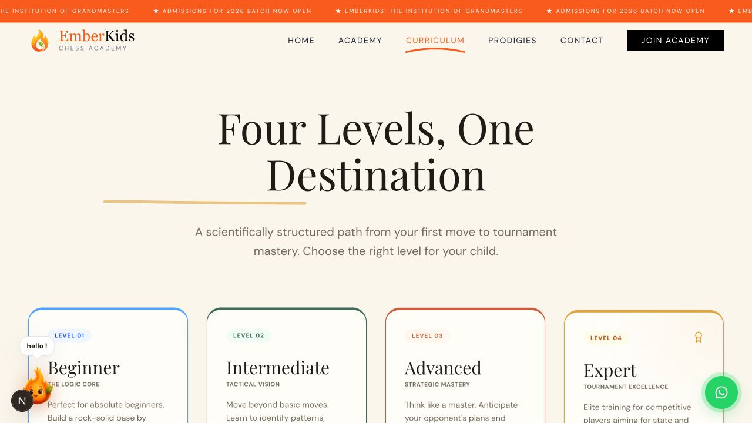
Figure A-2. Public courses page viewport — course/roadmap presentation and responsive site styling.
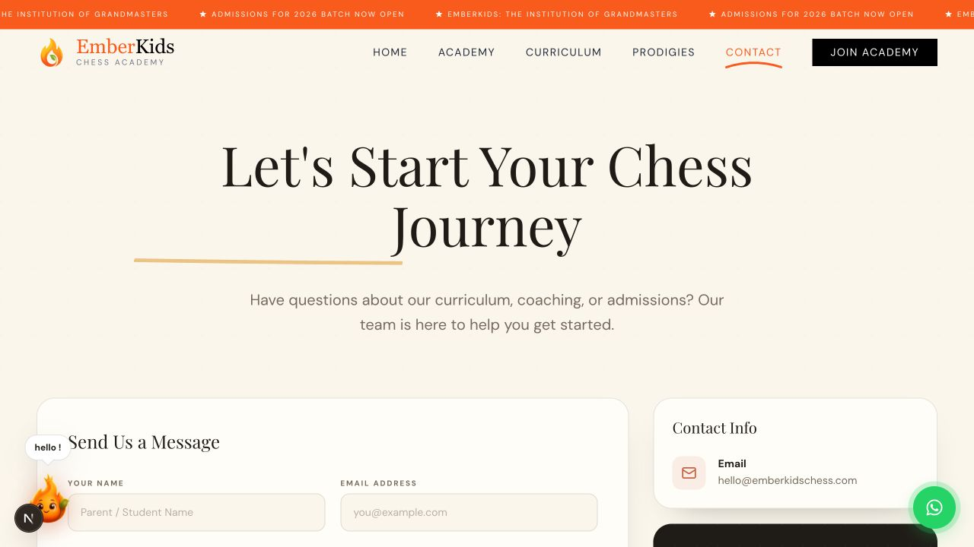
Figure A-3. Public contact page viewport — enquiry/contact route and academy-facing information.
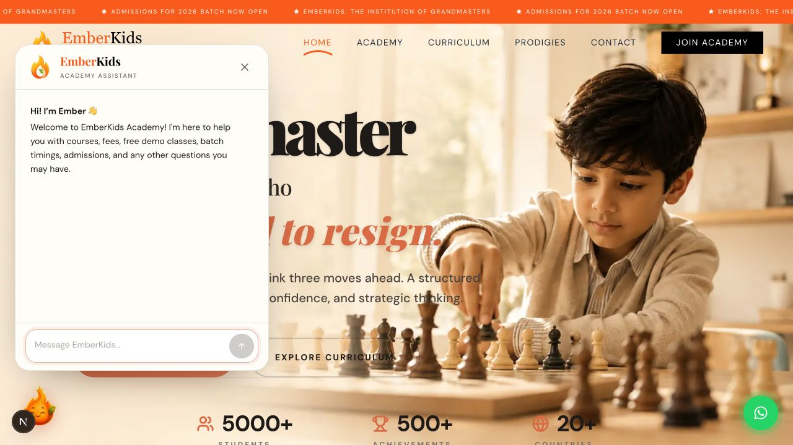
Figure A-4. Amber chatbot popup — launcher interaction, academy greeting, chat input and responsive visual treatment.

Appendix B — Evidence register and authorship record
ID | File | What it records | Source | Captured
A-1 | homepage.png | Public homepage and floating actions | Local preview | 21 Jul 2026
A-2 | courses.png | Courses/roadmap presentation | Local preview | 21 Jul 2026
A-3 | contact.png | Academy contact route | Local preview | 21 Jul 2026
A-4 | chatbot-popup.png | Amber chatbot popup and launcher | Local preview | 21 Jul 2026

B.1 Repository snapshot to attach before handover
Evidence item | Value | Action / interpretation
Current branch at evidence review | main | Create a signed release tag for final handover.
Recent commit | e67878a | Update chatbot components and add new audio file (19 Jul 2026).
Previous chatbot commit | 88820b4 | Add chatbot feature with knowledge base and UI components (19 Jul 2026).
Tracked code footprint | 42,863 lines | TS/TSX/JS/JSX/CSS in frontend and backend at evidence review.
Module counts | 51 components • 14 services • 28 models • 29 routes | Use Git export to preserve the exact final snapshot.
Final archive hash | [SHA-256: __________________________] | Compute after final code freeze; store with this signed record.

Authorship protection checklist
Before handover: commit all final changes, create a signed Git tag, export `git log` and `git status`, create a source archive, compute SHA-256, email this SRS and the hash from the developer’s own account, obtain written client acknowledgement, and keep the payment invoices/receipts. These steps create a stronger contemporaneous record than a screenshot alone.

Appendix C — Change log
Version | Date | Author | Change
1.0 | 21 Jul 2026 | [Developer Name] | Initial SRS, feature inventory, acceptance matrix, handover/payment clauses, 3-month maintenance policy and dated UI evidence.
[ ] | [date] | [name] | [Future approved change]

Appendix D — Final handover acknowledgement
By signing below, the parties confirm that they have reviewed this SRS, understand the listed scope and exclusions, and will use the agreed commercial agreement/payment record to determine when source-code/IP rights and full handover become effective.
Party | Acknowledgement | Signature
Client acknowledgement | I confirm receipt of the SRS and the listed scope/evidence. Outstanding payment and acceptance fields are recorded above. | Name/signature/date: ______________________________
Developer acknowledgement | I confirm that the listed implementation and maintenance promise reflect the agreed project record, subject to final UAT and the signed commercial terms. | Name/signature/date: ______________________________

Final reminder
Do not place production API keys, passwords or private client data in this document. Complete the bracketed fields, sign every page or initial the change/evidence pages as appropriate, and obtain legal review for the payment/IP language before relying on it in a dispute.

