Quantitative Trading Research Report

Noise-Averse Intraday Momentum Trading Strategy

By: Mariceline “Ember” Querubin
Date: 2026-07-09, Thursday

Purpose: To demonstrate understanding of the strategy, the market opportunity, its risk/return profile, and the controls required before any capital is allocated. This version adds the completed exit and position-sizing design (catastrophic stop + fixed-fractional risk sizing) and shows all statistics on the full 2020–2026 sample.

01 - Strategy Overview
• Asset class & market: Crypto perpetual futures (USDT-margined), 24/7.
• Instruments used: Liquid perps. Primary book: seven majors (BTC, ETH, SOL, BNB, XRP, DOGE, ADA). Research universe: full listed set (up to 741 symbols); tokenized-equity/RWA products excluded by rule.
• Time horizon: Intraday only — every position opens and closes within one 13:30–23:59 UTC session; zero overnight exposure.
• Trading frequency: Session-based; decisions at fixed half-hour marks; ~0.3 entries per asset-session after filters.
• Core hypothesis & market inefficiency: Most intraday movement is noise around the open. A move that escapes a statistically-defined “noise area” reflects a real demand/supply imbalance that takes hours to absorb, so it tends to continue to the session close.
• Why the strategy has an edge: A microstructure continuation effect: imbalance-driven breakouts persist intraday.
• Discretionary / systematic / hybrid: Fully systematic; no discretionary inputs. Manual override is stop-only.
• Market rationale: Imbalance absorption + participation confirmation; scheduled macro releases produce spikes that reverse, so they are excluded.
• Origin: Zarattini, Aziz & Barbon (2024, S&P 500 ETF); replicated on ES/NQ; ported here to crypto perps.

02 - Strategy Mechanics (MS/ EC/ PSL/ SL/ TP)
All quantities use only information available strictly before the decision instant (causal, event-driven forward pass). Session parameters are frozen at the 13:30 UTC open from prior-session data.

What is a Definition of a Session?
- ANCHOR/ OPEN
  - This refers to 13:30 UTC
  - O = first 1-minute bar open.
  - Forced flat at 23:59 UTC which avoids the 00:00 funding.
- DECISION MARKS:
  - Every 30 minutes from 14:00 UTC to 23:30 UTC.
  - Signal on the mark-bar close and is filled at the next bar open with a ≤ 5 minute tolerance.

Market Structure (MS - The Noise Area)
The strategy first asks: how much does this asset typically drift away from its session-open price, minute by minute, on a normal day? That typical drift is the “noise.” It is estimated as the average absolute move from the open, at each minute-of-session, over the prior N sessions (default N = 14):

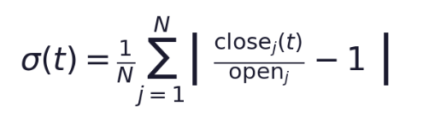

Reading it: for a given minute-of-session t, take each of the last 14 sessions, measure how far that session’s price at minute t had moved from that session’s open (as a percentage, absolute value), and average them. closeⱼ(t) is session j’s price at minute t; openⱼ is session j’s open. A minimum of 10 valid prior sessions is required or no band is drawn.

Because ranges widen through the day, σ(t) grows as the session progresses — the noise area is a funnel, narrow at the open and flaring out toward the close.

The Bands (Entry Boundaries)
The noise amplitude σ(t) is turned into an upper and lower price boundary around the session. A width multiplier k (default 1.0) scales how far outside the noise a move must break to count as a signal. The boundaries are anchored gap-aware — to the higher of {open, previous close} on top and the lower on the bottom — so an overnight gap does not create false breakouts:

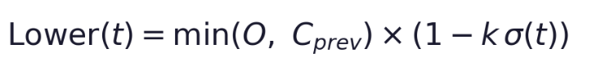

Reading it: O is the session open, C_{prev} the prior session’s close. Price inside the band is treated as noise and generates no trades. A close beyond a boundary is a candidate breakout. Raising k widens the band and demands a larger move; lowering k trades more often on smaller moves.

Volume Confirmation (Entry Filter)
A price breakout alone is not enough — real imbalances arrive with real participation, while thin-volume breakouts are typically stop-runs that reverse. An entry is therefore allowed only if the dollar volume in the window ending at the decision mark exceeds K times its own recent norm (default K = 2.0, i.e. twice the typical volume for that time of day):

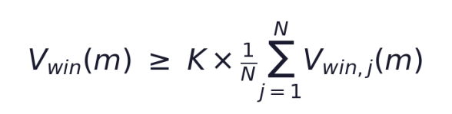

Reading it: V_{win}(m) is the dollar volume in the 30-minute window ending at mark m; the right-hand side is K times the average of that same window across the prior N sessions. This single filter removes roughly 59% of trades and nearly tripled gross edge per trade in testing. Setting K = 0 disables it.

VWAP (Used by the Dynamic Stop)
The intraday volume-weighted average price is the running fair-value reference the trailing stop leans on. It is computed from the session open up to the current bar:

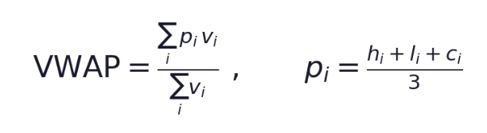

Reading it: p_{i} is each bar’s typical price (high+low+close over 3), v_{i} its volume; the sum runs from the session open to now. VWAP rising under a long position is confirmation; price falling back through it is the exit trigger below.

Exits (Dynamic Stop, Catastrophic Stop, Take Profit)
There are three ways a position closes (besides the forced 23:59 flat). First, the dynamic trailing stop — for a long, exit when price falls back below the higher of VWAP and the lower band:

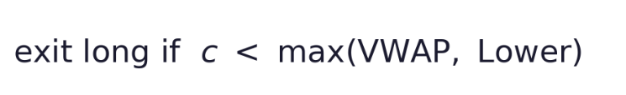

Second, a continuous intrabar catastrophic stop — a hard disaster brake checked every minute (not just at marks), set a fixed distance below entry (default 400 bps):

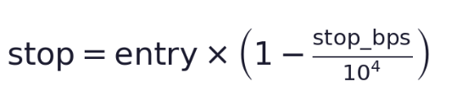

Reading it: stop_bps is the distance in basis points (400 = 4%). Its job is tail insurance — bounding the rare −600 to −1,000 bps gap — not improving returns. Excursion analysis showed a 400–500 bps level clips disasters while pre-empting under 11% of the big winners that carry the edge; tighter stops (≤200 bps) would gut 25%+ of big winners and are rejected.

Third, the take-profit. Deliberately, there is none. 96% of profit historically comes from the top ~50 trades (extreme positive skew, kurtosis above 100). A take-profit amputates exactly that right tail, so winners are instead held to the 23:59 forced close.

Position Sizing (Fixed-Fractional Risk)
Every position is sized so that hitting the catastrophic stop costs a fixed, small fraction of equity. The position notional is the risk budget divided by the stop distance, capped by maximum leverage:



Reading it: RISK_FRAC is the fraction of equity risked per trade (default 0.0001 = 0.01%), stop_dist the catastrophic-stop distance as a fraction (400 bps = 0.04), MAX_LEV the leverage ceiling (20×). Worked example at $100k equity:

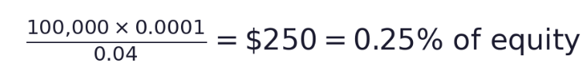

So a 0.01%-risk trade with a 400 bps stop takes a 0.25% notional position; if the stop is hit, the loss is 0.01% of equity by construction. RISK_FRAC and MAX_LEV are risk-budget choices set from limits, not parameters tuned on backtest returns. The small default fraction is deliberate for a many-position all-perps book, where aggregate (not per-trade) risk should carry normal size.

Important Note on Realistic Fills: The catastrophic stop uses conservative fills (worse of {stop, bar close} on gap-through), so sizing is computed off the NOMINAL stop distance and gap-through trades can realize more than RISK_FRAC. Measured realized risk: median 0.39× nominal, 99th percentile 1.45×, worst single trade 18.7× (one 6-year gap event). Reported, not assumed away.

Filters Used to Avoid Poor Trades
- Volume Confirmation
- News Blackout - No trades are made on all assets on the day CPI, FOMC, and NFP news are released.

03A - Backtesting and Research (Taker Execution)
Item | Detail
Backtest period | Jul 2020 – Jul 2026 (Binance, full cycle); Oct 2023 – Jul 2026 (Blofin, independent replication).
Data source | Binance Vision official archives (1-min klines + funding), single source, integrity-audited; independently replicated on Blofin.
Sample size | Up to 741 assets; ~2,100 active session-dates; 84k trades (all-perps sized run).
Transaction cost | Taker 2 bps/side assumed (to be replaced by actual venue tier — open item).
Slippage | 2 bps/side base; stress +1/+2/+4; catastrophic-stop fills modelled worse-than-touch.
Methodology | Pre-registered: frozen spec + anti-bias suite BEFORE results; single trial per hypothesis; append-only registry; deflated-Sharpe accounting.

Research Phases (all pre-registered)
Phase / variant | Result (net of costs) | Verdict
1. Frozen spec, full universe | Pooled Sharpe ≈ −0.9; gross ~2 bps/side < cost | Rejected
2. Per-asset walk-forward (grid) | OOS Sharpe +0.86 (t≈1.3) | Improved, unconfirmed
3. Cross-sectional market-neutral | Sharpe −0.23; real 13.2 bps/day spread < cost | Rejected
4. Volume-confirmed entries | Paired t=3.4; net −0.94→−0.38 (≤0) | Mechanism valid, econ fail
+ News blackout | +~0.2 Sharpe cross-venue | Valid. Recent returns are negative.
+ Catastrophic stop + fixed-risk sizing | Sharpe +0.46 all-perps (t=1.10), risk governor verified | Deployable config, forward-test only

Performance — final configuration (all-perps, 0.01% risk/trade, 400bps stop, 2020–2026)
Metric | Value | Metric | Value
Sharpe | +0.46 (t 1.10) | Max drawdown | −9.1%
Sortino | +1.07 | Day win-rate | 43.3%
Calmar | +0.35 | Trade win-rate | 44.7%
CAGR | +3.2% | Trades | 83,777 / 741 assets
Ann. vol | 8.4% | Stopped trades | 12.9%
Final equity | 1.225× (6.5y) | Realized risk (med/99th/max) | 0.39× / 1.45× / 18.7×

03B - Backtesting and Research (Maker Execution)

This section tests whether earning the exchange maker rebate on entry, instead of paying taker, improves the strategy's economics. Important framing: the winning configuration here is a DIFFERENT STRATEGY from §03A — it adds a breakout-confirmation entry layer (position entered only after price confirms the breakout by a few basis points, via a resting limit order, rather than at the signal bar). Results are therefore not directly comparable to the taker system above; they describe a modified entry mechanic. Walk-forward, per-asset, Binance 2020–2026, 541–547 assets. All exits and stops remain taker.

Entry Styles Tested
• Style A — passive pullback (true maker rebate): limit rests on the near side; fills only if price retraces; earns +1 bps. Misses breakouts that never retrace.
• Style B — breakout confirmation (taker): stop-limit on the far side; fills only if price continues past the breakout. A far-side resting order is marketable, so B pays taker — modelled that way so it cannot fabricate rebate edge.
• Style C — confirm-then-passive-maker (rebate): waits for the same confirmation as B (+5 bps), then posts a passive limit +3 bps beyond it, filling as momentum continues and earning +1 bps. The best configuration — and the one with the added confirmation layer.

Results — Entry-Style Comparison (walk-forward, pre-sizing)
Entry style | Sharpe | t | Ann. | Fill | Entry cost | 2025 | 2026
A — maker pullback | +0.29 | +0.71 | +4.0% | 93% | +1bps reb | +1.19 | −2.67
B — confirm (taker) | +1.05 | +2.57 | +14.7% | 91% | −2bps tkr | +1.69 | −1.39
C — confirm + maker | +1.17 | +2.87 | +16.6% | 89% | +1bps reb | +1.74 | −1.16

Offset robustness (Style B): Sharpe +1.13 / +1.05 / +1.02 at confirmation offsets 3 / 5 / 8 bps — barely moves, so not an artifact of one tuned value.

Deployable Style C — After Position Sizing & Catastrophic Stop
Applying the §03A risk framework (0.01% risk/trade, 400 bps catastrophic stop, 20× cap) to the Style-C machine gives the deployable curve. As with the taker system, fixed-risk sizing equalizes trade influence and lowers the headline Sharpe from the walk-forward figure — sizing changes the risk profile, not the edge:

Metric | Value | Metric | Value
Sharpe | +0.65 (t 1.59) | Max drawdown | −14.5%
Sortino | +1.68 | CAGR | +7.0%
Calmar | +0.48 | Realized risk (med/99th/max) | 0.31× / 1.11× / 10.9×

*Deployable yearly Sharpe: 2020 +0.58 · 2021 −0.76 · 2022 +2.05 · 2023 −0.09 · 2024 +0.76 · 2025 +1.49 (+36%) · 2026 −1.56.
*Final equity 1.50× over six years;
*137,014 trades / 541 assets;
*Realized risk well-controlled (median 0.31× nominal, worst gap-through 10.9× — cleaner than the taker system's 18.7×).

04 - Expected Returns and Risk Limits
- Max capital requested: Forward test first: paper or dust ($10k–$25k) to measure realized fills vs. assumptions.
- Max risk per trade: Fixed-fractional: 0.01% of equity to the 400 bps stop (≈ 0.25% notional). Realized median 0.39× nominal; worst gap-through 18.7× on one 6-year event.
- Max loss (daily/weekly/period): Proposed governors: −2%/day review, −5%/week halt, −10% peak-to-trough full stop. Realized max DD −9.1%; bootstrap tail to −48% at larger sizing — governors scale with RISK_FRAC.
- Exposure & leverage: Long/short, direction-balanced. Per-asset ≤ 20× cap (non-binding at this risk); effective leverage far lower under fixed-risk sizing.
- Liquidity & correlation: $5M session-volume floor; majors-7 primary book (keeps cost assumption realistic and concentrates in less-correlated names — alt legs are highly cross-correlated, so effective breadth is below nominal count).
- Tail risk: Extreme positive skew (edge in rare days) + fat-tailed adverse gaps between marks; the catastrophic stop bounds the latter but conservative fills still allow occasional multi-×-nominal losses.

What Could Cause the Strategy to Fail?
- Regime: sustained low-vol, range-bound markets
- Crowding/arbitrage of the public published edge
- Costs above ~4–6 bps/side taker turn the thin gross edge negative for the broad book.
- Execution: unfillable at assumed prices on illiquid alts; between-mark gap risk.

05 - Execution Plan
- Venues: Variational, Blofin, Evedex, Hibachi under evaluation. Fee schedule & liquidity confirmed per venue before allocation.
- Order type: Taker (marketable) at next-bar open; passive/maker execution is the designated next research step to attack the cost gap; not yet validated.
- Execution timing: Signal on mark bar-close; fill next bar open (≤5 min); catastrophic stop continuous intrabar; forced flat 23:59 UTC.
- Liquidity checks / slippage: Pre-trade $5M floor + majors primary book; assume 2 bps/side, stress +4; skip entries failing volume confirmation; prefer passive fills in live test.
- Monitoring / override: Daily P&L vs bootstrap bands; realized-risk-per-trade tracker; drawdown governors; regime dashboard. Kill-switch only (flatten + halt); no discretionary entries.

06 - Portfolio Fit
- Correlation / diversification: Intraday, market-neutral, flat overnight — structurally low correlation to directional/carry books; positive diversification in principle, conditional on the edge being real (currently unconfirmed).
- Capital efficiency: High when active (fractional leverage, no overnight capital); low current utilisation given regime and small forward-test size.
- Expected contribution: Not material at this stage; informational (forward-test signal) rather than P&L until confirmed live.
- Conflicts / overlaps: Shares intraday execution windows and venue/margin capacity with any existing intraday crypto book; check shared signals before concurrent running.

07 - Recommendation
Across four pre-registered variants and two venues, the strategy shows a real but small gross edge. The completed exit/sizing design produces a correctly risk-managed, deployable configuration (Sharpe +0.46, max DD −9.1% at 0.01% risk/trade) but does not change the edge — only its risk profile. Robustness puts the broad-book edge at coin-flip odds after deflation; majors-7 is strongest (deflated Sharpe 0.67) but still unconfirmed if not deployed on a forward test.

Recommended next step: a frozen, zero/dust-capital FORWARD test of the full machine (volume-confirmed + news-blackout walk-forward + 400bps catastrophic stop + fixed-risk sizing), majors-7 primary with ETH/BTC/SOL controls, at the venue’s ACTUAL fee tier, judged from the freeze date forward — the only uncontaminated test. In parallel, a pre-registered maker/passive-execution study (the sole untested lever on the cost gap).

Open items before allocation: (1) confirm actual per-venue taker fees; (2) run the forward test with pre-committed criteria; (3) measure realized correlation to the live portfolio; (4) finalise the deployment risk fraction.

