
FLUXMUSE
AI Marketing & WhatsApp Commerce for Africa
FLUX_PARTNER PROGRAMME PROPOSAL

Serve more clients under your own brand
Partner proposal for [[AGENCY NAME]]

Prepared for | [[AGENCY NAME]]
Date | [[DD MONTH YYYY]]
Proposal number | [[FM-PRO-YYYY-###]]
Prepared by | Thabo Malebadi, Founder, Fluxmuse (Pty) Ltd  thabo@fluxmuse.com · [[PHONE / WHATSAPP]]
Valid until | [[DATE + 30 days]]

Confidential. Prepared for [[AGENCY NAME]] only. Prices in South African rand (ZAR); the price shown is the amount charged.

How to use this template (delete this box before sending)
This is the Agency partner (Flux_Partner) proposal template. Fill it in, check it against the rules below, then save a PDF for the client.
☐ Replace every [[PLACEHOLDER]]: use Find for “[[”. Filled fields keep the yellow shading so a reviewer can check them; clear the shading (Home › Shading › No Colour) before sending, then search for “[[” once more.
☐ Quote prices only from 08_Prospects/CURRENT_OFFER.md. Every paid plan starts with payment: no trials, no free period. Free is a permanent plan, never a trial and never the lead offer.
☐ Founding Member is live for South African sign-ups: 30% off the first two monthly bills on Starter, Growth and Scale. No end date is set, so don't print one. Never on Agency or partner wholesale.
☐ Guarantee: only the lead guarantee, always with its conditions. Never promise cash back, sales or results.
☐ FluxMuse has no customers or results yet. No customer counts, ratings, testimonials or case-study numbers. KPI numbers are always “Target (goal)”. Describe live features as “newly launched”.
☐ Being switched on, never live: Facebook and Instagram auto-posting, checkout through FluxMuse, AI Voice (beta), daily digest, store sync. Not available: Instagram DMs and comments, checkout outside South Africa.
☐ South Africa only for paid plans. Prospects elsewhere join the waitlist: no prices, no checkout.
☐ Terms marked [[LEGAL REVIEW REQUIRED]] are completed by legal counsel. Don't write your own.
☐ Agencies get the partner wholesale price of R6,999/mo (30% off the R9,999 Agency list price). Never present it as a launch discount, and never add Founding Member on top.
☐ Partner economics are illustrative. Don't quote a fixed margin percentage: margin depends on the partner's retail price and costs.
☐ Referral commission and partner obligations stay as founder placeholders until decided.
☐ Delete this box, update fields (right-click the contents list › Update Field) and check the page count.

Contents

1. Why partner with FluxMuse
2. What partners get
3. Partner wholesale pricing
4. Partner economics
5. Onboarding plan (first 30 days)
6. Co-marketing
7. Referral commission
8. Partner obligations TBC
9. Brand usage rules
10. Trust and data protection
11. Terms
12. Acceptance
Word builds page numbers when you open the file (choose Yes to update fields), or right-click the list and choose Update Field.

1. Why partner with FluxMuse
[[AGENCY NAME]] manages [[N]] SMB clients who want more from social and WhatsApp than posts and a monthly report. FluxMuse lets your team run marketing, WhatsApp commerce and reporting for all of them from one platform, under your brand, at a wholesale price you mark up yourself.
What agencies tell us | What FluxMuse changes
Margin squeeze on every client retainer | Wholesale Agency plan, your own retail price: you keep the spread
Manual reporting and too many tools per client | White-label and multi-client on one platform, with unlimited brands and 80 channels
Clients asking for WhatsApp commerce and AI | Resell WhatsApp shops, AI posts and order alerts under your own brand

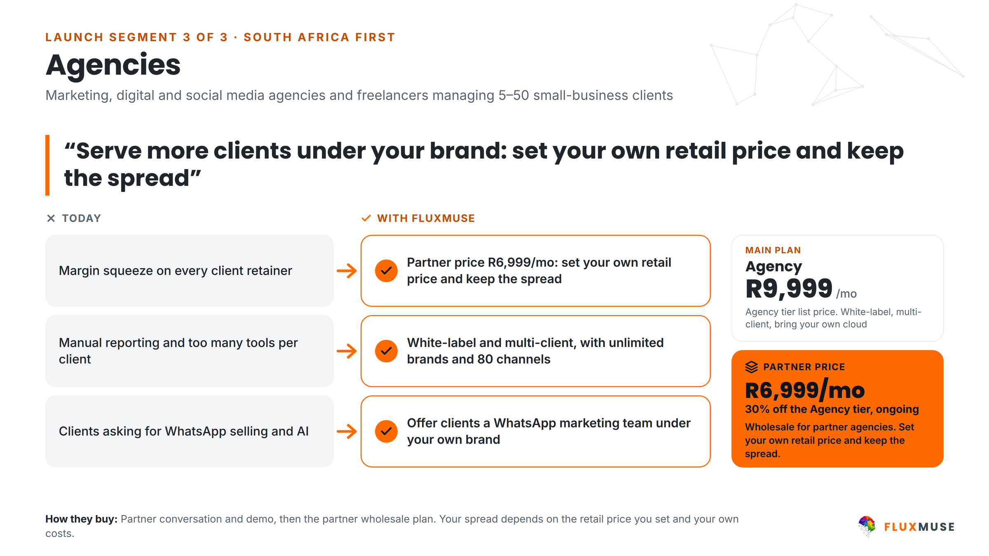
Figure 1. Agencies: today vs with FluxMuse.
Programme status
FluxMuse is newly launched and has no agency partners yet. You would be among the first, and we set you up by hand.
On the Agency tier: white-label, multi-client, unlimited brands, 80 channels, bring your own cloud. [[FOUNDER TO CONFIRM: reseller billing and partner directory status]]
On the roadmap (indicative, not dated): referral tracking and the wider Flux_Partner programme.

2. What partners get
Inclusion | Detail
White-label | Your brand on the client experience [[CONFIRM: app, reports, custom domain]]
Multi-client | One workspace per client, managed by your team [[CONFIRM: sub-account limit]]
Unlimited brands, 80 channels | Across all your clients
Bring your own cloud | Run on your own cloud account if you want to [[CONFIRM SCOPE]]
AI credits | Included; see fluxmuse.ai/pricing [[CONFIRM HOW CREDITS ARE SHARED ACROSS CLIENTS]]
Live for your clients (newly launched) | WhatsApp Concierge, hosted shop links, order alerts, AI captions, images and short video, WhatsApp broadcasts to opted-in contacts, TikTok video posting
Being switched on | Checkout through FluxMuse, Facebook and Instagram auto-posting, AI Voice (beta)
Support | Direct line to Thabo Malebadi, thabo@fluxmuse.com

3. Partner wholesale pricing
Partners buy the Agency tier at 30% off list for as long as the partner agreement is active, then set their own retail price for clients. Same inclusions as the Agency plan.
 | Agency list | Partner wholesale
Monthly | R9,999 | R6,999
Annual (10× monthly) | R99,990 | R69,990

- Payment first: the first month is paid when you subscribe. No trial period.
- Wholesale pricing doesn't stack with the Founding Member offer, which isn't offered on the Agency tier.
- Paid plans are for South African businesses. Clients outside South Africa can join the waitlist.
- Pass-through costs (Meta WhatsApp message fees, ad spend) are separate and can be re-billed to your clients.

4. Partner economics

Illustrative example
Illustrative only, not a forecast. A partner serving 20 clients at a retail price they set:
Line | Illustrative (ZAR per month)
Clients served | 20
Retail price per client (set by the partner) | R1,500
Retail revenue (20 × R1,500) | R30,000
Partner wholesale Agency plan | − R6,999
Gross spread before the partner's own service costs | R23,001
Platform cost per client (R6,999 ÷ 20) | about R350

Before payment fees, ad spend and your team's delivery costs. Your margin depends on your retail price and costs.
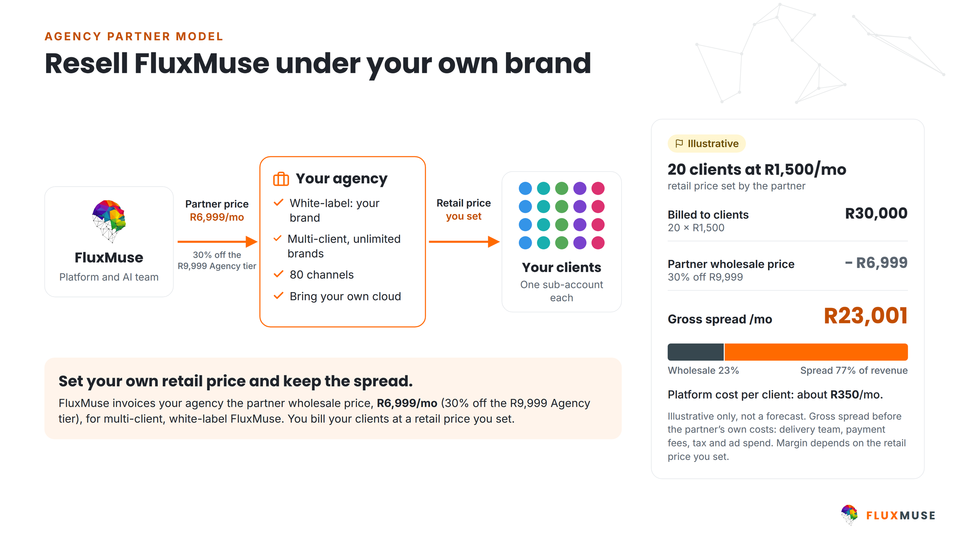
Figure 2. How the partner model works: FluxMuse bills the partner wholesale; the partner bills clients at their own price. Example is illustrative.

Your numbers
 | Line | How to calculate | [[AGENCY NAME]]
A | Number of clients | Your client count | [[ ]]
B | Your retail price per client /mo | You set it | [[R ]]
C | Monthly retail revenue | A × B | [[R ]]
D | Partner wholesale plan /mo | R6,999 | [[R ]]
E | Gross spread | C − D | [[R ]]
F | Your service costs /mo | Team hours, design, ad management | [[R ]]
G | Net contribution /mo | E − F | [[R ]]
H | Net contribution per client | G ÷ A | [[R ]]

5. Onboarding plan (first 30 days)
Days | Focus | Activities | Output
1–5 | Kickoff and white-label | Partner workspace; white-label set-up (logo, colours, [[DOMAIN]]); your retail price list | Branded workspace ready
6–10 | Team training | WhatsApp set-up for clients; WhatsApp Concierge and shop links; POST captions and images; broadcasts | [[N]] team members trained
11–20 | First client | Workspace for [[FIRST CLIENT]]; WhatsApp number, shop, first posts; targets agreed | First client live
21–30 | Report and plan | Review with FluxMuse, including the lead guarantee count; plan for the next [[N]] clients | Partner growth plan

Lead guarantee for each client you bring live
Lead guarantee: 3 qualified leads in the client's first 30 days after go-live. A qualified lead is a unique WhatsApp number that starts a conversation through a FluxMuse-tracked link or QR code. If fewer than 3 arrive and the client held up their side (shared the link and posted at least weekly), we keep working with you and the client at no extra charge until they have 3. It is extra support, not a cash payment.

6. Co-marketing
Activity | FluxMuse provides | [[AGENCY NAME]] provides | Status
Partner directory listing | Listing and profile | Services, areas, contact | [[FOUNDER TO CONFIRM]]
Sales materials | Brand kit, pitch deck and proposal templates (white-label versions [[TBC]]) | Your branding and offer | [[TBC]]
Joint case study | Case-study format and design | First client's written consent | Later, consent only
Webinar or workshop | Speaker and demo | Audience and venue | [[TBC]]
Referral leads | Leads that need an agency | Follow-up within [[N]] days | [[FOUNDER DECISION]]
Launch announcement | Social post and newsletter mention | Joint post | [[TBC]]

7. Referral commission
Some businesses a partner introduces may prefer their own Starter, Growth or Scale subscription instead of a sub-account. For those referrals:
Item | Position
Commission rate | [[FOUNDER DECISION: referral commission %]]
Basis and duration | [[FOUNDER DECISION: e.g. first-year subscription fees]]
Payout timing and method | [[FOUNDER DECISION]]
Tracking | Referral tracking is on the roadmap; interim tracking: [[TBC]]

Referral commission is separate from wholesale pricing and isn't a discount on the partner's own plan.

8. Partner obligations [[TBC]]
Obligation | Detail
Minimum commitment | [[TBC: e.g. minimum active client sub-accounts after 90 days]]
First-line client support | [[TBC]]
Training | Complete onboarding training within 30 days [[TBC]]
Messaging compliance | Follow POPIA and Meta WhatsApp Business policies: approved templates, opted-in contacts, opt-outs honoured
Data protection | POPIA; data processing agreement [[LEGAL REVIEW REQUIRED]]
Claims | Only use approved FluxMuse facts: no invented customer numbers, ratings, testimonials or results
Payment | Wholesale fees paid in advance [[TBC]]
Reporting to FluxMuse | [[TBC: e.g. quarterly partner review]]

9. Brand usage rules
Allowed | Not allowed
Full white-label: your name, logo and colours for clients | Changing, recolouring or stretching the FluxMuse logo
“Powered by FluxMuse” is optional; use it if you want to | Presenting FluxMuse customer counts, ratings, testimonials or results that aren't in approved materials
Describing the product as an AI marketing and WhatsApp commerce platform | Promising Facebook or Instagram auto-posting, or checkout, before they are switched on
Using FluxMuse brand-kit assets unmodified when co-branding | Promising clients or investors a fixed FluxMuse margin percentage
Quoting FluxMuse list prices from the official price table | Offering paid plans outside South Africa, or combining Founding Member with wholesale pricing

10. Trust and data protection
- Fluxmuse (Pty) Ltd (South Africa): a verified Meta Tech Provider (business and access verification, September 2026).
- Meta permissions approved: WhatsApp Business messaging and management, and Facebook Page messaging.
- Waiting for Meta approval (not live): posting to Facebook Pages and Instagram, and Instagram comments and DMs. They are switched on only once Meta approves them.
- Payments: Paystack is live in South Africa. Yoco and Ozow run FluxMuse's own subscription billing.
- WhatsApp policy: broadcasts use Meta-approved message templates and go only to contacts who opted in.

Protection of personal information (POPIA)
Fluxmuse (Pty) Ltd processes personal information in line with the Protection of Personal Information Act, 2013 (POPIA). For this proposal:
- Each end client decides why and how its customers' personal information is used; FluxMuse processes it to deliver the services. [[LEGAL REVIEW REQUIRED: responsible party and operator roles, operator agreement]]
- Where [[AGENCY NAME]] manages client sub-accounts, the roles of FluxMuse, the partner and each end client are set out in a data processing agreement. [[LEGAL REVIEW REQUIRED]]
- WhatsApp broadcasts go only to people who have opted in, and every broadcast includes a way to opt out.
- Platform safeguards: row-level security on database tables, encrypted access tokens, and data export and account deletion on request.
- Screenshots, reports and case studies shared outside the business blur customer names and phone numbers.
- Information Officer: [[FLUXMUSE INFORMATION OFFICER NAME AND EMAIL]]. Breach notification and cross-border processing (hosting regions): [[LEGAL REVIEW REQUIRED]]

11. Terms
These commercial headings are placeholders for the final agreement. Nothing here is binding until legal counsel has reviewed it and both parties have signed. [[LEGAL REVIEW REQUIRED]]
Heading | Position
Agreement | This proposal, the FluxMuse Terms of Service [[LINK]] and [[ORDER FORM / MASTER AGREEMENT]]. Order of precedence: [[LEGAL REVIEW REQUIRED]]
Term and renewal | Monthly plans renew monthly. Annual plans renew yearly (annual price = 10× monthly). Renewal and notice: [[LEGAL REVIEW REQUIRED]]
Payment first | Every paid plan is paid in advance, from the first month. There is no trial period. The Free plan is a separate permanent plan.
Cancellation (per plan) | Monthly plans: [[LEGAL REVIEW REQUIRED: notice period and effective date]]  Annual plans: [[LEGAL REVIEW REQUIRED: cancellation of annual plans]]  Founding Member discount on cancellation: [[LEGAL REVIEW REQUIRED]]
Lead guarantee | 3 qualified leads in 30 days of go-live, on the conditions in this proposal; remedy is extended support at no extra charge, not a cash payment. [[LEGAL REVIEW REQUIRED]]
Payment terms | Billed in advance in South African rand by [[PAYMENT METHOD: Paystack / Yoco / Ozow]]. Late payment: [[LEGAL REVIEW REQUIRED]]
Price changes | Notice of price changes: [[LEGAL REVIEW REQUIRED]]
Third-party costs | Meta WhatsApp message fees, ad spend and payment-processing fees are pass-through costs charged by those providers, not FluxMuse fees. Billing route: [[LEGAL REVIEW REQUIRED]]
Third-party platforms | Features that rely on Meta, payment providers or other platforms depend on their policies and approvals. [[LEGAL REVIEW REQUIRED: availability and change clause]]
Data protection | POPIA, as described in this proposal. Operator or data processing agreement: [[LEGAL REVIEW REQUIRED]]
Intellectual property | [[LEGAL REVIEW REQUIRED: ownership of client content, AI-generated content, brand assets, platform IP and licences]]
Confidentiality | [[LEGAL REVIEW REQUIRED]]
Support and service levels | Support channel by plan: [[CONFIRM]]. Service levels: [[LEGAL REVIEW REQUIRED]]
Wholesale pricing | 30% off Agency list for as long as the partner agreement is active [[LEGAL REVIEW REQUIRED]]
White-label and multi-client | Client data ownership and portability on termination: [[LEGAL REVIEW REQUIRED]]
Referral commission | [[FOUNDER DECISION]] then [[LEGAL REVIEW REQUIRED]]
Limitation of liability | Liability cap: [[LEGAL REVIEW REQUIRED: cap amount and basis]]. Exclusions: [[LEGAL REVIEW REQUIRED]]
Governing law and disputes | [[LEGAL REVIEW REQUIRED]]

12. Acceptance
To go ahead, tick your choices, sign below and send a copy to thabo@fluxmuse.com or WhatsApp [[PHONE / WHATSAPP]] before [[DATE + 30 days]].
☐ Partner wholesale, monthly: R6,999/mo
☐ Partner wholesale, annual: R69,990/yr
☐ 30-day onboarding plan starting [[DATE]] with first client [[FIRST CLIENT]]
☐ Co-marketing activities: [[LIST]]
☐ Referral programme (once commission terms are published)
By signing, [[AGENCY NAME]] accepts proposal [[FM-PRO-YYYY-###]] on the choices ticked above, subject to the final terms in section 11 once legal review is complete. [[LEGAL REVIEW REQUIRED]]
For [[AGENCY NAME]] |  | For Fluxmuse (Pty) Ltd
Name: |  | Name:
Title / role: |  | Title / role:
Signature: |  | Signature:
Date: |  | Date:
Place: |  | Place:

