
FLUXMUSE
AI Marketing & WhatsApp Commerce for Africa
CAMPAIGN PROPOSAL · [[CAMPAIGN TYPE]]

[[CAMPAIGN NAME]]: a WhatsApp-first campaign
For [[CLIENT NAME]] · [[CAMPAIGN START DATE]] to [[CAMPAIGN END DATE]]

Prepared for | [[CLIENT NAME]]
Date | [[DD MONTH YYYY]]
Proposal number | [[FM-PRO-YYYY-###]]
Prepared by | Thabo Malebadi, Founder, Fluxmuse (Pty) Ltd  thabo@fluxmuse.com · [[PHONE / WHATSAPP]]
Valid until | [[DATE + 30 days]]

Confidential. Prepared for [[CLIENT NAME]] only. Prices in South African rand (ZAR); the price shown is the amount charged.

How to use this template (delete this box before sending)
This is the Brand campaign proposal template. Fill it in, check it against the rules below, then save a PDF for the client.
☐ Replace every [[PLACEHOLDER]]: use Find for “[[”. Filled fields keep the yellow shading so a reviewer can check them; clear the shading (Home › Shading › No Colour) before sending, then search for “[[” once more.
☐ Quote prices only from 08_Prospects/CURRENT_OFFER.md. Every paid plan starts with payment: no trials, no free period. Free is a permanent plan, never a trial and never the lead offer.
☐ Founding Member is live for South African sign-ups: 30% off the first two monthly bills on Starter, Growth and Scale. No end date is set, so don't print one. Never on Agency or partner wholesale.
☐ Guarantee: only the lead guarantee, always with its conditions. Never promise cash back, sales or results.
☐ FluxMuse has no customers or results yet. No customer counts, ratings, testimonials or case-study numbers. KPI numbers are always “Target (goal)”. Describe live features as “newly launched”.
☐ Being switched on, never live: Facebook and Instagram auto-posting, checkout through FluxMuse, AI Voice (beta), daily digest, store sync. Not available: Instagram DMs and comments, checkout outside South Africa.
☐ South Africa only for paid plans. Prospects elsewhere join the waitlist: no prices, no checkout.
☐ Terms marked [[LEGAL REVIEW REQUIRED]] are completed by legal counsel. Don't write your own.
☐ Campaign type selector: tick one type in section 1 and set [[CAMPAIGN TYPE]] everywhere (Festive season, Black Friday / Cyber Monday, Back-to-school, Product launch, or Other). Delete the notes for the other types.
☐ Keep FluxMuse fees, optional services and pass-through costs (ad spend, Meta message fees) in their separate budget tables. Never blend them into one FluxMuse price.
☐ Checkout through FluxMuse is being switched on: plan orders to arrive on WhatsApp and be paid the client's usual way. Facebook and Instagram auto-posting await Meta approval: plan manual posting.
☐ Delete this box, update fields (right-click the contents list › Update Field) and check the page count.

Contents

1. Campaign brief recap
2. The big idea
3. Audience and segments
4. Channel plan
5. Content calendar
6. WhatsApp commerce funnel
7. Timeline
8. Budget
9. KPIs and targets
10. Reporting cadence
11. Approvals workflow
12. Risks and mitigations
13. Data protection and compliance
14. Terms
15. Acceptance
Word builds page numbers when you open the file (choose Yes to update fields), or right-click the list and choose Update Field.

1. Campaign brief recap
Campaign type (tick one):
☐ Festive season (November to December): gifting, end-of-year specials, delivery cut-off dates
☐ Black Friday / Cyber Monday (late November): time-boxed deals, stock limits, high message volume
☐ Back-to-school (January): uniforms, stationery, services; payday timing matters
☐ Product launch: waitlist, teaser, launch day, early-bird offer
☐ Other: [[CAMPAIGN TYPE]]
Brief item | What we understood
Business goal | [[e.g. sell out festive gift boxes; grow repeat orders]]
Products and offer | [[PRODUCTS]] · [[OFFER MECHANIC, e.g. 20% off, bundle, free delivery]]
Campaign dates | [[START]] to [[END]], with peak on [[PEAK DATE]]
Areas and languages | [[e.g. Gauteng; English, isiZulu, Sesotho]]
Budget range | FluxMuse plan + [[R]] optional services + [[R]] pass-through (section 8)
Mandatories | [[e.g. brand guidelines, legal copy, T&Cs of promotion, stock limits]]
Success looks like | [[ONE SENTENCE]]

2. The big idea
[[BIG IDEA IN ONE LINE]]
Key message: [[WHAT WE WANT CUSTOMERS TO FEEL AND DO]]
Why it works for [[CLIENT NAME]]: [[INSIGHT ABOUT THE AUDIENCE OR SEASON]]
Hook lines: English: [[ ]] · isiZulu: [[ ]] · Sesotho: [[ ]] · Afrikaans: [[ ]]
Call to action: “Chat to order” via the FluxMuse shop link or QR code: fluxmuse.ai/s/[[NAME]]

How FluxMuse runs the campaign
FluxMuse turns product photos into a shop link, writes captions and images for each post in each language, sends broadcasts to opted-in customers, and alerts you on WhatsApp for every order. We review what brought leads and adjust the next round.
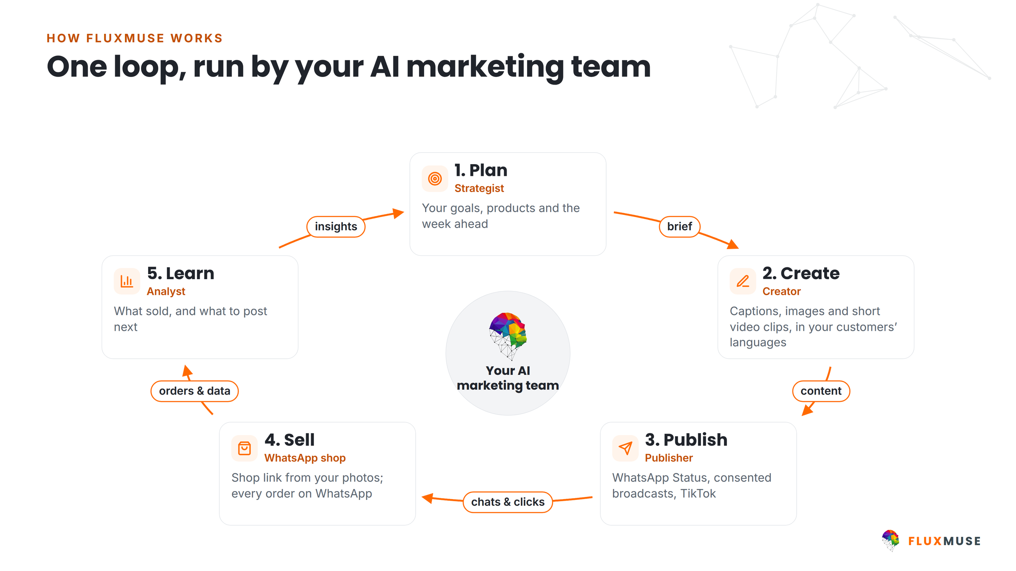
Figure 1. One loop: plan, create, publish, sell, learn. Some steps are being switched on (section 4).

3. Audience and segments
Segment | Who | Reached through | Message | Size
Opted-in WhatsApp customers | Past buyers who opted in | WhatsApp broadcast | Early access [[ ]] | [[N]]
Lapsed buyers who opted in | No order in [[90]] days | WhatsApp broadcast | Welcome-back offer | [[N]]
Status viewers | People who see your WhatsApp Status | Forwarded posts | Launch and countdown | [[N]]
Social followers | Facebook, Instagram and TikTok followers | Posts (TikTok via FluxMuse; others by hand) | Hero offer | [[N]]
New prospects | [[AGE, AREA, INTERESTS]] | Shop link and QR code | Hero offer | [[N]]

WhatsApp broadcasts go only to people who opted in (POPIA), with an opt-out in every message.

4. Channel plan
Channel | Role in the campaign | Formats | Status
WhatsApp broadcasts and templates | Main channel: announce, remind | Meta-approved templates | Live (newly launched)
Shop link and QR code | Where buyers choose and order | fluxmuse.ai/s/[[NAME]] | Live (newly launched)
Order alerts | Every order on your WhatsApp; reply SOLD | WhatsApp message | Live (newly launched)
WhatsApp Status | Daily reach | AI captions and images (POST) | Live (newly launched)
TikTok | Video reach | Short AI video clips | Live (newly launched)
Facebook Page and Instagram | Reach | Posts made by FluxMuse, posted by hand | Auto-posting being switched on
Checkout through FluxMuse | Pay in the flow | Paystack | Being switched on

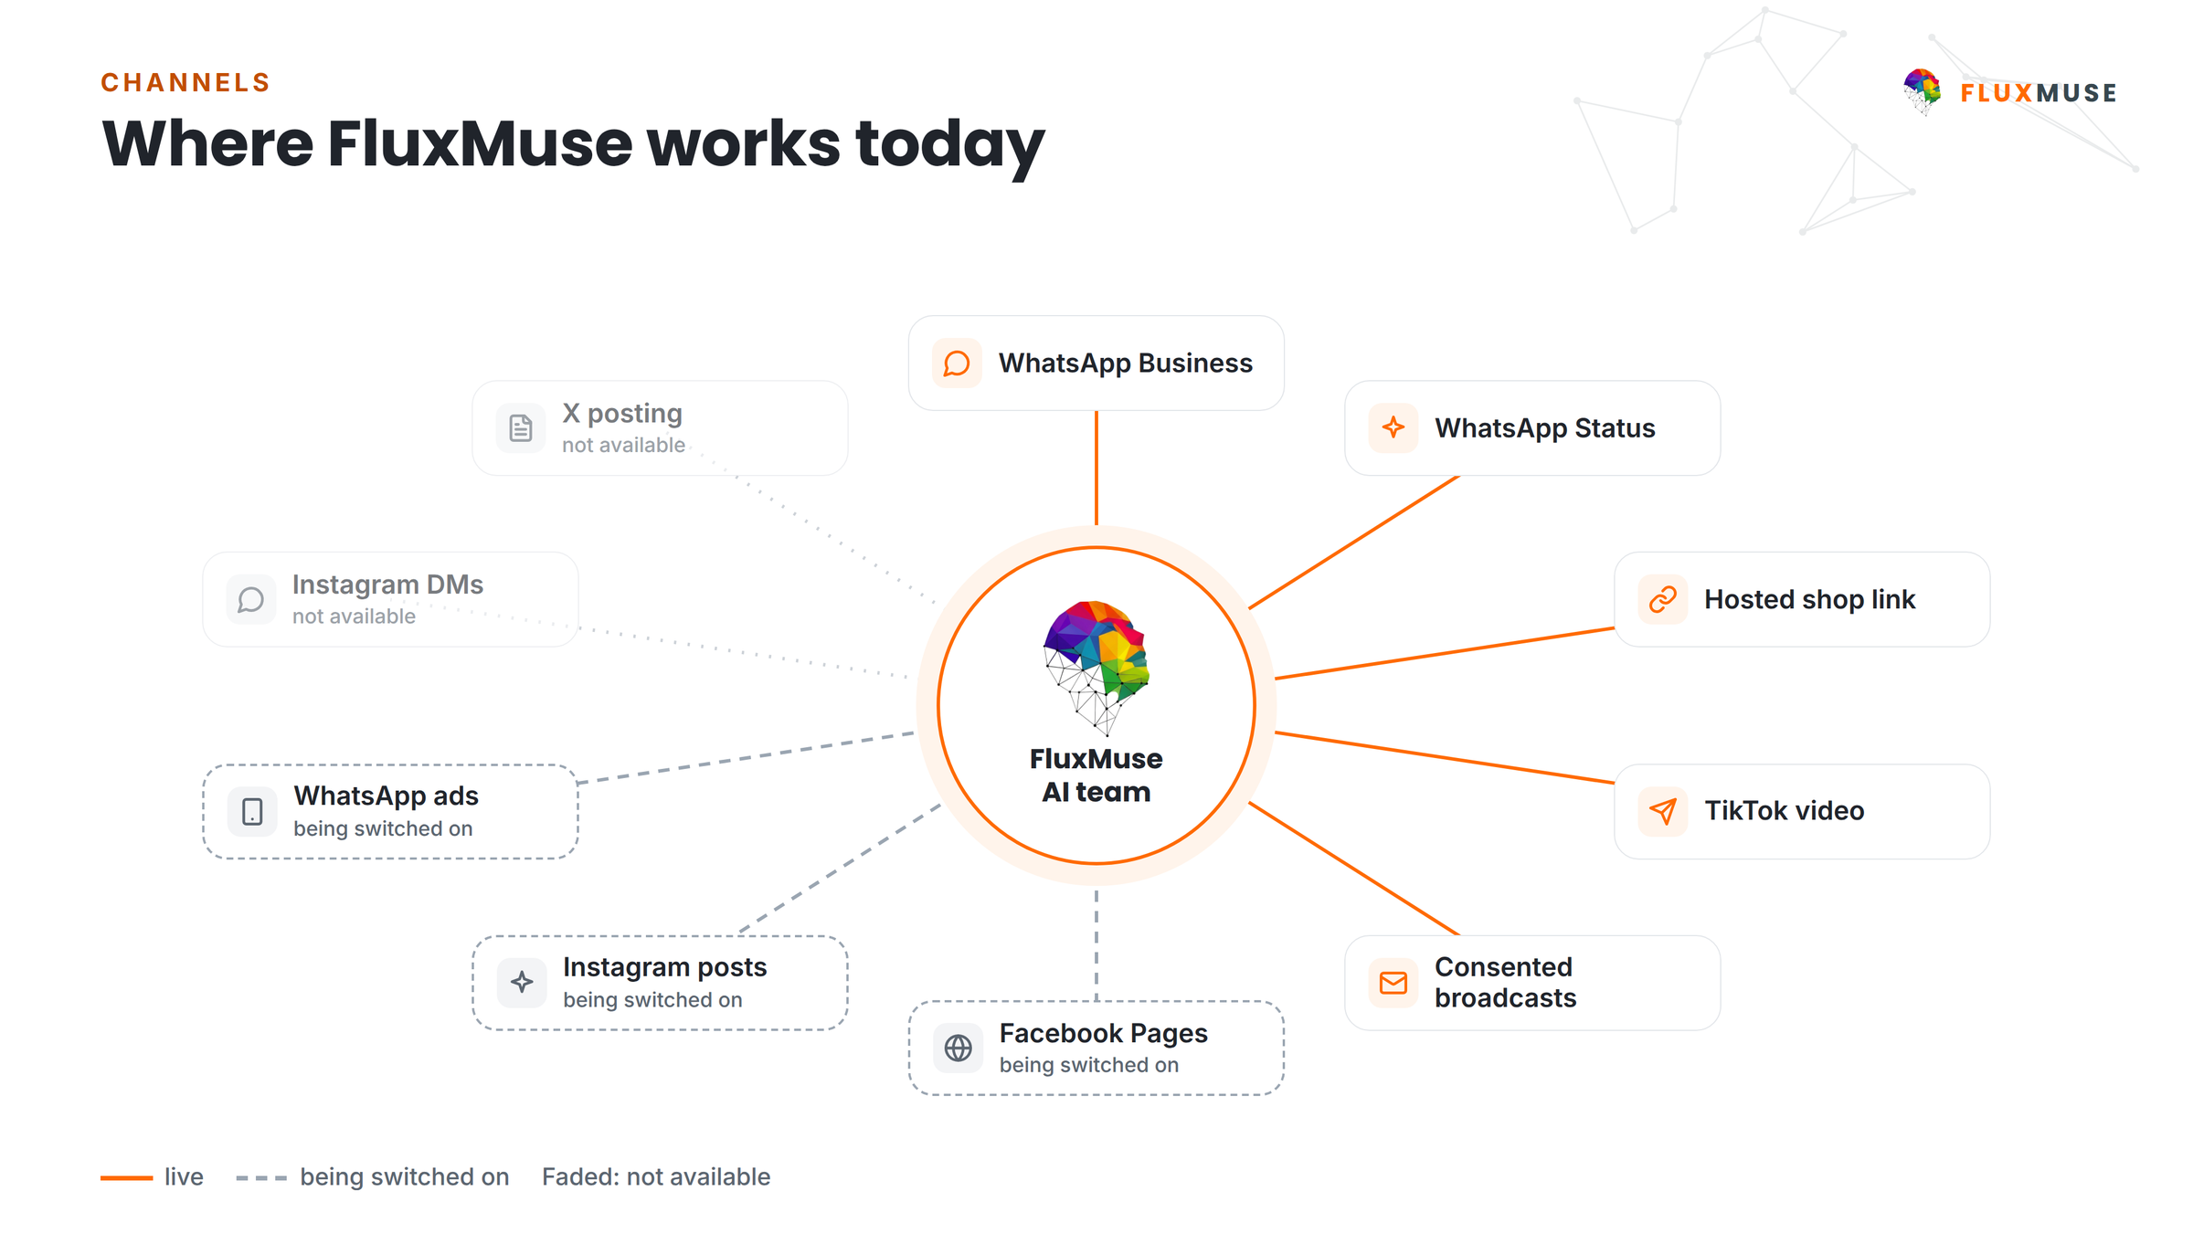
Figure 2. Channels around one WhatsApp-first hub. Facebook and Instagram auto-posting are being switched on.

5. Content calendar
Weeks relative to launch. Adjust to the campaign type (e.g. Black Friday peak = W3).
Channel | W-2 Prep | W1 Tease | W2 Launch | W3 Peak | W4 Last chance | W+1 Thank you
WhatsApp | Templates to Meta; opt-in drive | “Coming soon” to opted-in VIPs | Launch broadcast + shop link | Reminder | Last-chance broadcast | Thank-you
WhatsApp Status | Plan posts | Teasers | Launch post | Daily posts | Countdown | Best-sellers
TikTok | Plan clips | Teaser clip | Launch clip | 2 clips | Countdown clip | Recap clip
Facebook / Instagram* | Grid plan | Teasers (by hand) | Launch (by hand) | Posts (by hand) | Stories (by hand) | Recap (by hand)
Shop link | Products in | Link shared | Offer live | Update stock | Countdown | Archive

*Facebook and Instagram auto-posting are waiting for Meta approval; FluxMuse makes the posts and you post them by hand until then. Every cell: [[CONTENT DETAIL]] to be confirmed before scheduling.

6. WhatsApp commerce funnel
Stage | What happens | FluxMuse feature | KPI | Target (goal)
1. Link or QR | Buyer taps a post, Status or QR code | Shop link, QR code | Link visits | [[N]]
2. Shop | Buyer browses products | Hosted shop (Concierge catalogue) | Qualified leads | [[N]]
3. Order | Order arrives as a WhatsApp message | Order alerts, SOLD | Orders | [[N]]
4. Payment | Paid the business's usual way | Checkout through FluxMuse: being switched on | Orders paid | [[N]]
5. Follow-up | Offer to buyers who opted in | Broadcasts | Repeat orders | [[N]]

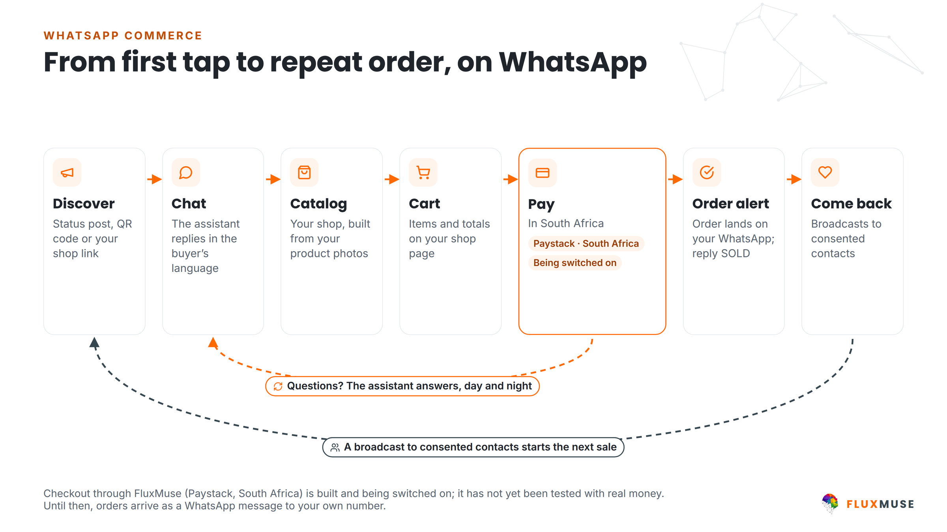
Figure 3. From first tap to an order on WhatsApp. Checkout through FluxMuse is being switched on.

7. Timeline
Activity | W-3 | W-2 | W-1 | W1 | W2 | W3 | W4 | W+1 | W+2
Brief sign-off and big idea | ●
Plan, shop products and link | ● | ●
WhatsApp templates to Meta for approval |  | ● | ●
Content production and approvals |  | ● | ● | ●
Opt-in drive (QR, link, in-store) |  | ● | ● | ●
Campaign live |  |  |  | ● | ● | ● | ●
Daily monitoring and optimisation |  |  |  | ● | ● | ● | ●
Post-campaign follow-up |  |  |  |  |  |  |  | ●
Final report |  |  |  |  |  |  |  |  | ●

● dark = main activity, ● light = supporting activity. Launch date (W1): [[DATE]].

8. Budget
Three separate parts. Only part A and any part B services you choose are FluxMuse charges.

A. FluxMuse plan
Plan | Price | Campaign months | Subtotal
Starter | R499/mo (Founding Member R349 for the first two monthly bills*) | [[N]] | [[R]]
Growth (3 brands, 15 channels) | R1,999/mo (Founding Member R1,399 for the first two monthly bills*) | [[N]] | [[R]]
Scale (10 brands, 40 channels) | R4,999/mo (Founding Member R3,499 for the first two monthly bills*) | [[N]] | [[R]]

*Founding Member: South African sign-ups pay 30% less for their first two monthly bills. It is a discount, not a free period. Payment first; no trial. Delete the plans you don't recommend.

B. Optional FluxMuse services
Service | Fee | Include
Campaign set-up (shop products, templates, QR codes) | [[TBC]] | ☐
Creative review and design | [[TBC]] | ☐
Campaign management during live weeks | [[TBC]] | ☐
Post-campaign report and workshop | [[TBC]] | ☐

C. Third-party pass-through costs (not FluxMuse fees)
Cost | Paid to | Estimate
Ad spend (Meta [[/ other]]) | Ad platform | [[estimate R]]
WhatsApp conversation and template message fees | Meta | [[estimate R]]
Printing (QR flyers, in-store) | Printer | [[estimate R]]

Budget summary
Part | Amount
A. FluxMuse plan | [[R]]
B. Optional FluxMuse services | [[R]]
C. Pass-through costs (estimate) | [[R]]
Total campaign budget | [[R]]

Our lead guarantee
Lead guarantee: 3 qualified leads in your first 30 days after go-live. A qualified lead is a unique WhatsApp number that starts a conversation through a FluxMuse-tracked link or QR code. If fewer than 3 arrive and you held up your side (shared the link and posted at least weekly), we keep working with you at no extra charge until you have 3. It is extra support, not a cash payment.

9. KPIs and targets
Targets are goals agreed before launch, not promised results.
KPI | Baseline (last comparable period) | Target (goal) | Source
Shop link visits and QR scans | [[ ]] | [[ ]] | Shop link
Qualified leads | [[ ]] | [[ ]] | FluxMuse tracking
Orders alerted | [[ ]] | [[ ]] | Order alerts
Posts and clips made | [[ ]] | [[ ]] | POST history
Opted-in contacts | [[ ]] | [[ ]] | Contact list
Opt-outs (keep low) | [[ ]] | [[ ]] | Broadcasts

10. Reporting cadence
When | What | Who
Daily during live weeks | Check orders, leads and stock; quick fixes | Thabo Malebadi
Weekly | Short report and 20-minute call: KPIs vs targets, next week's changes | Both teams
Peak day | Live monitoring and escalation line: [[PHONE / WHATSAPP]] | [[NAMES]]
W+2 | Final campaign report: results vs targets, learnings, next campaign | Both teams

11. Approvals workflow
Nothing goes out without your sign-off.
Step | Who | What happens | Turnaround
1. Draft | FluxMuse AI + Thabo Malebadi | Captions, images and broadcast drafts in each language | [[N]] days
2. Internal review | [[FLUXMUSE REVIEWER]] | Brand fit, facts, offer terms | [[N]] day
3. Client approval | [[APPROVER AT [[CLIENT NAME]]]] | Approve or comment on WhatsApp | [[N]] days
4. Compliance check | Both | Opt-in lists, Meta template approval, promotion T&Cs | Before scheduling
5. Publish | FluxMuse and client | Broadcasts and TikTok via FluxMuse; other posts by hand | Per calendar
6. Live changes | [[APPROVER]] | Price or stock changes re-approved | Same day

12. Risks and mitigations
Risk | Likelihood | Impact | Mitigation | Owner
Meta rejects a WhatsApp template | [[L/M/H]] | Launch delay | Submit templates in W-2 with backups | FluxMuse
Meta auto-posting not approved in time | [[L/M/H]] | More manual work | Post Facebook and Instagram by hand; lean on WhatsApp and TikTok | Client
Small opted-in contact list | [[L/M/H]] | Low broadcast reach | Opt-in drive with QR, link and in-store prompts from W-2 | Both
Stock runs out | [[L/M/H]] | Unhappy buyers | Mark items SOLD; stock limits in copy | Client
Message fatigue and opt-outs | [[L/M/H]] | List shrinks | Frequency cap of [[N]] broadcasts a week; segment offers | FluxMuse
Payment or connectivity outages | [[L/M/H]] | Lost orders | Orders kept on WhatsApp; confirm later | Both
Ad costs spike near peak | [[L/M/H]] | Budget overrun | Cap daily spend; shift to owned channels | Client
POPIA complaint | [[L/M/H]] | Reputational | Opted-in lists only; opt-outs honoured | Both

13. Data protection and compliance
Fluxmuse (Pty) Ltd processes personal information in line with the Protection of Personal Information Act, 2013 (POPIA). For this proposal:
- [[CLIENT NAME]] decides why and how its customers' personal information is used; FluxMuse processes it to deliver the services. [[LEGAL REVIEW REQUIRED: responsible party and operator roles, operator agreement]]
- WhatsApp broadcasts go only to people who have opted in, and every broadcast includes a way to opt out.
- Platform safeguards: row-level security on database tables, encrypted access tokens, and data export and account deletion on request.
- Screenshots, reports and case studies shared outside the business blur customer names and phone numbers.
- Information Officer: [[FLUXMUSE INFORMATION OFFICER NAME AND EMAIL]]. Breach notification and cross-border processing (hosting regions): [[LEGAL REVIEW REQUIRED]]
- Promotions follow [[CLIENT NAME]]'s competition and promotion T&Cs [[LINK]] and the Consumer Protection Act. [[LEGAL REVIEW REQUIRED]]

14. Terms
These commercial headings are placeholders for the final agreement. Nothing here is binding until legal counsel has reviewed it and both parties have signed. [[LEGAL REVIEW REQUIRED]]
Heading | Position
Agreement | This proposal, the FluxMuse Terms of Service [[LINK]] and [[ORDER FORM / MASTER AGREEMENT]]. Order of precedence: [[LEGAL REVIEW REQUIRED]]
Term and renewal | Monthly plans renew monthly. Annual plans renew yearly (annual price = 10× monthly). Renewal and notice: [[LEGAL REVIEW REQUIRED]]
Payment first | Every paid plan is paid in advance, from the first month. There is no trial period. The Free plan is a separate permanent plan.
Cancellation (per plan) | Monthly plans: [[LEGAL REVIEW REQUIRED: notice period and effective date]]  Annual plans: [[LEGAL REVIEW REQUIRED: cancellation of annual plans]]  Founding Member discount on cancellation: [[LEGAL REVIEW REQUIRED]]
Lead guarantee | 3 qualified leads in 30 days of go-live, on the conditions in this proposal; remedy is extended support at no extra charge, not a cash payment. [[LEGAL REVIEW REQUIRED]]
Payment terms | Billed in advance in South African rand by [[PAYMENT METHOD: Paystack / Yoco / Ozow]]. Late payment: [[LEGAL REVIEW REQUIRED]]
Price changes | Notice of price changes: [[LEGAL REVIEW REQUIRED]]
Third-party costs | Meta WhatsApp message fees, ad spend and payment-processing fees are pass-through costs charged by those providers, not FluxMuse fees. Billing route: [[LEGAL REVIEW REQUIRED]]
Third-party platforms | Features that rely on Meta, payment providers or other platforms depend on their policies and approvals. [[LEGAL REVIEW REQUIRED: availability and change clause]]
Data protection | POPIA, as described in this proposal. Operator or data processing agreement: [[LEGAL REVIEW REQUIRED]]
Intellectual property | [[LEGAL REVIEW REQUIRED: ownership of client content, AI-generated content, brand assets, platform IP and licences]]
Limitation of liability | Liability cap: [[LEGAL REVIEW REQUIRED: cap amount and basis]]. Exclusions: [[LEGAL REVIEW REQUIRED]]
Governing law and disputes | [[LEGAL REVIEW REQUIRED]]

15. Acceptance
To go ahead, tick your choices, sign below and send a copy to thabo@fluxmuse.com or WhatsApp [[PHONE / WHATSAPP]] before [[DATE + 30 days]].
☐ Campaign plan as described, launching [[DATE]]
☐ FluxMuse plan: [[Starter / Growth / Scale]], [[monthly / annual]]
☐ Optional services: [[LIST]]
☐ Pass-through budget estimate of [[R]] noted (paid to providers)
By signing, [[CLIENT NAME]] accepts proposal [[FM-PRO-YYYY-###]] on the choices ticked above, subject to the final terms in section 14 once legal review is complete. [[LEGAL REVIEW REQUIRED]]
For [[CLIENT NAME]] |  | For Fluxmuse (Pty) Ltd
Name: |  | Name:
Title / role: |  | Title / role:
Signature: |  | Signature:
Date: |  | Date:
Place: |  | Place:

