
FLUXMUSE
AI Marketing & WhatsApp Commerce for Africa
EXAMPLE: not a real client, no real results
A worked example of a proposal to a prospect: an imagined braiding & hair studio. It is not a real client and describes no real results. FluxMuse has no customers or results yet; every number in it is a target (goal) to agree with the prospect. Replace the [[PLACEHOLDERS]] before using any wording with a real prospect.

EXAMPLE PROPOSAL · BRAIDING & HAIR STUDIO

Your styles, your prices and your posts, all from WhatsApp
A FluxMuse plan for [[BRAND NAME]], [[AREA]]

Prepared for | [[BRAND NAME]]
Date | [[DD MONTH YYYY]]
Proposal number | [[FM-PRO-YYYY-###]]
Prepared by | Thabo Malebadi, Founder, Fluxmuse (Pty) Ltd  thabo@fluxmuse.com · [[PHONE / WHATSAPP]]
Valid until | [[DATE + 30 days]]

Confidential. Prepared for [[BRAND NAME]] only. Prices in South African rand (ZAR); the price shown is the amount charged.

How to use this template (delete this box before sending)
This is the Solo entrepreneur proposal (worked example). Fill it in, check it against the rules below, then save a PDF for the client.
☐ Replace every [[PLACEHOLDER]]: use Find for “[[”. Filled fields keep the yellow shading so a reviewer can check them; clear the shading (Home › Shading › No Colour) before sending, then search for “[[” once more.
☐ Quote prices only from 08_Prospects/CURRENT_OFFER.md. Every paid plan starts with payment: no trials, no free period. Free is a permanent plan, never a trial and never the lead offer.
☐ Founding Member is live for South African sign-ups: 30% off the first two monthly bills on Starter, Growth and Scale. No end date is set, so don't print one. Never on Agency or partner wholesale.
☐ Guarantee: only the lead guarantee, always with its conditions. Never promise cash back, sales or results.
☐ FluxMuse has no customers or results yet. No customer counts, ratings, testimonials or case-study numbers. KPI numbers are always “Target (goal)”. Describe live features as “newly launched”.
☐ Being switched on, never live: Facebook and Instagram auto-posting, checkout through FluxMuse, AI Voice (beta), daily digest, store sync. Not available: Instagram DMs and comments, checkout outside South Africa.
☐ South Africa only for paid plans. Prospects elsewhere join the waitlist: no prices, no checkout.
☐ Terms marked [[LEGAL REVIEW REQUIRED]] are completed by legal counsel. Don't write your own.
☐ This is a worked example for an imagined prospect. It shows tone and detail, not real results. Copy wording into the Solo template; don't send this file. Delete the EXAMPLE banner if you adapt it.
☐ Delete this box, update fields (right-click the contents list › Update Field) and check the page count.

1. Hi [[OWNER]]
Thank you for showing us around [[BRAND NAME]] in [[AREA]]. Clients book because they've seen your braids on WhatsApp Status and through word of mouth. What eats your time is the admin: sending the same price list again and again, and posting only when there's a gap between clients.
FluxMuse turns your style photos into a price list and a shop link you can share, writes captions for your before/after photos in the languages your clients speak, and alerts you on WhatsApp when someone wants to book.
FluxMuse is newly launched. We're opening with a small first group of businesses, and we set you up by hand. This proposal is short on purpose: what we heard, what we'll set up, your first 30 days, the plan we recommend and how we'll both know it's working.
Warm regards,
Thabo Malebadi, Founder, FluxMuse · thabo@fluxmuse.com · [[PHONE / WHATSAPP]]

2. What we heard
From our first conversation (ticked items came up):
☒ Booking requests get lost in busy WhatsApp chats, and messages after hours wait until the next day
☒ The same price list and style photos get sent to every new enquiry by hand
☒ Posting happens when there's a gap between clients, so weeks go by with nothing new
☒ Clients speak isiZulu, Sesotho and English, and captions are usually English only
☐ Regulars aren't reminded when it's time to redo their hair
☐ Braiding hair and aftercare products are sold only when someone asks
☐ In [[OWNER]]'s words: “[[OWNER'S WORDS FROM THE VISIT]]”
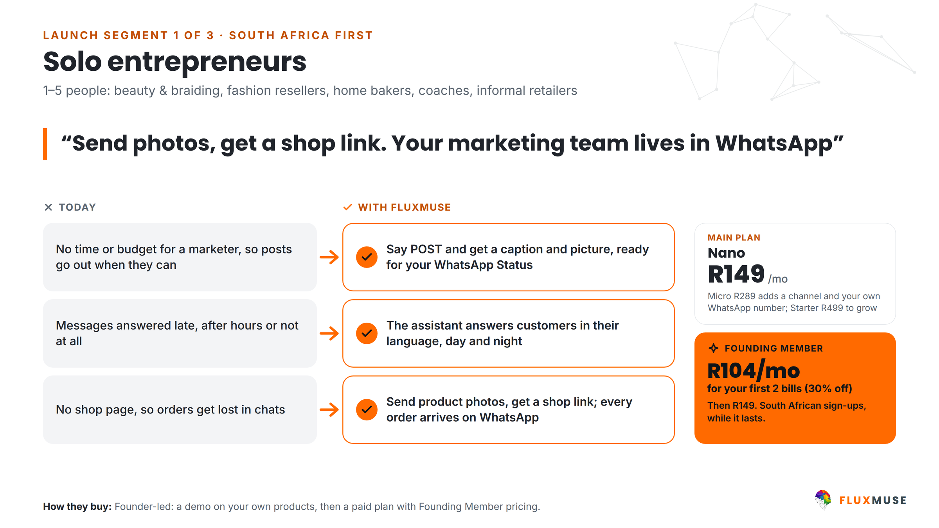
Figure 1. Solo entrepreneurs: today vs with FluxMuse.

3. What FluxMuse will do for you
- Your styles as a shop. Send photos of your styles to FluxMuse on WhatsApp. The AI drafts each entry (name, description, a price guess) and you reply YES, NO or fix it. Knotless, box braids, cornrows, [[STYLES]].
- A shop link to share (fluxmuse.ai/s/[[NAME]]) for your bio, Status and a QR code on the mirror. When a client picks a style, the request arrives on your own WhatsApp as a ready-typed message.
- Alerts on WhatsApp for every request, and you reply SOLD when a slot or product is taken.
- Posts made for you. Send POST with a before/after photo and get a caption and image back, ready to forward to your WhatsApp Status. Captions in isiZulu, Sesotho and English.
- Voice notes typed out, and short AI video clips for TikTok, which FluxMuse can post for you.
- Broadcasts to regulars who opted in, using Meta-approved templates, for a mid-week special or a rebooking nudge.
Being switched on (not live yet)
Checkout through FluxMuse. Built, but not yet tested end to end with real money. Until it is, you take payment the way you do today (including deposits).
Auto-posting to Facebook and Instagram. Waiting for Meta approval. For now, posts come back to you on WhatsApp, ready to forward to Status or post yourself.

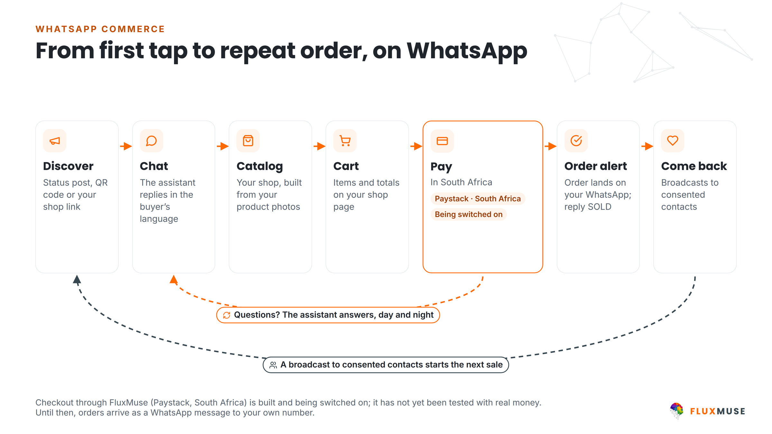
Figure 2. How a request reaches you on WhatsApp. Checkout through FluxMuse is being switched on.

4. Your first 30 days
We set you up by hand. Each week needs about [[N]] minutes of your time.
When | What we set up together | Your part
Week 1 | WhatsApp Business number and profile; your styles photographed into the shop with prices | Send your price list, style names and 10 favourite photos
Week 2 | Shop link live; QR code for the mirror and flyers; first before/after posts in isiZulu, Sesotho and English | Approve posts; print the QR code
Week 3 | Opt-in prompt for regulars; first broadcast with an approved template: [[OFFER]] | Ask walk-ins to opt in
Week 4 | Review: requests through the link, posts made, leads counted for the guarantee | 15-minute review call

Our lead guarantee
Lead guarantee: 3 qualified leads in your first 30 days after go-live. A qualified lead is a unique WhatsApp number that starts a conversation through a FluxMuse-tracked link or QR code. If fewer than 3 arrive and you held up your side (shared the link and posted at least weekly), we keep working with you at no extra charge until you have 3. It is extra support, not a cash payment.

5. Plans for you
Every paid plan starts with payment. Annual billing is 10× the monthly price for 12 months.
 | Nano | Micro | Starter
Monthly price | R149 | R289 | R499
Annual price | R1,490 | R2,890 | R4,990
Brands · channels | 1 · 3 | 1 · 4 | 1 · 3
WhatsApp Concierge, shop link, order alerts | ✓ | ✓ | ✓
AI captions, images and short video clips | ✓ | ✓ | ✓
Own WhatsApp Business number | [[CONFIRM]] | 1 number | ✓
Founding Member (first two monthly bills) | – | – | R349, then R499

AI credits come with every plan; see fluxmuse.ai/pricing for the current allowance. [[FOUNDER TO CONFIRM: whether Founding Member also covers Nano and Micro]]
- Nano (R149/mo) is the place to start for a side-hustle: your shop, your link and posts made for you.
- Micro (R289/mo) adds a channel and your own WhatsApp number on FluxMuse.
- Starter (R499/mo) is the step up when the business grows. Founding Member: South African sign-ups pay 30% less for their first two monthly bills. It is a discount, not a free period.
- A Free plan exists as a permanent option (1 brand, 1 channel, no card). It is not a trial of the paid plans.
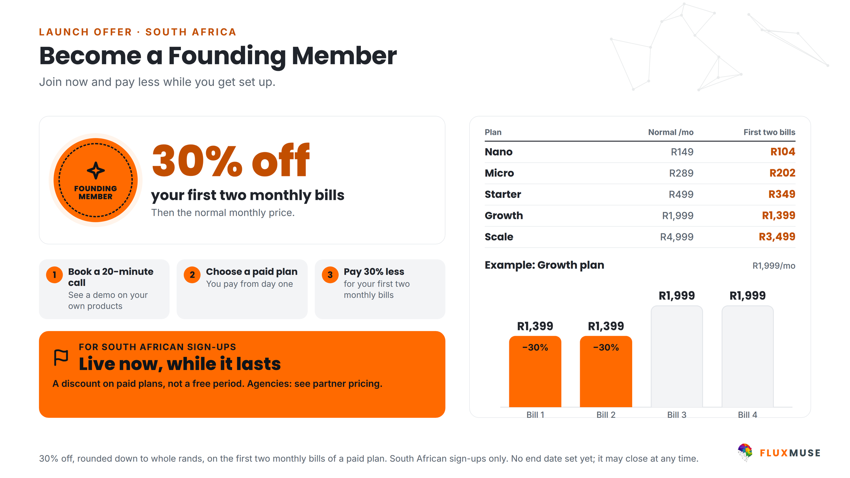
Figure 3. Founding Member launch offer for South African sign-ups: 30% off the first two monthly bills.
Our recommendation for [[BRAND NAME]]: start on Micro so the studio's own WhatsApp number runs through FluxMuse. Move to Starter when you want more from it.

6. How you'll get paid
- Today: the shop link sends each order to your WhatsApp, and you take payment the way you already do, including any deposit.
- Checkout through FluxMuse (Paystack, South African bank accounts) is built and being switched on: it has not yet been tested end to end with real money. Until it is, orders arrive on your WhatsApp and you take payment the way you do today. [[FEE WORDING ONLY ONCE CHECKOUT IS TESTED]]
- Your FluxMuse subscription is paid through Paystack, Yoco or Ozow.
- Deposit rule for the studio (your own, collected your way for now): [[R AMOUNT]]; no-show policy: [[OWNER'S POLICY]].

7. What you'll measure
We count from go-live. The numbers below are targets (goals) we agree together, not promised results.
KPI | Starting point | Target (goal) by day 30 | How we measure
Qualified leads through the shop link or QR | 0 at go-live | 3+ in 30 days (lead guarantee) | FluxMuse tracking
Booking requests via the shop link | [[ ]] | [[ ]] | Order alerts
Posts made per month | [[ ]] | [[e.g. 8+]] | POST history
Regulars opted in to broadcasts | [[ ]] | [[ ]] | Contact list
Owner hours saved per week | [[ ]] | [[ ]] | Owner's estimate at review

8. Next steps
- Reply “YES” on WhatsApp to [[PHONE / WHATSAPP]], email thabo@fluxmuse.com or sign section 10.
- Subscribe to your plan at fluxmuse.ai (payment first; Founding Member applies to South African sign-ups).
- We book a 30-minute set-up call on [[DATE]] and set you up by hand.
- Week 1 set-up begins, and we check in every week for the first 30 days.

Protection of personal information (POPIA)
Fluxmuse (Pty) Ltd processes personal information in line with the Protection of Personal Information Act, 2013 (POPIA). For this proposal:
- [[BRAND NAME]] decides why and how its customers' personal information is used; FluxMuse processes it to deliver the services. [[LEGAL REVIEW REQUIRED: responsible party and operator roles, operator agreement]]
- WhatsApp broadcasts go only to people who have opted in, and every broadcast includes a way to opt out.
- Platform safeguards: row-level security on database tables, encrypted access tokens, and data export and account deletion on request.
- Screenshots, reports and case studies shared outside the business blur customer names and phone numbers.
- Information Officer: [[FLUXMUSE INFORMATION OFFICER NAME AND EMAIL]]. Breach notification and cross-border processing (hosting regions): [[LEGAL REVIEW REQUIRED]]

9. Terms
These commercial headings are placeholders for the final agreement. Nothing here is binding until legal counsel has reviewed it and both parties have signed. [[LEGAL REVIEW REQUIRED]]
Heading | Position
Agreement | This proposal, the FluxMuse Terms of Service [[LINK]] and [[ORDER FORM / MASTER AGREEMENT]]. Order of precedence: [[LEGAL REVIEW REQUIRED]]
Term and renewal | Monthly plans renew monthly. Annual plans renew yearly (annual price = 10× monthly). Renewal and notice: [[LEGAL REVIEW REQUIRED]]
Payment first | Every paid plan is paid in advance, from the first month. There is no trial period. The Free plan is a separate permanent plan.
Cancellation (per plan) | Monthly plans: [[LEGAL REVIEW REQUIRED: notice period and effective date]]  Annual plans: [[LEGAL REVIEW REQUIRED: cancellation of annual plans]]  Founding Member discount on cancellation: [[LEGAL REVIEW REQUIRED]]
Lead guarantee | 3 qualified leads in 30 days of go-live, on the conditions in this proposal; remedy is extended support at no extra charge, not a cash payment. [[LEGAL REVIEW REQUIRED]]
Payment terms | Billed in advance in South African rand by [[PAYMENT METHOD: Paystack / Yoco / Ozow]]. Late payment: [[LEGAL REVIEW REQUIRED]]
Price changes | Notice of price changes: [[LEGAL REVIEW REQUIRED]]
Third-party costs | Meta WhatsApp message fees, ad spend and payment-processing fees are pass-through costs charged by those providers, not FluxMuse fees. Billing route: [[LEGAL REVIEW REQUIRED]]
Third-party platforms | Features that rely on Meta, payment providers or other platforms depend on their policies and approvals. [[LEGAL REVIEW REQUIRED: availability and change clause]]
Data protection | POPIA, as described in this proposal. Operator or data processing agreement: [[LEGAL REVIEW REQUIRED]]
Intellectual property | [[LEGAL REVIEW REQUIRED: ownership of client content, AI-generated content, brand assets, platform IP and licences]]
Limitation of liability | Liability cap: [[LEGAL REVIEW REQUIRED: cap amount and basis]]. Exclusions: [[LEGAL REVIEW REQUIRED]]
Governing law and disputes | [[LEGAL REVIEW REQUIRED]]

10. Acceptance
To go ahead, tick your choices, sign below and send a copy to thabo@fluxmuse.com or WhatsApp [[PHONE / WHATSAPP]] before [[DATE + 30 days]].
☐ Nano, monthly (R149/mo) or annual (R1,490/yr)
☐ Micro, monthly (R289/mo) or annual (R2,890/yr)
☐ Starter, monthly (R499/mo; Founding Member R349 for the first two monthly bills)
☐ Starter, annual (R4,990/yr)
By signing, [[BRAND NAME]] accepts proposal [[FM-PRO-YYYY-###]] on the choices ticked above, subject to the final terms in section 9 once legal review is complete. [[LEGAL REVIEW REQUIRED]]
For [[BRAND NAME]] |  | For Fluxmuse (Pty) Ltd
Name: |  | Name:
Title / role: |  | Title / role:
Signature: |  | Signature:
Date: |  | Date:
Place: |  | Place:

