
FLUXMUSE
An AI marketing team and a WhatsApp shop for African small businesses
BUSINESS PLAN

An AI marketing team and a shop, inside the chat app Africa already uses
Seed raise of R46 million · October 2026

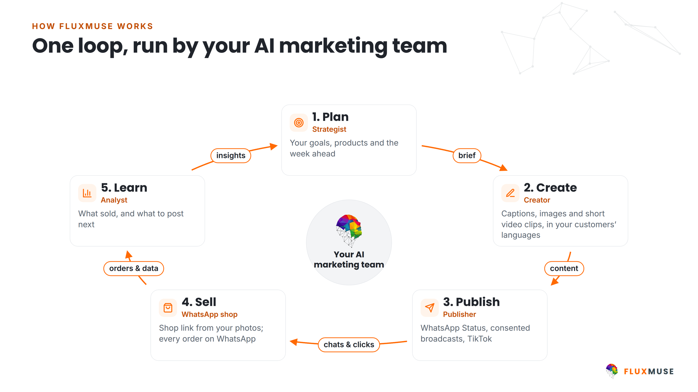
Figure 1. One loop, run by your AI marketing team. Newly launched in South Africa.
Company | Fluxmuse (Pty) Ltd (South Africa) · registration number [[COMPANY REGISTRATION NUMBER]]
Document | Business Plan · October 2026 · Confidential · version v2.0
Prepared by | Thabo Malebadi, [[TITLE]], Fluxmuse (Pty) Ltd  thabo@fluxmuse.com · [[PHONE / WHATSAPP]]
Prepared for | [[INVESTOR / FUNDER NAME]]
Financial model | FluxMuse Financial Model v3, model date 2026-10-05 (Base case)

Confidential. This document contains commercially sensitive information and is provided for evaluation only. Figures in South African rand (ZAR) unless stated. US dollar equivalents at R18.50 = US$1. No VAT: Fluxmuse (Pty) Ltd is not VAT-registered.

Document control and disclaimer
Document | FluxMuse Business Plan
Version | v2.0 · October 2026
Status | Draft for founder review. Contains [[PLACEHOLDERS]] and [[CONFIRM]] items that must be completed
Prepared by | Thabo Malebadi, [[TITLE]], Fluxmuse (Pty) Ltd
Approved by | [[APPROVER NAME AND DATE]]
Financial model | FluxMuse Financial Model v3, model date 2026-10-05, Base case selected
Sources | 00_FACTS_AND_ASSUMPTIONS.md; 08_Prospects/CURRENT_OFFER.md; 06_Financial_Model/Financial_Model_Notes.md
Distribution | Confidential. [[RECIPIENT]] only

Forward-looking statements
This plan contains forward-looking statements: projections of revenue, costs, cash, headcount, market launches and customer numbers. They are projections, not results, and not a promise of performance. Every financial figure is drawn from the FluxMuse Financial Model v3, model date 2026-10-05 (Base case unless stated). FluxMuse has no paying customers yet, so every volume and rate is an assumption. The assumptions are listed in Appendix E and will be replaced with measured data as the South African launch produces it. Actual outcomes will differ, potentially materially, because of demand, competition, exchange rates, decisions by Meta, payment-provider onboarding, regulation and execution.

What this plan does not claim
- No customers, no pilot, no results. There are no customer counts, ratings, testimonials or outcome figures anywhere in this document. Case studies come later, only with measured data and signed consent.
- No unapproved capability. Features waiting on Meta, a real-money checkout test or a beta are described as being switched on, never as live.
- No payment coverage that is not live. Paid checkout is open in South Africa only.
- No invented market data. Market-size figures are labelled as estimates with their sources.
- No valuation or return projection. Instrument, valuation and terms are for negotiation.
Third-party names, including Meta, WhatsApp, TikTok and the payment providers, are used descriptively and remain the property of their owners. Nothing in this plan is an offer of securities. [[LEGAL REVIEW OF THIS DISCLAIMER]]

Contents

Document control and disclaimer
1. Executive summary
2. Company overview
3. Problem and opportunity
4. Solution: products and services
5. Market analysis
6. Target customers
7. Competitive landscape
8. Marketing and sales strategy
9. Pricing strategy
10. Operations
11. Management and organisation
12. Financial plan
13. Funding request and use of funds
14. Risk analysis
15. Milestones and KPIs
16. Social and economic impact
Appendix A. Pricing tables
Appendix B. Payment rails and country coverage
Appendix C. First group and case-study template
Appendix D. Detailed financial tables
Appendix E. Model assumptions and open confirmations
Appendix F. Glossary
Word builds page numbers when you open the file (choose Yes to update fields), or right-click the list and choose Update Field.
If the list above is empty, the static contents below applies.

Contents (static fallback)
1. Executive summary
2. Company overview
3. Problem and opportunity
4. Solution: products and services
5. Market analysis
6. Target customers
7. Competitive landscape
8. Marketing and sales strategy
9. Pricing strategy
10. Operations
11. Management and organisation
12. Financial plan
13. Funding request and use of funds
14. Risk analysis
15. Milestones and KPIs
16. Social and economic impact
Appendix A. Pricing tables
Appendix B. Payment rails and country coverage
Appendix C. First group and case-study template
Appendix D. Detailed financial tables
Appendix E. Model assumptions and open confirmations
Appendix F. Glossary

1. Executive summary
FluxMuse gives African small businesses an AI marketing team and a shop that runs on WhatsApp. The owner sends product photos on WhatsApp; FluxMuse drafts the catalogue, builds a hosted shop link, writes captions and images for WhatsApp Status, and sends each order to the owner's own WhatsApp. The company is Fluxmuse (Pty) Ltd, a South African company and a verified Meta Tech Provider. The product is newly launched in South Africa. FluxMuse has no paying customers yet, and this plan does not pretend otherwise.

The opportunity
- Africa has an estimated 44 million MSMEs (IFC/World Bank est.), about 2.5–3 million SMMEs in South Africa (SEDA/Stats SA est.), 39 million in Nigeria (SMEDAN est.) and 7.4 million in Kenya (KNBS est.). All estimates; see section 5.
- They already sell where their customers are: more than 90% of internet users in South Africa and Nigeria use WhatsApp (DataReportal 2025 est.).
- What they lack is a marketing team they can afford and a simple shop. Global tools are priced in dollars, are not built around WhatsApp, and stop at the post rather than the sale.

The solution
- WhatsApp Concierge: send photos, get catalogue entries to approve with YES, NO or an edit.
- Hosted shop link: orders arrive as a WhatsApp message to the owner, who replies SOLD.
- AI content: captions and images (POST), short video clips and voice-note transcription, with answers in the customer's language.
- WhatsApp Business setup, templates and broadcasts to consented contacts, and TikTok video posting.
- Priced in rands: nine plans in three bands, paid plans from R149 a month.

Where we are today
- Live, newly launched: the capabilities above. No merchant has run them end to end yet, so we quote no results.
- Being switched on: Facebook and Instagram auto-publishing (Meta permissions not yet approved), checkout through FluxMuse (built, not yet tested with real money), AI Voice (beta) and the daily digest.
- Payments: Paystack is live in South Africa; Yoco and Ozow run FluxMuse's own subscription billing. pawaPay and Fincra are contracted for expansion, with accounts pending. There is no paid checkout outside South Africa yet.
- Opening by hand: we are opening with a small first group of businesses and setting each one up by hand. The model assumes about 4 a month, Oct 2026 to Jan 2027 [[CONFIRM]].

Business model and go to market
Recurring subscriptions in three bands: Small (Free, Nano R149, Micro R289), Medium (Starter R499, Growth R1,999, Scale R4,999) and Enterprise (Corporate R6,999, Agency R9,999, Custom by consultation). Annual is 10× monthly. Every paid plan starts with payment; Free is a permanent plan, not a trial. Agencies resell at a partner wholesale price of R6,999 a month. South Africa now; Nigeria, Kenya and Ghana once their payment accounts are live and their revenue gates are met; then other markets self-serve in US dollars.

Financial highlights
Base case of the FluxMuse Financial Model v3, model date 2026-10-05. These are forward-looking projections, not results. Every volume is an assumption, because there are no customers yet.
R million unless stated | FY1  Oct 2026–Sep 2027 | FY2  Oct 2027–Sep 2028 | FY3  Oct 2028–Sep 2029 | FY4  Oct 2029–Sep 2030 | FY5  Oct 2030–Sep 2031
Revenue (R m) | R1.9m | R9.5m | R25.5m | R54.1m | R93.5m
EBITDA (R m) | R-7.0m | R-11.7m | R-16.9m | R-10.6m | R4.5m
EBITDA margin | n/m | -124% | -66% | -20% | 5%
Paying workspaces (Sept) | 238 | 728 | 1,734 | 3,147 | 4,627
Subscription ARR (R m) | R3.9m | R12.7m | R32.0m | R63.0m | R99.9m
Closing cash (R m) | R39.7m | R28.5m | R12.8m | R4.2m | R11.3m
Headcount at year end | 13 | 23 | 41 | 67 | 70

Source: FluxMuse Financial Model v3, model date 2026-10-05 (Base case); Financial_Model_Notes.md.
- EBITDA break-even Jan 2031, positive every month from Jan 2031; operating cash flow positive from Dec 2030.
- In the Base case the R46m carries the business to profitability with no Series A. Minimum cash after the seed is R4.00m in Nov 2030, only R1.00m above the R3.0m buffer.
- Upside passes too. The Conservative case does not: on R46m its cash falls below the buffer from May 2031 and EBITDA does not turn positive by Sep 2031 (section 12).
- The headroom is thin. If Free users upgrade at 0.25% a month instead of 0.5%, minimum cash falls to R-0.72m and the Base case fails too.

The ask: R46 million seed
Fluxmuse (Pty) Ltd is raising R46 million (about US$2,486,486), modelled to close in Feb 2027. The size comes from the model: R45.1m is the smallest seed at which the Base case passes, rounded up [[CONFIRM]]. Instrument and valuation: [[INSTRUMENT: SAFE OR PRICED EQUITY]], [[PRE-MONEY VALUATION: TBC]].
Use of funds | Share | R million | What it buys
Product & engineering | 40% | R18.40m | Senior full-stack x2, AI/ML, designer, full-stack x2, DevOps/QA, integrations x2, PM, security.
Sales & marketing / partner programme | 30% | R13.80m | Head of Growth, performance & multilingual content marketers, partnerships managers, SME onboarding.
Market expansion (NG, KE, GH) & payments compliance | 15% | R6.90m | Country leads and local sales/CS in Nigeria, Kenya and Ghana.
Operations & working capital | 15% | R6.90m | Customer success team, finance & compliance, operations, G&A, tooling, travel, payment processing, support, WhatsApp pass-through costs, and the working-capital float that protects the R3.0M cash buffer..

Section 13 reconciles this allocation against modelled spend. Expansion is under-spent against its 15% share in the first two years because Nigeria, Kenya and Ghana open late; operations runs over because customer success, hosting and AI cost scale with customers.

Why this team
Thabo Malebadi, [[TITLE]]: [[BACKGROUND: WHAT THEY HAVE BUILT AND SOLD BEFORE, YEARS IN MARKET, WHY THIS PROBLEM]]. [[CO-FOUNDER / CTO NAME, TITLE]]: [[BACKGROUND]].
[[TEAM: THE CURRENT TEAM AND WHAT THEY HAVE SHIPPED]] and [[ADVISORS]].
What is already in place, and what is not
- The product is built and newly launched in South Africa. It has not yet been run end to end by a real merchant.
- Fluxmuse (Pty) Ltd is a verified Meta Tech Provider, a slow, gated process for any WhatsApp platform.
- Paystack is live in South Africa. Expansion rails are contracted but pending.
- There are no customers, no pilot and no results. The R46m reaches profitability in the Base and Upside cases only, with thin headroom.

2. Company overview

Legal entity and ownership
Registered name | Fluxmuse (Pty) Ltd
Jurisdiction | South Africa
Registration number | [[COMPANY REGISTRATION NUMBER]]
Date of incorporation | [[FOUNDING DATE]]
Registered address | [[REGISTERED ADDRESS]]
Operating location | [[OPERATING LOCATION / OFFICE]]
Directors | [[DIRECTORS]]
Shareholders and cap table | [[CAP TABLE: SHAREHOLDERS AND PERCENTAGES, OPTION POOL]]
B-BBEE status | [[B-BBEE LEVEL AND VERIFICATION DATE]]
Tax and VAT | [[INCOME TAX NUMBER]] · not VAT-registered (no active tax types on eFiling, Sept 2026)
Auditor / accountant | [[AUDITOR OR ACCOUNTING OFFICER]]
Banker | [[BANK]]
Product | FluxMuse (fluxmuse.ai): an AI marketing team and a WhatsApp shop for small businesses
Contact | Thabo Malebadi, thabo@fluxmuse.com

Every field marked [[ ]] must be completed from the company records before this plan goes to a funder. Development-finance funders will also ask for the items listed in Appendix E.

Mission, vision and promise
Mission. Give every African small business a marketing team and a shop, inside the chat app its customers already use.
Vision. A braider in Tembisa, a baker in Lagos and an agency in Nairobi market and sell as easily as any global brand, in their own language and their own currency.
Promise. Less admin, more sales you can see.
Mission, vision and promise are drafts from the brand kit and need founder sign-off before external use. [[FOUNDER SIGN-OFF ON MISSION, VISION AND PROMISE]]

Platform verification and regulatory status
Area | Status
Meta Business and Access Verification | Verified Meta Tech Provider (Sept 2026)
WhatsApp Business | Live: number connection, profile, templates, quick replies, broadcast to consented contacts
TikTok | Video posting approved
Facebook Pages and Instagram auto-publishing | Being switched on: Meta permissions not yet approved. Never sold as live
Instagram DMs and comments, X posting | Not available
Payment licensing | FluxMuse is not a payment institution and does not hold merchants' money. Paystack is live in South Africa; Yoco and Ozow run FluxMuse's own subscription billing; pawaPay and Fincra are contracted, accounts pending
Data protection | Built to be POPIA ready: row-level security on every table, encrypted tokens, data export and account deletion. Information Officer: [[INFORMATION OFFICER NAME AND EMAIL]]
VAT | Not VAT-registered. Prices are the amounts charged; no VAT is added
Intellectual property | Platform code, brand and the Muse icon owned by Fluxmuse (Pty) Ltd. Trade mark registration: [[TRADE MARK STATUS]]

Features waiting on Meta stay switched off until Meta approves them, and are never sold as live. This is the biggest platform dependency in the plan (section 14).

3. Problem and opportunity

The problem
A small business in Johannesburg, Lagos or Nairobi sells through WhatsApp, Instagram and Facebook. Marketing is a person, usually the owner, doing it late at night between jobs. The tools that exist were built for somewhere else:
- A patchwork of disconnected tools for posts, chats, email, SMS and payments.
- Agency retainers priced beyond most small-business budgets.
- No shop page, so the catalogue is a photo album and orders get lost in chats.
- After-hours messages go unanswered, and the sale goes cold.
- Content in the wrong language and register for the customer being sold to.
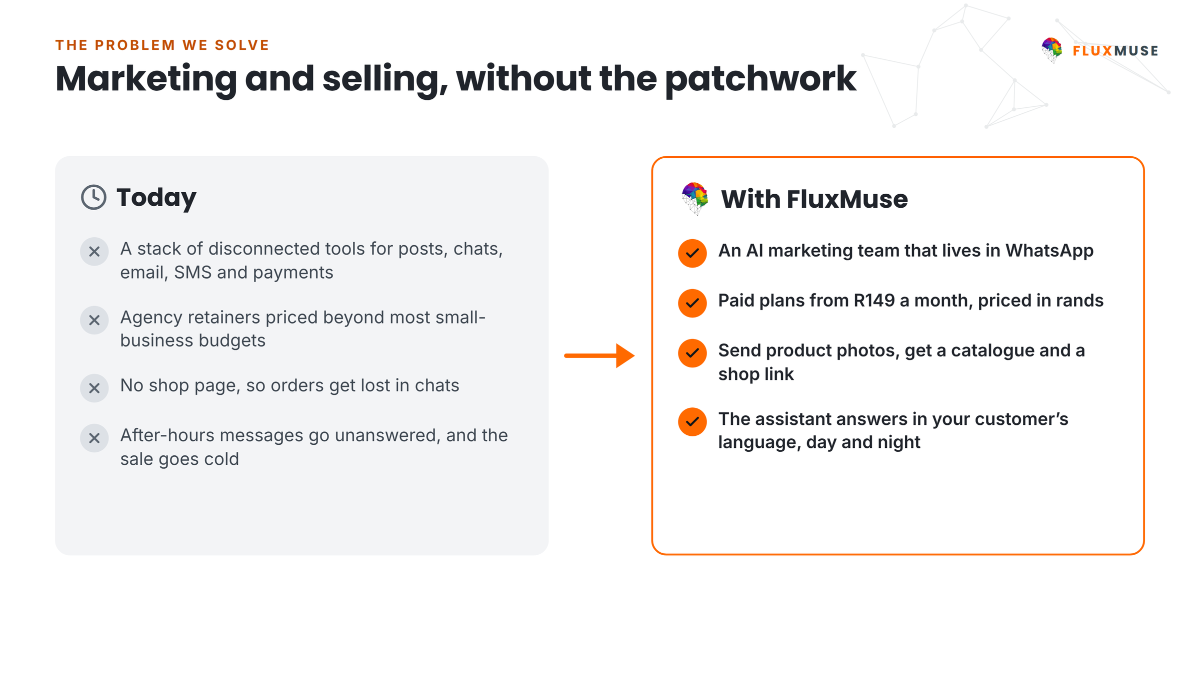
Figure 2. The problem we solve, and what replaces it.

Why now
- The channel is settled. WhatsApp is where African small businesses already sell, and the WhatsApp Cloud API makes a shop around the chat possible for small businesses, not only enterprises.
- AI has made the marketing team affordable. Captions, images, short video and catalogue entries can now be produced at a price a R149-a-month business can pay.
- The gate is verification, not code. Meta Tech Provider verification takes months, and FluxMuse already holds it.
- Payments are reaching across the continent through aggregators. FluxMuse has contracts in place for expansion; the accounts are pending.

The gap in the market
Global social-media tools publish but don't sell. WhatsApp chatbot vendors handle conversations but don't create marketing. E-commerce platforms sell on a website, not around a chat. Local agencies charge retainers most of this market cannot pay. Nobody covers photos → catalogue → shop link → posts → orders on WhatsApp in one product, priced in rands. Section 7 sets this out.

4. Solution: products and services
FluxMuse is one product that runs a marketing loop and takes orders in the same place: WhatsApp.
Figure 3. The loop: Plan, Create, Publish, Sell, Learn.

What it does today
Capability | What the owner does | Status
WhatsApp Concierge | Sends product photos; approves each catalogue entry with YES, NO or an edit | Live, newly launched
Hosted shop link | Shares fluxmuse.ai/s/<name>; each order arrives as a WhatsApp message | Live, newly launched
Order alerts and SOLD | Gets an alert per order; replies SOLD to mark it sold | Live, newly launched
AI captions and images (POST) | Gets a caption and photo back, ready for WhatsApp Status | Live, newly launched
Short AI video clips, voice-note transcription | Asks on WhatsApp | Live, newly launched
WhatsApp Business setup | Number, profile, templates, quick replies, broadcasts to consented contacts | Live, newly launched
Answers in the customer's language | Nothing: the assistant follows the customer | Live, newly launched
TikTok posting | Video only | Live (approved)
Facebook Pages and Instagram auto-publishing | Until approved, forwards to WhatsApp Status | Being switched on
Checkout through FluxMuse (Paystack, South Africa) | Built; not yet tested with real money | Being switched on
AI Voice (inbound on Growth; inbound and outbound on Scale) | Beta, evaluated together | Being switched on
Daily digest; click-to-WhatsApp ads (FluxLoop) | Digest in dry run; ads on FluxMuse's own account first | Being switched on
Shopify, WooCommerce and Takealot sync | Exists in part; tenant catalogue sync is a gap | Being switched on
Instagram DMs and comments; X posting; checkout outside South Africa | — | Not available

Source: CURRENT_OFFER.md §3. Live features are newly launched; no merchant has run them end to end, so the plan quotes no results.

WhatsApp commerce
The buyer finds the business through a Status post, a QR code or a shop link, chats with the assistant, browses a shop built from the owner's photos and sends the order. The owner gets the order on WhatsApp and replies SOLD. A broadcast to consented contacts starts the next sale. Paid checkout through FluxMuse is built and being switched on; until it has been tested with real money, orders arrive as a WhatsApp message to the owner's own number.
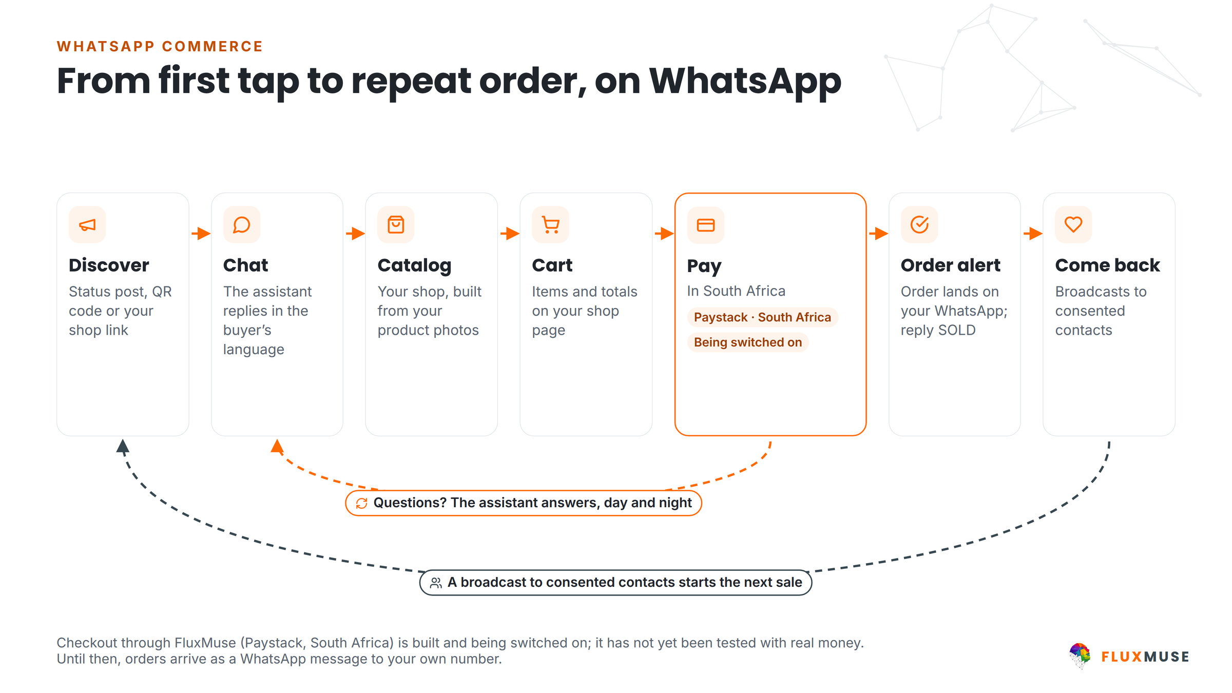
Figure 4. From first tap to repeat order, on WhatsApp. Checkout is being switched on.

The platform
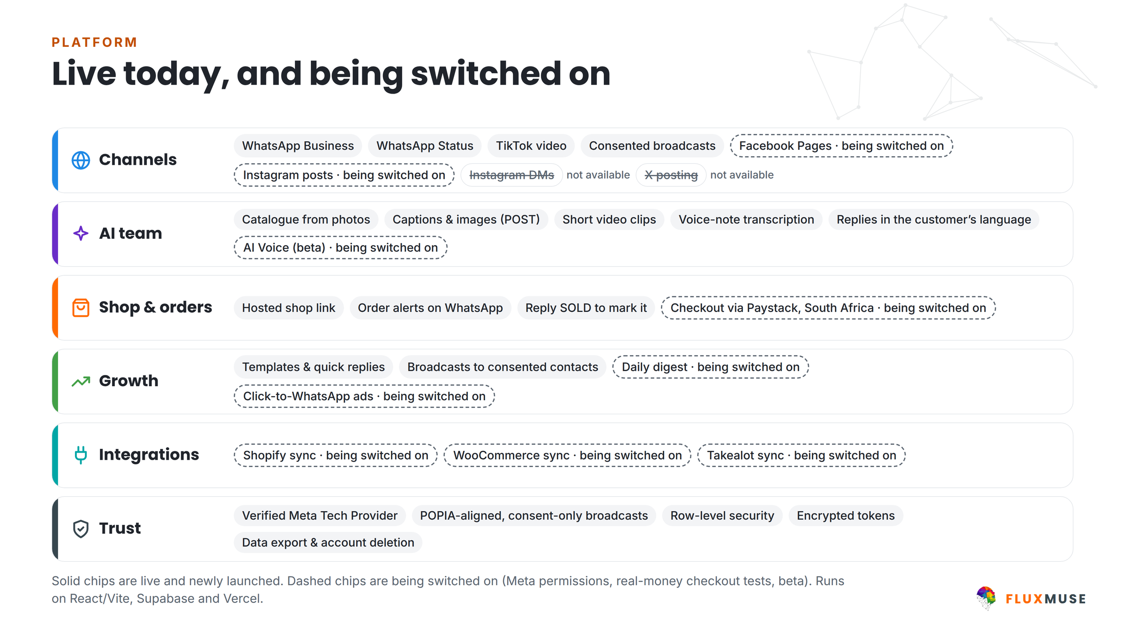
Figure 5. Live today, and being switched on. Solid chips are live; dashed chips are being switched on.

The agency and white-label offering
Agencies buy the Agency tier (R9,999 list) at the partner wholesale price of R6,999 a month (30% off): white-label, multi-client, unlimited brands, 80 channels and bring-your-own-cloud. The partner sets its own retail price for its clients and keeps the difference. Wholesale does not stack with Founding Member.
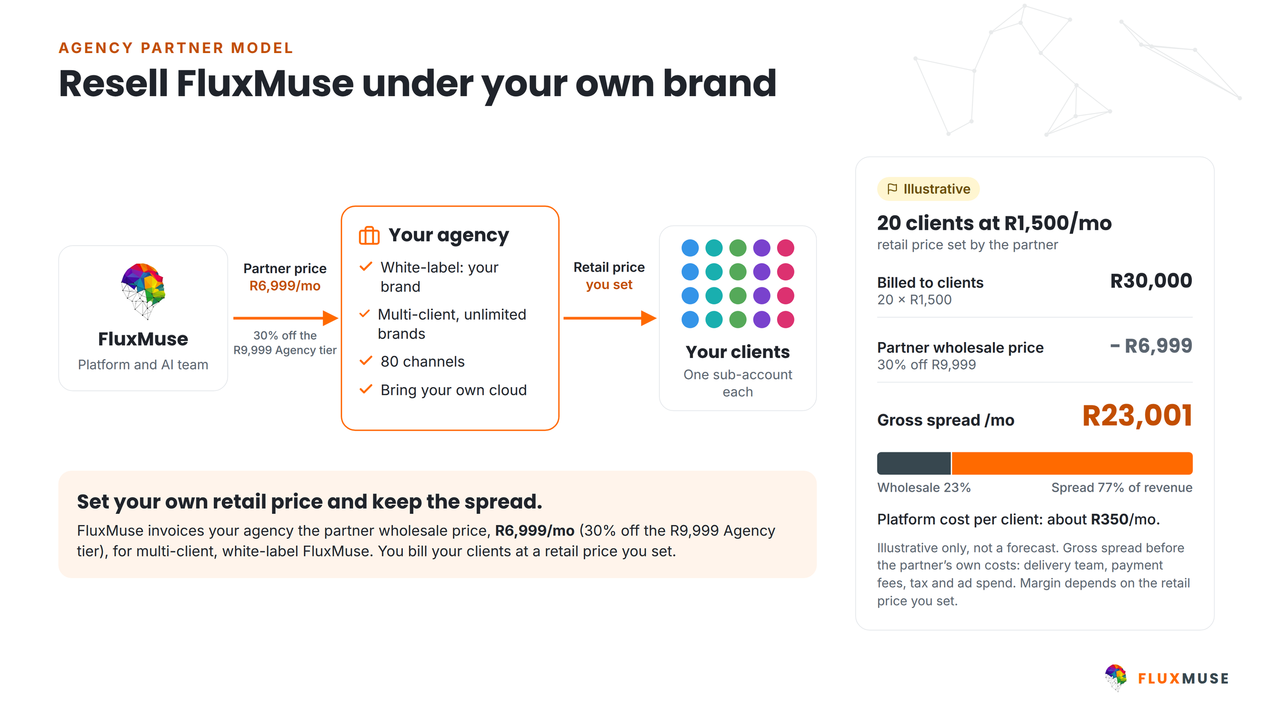
Figure 6. The partner model. The worked example is illustrative, not a forecast.
Illustrative only. FluxMuse does not quote a fixed partner margin, because it depends on the partner's retail price and delivery costs.

The lead guarantee
FluxMuse backs the offer with a lead guarantee, paid in support, not cash: 3 qualified leads in 30 days of go-live, counted as unique WhatsApp numbers that start a conversation through a FluxMuse-tracked entry point. If fewer than 3 arrive and the merchant held up their side (shared the link, posted at least weekly), FluxMuse extends support at no extra charge until 3 are reached.

Trust and compliance
- Built to be POPIA ready, with row-level security on every database table, encrypted access tokens, and data export and account deletion on request.
- WhatsApp policy: broadcasts use Meta-approved message templates and go only to contacts who opted in, with a way to opt out.
- Payments are handled by licensed providers; FluxMuse does not hold merchants' money.

5. Market analysis
All market figures below are estimates and are labelled with their source. They are planning inputs, not measured results, and should be re-verified before any external commitment ([[VERIFY MARKET SIZING WITH A CURRENT SOURCE]]).

Market size
Measure | Estimate | Basis
TAM: MSMEs in Sub-Saharan Africa | 44 million businesses | IFC / World Bank est.
SAM: digitally active small businesses in the African markets FluxMuse's contracted payment partners can reach, selling via social or WhatsApp and able to pay US$25 a month or more | about 3.5 million businesses | Planning estimate
SAM value at US$25 a month | about R19.4 billion a year | SAM × US$25 × 12 at R18.50 = US$1
SOM over 5 years | about 17,500 paying workspaces (0.5% of SAM) | Planning estimate
Base case FY5 in this plan | 4,627 paying workspaces (26.4% of the SOM) | FluxMuse Financial Model v3, Base case

Today only South Africa is on sale. The SAM counts markets FluxMuse can reach once its pending payment accounts are live; it is not a statement of current coverage.

South Africa: the home market
South Africa has an estimated 2.5–3 million SMMEs (SEDA/Stats SA est.). It is the right first market: Paystack is live there, WhatsApp is near-universal, SMME support structures are well developed, and the company and team are here. Base case FY1 revenue is entirely South African.

Nigeria, Kenya and Ghana: the first expansion wave
- Nigeria: about 39 million MSMEs (SMEDAN est.).
- Kenya: about 7.4 million MSMEs (KNBS est.); deep mobile-money usage.
- Ghana: strong mobile money and a large informal trading sector.
- All three are priced in local currency but not yet on sale. Checkout there waits for the Fincra and pawaPay accounts, then for a revenue gate (section 15). The model's planned earliest months are Nigeria Apr 2028, Kenya Jul 2028 and Ghana Oct 2028 [[CONFIRM]]; in the Base case the gates bind, so they open in Oct 2028, Jan 2029 and Apr 2029.

Trends
- Chat commerce is becoming the default for small-business selling in these markets.
- Mobile money keeps widening: Sub-Saharan Africa accounts for about 70% of global mobile money value (GSMA 2025 est.).
- AI lowers the price floor of marketing services, which opens a segment agencies cannot serve profitably.
- Data-protection regimes are maturing, which favours platforms built for consent from the start.

Regulatory environment
Market | Regime | What it means for FluxMuse
South Africa | Protection of Personal Information Act (POPIA) | Information Officer registered, operator agreements, opt-in marketing, breach notification. Outreach is human-sent and one-to-one (POPIA s69). [[INFORMATION OFFICER REGISTRATION CONFIRMED]]
South Africa | VAT | Not VAT-registered today. Registration becomes compulsory above R1m of taxable supplies in 12 months, which the Base case passes late in FY1 [[FOUNDER: VAT PLAN]]
Nigeria | NDPR / Nigeria Data Protection Act | Data-controller registration and local counsel, funded from the expansion budget
Kenya | Kenya Data Protection Act | Registration with the Office of the Data Protection Commissioner
Ghana | Ghana Data Protection Act | Registration with the Data Protection Commission
All markets | Payments regulation | Handled by licensed providers. FluxMuse does not take deposits or hold merchants' money
All markets | Meta platform policy | WhatsApp Business messaging policy, template approval and opt-in rules govern what may be sent

6. Target customers
Three launch segments, all in South Africa first. Corporate and Custom are taken inbound only: no sales motion or hire is built for them in FY1.
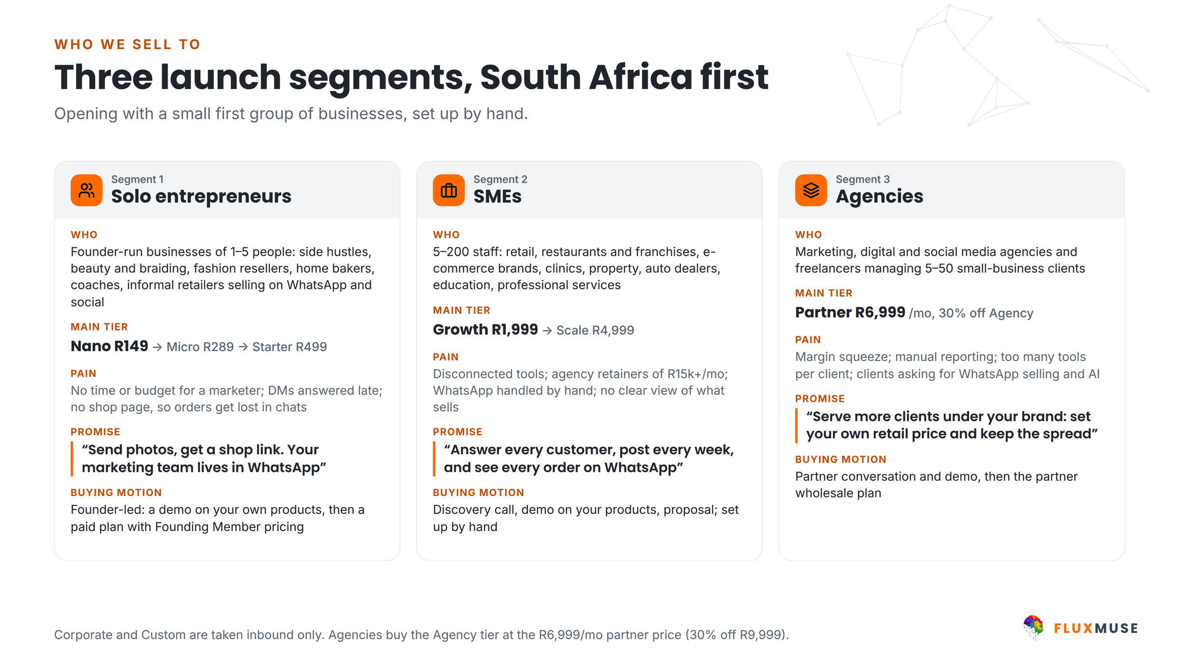
Figure 7. The three launch segments, South Africa first.
 | Solo sellers | SMEs | Agencies
Who | Founder-run businesses of 1–5 people: side hustles, beauty and braiding, fashion resellers, home bakers, informal retailers selling on WhatsApp and social | 5–200 staff: retail, restaurants, e-commerce brands, clinics, property, education, professional services | Marketing, digital and social agencies and freelancers managing many small-business clients
Main tier | Nano R149 → Micro R289 → Starter R499 | Starter R499 → Growth R1,999 → Scale R4,999 | Agency tier at partner wholesale R6,999
Pain | No time or budget for a marketer; DMs answered late; no shop page, so orders get lost | Disconnected tools; agency retainers; WhatsApp handled by hand; no clear view of what sells | Margin squeeze; manual reporting; too many tools per client; clients asking for WhatsApp selling
Promise | “Send photos, get a shop link. Your marketing team lives in WhatsApp” | “Answer every customer, post every week, and see every order on WhatsApp” | “Serve more clients under your brand: set your own retail price and keep the spread”
Buying motion | Self-serve, or a demo on their own products; Free plan as an on-ramp, not a trial | Discovery call, demo on their products, proposal; set up by hand | Partner conversation and a live demo on a client's public catalogue, then the wholesale plan
Base case FY5 workspaces | 2,071 | 2,322 | 203

Corporate and Custom are inbound only: 24 Corporate and 8 Custom workspaces by FY5 in the Base case.

Personas
Persona 1: the braiding studio owner (solo seller)
Runs a braiding and hair studio. Decides alone. Already books clients and posts work on WhatsApp, Instagram and Facebook.
- Needs: bookings that don't get lost in DMs, consistent posts in isiZulu, Sesotho and English, and a simple page that shows what she offers.
- Buys: Nano or Micro, usually on a phone, often on a peer's recommendation. Founding Member brings Nano to R104 for the first two monthly bills.

Persona 2: the multi-branch SME marketing lead
Runs marketing for a business with several branches or an online store, and is asked every month what the marketing earned.
- Needs: one product instead of several, WhatsApp handled properly rather than on staff phones, and every order visible.
- Buys: after a call and a demo on their own products; Starter or Growth, moving to Scale for more brands.

Persona 3: the agency owner
Runs a social or digital agency. Margin is squeezed by delivery time and tool costs, and clients are asking for WhatsApp selling and AI.
- Needs: white-label delivery, client sub-accounts and less time on reporting.
- Buys: through the partner programme at R6,999 a month, and sets its own retail price.

7. Competitive landscape
FluxMuse competes with four categories at once, and with none of them completely. The comparison below is qualitative and about categories, not named competitors.
Category | What they do well | Where they leave the customer | FluxMuse
Global social media management tools | Scheduling, publishing and analytics across many networks | Stop at the post: no shop, priced in hard currency, little local-language support | Runs from WhatsApp, builds the shop, priced in rands
WhatsApp business solution providers and chatbot vendors | Reliable messaging infrastructure and chatbot building | No marketing team or content creation; often aimed at larger businesses | Messaging inside a marketing product, on flat plans from R149
E-commerce platforms | Storefronts, catalogues and payment integrations | Sell on a website; building the catalogue is the owner's job | The catalogue is built from photos sent on WhatsApp
Local agencies and freelancers | Local knowledge, relationships and creative judgement | Retainer pricing this market mostly cannot afford | Sold to agencies, not against them: white-label at R6,999 so they serve more clients

Our differentiation
- WhatsApp-first: the owner runs the business from WhatsApp, where they already work.
- Priced in rands, from a permanent Free plan to Custom, with paid plans from R149 a month.
- Answers in the customer's language, a product feature rather than an afterthought.
- Verified Meta Tech Provider, already held.
- A partner channel that turns the most obvious local competitor into a distribution route.

Defensibility
- Verification takes time. Meta Tech Provider verification is months of work a new entrant must repeat. Payment contracts for expansion are signed; accounts are pending.
- Switching costs. The WhatsApp number, catalogue, templates, contacts and shop link all live in the workspace.
- Channel lock-in through partners. An agency that rebuilds its delivery on a white-label platform does not move lightly.
- Price position. A product built for R149-a-month customers is hard to attack from above.
This position has not yet been tested in the market. Risks, including Meta dependency and pending payment accounts, are set out in section 14.

8. Marketing and sales strategy

Sequence
The order is fixed: South Africa now; Nigeria, Kenya and Ghana once their payment accounts are live and checkout is tested; then other covered markets self-serve in US dollars. Botswana and Namibia are coming soon. Everywhere else is waitlist only.
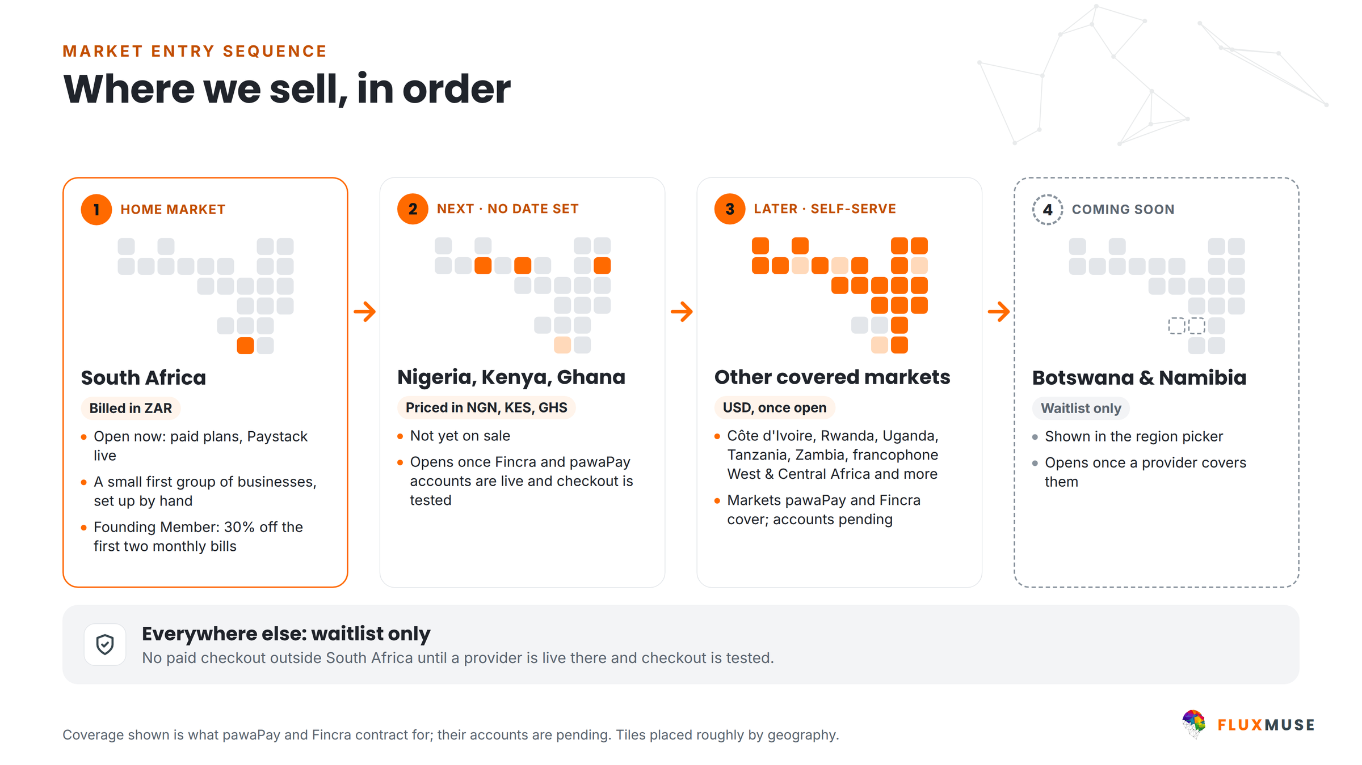
Figure 8. Where we sell, in order. Launch dates in this plan are set by payment accounts and revenue gates.

Opening with a small first group
There is no pilot and no free period. We are opening with a small first group of businesses and setting each one up by hand. The model assumes 4 a month from Oct 2026 to Jan 2027 (16 in total, half solo sellers), at R10,000 a month of set-up cost [[CONFIRM]]. They pay list price less Founding Member from the first bill. Each may become a case study, only with measured data and signed consent (Appendix C).

Channels by segment
Segment | Acquisition channels | What we measure first
Solo sellers | Founder-led demos, WhatsApp short links, creators, community markets, Meta and TikTok ads after the seed (capped) | Pay-at-sign-up rate and Free-to-paid upgrades
SMEs | Discovery calls and demos on the prospect's own products, business networks, referrals | Conversion after a demo; early churn
Agencies | Direct outreach, agency communities, a live demo on a client's public catalogue | Agencies signed per partnerships manager

Outreach is human-sent and one-to-one, through channels the business publishes, with a clear opt-out (CURRENT_OFFER.md §6). No bulk automation and no AI cold calls.

Founding Member
One launch offer, live since 1 October 2026: 30% off the first two monthly bills for South African sign-ups (for example Nano R104, Micro R202, Starter R349, Growth R1,399, Scale R3,499). It is a discount, not a free period. No end date is set; the model ends it in March 2027 [[CONFIRM]]. It does not stack with partner wholesale, and no offer is modelled for Nigeria, Kenya or Ghana.
The offer is cheap and it is modelled. It costs R32,143 in FY1 and nothing after. Because sign-ups are assumed to rise 20% while it runs (unproven, to be measured), it leaves slightly more cash than no offer at all.
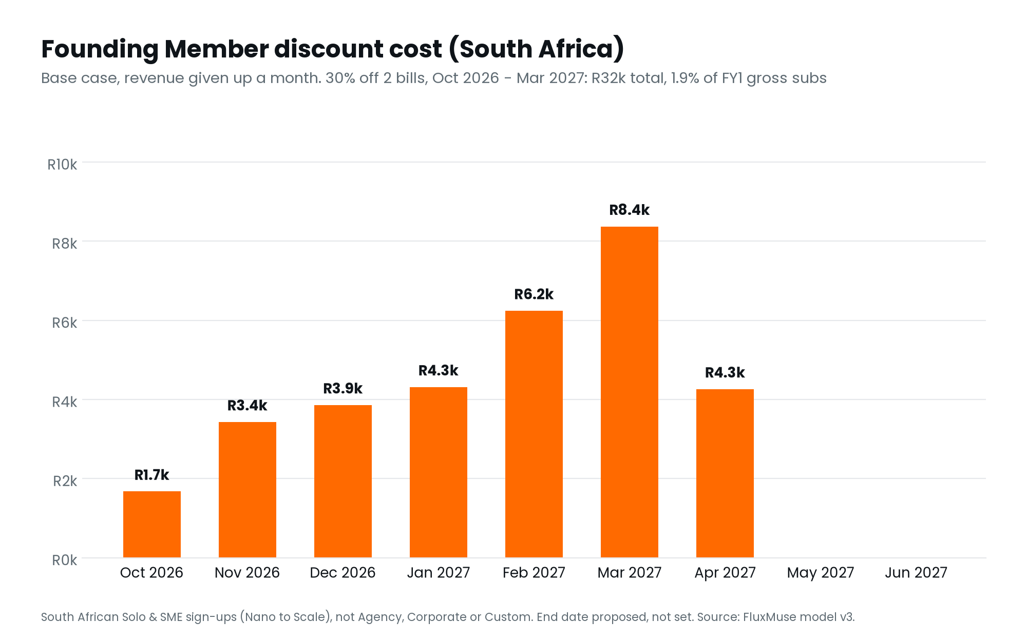
Figure 9. Founding Member discount cost by month (Base case).

The lead guarantee
3 qualified leads in 30 days of go-live; if fewer arrive and the merchant shared the link and posted at least weekly, FluxMuse extends support at no extra charge until 3 are reached. It is never a cash payment and never a promise of sales.

The partner programme
Agencies are a channel, not only a segment. Partners buy the Agency tier at R6,999 a month and set their own retail price. In the Base case the partner channel grows from 17 agency workspaces in FY1 to 203 in FY5, through a partnerships team rather than paid advertising. A referral commission is undecided and not modelled.

Brand positioning and messaging
Positioning. For solo sellers, SMEs and agencies in South Africa who sell on social media and WhatsApp but have no time, budget or tools for a marketing team, FluxMuse is the AI marketing team and WhatsApp shop that turns photos into a catalogue, posts and orders, in their language and priced in rands.
Voice. Plain, warm and direct. Newly launched, and said plainly. No results quoted until they are measured.

Sales process and funnel
There are no free trials. Sign-ups either pay at once or join the permanent Free plan, from which some upgrade over time. The funnel assumptions that drive the model are:
Funnel assumption | Solo | SMEs | Agencies | Corporate / Custom
Pay at sign-up | 5% | 8% | n/a | n/a
Free plan | Upgrade 0.5% a month; dormant 10% a month | Same | n/a | n/a
Acquisition | Self-serve, Free upgrades, capped paid ads | Self-serve plus guided onboarding | Inbound plus partnerships managers and country leads | Inbound only
FY3 modelled CAC | R3,760 | R5,957 | R33,673 | R10,000 / R25,000
FY3 modelled LTV:CAC | 0.7x | 6.6x | 7.3x | 33.6x / 57.6x

Source: FluxMuse Financial Model v3, model date 2026-10-05 (Base case); Financial_Model_Notes.md.
Solo does not pay back on fully loaded CAC (0.7x). Solo customers are worth having through the Free plan and upgrades, not through paid acquisition at scale.
Paid acquisition is capped. Monthly paid spend is limited to R40,000 plus 35% of last month's net MRR in the Base case, and is switched off where CAC payback would exceed 12 months. In FY1 the cap funds 78% of the paid acquisition the funnel wants.

9. Pricing strategy
Base currency is the South African rand. Annual plans cost 10× the monthly price. There are no free trials: every paid plan starts with payment. Free is a permanent plan with no card, and we don't lead with it. Prices are the amounts charged: FluxMuse is not VAT-registered, so no VAT is added.

Nine plans in three bands
Band | Plan | Monthly | Annual | Brands | Channels | Notes
Small | Free | R0 | R0 | 1 | 1 | Permanent plan, not a trial; no card
 | Nano | R149 | R1,490 | 1 | 3 | Entry paid plan for side hustles
 | Micro | R289 | R2,890 | 1 | 4 | 1 WhatsApp number
Medium | Starter | R499 | R4,990 | 1 | 3
 | Growth | R1,999 | R19,990 | 3 | 15 | + inbound AI Voice (beta)
 | Scale | R4,999 | R49,990 | 10 | 40 | + inbound and outbound AI Voice (beta)
Enterprise | Corporate | R6,999 | R69,990 | 25 | 60 | Bring your own cloud
 | Agency | R9,999 | R99,990 | Unlimited | 80 | Bring your own cloud, white-label, multi-client
 | Custom | On request | — | — | — | Sold by consultation

AI credit allowances changed on 24 September and are set on the pricing page; this plan never quotes per-plan credit numbers. Custom is modelled from R19,999 a month [[CONFIRM]].
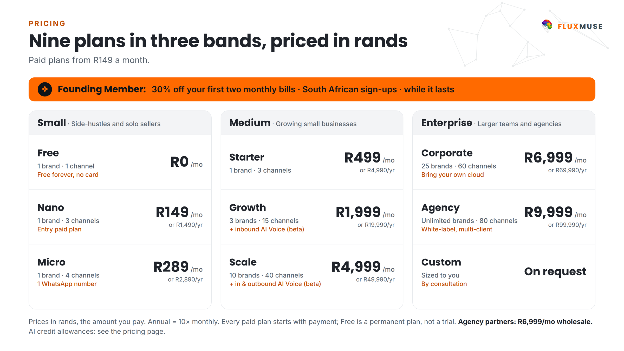
Figure 10. Nine plans in three bands, priced in rands.

Local pricing: priced, not yet on sale
Nigeria, Kenya and Ghana have fixed local price points in the product, set at parity with the rand (1 ZAR = ₦82.83 = KSh 8.07 = GH₵ 0.68), and other markets have US dollar prices at R18.50 = US$1. None of these is on sale: checkout outside South Africa waits for the Fincra and pawaPay accounts and a real-money test.
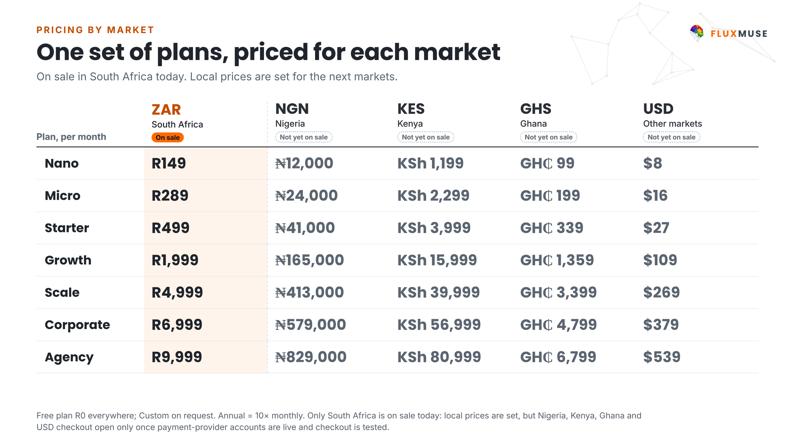
Figure 11. One set of plans, priced for each market. Only South Africa is on sale.

Repricing policy
- Local prices are reviewed quarterly. If the rand value of a local price has drifted more than 10%, the price is reset to parity.
- A 6% list-price escalator applies each October in the model [[CONFIRM]].
- The model assumes annual depreciation against the rand of NGN −10%, GHS −8%, KES −3% and USD 0% ([[CONFIRM FX ASSUMPTIONS]]).
- Section 12 shows why this matters: in a 15% rand-strengthening shock without repricing, the Base case fails the cash test.

Partner wholesale
 | ZAR | NGN | KES | GHS | USD
Agency list, monthly | R9,999 | ₦829,000 | KSh 80,999 | GH₵ 6,799 | $539
Partner wholesale, monthly (−30%) | R6,999 | ₦579,000 | KSh 56,999 | GH₵ 4,799 | $379
Partner wholesale, annual (10×) | R69,990 | ₦5,790,000 | KSh 569,990 | GH₵ 47,990 | $3,790

The partner price is a permanent wholesale price, not a launch discount. The product has no regional wholesale rows, so local wholesale uses the Corporate local prices [[CONFIRM]]. The model assumes 100% of agency-segment customers buy at wholesale. A referral commission is [[FOUNDER DECISION: REFERRAL COMMISSION %]] and is not modelled.

Discounts
- One launch offer only: Founding Member, 30% off the first two monthly bills for South African sign-ups (Nano R104 to Scale R3,499). Live now; no end date set.
- No stacking. Founding Member does not combine with partner wholesale.
- Every paid plan starts with payment. The offer is backed by the lead guarantee (section 4), paid in support, not cash.

Checkout fees
When checkout through FluxMuse is switched on, card payments carry Paystack's standard fee (2.9% + R1), deducted before payout, and EFT is 2%. FluxMuse adds no fee on checkout in any scenario of the model.

10. Operations

Technology and architecture
- Front end: React with Vite, deployed on Vercel.
- Back end: Supabase, providing Postgres, authentication and edge functions.
- Security: row-level security on every table, encrypted third-party access tokens.
- Integrations: WhatsApp Cloud API, Meta Graph API, TikTok, Paystack; Shopify, WooCommerce and Takealot sync in part.
- Why it scales cheaply: managed infrastructure with per-workspace costs. Hosting is modelled at R30,000 a month plus R35 per workspace after the seed.
- AI cost: one AI credit is R0.15 of real provider cost (the product's own figure). Corporate, Agency and Custom run AI on the customer's own keys.

Meta platform dependency
FluxMuse depends on Meta for WhatsApp and for Facebook and Instagram publishing. Fluxmuse (Pty) Ltd is a verified Meta Tech Provider and WhatsApp Business is live. Facebook and Instagram auto-publishing wait on Meta permissions; until approved they stay switched off and the real value is forwarding to WhatsApp Status. Instagram DMs and comments are not available.
Stage | Scope
1. Switch on what is built | Checkout through FluxMuse (real-money test), Meta publishing permissions, daily digest template, AI Voice beta
2. Expansion rails | Fincra and pawaPay accounts live; Nigeria, Kenya and Ghana checkout tested
3. Integrations | Tenant catalogue sync from Shopify, WooCommerce and Takealot
4. Partner programme | Referral tracking and partner-managed workspaces

No dates are set for these stages. [[FOUNDER: TARGET DATES]]

Payment rails and settlement
Provider | Role | Status
Paystack | Cards and EFT in South Africa; FluxMuse checkout for merchants | Live in South Africa; merchant checkout being switched on
Yoco, Ozow | FluxMuse's own subscription billing | Integrated
pawaPay | Mobile money for expansion markets | Contracted, account pending
Fincra | Collections and payouts for expansion markets | Contracted, account pending

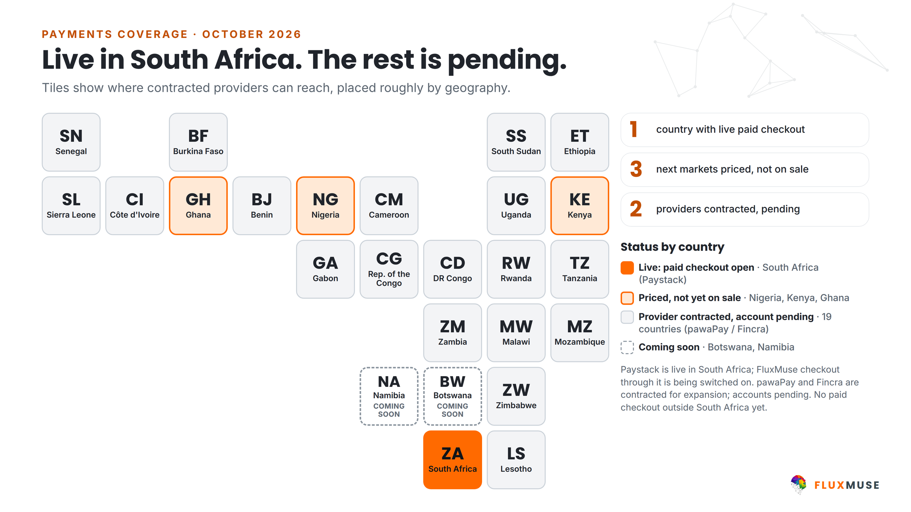
Figure 12. Live in South Africa. The rest is pending.
- Settlement runs through each provider to the merchant's own South African bank account; FluxMuse does not hold the money. [[SETTLEMENT TERMS AND RECONCILIATION PROCESS]].
- Processing cost on FluxMuse's own subscriptions is modelled at 3.0% (Paystack 2.9% + R1), plus 1.5% for mobile money and FX on non-South African revenue.
- Appendix B shows status by country.

Customer onboarding and support
- First group: set up by hand by the founders, one business at a time.
- Solo: self-serve or a short demo on their own products.
- SME: a discovery call, a demo and set-up by hand.
- Agency: a live demo on a client's public catalogue, then white-label set-up.
- A customer success team is hired from the seed month and sits in cost of revenue: 3 people at the end of FY1 rising to 13 by FY5.

Data protection and security
- Built to be POPIA ready; row-level security on every table; encrypted tokens; data export and account deletion on request.
- Broadcasts go only to consented contacts, using Meta-approved templates, with an opt-out.
- Screenshots and case studies blur customer names and phone numbers.
- [[SECURITY POLICY, BREACH-RESPONSE PLAN, PENETRATION TEST AND HOSTING REGIONS: TO CONFIRM]]

Suppliers and key partners
Partner | Role | Dependency
Meta | WhatsApp Cloud API, Facebook and Instagram | High: see section 14
Supabase and Vercel | Database, authentication, edge functions, hosting | Medium: replaceable, with effort
AI model providers | Inference behind the assistant | Medium: cost and availability
Paystack; pawaPay and Fincra (pending) | Collections and payouts | High until expansion rails are live
Agency partners | White-label distribution | Builds over time

11. Management and organisation

Founders and team
Role | Name | Background and responsibility
Founder | Thabo Malebadi | [[TITLE, BACKGROUND, YEARS OF EXPERIENCE, RESPONSIBILITY]]
CTO / founding engineer | [[CTO NAME]] | [[BACKGROUND, RESPONSIBILITY]]
[[ROLE]] | [[NAME]] | [[BACKGROUND, RESPONSIBILITY]]

Both founders are on reduced salaries until the seed lands (R45,000 and R55,000 cost to company a month) [[CONFIRM]], which keeps the pre-seed burn small.
Advisors. [[ADVISORS: NAMES, AREAS AND WHAT THEY CONTRIBUTE]]

Governance
- Board composition after the round: [[BOARD COMPOSITION AND INVESTOR RIGHTS]].
- Reporting: monthly management accounts and the KPI dashboard in section 15; quarterly board meetings ([[CONFIRM REPORTING CADENCE WITH INVESTORS]]).
- Financial controls: [[SIGNING AUTHORITY, APPROVAL LIMITS, PAYROLL AND PAYMENT CONTROLS]].

The hiring plan
Nobody is hired on a calendar date alone. Every non-founder role waits for its earliest month, the seed, and last month's net MRR clearing that role's gate. The hiring plan is unchanged from the previous model; the seed was sized to it rather than the other way round.
Department | FY1  Oct 2026–Sep 2027 | FY2  Oct 2027–Sep 2028 | FY3  Oct 2028–Sep 2029 | FY4  Oct 2029–Sep 2030 | FY5  Oct 2030–Sep 2031
Leadership | 2 | 2 | 2 | 2 | 2
Engineering & product | 4 | 7 | 11 | 16 | 18
Marketing | 2 | 4 | 6 | 9 | 9
Sales & partnerships | 1 | 4 | 4 | 7 | 7
Customer success | 3 | 3 | 7 | 13 | 13
G&A & compliance | 1 | 2 | 3 | 5 | 6
Country teams | 0 | 1 | 8 | 15 | 15
Total headcount | 13 | 23 | 41 | 67 | 70

Source: FluxMuse Financial Model v3 (Base case), derived from the model's headcount rows.
Jobs created. The plan grows from 2 founders to 13 people by the end of FY1 and 70 by FY5, of which 15 are country-team roles in Nigeria, Kenya and Ghana and 13 are customer-success roles.

When each role is hired
The first month each role group is hired in the Base case, and the net MRR gate it waits for. Country-team roles are tied to their market's launch. Roles whose gate is not reached within FY5 are left out.
FY | First hired | FTE | Role | Net MRR gate
FY1 | Mar 2027 | 1 | AI / ML engineer | At the seed
FY1 | Jun 2027 | 2 | CS & onboarding agents | R150,000
FY1 | Feb 2027 | 1 | Customer success lead | At the seed
FY1 | Jun 2027 | 1 | Finance & compliance manager | R150,000
FY1 | Feb 2027 | 1 | Head of Growth | At the seed
FY1 | Feb 2027 | 1 | Partnerships manager #1 (agency programme) | At the seed
FY1 | Apr 2027 | 1 | Performance marketer | R100,000
FY1 | Jun 2027 | 1 | Product designer (UX) | R150,000
FY1 | Feb 2027 | 2 | Senior full-stack engineers | At the seed
FY2 | Aug 2028 | 1 | Country lead: Nigeria | Tied to market launch
FY2 | Jul 2028 | 1 | DevOps / QA engineer | R800,000
FY2 | Dec 2027 | 2 | Full-stack engineers | R400,000
FY2 | Oct 2027 | 2 | Multilingual content & community | R300,000
FY2 | Feb 2028 | 1 | Operations & admin | R500,000
FY2 | Jul 2028 | 1 | Partnerships manager #2 | R800,000
FY2 | Mar 2028 | 2 | SME onboarding & sales-assist | R600,000
FY3 | Nov 2028 | 4 | CS agents II | R1,200,000
FY3 | Feb 2029 | 1 | Country lead: Ghana | Tied to market launch
FY3 | Nov 2028 | 1 | Country lead: Kenya | Tied to market launch
FY3 | Apr 2029 | 2 | Ghana sales & CS | Tied to market launch
FY3 | Oct 2028 | 2 | Integrations engineers (social adapters, commerce, CRM) | R1,000,000
FY3 | Jan 2029 | 1 | Kenya sales & CS | Tied to market launch
FY3 | Jun 2029 | 1 | Legal & data-protection counsel | R2,000,000
FY3 | Feb 2029 | 2 | Lifecycle & growth marketers | R1,500,000
FY3 | Oct 2028 | 2 | Nigeria sales & CS | Tied to market launch
FY3 | Feb 2029 | 1 | Product manager | R1,500,000
FY3 | Sep 2029 | 1 | Security & compliance engineer | R2,500,000
FY4 | Feb 2030 | 6 | CS agents III | R3,500,000
FY4 | Sep 2030 | 3 | Engineers (scale-up I) | R5,000,000
FY4 | Sep 2030 | 1 | Finance analyst | R5,000,000
FY4 | Apr 2030 | 2 | Ghana team expansion | Tied to market launch
FY4 | Sep 2030 | 1 | Head of Sales & Partnerships | R5,000,000
FY4 | Jan 2030 | 2 | Kenya team expansion | Tied to market launch
FY4 | Sep 2030 | 3 | Marketing team expansion I | R5,000,000
FY4 | Oct 2029 | 3 | Nigeria team expansion | Tied to market launch
FY4 | Feb 2030 | 2 | Partnerships managers (scale-up I) | R3,500,000
FY4 | Feb 2030 | 2 | Payments & data engineers | R3,500,000
FY4 | Feb 2030 | 1 | People & HR partner | R3,500,000
FY5 | Sep 2031 | 1 | CFO | R8,000,000
FY5 | Sep 2031 | 1 | Product manager #2 | R8,000,000
FY5 | May 2031 | 1 | VP Engineering | R7,000,000

Source: FluxMuse Financial Model v3, model date 2026-10-05 (Base case); Financial_Model_Notes.md.

12. Financial plan
Every figure in this section comes from the FluxMuse Financial Model v3, model date 2026-10-05, Base case unless stated. The workbook carries the monthly build; this section summarises it. These are forward-looking projections, not results. FluxMuse has no paying customers yet, so every volume and rate is an assumption, and many are still marked [[CONFIRM]] (Appendix E).

Key assumptions
- Timing. Month 1 is October 2026; the fiscal year runs October to September. The R46m seed is modelled to land in Feb 2027 [[CONFIRM]]. Until then the business runs lean: two founders on reduced salaries, lean hosting and overheads, the first-group set-up cost, and no paid marketing or hiring.
- No trials, no pilot. South Africa sells from October 2026. A first group of businesses is set up by hand from October 2026 to January 2027 [[CONFIRM]].
- Sign-ups. 150 self-serve sign-ups in South Africa in October 2026, growing 12% a month in FY1 [[CONFIRM]]. 5% of Solo and 8% of SME sign-ups pay at once; the rest join Free, which upgrades at 0.5% a month [[CONFIRM]].
- Pricing. The nine live plans; Solo buyers mostly on Nano and Micro, SMEs on Starter, Growth and Scale. Annual plans are 10× monthly and 25% of subscriptions. No VAT.
- AI cost. R0.15 of provider cost per credit, the product's own figure.
- Markets. South Africa only until Nigeria, Kenya and Ghana checkout is live; each then waits for an MRR gate.
- Cost discipline. Hiring and launches wait for net MRR gates; paid acquisition is capped at R40,000 plus 35% of last month's net MRR and switched off where CAC payback would exceed 12 months.
- Funding. The R46m seed only; the Series A input is zero. Tax at 27% only once cumulative EBITDA is positive.

Revenue build
Revenue is mostly recurring subscriptions, plus AI-credit packs, WhatsApp messaging resold at Meta cost plus a margin, and Custom setup fees. There is no FluxMuse checkout fee.
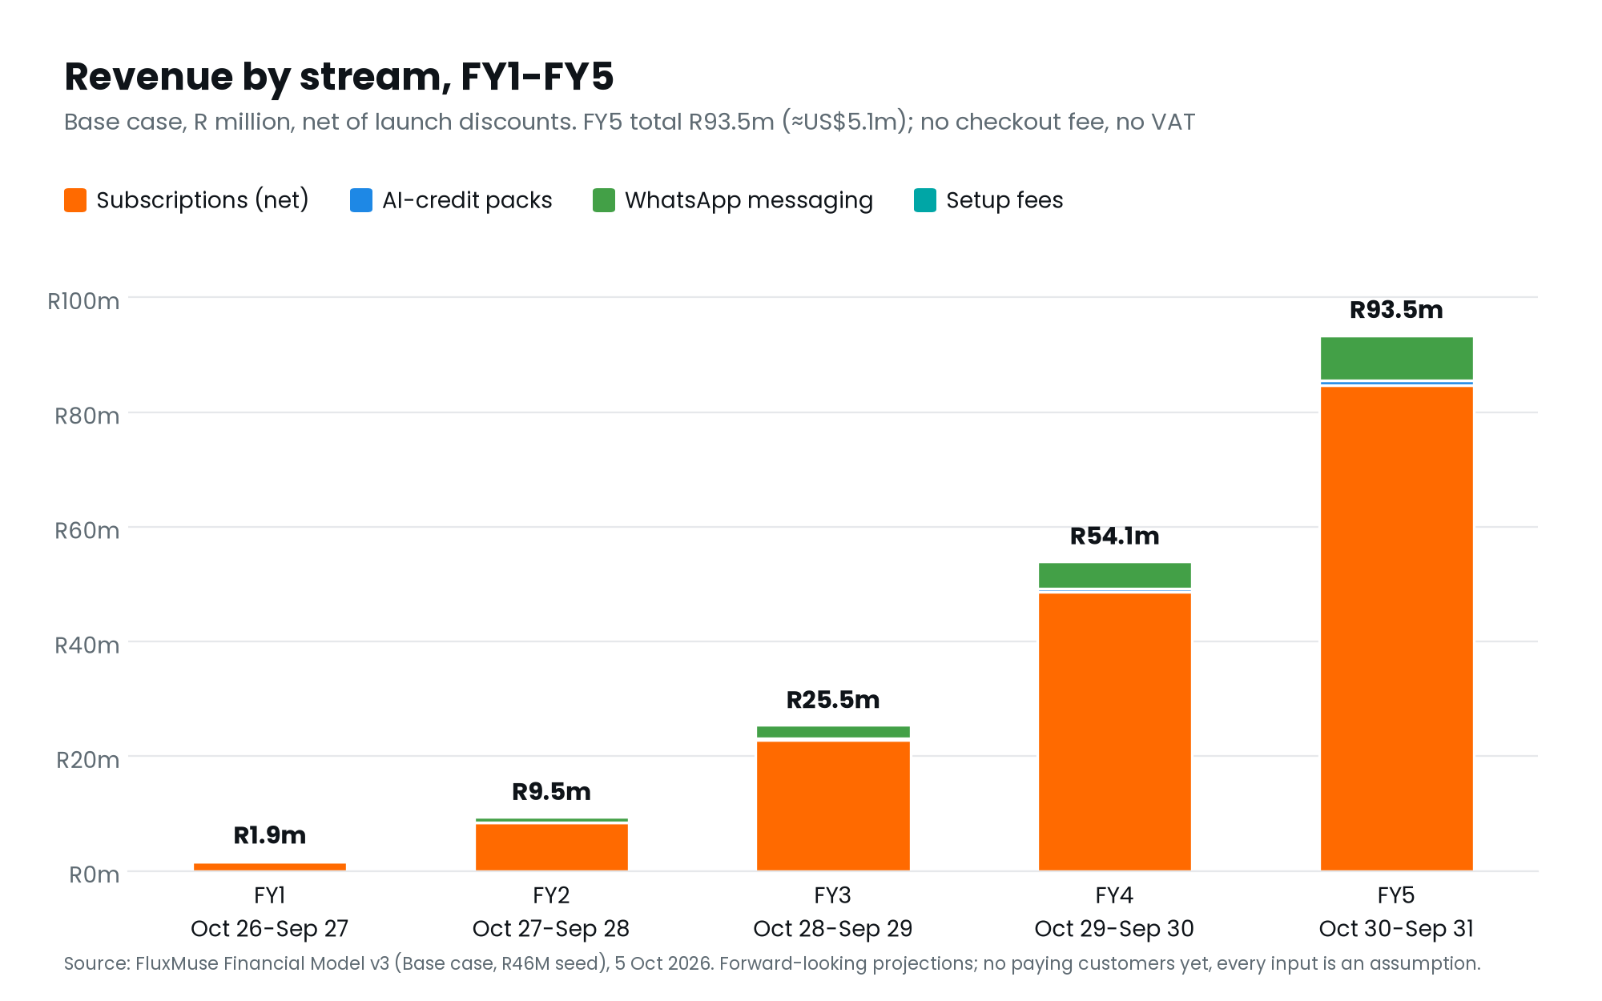
Figure 13. Revenue by stream, FY1–FY5 (Base case), net of the Founding Member discount.
R million unless stated | FY1  Oct 2026–Sep 2027 | FY2  Oct 2027–Sep 2028 | FY3  Oct 2028–Sep 2029 | FY4  Oct 2029–Sep 2030 | FY5  Oct 2030–Sep 2031
Subscriptions (net) | R1.6m | R8.4m | R22.8m | R48.7m | R84.7m
AI-credit packs | R0.02m | R0.09m | R0.23m | R0.50m | R0.85m
WhatsApp messaging | R0.20m | R0.93m | R2.39m | R4.79m | R7.88m
Custom setup fees | R0.00m | R0.03m | R0.05m | R0.07m | R0.10m
Total revenue | R1.9m | R9.5m | R25.5m | R54.1m | R93.5m
Total revenue (US$ m) | US$0.10m | US$0.51m | US$1.38m | US$2.92m | US$5.06m
Growth on prior year | n/a | 407% | 169% | 112% | 73%

Source: FluxMuse Financial Model v3, model date 2026-10-05 (Base case); Financial_Model_Notes.md.
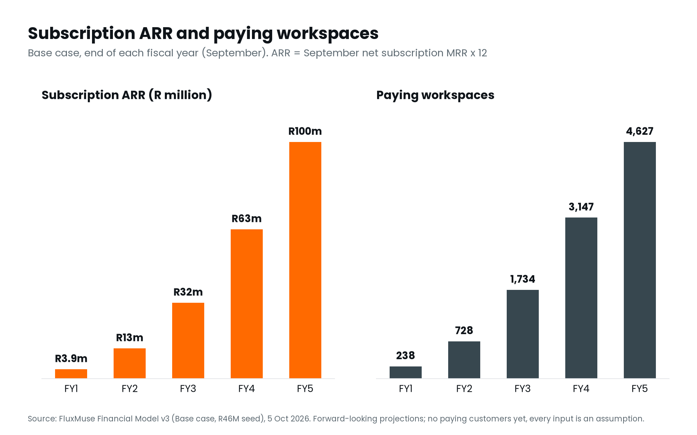
Figure 14. Subscription ARR and paying workspaces at each year end (Base case).
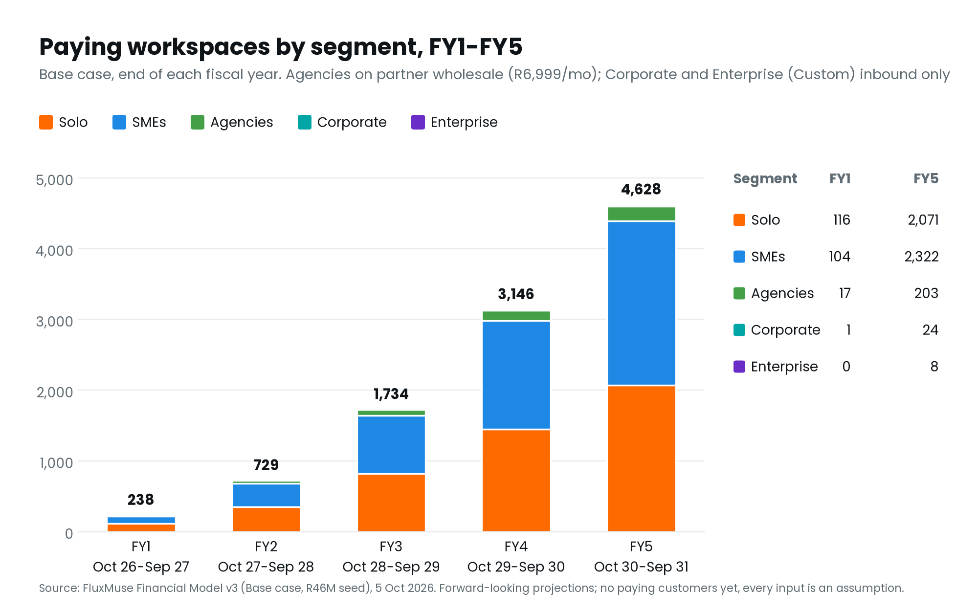
Figure 15. Paying workspaces by segment (Base case).
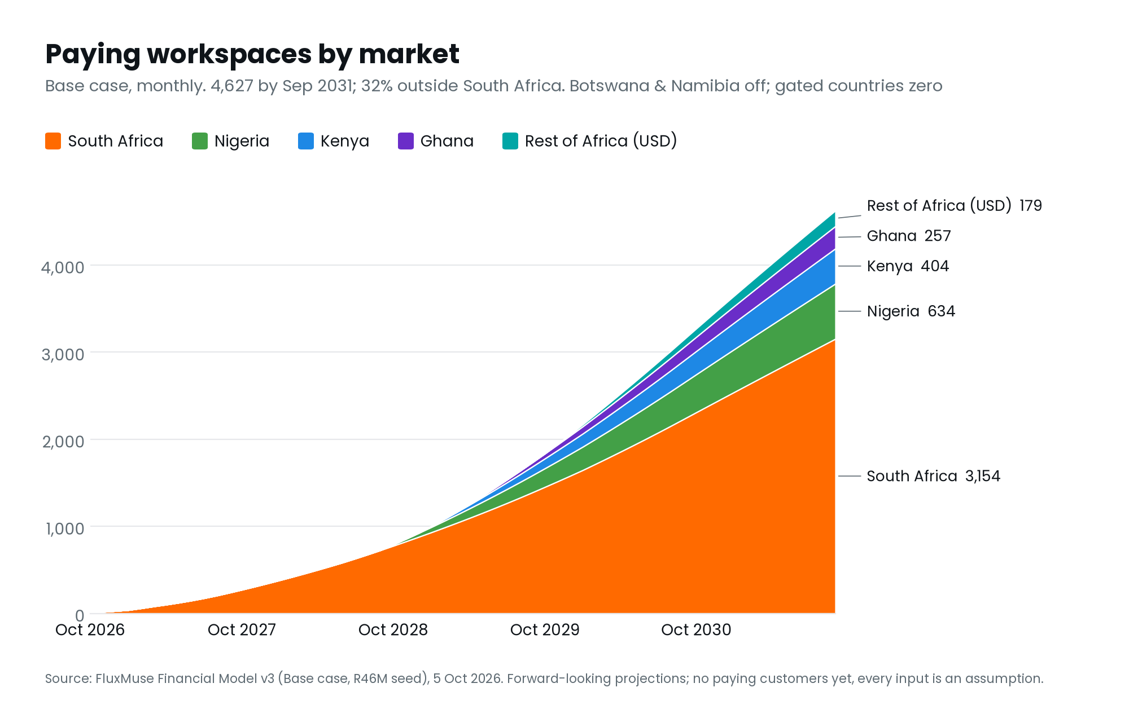
Figure 16. Paying workspaces by market (Base case). Markets outside South Africa wait for payment accounts.
Free plan | FY1  Oct 2026–Sep 2027 | FY2  Oct 2027–Sep 2028 | FY3  Oct 2028–Sep 2029 | FY4  Oct 2029–Sep 2030 | FY5  Oct 2030–Sep 2031
Active Free users (Sept) | 2,275 | 5,490 | 12,484 | 20,478 | 27,061
Free users upgrading to paid in the year | 54 | 224 | 511 | 969 | 1,419
Cost of the Free plan (R) | R85,805 | R299,743 | R645,764 | R1,135,323 | R1,556,763

Source: FluxMuse Financial Model v3, model date 2026-10-05 (Base case); Financial_Model_Notes.md.

Profit and loss summary
R million unless stated | FY1  Oct 2026–Sep 2027 | FY2  Oct 2027–Sep 2028 | FY3  Oct 2028–Sep 2029 | FY4  Oct 2029–Sep 2030 | FY5  Oct 2030–Sep 2031
Revenue | R1.9m | R9.5m | R25.5m | R54.1m | R93.5m
Cost of revenue | R1.5m | R4.3m | R9.7m | R18.1m | R27.2m
Gross profit | R0.4m | R5.2m | R15.8m | R36.0m | R66.3m
Gross margin | 22% | 54% | 62% | 66% | 71%
Software gross margin | 23% | 59% | 67% | 71% | 76%
Operating expenses | R7.4m | R16.9m | R32.8m | R46.5m | R61.8m
EBITDA | R-7.0m | R-11.7m | R-16.9m | R-10.6m | R4.5m
EBITDA margin | n/m | -124% | -66% | -20% | 5%
Tax | R0.00m | R0.00m | R0.00m | R0.00m | R0.00m
Net income | R-7.0m | R-11.7m | R-16.9m | R-10.6m | R4.5m

Source: FluxMuse Financial Model v3, model date 2026-10-05 (Base case); Financial_Model_Notes.md.
Gross margin is low in FY1 and FY2 because AI cost (R0.15 a credit) and the Free plan weigh on a small revenue base. WhatsApp messaging is booked gross, so the software gross margin line shows the platform margin.

Cash flow and funding
R million unless stated | FY1  Oct 2026–Sep 2027 | FY2  Oct 2027–Sep 2028 | FY3  Oct 2028–Sep 2029 | FY4  Oct 2029–Sep 2030 | FY5  Oct 2030–Sep 2031
Opening cash | R0.5m | R39.7m | R28.5m | R12.8m | R4.2m
EBITDA | R-7.0m | R-11.7m | R-16.9m | R-10.6m | R4.5m
Tax paid | R0.0m | R0.0m | R0.0m | R0.0m | R0.0m
Working capital movement | R0.17m | R0.51m | R1.18m | R2.03m | R2.56m
Operating cash flow | R-6.8m | R-11.2m | R-15.7m | R-8.5m | R7.1m
Equity funding (seed) | R46.0m | R0.0m | R0.0m | R0.0m | R0.0m
Closing cash | R39.7m | R28.5m | R12.8m | R4.2m | R11.3m
Lowest month-end cash in year | R-0.07m | R28.50m | R12.76m | R4.23m | R4.00m

Source: FluxMuse Financial Model v3, model date 2026-10-05 (Base case); Financial_Model_Notes.md.
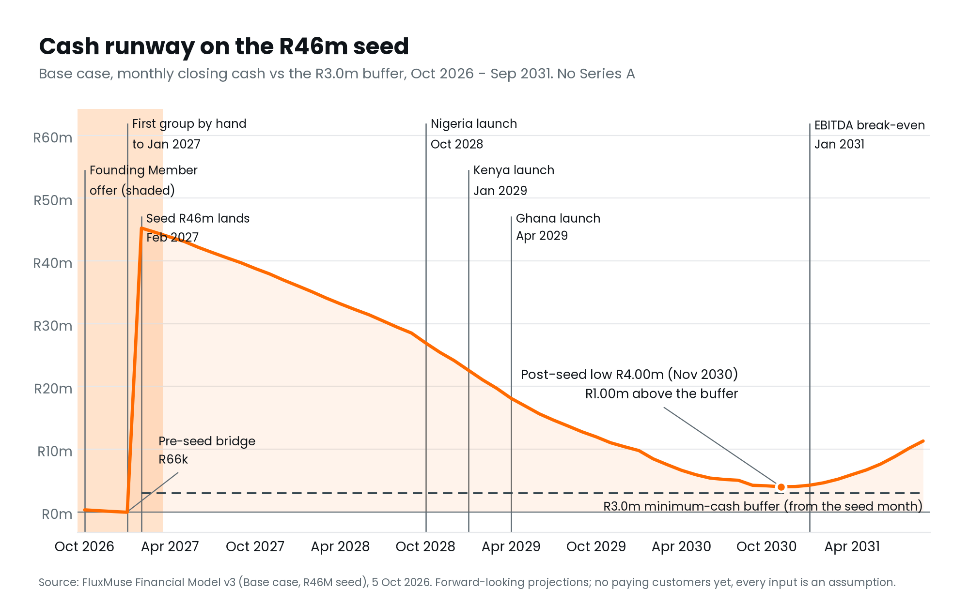
Figure 17. Monthly closing cash on the R46m seed against the R3.0m buffer (Base case). No Series A.
- Pre-seed bridge: R66,279. On opening cash of R500,000 ([[CONFIRM OPENING CASH]]), cash dips to −R66k in Jan 2027, one month before the seed lands.
- Minimum cash after the seed: R4.00m in Nov 2030, only R1.00m above the R3.0m buffer, 45 months after the seed.
- Runway at the seed close: about 54 months at the average net burn of the following year (R845,756 a month).

Break-even
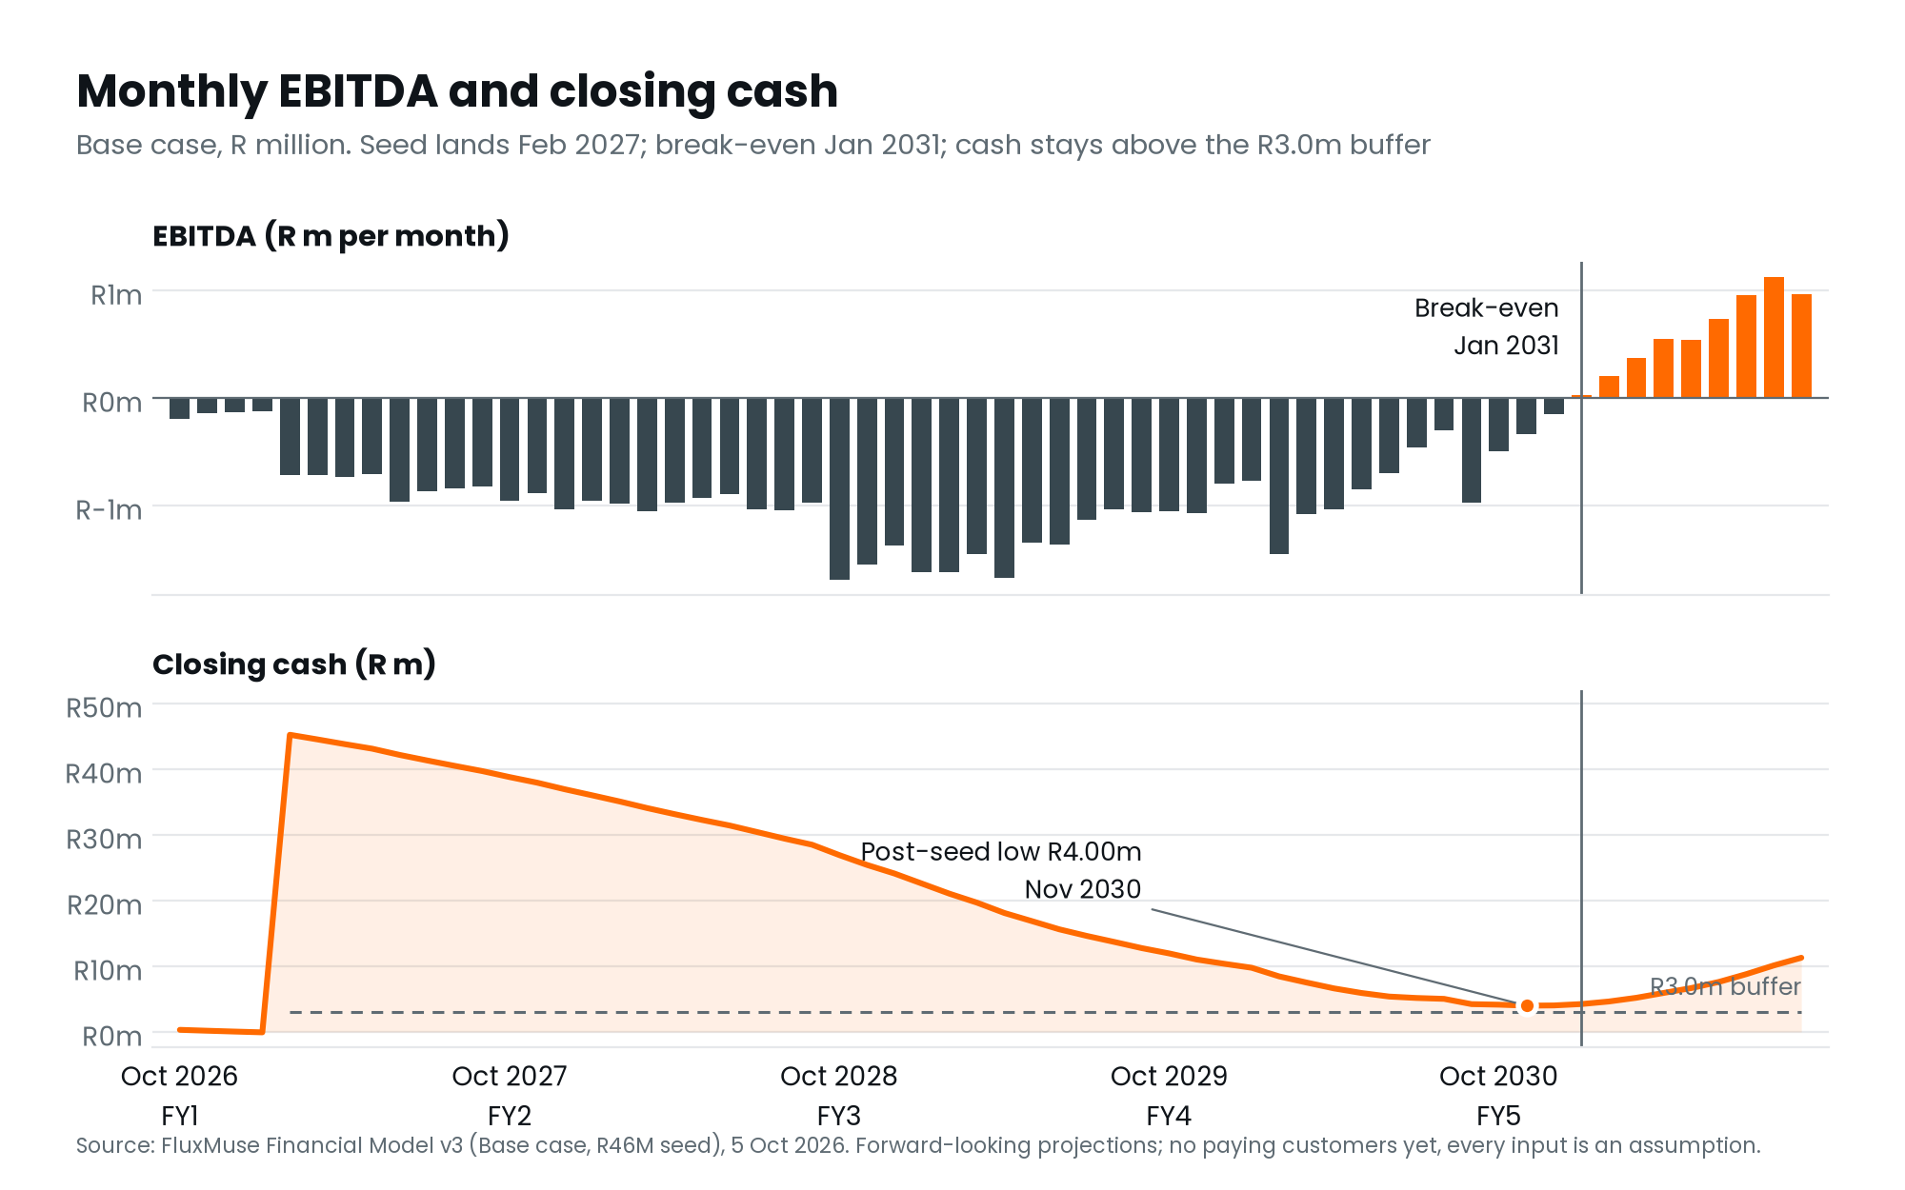
Figure 18. Monthly EBITDA and closing cash (Base case).
Milestone | Base case
First month of positive EBITDA | Jan 2031
EBITDA positive every month from | Jan 2031
First month of positive operating cash flow | Dec 2030
Operating cash flow positive every month from | Dec 2030
Profitable on the R46m seed alone | Base Yes; Upside Yes; Conservative No

Unit economics
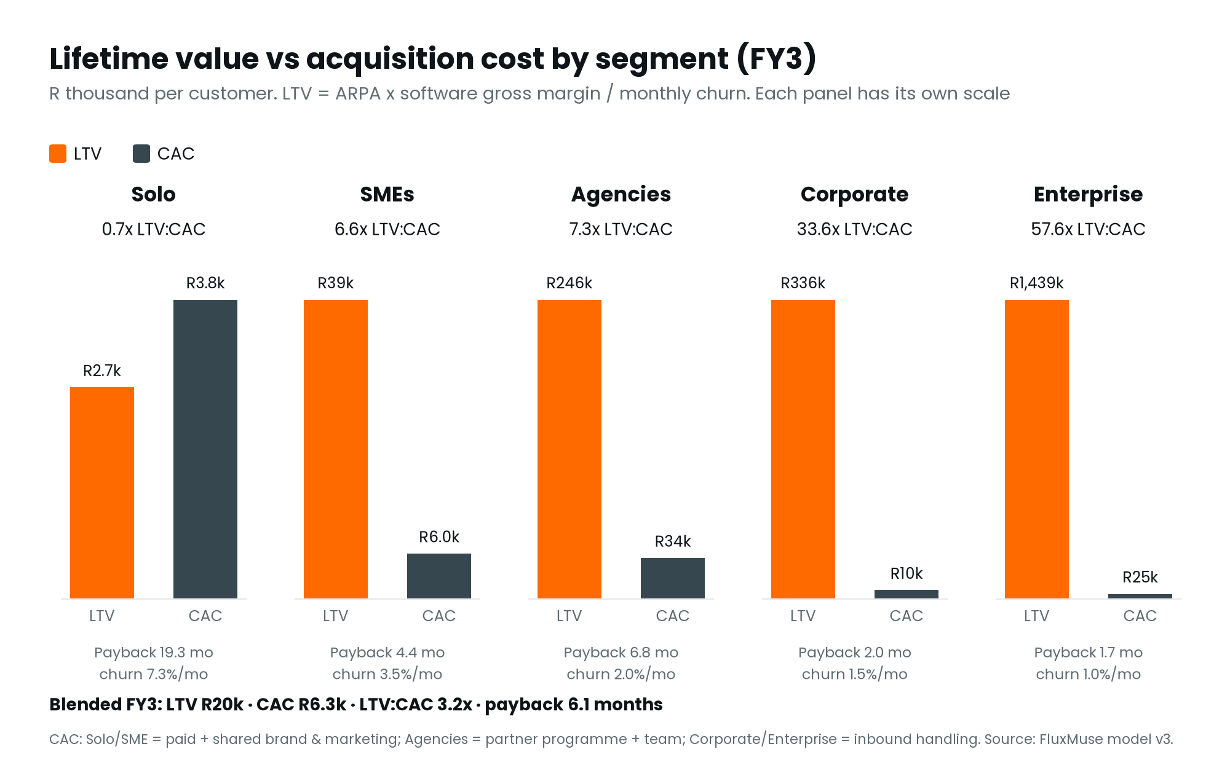
Figure 19. Lifetime value against acquisition cost by segment, FY3 (Base case).
Segment, FY3 | ARPA (R/month) | Monthly churn | LTV | CAC | LTV:CAC | Payback
Solo | R291 | 7.3% | R2,659 | R3,760 | 0.7x | 19.3 months
SMEs | R2,024 | 3.5% | R39,214 | R5,957 | 6.6x | 4.4 months
Agencies | R7,453 | 2.0% | R245,679 | R33,673 | 7.3x | 6.8 months
Corporate | R7,536 | 1.5% | R335,754 | R10,000 | 33.6x | 2.0 months
Custom | R21,535 | 1.0% | R1,439,081 | R25,000 | 57.6x | 1.7 months
Blended | R1,546 | — | R19,908 | R6,272 | 3.2x | 6.1 months

Source: FluxMuse Financial Model v3, model date 2026-10-05 (Base case); Financial_Model_Notes.md.
- LTV is ARPA × software gross margin ÷ monthly logo churn. Solo and SME CAC includes paid spend plus a share of brand, launch and marketing payroll.
- Solo does not pay back on fully loaded CAC (0.7×). Nano and Micro are cheap and churn fast. Solo customers earn their place through the Free plan and upgrades, not paid acquisition at scale.
- SMEs and agencies carry the economics (6.6× and 7.3×).

Scenarios
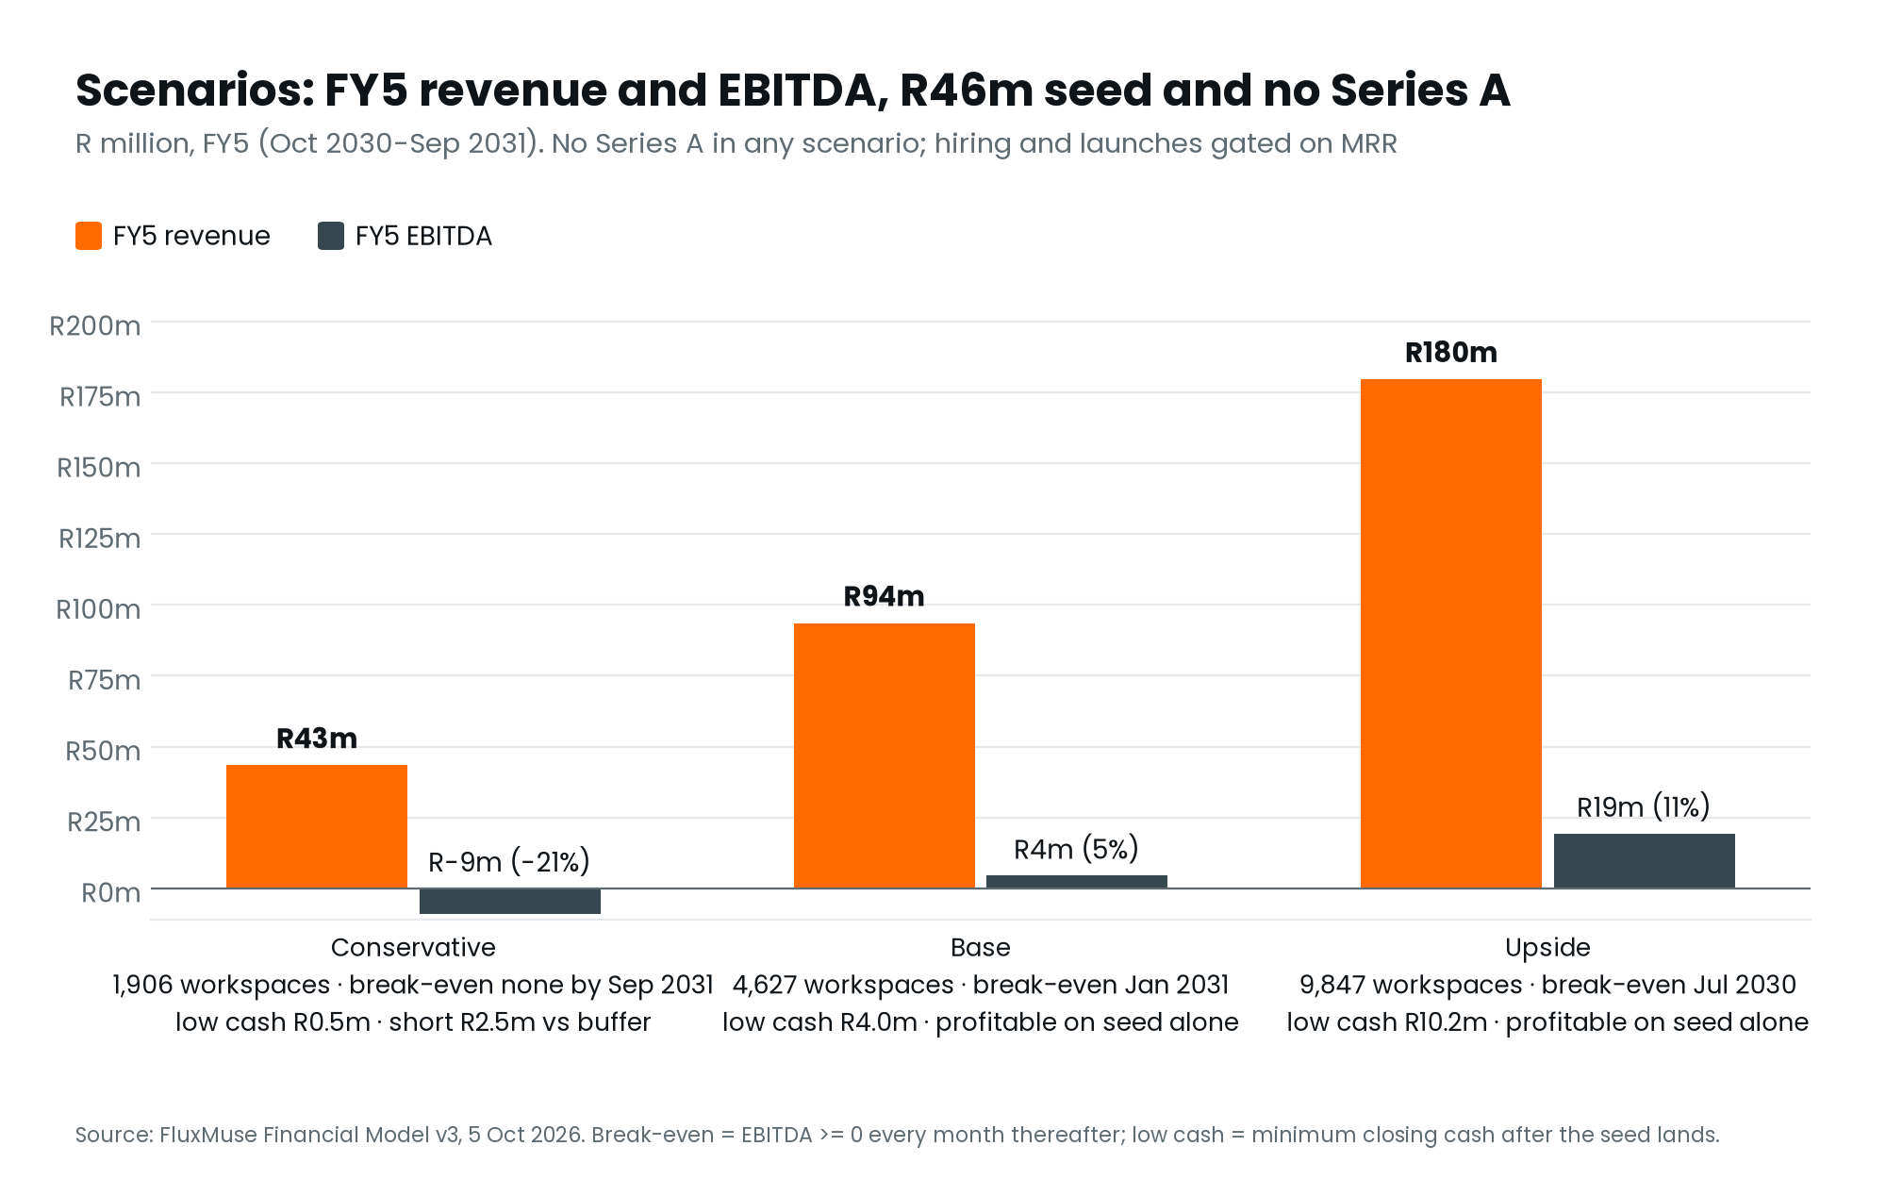
Figure 20. FY5 revenue and EBITDA in all three scenarios, on the R46m seed. Conservative fails the test.
 | Conservative | Base | Upside
Revenue FY1 / FY3 / FY5 (R m) | 1.6 / 14.5 / 43.4 | 1.9 / 25.5 / 93.5 | 2.2 / 44.8 / 179.6
EBITDA FY3 / FY5 (R m) | -9.7 / -9.2 | -16.9 / 4.5 | -15.2 / 19.4
FY5 EBITDA margin | -21% | 5% | 11%
Paying workspaces FY5 | 1,906 | 4,627 | 9,847
Headcount FY5 | 48 | 70 | 135
EBITDA positive every month from | Not within horizon (to Sep 2031) | Jan 2031 | Jul 2030
Minimum cash after the seed | R0.53m (Sep 2031) | R4.00m (Nov 2030) | R10.16m (Dec 2029)
First month below the buffer | May 2031 | Never | Never
Nigeria / Kenya / Ghana launch | Nov 2029 / Apr 2030 / Sep 2030 | Oct 2028 / Jan 2029 / Apr 2029 | Apr 2028 / Jul 2028 / Sep 2028
Profitable on R46m alone | No | Yes | Yes

Source: FluxMuse Financial Model v3, model date 2026-10-05 (Base case); Financial_Model_Notes.md.
The Conservative case fails on R46m, and we say so
Cash stays above zero but falls below the R3.0m buffer from May 2031 (low R0.53m, short R2.47m), and EBITDA does not turn positive by Sep 2031.
- The smallest single fixes would be a 2.5× hiring and launch gate multiplier, or a 31% cut to every non-founder salary. Neither is adopted.
- If early data looks like Conservative, the response is to slow hiring and launches early, before the cash is spent.

Sensitivities: the headroom is thin
The R46m buys about R1.0m of headroom, not a margin of safety. The grid shows minimum post-seed cash on Base gates as new-customer volume and churn move.
Churn × / Volume → | 70% | 85% | 100% | 115% | 130%
0.70× | R1.26m | R5.22m | R7.98m | R9.96m | R12.25m
0.85× | R-0.81m | R3.49m | R6.11m | R8.70m | R10.59m
1.00× | R-4.12m | R0.80m | R4.00m | R6.83m | R8.92m
1.15× | R-5.70m | R-1.42m | R2.95m | R5.18m | R6.90m
1.30× | R-8.62m | R-4.52m | R-0.38m | R3.43m | R5.55m

Source: FluxMuse Financial Model v3, model date 2026-10-05 (Base case); Financial_Model_Notes.md.
Free-to-paid upgrade rate | FY3 revenue | FY5 EBITDA | Minimum post-seed cash | Passes
0.25% a month | R22.3m | R-2.3m | R-0.72m | No
0.5% a month (default) | R25.5m | R4.5m | R4.00m | Yes
1.0% a month | R31.1m | R15.2m | R10.76m | Yes

Source: FluxMuse Financial Model v3, model date 2026-10-05 (Base case); Financial_Model_Notes.md.
- Sign-ups 15% below plan take minimum cash to R0.80m, below the buffer; churn 15% worse takes it to R2.95m.
- Free upgrades at 0.25% a month take it to R-0.72m: the plan fails.
- The response is pre-agreed: measure pay-at-sign-up and Free upgrades from the first month, and raise the hiring gates early if they lag.

FX shock: the rand 15% stronger
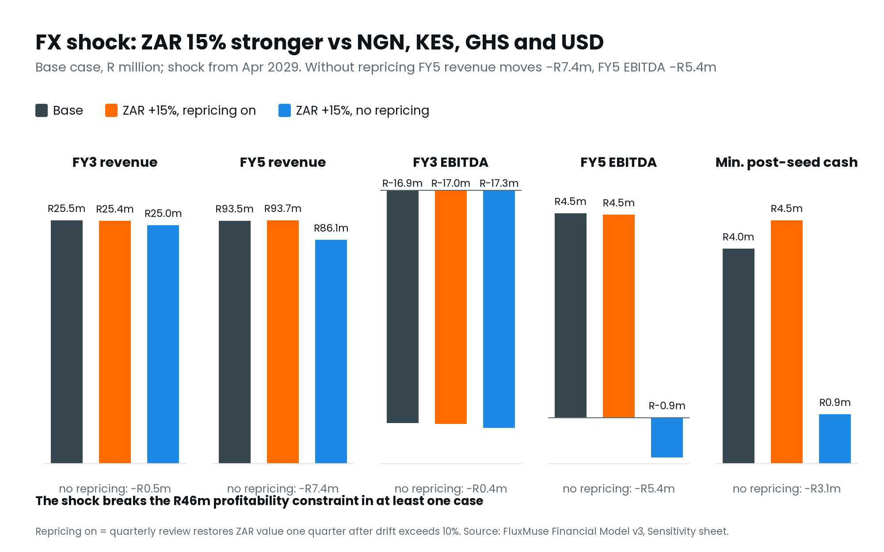
Figure 21. A 15% stronger rand against NGN, KES, GHS and USD from April 2029, with and without quarterly repricing.
Outcome | Base | Rand +15%, repricing on | Rand +15%, no repricing
FY3 revenue | R25.49m | R25.44m | R24.98m
FY5 revenue | R93.52m | R93.66m | R86.12m
FY5 EBITDA | R4.50m | R4.47m | R-0.88m
Minimum post-seed cash | R4.00m | R4.53m | R0.92m
Profitable on R46m alone | Yes | Yes | No

Source: FluxMuse Financial Model v3, model date 2026-10-05 (Base case); Financial_Model_Notes.md.
Quarterly repricing is the main FX control. Without it, the shock breaks the buffer.

What the launch offer costs
Launch offer (Base case) | FY1–FY3 discount cost | Minimum post-seed cash | Profitable on R46m
Founding Member (live) | R32k | R4.00m | Yes
No launch offer | R0 | R3.95m | Yes

Because sign-ups are assumed to rise 20% while the offer runs, it leaves marginally more cash than no offer. That uplift is unproven.

13. Funding request and use of funds

The ask
Amount | R46,000,000 (about US$2,486,486)
Round | Seed
Instrument | [[INSTRUMENT: SAFE OR PRICED EQUITY]]
Valuation | [[PRE-MONEY VALUATION: TBC]]
Modelled close | Feb 2027 (model input; an earlier close removes the pre-seed bridge)
Why this size | R45.1m is the smallest seed at which the Base case passes on the current offer, rounded up to R46m [[CONFIRM]]
Follow-on funding | None in the Base and Upside cases. The Conservative case falls short
Minimum-cash policy | Closing cash at or above R3.0m every month from the seed

Allocation
Category | Share | R | What it buys and when
Product & engineering | 40% | R18.40m | Senior full-stack x2, AI/ML, designer, full-stack x2, DevOps/QA, integrations x2, PM, security; founders' salaries; hosting & AI inference; Instagram/Threads/LinkedIn/TikTok adapters, commerce/CRM integrations, AI cost optimisation.
Sales & marketing / partner programme | 30% | R13.80m | Head of Growth, performance & multilingual content marketers, partnerships managers, SME onboarding; paid acquisition (capped at a % of MRR and a CAC-payback test), brand & community, Flux_Partner programme.
Market expansion (NG, KE, GH) & payments compliance | 15% | R6.90m | Country leads and local sales/CS in Nigeria, Kenya and Ghana; NDPR/KDPA/Ghana DPC registrations, local counsel, launch campaigns, POPIA/Meta compliance base, Rest-of-Africa digital-services tax registrations where required.
Operations & working capital | 15% | R6.90m | Customer success team, finance & compliance, operations, G&A, tooling, travel, payment processing, support, WhatsApp pass-through costs, and the working-capital float that protects the R3.0M cash buffer.

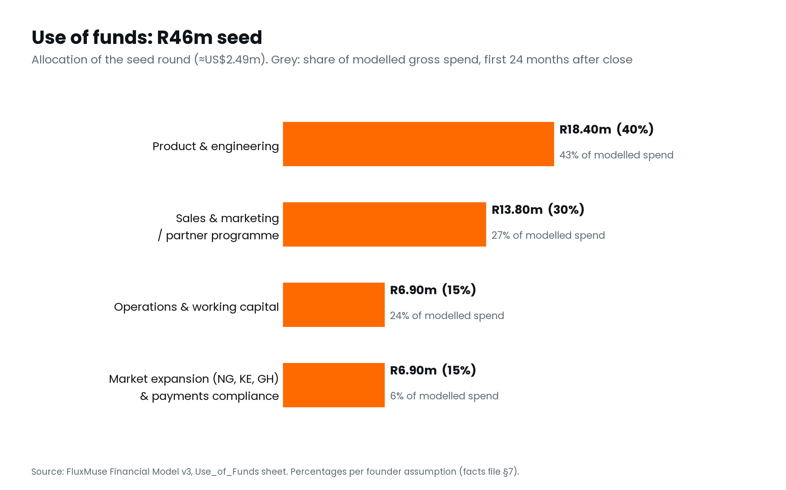
Figure 22. The R46m seed by category.
Timing. Product and engineering hires begin in the seed month; growth and partnerships hires follow; country leads are hired two months before each market launch, which waits for the payment accounts and an MRR gate.

How the allocation compares with modelled spend
The seed funds net burn, not gross spend, because revenue pays a growing share of costs. Over the 24 months from the seed (Feb 2027 - Jan 2029 (months 5-28)):
Category | Allocation | Modelled spend, 24 months | Share of spend | Gap
Product & engineering | 40% | R17.60m | 43.1% | +3.1 pp
Sales & marketing / partner programme | 30% | R10.90m | 26.7% | -3.3 pp
Market expansion (NG, KE, GH) & payments compliance | 15% | R2.38m | 5.8% | -9.2 pp
Operations & working capital | 15% | R9.91m | 24.3% | +9.3 pp
Total gross spend |  | R40.79m
less revenue collected |  | R17.43m
Net cash consumed from the seed |  | R23.36m
Seed remaining after 24 months |  | R22.64m

Source: FluxMuse Financial Model v3, model date 2026-10-05 (Base case); Financial_Model_Notes.md.
- Expansion is under-spent against its 15% share (5.8% of spend, -9.2 points) because Nigeria, Kenya and Ghana open late in the window.
- Operations runs over its 15% share (24.3%, +9.3 points) because customer success, hosting, AI and support scale with customers.

Why most of the seed is still there after two years
About R22.6m is unspent 24 months after close. It is not a reserve on top of the plan: the Base case needs it to carry the business through the long loss-making stretch to the Nov 2030 low, 45 months after the seed.

The pre-seed bridge
On the modelled Feb 2027 close and opening cash of R500,000, the business needs a bridge of R66,279 in Jan 2027. Options are a founder loan or closing the round earlier. [[HOW THE PRE-SEED BRIDGE WILL BE COVERED]]

Investor return considerations
This plan does not propose a valuation or model a return. What it does say:
- The round is sized to reach profitability in the Base case, with no Series A. It is not sized for the Conservative case, which falls short, and the Base headroom is thin.
- Cash generation starts inside the horizon in the Base case: operating cash flow turns positive in Dec 2030.
- Recurring revenue: subscription ARR of R100m by FY5, FY3 blended LTV:CAC of 3.2×.
- Not in the projections: campaign financing (upside only), partner referral commission (undecided), series a (optional acceleration only).
- Exit routes: [[EXIT CONSIDERATIONS: TO BE DISCUSSED WITH INVESTORS]].

14. Risk analysis
Likelihood and impact are assessed on the plan as it stands, after the mitigations built into the model (MRR-gated hiring and launches, capped paid acquisition and the R3.0m minimum-cash buffer). Owners are to be assigned before this plan is issued.
# | Risk | Likelihood | Impact | Mitigation | Owner
R1 | Demand is unproven. There are no paying customers; sign-ups and conversion may fall short | High | High | The model quantifies it: sign-ups 15% below plan take minimum cash to R0.80m, below the buffer. Measure from month 1; raise hiring and launch gates early if early data lags | [[OWNER]]
R2 | Thin headroom on the seed. The Base case passes by about R1.0m; Conservative fails | Medium | High | Free upgrades at 0.25% a month take minimum cash to R-0.72m. Pre-agreed response: slow hiring, delay launches. If that is not enough, raise more or cut cost early [[FOUNDER: CONTINGENCY]] | [[OWNER]]
R3 | Meta dependency. Publishing permissions refused or delayed, or policy and pricing change | Medium | High | Verified Tech Provider; WhatsApp Business is live. Nothing waiting on Meta is sold as live; WhatsApp Status and TikTok work today | [[OWNER]]
R4 | Payment accounts. Only South Africa has live checkout; FluxMuse checkout is untested with real money | Medium | High | Test checkout end to end before offering it. pawaPay and Fincra are contracted; no expansion market opens until its accounts are live | [[OWNER]]
R5 | FX. The rand strengthens against NGN, KES, GHS or USD | Medium | Medium | Quarterly repricing at more than 10% drift. Without it, a 15% shock takes minimum cash to R0.92m and the plan fails | [[OWNER]]
R6 | AI cost. Credit usage runs ahead of assumptions | Medium | Medium | Credits priced at R0.15 of provider cost with 40% utilisation assumed; allowances per plan, packs for more; Corporate and above use their own keys. Cost per credit is a monthly KPI | [[OWNER]]
R7 | Competition. A global platform adds WhatsApp selling and rand pricing | Medium | Medium | WhatsApp-first product, rand pricing and the partner channel (section 7) | [[OWNER]]
R8 | Hiring and execution | Medium | Medium | Every non-founder role waits for an MRR gate, so payroll cannot outrun revenue by design | [[OWNER]]
R9 | Regulatory. POPIA, VAT registration, data-protection registrations in new markets | Medium | Medium | Consent-only broadcasts and human-sent outreach; VAT plan before the threshold; registrations funded from the expansion budget | [[OWNER]]
R10 | Key person. The business depends on two founders | Medium | High | Senior hires as MRR allows. [[KEY-PERSON COVER AND INSURANCE]] | [[OWNER]]

The model's own limitations are listed in Appendix E: fractional customers, one-way launch and hiring decisions, deterministic FX, no downgrades, and simplified tax and working capital.

15. Milestones and KPIs

Timeline
Dates to October 2026 are facts. Later dates are model inputs or are gated on payment accounts and revenue, not on the calendar.
When | Milestone | Gate or condition
Sept 2026 | Verified Meta Tech Provider | Done
Oct 2026 | Selling in South Africa; Founding Member live (1 Oct) | Done
Oct 2026 to Jan 2027 | First group of businesses set up by hand (model input) | [[CONFIRM]]
[[TARGET DATE]] | Checkout through FluxMuse tested with real money; Meta publishing approved | Real-money test; Meta approval
Feb 2027 | R46m seed closes; hiring and capped paid acquisition begin | Round closed (model input)
Pending | Fincra and pawaPay accounts live | Provider onboarding
Oct 2028 to Apr 2029 | Nigeria Oct 2028, Kenya Jan 2029, Ghana Apr 2029 | Accounts live, then net MRR gates of R0.9m, R1.2m and R1.5m
Nov 2029 | Other covered markets, self-serve in US dollars | R2.5m net MRR gate
Dec 2030 | Operating cash flow turns positive | —
Jan 2031 | EBITDA break-even, sustained | —
FY5 (Oct 2030 – Sep 2031) | 4,627 paying workspaces, R100m subscription ARR | —
Not scheduled | Botswana and Namibia | A payment provider must cover them first

Source: FluxMuse Financial Model v3, model date 2026-10-05 (Base case); Financial_Model_Notes.md.

The KPI dashboard
Reported to investors monthly, within [[N]] working days of month end, against the model.
KPI | Why it matters | Base case reference point
Sign-ups, by market and segment | The leading indicator | 150 a month in South Africa at launch
Pay-at-sign-up rate | Sets early revenue | Solo 5%, SME 8%
Free-to-paid upgrade rate | The input that most decides whether the seed is enough | 0.5% a month
New and total paying workspaces | The headline growth number | 238 at the end of FY1
Net subscription MRR | Drives every hiring and launch gate | R326,132 in September 2027
Monthly churn by tier | Nano and Micro churn set Solo economics | Nano 8.0%, Micro 7.0%
CAC and payback by segment | The paid-spend switch is set on payback | FY3 blended CAC R6,272, payback 6.1 months
AI credits used per workspace, Free and paid | AI is the largest variable cost | 40% of allowance; R0.15 a credit
Gross margin and software gross margin | AI and messaging cost control | FY1 22% / 23%
Closing cash against the buffer | The constraint the plan is built around | Low of R4.00m in Nov 2030
Qualified leads per merchant in 30 days | The lead guarantee | 3 in 30 days of go-live
Agency partners signed | Channel health | 17 agencies by the end of FY1
Meta permissions and payment accounts | The platform and rail dependencies | Being switched on

16. Social and economic impact
This section is written for development-finance funders. Every claim below is either a modelled figure or a measurement commitment. Where we cannot yet measure something, the plan says so.

SMME enablement
- The Base case puts 4,627 small and medium businesses on paid plans by FY5, of which 2,071 are solo sellers, plus about 27,061 active users of the permanent Free plan.
- Paid plans start at R149 a month, which puts a marketing capability within reach of a business that could never fund an agency retainer.
- Customer outcomes (leads, orders, hours saved) are measured per workspace. [[BASELINE AND TARGETS: TO BE MEASURED WITH THE FIRST GROUP]]

Digital inclusion
- Owners run their marketing and shop from WhatsApp, on the phone they already own, without a website or a card machine.
- Answers in the customer's language, and voice notes are transcribed, so owners can work the way they already talk.
- Paid checkout opens only where a payment provider is live, so no business is sold a service it cannot pay for.

Jobs created
Department | FY1  Oct 2026–Sep 2027 | FY2  Oct 2027–Sep 2028 | FY3  Oct 2028–Sep 2029 | FY4  Oct 2029–Sep 2030 | FY5  Oct 2030–Sep 2031
Leadership | 2 | 2 | 2 | 2 | 2
Engineering & product | 4 | 7 | 11 | 16 | 18
Marketing | 2 | 4 | 6 | 9 | 9
Sales & partnerships | 1 | 4 | 4 | 7 | 7
Customer success | 3 | 3 | 7 | 13 | 13
G&A & compliance | 1 | 2 | 3 | 5 | 6
Country teams | 0 | 1 | 8 | 15 | 15
Total direct jobs | 13 | 23 | 41 | 67 | 70

Source: FluxMuse Financial Model v3, model date 2026-10-05 (Base case); Financial_Model_Notes.md.
- 13 jobs by the end of FY1 and 70 by FY5, from a base of two founders.
- 13 customer-success roles by FY5: the most accessible entry-level positions in the plan.
- 15 country-team roles in Nigeria, Kenya and Ghana, hired locally once those markets open.
- Indirect employment through agency partners is not counted. [[MEASUREMENT PLAN]]

Women- and youth-owned businesses
The launch segments lean towards categories where women- and youth-owned businesses are strongly represented in South Africa: beauty and braiding, fashion resale, home baking and personal services.
We do not yet have data, and will not claim any. From the first group onward we will measure reach with a voluntary, POPIA-compliant question at onboarding, and report: [[MEASURE: % OF WORKSPACES THAT ARE WOMEN-OWNED]], [[MEASURE: % YOUTH-OWNED (OWNER UNDER 35)]], [[MEASURE: % IN TOWNSHIP OR RURAL AREAS]], and [[TARGETS AGREED WITH THE FUNDER]].

Transformation and B-BBEE
B-BBEE level | [[B-BBEE LEVEL AND VERIFICATION DATE]]
Ownership | [[BLACK OWNERSHIP %, BLACK WOMEN OWNERSHIP %]]
Employment equity | [[EMPLOYMENT EQUITY PROFILE AND TARGETS FOR THE HIRING PLAN]]
Skills development | [[SKILLS DEVELOPMENT / LEARNERSHIP PLAN, IF ANY]]
Enterprise and supplier development | [[WHETHER THE PLATFORM QUALIFIES AS AN ESD CONTRIBUTION FOR CORPORATE PARTNERS]]

These fields must be completed from verified records. Do not estimate a B-BBEE level.

How impact will be reported
- Impact metrics reported quarterly alongside the monthly KPI dashboard.
- Customer-level figures aggregated and anonymised; no business named without written consent; customer names and phone numbers blurred in any screenshot (POPIA).
- [[IMPACT REPORTING FORMAT AND FREQUENCY AGREED WITH THE FUNDER]]

Appendix A. Pricing tables

South Africa (on sale)
Band | Plan | Monthly | Annual (10×) | Founding Member, first 2 monthly bills
Small | Free | R0 | R0 | —
 | Nano | R149 | R1,490 | R104
 | Micro | R289 | R2,890 | R202
Medium | Starter | R499 | R4,990 | R349
 | Growth | R1,999 | R19,990 | R1,399
 | Scale | R4,999 | R49,990 | R3,499
Enterprise | Corporate | R6,999 | R69,990 | —
 | Agency | R9,999 | R99,990 | —
 | Custom | On request | — | —
 | Partner wholesale (Agency tier) | R6,999 | R69,990 | Does not stack

Local currency and US dollars (priced, not yet on sale)
Plan, monthly | Nigeria (NGN) | Kenya (KES) | Ghana (GHS) | USD markets
Nano | ₦12,000 | KSh 1,199 | GH₵ 99 | $8
Micro | ₦24,000 | KSh 2,299 | GH₵ 199 | $16
Starter | ₦41,000 | KSh 3,999 | GH₵ 339 | $27
Growth | ₦165,000 | KSh 15,999 | GH₵ 1,359 | $109
Scale | ₦413,000 | KSh 39,999 | GH₵ 3,399 | $269
Corporate | ₦579,000 | KSh 56,999 | GH₵ 4,799 | $379
Agency | ₦829,000 | KSh 80,999 | GH₵ 6,799 | $539
Custom (from) | ₦1,650,000 | KSh 161,000 | GH₵ 13,600 | $1,099
Partner wholesale | ₦579,000 | KSh 56,999 | GH₵ 4,799 | $379

- Free is R0 everywhere. Annual is 10× monthly in every currency.
- Local prices are set at parity with the rand and reviewed quarterly. None is on sale until the relevant payment accounts are live and checkout is tested.
- Founding Member applies to South African sign-ups only. No offer is set for other markets.
- Custom is sold by consultation; the model books it from the figures above [[CONFIRM]].

Appendix B. Payment rails and country coverage
Country | ISO | Currency | Status (October 2026)
South Africa | ZA | ZAR | Open: Paystack live; Yoco and Ozow for FluxMuse billing
Nigeria | NG | NGN | Priced, not on sale: Paystack, pawaPay, Fincra pending
Kenya | KE | KES | Priced, not on sale: Paystack, pawaPay, Fincra pending
Ghana | GH | GHS | Priced, not on sale: Paystack, pawaPay, Fincra pending
Côte d'Ivoire | CI | XOF | Closed: Paystack, pawaPay, Fincra pending
Rwanda | RW | RWF | Closed: Paystack, pawaPay, Fincra pending
Uganda, Tanzania, Zambia, Cameroon, Senegal, Benin, Burkina Faso, Republic of the Congo, Gabon, DR Congo | — | local / USD | Closed: pawaPay and Fincra pending
Malawi, Mozambique, Sierra Leone, Ethiopia, Lesotho | — | local / USD | Closed: pawaPay pending
South Sudan, Zimbabwe | SS, ZW | SSP / USD | Closed: Fincra pending
Botswana, Namibia | BW, NA | BWP / NAD | Coming soon: no provider yet; waitlist

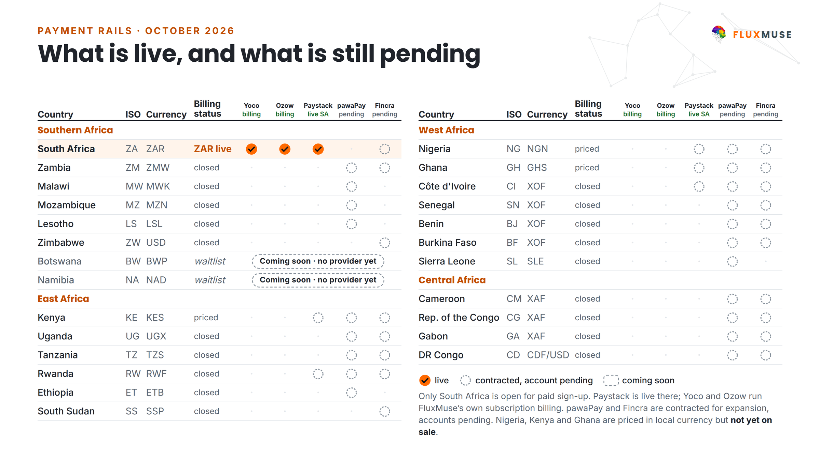
Figure 23. What is live, and what is still pending.
- Only South Africa is open for paid sign-up. Paystack is live there; Yoco and Ozow run FluxMuse's own subscription billing.
- pawaPay and Fincra are contracted for expansion; accounts are pending. No country they cover is described as live.
- Every other country is waitlist only: no prices, no checkout.

Appendix C. First group and case-study template

The first group
Item | Detail
What it is | A small first group of South African businesses, set up by hand by the founders. Not a pilot, not free
Pace (model input) | 4 a month, Oct 2026 to Jan 2027, 16 in total, 50% solo [[CONFIRM]]
Price | List price less Founding Member from the first bill
Set-up cost (model) | R10,000 a month
Case studies | Only with measured data and signed consent. None exists yet
Working notes | 07_Case_Studies/First_Group_Case_Studies.md

Case-study template
Each case study follows this structure. Every metric is a placeholder until measured, and target columns are labelled as goals, never as results.
KPI | Baseline | Target (goal) | Actual
Qualified leads in 30 days of go-live | [[ ]] | 3 (lead guarantee) | [[ ]]
Orders via the shop link | [[ ]] | [[ ]] | [[ ]]
Catalogue items built from photos | [[ ]] | [[ ]] | [[ ]]
Posts made per month | [[ ]] | [[ ]] | [[ ]]
Median first-reply time | [[ ]] | [[ ]] | [[ ]]
Owner hours saved per week | [[ ]] | [[ ]] | [[ ]]

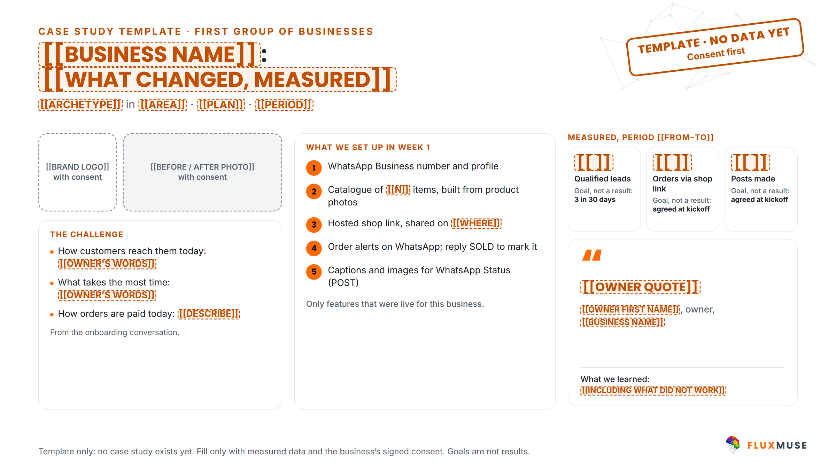
Figure 24. The case-study layout, with placeholder fields. Template only; no data yet.
- No business name, logo or photograph is used without signed consent; customer names and phone numbers are blurred in every screenshot.
- Every published figure states the period and how it was measured. Goals are never shown as results.

Appendix D. Detailed financial tables

Annual profit and loss
R | FY1  Oct 2026–Sep 2027 | FY2  Oct 2027–Sep 2028 | FY3  Oct 2028–Sep 2029 | FY4  Oct 2029–Sep 2030 | FY5  Oct 2030–Sep 2031
Subscriptions (gross) | R1,681,255 | R8,431,041 | R22,815,441 | R48,702,957 | R84,682,563
less Founding Member discount | (R32,143) | (R0) | (R0) | (R0) | (R0)
Subscriptions (net) | R1,649,112 | R8,431,041 | R22,815,441 | R48,702,957 | R84,682,563
AI-credit packs | R16,851 | R87,206 | R234,089 | R502,454 | R852,451
WhatsApp messaging | R201,496 | R930,979 | R2,392,201 | R4,791,872 | R7,883,437
Custom setup fees | R0 | R25,000 | R50,000 | R75,000 | R100,000
Total revenue | R1,867,459 | R9,474,226 | R25,491,731 | R54,072,283 | R93,518,450
Cost of revenue | (R1,450,860) | (R4,309,170) | (R9,653,030) | (R18,112,424) | (R27,179,829)
Gross profit | R416,599 | R5,165,056 | R15,838,701 | R35,959,858 | R66,338,621
Payroll (excluding customer success) | (R4,950,000) | (R11,471,108) | (R20,777,724) | (R30,567,664) | (R42,429,704)
Marketing and sales programmes | (R921,956) | (R2,244,401) | (R5,162,100) | (R6,903,160) | (R9,243,600)
G&A (non-payroll) | (R900,000) | (R1,780,000) | (R3,068,000) | (R4,396,000) | (R4,864,000)
Meta, legal and compliance | (R160,000) | (R240,000) | (R1,302,000) | (R1,018,000) | (R888,000)
Software and tools | (R279,000) | (R690,000) | (R1,311,000) | (R1,962,000) | (R2,433,000)
Travel | (R170,000) | (R460,000) | (R1,144,000) | (R1,668,000) | (R1,982,000)
Total operating expenses | (R7,380,956) | (R16,885,509) | (R32,764,824) | (R46,514,823) | (R61,840,304)
EBITDA | R-6,964,357 | R-11,720,453 | R-16,926,122 | R-10,554,965 | R4,498,317
Tax | (R0) | (R0) | (R0) | (R0) | (R0)
Net income | R-6,964,357 | R-11,720,453 | R-16,926,122 | R-10,554,965 | R4,498,317

Source: FluxMuse Financial Model v3, model date 2026-10-05 (Base case); Financial_Model_Notes.md.

Cost of revenue detail
R | FY1  Oct 2026–Sep 2027 | FY2  Oct 2027–Sep 2028 | FY3  Oct 2028–Sep 2029 | FY4  Oct 2029–Sep 2030 | FY5  Oct 2030–Sep 2031
AI inference, paid plans | R216,355 | R1,003,823 | R2,391,445 | R4,525,923 | R6,815,882
AI and hosting, Free plan | R85,805 | R299,743 | R645,764 | R1,135,323 | R1,556,763
Hosting | R342,609 | R564,732 | R876,506 | R1,399,661 | R2,021,596
WhatsApp Meta fees (pass-through) | R161,197 | R744,783 | R1,913,761 | R3,833,497 | R6,306,749
Payment processing | R56,024 | R284,256 | R813,522 | R1,833,881 | R3,239,041
Variable support | R60,870 | R292,474 | R737,866 | R1,485,230 | R2,373,708
Customer success team | R528,000 | R1,119,360 | R2,274,166 | R3,898,910 | R4,866,091
Total cost of revenue | R1,450,860 | R4,309,170 | R9,653,030 | R18,112,424 | R27,179,829

Source: FluxMuse Financial Model v3, model date 2026-10-05 (Base case); Financial_Model_Notes.md.
The Free-plan line is the AI and hosting cost of active Free users, shown separately from paid AI inference.

Annual cash flow
R | FY1  Oct 2026–Sep 2027 | FY2  Oct 2027–Sep 2028 | FY3  Oct 2028–Sep 2029 | FY4  Oct 2029–Sep 2030 | FY5  Oct 2030–Sep 2031
Opening cash | R500,000 | R39,705,357 | R28,497,286 | R12,755,512 | R4,229,547
EBITDA | R-6,964,357 | R-11,720,453 | R-16,926,122 | R-10,554,965 | R4,498,317
Tax paid | R0 | R0 | R0 | R0 | R0
Increase in deferred revenue | R287,069 | R723,596 | R1,615,726 | R2,672,850 | R3,263,552
Increase in receivables | (R117,355) | (R211,213) | (R431,378) | (R643,851) | (R702,575)
Operating cash flow | R-6,794,643 | R-11,208,071 | R-15,741,774 | R-8,525,965 | R7,059,294
Seed equity | R46,000,000 | R0 | R0 | R0 | R0
Net cash flow | R39,205,357 | R-11,208,071 | R-15,741,774 | R-8,525,965 | R7,059,294
Closing cash | R39,705,357 | R28,497,286 | R12,755,512 | R4,229,547 | R11,288,840
Lowest month-end cash in year | R-66,279 | R28,497,286 | R12,755,512 | R4,229,547 | R3,997,192

Source: FluxMuse Financial Model v3, model date 2026-10-05 (Base case); Financial_Model_Notes.md.

Payroll by department
R | FY1  Oct 2026–Sep 2027 | FY2  Oct 2027–Sep 2028 | FY3  Oct 2028–Sep 2029 | FY4  Oct 2029–Sep 2030 | FY5  Oct 2030–Sep 2031
Leadership | R1,320,000 | R1,399,200 | R1,483,152 | R1,572,141 | R1,666,470
Engineering & product | R2,068,000 | R5,270,320 | R9,096,666 | R12,780,197 | R18,115,913
Marketing | R880,000 | R2,322,672 | R3,253,047 | R4,032,542 | R6,199,267
Sales & partnerships | R440,000 | R1,364,220 | R2,373,043 | R3,687,981 | R5,915,967
Customer success | R528,000 | R1,119,360 | R2,274,166 | R3,898,910 | R4,866,091
G&A & compliance | R242,000 | R974,776 | R1,488,096 | R2,835,094 | R4,032,856
Country teams | R0 | R139,920 | R3,083,720 | R5,659,708 | R6,499,231

Source: FluxMuse Financial Model v3, model date 2026-10-05 (Base case); Financial_Model_Notes.md.
Customer-success payroll sits in cost of revenue, not operating expenses.

Workspaces by segment, market and tier
Workspaces | FY1  Oct 2026–Sep 2027 | FY2  Oct 2027–Sep 2028 | FY3  Oct 2028–Sep 2029 | FY4  Oct 2029–Sep 2030 | FY5  Oct 2030–Sep 2031
Segment: Solo | 116 | 348 | 817 | 1,448 | 2,071
Segment: SMEs | 104 | 336 | 821 | 1,532 | 2,322
Segment: Agencies | 17 | 40 | 85 | 146 | 203
Segment: Corporate | 1 | 4 | 8 | 15 | 24
Segment: Enterprise (Custom) | 0 | 1 | 3 | 5 | 8
Market: South Africa | 238 | 727 | 1,389 | 2,233 | 3,154
Market: Nigeria | 0 | 1 | 196 | 417 | 634
Market: Kenya | 0 | 0 | 101 | 254 | 404
Market: Ghana | 0 | 0 | 48 | 155 | 257
Market: Rest of Africa (USD) | 0 | 0 | 0 | 88 | 179
Tier: Nano | 48 | 137 | 317 | 548 | 763
Tier: Micro | 48 | 147 | 346 | 617 | 886
Tier: Starter | 58 | 180 | 431 | 781 | 1,142
Tier: Growth | 53 | 174 | 428 | 803 | 1,222
Tier: Scale | 12 | 44 | 116 | 232 | 380
Tier: Corporate | 1 | 4 | 8 | 15 | 24
Tier: Agency | 17 | 40 | 85 | 146 | 203
Tier: Custom | 0 | 1 | 3 | 5 | 8
Total paying workspaces | 238 | 728 | 1,734 | 3,147 | 4,627

Source: FluxMuse Financial Model v3, model date 2026-10-05 (Base case); Financial_Model_Notes.md.
Each breakdown sums to the total, subject to rounding. Botswana, Namibia and every gated country are zero in all five years.

Appendix E. Model assumptions and open confirmations
Internal section: remove before sending to an external party
Appendix E lists assumptions that still need founder sign-off. Delete this appendix, or the open-confirmations table below, before the plan goes to an investor or funder.

Key assumptions
- Month 1 = Oct 2026. Opening cash R500,000 [[CONFIRM]]. Lean pre-seed mode until the R46M seed lands in Feb 2027: two founders on reduced salaries, lean hosting and overheads, the first-group set-up cost; no paid marketing or hires.
- No trials and no pilot. South Africa sells from Oct 2026. A first group of 4 paying businesses a month is set up by hand from Oct 2026 to Jan 2027 (50% Solo, the rest SMEs) [[CONFIRM]].
- Self-serve sign-ups (Free + paid): South Africa 150 in Oct 2026 [[CONFIRM]], growing 12% a month in FY1 (Base). 5% of Solo and 8% of SME sign-ups pay at once [[CONFIRM]]; the rest join Free. Active Free users upgrade at 0.5% a month and go dormant at 10% a month [[CONFIRM]].
- Founding Member: 30% off the first 2 monthly bills for South African Solo and SME sign-ups, live from Oct 2026; proposed end Mar 2027 [[CONFIRM]]. Not modelled on Agency, Corporate, Custom or annual plans. +20% paying sign-ups while it runs [[CONFIRM]]. No NG/KE/GH launch windows.
- Pricing (ZAR / month): Free R0, Nano R149, Micro R289, Starter R499, Growth R1,999, Scale R4,999, Corporate R6,999, Agency R9,999, Custom from R19,999 [[CONFIRM]]. NG/KE/GH/USD use the live tier_regional_prices at FX parity. Annual = 10x monthly, 25% of subscriptions on annual billing; +6% list escalator each October. No VAT (not VAT-registered).
- Partner wholesale: agency-segment customers (100%) pay R6,999 a month (Agency list -30%); local wholesale at the Corporate local price points [[CONFIRM]]. Partner referral commission undecided and not modelled.
- Segment tier mix: Solo 45% Nano / 40% Micro / 15% Starter; SMEs 40% Starter / 50% Growth / 10% Scale. Upgrades a month: Nano->Micro 1.5%, Micro->Starter 0.8%, Starter->Growth 1.0%, Growth->Scale 0.6% [[CONFIRM]]. Agencies: 0.5 inbound a month in SA plus 1.5 per partnerships manager; 0.4 per NG/KE/GH country lead. Corporate inbound 1/3/6/9/12 deals a year; Custom 0/1/2/3/4 [[CONFIRM]].
- Monthly churn: Nano 8.0%, Micro 7.0%, Solo Starter 6.0%, SME Starter 4.5%, SME Growth 3.0%, SME Scale 2.2%, Agency 2.0%, Corporate 1.5%, Custom 1.0% (Base; NG/KE/GH/Rest churn indices 1.05-1.25x).
- Markets: South Africa only until NG/KE/GH checkout is live (Fincra/pawaPay pending). Planned earliest launches Nigeria Apr 2028, Kenya Jul 2028, Ghana Oct 2028, Rest of Africa (USD) May 2029 [[CONFIRM]], each also behind an MRR gate (R0.9M / R1.2M / R1.5M / R2.5M x scenario gate multiplier). Botswana & Namibia off; gated countries zero.
- Cost discipline: every non-founder hire waits for its earliest month, the seed, and an MRR gate x scenario multiplier (Conservative 1.4x, Base 1.0x, Upside 0.8x); paid acquisition = MIN(desired, R40,000 + 35% of last month's MRR in Base) and off where CAC payback > 12 months. Paid CAC Solo R1,500 [[CONFIRM]], SME R6,500.
- Other revenue: AI-credit packs (R300 for 1,000 credits, 5% of metered workspaces a month [[CONFIRM]]), WhatsApp messages resold at Meta cost +25%, R25,000 Custom setup fee [[CONFIRM]]. No agency setup fee. No FluxMuse checkout fee: Paystack fees pass through to the merchant (0% in every scenario). Campaign Financing excluded.
- COGS: AI at R0.15 of provider cost per credit (ai-credit-math.ts and platform_billing_config), falling 10% a year, 40% utilisation of the live allowances; Corporate, Agency and Custom use their own AI keys. Free users cost 60 credits a month at 40% use plus R3 hosting. Hosting R30k/month + R35 per workspace after the seed, 3.0% processing + 1.5% mobile-money/FX on non-SA revenue, R50 per workspace support, customer success team in COGS.
- Funding & tax: R46M seed only; Series A input kept at R0. Tax 27% only once cumulative EBITDA is positive; D&A, interest and VAT ignored (not VAT-registered).

Not modelled
- Campaign Financing (upside only)
- Partner referral commission (undecided)
- Series A (optional acceleration only)
- Botswana & Namibia revenue (switched off until a rail covers them)
- Gated countries
- Any FluxMuse fee on checkout GMV (none in the current offer)
- VAT (not VAT-registered)
- AI Voice minute revenue on Corporate/Agency prepaid balances
- NG/KE/GH launch offers

Known limitations of the model
- Customers are fractional, and launch and hiring decisions are one-way.
- Gates use last month's MRR, with no look-ahead.
- There are no downgrades. Free users who go dormant never come back.
- Sign-ups that pay at once and Free users split Solo/SME by the same share.
- AI utilisation (40%) is assumed; R0.15 a credit is the platform's own figure, not a measured average.
- FX paths are deterministic, and repricing is assumed to cause no extra churn.
- WhatsApp pass-through is booked as gross revenue, which lowers blended gross margin.
- Tax ignores South Africa's 80% cap on assessed losses; depreciation, amortisation, interest and payables are ignored. VAT is not modelled because FluxMuse is not registered; registration would change pricing or margin.

Open confirmations (founder)
# | To confirm
1 | Opening cash at 1 Oct 2026 (default R500,000) and how to cover the R66,279 pre-seed bridge if the seed lands Feb 2027.
2 | Seed close month (Feb 2027) and instrument (SAFE vs priced equity).
3 | First group set up by hand: 4 a month, Oct 2026 to Jan 2027, 50% Solo; R10,000 a month set-up cost.
4 | South African sign-ups at launch (150 a month) and the pay-at-sign-up rates (Solo 5%, SME 8%).
5 | Free plan: 0.5% a month upgrade, 10% a month dormancy, R3 hosting per active Free user. Free allowance is 60 credits in the product (100 in older copy).
6 | Segment tier mixes, the upgrade rates and the new churn rates for Nano, Micro, SME Starter and Corporate.
7 | Founding Member end date (proposed Mar 2027), whether it applies to Corporate or annual plans, and the +20% sign-up uplift. Whether NG/KE/GH get a launch offer (none modelled).
8 | New NG/KE/GH and Rest-of-Africa plan months (Apr 2028 / Jul 2028 / Oct 2028 / May 2029) and their dependence on Fincra/pawaPay going live.
9 | Corporate and Custom inbound deal volumes, Custom modelled at R19,999, Custom setup fee R25,000, Corporate handling cost.
10 | Local partner wholesale prices (modelled at the Corporate local prices) and whether 100% of agency customers buy at wholesale.
11 | AI-credit pack attach rate (5%) and the R1,500 paid CAC for Solo.
12 | FX depreciation assumptions vs ZAR (NGN -10%, GHS -8%, KES -3%, USD 0% a year) and the quarterly repricing policy.
13 | Cost-discipline rules: MRR gates per hire and launch, the scenario gate multipliers, the paid-acquisition cap (35% of MRR in Base) and the 12-month CAC payback limit.
14 | Salaries and hiring plan (cost-to-company per role), including founders' reduced salaries.
15 | Market-sizing estimates (TAM/SAM/SOM) before external use.

What live data replaces first
- Pay-at-sign-up rates (Solo 5%, SME 8%) and the Free upgrade rate (0.5% a month). These decide whether the seed is enough.
- Sign-up volume (150 a month in South Africa at launch) and its growth.
- Tier mix of new paying customers, especially the Nano share, and early churn by tier.
- The Founding Member effect on sign-ups.
- AI-credit utilisation by plan and on Free.
- Agency and Corporate demand.
- Fincra and pawaPay go-live dates, then Nigeria, Kenya and Ghana sign-ups, CAC and churn.

Appendix F. Glossary
Term | Meaning
ARPA | Average revenue per account, per month
ARR | Annual recurring revenue: September net subscription MRR × 12
B-BBEE | Broad-Based Black Economic Empowerment (South Africa)
Being switched on | Built, but waiting on an approval, a real-money test or a beta
CAC | Customer acquisition cost
CAC payback | Months of gross profit needed to recover the CAC
Cloud API | Meta's hosted WhatsApp Business API
EBITDA | Earnings before interest, tax, depreciation and amortisation
First group | The small first set of South African businesses the founders set up by hand
Founding Member | 30% off the first two monthly bills for South African sign-ups
Free plan | A permanent R0 plan with 1 brand and 1 channel. Not a trial
FY | Fiscal year, October to September. FY1 is October 2026 to September 2027
Lead guarantee | 3 qualified leads in 30 days of go-live, or extended support at no extra charge
LTV | Lifetime value: ARPA × software gross margin ÷ monthly churn
MRR | Monthly recurring revenue
MRR gate | The net MRR a hire or a market launch must wait for
MSME / SMME | Micro, small and medium enterprise. SMME is the South African usage
Partner wholesale | The permanent Agency-tier price for partners: R6,999 a month
POPIA | Protection of Personal Information Act, 2013 (South Africa)
SAM / SOM / TAM | Serviceable addressable, serviceable obtainable and total addressable market
Tech Provider | Meta's verified status for a platform acting for other businesses
Workspace | One paying customer account on FluxMuse

