
FLUXMUSE
AI Marketing & WhatsApp Commerce for Africa
PROPOSAL · SME GROWTH

Sell and grow on WhatsApp, with an AI team behind you
A 60-day set-up and growth plan for [[CLIENT NAME]]

Prepared for | [[CLIENT NAME]]
Date | [[DD MONTH YYYY]]
Proposal number | [[FM-PRO-YYYY-###]]
Prepared by | Thabo Malebadi, Founder, Fluxmuse (Pty) Ltd  thabo@fluxmuse.com · [[PHONE / WHATSAPP]]
Valid until | [[DATE + 30 days]]

Confidential. Prepared for [[CLIENT NAME]] only. Prices in South African rand (ZAR); the price shown is the amount charged.

How to use this template (delete this box before sending)
This is the SME growth proposal template. Fill it in, check it against the rules below, then save a PDF for the client.
☐ Replace every [[PLACEHOLDER]]: use Find for “[[”. Filled fields keep the yellow shading so a reviewer can check them; clear the shading (Home › Shading › No Colour) before sending, then search for “[[” once more.
☐ Quote prices only from 08_Prospects/CURRENT_OFFER.md. Every paid plan starts with payment: no trials, no free period. Free is a permanent plan, never a trial and never the lead offer.
☐ Founding Member is live for South African sign-ups: 30% off the first two monthly bills on Starter, Growth and Scale. No end date is set, so don't print one. Never on Agency or partner wholesale.
☐ Guarantee: only the lead guarantee, always with its conditions. Never promise cash back, sales or results.
☐ FluxMuse has no customers or results yet. No customer counts, ratings, testimonials or case-study numbers. KPI numbers are always “Target (goal)”. Describe live features as “newly launched”.
☐ Being switched on, never live: Facebook and Instagram auto-posting, checkout through FluxMuse, AI Voice (beta), daily digest, store sync. Not available: Instagram DMs and comments, checkout outside South Africa.
☐ South Africa only for paid plans. Prospects elsewhere join the waitlist: no prices, no checkout.
☐ Terms marked [[LEGAL REVIEW REQUIRED]] are completed by legal counsel. Don't write your own.
☐ Shopify, WooCommerce and Takealot sync is partly built and not offered yet. Don't promise it.
☐ AI Voice is beta on Growth (inbound) and Scale (inbound and outbound): offer it as “beta, evaluated together”, never as a receptionist replacement.
☐ Optional service fees are [[TBC]] until the founder publishes a services price list.
☐ Delete this box, update fields (right-click the contents list › Update Field) and check the page count.

Contents

1. Executive summary
2. About CLIENT NAME and our understanding
3. Objectives and success metrics
4. What FluxMuse does
5. Scope of work and deliverables
6. 60-day plan
7. Investment options
8. Payments and our guarantee
9. Reporting and governance
10. Where we are
11. Trust and compliance
12. Assumptions and client dependencies
13. Terms
14. Acceptance
Word builds page numbers when you open the file (choose Yes to update fields), or right-click the list and choose Update Field.

1. Executive summary
[[CLIENT NAME]] sells to customers who already live on WhatsApp, but [[SUMMARY OF THE PROBLEM IN ONE SENTENCE, e.g. enquiries are handled by hand on several phones, and posting depends on who has time]].
FluxMuse proposes a 60-day set-up and growth plan on the plan that fits [[CLIENT NAME]]: your products in a WhatsApp-ready shop, posts made by AI in your customers' languages, and every order alerted on WhatsApp. FluxMuse is newly launched; we're opening with a small first group of businesses and we set you up by hand. We agree targets at kickoff, check in weekly, and review at day 30 and day 60.
Item | Proposed
Recommended plan | [[Starter R499/mo / Growth R1,999/mo / Scale R4,999/mo]]
Set-up and review | 60 days from [[START DATE]], with reviews at day 30 and day 60
Channels | WhatsApp, hosted shop link, TikTok video. Facebook and Instagram auto-posting are being switched on (Meta approval)
Orders | Orders arrive on your WhatsApp. Checkout through FluxMuse is being switched on
Guarantee | 3 qualified leads in 30 days of go-live, with conditions (section 8)
Investment | From R499/mo, plus optional services [[TBC]] and third-party pass-through costs (section 8)
Decision needed by | [[DATE + 30 days]]

2. About [[CLIENT NAME]] and our understanding

Business snapshot
Area | [[CLIENT NAME]]
Industry and offer | [[e.g. restaurant, online beauty brand, clinic, auto services]]
Locations and team | [[N]] branches · [[N]] staff · [[AREAS]]
Customers | [[WHO THEY ARE, LANGUAGES, WHERE THEY BUY]]
Channels today | [[e.g. WhatsApp Business app on 3 phones, Facebook, Instagram, website]]
How customers pay today | [[e.g. card on delivery, EFT, cash]]

What we heard (hypotheses to check with you)
☐ WhatsApp is handled by hand by staff on personal or shared phones
☐ Slow replies after hours and at peak times; enquiries go cold
☐ Product photos and prices are sent one chat at a time
☐ Posting depends on who has time, in one language only
☐ No simple count of which posts or links bring in enquiries
☐ Other: [[IN THE CLIENT'S WORDS]]
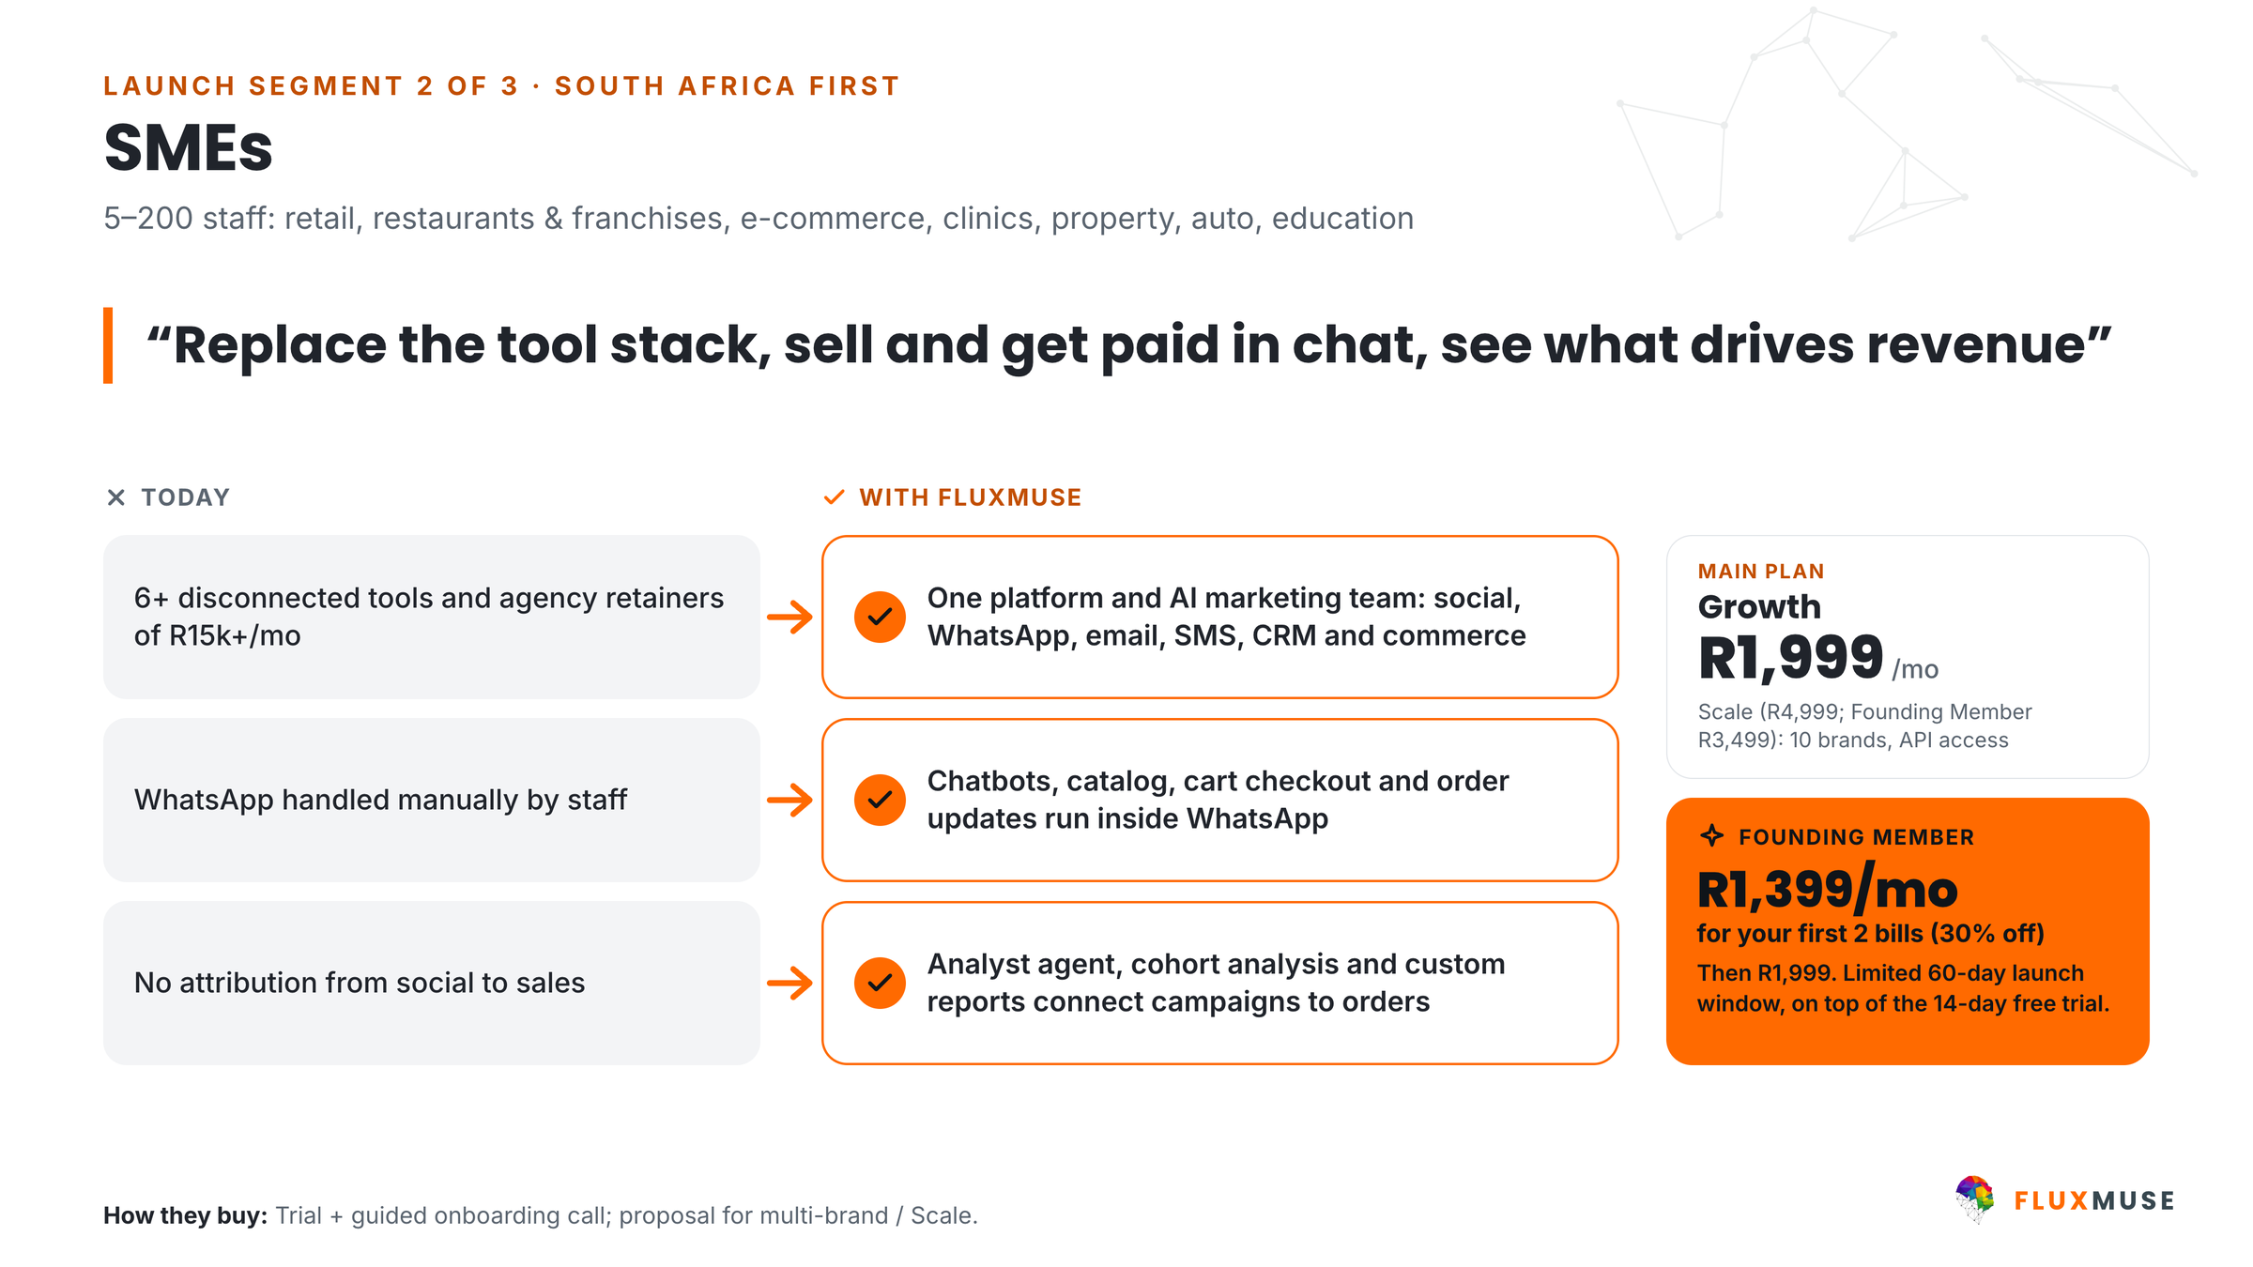
Figure 1. SMEs: today vs with FluxMuse.

3. Objectives and success metrics
We confirm the starting point in the first week. Every number in the target column is a goal agreed at kickoff, not a promised result.
# | Objective | KPI | Baseline | Target (goal) | By
O1 | Bring in new WhatsApp leads | Qualified leads through tracked links | 0 at go-live | 3+ (lead guarantee) | Day 30
O2 | Get products in front of buyers | Products live in the shop | [[ ]] | [[e.g. 30]] | Day 14
O3 | Never miss an order | Orders alerted on WhatsApp | [[ ]] | [[N]] | Day 60
O4 | Publish consistently | Posts made per month | [[ ]] | [[e.g. 12+]] | Day 30
O5 | Grow the opted-in list | Contacts opted in to broadcasts | [[ ]] | [[N]] | Day 60
O6 | Free up staff time | Staff hours saved per week | [[ ]] | [[ ]] | Day 60

4. What FluxMuse does
Every capability below carries its real status today.
Capability | Status
WhatsApp Concierge: send product photos, AI drafts the catalogue entry, you reply YES, NO or an edit | Live (newly launched)
Hosted shop link (fluxmuse.ai/s/your-name): orders arrive as a WhatsApp message to your own number | Live (newly launched)
Order alerts on WhatsApp; reply SOLD to mark an item sold | Live (newly launched)
AI captions and images for posts (send POST), ready to forward to WhatsApp Status | Live (newly launched)
Short AI video clips and voice-note transcription on WhatsApp | Live (newly launched)
WhatsApp Business set-up: number, profile, templates, quick replies, broadcasts to consented contacts | Live (newly launched)
Answers in your customer's language | Live (newly launched)
TikTok video posting | Live (newly launched)
Checkout through FluxMuse (Paystack, South African bank accounts) | Being switched on
Auto-posting to Facebook Pages and Instagram (waiting for Meta approval) | Being switched on
Daily digest message | Being switched on
AI Voice: inbound calls on Growth, inbound and outbound on Scale | Beta, evaluated together
Sync from Shopify, WooCommerce or Takealot | Not offered yet

Newly launched means built and running, but no outside business has run it end to end yet, so we watch it closely with you. Being switched on means it is waiting on an approval or final testing. Not available: Instagram DMs and comments, X posting, and paid checkout outside South Africa.
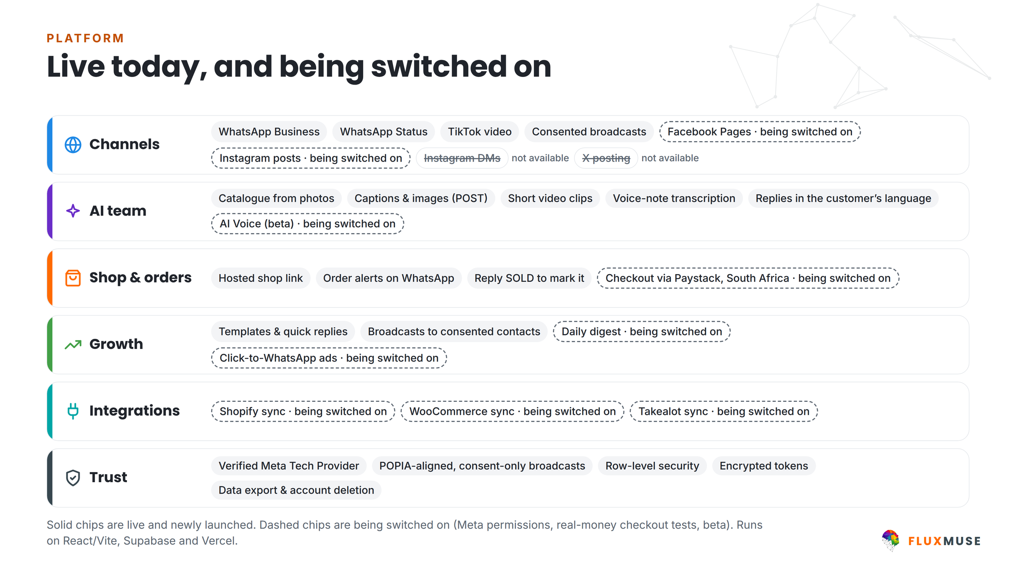
Figure 2. How FluxMuse fits together. Items being switched on are labelled in the table above.

5. Scope of work and deliverables
Included = part of the FluxMuse plan. Optional = a FluxMuse service at an extra fee [[TBC]]. Client = what [[CLIENT NAME]] provides.
Area | Deliverable | Included | Optional [[TBC]] | Client responsibility
Set-up | WhatsApp Business number, profile and quick replies | Hand set-up with you | – | Meta Business account access, number, display name
Set-up | Shop of [[N]] products from your photos | WhatsApp Concierge drafts; you approve | Catalogue build by our team | Photos, prices, stock
Content | Posts and captions in [[LANGUAGES]] | AI captions, images and short video clips | Human review of drafts | Brand guidelines, approvals
Messaging | Broadcast templates to opted-in contacts | Templates and Meta submission | – | Opted-in contact lists
Reporting | Weekly check-ins, 30- and 60-day reviews | Included | Monthly review pack | Attend reviews, act on actions

Out of scope unless agreed in writing: [[e.g. photo shoots, website rebuilds, ad management, printing]].

6. 60-day plan
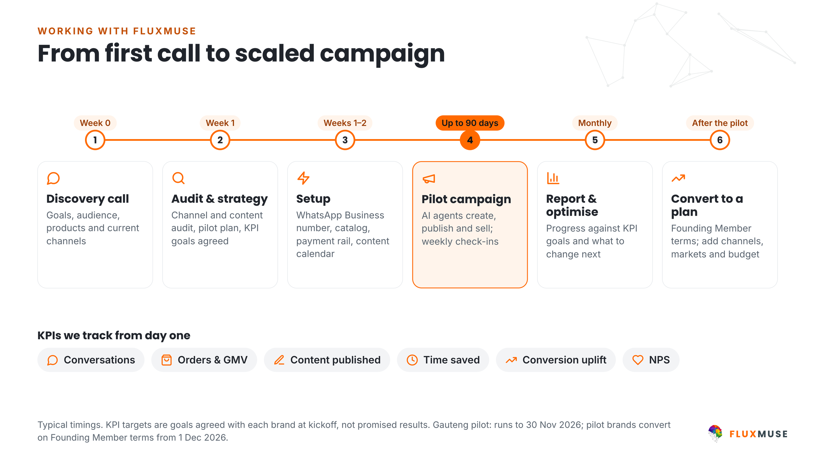
Figure 3. How we work together, from discovery call to a plan. Timings are typical; KPI targets are goals.
Phase | Objectives | Deliverables | Tracked
Days 1–30  Set up and go live | Go live on WhatsApp with a shop link; start counting leads | Number and shop live; QR codes and links; first posts; first broadcast | Qualified leads; orders alerted; posts
Days 31–60  Improve | Do more of what brings leads; grow the opted-in list | Two post styles tested; opt-in drive; day-60 review | Leads; orders; opt-ins; hours saved

Milestone | Date
Proposal accepted and first payment | [[DATE]]
Kickoff | [[DATE]]
Go-live | [[DATE]]
Day-30 review (lead guarantee check) | [[DATE]]
Day-60 review | [[DATE]]

7. Investment options
Every paid plan starts with payment. Annual = 10× monthly for 12 months.
Plan | Monthly | Annual | Founding Member* | Includes
Starter | R499 | R4,990 | R349 for the first two monthly bills | 1 brand, 3 channels
Growth | R1,999 | R19,990 | R1,399 for the first two monthly bills | 3 brands, 15 channels, inbound AI Voice (beta)
Scale | R4,999 | R49,990 | R3,499 for the first two monthly bills | 10 brands, 40 channels, inbound and outbound AI Voice (beta)

*Founding Member: South African sign-ups pay 30% less for their first two monthly bills. It is a discount, not a free period. AI credits come with every plan; see fluxmuse.ai/pricing for the current allowance. More than 10 brands: Corporate (R6,999/mo) or Custom, by consultation.
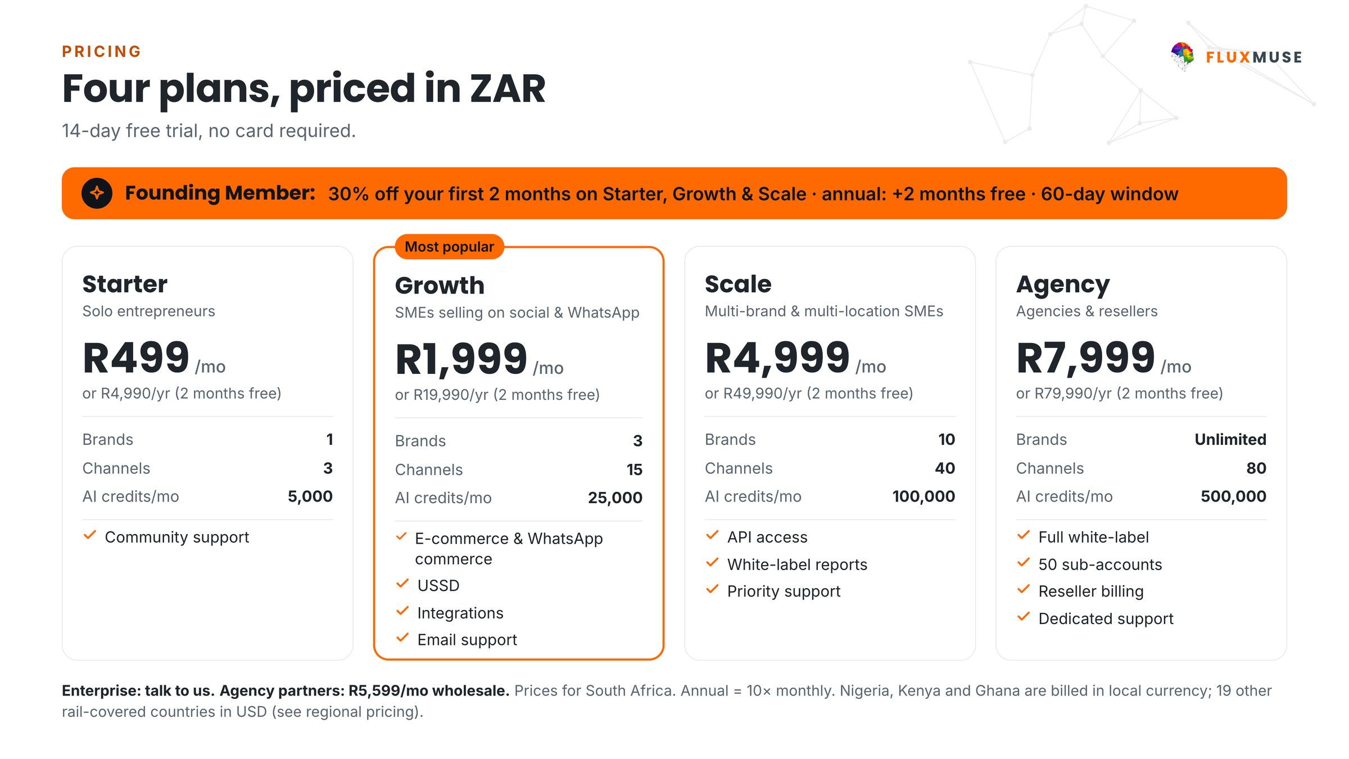
Figure 4. FluxMuse plans in ZAR. Annual = 10× monthly.

Optional FluxMuse services
Service | Fee | Notes
Hand set-up | Included | We set you up by hand
Catalogue build | [[TBC]] | Up to [[N]] products
Content review | [[TBC]] /mo | Human review of AI drafts
Extra training | [[TBC]] per session | For additional teams or branches

Third-party pass-through costs
Charged by the provider at their rates, not by FluxMuse. Estimates until usage is known.
Cost | Charged by | Estimate | Depends on
WhatsApp template message fees | Meta | [[estimate R/mo]] | Message volume and category
Ad spend (if any) | Meta | [[estimate R/mo]] | Budget set by [[CLIENT NAME]]

First three months at a glance
Item | Month 1 | Month 2 | Month 3
FluxMuse plan ([[Starter / Growth / Scale]]) | [[R]] | [[R]] | [[R]]
Optional services | [[TBC]] | [[TBC]] | [[TBC]]
Pass-through costs (estimate) | [[R]] | [[R]] | [[R]]
Total | [[R]] | [[R]] | [[R]]

8. Payments and our guarantee
- Orders from the shop link arrive on your WhatsApp; you take payment the way you do today.
- Checkout through FluxMuse (Paystack, South African bank accounts) is built and being switched on: it has not yet been tested end to end with real money. Until it is, orders arrive on your WhatsApp and you take payment the way you do today. [[FEE WORDING ONLY ONCE CHECKOUT IS TESTED]]
- Your FluxMuse subscription is paid through Paystack, Yoco or Ozow.
- Paid plans are for South African businesses. Businesses elsewhere can join the waitlist.
Our lead guarantee
Lead guarantee: 3 qualified leads in your first 30 days after go-live. A qualified lead is a unique WhatsApp number that starts a conversation through a FluxMuse-tracked link or QR code. If fewer than 3 arrive and you held up your side (shared the link and posted at least weekly), we keep working with you at no extra charge until you have 3. It is extra support, not a cash payment.

9. Reporting and governance
Cadence | What | Who | Format
Weekly | 30-minute check-in: progress against targets, blockers, next actions | Thabo Malebadi + [[CLIENT OWNER]] | Call + written actions
Day 30 | Review, including the lead guarantee count | Both teams | Report
Day 60 | Review and plan decision | Decision makers | Report + meeting

Roles
Role | Name | Responsible for
FluxMuse lead | Thabo Malebadi | Plan, set-up, reviews, escalations
[[CLIENT NAME]] project owner | [[NAME]] | Access, data, internal decisions
Content approver | [[NAME]] | Approves posts and broadcasts

10. Where we are
FluxMuse is newly launched. We have no customer results to show you yet, and we won't invent any. We're opening with a small first group of businesses, and we set each one up by hand. Case studies come later, only with a business's written consent.

11. Trust and compliance
- Fluxmuse (Pty) Ltd (South Africa): a verified Meta Tech Provider (business and access verification, September 2026).
- Meta permissions approved: WhatsApp Business messaging and management, and Facebook Page messaging.
- Waiting for Meta approval (not live): posting to Facebook Pages and Instagram, and Instagram comments and DMs. They are switched on only once Meta approves them.
- Payments: Paystack is live in South Africa. Yoco and Ozow run FluxMuse's own subscription billing.
- WhatsApp policy: broadcasts use Meta-approved message templates and go only to contacts who opted in.

Protection of personal information (POPIA)
Fluxmuse (Pty) Ltd processes personal information in line with the Protection of Personal Information Act, 2013 (POPIA). For this proposal:
- [[CLIENT NAME]] decides why and how its customers' personal information is used; FluxMuse processes it to deliver the services. [[LEGAL REVIEW REQUIRED: responsible party and operator roles, operator agreement]]
- WhatsApp broadcasts go only to people who have opted in, and every broadcast includes a way to opt out.
- Platform safeguards: row-level security on database tables, encrypted access tokens, and data export and account deletion on request.
- Screenshots, reports and case studies shared outside the business blur customer names and phone numbers.
- Information Officer: [[FLUXMUSE INFORMATION OFFICER NAME AND EMAIL]]. Breach notification and cross-border processing (hosting regions): [[LEGAL REVIEW REQUIRED]]

12. Assumptions and client dependencies
- [[CLIENT NAME]] gives FluxMuse admin access to its Meta Business account within [[N]] working days of kickoff.
- A phone number is available for the WhatsApp Business account and Meta approves the display name.
- WhatsApp broadcasts use Meta-approved templates and go only to contacts who opted in.
- [[CLIENT NAME]] provides product photos and prices, and approves content within [[N]] working days.
- Ad budgets and Meta message fees are paid by the client (pass-through).
- Facebook and Instagram auto-posting start only after Meta approval; the plan doesn't depend on them.
- [[OTHER ASSUMPTIONS]]

13. Terms
These commercial headings are placeholders for the final agreement. Nothing here is binding until legal counsel has reviewed it and both parties have signed. [[LEGAL REVIEW REQUIRED]]
Heading | Position
Agreement | This proposal, the FluxMuse Terms of Service [[LINK]] and [[ORDER FORM / MASTER AGREEMENT]]. Order of precedence: [[LEGAL REVIEW REQUIRED]]
Term and renewal | Monthly plans renew monthly. Annual plans renew yearly (annual price = 10× monthly). Renewal and notice: [[LEGAL REVIEW REQUIRED]]
Payment first | Every paid plan is paid in advance, from the first month. There is no trial period. The Free plan is a separate permanent plan.
Cancellation (per plan) | Monthly plans: [[LEGAL REVIEW REQUIRED: notice period and effective date]]  Annual plans: [[LEGAL REVIEW REQUIRED: cancellation of annual plans]]  Founding Member discount on cancellation: [[LEGAL REVIEW REQUIRED]]
Lead guarantee | 3 qualified leads in 30 days of go-live, on the conditions in this proposal; remedy is extended support at no extra charge, not a cash payment. [[LEGAL REVIEW REQUIRED]]
Payment terms | Billed in advance in South African rand by [[PAYMENT METHOD: Paystack / Yoco / Ozow]]. Late payment: [[LEGAL REVIEW REQUIRED]]
Price changes | Notice of price changes: [[LEGAL REVIEW REQUIRED]]
Third-party costs | Meta WhatsApp message fees, ad spend and payment-processing fees are pass-through costs charged by those providers, not FluxMuse fees. Billing route: [[LEGAL REVIEW REQUIRED]]
Third-party platforms | Features that rely on Meta, payment providers or other platforms depend on their policies and approvals. [[LEGAL REVIEW REQUIRED: availability and change clause]]
Data protection | POPIA, as described in this proposal. Operator or data processing agreement: [[LEGAL REVIEW REQUIRED]]
Intellectual property | [[LEGAL REVIEW REQUIRED: ownership of client content, AI-generated content, brand assets, platform IP and licences]]
Confidentiality | [[LEGAL REVIEW REQUIRED]]
Support and service levels | Support channel by plan: [[CONFIRM]]. Service levels: [[LEGAL REVIEW REQUIRED]]
Limitation of liability | Liability cap: [[LEGAL REVIEW REQUIRED: cap amount and basis]]. Exclusions: [[LEGAL REVIEW REQUIRED]]
Governing law and disputes | [[LEGAL REVIEW REQUIRED]]

14. Acceptance
To go ahead, tick your choices, sign below and send a copy to thabo@fluxmuse.com or WhatsApp [[PHONE / WHATSAPP]] before [[DATE + 30 days]].
☐ Starter, monthly (R499/mo) or annual (R4,990/yr)
☐ Growth, monthly (R1,999/mo) or annual (R19,990/yr)
☐ Scale, monthly (R4,999/mo) or annual (R49,990/yr)
☐ Founding Member discount (South African sign-up, first two monthly bills)
☐ Optional services: [[LIST]]
☐ 60-day plan as described, starting [[DATE]]
By signing, [[CLIENT NAME]] accepts proposal [[FM-PRO-YYYY-###]] on the choices ticked above, subject to the final terms in section 13 once legal review is complete. [[LEGAL REVIEW REQUIRED]]
For [[CLIENT NAME]] |  | For Fluxmuse (Pty) Ltd
Name: |  | Name:
Title / role: |  | Title / role:
Signature: |  | Signature:
Date: |  | Date:
Place: |  | Place:

