
FLUXMUSE
AI Marketing & WhatsApp Commerce for Africa
PROPOSAL · SOLO ENTREPRENEUR

Your shop and your posts, run from WhatsApp
A FluxMuse plan for [[CLIENT NAME]]

Prepared for | [[CLIENT NAME]]
Date | [[DD MONTH YYYY]]
Proposal number | [[FM-PRO-YYYY-###]]
Prepared by | Thabo Malebadi, Founder, Fluxmuse (Pty) Ltd  thabo@fluxmuse.com · [[PHONE / WHATSAPP]]
Valid until | [[DATE + 30 days]]

Confidential. Prepared for [[CLIENT NAME]] only. Prices in South African rand (ZAR); the price shown is the amount charged.

How to use this template (delete this box before sending)
This is the Solo entrepreneur proposal template. Fill it in, check it against the rules below, then save a PDF for the client.
☐ Replace every [[PLACEHOLDER]]: use Find for “[[”. Filled fields keep the yellow shading so a reviewer can check them; clear the shading (Home › Shading › No Colour) before sending, then search for “[[” once more.
☐ Quote prices only from 08_Prospects/CURRENT_OFFER.md. Every paid plan starts with payment: no trials, no free period. Free is a permanent plan, never a trial and never the lead offer.
☐ Founding Member is live for South African sign-ups: 30% off the first two monthly bills on Starter, Growth and Scale. No end date is set, so don't print one. Never on Agency or partner wholesale.
☐ Guarantee: only the lead guarantee, always with its conditions. Never promise cash back, sales or results.
☐ FluxMuse has no customers or results yet. No customer counts, ratings, testimonials or case-study numbers. KPI numbers are always “Target (goal)”. Describe live features as “newly launched”.
☐ Being switched on, never live: Facebook and Instagram auto-posting, checkout through FluxMuse, AI Voice (beta), daily digest, store sync. Not available: Instagram DMs and comments, checkout outside South Africa.
☐ South Africa only for paid plans. Prospects elsewhere join the waitlist: no prices, no checkout.
☐ Terms marked [[LEGAL REVIEW REQUIRED]] are completed by legal counsel. Don't write your own.
☐ Delete this box, update fields (right-click the contents list › Update Field) and check the page count.

1. Hi [[FIRST NAME]]
Thank you for telling us about [[CLIENT NAME]]. You said you want [[THEIR MAIN GOAL, e.g. more orders without living on your phone]]. You're already doing the hard part: people know your work and message you on WhatsApp. FluxMuse helps you put your products in a shop link, post more often and see every order on WhatsApp, without hiring a marketer.
FluxMuse is newly launched. We're opening with a small first group of businesses, and we set you up by hand. This proposal is short on purpose: what we heard, what we'll set up, your first 30 days, the plan we recommend and how we'll both know it's working.
Warm regards,
Thabo Malebadi, Founder, FluxMuse · thabo@fluxmuse.com · [[PHONE / WHATSAPP]]

2. What we heard
Tick what applies.
☐ I miss messages and lose sales in busy WhatsApp chats
☐ I send the same photos and prices to every new customer
☐ I don't have time or budget for a marketer, so I post when I can
☐ I want to post in more than one language: [[LANGUAGES]]
☐ Customers don't come back as often as I'd like, and I don't follow up
☐ In your words: “[[QUOTE FROM THE DISCOVERY CALL]]”
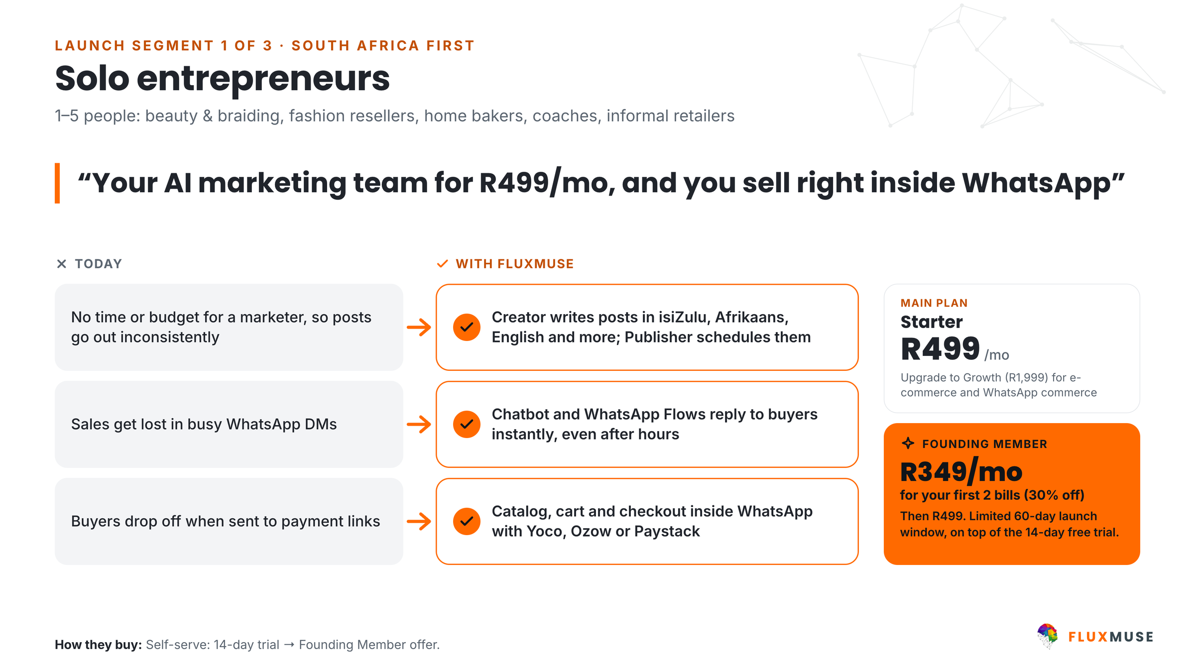
Figure 1. Solo entrepreneurs: today vs with FluxMuse.

3. What FluxMuse will do for you
- Your products as a shop. Send product photos to FluxMuse on WhatsApp. The AI drafts each catalogue entry (name, description, a price guess) and you reply YES, NO or an edit.
- A shop link to share (fluxmuse.ai/s/[[NAME]]). Orders arrive on your own WhatsApp number as a ready-typed message, so you never miss one.
- Order alerts on WhatsApp. Reply SOLD to mark an item sold.
- Posts made for you. Send POST with a photo and get a caption and image back, ready to forward to WhatsApp Status, in [[LANGUAGES]].
- Short AI video clips and voice notes typed out. TikTok video posting is available.
- Answers in your customer's language, and broadcasts to customers who opted in.
Being switched on (not live yet)
Checkout through FluxMuse. Built, but not yet tested end to end with real money. Until it is, you take payment the way you do today.
Auto-posting to Facebook and Instagram. Waiting for Meta approval. For now, posts come back to you on WhatsApp, ready to forward to Status or post yourself.

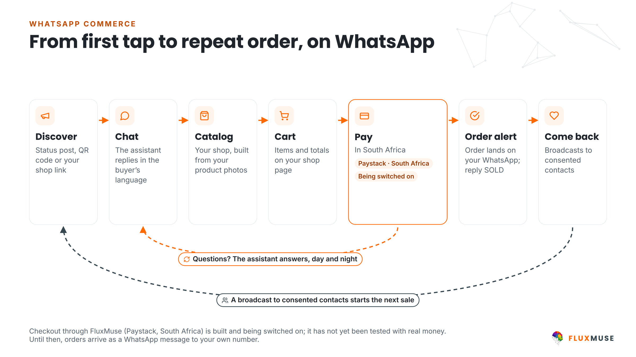
Figure 2. How a request reaches you on WhatsApp. Checkout through FluxMuse is being switched on.

4. Your first 30 days
We set you up by hand. Each week needs about [[N]] minutes of your time.
When | What we set up together | Your part
Week 1 | WhatsApp Business number and profile; first products into the shop from your photos | Send photos and prices; approve the drafts
Week 2 | Shop link live; QR code; first posts in [[LANGUAGES]] | Share the link; post at least weekly
Week 3 | First broadcast to opted-in customers with an approved template: [[OFFER]] | Choose the offer; ask regulars to opt in
Week 4 | Review: leads through the link, orders, posts; agree Target (goal) numbers for the next month | 15-minute review call

Our lead guarantee
Lead guarantee: 3 qualified leads in your first 30 days after go-live. A qualified lead is a unique WhatsApp number that starts a conversation through a FluxMuse-tracked link or QR code. If fewer than 3 arrive and you held up your side (shared the link and posted at least weekly), we keep working with you at no extra charge until you have 3. It is extra support, not a cash payment.

5. Plans for you
Every paid plan starts with payment. Annual billing is 10× the monthly price for 12 months.
 | Nano | Micro | Starter
Monthly price | R149 | R289 | R499
Annual price | R1,490 | R2,890 | R4,990
Brands · channels | 1 · 3 | 1 · 4 | 1 · 3
WhatsApp Concierge, shop link, order alerts | ✓ | ✓ | ✓
AI captions, images and short video clips | ✓ | ✓ | ✓
Own WhatsApp Business number | [[CONFIRM]] | 1 number | ✓
Founding Member (first two monthly bills) | – | – | R349, then R499

AI credits come with every plan; see fluxmuse.ai/pricing for the current allowance. [[FOUNDER TO CONFIRM: whether Founding Member also covers Nano and Micro]]
- Nano (R149/mo) is the place to start for a side-hustle: your shop, your link and posts made for you.
- Micro (R289/mo) adds a channel and your own WhatsApp number on FluxMuse.
- Starter (R499/mo) is the step up when the business grows. Founding Member: South African sign-ups pay 30% less for their first two monthly bills. It is a discount, not a free period.
- A Free plan exists as a permanent option (1 brand, 1 channel, no card). It is not a trial of the paid plans.
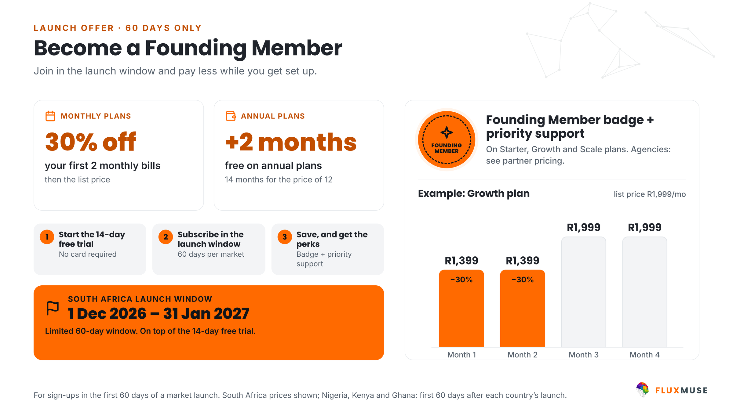
Figure 3. Founding Member launch offer for South African sign-ups: 30% off the first two monthly bills.
Our recommendation for [[CLIENT NAME]]: [[Nano / Micro / Starter]], because [[REASON IN ONE SENTENCE]].

6. How you'll get paid
- Today: the shop link sends each order to your WhatsApp, and you take payment the way you already do.
- Checkout through FluxMuse (Paystack, South African bank accounts) is built and being switched on: it has not yet been tested end to end with real money. Until it is, orders arrive on your WhatsApp and you take payment the way you do today. [[FEE WORDING ONLY ONCE CHECKOUT IS TESTED]]
- Your FluxMuse subscription is paid through Paystack, Yoco or Ozow.

7. What you'll measure
We count from go-live. The numbers below are targets (goals) we agree together, not promised results.
KPI | Starting point | Target (goal) by day 30 | How we measure
Qualified leads through the shop link or QR | 0 at go-live | 3+ in 30 days (lead guarantee) | FluxMuse tracking
Orders via the shop link | [[ ]] | [[ ]] | Order alerts
Posts made per month | [[ ]] | [[e.g. 8+]] | POST history
Customers opted in to broadcasts | [[ ]] | [[ ]] | Contact list
Hours you save per week | [[ ]] | [[ ]] | Your estimate at the review

8. Next steps
- Reply “YES” on WhatsApp to [[PHONE / WHATSAPP]], email thabo@fluxmuse.com or sign section 10.
- Subscribe to your plan at fluxmuse.ai (payment first; Founding Member applies to South African sign-ups).
- We book a 30-minute set-up call on [[DATE]] and set you up by hand.
- Week 1 set-up begins, and we check in every week for the first 30 days.

Protection of personal information (POPIA)
Fluxmuse (Pty) Ltd processes personal information in line with the Protection of Personal Information Act, 2013 (POPIA). For this proposal:
- [[CLIENT NAME]] decides why and how its customers' personal information is used; FluxMuse processes it to deliver the services. [[LEGAL REVIEW REQUIRED: responsible party and operator roles, operator agreement]]
- WhatsApp broadcasts go only to people who have opted in, and every broadcast includes a way to opt out.
- Platform safeguards: row-level security on database tables, encrypted access tokens, and data export and account deletion on request.
- Screenshots, reports and case studies shared outside the business blur customer names and phone numbers.
- Information Officer: [[FLUXMUSE INFORMATION OFFICER NAME AND EMAIL]]. Breach notification and cross-border processing (hosting regions): [[LEGAL REVIEW REQUIRED]]

9. Terms
These commercial headings are placeholders for the final agreement. Nothing here is binding until legal counsel has reviewed it and both parties have signed. [[LEGAL REVIEW REQUIRED]]
Heading | Position
Agreement | This proposal, the FluxMuse Terms of Service [[LINK]] and [[ORDER FORM / MASTER AGREEMENT]]. Order of precedence: [[LEGAL REVIEW REQUIRED]]
Term and renewal | Monthly plans renew monthly. Annual plans renew yearly (annual price = 10× monthly). Renewal and notice: [[LEGAL REVIEW REQUIRED]]
Payment first | Every paid plan is paid in advance, from the first month. There is no trial period. The Free plan is a separate permanent plan.
Cancellation (per plan) | Monthly plans: [[LEGAL REVIEW REQUIRED: notice period and effective date]]  Annual plans: [[LEGAL REVIEW REQUIRED: cancellation of annual plans]]  Founding Member discount on cancellation: [[LEGAL REVIEW REQUIRED]]
Lead guarantee | 3 qualified leads in 30 days of go-live, on the conditions in this proposal; remedy is extended support at no extra charge, not a cash payment. [[LEGAL REVIEW REQUIRED]]
Payment terms | Billed in advance in South African rand by [[PAYMENT METHOD: Paystack / Yoco / Ozow]]. Late payment: [[LEGAL REVIEW REQUIRED]]
Price changes | Notice of price changes: [[LEGAL REVIEW REQUIRED]]
Third-party costs | Meta WhatsApp message fees, ad spend and payment-processing fees are pass-through costs charged by those providers, not FluxMuse fees. Billing route: [[LEGAL REVIEW REQUIRED]]
Third-party platforms | Features that rely on Meta, payment providers or other platforms depend on their policies and approvals. [[LEGAL REVIEW REQUIRED: availability and change clause]]
Data protection | POPIA, as described in this proposal. Operator or data processing agreement: [[LEGAL REVIEW REQUIRED]]
Intellectual property | [[LEGAL REVIEW REQUIRED: ownership of client content, AI-generated content, brand assets, platform IP and licences]]
Limitation of liability | Liability cap: [[LEGAL REVIEW REQUIRED: cap amount and basis]]. Exclusions: [[LEGAL REVIEW REQUIRED]]
Governing law and disputes | [[LEGAL REVIEW REQUIRED]]

10. Acceptance
To go ahead, tick your choices, sign below and send a copy to thabo@fluxmuse.com or WhatsApp [[PHONE / WHATSAPP]] before [[DATE + 30 days]].
☐ Nano, monthly (R149/mo) or annual (R1,490/yr)
☐ Micro, monthly (R289/mo) or annual (R2,890/yr)
☐ Starter, monthly (R499/mo; Founding Member R349 for the first two monthly bills)
☐ Starter, annual (R4,990/yr)
By signing, [[CLIENT NAME]] accepts proposal [[FM-PRO-YYYY-###]] on the choices ticked above, subject to the final terms in section 9 once legal review is complete. [[LEGAL REVIEW REQUIRED]]
For [[CLIENT NAME]] |  | For Fluxmuse (Pty) Ltd
Name: |  | Name:
Title / role: |  | Title / role:
Signature: |  | Signature:
Date: |  | Date:
Place: |  | Place:

