Supplementary Materials
Supplementary Table S1. Cluster validation metrics to determine the optimal number of clusters (k):
k | Inertia | Silhouette | Calinski–Harabasz | Davies–Bouldin
2 | 17758.05 | 0.2698 | 94.84 | 2.3251
3 | 16370.38 | 0.2359 | 82.69 | 2.0636
4 | 15365.29 | 0.2203 | 74.75 | 1.8450
5 | 13985.85 | 0.1984 | 79.68 | 1.6946
6 | 13454.01 | 0.1278 | 71.99 | 1.8265
7 | 12545.42 | 0.1782 | 73.12 | 1.4342
8 | 11683.71 | 0.2341 | 74.94 | 1.1664

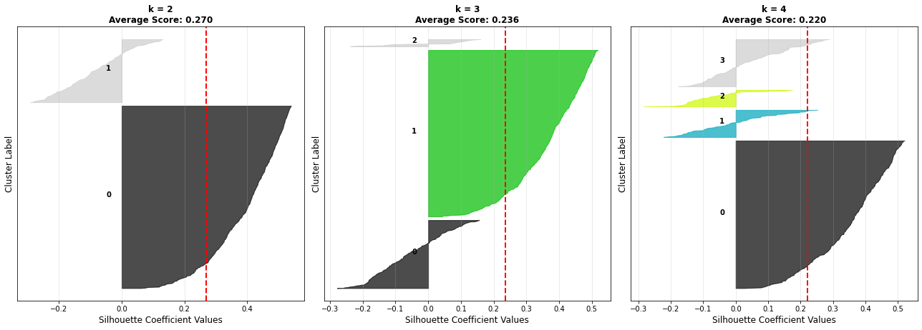
Supplementary Figure S1. Silhouette plots for k = 2, k = 3, and k = 4 cluster configurations. The silhouette value (x-axis) measures the degree of cohesion and separation for each sample, while the cluster labels (y-axis) denote the respective groups. For k = 2, the silhouette distribution shows a clear separation between two dominant clusters, although the within-cluster cohesion varies. For k = 3, the green region indicates a more refined internal structure, suggesting biologically interpretable subgroups with moderate inter-cluster overlap. For k = 4, additional subclusters emerge (cyan and yellow), but the mean silhouette width decreases, reflecting reduced overall cluster compactness and possible over-partitioning. The red dashed vertical line marks the average silhouette score for each configuration, highlighting that k = 3 achieves a balance between cohesion and separation.

