# CS500-01 Fundamentals of Programming

# Assignment 1

Tharinda Embuldeniya

S01996041

# Question 1.13

*Screenshot*

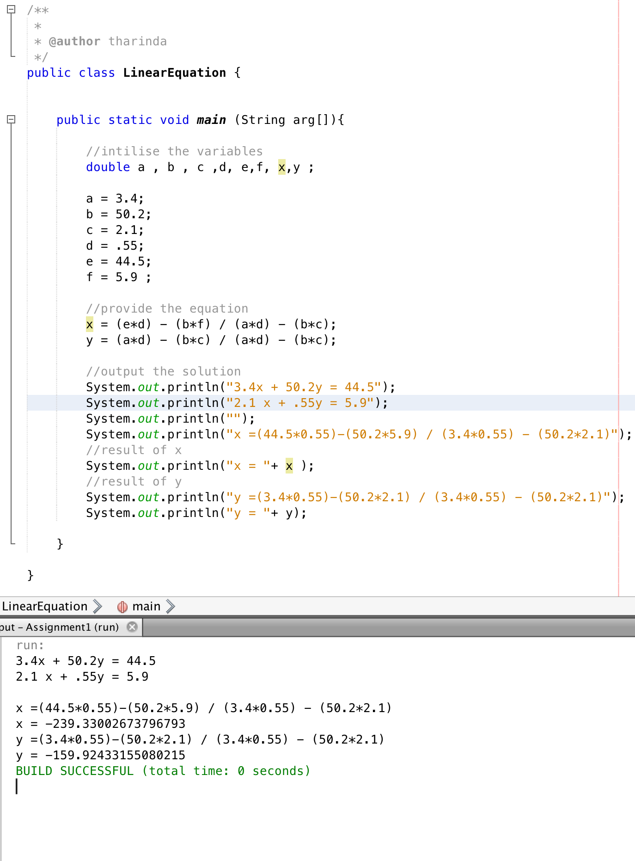

*Code*

public class LinearEquation {

public static void main (String arg[]){

//intilise the variables

double a , b , c ,d, e,f, x,y ;

a = 3.4;

b = 50.2;

c = 2.1;

d = .55;

e = 44.5;

f = 5.9 ;

//provide the equation

x = (e*d) - (b*f) / (a*d) - (b*c);

y = (a*d) - (b*c) / (a*d) - (b*c);

//output the solution

System.out.println("3.4x + 50.2y = 44.5");

System.out.println("2.1 x + .55y = 5.9");

System.out.println("");

System.out.println("x =(44.5*0.55)-(50.2*5.9) / (3.4*0.55) - (50.2*2.1)");

//result of x

System.out.println("x = "+ x );

//result of y

System.out.println("y =(3.4*0.55)-(50.2*2.1) / (3.4*0.55) - (50.2*2.1)");

System.out.println("y = "+ y);

}

}

# Question 2.19

*Screenshot*

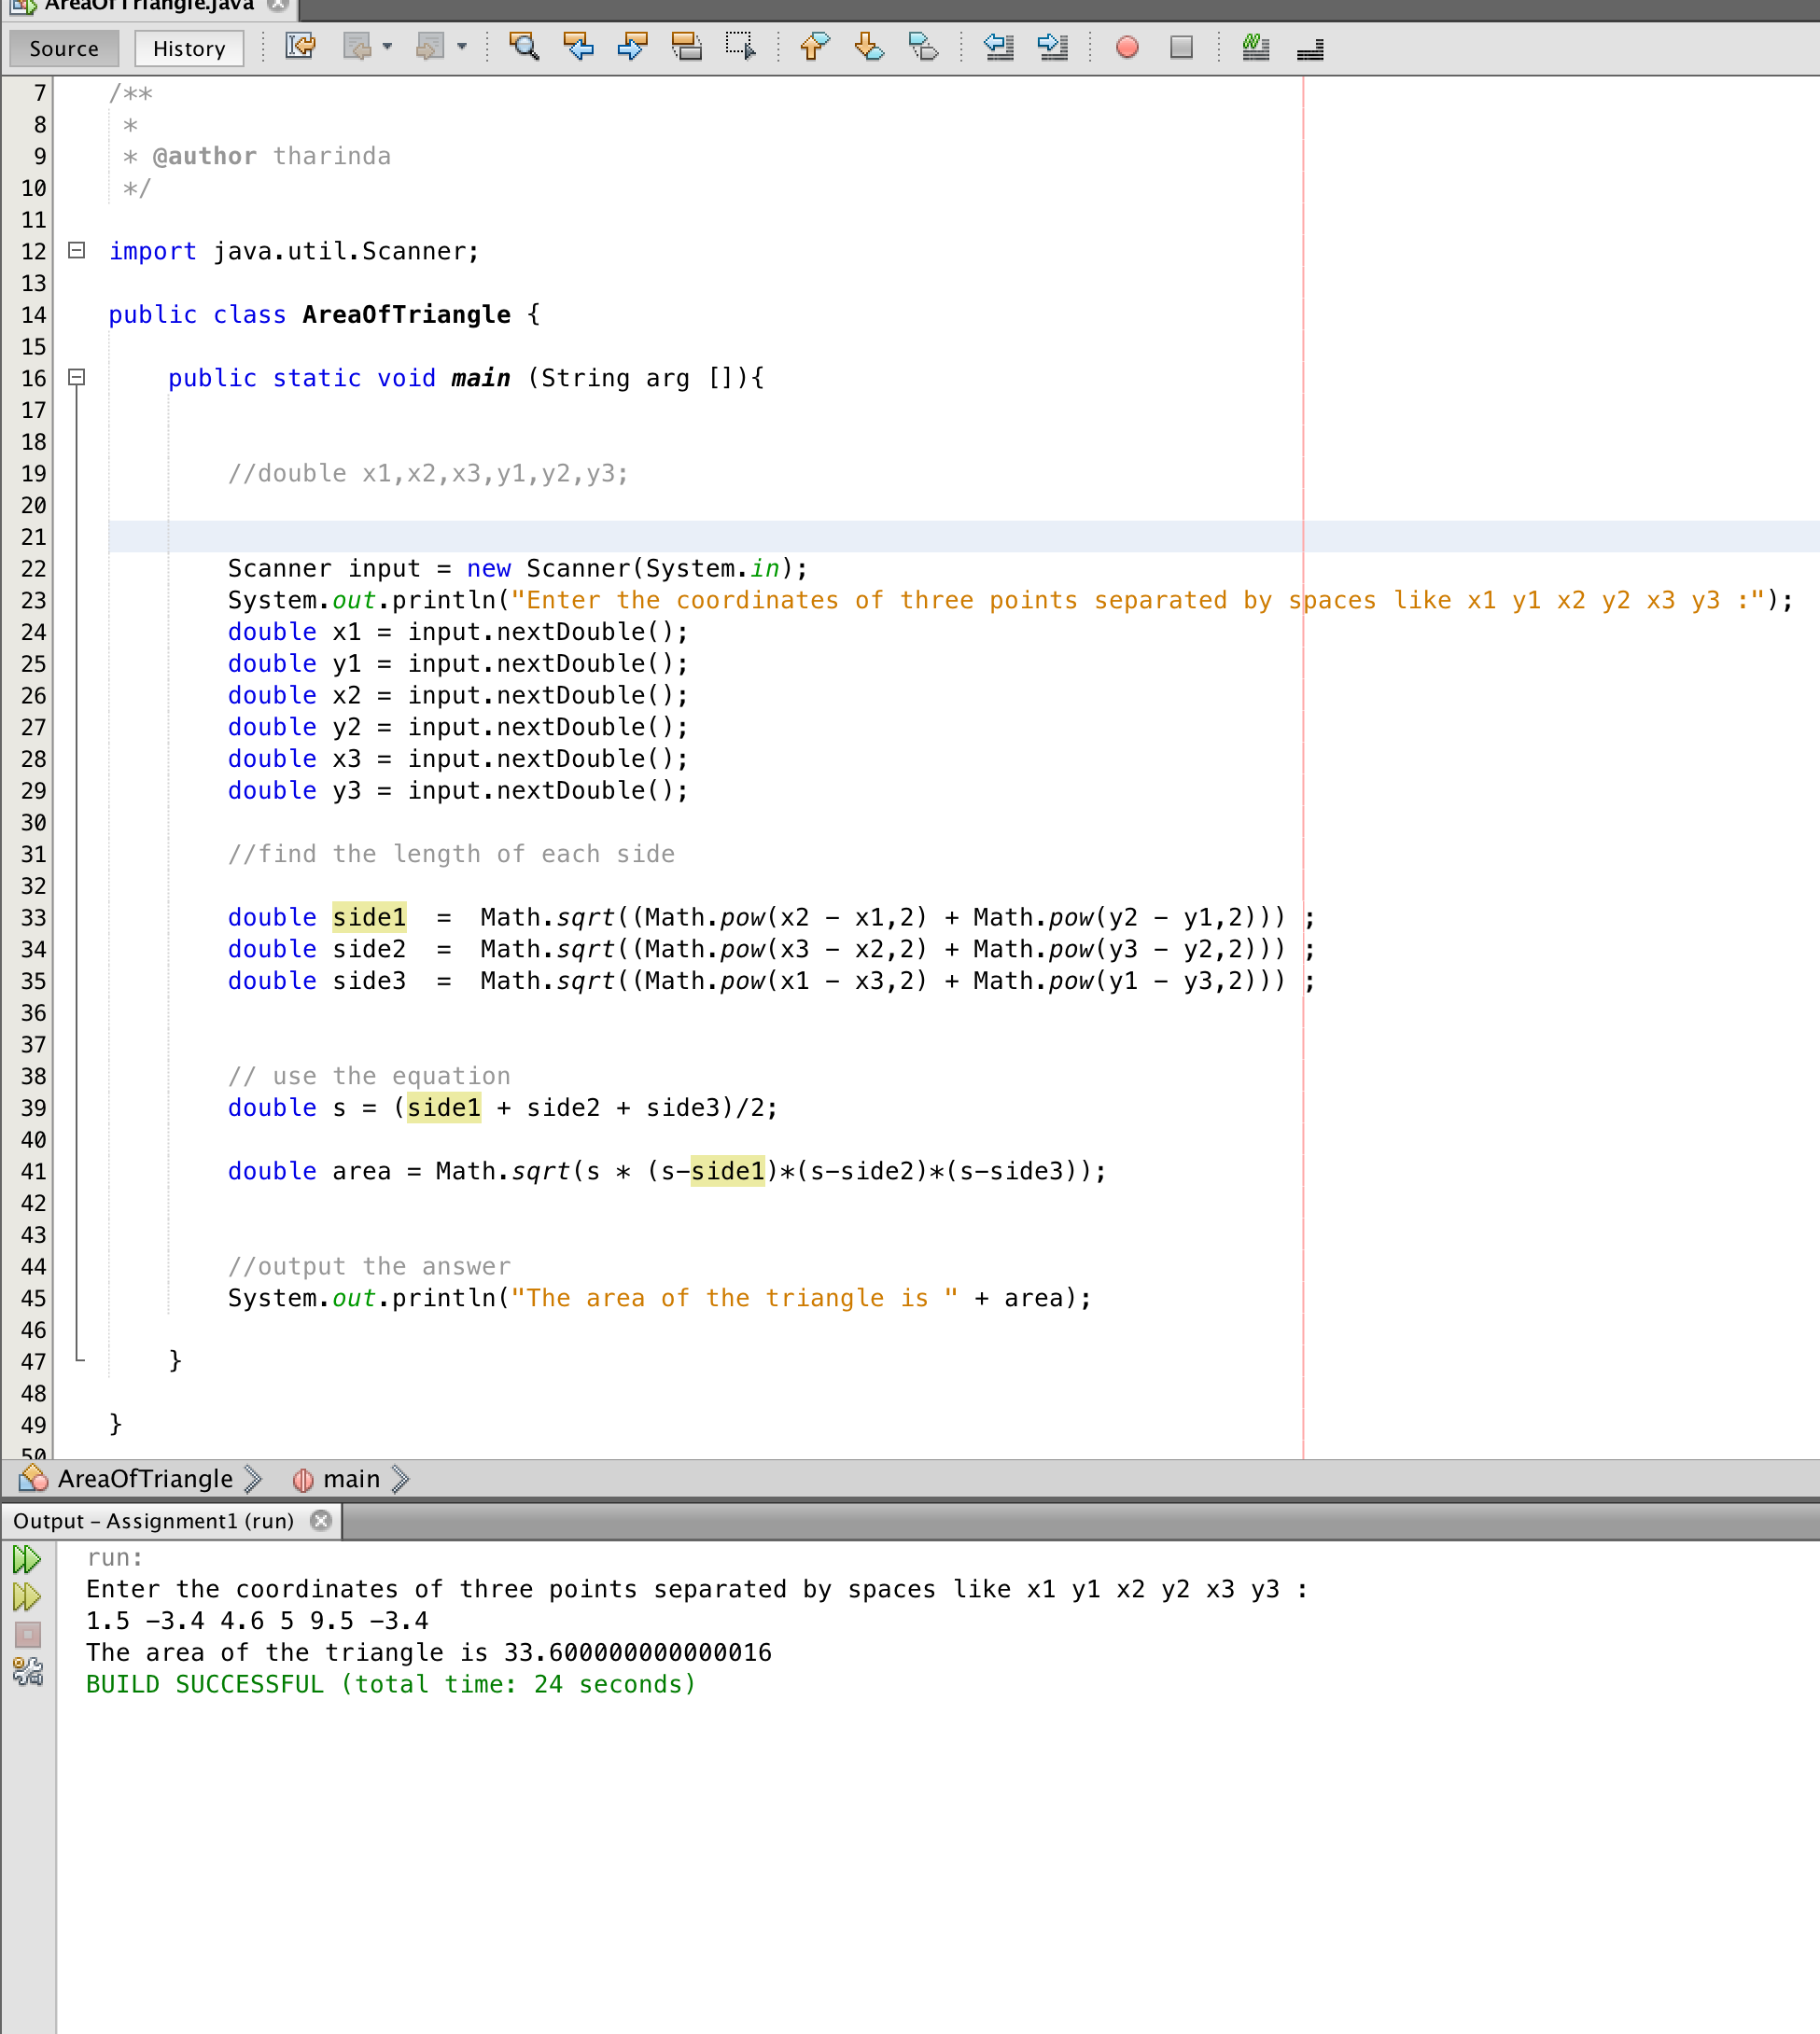

*Code*

import java.util.Scanner;

public class AreaOfTriangle {

public static void main (String arg []){

Scanner input = new Scanner(System.in);

System.out.println("Enter the coordinates of three points separated by spaces like x1 y1 x2 y2 x3 y3 :");

double x1 = input.nextDouble();

double y1 = input.nextDouble();

double x2 = input.nextDouble();

double y2 = input.nextDouble();

double x3 = input.nextDouble();

double y3 = input.nextDouble();

//find the length of each side

double side1 = Math.sqrt((Math.pow(x2 - x1,2) + Math.pow(y2 - y1,2))) ;

double side2 = Math.sqrt((Math.pow(x3 - x2,2) + Math.pow(y3 - y2,2))) ;

double side3 = Math.sqrt((Math.pow(x1 - x3,2) + Math.pow(y1 - y3,2))) ;

// use the equation

double s = (side1 + side2 + side3)/2;

double area = Math.sqrt(s * (s-side1)*(s-side2)*(s-side3));

//output the answer

System.out.println("The area of the triangle is " + area);

}

}

# Question 3.33

*Screenshot*

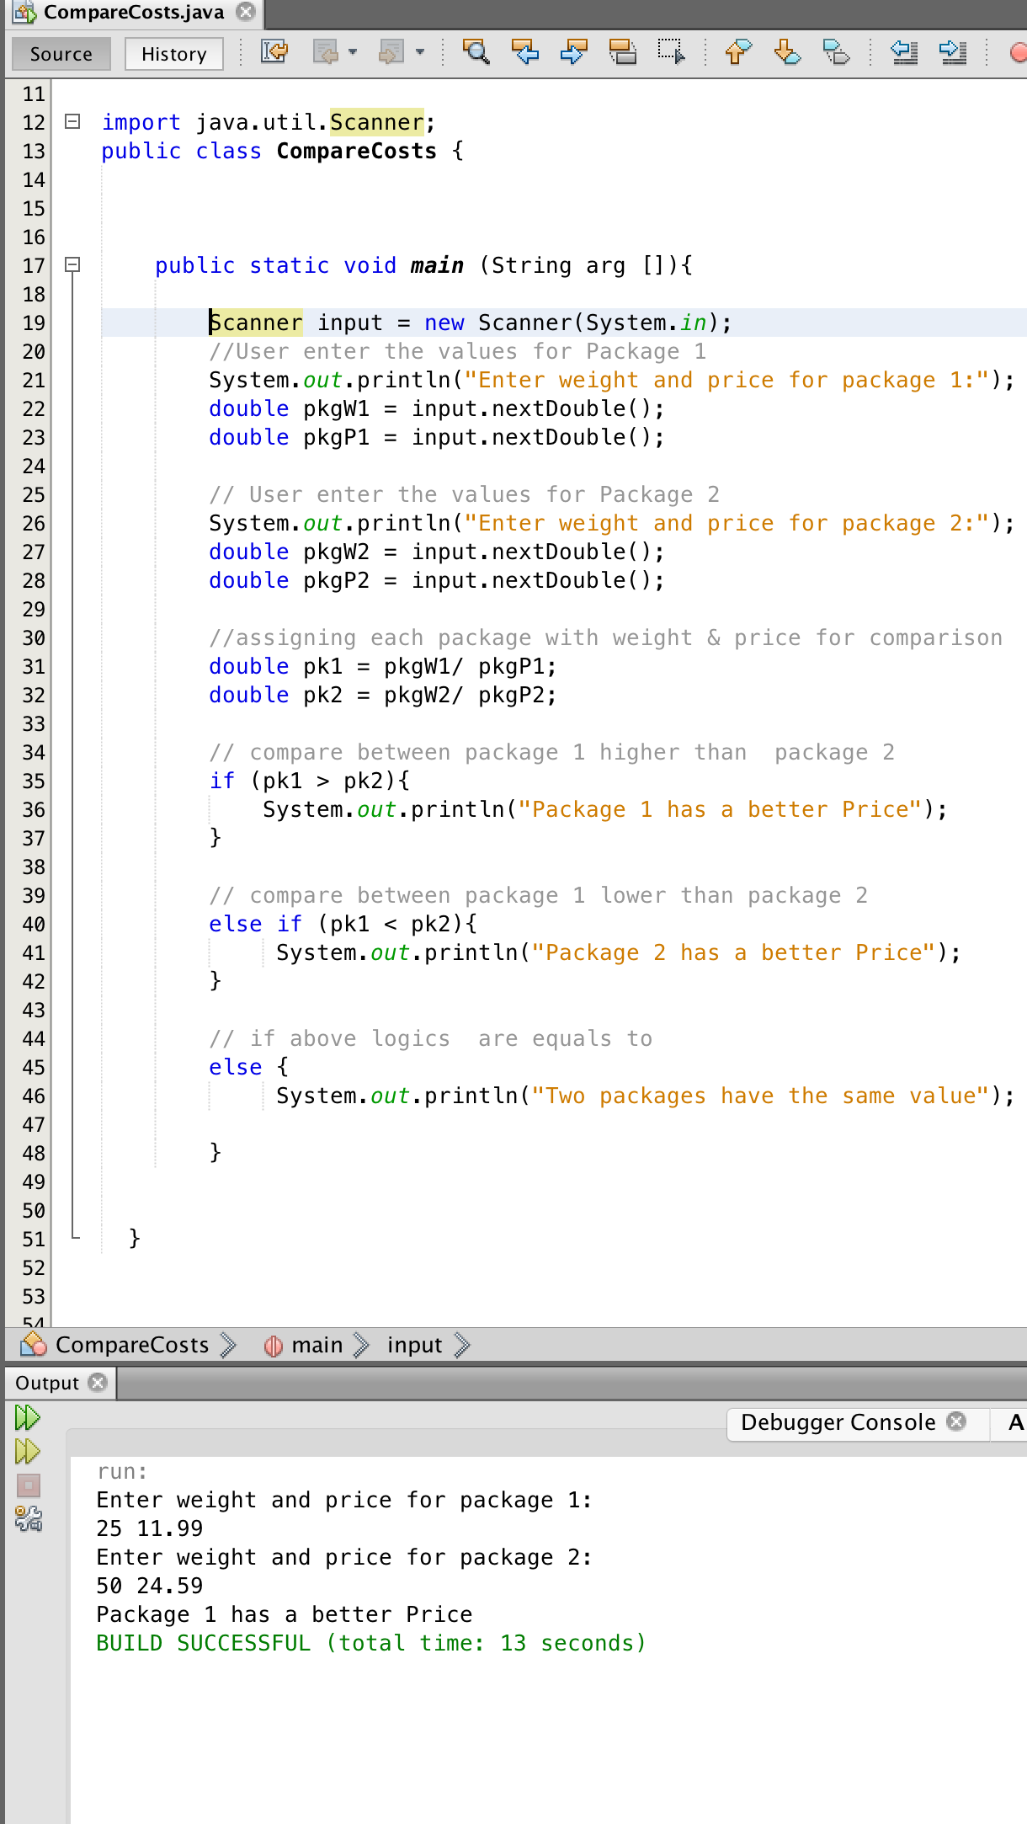

*Code*

import java.util.Scanner;

public class CompareCosts {

public static void main (String arg []){

Scanner input = new Scanner(System.in);

//User enter the values for Package 1

System.out.println("Enter weight and price for package 1:");

double pkgW1 = input.nextDouble();

double pkgP1 = input.nextDouble();

// User enter the values for Package 2

System.out.println("Enter weight and price for package 2:");

double pkgW2 = input.nextDouble();

double pkgP2 = input.nextDouble();

//assigning each package with weight & price for comparison

double pk1 = pkgW1/ pkgP1;

double pk2 = pkgW2/ pkgP2;

// compare between package 1 higher than package 2

if (pk1 > pk2){

System.out.println("Package 1 has a better Price");

}

// compare between package 1 lower than package 2

else if (pk1 < pk2){

System.out.println("Package 2 has a better Price");

}

// if above logics are equals to

else {

System.out.println("Two packages have the same value");

}

}

# Question 4.21

*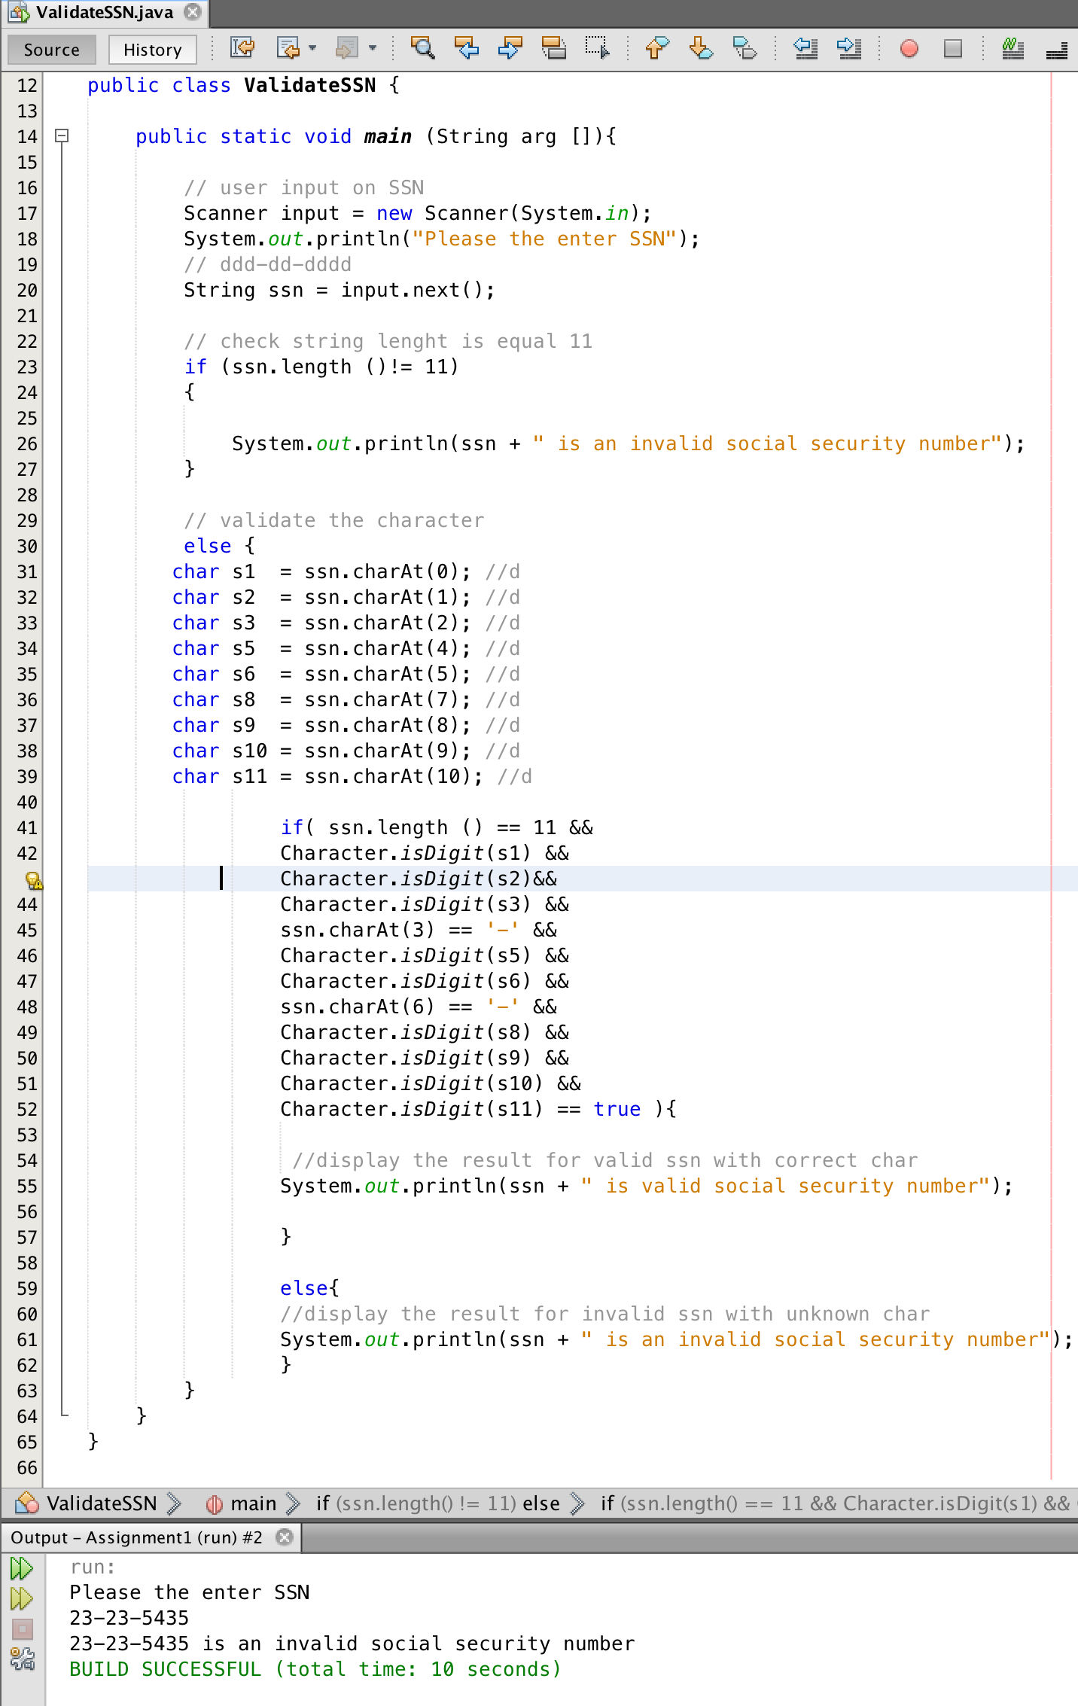Screenshot*

*Code*

import java.util.Scanner;

public class ValidateSSN {

public static void main (String arg []){

// user input on SSN

Scanner input = new Scanner(System.in);

System.out.println("Please the enter SSN");

// ddd-dd-dddd

String ssn = input.next();

// check string lenght is equal 11

if (ssn.length ()!= 11)

{

System.out.println(ssn + " is an invalid social security number");

}

// validate the character

else {

char s1 = ssn.charAt(0); //d

char s2 = ssn.charAt(1); //d

char s3 = ssn.charAt(2); //d

char s5 = ssn.charAt(4); //d

char s6 = ssn.charAt(5); //d

char s8 = ssn.charAt(7); //d

char s9 = ssn.charAt(8); //d

char s10 = ssn.charAt(9); //d

char s11 = ssn.charAt(10); //d

if( ssn.length () == 11 &&

Character.isDigit(s1) &&

Character.isDigit(s2)&&

Character.isDigit(s3) &&

ssn.charAt(3) == '-' &&

Character.isDigit(s5) &&

Character.isDigit(s6) &&

ssn.charAt(6) == '-' &&

Character.isDigit(s8) &&

Character.isDigit(s9) &&

Character.isDigit(s10) &&

Character.isDigit(s11) == true ){

//display the result for valid ssn with correct char

System.out.println(ssn + " is valid social security number");

}

else{

//display the result for invalid ssn with unknown char

System.out.println(ssn + " is an invalid social security number");

}

}

}

}

# Question 5.51

*Screenshot*

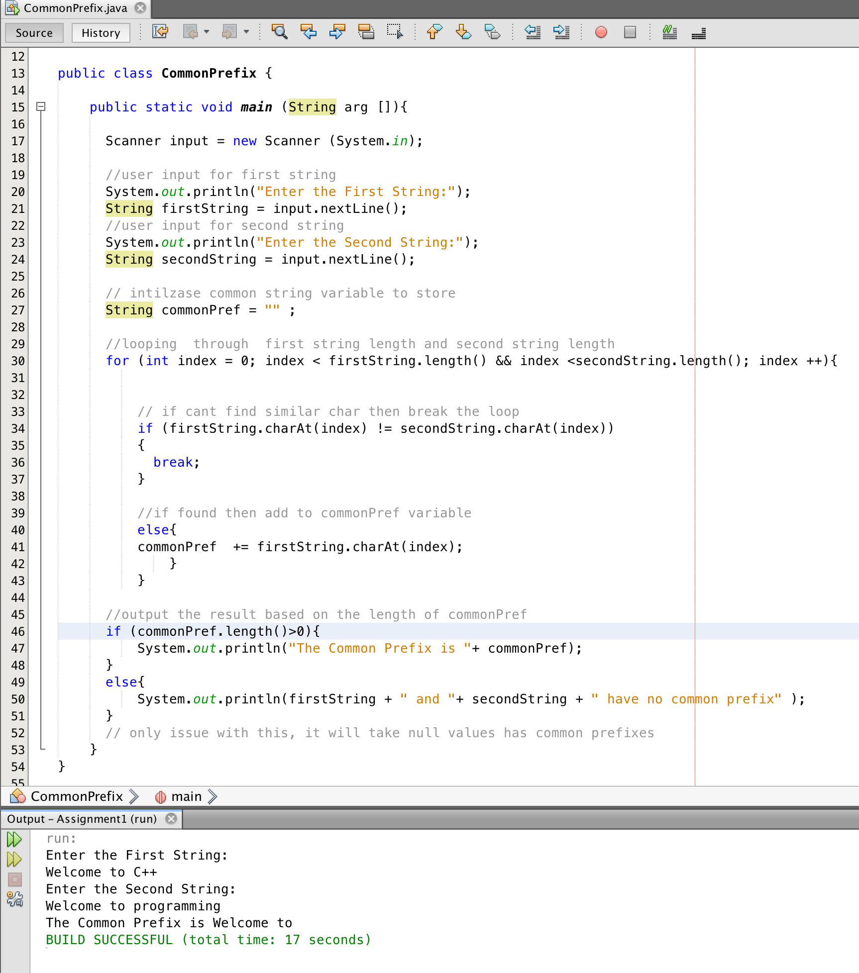

*Code*

import java.util.Scanner;

public class CommonPrefix {

public static void main (String arg []){

Scanner input = new Scanner (System.in);

//user input for first string

System.out.println("Enter the First String:");

String firstString = input.nextLine();

//user input for second string

System.out.println("Enter the Second String:");

String secondString = input.nextLine();

// intilzase common string variable to store

String commonPref = "" ;

//looping through first string length and second string length

for (int index = 0; index < firstString.length() && index <secondString.length(); index ++){

// if cant find similar char then break the loop

if (firstString.charAt(index) != secondString.charAt(index))

{

break;

}

//if found then add to commonPref variable

else{

commonPref += firstString.charAt(index);

}

}

//output the result based on the length of commonPref

if (commonPref.length()>0){

System.out.println("The Common Prefix is "+ commonPref);

}

else{

System.out.println(firstString + " and "+ secondString + " have no common prefix" );

}

// only issue with this, it will take null values has common prefixes

}

}