# CS500-01 Fundamentals of Programming

# Assignment 2

Tharinda Embuldeniya

S01996041

# Question 4.17

*Code*

**import** java.util.Scanner;

**public** **class** DaysOfMonth {

**public** **static** **void** main (String arg []) {

Scanner input = **new** Scanner (System.***in***);

// user input for year

System.***out***.println("Enter a Year:");

**int** year = input.nextInt();

// user input for month

System.***out***.println("Enter a month:");

String month = input.next();

// check for whether year is leap year or not

**boolean** isleapYear = (year % 4 == 0 && year % 100 !=0) || (year % 400 == 0);

//Outer if - Month Validation on length and first Char is Uppercase & others Chars are lowercase (code validation eg : FeB)

**if** (month.length () == 3 && Character.*isUpperCase*(month.charAt(0)) &&

Character.*isLowerCase*(month.charAt(1)) && Character.*isLowerCase*(month.charAt(2))) {

//Inner if - check against Char equals to following months , then display 31 days

**if** (month.equals("Jan")||month.equals("Mar") || month.equals("May") ||

month.equals("Jul")||month.equals("Aug") || month.equals("Oct") ||

month.equals( "Dec")){

System.***out***.println(month + " "+ year + " has 31 days");

}

//Inner else if - check against Char equals to following month, then display 30days

**else** **if** (month.equals("Apr")||month.equals("Jun") || month.equals("Sep") ||

month.equals("Nov")){

System.***out***.println(month + " " + year + " has 30 days");

}

//Inner else if - check against Char equals to Feb Month & Based on Variable above on isleapYear to display result

**else** **if** (isleapYear == **true** && month.equals("Feb")) {

System.***out***.println(month + " " + year + " has 29 days");

}

**else** **if** (isleapYear == **false** && month.equals("Feb")) {

System.***out***.println(month + " " + year + " has 28 days");

}

// Anything doesnt fit above criteria & code validation eg : Fed

**else** {

System.***out***.println(month + " is not correct month name");

}

}

// Outer If conditions fails, display this

**else**

{

System.***out***.println(month + " is not correct month name");

}

}

}

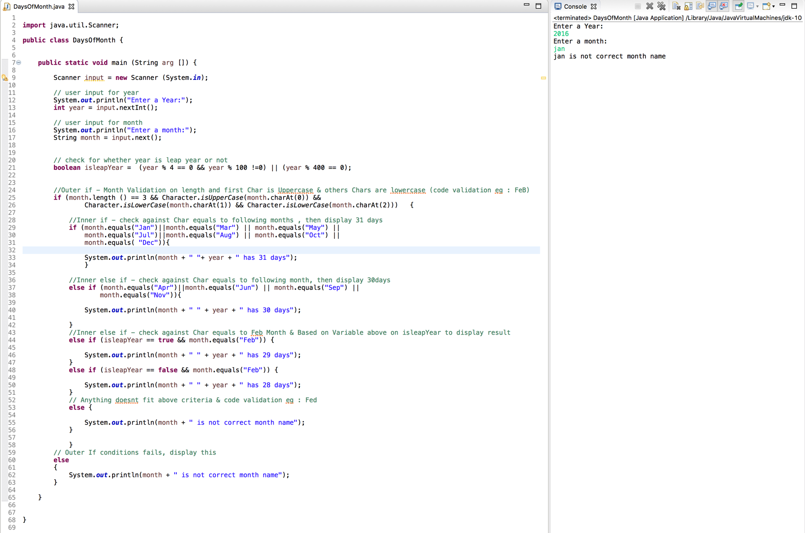*Screenshot*

# Question 5.50

*Code*

**import** java.util.Scanner;

**public** **class** CountUpperCase {

**public** **static** **void** main (String arg []) {

Scanner input = **new** Scanner (System.***in***);

// user input for a string

System.***out***.println("Enter a String:");

String sent = input.nextLine();

// set the count var to 0

**int** count = 0;

// loop through each letter of the string

**for** (**int** j = 0 ; j < sent.length(); j++) {

// check whether the char is uppercase or not

**if** (Character.*isUpperCase*(sent.charAt(j)))

{

count++;

}

}

//display the output

System.***out***.println("The number of uppercase letter is " + count);

}

}

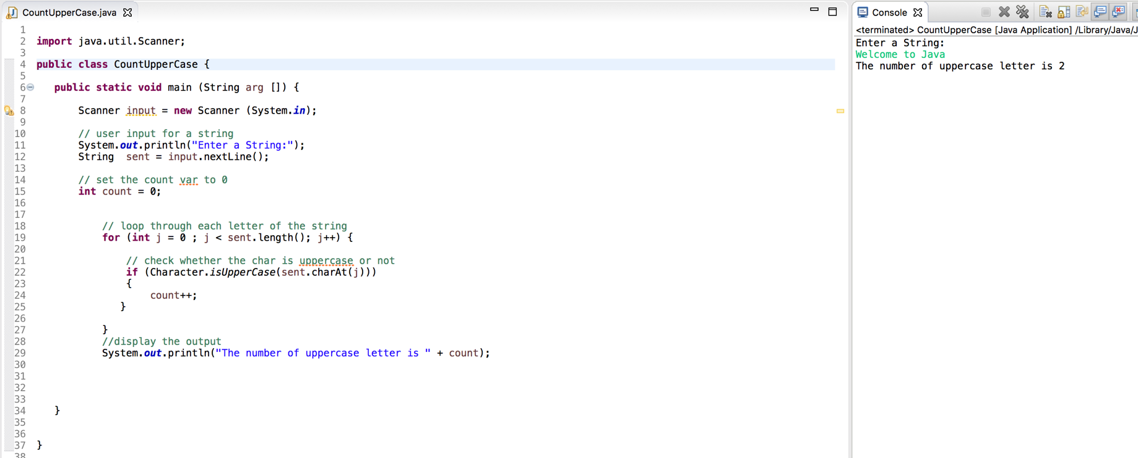*Screenshot*

# Question 6.35

*Code*

**import** java.util.Scanner;

**public** **class** AreaOfPentagon {

**public** **static** **void** main (String [] args) {

Scanner input = **new** Scanner(System.***in***);

System.***out***.println("Enter the side" );

// user input data

**double** side = input.nextDouble();

//output the result + calling area method

System.***out***.println("The area of the pentagon is " + *area*(side) );

}

// define the area while returning a value

**public** **static** **double** area(**double** side1) {

**double** result = 0;

//final double PI = 3.14159;

// subs math formula given

result = (5* (Math.*pow*(side1, 2)))/ (4 * (Math.*tan*((Math.***PI***/5))) );

**return** result;

}

}

*Screenshot*

