**Question 1 (chapter 13)**

**Create a Student class that has instance variables for the student's last name and ID number, along with appropriate constructor, accesssors (get methods)  and mutators (set methods) , Make the Student class implement the Comparable interface. Define the compareTo method to order Student Objects based on the student ID number. In the main method, create an array of at least five Student objects, sort them using Arrays.sort, and output the students. They should be listed by ascending student number. Next, modify the compareTo method so it orders Student objects based on their last name. Without modifications to the main method, the program should now output the students ordered by name.**

**Provide a copy of both versions of the program.**

*Screenshot*

Student Class

**public** **class** Student **implements** Comparable <Student> {

**private** String lastName ;

**private** **int** id ;

**public** Student() {

}

**public** Student (String newLast , **int** newId) {

lastName = newLast;

id = newId;

}

//setter

**public** **void** setLastName (String newLast) {

lastName = newLast;

}

**public** **void** setID (**int** newID) {

id = newID;

}

//getter

**public** String getLastName () {

**return** lastName;

}

**public** **int** getID () {

**return** id;

}

//Comparison based on Student ID

**public** **int** compareTo(Student a) {

**if** (id == a.id) {

**return** 0;

}

**else** **if** (id > a.id) {

**return** 1;

}

**else** {

**return** -1;

}

}

//Comparison based on Student Last Name

/*

* public int compareTo(Student a) {

return getLastName().compareTo(a.getLastName());

}

*/

**public** String toString () {

**return** "Student ID :" + id + " " + "Student Last Name : " + lastName + "\n";

}

}

Main Class

**import** java.util.Arrays;

**public** **class** Student_Main {

**public** **static** **void** main(String[] args) {

Student [] stAr = **new** Student [5];

stAr [0] = **new** Student ("Meyers", 102);

stAr [1] = **new** Student ("Kyle", 105);

stAr [2] = **new** Student ("Reed", 101);

stAr [3] = **new** Student ("Armisen",113);

stAr [4] = **new** Student ("Moss", 104);

Arrays.*sort*(stAr);

**for** (Student st : stAr) {

System.***out***.print(st.toString());

}

}

}

*Screenshot*

Based on Student ID

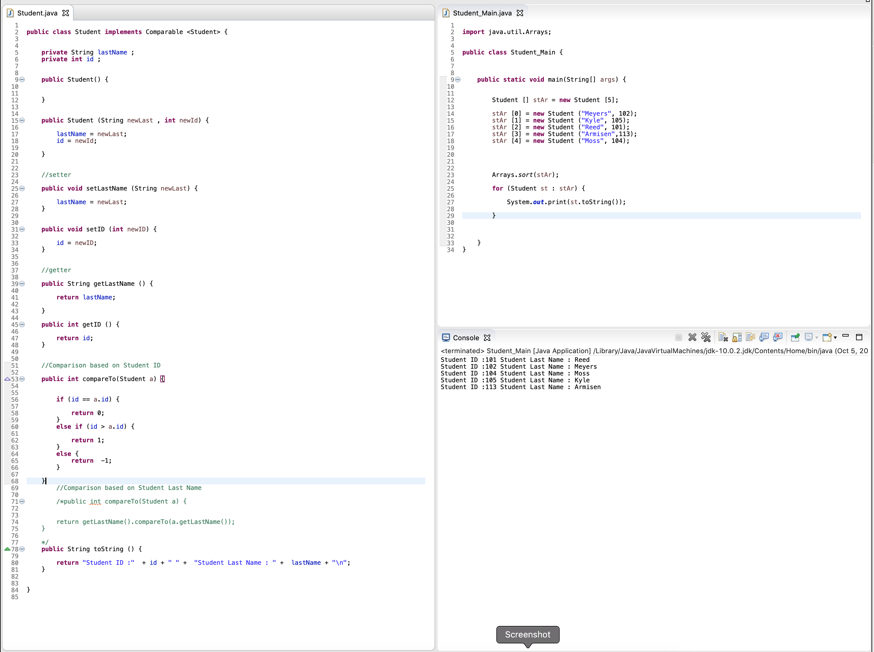

Based on Student Last Name

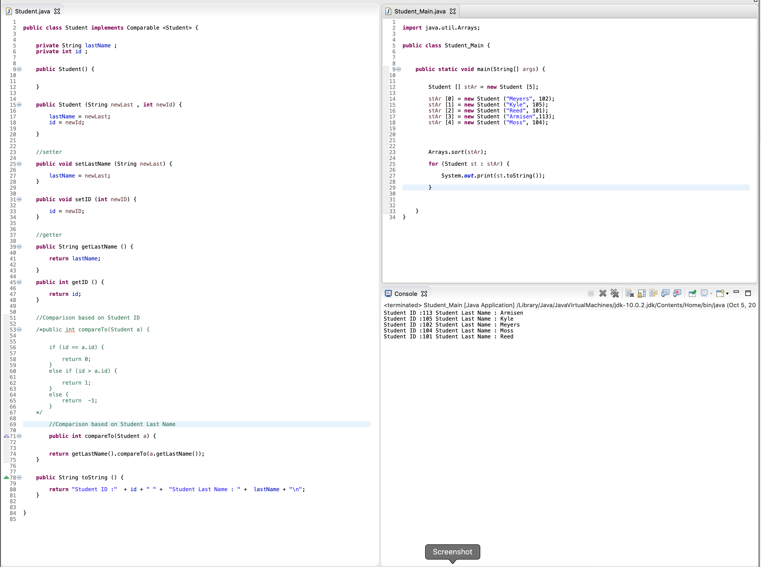

**Question 2: (chapter 14)**

**Write a program that displays a smiley face in a grid pane. It uses a circle for the face, circles for eyes, triangle pointing downwards for a nose and an arc for mouth. The face is yellow, the eyes are brown and the mouth is red. A message is displayed "Programming in Java is fun".**

*Code*

package application;

import javafx.application.Application;

import javafx.geometry.Insets;

import javafx.geometry.Pos;

import javafx.scene.Scene;

import javafx.scene.layout.GridPane;

import javafx.scene.paint.Color;

import javafx.scene.shape.Arc;

import javafx.scene.shape.Circle;

import javafx.scene.shape.Polygon;

import javafx.scene.text.Font;

import javafx.scene.text.FontPosture;

import javafx.scene.text.FontWeight;

import javafx.scene.text.Text;

import javafx.scene.transform.Translate;

import javafx.stage.Stage;

public class SmileyGrid extends Application {

@Override

public void start(Stage primaryStage) {

GridPane pane = new GridPane();

pane.setAlignment(Pos.CENTER);

pane.setPadding(new Insets (20,20,20,20));

pane.setHgap(50);

pane.setVgap(50);

//face

Circle face = new Circle(100,50,100);

face.setFill(Color.YELLOW);

//Eyes 1

Circle eye = new Circle(155,100,10);

eye.setFill(Color.BROWN);

Translate eye1 = new Translate();

eye1.setX(50);

eye1.setY(-40);

eye1.setZ(0);

eye.getTransforms().addAll(eye1);

//Eyes 2

Circle eye2 = new Circle(230,100,10);

eye2.setFill(Color.BROWN);

Translate trans = new Translate();

trans.setX(130);

trans.setY(-40);

trans.setZ(0);

eye2.getTransforms().addAll(trans);

// Nose

Polygon nose = new Polygon ();

nose.getPoints().addAll(new Double [] {

50.0,75.0,

75.0,125.0,

100.0,75.0,

});

Translate down = new Translate ();

down.setX(75);

down.setY(10);

down.setZ(0);

nose.getTransforms().addAll(down);

// Arc

Arc mouth = new Arc ();

mouth.setCenterX(100.0);

mouth.setCenterY(100.0);

mouth.setRadiusX(46.0);

mouth.setRadiusY(60.0);

mouth.setStartAngle(220.0);

mouth.setLength(100.0);

mouth.setFill(Color.RED);

Translate open = new Translate ();

open.setX(65);

open.setY(60);

open.setZ(0);

mouth.getTransforms().addAll(open);

//Text

Text text1 = new Text(0,0, "Programming in Java is fun");

text1.setFont(Font.font("Comic Sans MS", FontWeight.BOLD, FontPosture.REGULAR, 16));

Translate loc = new Translate ();

loc.setX(0);

loc.setY(110);

loc.setZ(0);

text1.getTransforms().addAll(loc);

//draw

pane.getChildren().addAll(face,eye,eye2,nose,mouth,text1);

//scene

Scene scene = new Scene (pane,275,275 );

primaryStage.setTitle("Smiley Face");

primaryStage.setScene(scene);

primaryStage.show();

}

public static void main(String[] args) {

launch(args);

}

}

*Screenshot*

