**Question 1 (Chapter 17)**

**Write a program to create a new file named File1.txt.  Write 100 integers created randomly into the file using text I/O. Integers are separated by a space.  print screen the content of created file and add it to your submission.**

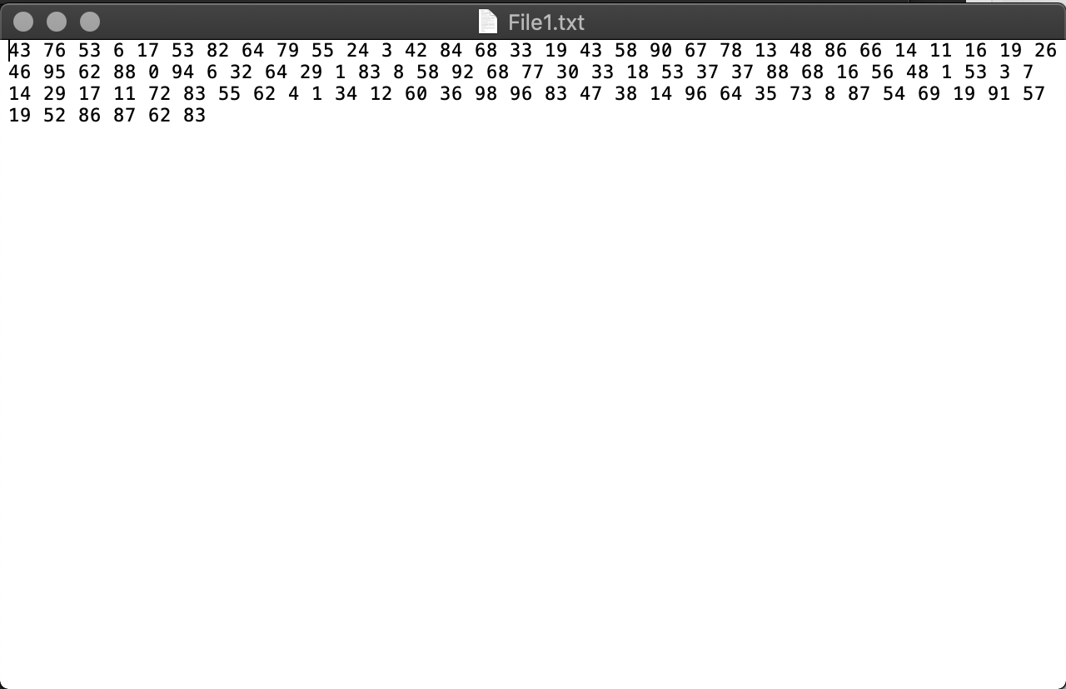

**Copy content of File1.txt to File2.dat (convert it to binary). print screen the content of created file and add it to your submission.**

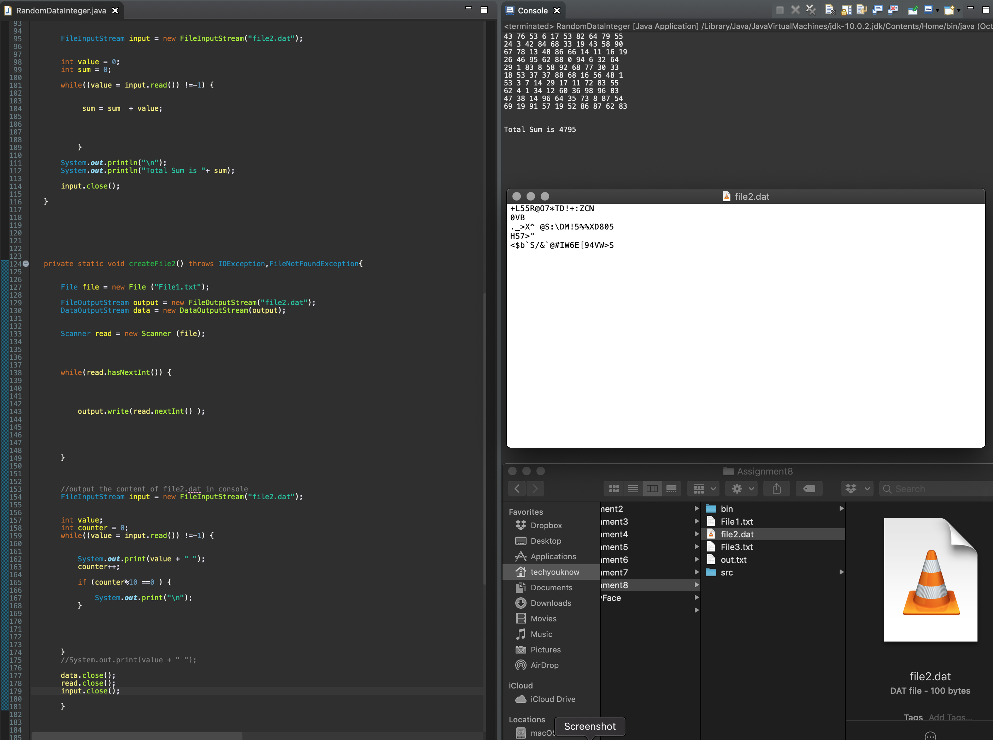

**Sum all the integers in the binary data file File2.dat and print result to screen. Suppose that the file contains an unspecified number of integers.**

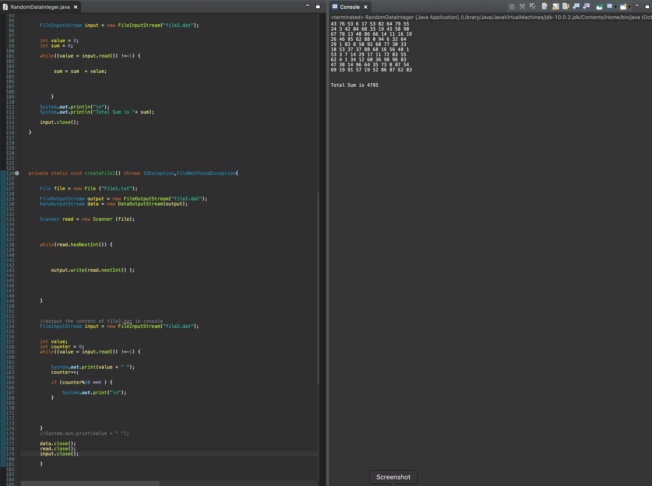

**Copy content of File2.dat to File3.txt (convert back to text). print screen the content of created file and add it to your submission.**

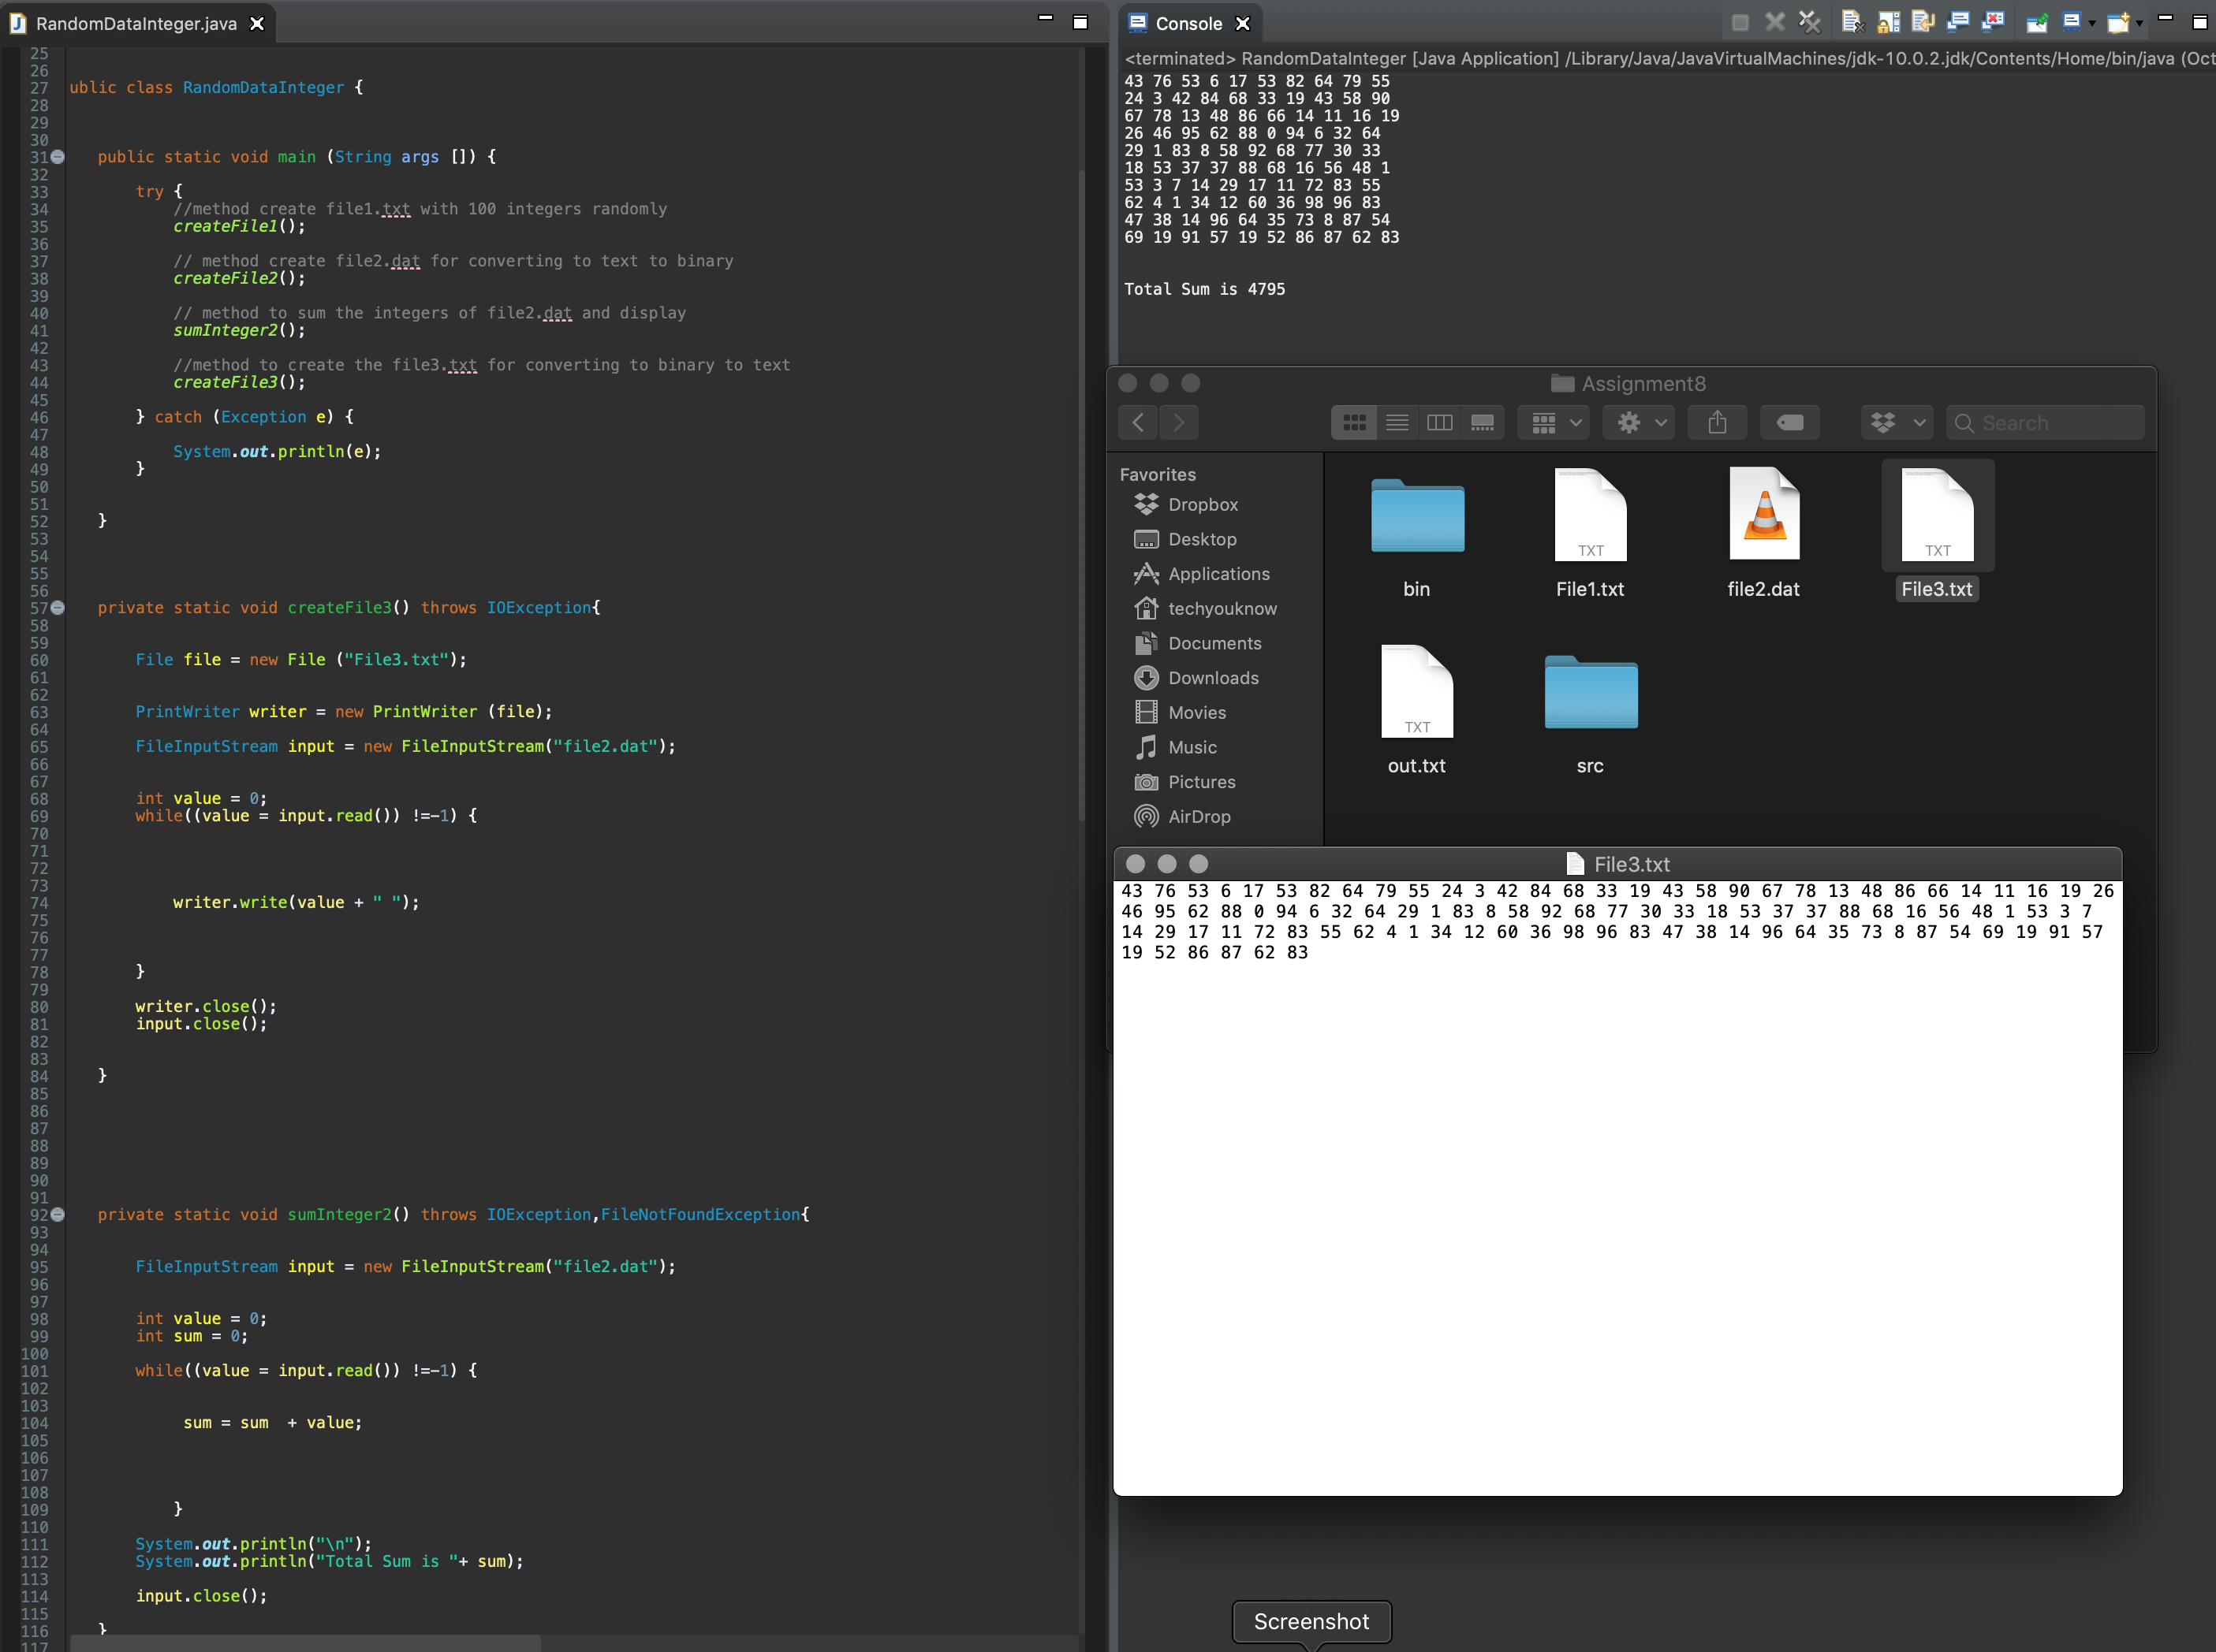

*Code*

*import java.io.DataOutputStream;*

*import java.io.File;*

*import java.io.FileInputStream;*

*import java.io.FileNotFoundException;*

*import java.io.FileOutputStream;*

*import java.io.IOException;*

*import java.io.PrintWriter;*

*import java.util.Scanner;*

*/\**

*\* Question 1 (Chapter 17)*

*Write a program to create a new file named File1.txt. Write 100 integers created randomly into the file using text I/O. Integers are separated by a space. print screen the content of created file and add it to your submission.*

*Copy content of File1.txt to File2.dat (convert it to binary). print screen the content of created file and add it to your submission.*

*Sum all the integers in the binary data file File2.dat and print result to screen. Suppose that the file contains an unspecified number of integers.*

*Copy content of File2.dat to File3.txt (convert back to text). print screen the content of created file and add it to your submission.*

*\**

*\**

*\*/*

*public class RandomDataInteger {*

*public static void main (String args []) {*

*try {*

*//method create file1.txt with 100 integers randomly*

*createFile1();*

*// method create file2.dat for converting to text to binary*

*createFile2();*

*// method to sum the integers of file2.dat and display*

*sumInteger2();*

*//method to create the file3.txt for converting to binary to text*

*createFile3();*

*} catch (Exception e) {*

*System.out.println(e);*

*}*

*}*

*private static void createFile3() throws IOException{*

*File file = new File ("File3.txt");*

*PrintWriter writer = new PrintWriter (file);*

*FileInputStream input = new FileInputStream("file2.dat");*

*int value = 0;*

*while((value = input.read()) !=-1) {*

*writer.write(value + " ");*

*}*

*writer.close();*

*input.close();*

*}*

*private static void sumInteger2() throws IOException,FileNotFoundException{*

*FileInputStream input = new FileInputStream("file2.dat");*

*int value = 0;*

*int sum = 0;*

*while((value = input.read()) !=-1) {*

*sum = sum + value;*

*}*

*System.out.println("\n");*

*System.out.println("Total Sum is "+ sum);*

*input.close();*

*}*

*private static void createFile2() throws IOException,FileNotFoundException{*

*File file = new File ("File1.txt");*

*FileOutputStream output = new FileOutputStream("file2.dat");*

*DataOutputStream data = new DataOutputStream(output);*

*Scanner read = new Scanner (file);*

*while(read.hasNextInt()) {*

*output.write(read.nextInt() );*

*}*

*//output the content of file2.dat in console*

*FileInputStream input = new FileInputStream("file2.dat");*

*int value;*

*int counter = 0;*

*while((value = input.read()) !=-1) {*

*System.out.print(value + " ");*

*counter++;*

*if (counter%10 ==0 ) {*

*System.out.print("\n");*

*}*

*}*

*//System.out.print(value + " ");*

*data.close();*

*read.close();*

*input.close();*

*}*

*private static void createFile1() throws IOException{*

*//create a new file named File1.txt.*

*File file = new File ("File1.txt");*

*PrintWriter writer = new PrintWriter (file);*

*for (int i=0; i<100; i++) {*

*double x = 0;*

*for (int j=0; j<100 ;j++) {*

*x = Math.random()*101;*

*}*

*//Integers are separated by a space*

*writer.write((int)x + " ");*

*}*

*writer.close();*

*}*

*}*

*Screenshot*

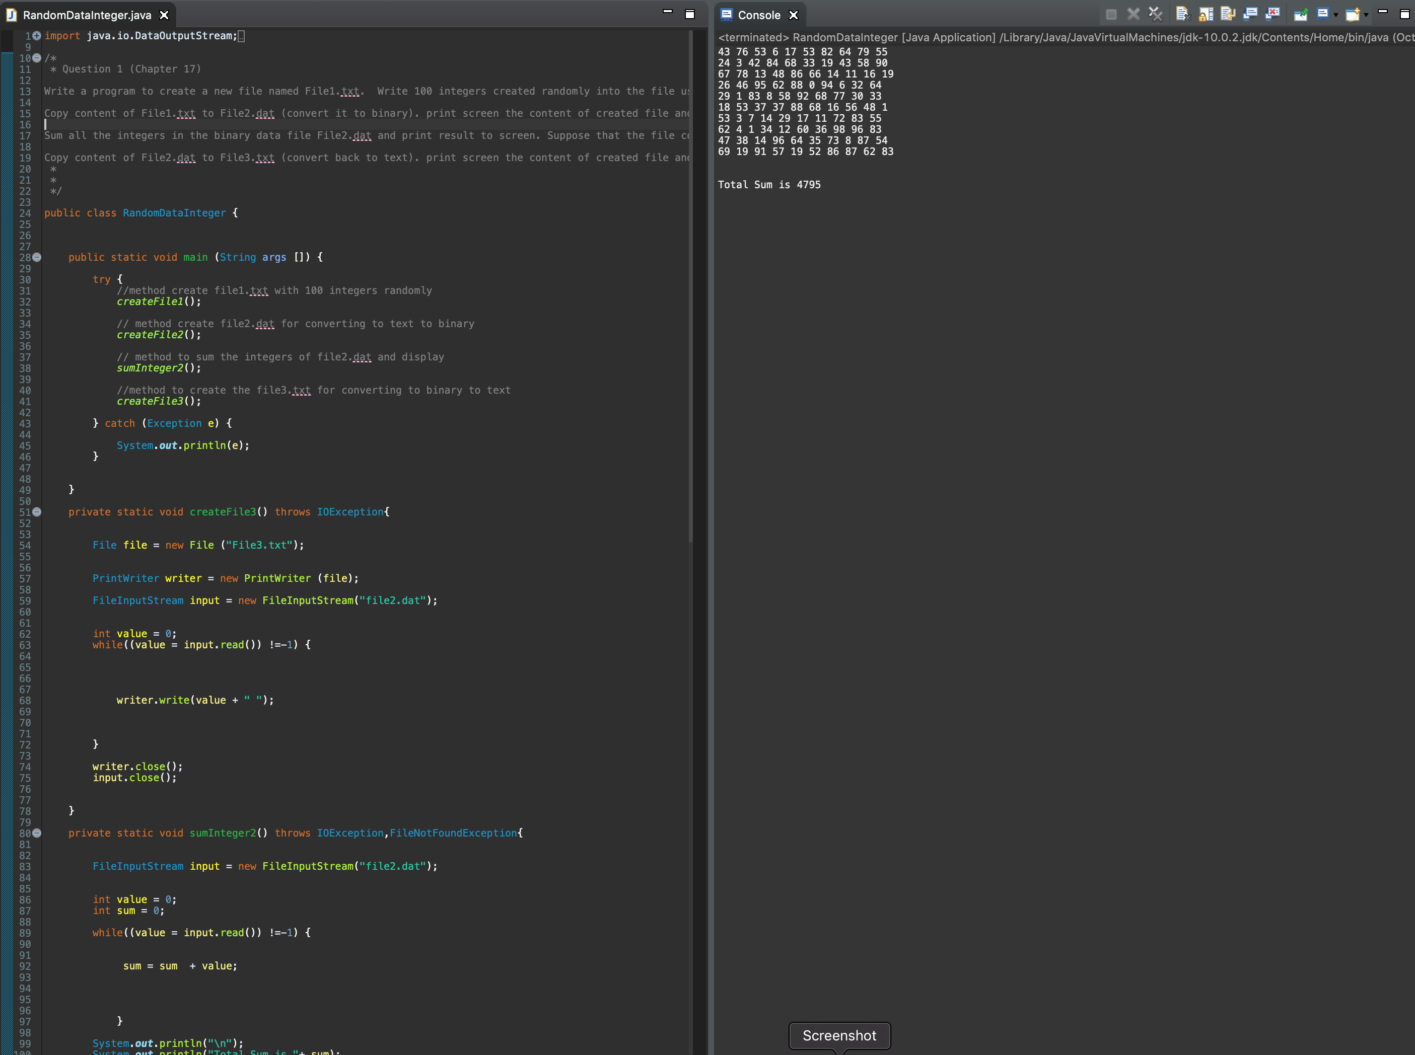

**Question 1 (Chapter 18)**

**Write a program to ask the user to either**

**Select 1 to print the digits in an integer reversely**

**Select 2 to print the characters in a string reversely**

**using a switch case, your program will either**

**1- call the recursive method that displays an int value reversely on the console using the following header public static void reverseIntDisplay(int value)**

**for example, reverseIntDiplay(12345) displays 54321**

**2- call the recursive method that displays a String value reversely on the console using the following header**

**public static void reverseStringDisplay (String value)**

**for example, reverseStringDisplay ("abcd") displays dcba**

**Write a test program the prompts the user to enter his/her choice then an integer or a string and then displays its reversal**

*Code*

/*

*

Write a program to ask the user to either

Select 1 to print the digits in an integer reversely

Select 2 to print the characters in a string reversely

using a switch case, your program will either

1- call the recursive method that displays an int value reversely on the console using the following header public static void reverseIntDisplay(int value)

for example, reverseIntDiplay(12345) displays 54321

2- call the recursive method that displays a String value reversely on the console using the following header

public static void reverseStringDisplay (String value)

for example, reverseStringDisplay ("abcd") displays dcba

Write a test program the prompts the user to enter his/her choice then an integer or a string and then displays its reversal.

*

*

*/

import java.util.Scanner;

public class Recursive {

public static void main(String[] args) {

Scanner input = new Scanner(System.in);

System.out.println("Please select a option from Below");

System.out.println("Option 1 --> Display Digits in an integer reversely");

System.out.println("Option 2 --> Display Characters in a string reversely");

int opt = input.nextInt();

switch (opt) {

case 1 : System.out.println("Enter a integer");

reverseIntDiplay(input.nextInt());

break;

case 2 : System.out.println("Enter a String");

reverseStringDisplay(input.next());

break;

}

}

public static void reverseStringDisplay(String value) {

if (value.length() !=1) {

System.out.print(value.charAt(value.length() - 1));

reverseStringDisplay(value.substring(0, value.length() - 1));

}

else {

System.out.println(value);

}

}

public static void reverseIntDiplay(int value) {

if (value <10) {

System.out.println(value);

/* another condition without print statement

*

* if (value == 0){

*

*

*/

}

else {

System.out.print(value %10);

int number = (int) value/10;

reverseIntDiplay(number);

}

}

}

*Screenshoots*

