**Assignment 1 for CS 603**

## Mohammed Fizer Fazmi

## Hari Charan Kaveri

## Tharinda Embuldeniya

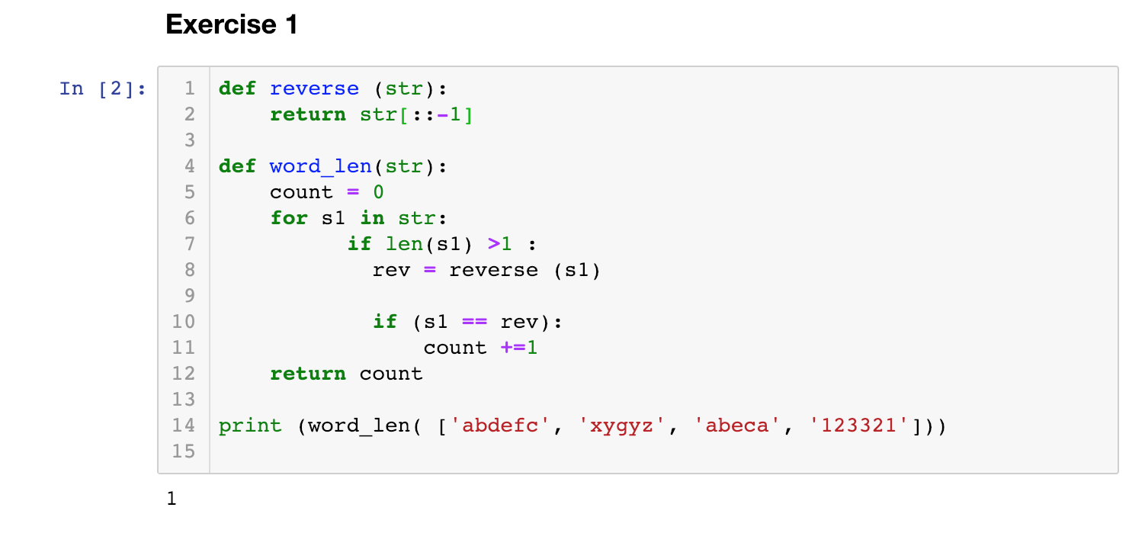

**Code:**

def reverse (str):

return str[::-1]

def word_len(str):

count = 0

for s1 in str:

if len(s1) >1 :

rev = reverse (s1)

if (s1 == rev):

count +=1

return count

print (word_len( ['abdefc', 'xygyz', 'abeca', '123321']))

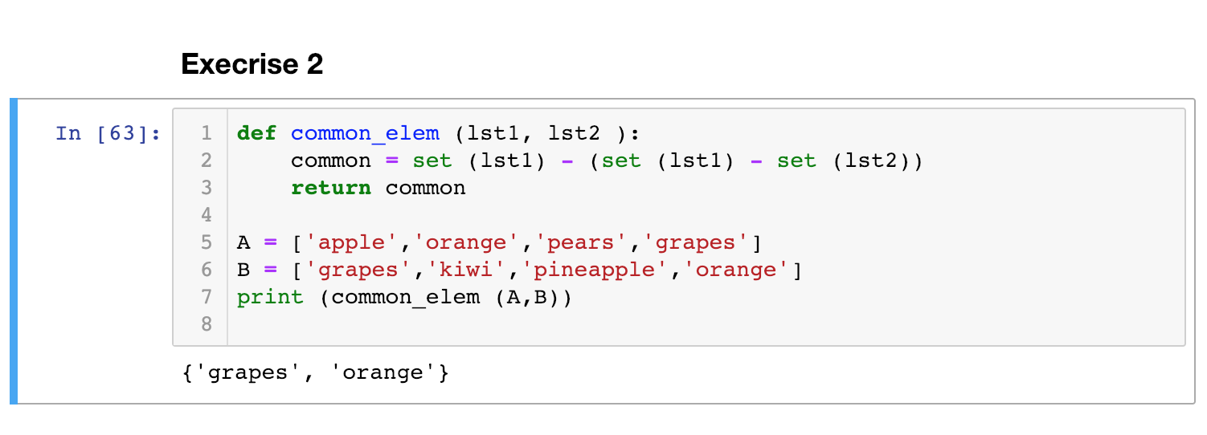

**Code :**

def common_elem (lst1, lst2 ):

common = set (lst1) - (set (lst1) - set (lst2))

return common

A = ['apple','orange','pears','grapes']

B = ['grapes','kiwi','pineapple','orange']

print (common_elem (A,B))

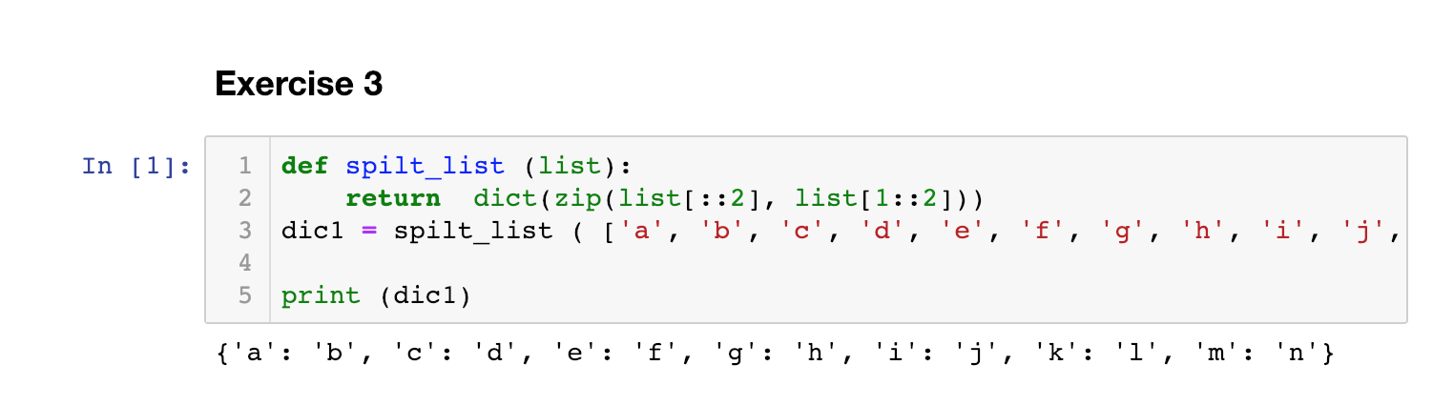

**Code**

def spilt_list (list):

return dict(zip(list[::2], list[1::2]))

dic1 = spilt_list ( ['a', 'b', 'c', 'd', 'e', 'f', 'g', 'h', 'i', 'j', 'k', 'l', 'm', 'n'])

print (dic1)

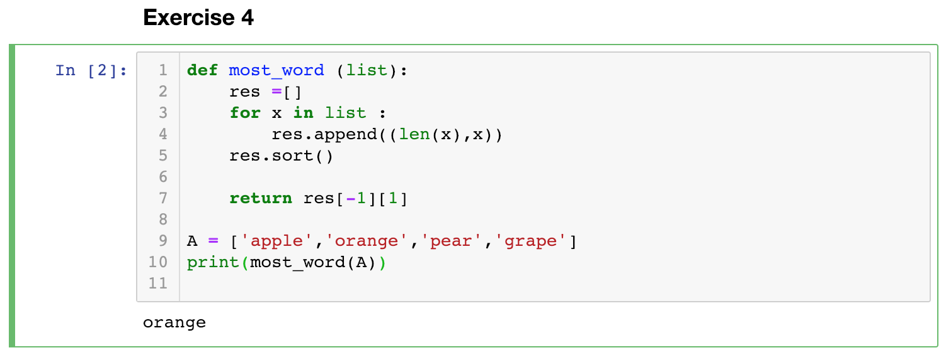

**Code**

def most_word (list):

res =[]

for x in list :

res.append((len(x),x))

res.sort()

return res[-1][1]

A = ['apple','orange','pear','grape']

print(most_word(A))

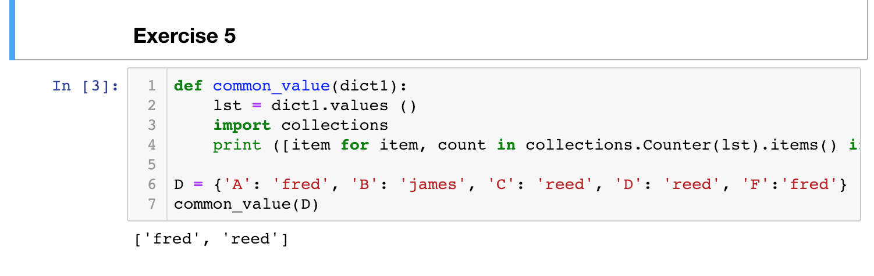

**Code**

def common_value(dict1):

lst = dict1.values ()

import collections

print ([item for item, count in collections.Counter(lst).items() if count > 1])

D = {'A': 'fred', 'B': 'james', 'C': 'reed', 'D': 'reed', 'F':'fred'}

common_value(D)

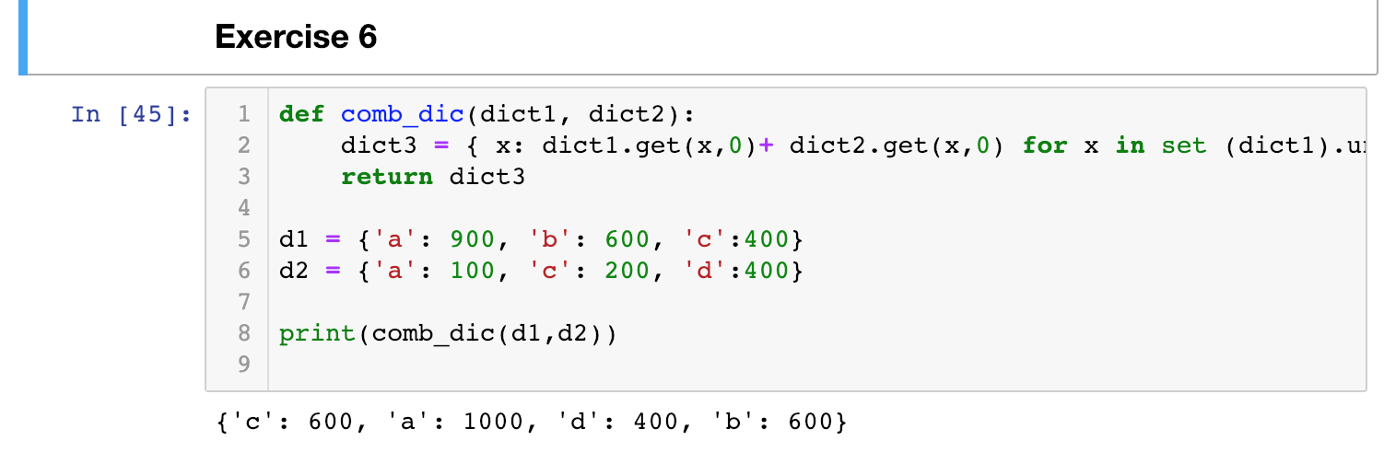

**Code:**

def comb_dic(dict1, dict2):

dict3 = { x: dict1.get(x,0)+ dict2.get(x,0) for x in set (dict1).union (dict2) }

return dict3

d1 = {'a': 900, 'b': 600, 'c':400}

d2 = {'a': 100, 'c': 200, 'd':400}

print(comb_dic(d1,d2))

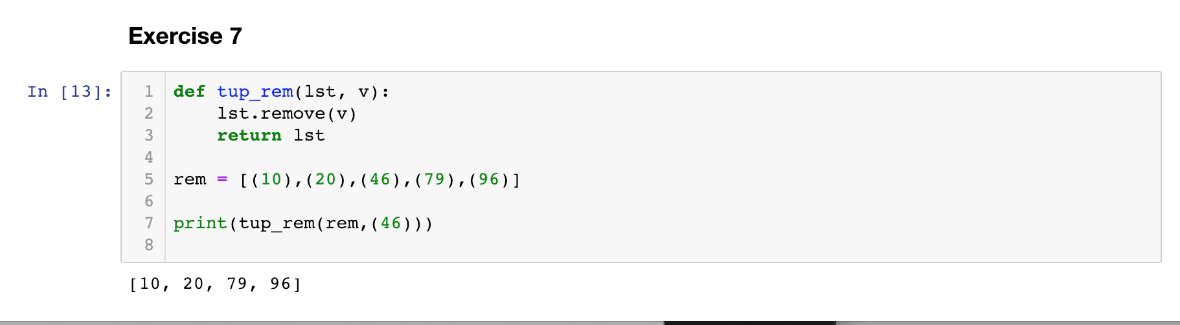

**Code**

def tup_rem(lst, v):

lst.remove(v)

return lst

rem = [(10),(20),(46),(79),(96)]

print(tup_rem(rem,(46)))

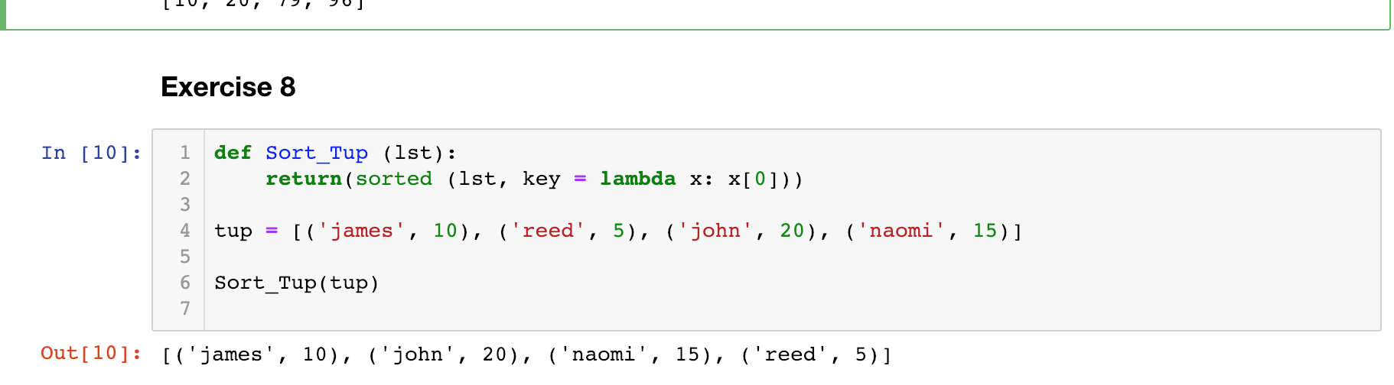

**Code**

def Sort_Tup (lst):

return(sorted (lst, key = lambda x: x[0]))

tup = [('james', 10), ('reed', 5), ('john', 20), ('naomi', 15)]

Sort_Tup(tup)