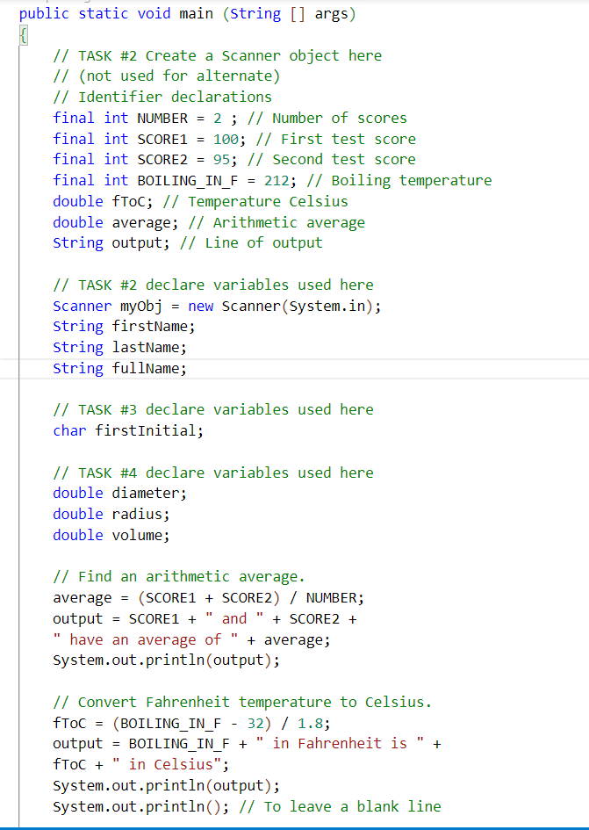

1. A screenshot of a computer

   Description automatically generated with medium confidence

