1. A screenshot of a computer screen

   Description automatically generated with medium confidence
2. A screenshot of a computer screen

   Description automatically generated with medium confidenceA screenshot of a computer screen

   Description automatically generated with medium confidence
3. 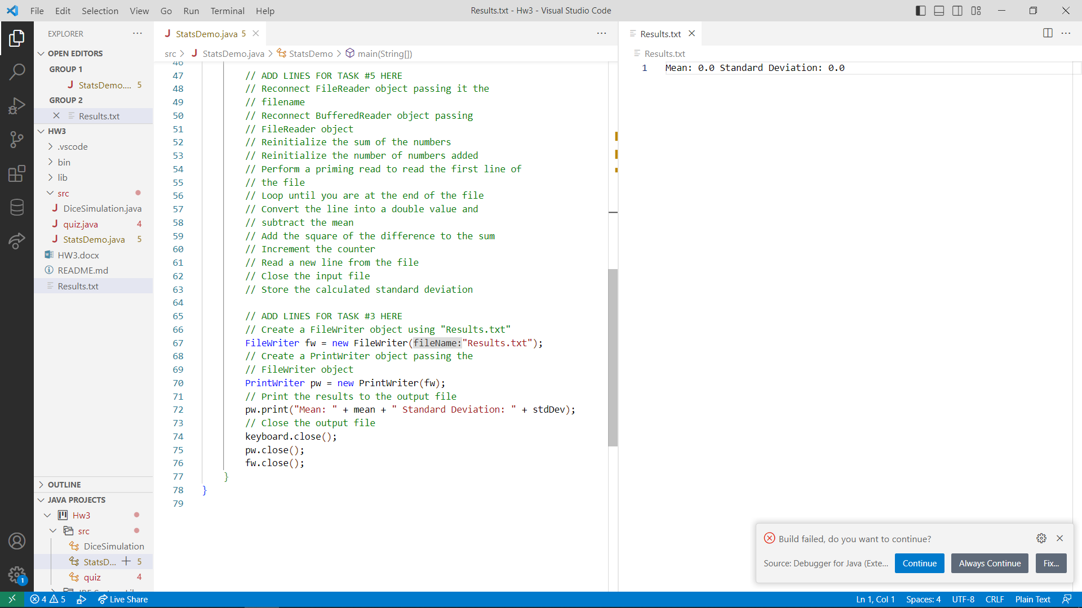
4. 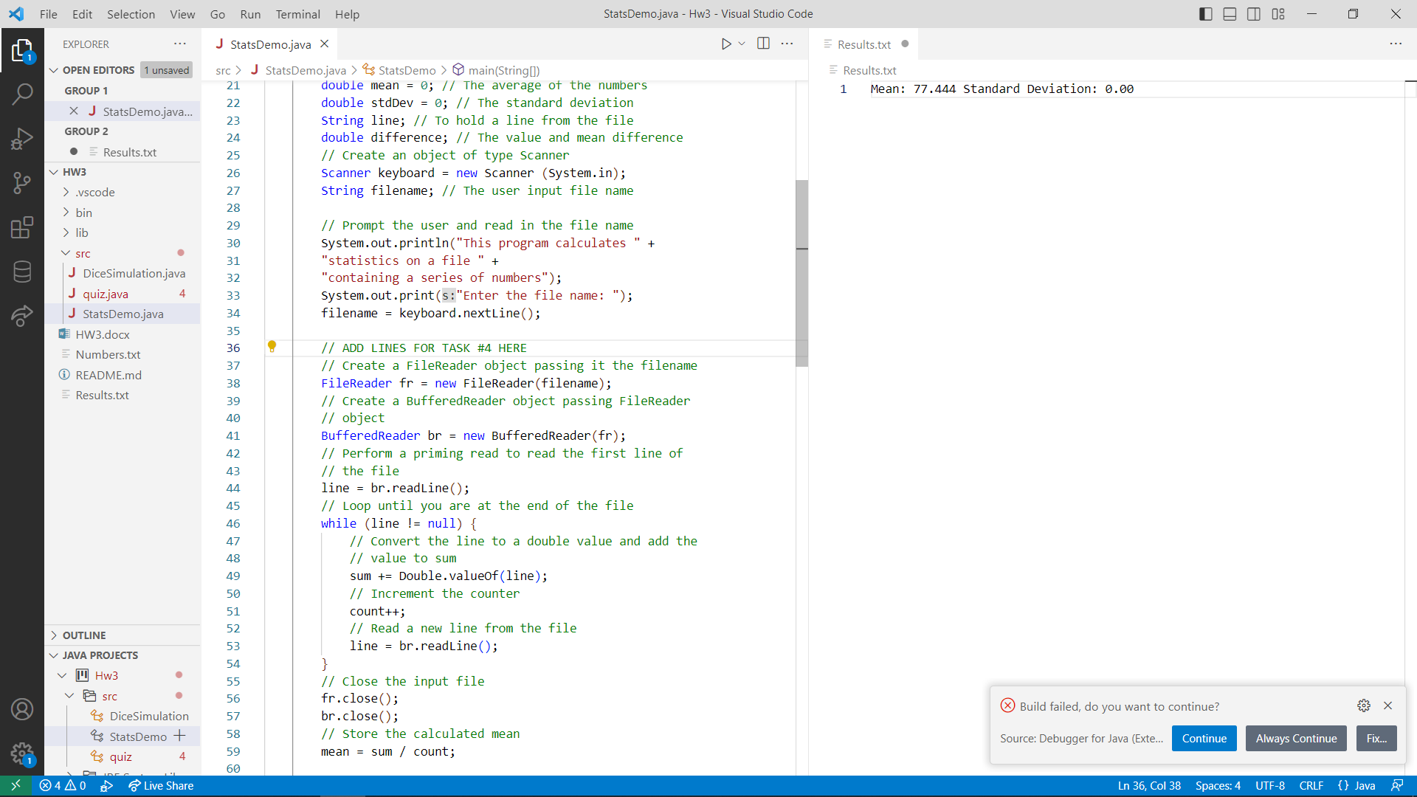
5. A screenshot of a computer

   Description automatically generated