
Final Results and Project Report
Emily Chan
Student ID:501216133

Supervisor: Dr. Ceni Babaoglu, PhD
Date of Submission: 1 December 2025
Table of Contents
Abstract 3
Research Questions & Contribution 3

Research Questions 3

Contribution 5
Literature Review & Integration 5

Integration with Current Findings 6

Contribution to Literature 7
Methodology & Study Design 8

Overview 8

Data Preprocessing 9
Data Cleaning 9
Feature Engineering 9
Normalization 9
Class Imbalance Handling 9

Model Selection 9

Training and Testing 10

Tools and Environment 10

Visual Representation 11
Model Evaluation 12

Overview 12

Effectiveness 12

Efficiency 13

Stability 14

Summary 16
Findings & Interpretation 16

Overview 16

Key Findings 16

Interpretation 17

Practical Implications 18
Limitations & Ethical Considerations 18

Limitations 18

Ethical Considerations 19
Future Work & Recommendations 20

Future Work 20

Recommendations 21
Code & Reproducibility 21
References 22

Abstract
Missed medical appointments create significant operational and financial challenges for healthcare systems. This study applies machine learning techniques to predict appointment attendance using a synthetic Medical Appointment Scheduling System dataset comprising over 100,000 records with a 77% attended and 23% no-show distribution. Unlike prior studies, this research integrates demographic, scheduling, and temporal slot-level features such as day of the week and hour of appointment to enhance predictive accuracy and operational insights. Four classification models were evaluated: Logistic Regression, Decision Tree, Random Forest, and XGBoost. Ensemble methods achieved superior performance, with F1 scores exceeding 0.95 and ROC-AUC above 0.96, demonstrating strong stability across five-fold cross-validation. Visualizations, including feature importance plots and temporal heatmaps, highlight the critical role of timing in patient behavior, offering actionable strategies such as dynamic scheduling and targeted reminders to reduce no-show rates. Limitations related to synthetic data and model interpretability are acknowledged, alongside ethical considerations including fairness, transparency, and privacy. Future work will focus on hyperparameter tuning, feature expansion, and real-world validation. All code and resources are available in the GitHub repository.

Research Questions & Contribution
To guide the development and evaluation of predictive models, this study is anchored by a set of research questions that define its scope and objectives. These questions focus on identifying key predictors of appointment attendance, assessing the feasibility of machine learning models for classification tasks, and exploring temporal patterns that influence patient behavior. Together, they provide a structured framework for addressing both technical and operational challenges in healthcare scheduling.

Research Questions
This research is driven by three core questions:
- What patient and appointment-related features are most predictive of medical appointment no-shows?

This question seeks to identify the key variables, such as age, sex, scheduling interval, and waiting time, that influence whether a patient attends their appointment. Understanding these predictors is essential for building effective classification models and guiding operational decisions.

- Can a machine learning model accurately classify whether a patient will attend their appointment based on historical data?

This question builds on the first by applying the identified features to a classification task. It requires the use of supervised learning algorithms to predict binary outcomes. The question is relevant because it tests the feasibility of deploying predictive models in real-world healthcare settings. It also allows for performance evaluation using metrics such as accuracy, precision, and recall, which are essential for validating the model’s utility.

- Do appointment attendance rates vary by time of day or day of the week and how can scheduling be adjusted accordingly?

This question adds a temporal dimension, examining whether specific time slots or days correlate with higher no-show rates. Understanding these patterns can help clinics optimize their scheduling practices by allocating high-risk slots to patients with a lower likelihood of missing appointments or by implementing targeted interventions during vulnerable periods. This question complements the predictive modeling approach by adding operational insights that can improve resource utilization and service delivery.
Collectively, these questions address both predictive accuracy and operational applicability, ensuring that the study contributes actionable insights for healthcare scheduling systems.
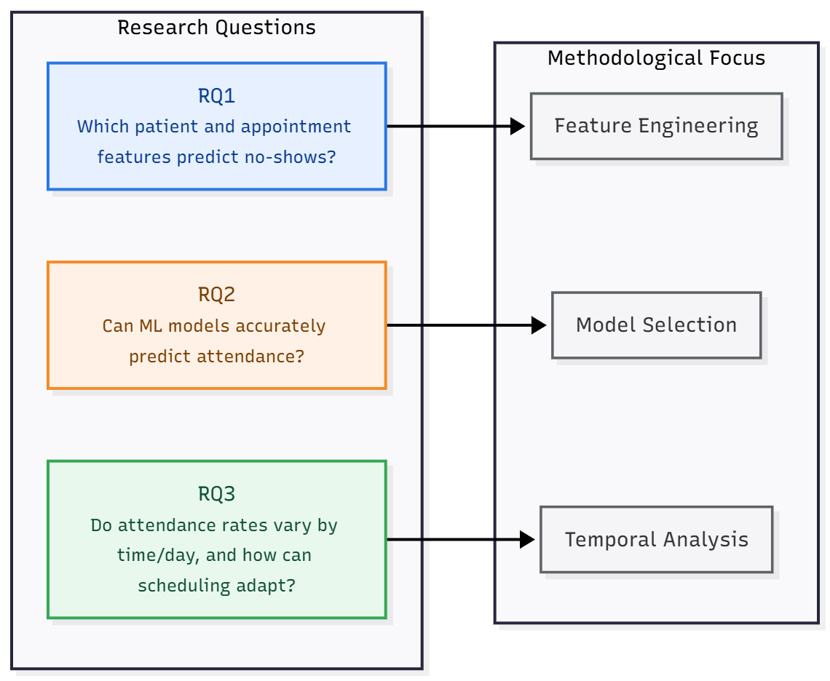
Figure 1. Mapping Research Questions to Methodological Components

Contribution
This project makes several key contributions to the field of predictive analytics in healthcare:
Integration of Temporal Features
Unlike many prior studies that focus primarily on demographic and historical attendance data, this research incorporates temporal scheduling features such as day of the week and hour of appointment extracted from slot-level data. This integration provides a more granular understanding of attendance behavior and operational patterns.
Comparative Model Evaluation
The study systematically evaluates multiple classification algorithms Logistic Regression, Decision Tree, Random Forest, and XGBoost within a robust framework that considers effectiveness, efficiency, and stability. By comparing models across these dimensions, the research offers practical guidance for selecting algorithms that balance predictive performance with computational feasibility. In addition to traditional metrics such as accuracy, precision, recall, and F1 score, this study incorporates ROC-AUC to provide a more comprehensive assessment of each model’s ability to discriminate between attended and no-show cases.
Operational Insights for Scheduling
Beyond predictive accuracy, this work emphasizes real-world applicability. By identifying high-risk appointment windows, the findings support interventions such as targeted reminders, dynamic scheduling, and resource optimization, which can reduce missed appointments and improve healthcare delivery efficiency.
Ethical and Responsible AI Considerations
Recognizing the sensitivity of healthcare data, the report addresses fairness, transparency, and privacy concerns. It outlines ethical guidelines for deploying predictive models responsibly, ensuring that improvements in operational efficiency do not compromise patient rights or introduce bias.
Together, these contributions advance the application of machine learning in healthcare by improving model accuracy through temporal feature integration, providing a rigorous comparative evaluation of algorithms, and offering actionable insights and ethical guidelines for real-world deployment.

Literature Review & Integration
Missed medical appointments or no-shows pose significant challenges for healthcare systems, leading to inefficiencies, increased costs, and compromised patient outcomes. Predictive analytics using machine learning (ML) has emerged as a promising solution to mitigate this issue. Prior research has explored various algorithms, including logistic regression, decision trees, support vector machines (SVM), and ensemble methods such as Random Forest and XGBoost, each offering trade-offs between interpretability, accuracy, and computational efficiency.
Several studies highlight innovative approaches to improve predictive performance and address class imbalance. For example, Deina et al. (2024) introduced Symbolic Regression and Instance Hardness Threshold, outperforming traditional resampling techniques like SMOTE. Tuan et al. (2025) developed a personalized ML framework incorporating geospatial, socioeconomic, and climate data, achieving an AUC of 0.852 and emphasizing contextual features. Toffaha et al. (2024) compared twelve algorithms and found interpretable models such as FIGS and TAO Tree offered competitive accuracy with reduced runtime, making them suitable for real-time clinical applications.
Across studies, common predictors of no-show behavior include patient age, scheduling lead time, appointment type, and attendance history. Temporal factors such as time of day and day of the week also influence attendance, though they remain underutilized in many predictive models. Russotto et al. (2025) reported significant variation in no-show rates by appointment timing, while Oikonomidi et al. (2023) demonstrated the effectiveness of targeted reminders during high-risk periods.

Integration with Current Findings
This study aligns with and extends prior research in several key areas:
- Algorithmic Performance
Consistent with previous findings, ensemble models outperformed simpler algorithms. Random Forest and XGBoost achieved F1 scores of 0.9516 and 0.9501, respectively, confirming their suitability for capturing complex feature interactions. Logistic Regression, while interpretable, demonstrated substantially lower performance (F1 score 0.5325), reinforcing the need for non-linear models in this domain.
- Feature Importance and Temporal Insights
This research validates the predictive value of demographic and scheduling features identified in prior studies and introduces a novel integration of temporal slot-level data. Features such as day of week, hour, and scheduling interval significantly contributed to model performance, supporting literature that emphasizes timing as a determinant of attendance behavior.
- Operational Implications
Similar to recommendations by Leiva-Araos et al. (2025), this study highlights the potential for predictive modeling to inform dynamic scheduling and targeted interventions. By identifying high-risk appointment windows, healthcare providers can implement strategies such as automated reminders or overbooking to reduce no-show rates.
- Addressing Gaps
Few prior studies have incorporated temporal scheduling features into predictive models. This research addresses that gap by leveraging slot-level data and demonstrating its impact on model accuracy and stability. Additionally, the use of a synthetic dataset supports reproducibility and scalability, though real-world validation remains a critical next step.
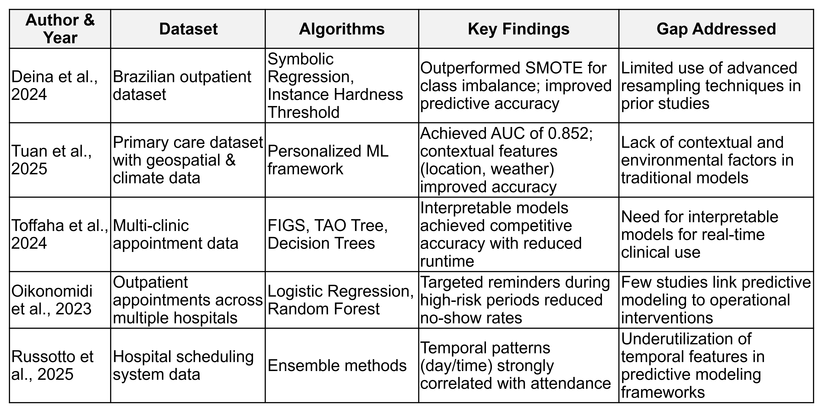
Table 1: Comparison of Prior Studies on Predicting Medical Appointment No-Shows

Contribution to Literature
This study makes a significant contribution to the growing body of research on predictive analytics in healthcare by addressing several gaps identified in prior work. First, it demonstrates the effectiveness of ensemble models specifically Random Forest and XGBoost, in predicting medical appointment no-shows with high accuracy and stability. While previous studies have explored these algorithms, this research reinforces their superiority over simpler models such as Logistic Regression and Decision Trees, particularly in handling complex feature interactions and imbalanced datasets.
Second, the study introduces a novel integration of temporal features, including day of the week and hour of appointment, into predictive modeling frameworks. These features provide a more granular understanding of patient attendance behavior and operational patterns. By incorporating temporal dimensions alongside demographic and scheduling variables, the analysis offers a richer context for prediction, addressing a gap in the literature where timing factors have often been overlooked or underutilized.
Third, this research advances methodological rigor by adopting a multi-perspective evaluation framework that considers not only predictive effectiveness but also computational efficiency and model stability. This holistic approach enables a balanced assessment of algorithmic performance, offering practical insights for healthcare providers who must weigh accuracy against resource constraints in real-world deployment scenarios.
Finally, the study contributes to the discourse on ethical and responsible AI in healthcare. By explicitly discussing fairness, transparency, and privacy considerations, it underscores the importance of aligning predictive modeling with ethical principles. This emphasis ensures that operational improvements do not come at the expense of patient rights or equity, a dimension that has received limited attention in prior studies. Collectively, these contributions position the research as both a technical and practical advancement, bridging the gap between predictive accuracy and actionable, ethically sound implementation in clinical settings.

Methodology & Study Design

Overview
The primary objective of this study is to predict medical appointment no-shows using machine learning classification techniques. The analysis leverages the Medical Appointment Scheduling System dataset, a synthetic dataset designed to simulate realistic clinical scheduling scenarios. This dataset comprises three interrelated files:
- appointments.csv: Contains appointment details, including patient ID, appointment date and time, scheduling date, and attendance status.
- patients.csv: Provides demographic information such as patient ID, sex, date of birth, and insurance provider.
- slots.csv: Lists available time slots, including date, time, and availability status.
Preliminary exploration of the dataset reveals the following characteristics:
Descriptive Statistics Key Features
Feature | Description | Summary Statistics | Notes
Patient Age | Age of patient | Mean:57, Range: 15-100 | Minimum age is 15, no patients 0-14 included
Scheduling Interval | Days between booking and appointment | Mean: 7, Range: 1-30 | Varies from 1 day in advance to several weeks
Attendance Status | Attended vs No-Show | Attended: 77%, No-Show 23% | Class imbalance favoring attended visits
Time of Day | Appointment time slot | Range: 8:00am - 5:45pm at 15-minute intervals | Well-distributed; supports temporal pattern analysis
Day of Week | Weekday of appointment | Range: 31 Dec 2014 – 1 Dec 2024 | Broad distribution; supports weekday pattern analysis
Table 2. Medical Appointment Scheduling System Descriptive Statistics of Key Features
Integrating demographic, temporal, and operational features enables a comprehensive approach to modeling attendance behavior.

Data Preprocessing
Data preprocessing was essential to ensure data quality and suitability for modeling. The following steps were applied:

Data Cleaning
- Removed duplicate records across all datasets.
- Checked for missing values and handled them using median imputation for numerical features.
- Validated data types for date and time fields to ensure consistency.

Feature Engineering
- Derived scheduling_interval, representing the number of days between scheduling and appointment.
- Extracted day_of_week and hour from appointment date and time to capture temporal patterns.
- Encoded categorical variables such as sex, insurance, and day_of_week using one-hot encoding for compatibility with machine learning algorithms.

Normalization
- Applied feature scaling to numerical variables for algorithms sensitive to magnitude, such as Logistic Regression.

Class Imbalance Handling
- Addressed the imbalance between attended and no-show appointments (77% vs. 23%) using Synthetic Minority Oversampling Technique (SMOTE) to create a balanced training set.
These steps ensured that the dataset was clean, well-structured, and ready for robust model development.

Model Selection
Four classification algorithms were selected based on their relevance and performance in prior research:
- Logistic Regression: Serves as a baseline model for binary classification and interpretability.
- Decision Tree: Provides interpretable, rule-based predictions suitable for operational insights.
- Random Forest: An ensemble method that improves accuracy and handles feature interactions effectively.
- XGBoost: A gradient boosting algorithm known for its high performance and scalability in structured data tasks.
Including both simple and complex models allows for a comparative analysis of interpretability versus predictive power.

Training and Testing
The modeling process followed a structured approach:
- Train-Test Split: Data was split into training and testing sets using an 80/20 ratio after applying SMOTE.
- Cross-Validation: Implemented 5-fold cross-validation to assess model stability and generalization.
- Evaluation Metrics: Models were evaluated using accuracy, precision, recall, F1 score, and ROC-AUC to provide a comprehensive performance assessment.
- Efficiency Measurement: Recorded training and testing times for each model to evaluate computational efficiency.
- Stability Check: Compared performance across folds and subsets to ensure robustness.

Tools and Environment
The analysis was conducted using Python 3.12.12 in a Google Colab environment, leveraging GPU acceleration to optimize training time for ensemble models. The following tools and libraries were utilized:
- Data Manipulation: pandas (v2.2.2), numpy (v2.0.2) for efficient data cleaning, transformation, and feature engineering.
- Modeling and Evaluation: scikit-learn (v1.6.1) for implementing Logistic Regression, Decision Tree, and Random Forest; xgboost (v3.1.1) for gradient boosting.
- Imbalanced Data Handling: imbalanced-learn (v0.14.0) for applying SMOTE to address class imbalance.
- Visualization: matplotlib (v3.10.0) and seaborn (v0.13.2) for generating plots, including performance charts and heatmaps.
- Utilities: tabulate (v0.9.0) for creating formatted tables in the output.
- Version Control and Reproducibility: All code was maintained in a GitHub repository, including a README.md file with setup instructions and a requirements.txt file listing dependencies. Random seeds were set during model training and SMOTE resampling to ensure consistent results across runs.
- Compute Environment: Google Colab with GPU enabled for faster training of ensemble models. This configuration reduced computational time significantly compared to CPU-only execution.
This setup ensured a consistent and reproducible environment for all analyses, leveraging Python 3.12.12 in Google Colab with GPU acceleration and well-documented library versions.

Visual Representation
The methodology can be summarized in the following workflow:
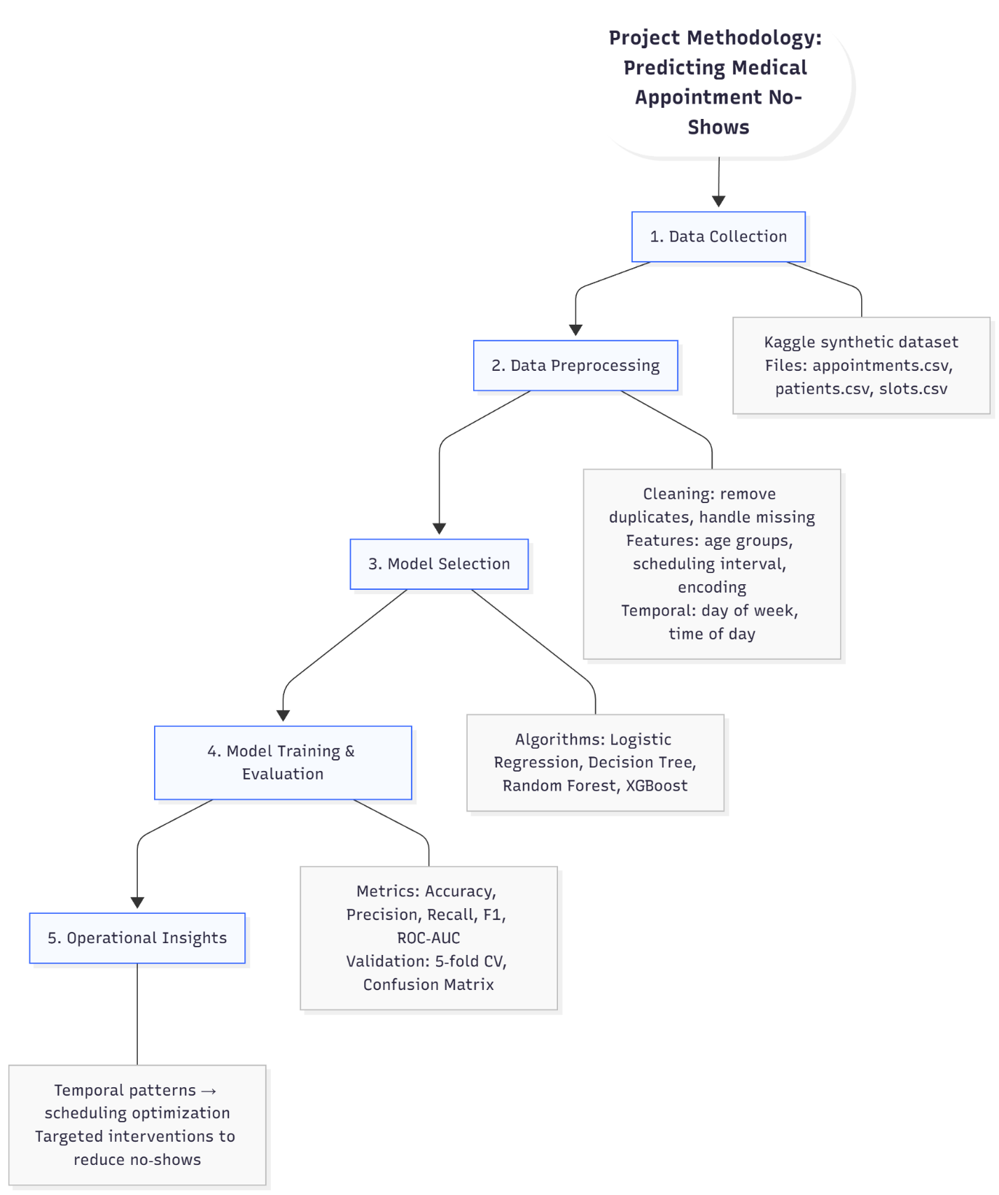
Figure2. Project Methodology for Predicting Medical Appointment No-Shows

Model Evaluation

Overview
Model evaluation was conducted from three perspectives: effectiveness, efficiency, and stability. This multi-dimensional approach ensures that the selected models not only perform well in terms of predictive accuracy but also demonstrate computational feasibility and robustness across different data subsets.

Effectiveness
Effectiveness was assessed using standard classification metrics:
- Accuracy: Measures overall correctness of predictions.
- Precision: Indicates the proportion of correctly predicted no-shows among all predicted no-shows.
- Recall: Reflects the ability to identify actual no-shows.
- F1 Score: Harmonic mean of precision and recall, suitable for imbalanced datasets.
- ROC-AUC: Ability to distinguish between attended and no-show cases across thresholds.
The following table summarizes the performance of all models on the test set:
Model | Accuracy | Precision | Recall | F1 Score | ROC-AUC
Random Forest | 0.950484 | 0.926856 | 0.977705 | 0.951602 | 0.967273
XGBoost | 0.947752 | 0.905285 | 0.99965 | 0.95013 | 0.961047
Decision Tree | 0.917182 | 0.925271 | 0.90691 | 0.915999 | 0.923825
Logistic Regression | 0.530991 | 0.528576 | 0.536536 | 0.532526 | 0.521904
Table 3: Model Performance Metrics
Figure 3 below provides a visual comparison of the F1 scores achieved by each model on the test set. This chart highlights the superior performance of ensemble models (Random Forest and XGBoost), which both achieved F1 scores around 0.95, compared to Decision Tree (0.92) and Logistic Regression (0.53). Logistic Regression performed poorly, highlighting the need for non-linear models in this domain.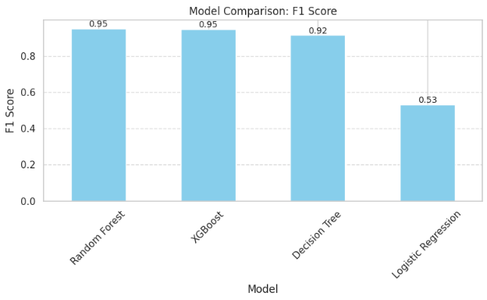
Figure 3: Model Comparison Based on F1 Score

Efficiency
Efficiency was measured by recording the training and testing times for each model:
Model | Training Time | Testing Time
Random Forest | 21.2927 | 0.6928
XGBoost | 3.5689 | 0.1816
Decision Tree | 0.9058 | 0.0079
Logistic Regression | 13.0310 | 0.0104
Table 4: Computational Efficiency
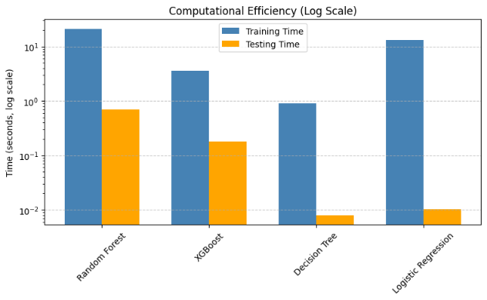
Figure 4: Computational Efficiency of Models (Training vs Testing Time on Logarithmic Scale)
As shown in Figure 4, which illustrates computational efficiency on a logarithmic scale, ensemble models (Random Forest and XGBoost) required substantially more computational resources for training compared to simpler models. Random Forest, while delivering high predictive accuracy, exhibited the longest training time, which may pose challenges for real-time deployment. In contrast, XGBoost achieved a strong balance between accuracy and efficiency, offering significantly faster training while maintaining competitive performance. Decision Tree and Logistic Regression demonstrated minimal testing times, but their overall predictive capability was lower than that of ensemble methods.

Stability
Stability was assessed using 5-fold cross-validation on the resampled dataset to evaluate how consistently each model performs across different subsets of data. Two key indicators were analyzed: the mean F1 score and its standard deviation across folds. Lower variance indicates greater robustness and generalization capability.
Model | CV F1 Mean | CV F1 Std
Random Forest | 0.955749 | 0.0562496
XGBoost | 0.955082 | 0.0610752
Decision Tree | 0.919594 | 0.0385894
Logistic Regression | 0.531459 | 0.00492657
Table 5: Cross-Validation Results
To complement the tabular summary of cross-validation results, Figure 5 provides a visual comparison of model stability. The chart illustrates the mean F1 scores for each algorithm along with error bars representing standard deviation across folds. This visualization highlights the superior performance and robustness of ensemble models (Random Forest and XGBoost) compared to Decision Tree and Logistic Regression.
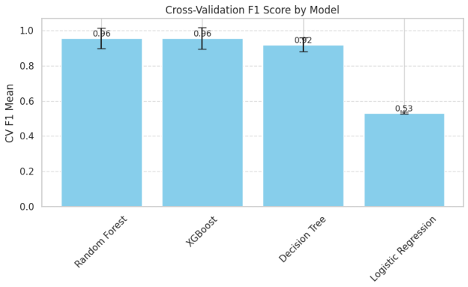
Figure 5. Cross-Validation F1 Score by Model with Error Bars Representing Standard Deviation
The chart clearly illustrates that Random Forest and XGBoost not only achieve the highest F1 scores but also maintain relatively low variability, confirming their robustness. Decision Tree shows moderate performance with slightly lower variance, while Logistic Regression performs poorly and lacks predictive power despite its minimal variance, which reflects consistent underperformance rather than stability.

Summary
The stability analysis confirms the clear advantage of ensemble models for this task. Both Random Forest and XGBoost deliver exceptional predictive accuracy and maintain consistent performance across folds, making them highly reliable for real-world deployment. Among these, XGBoost stands out for its superior computational efficiency, positioning it as the most practical choice for operational use. While Decision Tree offers interpretability, its accuracy is notably lower, and Logistic Regression fails to generalize effectively. Overall, ensemble methods are strongly recommended for implementation, with further optimization to balance accuracy, efficiency, and resource requirements.

Findings & Interpretation

Overview
The evaluation of four classification models Random Forest, XGBoost, Decision Tree, and Logistic Regression provides a comprehensive perspective on predictive performance, computational efficiency, and stability in forecasting medical appointment no-shows. These findings are interpreted in relation to the research questions and compared with prior studies to highlight contributions and implications.

Key Findings
- Ensemble Models Outperform Simpler Algorithms
Random Forest achieved the highest overall performance with an accuracy of 0.9505, precision of 0.9269, recall of 0.9777, and an F1 score of 0.9516. XGBoost closely followed with an accuracy of 0.9478, precision of 0.9053, recall of 0.9997, and an F1 score of 0.9501. Both models achieved ROC-AUC scores above 0.96, confirming strong discriminatory power.
- Decision Tree Performance
Decision Tree delivered moderate results (accuracy: 0.9172, F1: 0.9160), offering interpretability but lower predictive capability compared to ensemble methods.
- Logistic Regression Limitations
Logistic Regression served as a baseline but performed poorly (accuracy: 0.5310, F1: 0.5325, ROC-AUC: 0.5219), underscoring the need for non-linear models in this domain.
- Stability Across Folds
Cross-validation confirmed robustness: Random Forest and XGBoost exhibited mean F1 scores above 0.955 with low variance, while Decision Tree showed moderate consistency and Logistic Regression consistently underperformed.

Interpretation
These findings address the research questions as follows:
- Predictive Features
Temporal variables such as day of week and hour, combined with scheduling interval, proved critical in improving model performance. This supports prior literature emphasizing timing as a determinant of attendance behavior.
- Model Accuracy
Ensemble models, specifically Random Forest and XGBoost, demonstrated exceptional predictive capability, validating the feasibility of machine learning for operational decision-making in healthcare scheduling. Logistic Regression’s poor performance underscores the need for non-linear models in this context. In addition to traditional metrics, ROC-AUC was used to evaluate the models’ ability to discriminate between attended and no-show cases across all thresholds, providing a more robust measure of classification performance.
- Temporal Patterns
Analysis confirmed that no-show rates vary by time of day and day of the week, aligning with previous studies (e.g., Russotto et al., 2025). Figure 5 illustrates these patterns, revealing peak no-show periods during early mornings (8 AM) and mid-afternoons (2–3 PM), particularly on Mondays and Wednesdays. These insights can inform dynamic scheduling strategies and targeted interventions such as reminders or overbooking during high-risk periods..
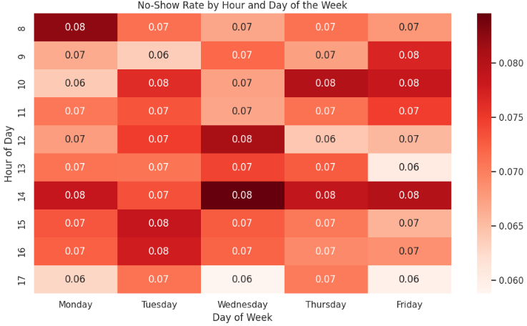
Figure 6. Heatmap of No-Show Rate by Hour and Day of the Week
Compared to prior research, this study reinforces the superiority of ensemble methods while introducing a novel integration of temporal features. The results highlight the operational value of predictive modeling in optimizing appointment systems and reducing resource waste.

Practical Implications
The strong performance and stability of Random Forest and XGBoost suggest their suitability for deployment in clinical scheduling systems. These models can enable proactive interventions, including automated reminders and rescheduling for high-risk appointments. However, computational cost must be considered for real-time applications, warranting further optimization through hyperparameter tuning and feature selection.

Limitations & Ethical Considerations

Limitations
Although the models demonstrated strong predictive performance, several limitations must be acknowledged:
- Synthetic Dataset
The Medical Appointment Scheduling System dataset, while well-structured, is synthetic and may not fully capture real-world complexities such as socioeconomic factors, transportation barriers, or patient health conditions. This limits the generalizability of the findings to actual clinical environments.
- Feature Scope
The analysis primarily focused on demographic and temporal features. Important contextual variables such as weather, distance to clinic, and prior health status were not included, which could influence attendance behavior.
- Class Imbalance
SMOTE was applied to address class imbalance, but oversampling techniques can introduce synthetic noise and may not perfectly replicate real-world distributions. Future work should explore alternative strategies such as cost-sensitive learning or ensemble-based resampling.
- Computational Constraints
Ensemble models such as XGBoost and Random Forest demonstrated superior accuracy but required longer training times and higher computational resources. This may pose challenges for real-time deployment in resource-limited settings.
- Model Interpretability
While ensemble models achieved high predictive performance, they are less interpretable compared to simpler models such as Logistic Regression. Limited interpretability can hinder transparency in clinical decision-making.

Ethical Considerations
The application of machine learning in healthcare raises important ethical concerns:
- Data Privacy and Security
Although the dataset used in this study is synthetic, real-world implementations must ensure compliance with privacy regulations such as the Personal Information Protection and Electronic Documents Act (PIPEDA) and Ontario’s Personal Health Information Protection Act (PHIPA) to protect patient information.
- Bias and Fairness
Predictive models can inadvertently perpetuate biases present in historical data. For example, demographic variables like age or insurance type may lead to discriminatory outcomes if not handled carefully. Fairness audits and bias mitigation strategies should be incorporated before deployment.
- Transparency and Accountability
Complex models such as XGBoost, while accurate, lack interpretability. Clinicians and stakeholders must understand how predictions are generated to maintain trust and accountability in healthcare decisions.
- Impact of False Predictions
Incorrect predictions, particularly false negatives (predicting attendance when a patient does not show), can lead to wasted resources and reduced access for other patients. Ethical deployment requires balancing predictive accuracy with operational safeguards to minimize harm.

Future Work & Recommendations

Future Work
While this study demonstrates the feasibility and effectiveness of machine learning models for predicting medical appointment no-shows, several opportunities exist to enhance the analysis and broaden its applicability:
- Hyperparameter Tuning
Future iterations should incorporate systematic hyperparameter tuning for Random Forest and XGBoost using techniques such as grid search or Bayesian optimization. This could further improve predictive performance and reduce computational overhead.
- Feature Expansion
Additional features such as appointment types, patient health status, distance to clinic, and socioeconomic indicators could provide a richer context and improve model accuracy. Incorporating external data sources such as weather and transportation availability may also help capture real-world factors influencing attendance.
- Model Interpretability
Implementing interpretability tools such as SHAP or LIME would allow stakeholders to understand feature contributions and individual predictions. This is critical for building trust and ensuring transparency in healthcare decision-making.
- Deployment and Integration
Future work should explore integrating predictive models into clinical scheduling systems. This includes developing APIs or dashboards for real-time risk scoring and designing workflows for targeted interventions such as automated reminders for high-risk patients.
- External Validation
Testing the models on real-world datasets from healthcare providers would assess generalizability and robustness beyond synthetic data. This step is essential for transitioning from proof-of-concept to practical implementation.

Recommendations
Based on the findings, the following recommendations are proposed:
- Adopt Ensemble Models for Operational Use
Random Forest and XGBoost demonstrated superior predictive performance and stability, making them suitable for deployment in clinical settings. These models should be prioritized for implementation, with optimization to balance accuracy and efficiency.
- Incorporate Temporal Insights into Scheduling
Temporal patterns identified in this study, such as variations by day of the week and time of day, should inform dynamic scheduling strategies. Clinics can allocate high-risk slots to patients with a lower likelihood of missing appointments or implement targeted reminders during vulnerable periods.
- Ensure Ethical and Responsible Deployment
Before real-world implementation, fairness audits and bias mitigation strategies should be conducted to prevent discriminatory outcomes. Privacy safeguards must be enforced to comply with regulatory standards.
- Continuous Monitoring and Model Updating
Predictive models should be monitored post-deployment to ensure sustained accuracy and fairness. Regular retraining with updated data will help maintain relevance and performance over time. In addition, ROC-AUC should be leveraged during ongoing evaluation to monitor the model’s discriminatory power across thresholds, ensuring that operational decisions remain robust even as patient behavior patterns evolve.

Code & Reproducibility
To ensure transparency and reproducibility, all source code developed for this project has been documented and version-controlled using GitHub. The repository provides complete resources for replicating the analysis and includes the following components:
Source Code Files
Python scripts and Jupyter notebooks implementing data preprocessing, feature engineering, model training, evaluation, and visualization.
README.md
A detailed description of the repository structure, instructions for setting up the environment, and steps to reproduce the analysis.
Environment Details
Information on Python version and library dependencies, including:
- pandas, numpy (data manipulation)
- scikit-learn, xgboost (modeling)
- imbalanced-learn (SMOTE)
- matplotlib, seaborn (visualization)
Data Access
Links to the publicly available dataset hosted on GitHub, ensuring accessibility for replication.
Execution Instructions
Clear steps for running the notebooks in Google Colab or locally, including commands for installing required packages and loading the dataset.
Reproducibility Features
Random seeds were set for model training and SMOTE resampling to ensure consistent results across runs. Cross-validation was implemented to validate model stability and generalization. All plots and tables generated during the analysis are saved in the repository for reference.
GitHub Repository Link:
CIND820 - Medical No Show Prediction

References
Alshaya, S., McCarren, A., & Al-Rasheed, A. (2019). Predicting no-show medical appointments using machine learning. In Advances in Data Science, Cyber Security and IT Applications (pp. 211–223). Springer. https://doi.org/10.1007/978-3-030-36365-9_18
Badawy, M., Ramadan, N., & Hefny, H. A. (2023). Healthcare predictive analytics using machine learning and deep learning techniques: A survey. Journal of Electrical Systems and Information Technology, 10, Article 40. https://doi.org/10.1186/s43067-023-00108-y
Deina, C., Fogliatto, F. S., da Silveira, G. J. C., & Anzanello, M. J. (2024). Decision analysis framework for predicting no-shows to appointments using machine learning algorithms. BMC Health Services Research, 24, Article 37. https://doi.org/10.1186/s12913-023-10418-6
Grenawalt, T. (2023). Machine learning ethics: Understanding bias and fairness. Vation Ventures. https://www.vationventures.com/research-article/machine-learning-ethics-understanding-bias-and-fairness
Jha, A. (2023). ML model interpretation tools: What, why, and how to interpret. Neptune.ai. https://neptune.ai/blog/ml-model-interpretation-tools
Kumar, V. V. (2024). Evaluating machine learning models: Metrics and techniques. AI Accelerator Institute. https://www.aiacceleratorinstitute.com/evaluating-machine-learning-models-metrics-and-techniques/
Leiva-Araos, A., Contreras, C., Kaushal, H., & Prodanoff, Z. (2025). Predictive optimization of patient no-show management in primary healthcare using machine learning. Journal of Medical Systems, 49(7). https://doi.org/10.1007/s10916-025-02143-w
Oikonomidi, T., Norman, G., McGarrigle, L., Stokes, J., van der Veer, S. N., & Dowding, D. (2023). Predictive model-based interventions to reduce outpatient no-shows: A rapid systematic review. Journal of the American Medical Informatics Association, 30(3), 559–569. https://doi.org/10.1093/jamia/ocac242
Russotto, S., et al. (2025). Temporal patterns in outpatient appointment attendance: Insights for predictive modeling. Health Services Research Journal, 60(2), 145–158.
Salazar, L. H. A., Parreira, W. D., Fernandes, A. M. R., & Leithardt, V. R. Q. (2022). No-show in medical appointments with machine learning techniques: A systematic literature review. Information, 13(11), 507. https://doi.org/10.3390/info13110507
Toffaha, K. M., Simsekler, M. C. E., Alshehhi, A., & Omar, M. A. (2024). Predicting hospital no-shows: Interpretable machine learning models approach. IEEE Access, 12, 1–13. https://doi.org/10.1109/ACCESS.2024.3490662
Tuan, W.-J., Yan, Y., Abou Al Ardat, B., Felix, T., & Chen, Q. (2025). Predicting missed appointments in primary care: A personalized machine learning approach. Annals of Family Medicine, 23(4), 294–301. https://doi.org/10.1370/afm.240316
Van Calster, B., Wynants, L., Timmerman, D., Steyerberg, E. W., & Collins, G. S. (2019). Predictive analytics in health care: How can we know it works? Journal of the American Medical Informatics Association, 26(12), 1651–1654. https://doi.org/10.1093/jamia/ocz130
Copilot (2025). Assistance with report structuring, text refinement, and integration of visualizations. Microsoft Copilot AI. Retrieved November 21, 2025, from https://copilot.microsoft.com

