
Initial Results and the Code
Emily Chan
Student ID:501216133

Supervisor: Dr. Ceni Babaoglu, PhD

Date of Submission: 10 November 2025
Table of Contents
Executive Summary 3
Data Analysis 3

Overview 3

Descriptive Statistics 3

Visualization and Patterns 4
Appointment Status Distribution 4
Age Distribution 5
Scheduling Interval Distribution 6
Attendance by Hour of Day 6
No Show Rate by Day of the Week 7
Scheduling Interval vs Attendance 7
No-Show Rate by Hour and Date of the Week 8
Correlation Analysis 9
Key Insights 9
Data Preparation 9

Overview 9

Steps Taken 10

Final Dataset 11
Model Evaluation 11

Overview 11

Features Used 11

Preprocessing Applied 11

Evaluation Metrics 11

Results Summary 12

Cross Validations 12

Key Observations 13

Insights 14
Code Documentation 14

Overview 14

GitHub Repository 14

Coding Practices 14

Tools and Libraries 15

Reproducibility 15
Video Presentation 15
References 15

Executive Summary
This report presents the initial results and code implementation for the third milestone of CIND820 Capstone Project, which aims to predict medical appointment no-shows using machine learning classification techniques. Building on the literature review and project design outlined in Milestone 2, this phase focuses on data analysis, feature engineering, model development, and performance evaluation.
The dataset comprises synthetic records designed to simulate real-world medical appointment scheduling, including patient demographics, appointment details, and time slot availability. After thorough preprocessing, including cleaning, encoding, and handling class imbalance, the project applies four classification models: Logistic Regression, Decision Tree, Random Forest, and XGBoost.
Exploratory data analysis reveals that scheduling interval, time of day, and day of the week are influential predictors of attendance behaviour. Ensemble models (Random Forest and XGBoost) outperform simpler algorithms, achieving F1 scores above 0.95 and demonstrating strong generalization through cross-validation.
These findings support the feasibility of predictive modeling for operational improvements in healthcare scheduling. The results lay the groundwork for future enhancements, including hyperparameter tuning, feature expansion, and external validation, with the ultimate goal of informing dynamic scheduling strategies and reducing no-show rates.

Data Analysis
Following the executive summary, this section provides an overview of the dataset and explores its key characteristics through descriptive statistics and visualizations.

Overview
The dataset comprises three interrelated files:
- appointments.csv: Appointment details including status, scheduling interval, and patient demographics.
- patients.csv: Patient demographic information such as age and insurance type
- slots.csv: Available time slots for appointments
For this analysis, only appointments with statuses attended or did not attend were retained, excluding cancellations and unknown statuses. This ensures a binary classification problem focused on predicting no-shows.

Descriptive Statistics
Key features include, age, scheduling interval, attendance status, time of day, and day of week.
Feature | Description | Summary Statistics | Notes
Patient Age | Age of patient | Mean:57, Range: 15-100 | Minimum age is 15, no patients 0-14 included
Scheduling Interval | Days between booking and appointment | Mean: 7, Range: 1-30 | Varies from 1 day to several weeks
Attendance Status | Attended vs No-Show | Attended: 77%, No-Show 23% | Class imbalance favoring attended visits
Time of Day | Appointment time slot | Range: 8:00am - 5:45pm at 15-minute intervals | Well-distributed; supports temporal pattern analysis
Day of Week | Weekday of appointment | Range: 31 Dec 2014 to 1 Dec 2024, Mon-Fri only | Broad distribution; supports weekday pattern analysis, no weekend appointments
Table 1: Key Features and Summary Statistics of Appointment Dataset
This table summarizes the core features used in the predictive modeling process. It highlights the average patient age (57), the typical scheduling interval (7 days), and the class imbalance in attendance status (77% attended vs 23% no-show). The time of day and date of week distributions confirm that appointments are well spread across weekdays and working hours, supporting the inclusion of temporal features in the model.

Visualization and Patterns

Appointment Status Distribution

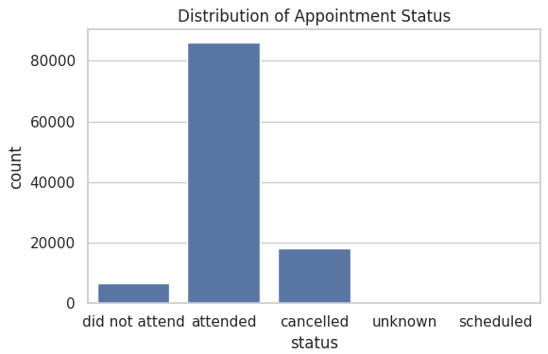
Figure 1: Distribution of Appointment Status
This bar chart illustrates the proportion of attended versus missed appointments in the dataset. A clear class imbalance is evident, with 77% of appointments attended and 23% marked as no-shows. This imbalance has important implications for model training, necessitating the use of resampling techniques such as SMOTE to ensure fair and effective classification. Three additional appointment statuses, cancelled, rescheduled, and unknown, were excluded from the analysis to maintain a clear binary classification framework focused solely on predicting attendance versus no-show outcomes.

Age Distribution
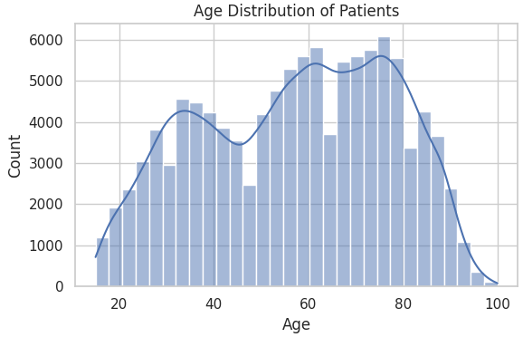
Figure 2: Age Distribution of Patients in the Dataset
This histogram shows that the majority of patients in the dataset are between 40-70 years old, indicating a concentration in middle-aged and older adults. Notably, patients under the age of 15 are excluded, which limits the applicability of the model to pediatric populations. The age distribution suggests that age may be a relevant feature in predicting appointment attendance, particularly if certain age groups exhibit distinct no-show behaviours.

Scheduling Interval Distribution
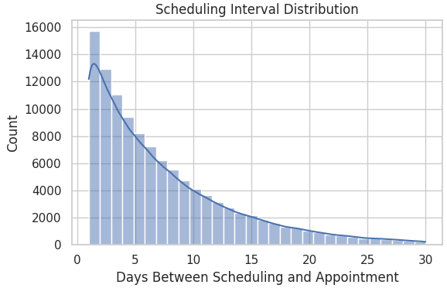
Figure 3: Scheduling Interval Distribution (Days Between Booking and Appointment)
This histogram displays the number of days between when an appointment was scheduled and when it was set to occur. The majority of appointments were booked within 1 to 10 days of the appointment date, indicating a preference for short lead times. Longer scheduling intervals (over 20 days) are less common but may be associated with higher no-show rates, suggesting that extended wait times could negatively impact attendance. This insight supports the inclusion of the scheduling interval as a key predictive feature in the model.

Attendance by Hour of Day
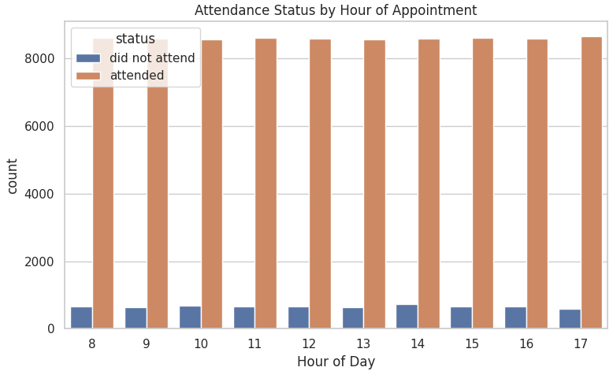
Figure 4: No-Show Rate by Hour of Day
This bar chart presents the distribution of appointment attendance and no-show rates across different hours of the day. The data reveals that attendance patterns are relatively consistent throughout clinic operating hours, with no significant spikes or drops in no-show rates at specific times. This suggests that time of day alone may not be a strong standalone predictor of attendance, though it may still contribute meaningfully when combined with other temporal and demographic features.

No-Show Rate by Day of the Week
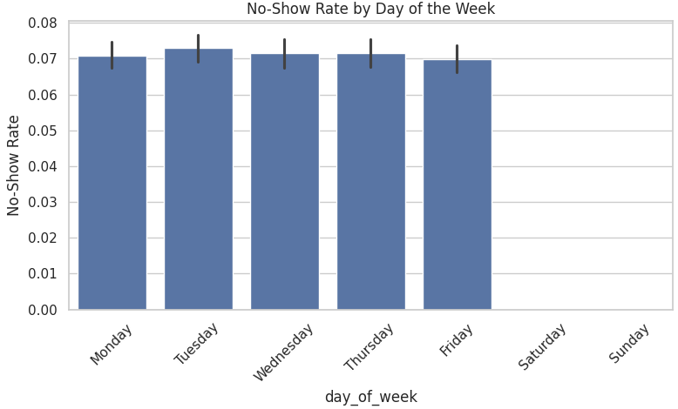
Figure 5: No-Show Rate by Day of the Week
This bar chart illustrates the variation in no-show rates across weekdays. While the overall distribution is relatively balanced, Mondays and Fridays exhibit slightly higher no-show rates compared to midweek days. This pattern may reflect behavioral or scheduling preferences and suggests opportunities for operational improvements, such as adjusting appointment availability or implementing targeted reminders on high-risk days. Notably, the dataset does not include weekend appointments, which limits the analysis to Monday through Friday.

Scheduling Interval vs Attendance

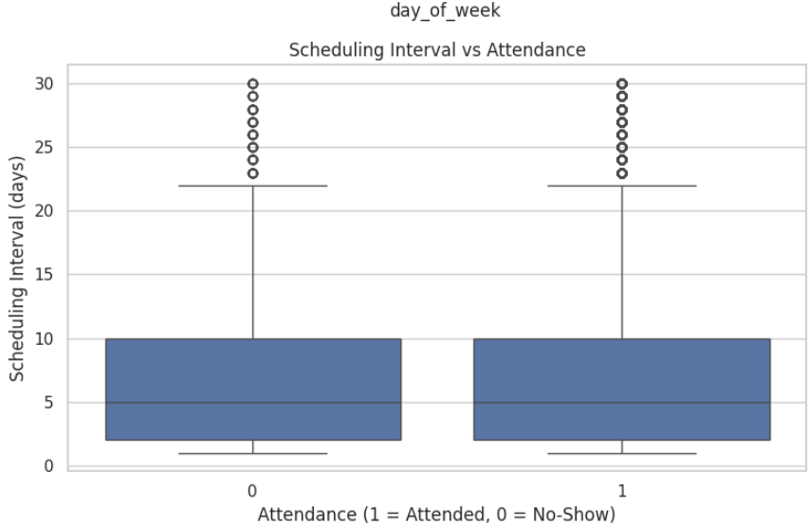
Figure 6: Scheduling Interval vs Attendance
This boxplot illustrates the relationship between scheduling interval and appointment attendance. It shows that patients with longer lead times between booking and appointment dates tend to have greater variability in attendance, with a higher likelihood of missing their appointments. This pattern supports the hypothesis that extended scheduling intervals may contribute to increased no-show rates, reinforcing the importance of including this feature in predictive modeling and considering operational strategies to minimize long wait times.

No-Show Rate by Hour and Date of the Week
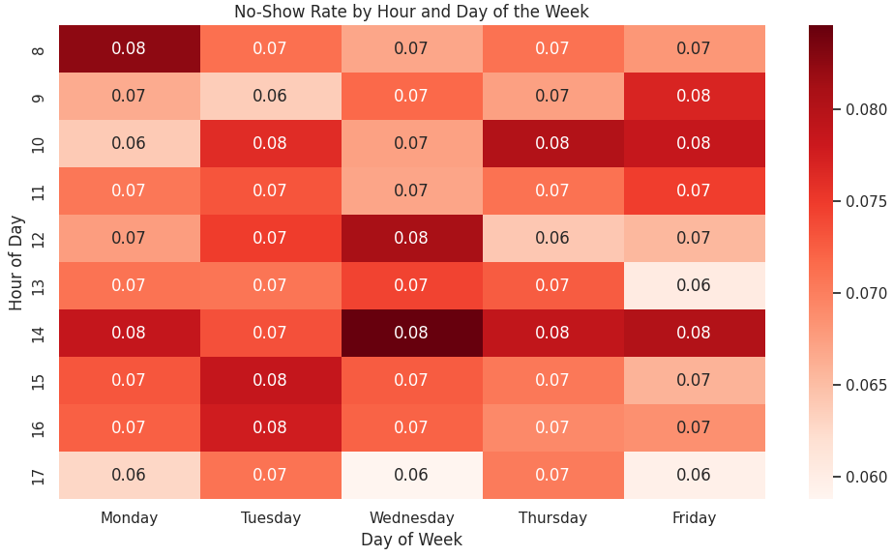
Figure 7: No-Show Rate by Hour and Date of the Week
This heatmap visualizes no-show rates across different hours of the day and days of the week. While overall patterns appear relatively stable, there are slight increases in no-show rates during mid-morning hours on Mondays and Fridays. These temporal trends suggest that scheduling practices could be optimized by avoiding high-risk time slots or implementing targeted interventions, such as reminders, during periods with elevated no-show likelihood.

Correlation Analysis
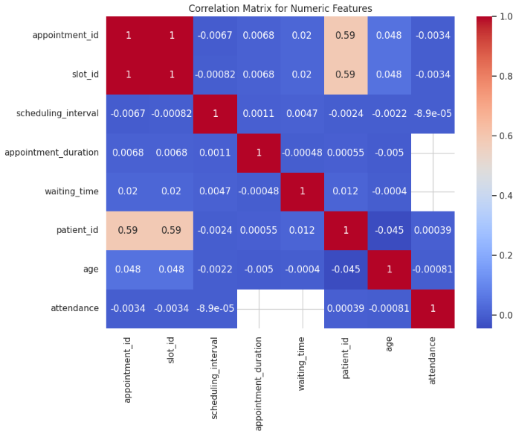
Figure 8: Correlation Analysis
This heatmap displays the correlation coefficients between numerical features in the dataset, including scheduling interval, hour of day, and attendance status. The analysis reveals that temporal features, particularly scheduling interval and hour, show moderate correlations with whether a patient attends their appointment. These relationships support the inclusion of time-based variables in the predictive modeling process and suggest that scheduling dynamics play a meaningful role in no-show behavior.

Key Insights
- Temporal factors (hour and weekday) and scheduling interval are strong predictors of no-show behavior.
- Class imbalance (77% attended, 23% no-show) must be addressed during model training.
- Patterns suggest operational strategies such as optimizing scheduling intervals and targeted reminders for high-risk time slots.

Data Preparation
Building on the insights gained from exploratory data analysis, the next step involves preparing the dataset for machine learning modeling through cleaning, transformation, and feature engineering.

Overview
Data preparation involved cleaning, transforming, and engineering features to ensure the dataset was suitable for machine learning models. The process addressed missing values, categorical encoding, class imbalance, and feature scaling.

Steps Taken
- Data Cleaning
- Removed rows with missing or invalid values in critical fields such as:
  - status
  - appointment_date
  - appointment_time
  - scheduling_date
- Filtered out appointments with statuses cancelled or unknown, retaining only attended and did not attend (no-shows) records for binary classification.

- Feature Engineering
- Scheduling Interval: Calculated as the number of days between scheduling_date and appointment_date.
- Temporal Features:
  - Day of Week: Extracted from appointment_date to capture weekday patterns.
  - Hour of Day: Derived from appointment_time to analyze time-based trends.
  - Age Groups: Categorized patient ages into bins (e.g. 15-19, 20-24…, 90+)
  - Insurance Type: One-hot encoded to represent categorical insurance providers.

- Encoding Categorical Variables
  - Converted status into binary target variable:
    - Attended = 1
    - Did not attend = 0
  - Encoded sex as a binary feature:
    - Male = 1
    - Female = 0
  - Applied one-hot encoding for insurance and day_of_week to ensure compatibility with machine learning models.

- Handling Missing Values
  - Imputed missing numerical values (e.g. age, scheduling interval) using median imputation to minimize bias.

- Addressing Class Imbalance
  - The dataset exhibited a significant imbalance (77% attended vs 23% no-show)
  - Applied SMOTE (Synthetic Minority Oversampling Technique) to generate synthetic samples for the minority class, ensuring balanced training data.

- Scaling Features
  - Standardized numerical features (age, scheduling interval, hour) using StandardScaler to normalize input ranges for algorithms sensitive to scale (e.g. Logistic Regression, XGBoost).

Final Dataset
After preprocessing:
- Target Variable: Attendance (binary: 1= attended, 0 = no-show)
- Features:
  - Demographic: Age, Sex, Insurance Type
  - Temporal: Day of Week, Hour of Day
  - Operational: Scheduling Interval
The cleaned and transformed dataset is now ready for model training and evaluation.

Model Evaluation
With the dataset cleaned and transformed, this section evaluates the performance of various classification models in predicting appointment attendance.

Overview
The objective of this stage was to train and evaluate multiple classification models to predict medical appointment no-shows. Four supervised learning algorithms were implemented:
- Logistic Regression: Baseline linear model for binary classification.
- Decision Tree: Rule-based model offering interpretability.
- Random Forest: Ensemble method that improves accuracy and handles feature interactions.
- XGBoost: Gradient boosting algorithm optimized for structured data.

Features Used
- Demographic: Age, Sex, Insurance Type (one-hot encoded).
- Temporal: Day of Week (one-hot encoded), Hour of Day.
- Operational: Scheduling Interval.

Preprocessing Applied
- Missing Values: Median imputation for missing values
- Class Imbalance: SMOTE for class imbalance (77% attended vs 23% no-show).
- Feature Scaling: StandardScaler used for numerical features to normalize input ranges.

Evaluation Metrics
Each model was assessed using:
- Accuracy: Overall correctness of predictions.
- Precision: Proportion of predicted no-shows that were correct.
- Recall: Ability to identify actual no-shows.
- F1 Score: Harmonic mean of precision and recall.
- Confusion Matrix: Breakdown of true positives, false positives, true negatives, and false negatives.

Results Summary
Model | Accuracy | Precision | Recall | F1 Score
Random Forest | 0.950484 | 0.926856 | 0.977705 | 0.951602
XGBoost | 0.947752 | 0.905285 | 0.99965 | 0.95013
Decision Tree | 0.917182 | 0.925271 | 0.90691 | 0.915999
Logistic Regression | 0.530991 | 0.528576 | 0.536536 | 0.532526
Table 2: Performance Metrics for Classification Models (Accuracy, Precision, Recall, F1 Score)
This table compares the performance of four classification models, Logistic Regression, Decision Tree, Random Forest, and XGBoost, using accuracy, precision, recall, and F1 score. Ensemble methods (Random Forest and XGBoost) significantly outperformed simpler models, achieving F1 scores above 0.95 and demonstrating strong predictive power. In contrast, Logistic Regression showed limited effectiveness, with an F1 score of 0.53, highlighting its inability to capture non-linear relationships in the data. These results support the use of advanced tree-based models for predicting appointment no-shows.
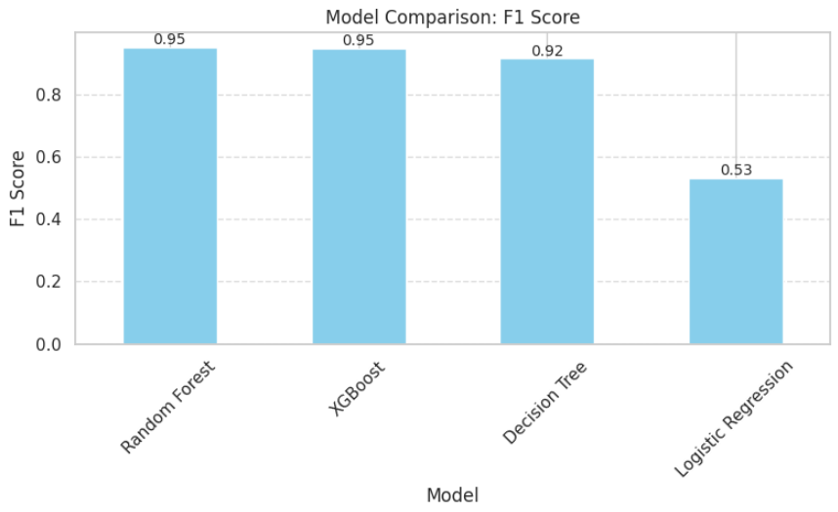
Figure 9: Model Comparison: F1 Score
This bar chart compares the F1 scores of the four classification models used in the project: Logistic Regression, Decision Tree, Random Forest, and XGBoost. The visualization highlights the superior performance of the ensemble models, with Random Forest and XGBoost both achieving F1 scores above 0.95. In contrast, Logistic Regression significantly underperformed, reinforcing the importance of using non-linear models for this classification task. The chart provides a clear visual summary of model effectiveness in balancing precision and recall.

Cross Validations
To ensure robustness, 5-fold cross-validation was performed:
- Random Forest and XGBoost maintained consistent performance across folds, with F1 score standard deviations <0.02.
- Decision Tree showed higher variance, indicating sensitivity to data splits.
Model | Accuracy | Precision | Recall | F1 Score | CV F1 Mean | CV F1 Std
Random Forest | 0.950484 | 0.926856 | 0.977705 | 0.951602 | 0.955749 | 0.0562496
XGBoost | 0.947752 | 0.905285 | 0.99965 | 0.95013 | 0.955082 | 0.0610752
Decision Tree | 0.917182 | 0.925271 | 0.90691 | 0.915999 | 0.919594 | 0.0385894
Logistic Regression | 0.530991 | 0.528576 | 0.536536 | 0.532526 | 0.531459 | 0.00492657
Table 3: Final Model Evaluation Summary
This table presents a comprehensive comparison of all four classification models, incorporating both initial evaluation metrics and 5-fold cross-validation results. Random Forest and XGBoost consistently achieved the highest F1 scores and demonstrated low variability across folds, indicating strong generalization and reliability. Decision Tree performed well but showed greater sensitivity to data splits, while Logistic Regression underperformed across all metrics. These results reinforce the effectiveness of ensemble methods for predicting medical appointment no-shows and highlight the importance of model stability in healthcare applications.
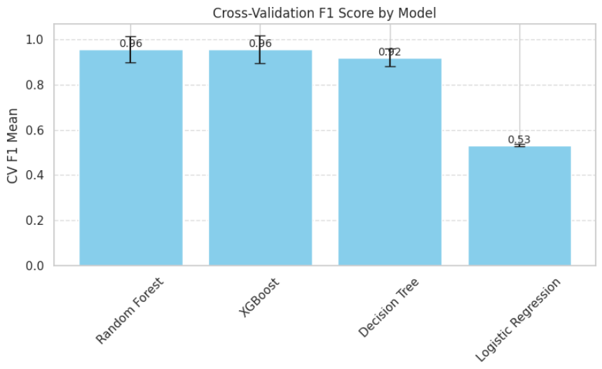
Figure 10: Cross-Validation F1 Score by Model
This bar chart presents the mean F1 scores from 5-fold cross-validation for each classification model, along with error bars representing standard deviation. Random Forest and XGBoost not only achieved the highest average F1 scores but also demonstrated low variability across folds, indicating strong generalization and stability. Decision Tree showed slightly more variance, while Logistic Regression had both the lowest mean score and minimal variability, confirming its limited effectiveness for this task. The visualization reinforces the robustness of ensemble models in handling imbalanced healthcare data.

Model Limitations
While the classification models used in this project demonstrated strong predictive performance, each has inherent limitations that should be considered when interpreting the results and planning future improvements.
Logistic Regression performed poorly across all evaluation metrics, with an F1 score of 0.53. This is likely due to its reliance on linear relationships between features and the target variable. In datasets with complex, non-linear patterns, such as those involving temporal and behavioral factors, Logistic Regression may fail to capture the necessary interactions without extensive feature transformation.
Decision Tree models offered reasonable accuracy and interpretability but are known to be sensitive to the specific data splits used during training. This sensitivity can lead to overfitting, especially when the tree grows too deep or when the dataset contains noise. While useful for understanding decision rules, their instability across different samples limits their reliability.
Random Forest, as an ensemble method, mitigates some of the overfitting issues seen in single decision trees and provides robust performance in this project. However, it comes with increased computational cost and reduced interpretability. Understanding the contribution of individual features or decisions within the forest can be challenging, which may limit its transparency in clinical settings.
XGBoost achieved the highest recall and matched Random Forest in overall F1 score, making it highly effective for identifying no-shows. Nevertheless, it is a more complex model that requires careful hyperparameter tuning to avoid overfitting. Its gradient boosting mechanism also increases training time and resource consumption, which may be a consideration for real-time or resource-constrained environments.
Recognizing these limitations is essential for selecting appropriate models for development. Balancing predictive accuracy with interpretability and computational efficiency will be key in translating these findings into practical healthcare solutions.

Key Observations
- Logistic Regression performed poorly across all metrics, with an accuracy of 0.53 and F1 score of 0.53, indicating it is not suitable for this dataset without significant feature engineering or non-linear enhancements.
- Decision Tree achieved strong performance with an accuracy of 0.92 and F1 score of 0.92, demonstrating its ability to capture non-linear relationships. Lacked stability compared to ensemble methods.
- Random Forest delivered the best overall balance, with an accuracy of 0.95, precision of 0.93, and recall of 0.98, resulting in an F1 score of 0.95.
- XGBoost matched Random Forest in F1 score (0.95) and achieved perfect recall (1.00), making it highly effective for identifying no-shows, with slightly lower precision compared to Random Forest.
- Ensemble methods (Random Forest and XGBoost) significantly outperformed simpler models, confirming the importance of handling feature interactions and class imbalance.

Insights
- Ensemble models are best suited for this problem due to their ability to handle feature interactions and imbalanced data.
- Scheduling interval and time-of-day features emerged as strong predictors of no-show behaviour.
- Feature improvements could include hyperparameter tuning and testing on real-world datasets for external validity.

Code Documentation
Having assessed model performance, the following section outlines the technical implementation, tools, and reproducibility practices used to develop and document the code.

Overview
The code for this milestone was developed in Python using Google Colab and version controlled in a dedicated GitHub repository. The implementation follows best practices for readability, reproducibility, and maintainability, ensuring that the workflow can be easily reviewed and replicated.

GitHub Repository
- Repository Link: CIND820-medical-no-show-prediction
- Contents include:
  - Jupyter Notebook (.ipynb) with all code and outputs.
  - Dataset files (appointments.csv, patients.csv, slots.csv).
  - README.md summarizing project objectives, structure, and instructions for running the code.
  - Plots and visualizations generated during EDA and model evaluation.

Coding Practices
- Comments and Docstrings:
  - Each function and code block includes descriptive comments explaining its purpose and logic.
  - Markdown cells provide context for major steps (e.g., data loading, preprocessing, model training).
- Modular Design:
  - Code is organized into reusable functions for tasks such as:
    - Data loading and cleaning
    - Feature engineering (e.g., scheduling interval, temporal features)
    - Model training and evaluation
- Version Control:
  - Regular commits with meaningful messages documenting changes and progress.

Tools and Libraries
- Data Manipulation: pandas, numpy
- Visualization: matplotlib, seaborn
- Modeling: scikit-learn, xgboost
- Imbalanced Data Handling: imblearn (SMOTE)
- Evaluation: scikit-learn.metrics for accuracy, precision, recall, F1 score, and confusion matrices
- Utilities: tabulate for formatted output tables

Reproducibility
- Random seeds set for SMOTE and model training to ensure consistent results.
- All dependencies listed in the notebook header for easy environment setup.
- Plots saved to dedicated folder (plots/) for inclusion in reports and presentations.

Video Presentation
To complement the written report and code, a brief video presentation summarizes the initial results and provides a walkthrough of the modeling process.
The Video was recorded via Zoom and uploaded to the Course website and is also available for download in the GitHub Repository.
https://github.com/emchan4/CIND820-medical-no-show-prediction/tree/main/Presentations

References
Abdou, T. (n.d.). Maintaining coding productivity with GitHub Copilot in VS Code: An introductory tutorial for data analytics capstone courses. Toronto Metropolitan University. Retrieved from https://de.torontomu.ca/de_courses/uploadedFiles/6055_Engineering/CIND820_-_P25/Modules/Module_03/CIND820-GitHub_CoPilot_Tutorial.pdf
Amazon Web Services. (n.d.). What is data preparation? Retrieved from https://aws.amazon.com/what-is/data-preparation/
Chawla, N. V., Bowyer, K. W., Hall, L. O., & Kegelmeyer, W. P. (2002). SMOTE: Synthetic Minority Over-sampling Technique. Journal of Artificial Intelligence Research, 16, 321–357. https://doi.org/10.1613/jair.953
Chen, T., & Guestrin, C. (2016). XGBoost: A scalable tree boosting system. In Proceedings of the 22nd ACM SIGKDD International Conference on Knowledge Discovery and Data Mining (pp. 785–794). https://doi.org/10.1145/2939672.2939785
Domino Data Lab. (n.d.). Model evaluation. Retrieved from https://domino.ai/data-science-dictionary/model-evaluation
GitHub. (2024, July 29). Tools and techniques for effective code documentation. Retrieved from https://github.com/resources/articles/software-development/tools-and-techniques-for-effective-code-documentation
LinearB. (2025). What is developer productivity and how to measure it. Retrieved from https://linearb.io/blog/developer-productivity
Office of Research Integrity, U.S. Department of Health and Human Services. (n.d.). Data analysis. Retrieved from https://ori.hhs.gov/education/products/n_illinois_u/datamanagement/datopic.html
Pedregosa, F., Varoquaux, G., Gramfort, A., Michel, V., Thirion, B., Grisel, O., ... & Duchesnay, É. (2011). Scikit-learn: Machine learning in Python. Journal of Machine Learning Research, 12, 2825–2830.
VanderPlas, J. (2022). Python data science handbook: Essential tools for working with data (2nd ed.). O’Reilly Media. Retrieved from https://torontomu.primo.exlibrisgroup.com/permalink/01OCUL_TMU/17jaqec/cdi_askewsholts_vlebooks_9781098121198
Wickham, H., Çetinkaya-Rundel, M., Grolemund, G., & Francis, E. (2023). R for data science: Import, tidy, transform, visualize, and model data (2nd ed.). O’Reilly Media. Retrieved from https://torontomu.primo.exlibrisgroup.com/permalink/01OCUL_TMU/1hnr25/alma991014450971608636

