According to PDSI obtained from NOAA, there was a regional drought around 2011-2014 that was on par with the one in mid-1950s. Values of PDSI below -4 are considered extreme drought.

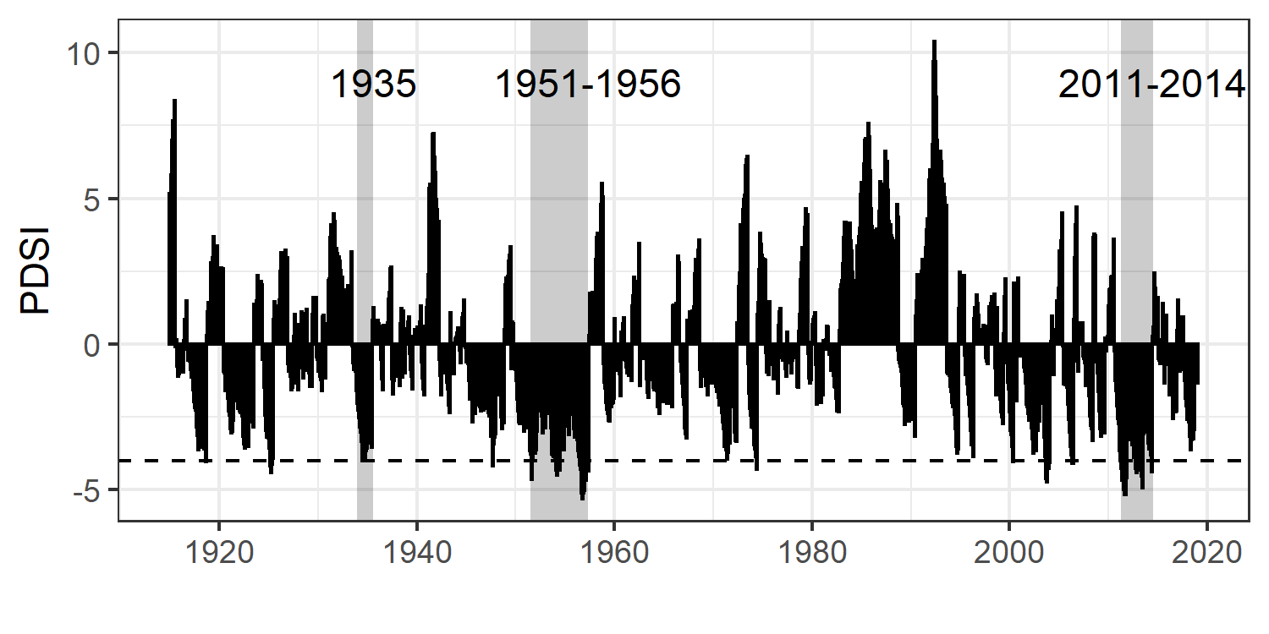

(figure created by get_PDSI.R in JRN_quadrat_datapaper/Climate)

Yearly precip values from HQ rain gauge back up this prediction. Rainfall was well below long-term average for 2009-2012.

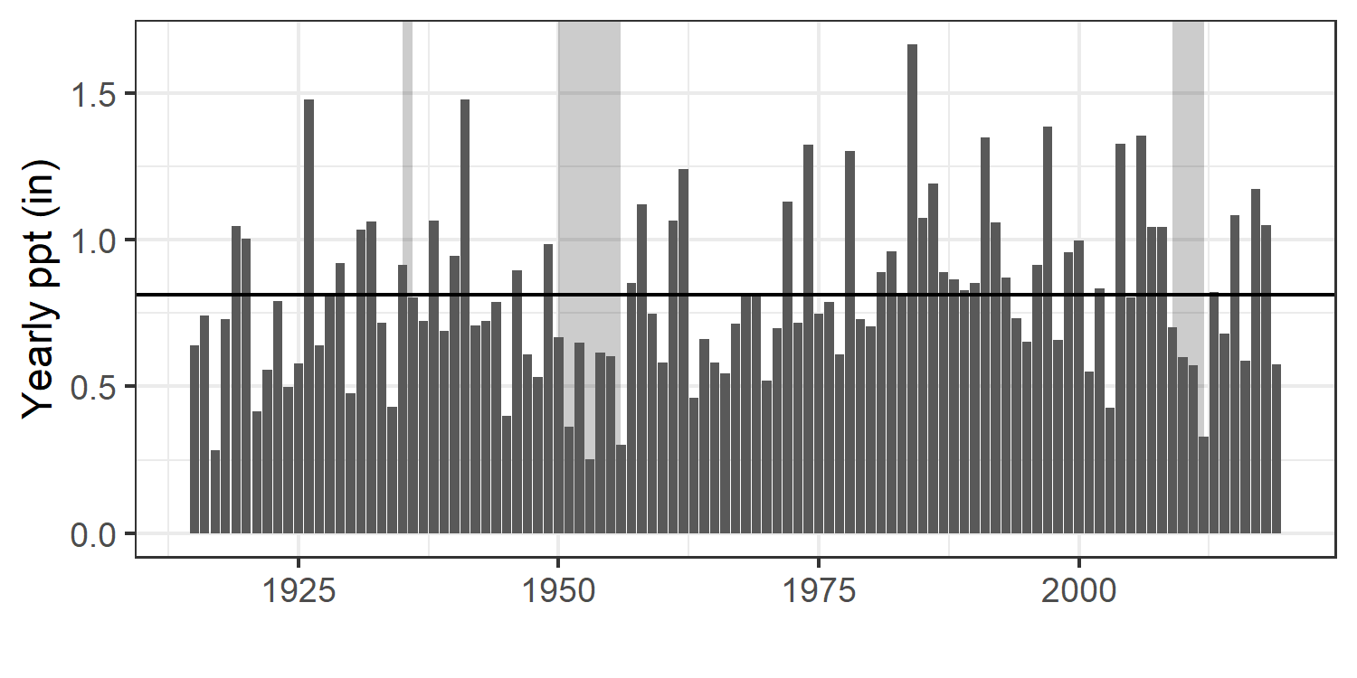

Is there significant spatial variation in precipitation on the Jornada during these drought periods?

Due to variation in timing when rain gauges were checked (Williamson et al 2012) I aggregated monthly values to year and season. Summer = July-September

**1935 drought: data from Jan 1934-Dec 1935**

Yearly mean for this period:

|  |  |  |
| --- | --- | --- |
|  | Value | Gauge |
| Min | 6.00 | South Well |
| Max | 9.62 | New Well |
| Mean | 7.43 |  |
| SD | 0.86 |  |

Just summer means:

|  |  |  |
| --- | --- | --- |
|  | Value | Gauge |
| Min | 2.70 | Sandhill |
| Max | 5.49 | New Well |
| Mean | 4.07 |  |
| SD | 0.68 |  |

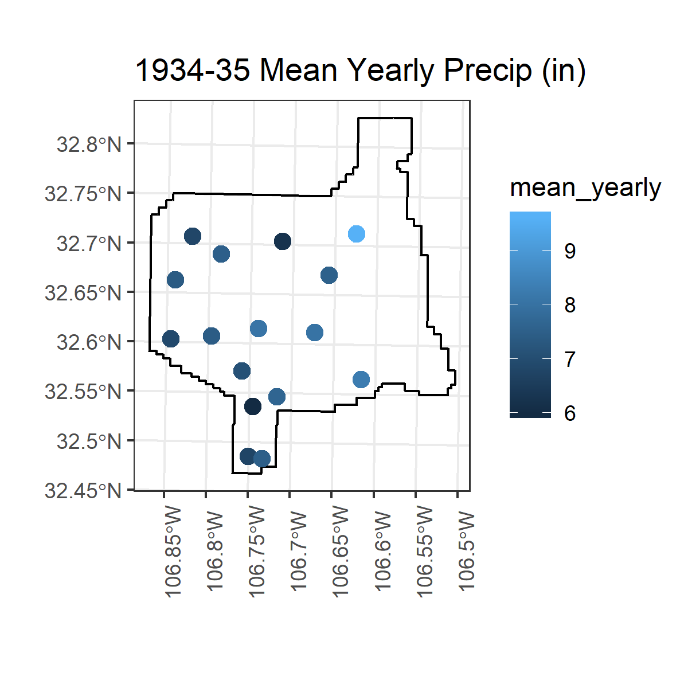

**1950s drought: Data from Jan 1950-Dec 1956**

Yearly mean for this period:

|  |  |  |
| --- | --- | --- |
|  | Value | Gauge |
| Min | 4.27 | Mesquite |
| Max | 5.91 | Headquarters |
| Mean | 5.03 |  |
| SD | 0.55 |  |

Just summer means:

|  |  |  |
| --- | --- | --- |
|  | Value | Gauge |
| Min | 2.33 | Mesquite |
| Max | 3.78 | New Well |
| Mean | 2.94 |  |
| SD | 0.41 |  |

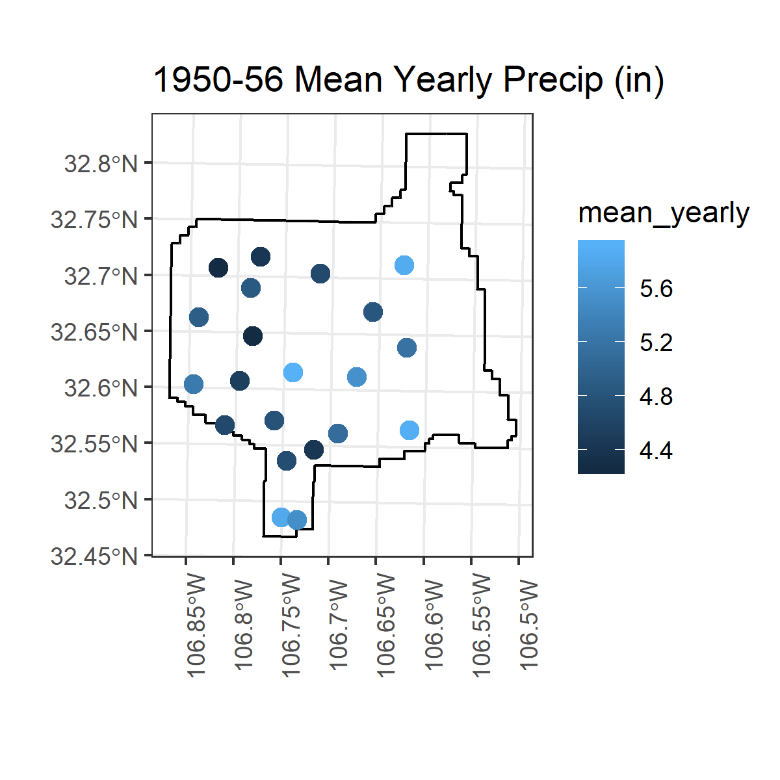

**2011-2012 drought: Data from Jan 2010-Dec 2012**

Yearly mean for this period:

|  |  |  |
| --- | --- | --- |
|  | Value | Gauge |
| Min | 5.46 | Taylor well |
| Max | 9.04 | Parker Tank |
| Mean | 7.18 |  |
| SD | 1.00 |  |

Just summer means:

|  |  |  |
| --- | --- | --- |
|  | Value | Gauge |
| Min | 3.00 | Antelope Tank |
| Max | 5.81 | IBP |
| Mean | 4.44 |  |
| SD | 0.76 |  |

