Shrub cover in a neighborhood (10m radius) of each quadrat obtained from Wenji. We have data for 2005, 2011, and 2016, though it is probably best to take the average of these three values.

Comparing neighborhood shrub cover to actual shrub cover on each quadrat, there is little correlation:

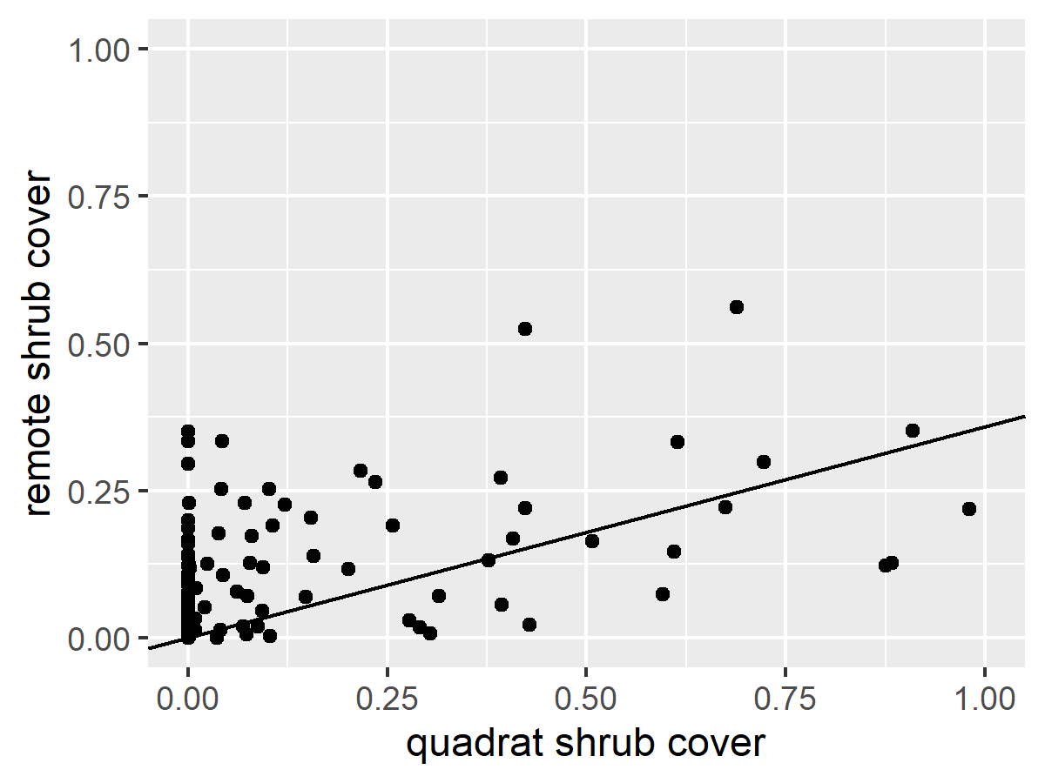

Line is linear model of data: slope = 0.358, intercept=0, adjusted r-sq = .394

We also have shrub cover data from when Jin collected additional data in 2001. They did DK cover on 20 quadrats within a 20m x 20m square around each quadrat. Shrub cover estimated from this method is more correlated with the remote sensed data (using mean value):

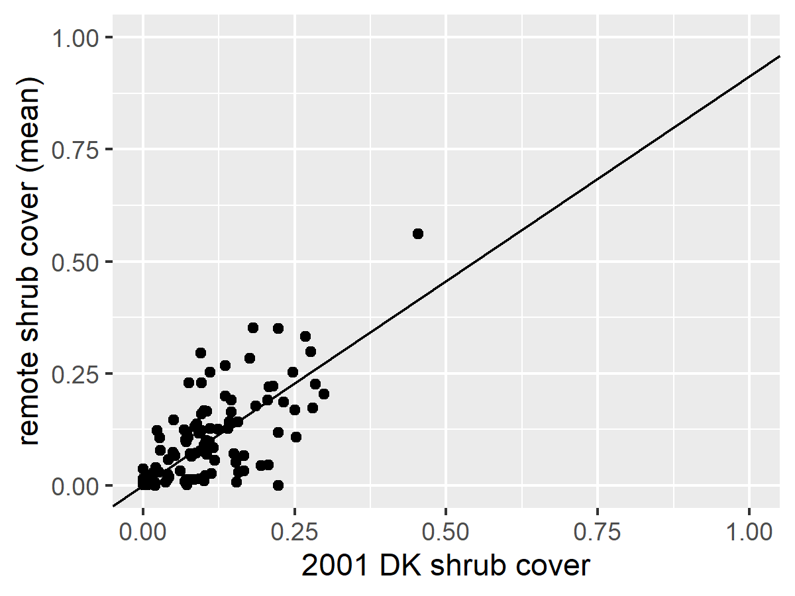

Line is linear model of the data. Slope = 0.91, intercept = 0, adjusted R^2 = 0.7468

When estimating 2001 shrub cover from DK, I included shrub, tree, and subshrub species. Using only shrub species seemed to underestimate cover compared to remote data.