# Front End Technologies Week 5 Coding Assignment

**Points possible:** 70

|  |  |  |
| --- | --- | --- |
| Category | Criteria | % of Grade |
| Functionality | Does the code work? | 25 |
| Organization | Is the code clean and organized? Proper use of white space, syntax, and consistency are utilized. Names and comments are concise and clear. | 25 |
| Creativity | Student solved the problems presented in the assignment using creativity and out of the box thinking. | 25 |
| Completeness | All requirements of the assignment are complete. | 25 |

**Instructions:** In VS Code, or an IDE of your choice, write the code that accomplishes the objectives listed below. Ensure that the code compiles and runs as directed. Take screenshots of the code and of the running program (make sure to get screenshots of all required functionality) and paste them in this document where instructed below. Create a new repository on GitHub for this week’s assignments and push this document, with your JavaScript project code, to the repository. Add the URL for this week’s repository to this document where instructed and submit this document to your instructor when complete.

**Coding Steps:**

1. Using any of the tools you’ve worked with so far, create a game of tic-tac-toe.
   1. A heading should say whether it is X’s or O’s turn and change with each move made.
   2. Create a tic-tac-toe grid using your HTML element of choice. When a cell in the grid is clicked, an X or O should appear in that spot depending on whose turn it is.
   3. A button should be available to clear the grid and restart the game.
   4. When a player has won, or the board is full and the game results in a draw, a Bootstrap alert or similar Bootstrap component should appear across the screen announcing the winner.

**Screenshots of Code:**

**index_tic_tac_toe.html**

<!DOCTYPE html>

<head>

    <meta name="viewport" content=

        "width=device-width, initial-scale=1.0">

    <link href="node_modules/bootstrap/dist/css/bootstrap.css">

    <link rel="stylesheet"

        type="text/css" href="style_tic.css">

</head>

<body>

    <div id="main">

        <h1>This is the Game of TIC TAC TOE</h1>

        <!-- Instructions-->

        <p id ="ins1">To start the game

            choose a box<br><br>First Player =

            <b>Player X&nbsp;&nbsp;&nbsp</b>

               Second Player = <b>Player 0</b>

        </p>

        <br><br>

        <!-- input is used to create interactive

            controls, type creates single line

            text fields, onclick executes a javascript -->

      <!-- the following code is series of buttons

            in a 3x3 grid and are separtated by

            breaks -->

        <input type="text" id="btn1" onclick=

            "btnfunc_3(); btnfunc();" readonly>

        <input type="text" id="btn2" onclick=

            "btnfunc_4(); btnfunc();" readonly>

        <input type="text" id="btn3" onclick=

            "btnfunc_5(); btnfunc();" readonly>

        <br><br>

        <input type="text" id="btn4" onclick=

            "btnfunc_6(); btnfunc();" readonly>

        <input type="text" id="btn5" onclick=

            "btnfunc_7(); btnfunc();" readonly>

        <input type="text" id="btn6" onclick=

            "btnfunc_8(); btnfunc();" readonly>

        <br><br>

        <input type="text" id="btn7" onclick=

            "btnfunc_9(); btnfunc();" readonly>

        <input type="text" id="btn8" onclick=

            "btnfunc_10();btnfunc();" readonly>

        <input type="text" id="btn9" onclick=

            "btnfunc_11();btnfunc();" readonly>

        <br><br><br>

 <!-- The button below executes a function that

       initiates a new game. All input boxes are

       cleared -->

  <div>

        <button id="but" onclick="btnfunc_2()">

           <a>Start New Game</a>

        </button>

        <br><br>

        <p id="print"></p>

    </div>

    </div>

        <script src="script_tic.js"></script>

      <script src="node_modules/jquery/dist/jquery.js"></script>

        <script src="node_modules/bootstrap/dist/js/bootstrap.js"></script>

</body>

</html>

**Script_tic.js**

// Function called whenever a box is selected

function btnfunc() {

    // When a button is clicked two functions are executed

    // the btnfunc declares variables for each button in the DOM

    // by getting the current values. the variables are set equal to the value in the

    // input box assigned to each button and the DOM method

    // returns an Element object representing the element

    // whose id property matches the specified string

    // the rest of this code the status of player x and player 0

    // each time a button is clicked

    // before btnfunc is executed the btnfunc_number is checked

    // for three things, what player X or 0, is the flag=1 if yes

    // place an X or 0 or if flag=0, the button (element) is disabled,

    // once the btnfunc_number is executed then btnfunc is executed

    var b1, b2, b3, b4, b5, b6, b7, b8, b9;

    b1 = document.getElementById("btn1").value;

    b2 = document.getElementById("btn2").value;

    b3 = document.getElementById("btn3").value;

    b4 = document.getElementById("btn4").value;

    b5 = document.getElementById("btn5").value;

    b6 = document.getElementById("btn6").value;

    b7 = document.getElementById("btn7").value;

    b8 = document.getElementById("btn8").value;

    b9 = document.getElementById("btn9").value;

    // for this function named btnfunc the following conditional statements

    // check the different ways Player X can win

    // If player X wins then all of the other buttons are

    // disabled and the game is over.

    // this is the first row

    if ((b1 == 'x' || b1 == 'X') && (b2 == 'x' ||

        b2 == 'X') && (b3 == 'x' || b3 == 'X')) {

        document.getElementById('print')

            .innerHTML = "Player X wins";

        document.getElementById("btn4").disabled = true;

        document.getElementById("btn5").disabled = true;

        document.getElementById("btn6").disabled = true;

        document.getElementById("btn7").disabled = true;

        document.getElementById("btn8").disabled = true;

        document.getElementById("btn9").disabled = true;

        window.alert('Player X wins');

    }

    // this is the left column of the grid

    else if ((b1 == 'x' || b1 == 'X') && (b4 == 'x' ||

        b4 == 'X') && (b7 == 'x' || b7 == 'X')) {

        document.getElementById('print')

            .innerHTML = "Player X wins";

        document.getElementById("btn2").disabled = true;

        document.getElementById("btn3").disabled = true;

        document.getElementById("btn5").disabled = true;

        document.getElementById("btn6").disabled = true;

        document.getElementById("btn8").disabled = true;

        document.getElementById("btn9").disabled = true;

        window.alert('Player X wins');

    }

    // this is the the bottom row of the grid

    else if ((b7 == 'x' || b7 == 'X') && (b8 == 'x' ||

        b8 == 'X') && (b9 == 'x' || b9 == 'X')) {

        document.getElementById('print')

            .innerHTML = "Player X wins";

        document.getElementById("btn1").disabled = true;

        document.getElementById("btn2").disabled = true;

        document.getElementById("btn3").disabled = true;

        document.getElementById("btn4").disabled = true;

        document.getElementById("btn5").disabled = true;

        document.getElementById("btn6").disabled = true;

        window.alert('Player X wins');

    }

    // this is the right column of the grid

    else if ((b3 == 'x' || b3 == 'X') && (b6 == 'x' ||

        b6 == 'X') && (b9 == 'x' || b9 == 'X')) {

        document.getElementById('print')

            .innerHTML = "Player X wins";

        document.getElementById("btn1").disabled = true;

        document.getElementById("btn2").disabled = true;

        document.getElementById("btn4").disabled = true;

        document.getElementById("btn5").disabled = true;

        document.getElementById("btn7").disabled = true;

        document.getElementById("btn8").disabled = true;

        window.alert('Player X wins');

    }

    // this is the left diagonal of the grid

    else if ((b1 == 'x' || b1 == 'X') && (b5 == 'x' ||

        b5 == 'X') && (b9 == 'x' || b9 == 'X')) {

        document.getElementById('print')

            .innerHTML = "Player X wins";

        document.getElementById("btn2").disabled = true;

        document.getElementById("btn3").disabled = true;

        document.getElementById("btn4").disabled = true;

        document.getElementById("btn6").disabled = true;

        document.getElementById("btn7").disabled = true;

        document.getElementById("btn8").disabled = true;

        window.alert('Player X wins');

    }

       // this is the right diagonal of the grid

    else if ((b3 == 'x' || b3 == 'X') && (b5 == 'x' ||

        b5 == 'X') && (b7 == 'x' || b7 == 'X')) {

        document.getElementById('print')

            .innerHTML = "Player X wins";

        document.getElementById("btn1").disabled = true;

        document.getElementById("btn3").disabled = true;

        document.getElementById("btn4").disabled = true;

        document.getElementById("btn6").disabled = true;

        document.getElementById("btn8").disabled = true;

        document.getElementById("btn9").disabled = true;

        window.alert('Player X wins');

    }

       // this is the middle column of the grid

    else if ((b2 == 'x' || b2 == 'X') && (b5 == 'x' ||

        b5 == 'X') && (b8 == 'x' || b8 == 'X')) {

        document.getElementById('print')

            .innerHTML = "Player X wins";

        document.getElementById("btn1").disabled = true;

        document.getElementById("btn3").disabled = true;

        document.getElementById("btn4").disabled = true;

        document.getElementById("btn6").disabled = true;

        document.getElementById("btn7").disabled = true;

        document.getElementById("btn9").disabled = true;

        window.alert('Player X wins');

    }

       // this is the middle row of the grid

    else if ((b4 == 'x' || b4 == 'X') && (b5 == 'x' ||

        b5 == 'X') && (b6 == 'x' || b6 == 'X')) {

        document.getElementById('print')

            .innerHTML = "Player X wins";

        document.getElementById("btn1").disabled = true;

        document.getElementById("btn2").disabled = true;

        document.getElementById("btn3").disabled = true;

        document.getElementById("btn7").disabled = true;

        document.getElementById("btn8").disabled = true;

        document.getElementById("btn9").disabled = true;

        window.alert('Player X wins');

    }

    // Checking for Player 0 starts, Is player 0 wins or

    // not and after that disabled all the other fields

    else if ((b1 == '0' || b1 == '0') && (b2 == '0' ||

        b2 == '0') && (b3 == '0' || b3 == '0')) {

        document.getElementById('print')

            .innerHTML = "Player 0 wins";

        document.getElementById("btn4").disabled = true;

        document.getElementById("btn5").disabled = true;

        document.getElementById("btn6").disabled = true;

        document.getElementById("btn7").disabled = true;

        document.getElementById("btn8").disabled = true;

        document.getElementById("btn9").disabled = true;

        window.alert('Player 0 wins');

    }

    else if ((b1 == '0' || b1 == '0') && (b4 == '0' ||

        b4 == '0') && (b7 == '0' || b7 == '0')) {

        document.getElementById('print')

            .innerHTML = "Player 0 wins";

        document.getElementById("btn2").disabled = true;

        document.getElementById("btn3").disabled = true;

        document.getElementById("btn5").disabled = true;

        document.getElementById("btn6").disabled = true;

        document.getElementById("btn8").disabled = true;

        document.getElementById("btn9").disabled = true;

        window.alert('Player 0 wins');

    }

    else if ((b7 == '0' || b7 == '0') && (b8 == '0' ||

        b8 == '0') && (b9 == '0' || b9 == '0')) {

        document.getElementById('print')

            .innerHTML = "Player 0 wins";

        document.getElementById("btn1").disabled = true;

        document.getElementById("btn2").disabled = true;

        document.getElementById("btn3").disabled = true;

        document.getElementById("btn4").disabled = true;

        document.getElementById("btn5").disabled = true;

        document.getElementById("btn6").disabled = true;

        window.alert('Player 0 wins');

    }

    else if ((b3 == '0' || b3 == '0') && (b6 == '0' ||

        b6 == '0') && (b9 == '0' || b9 == '0')) {

        document.getElementById('print')

            .innerHTML = "Player 0 wins";

        document.getElementById("btn1").disabled = true;

        document.getElementById("btn2").disabled = true;

        document.getElementById("btn4").disabled = true;

        document.getElementById("btn5").disabled = true;

        document.getElementById("btn7").disabled = true;

        document.getElementById("btn8").disabled = true;

        window.alert('Player 0 wins');

    }

    else if ((b1 == '0' || b1 == '0') && (b5 == '0' ||

        b5 == '0') && (b9 == '0' || b9 == '0')) {

        document.getElementById('print')

            .innerHTML = "Player 0 wins";

        document.getElementById("btn2").disabled = true;

        document.getElementById("btn3").disabled = true;

        document.getElementById("btn4").disabled = true;

        document.getElementById("btn6").disabled = true;

        document.getElementById("btn7").disabled = true;

        document.getElementById("btn8").disabled = true;

        window.alert('Player 0 wins');

    }

    else if ((b3 == '0' || b3 == '0') && (b5 == '0' ||

        b5 == '0') && (b7 == '0' || b7 == '0')) {

        document.getElementById('print')

            .innerHTML = "Player 0 wins";

        document.getElementById("btn1").disabled = true;

        document.getElementById("btn2").disabled = true;

        document.getElementById("btn4").disabled = true;

        document.getElementById("btn6").disabled = true;

        document.getElementById("btn8").disabled = true;

        document.getElementById("btn9").disabled = true;

        window.alert('Player 0 wins');

    }

    else if ((b2 == '0' || b2 == '0') && (b5 == '0' ||

        b5 == '0') && (b8 == '0' || b8 == '0')) {

        document.getElementById('print')

            .innerHTML = "Player 0 wins";

        document.getElementById("btn1").disabled = true;

        document.getElementById("btn3").disabled = true;

        document.getElementById("btn4").disabled = true;

        document.getElementById("btn6").disabled = true;

        document.getElementById("btn7").disabled = true;

        document.getElementById("btn9").disabled = true;

        window.alert('Player 0 wins');

    }

    else if ((b4 == '0' || b4 == '0') && (b5 == '0' ||

        b5 == '0') && (b6 == '0' || b6 == '0')) {

        document.getElementById('print')

            .innerHTML = "Player 0 wins";

        document.getElementById("btn1").disabled = true;

        document.getElementById("btn2").disabled = true;

        document.getElementById("btn3").disabled = true;

        document.getElementById("btn7").disabled = true;

        document.getElementById("btn8").disabled = true;

        document.getElementById("btn9").disabled = true;

        window.alert('Player 0 wins');

    }

  // if both Player X and Player 0 have not won then the

  // there is a check to see if there is a tie,

  // essentially if all cells are

    else if ((b1 == 'X' || b1 == '0') && (b2 == 'X'

        || b2 == '0') && (b3 == 'X' || b3 == '0') &&

        (b4 == 'X' || b4 == '0') && (b5 == 'X' ||

        b5 == '0') && (b6 == 'X' || b6 == '0') &&

        (b7 == 'X' || b7 == '0') && (b8 == 'X' ||

        b8 == '0') && (b9 == 'X' || b9 == '0')) {

            document.getElementById('print')

                .innerHTML = "Match Tie";

            window.alert('Match Tie');

    }

    else {

        if (flag == 1) {

            document.getElementById('print')

                .innerHTML = "Player X Turn";

        }

        else {

            document.getElementById('print')

                .innerHTML = "Player 0 Turn";

        }

    }

}

// The function below resets B(new game) the input boxes to

// empty when the new game button is clicked in the DOM

function btnfunc_2() {

    location.reload();

    document.getElementById('btn1').value = '';

    document.getElementById("btn2").value = '';

    document.getElementById("btn3").value = '';

    document.getElementById("btn4").value = '';

    document.getElementById("btn5").value = '';

    document.getElementById("btn6").value = '';

    document.getElementById("btn7").value = '';

    document.getElementById("btn8").value = '';

    document.getElementById("btn9").value = '';

}

// a flag variable is used to do something while the

// condition is true (boolean) and then change it to a different value

// based on the condition of the flag variable

// a value of X or 0 is put in the box.

// the value of flag is also set to 0 which takes the button

// out of play

flag = 1;

function btnfunc_3() {

    if (flag == 1) {

        // if flag =1 then it's Player's X turn

        document.getElementById("btn1").value = "X";

        // after the value has been put in the box

        // the button "b1" is disabled

        document.getElementById("btn1").disabled = true;

        flag = 0; // f;ag=0 implies it is Player's 0 turn

    }

    else {

        document.getElementById("btn1").value = "0";

        document.getElementById("btn1").disabled = true;

        flag = 1;

    }

}

function btnfunc_4() {

    if (flag == 1) {

        document.getElementById("btn2").value = "X";

        document.getElementById("btn2").disabled = true;

        flag = 0;

    }

    else {

        document.getElementById("btn2").value = "0";

        document.getElementById("btn2").disabled = true;

        flag = 1;

    }

}

function btnfunc_5() {

    if (flag == 1) {

        document.getElementById("btn3").value = "X";

        document.getElementById("btn3").disabled = true;

        flag = 0;

    }

    else {

        document.getElementById("btn3").value = "0";

        document.getElementById("btn3").disabled = true;

        flag = 1;

    }

}

function btnfunc_6() {

    if (flag == 1) {

        document.getElementById("btn4").value = "X";

        document.getElementById("btn4").disabled = true;

        flag = 0;

    }

    else {

        document.getElementById("btn4").value = "0";

        document.getElementById("btn4").disabled = true;

        flag = 1;

    }

}

function btnfunc_7() {

    if (flag == 1) {

        document.getElementById("btn5").value = "X";

        document.getElementById("btn5").disabled = true;

        flag = 0;

    }

    else {

        document.getElementById("btn5").value = "0";

        document.getElementById("btn5").disabled = true;

        flag = 1;

    }

}

function btnfunc_8() {

    if (flag == 1) {

        document.getElementById("btn6").value = "X";

        document.getElementById("btn6").disabled = true;

        flag = 0;

    }

    else {

        document.getElementById("btn6").value = "0";

        document.getElementById("btn6").disabled = true;

        flag = 1;

    }

}

function btnfunc_9() {

    if (flag == 1) {

        document.getElementById("btn7").value = "X";

        document.getElementById("btn7").disabled = true;

        flag = 0;

    }

    else {

        document.getElementById("btn7").value = "0";

        document.getElementById("btn7").disabled = true;

        flag = 1;

    }

}

function btnfunc_10() {

    if (flag == 1) {

        document.getElementById("btn8").value = "X";

        document.getElementById("btn8").disabled = true;

        flag = 0;

    }

    else {

        document.getElementById("btn8").value = "0";

        document.getElementById("btn8").disabled = true;

        flag = 1;

    }

}

function btnfunc_11() {

    if (flag == 1) {

        document.getElementById("btn9").value = "X";

        document.getElementById("btn9").disabled = true;

        flag = 0;

    }

    else {

        document.getElementById("btn9").value = "0";

        document.getElementById("btn9").disabled = true;

        flag = 1;

    }

}

**script_tic.css**

#main {

        color: dodgerblue;

        text-align: center;

    }

    #ins {

        font-family: Verdana,

            Geneva, Tahoma, sans-serif;

        color: rgb(151, 40, 179);

        font-size: 17px;

    }

      #ins1 {

        font-family: Verdana,

            Geneva, Tahoma, sans-serif;

        color: rgb(15, 19, 16);

        font-size: 17px;

    }

    h1 {

        color: blueviolet (255, 68, 0, 0.877);

        font-size: 75px;

    }

    #btn1, #btn2, #btn3, #btn4, #btn5,

    #btn6, #btn7, #btn8, #btn9 {

        width: 160px;

        height: 104px;

        margin: auto;

        border: 1px solid gray;

        border-radius: 6px;

        font-size: 30px;

        text-align: center;

    }

 v

    #but {

        box-sizing: border-box;

        width:110px;

        height:60px;

        border: 1px solid blue;

        margin: auto;

        border-radius: 10px;

        font-family: Verdana,

            Geneva, Tahoma, sans-serif;

        background-color: rgb(45, 131, 218);

        color: rgb(236, 133, 133);

        font-size: 20px;

        cursor: pointer;

    }

    #print {

        font-family: Verdana,

            Geneva, Tahoma, sans-serif;

        color: dodgerblue;

        font-size: 20px;

    }

**Screenshots of Running Application:**

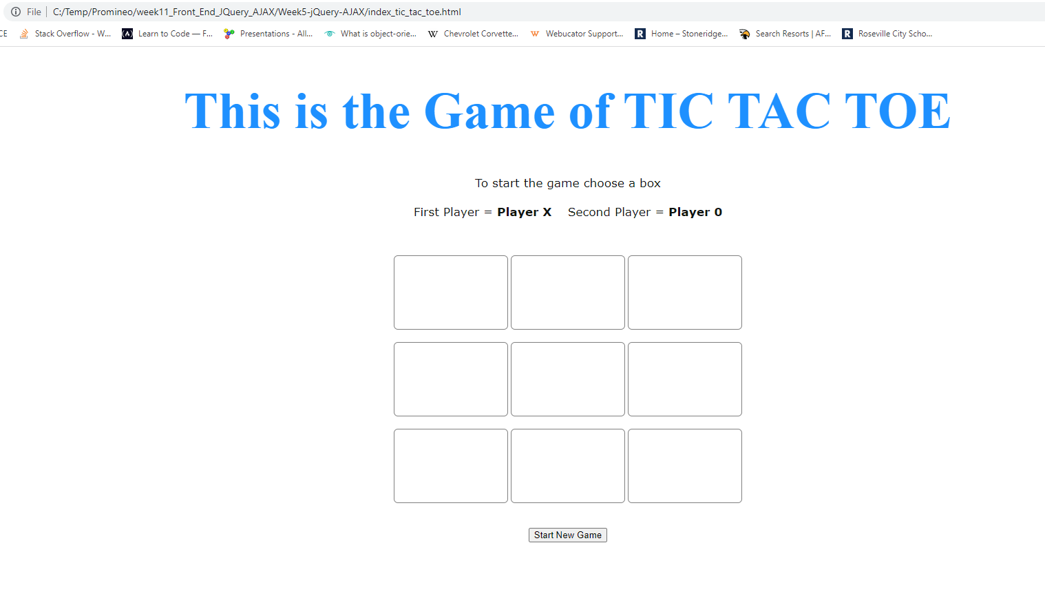

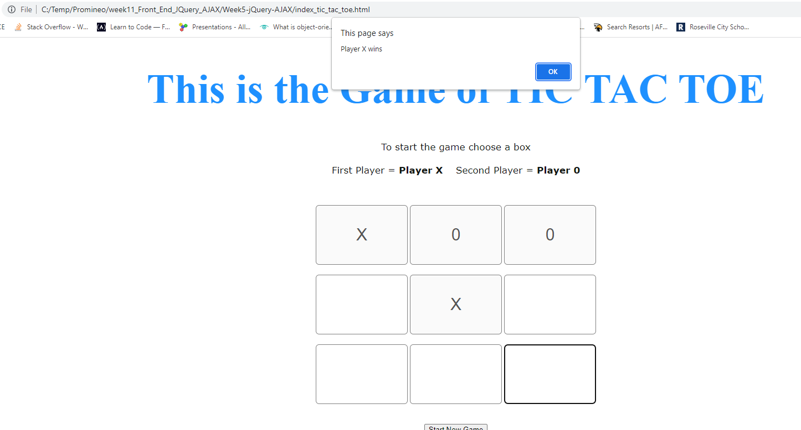

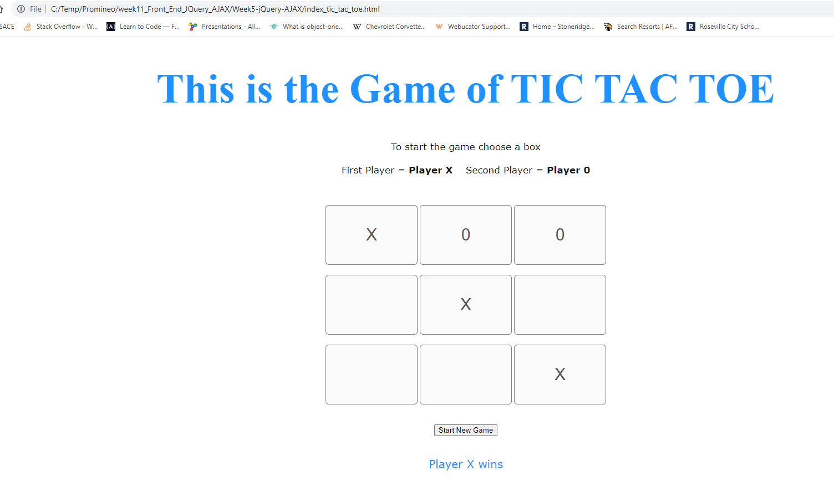

**URL to GitHub Repository:**

**https://github.com/emcis/https-github.com-emcis-week_11_repository**