# Front End Technologies Week 4 Coding Assignment

**Points possible:** 70

|  |  |  |
| --- | --- | --- |
| Category | Criteria | % of Grade |
| Functionality | Does the code work? | 25 |
| Organization | Is the code clean and organized? Proper use of white space, syntax, and consistency are utilized. Names and comments are concise and clear. | 25 |
| Creativity | Student solved the problems presented in the assignment using creativity and out of the box thinking. | 25 |
| Completeness | All requirements of the assignment are complete. | 25 |

**Instructions:** In VS Code, or an IDE of your choice, write the code that accomplishes the objectives listed below. Ensure that the code compiles and runs as directed. Take screenshots of the code and of the running program (make sure to get screenshots of all required functionality) and paste them in this document where instructed below. Create a new repository on GitHub for this week’s assignments and push this document, with your JavaScript project code, to the repository. Add the URL for this week’s repository to this document where instructed and submit this document to your instructor when complete.

**Coding Steps:**

1. Using HTML, Bootstrap, and JavaScript create a single page website that contains the following:
   1. **A Bootstrap styled table representing your choice of data**.
   2. **A Bootstrap styled form that allows a user to add a new row to the table when submitted.**

**Screenshots of Code:**

**a Bootstrap styled table representing your choice of data.**

<html lang="en">

    <head>

        <meta charset="utf-8">

        <meta name="viewport" content="width=device-width, initial-scale=1.0">

        <title>Project App</title>

        <link rel="stylesheet" href="node_modules/bootstrap/dist/css/bootstrap.css">

    </head>

      <body class="container">

       <br>

       <div class = "card">

        <div class = card-body>

         <div class="row">

           <div class = "col-sm">

             <div class="form-group">

            <label class-control labor for="new-Project">Basketball Greats</label>

           </div>

         </div>

       </div>

       <div class="table-responsive">

       <table class="table table-dark">

        <thead>

          <tr>

            <th scope="col">#</th>

            <th scope="col">First Name</th>

            <th scope="col">Last Name</th>

            <th scope="col">NickName</th>

          </tr>

        </thead>

        <tbody>

          <tr>

            <th scope="row">1</th>

            <td>John</td>

            <td>Hammer</td>

            <td>Bring it</td>

          </tr>

          <tr>

            <th scope="row">2</th>

            <td>Clyde</td>

            <td>Drexler</td>

            <td>The Glide</td>

          </tr>

          <tr>

            <th scope="row">3</th>

            <td>Larry</td>

            <td>Bird</td>

            <td>Can't Miss</td>

          </tr>

        </tbody>

      </table>

    </div>

        <script src="node_modules/bootstrap/dist/js/bootstrap.bundle.js"></script>

    </body>

</html>

**b Bootstrap styled form that allows a user to add a new row to the table when submitted.**

**index_Front_End_Week4_Form.html**

<html lang="en">

    <head>

        <meta charset="utf-8">

        <meta name="viewport" content="width=device-width, initial-scale=1.0">

        <title>Project App</title>

        <link rel="stylesheet" href="node_modules/bootstrap/dist/css/bootstrap.css">

    </head>

      <body class ="container">

       <br>

       <div class = "card">

           <div class = card-body>

            <div class="row">

              <div class = "col-sm">

                <div class="form-group">

               <label for="new-Project">Project</label>

               <input type="text" class="form-control" id="new-Project" placeholder="Project">

              </div>

            </div>

          </div>

               <div class="row">

                 <div class = "col-sm">

                    <div class="form-group">

                        <label for="Project-start-date">Project Start</label>

                        <input type="date" class="form-control" id="Project-start-date">

                    </div>

                 </div>

                 <div class = "col-sm">

                  <div class="form-group">

                    <label for="new-end-date">Project Finish Date</label>

                    <input type="date" class="form-control" id="Project-end-date">

                 </div>

              </div>

             </div>

            <div>

            <button id="add" class="btn btn-primary from-control">Create</button>

           </div>

        </div>

      </div>

    <table id="list" class="table table-dark table-striped">

        <tr>

        <th>Project</th>>

        <th>Date Scheduled</th>>

        <th>Start Date</th>>

        <th>Finish Date</th>>

        <th>Action</th>>

        </tr>

    </table>

        <script src="Front_End_Week_4_Homework_Form.js"></script>

        <script src="node_modules/jquery/dist/jquery.js"></script>

        <script src="node_modules/bootstrap/dist/js/bootstrap.bundle.js"></script>

    </body>

</html>

**Screenshots of Running Application:**

**a Bootstrap styled table representing your choice of data.**

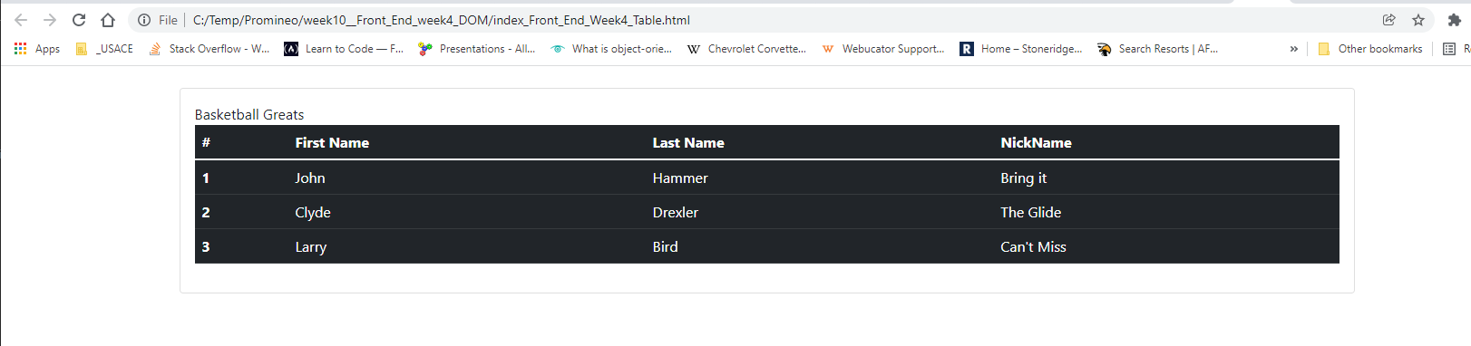

**b. A Bootstrap styled form that allows a user to add a new row to the table when submitted.**

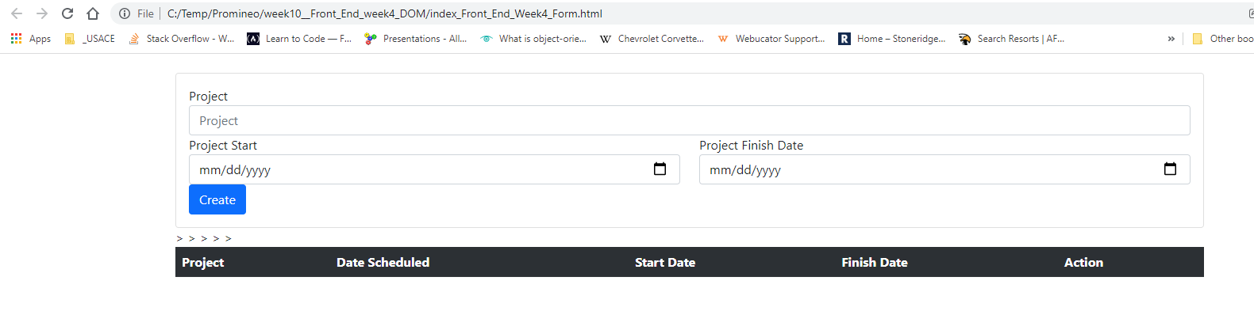

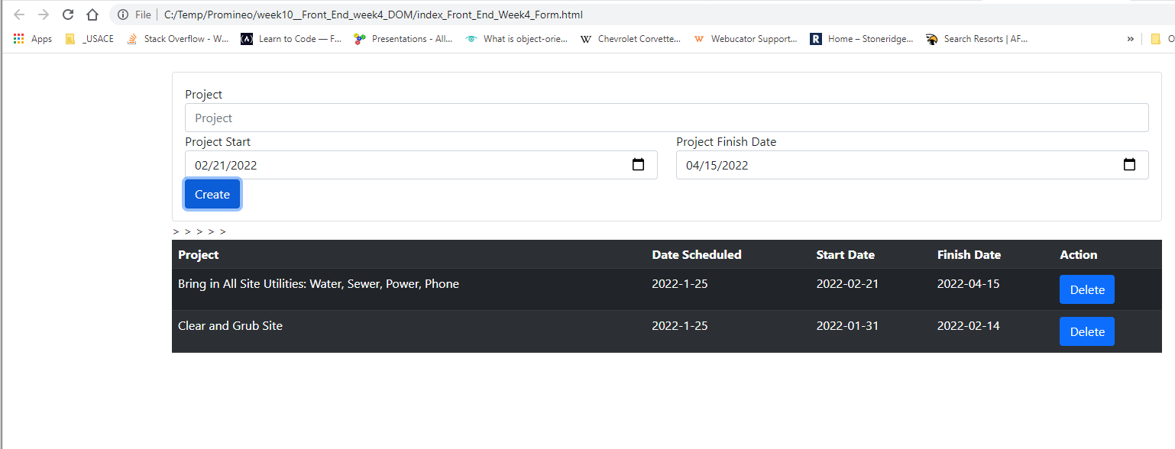

**URL to GitHub Repository:**

**https://github.com/emcis/week_10_repository**