Front End Technologies Week 2 Coding Assignment

**Points possible:** 70

|  |  |  |
| --- | --- | --- |
| Category | Criteria | % of Grade |
| Functionality | Does the code work? | 25 |
| Organization | Is the code clean and organized? Proper use of white space, syntax, and consistency are utilized. Names and comments are concise and clear. | 25 |
| Creativity | Student solved the problems presented in the assignment using creativity and out of the box thinking. | 25 |
| Completeness | All requirements of the assignment are complete. | 25 |

**Instructions:** In VS Code, or an IDE of your choice, write the code that accomplishes the objectives listed below. Ensure that the code compiles and runs as directed. Take screenshots of the code and of the running program (make sure to get screenshots of all required functionality) and paste them in this document where instructed below. Create a new repository on GitHub for this week’s assignments and push this document, with your JavaScript project code, to the repository. Add the URL for this week’s repository to this document where instructed and submit this document to your instructor when complete.

**Coding Steps:**

1. Style the website you made last week using CSS. Below are the requirements:
   1. Use only external CSS file (no internal or inline styling)
   2. Every element must be styled
   3. Create style rules using class, id, and element selectors

**Screenshots of Code:**

**real_Time_Wm.html**

<!DOCTYPE html>

<html lang="en">

    <head>

        <meta charset="UTF-8">

        <meta  http-equiv="X-UA-Compatible" content="IE=edge">

        <meta name="viewport" content="width=device-width, initial-scale=1.0">

        <title>Municipal Water Resource Agency (MWRA)</title>

        <link rel="stylesheet" href="styles_WM.css">

    </head>

    <body>

        <h1>Home</h1>

            <div class="hov" id="box-model" >

                <a href="real_Time_Wm.html">Real Time Water Management Monitoring and Modeling Tool <a><br>

                <a href="data_management.html">Data Management<a><br>

                <a href="modeling.html">Modeling<a><br>

            </div>

       <p>

        <a1>  Map of the United States.<a1><br>

        <img height="3000 px" src=US.png> <br>

       </p>

    </body>

    </html>

**modeling.html**

DOCTYPE html>

<html lang="en">

<head>

    <meta charset="UTF-8">

    <meta http-equiv="X-UA-Compatible" content="IE=edge">

    <meta name="viewport" content="width=device-width, initial-scale=1.0">

    <title>Document</title>

    <link rel="stylesheet" href="styles_WM.css">

</head>

<body>

    <div id = "box-model">

        <a href="real_Time_Wm.html">Real Time Water Management Monitoring and Modeling Tool <a><br>

        <a href="data_management.html">Data Management<a><br>

        <a href="modeling.html">Modeling<a><br>

    </div>

    <h1>Modeling</h1>

</body>

       <ol class="every">

        <h2>  </h2>

           <li>Hydrology</li>

           <li>Reservoirs</li>

           <li>Rivers</li>

              </ol>

       <form>

    <h1>Login  </h1>

        <input class="hov" type="text" name="firstName" placeholder="First Name">

        <input class="hov" type="text" name="lastName" placeholder="Last Name">

        <input class="hov" type="text" name="phone" placeholder="Phone Number">

        <input class="hov" type="submit" value='Submit'>

           </form>

    <br>

    <br>

    <br>

    <a1> Conceptual Models</a1>

     <img  height="4000 px" src=visual.png>

</html>

**data_management.html**

<!DOCTYPE html>

<html lang="en">

<head>

    <meta charset="UTF-8">

    <meta http-equiv="X-UA-Compatible" content="IE=edge">

    <meta name="viewport" content="width=device-width, initial-scale=1.0">

    <title></title>

    <link rel="stylesheet" href="styles_WM.css">

</head>

<body>

    <div id = "box-model">

        <a href="real_Time_Wm.html">Real Time Water Management Monitoring and Modeling Tool <a> <br>

        <a href="data_management.html">Data Management<a><br>

        <a href="modeling.html">Modeling<a><br>

    </div>

          <h2>Data Management<h2>

    <table>

        <tr>

         <th>Watershed</h>

           <th>Precipitation</h>

          <th>Streamflow</h>

        <tr>

            <td>Basin A</td>

            <td>yes</td>

            <td>yes</td>

         <tr>

          <td>Basin B</td>

           <td>yes</td>

           <td>yes</td>

         </table>

            <br>

            <br>

            <br>

    </body>

        <a1> Data Flow Process</a1>

         <img height="5000 px" src=visual_2.png>

 </html>

**styles_WM.css**

body {

    <!-- there a-->

   background-color:rgb(38, 113,235);

}

h1 {

   color:Purple ;

}

a1 {

    font-size: 30px;

}

h2 {

    color:rgb(0, 45, 128) ;

    float: left;

 }

title {

    background-color: Purple

    border-style: solid;

    border-color: black;

    border-radius: 10px;

}

th {

    background-color: rgb(191, 228, 150);

    border-style: solid;

    border-color: black;

    border-radius: 5px;

}

tr {

    background-color: rgb(191, 228, 150);

    border-style: solid;

    border-color: black;

    border-radius: 5px;

}

td {

    background-color: rgb(191, 228, 150);

    border-style: solid;

    border-color: black;

    border-radius: 5px;

}

div {

   background-color: rgb(82, 82, 221);

   border-style: solid;

   border-color: black;

   border-radius: 5px;

}

.shadow-text {

   text-shadow: gray 50px 50px;

}

#large-paragraph {

   font-size: 30px;

}

/* when talking about html element can be thought of as a box */

/* there are padding, border, and margin */

/* <div id="box-model">

  content

  </div>   */

  #box-model {

    padding: 20px;

    border-style: solid;

    border-width: 1 px;

    width: 400px;

    margin: 0px;

    background-color: rgb(221, 236, 241);

}

img {

    float: left

   }

/* just put this in the styles.css file because in the html file there is an img file */

.hov {

    background-color: white;

}

.hov:hover {

    background-color:red;

}

/* <div class="hov"> */

/* styling every other line */

/* in the html file  */

/* <uL class="every-even"> */

/* <li>Item</li> */

/* <li>Item</li> */

/* <li>Item</li> */

/* <li>Item</li> */

/* <li>Item</li> */

/* <li>Item</li> */

/* </ul> */

.every li:nth-child(n) {

     color: red;

}

.every-third li:nth-child(3n) {

    background-color: red;

}

**Screenshots of Running Application:**

**real_Time_Wm.html**

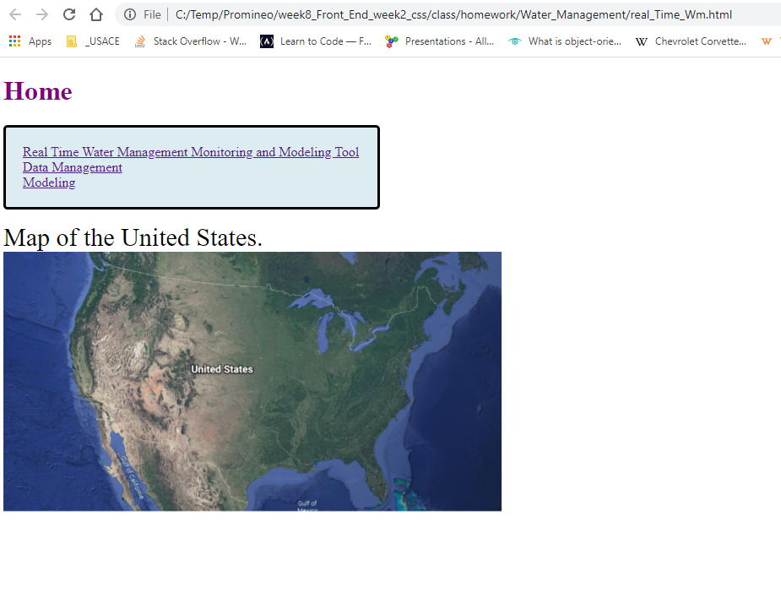

**modeling.html**

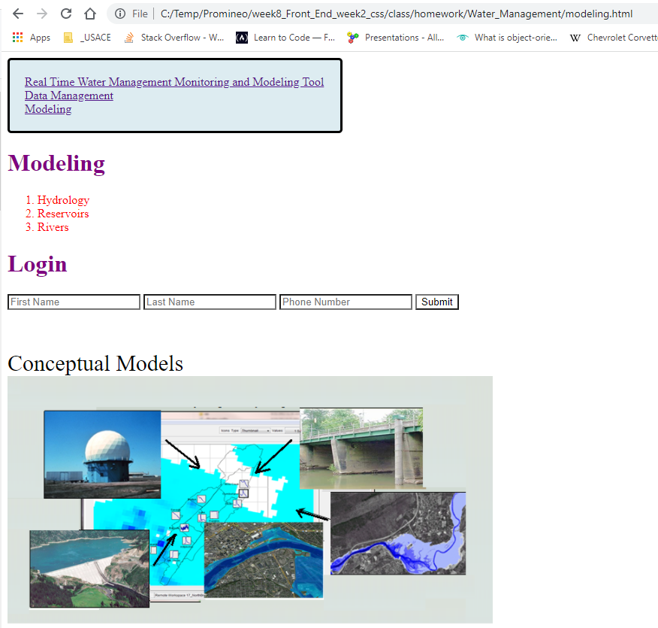

**data_management.html**

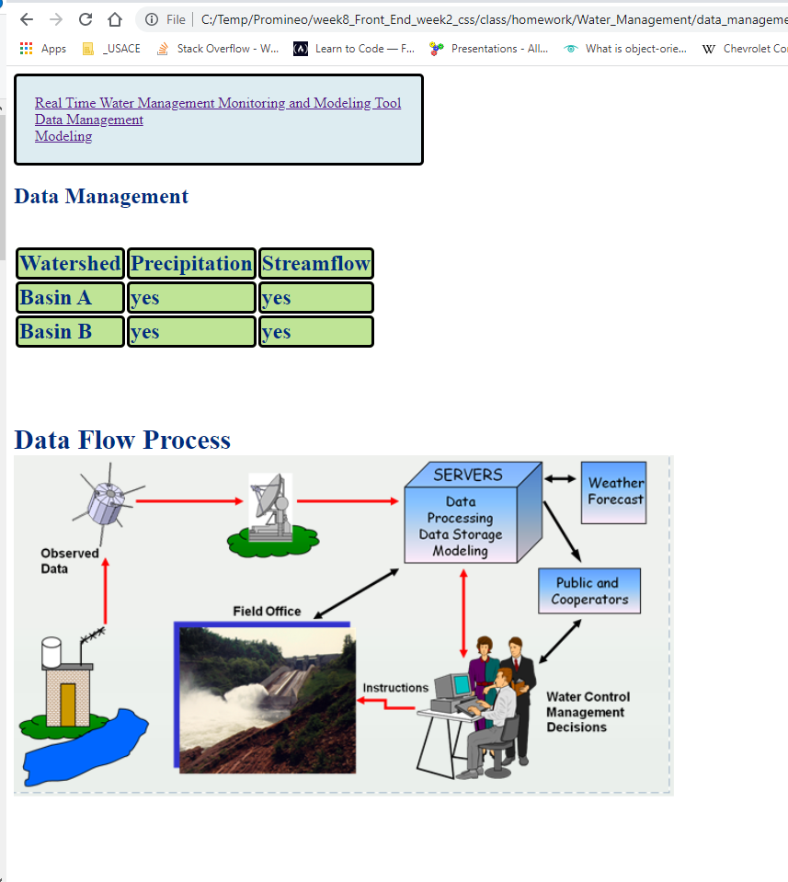

**URL to GitHub Repository:**

**https://github.com/emcis/week_8_repository.git**