# Front End Technologies Week 3 Coding Assignment

**Points possible:** 70

|  |  |  |
| --- | --- | --- |
| Category | Criteria | % of Grade |
| Functionality | Does the code work? | 25 |
| Organization | Is the code clean and organized? Proper use of white space, syntax, and consistency are utilized. Names and comments are concise and clear. | 25 |
| Creativity | Student solved the problems presented in the assignment using creativity and out of the box thinking. | 25 |
| Completeness | All requirements of the assignment are complete. | 25 |

**Instructions:** In VS Code, or an IDE of your choice, write the code that accomplishes the objectives listed below**. Ensure that the code compiles and runs as directed.** Take screenshots of the code and of the running program (make sure to get screenshots of all required functionality) and **paste them in this document where instructed below**. **Create a new repository on GitHub for this week’s assignments and push this document**, **with your JavaScript project code**, to the repository**. Add the URL for this week’s repository to this document where instructed and submit this document to your instructor when complete.**

**Coding Steps:**

1. Create a **new website using HTML and Bootstrap**. The website must include the following:
   1. A **Bootstrap navbar**
   2. A **Bootstrap styled table**
   3. **A Bootstrap styled form**
   4. **At least 2 pages**
   5. **Bootstrap grid used throughout to format elements**
      1. Elements should stack vertically when the window is small

**Screenshots of Code:**

**Index.html**

<!DOCTYPE html>

<html lang="en">

    <head>

        <meta charset="utf-8">

        <meta name="viewport" content="width=device-width, initial-scale=1.0">

        <title>Document</title>

        <link rel="stylesheet" href="node_modules/bootstrap/dist/css/bootstrap.css">

    </head>

    <div >

    <body class="container-fluid">

       <nav class="navbar navbar-expand-sm navbar-dark bg-dark">

        <a class="navbar-brand" href="#">Office Automation INC</a>

        <button class="navbar-toggler" type="button" data-toggle="collapse" data-target="#navbarNavDropdown" aria-controle="navbarNavDropdown" aria-expanded="false" aria-label="Toggle navigation">

            <span class="navbar-toggler-icon"></span>

        </button>

         <div class="col-sm" class="collapse navbar-collapse" id="navbarNavDropdown">

           <uL class="navbar-nav">

             <li class="nav-item active">

                 <a class="nav-link" href="Index.html">Home</a>

             </li>

            <li class="nav-item active">

                <a class="nav-link" href="Index_Navbar_Contact.html">Contact</a>

            </li>

           <li  class="nav-item active">

                    <a class="nav-link" href="Index_Navbar_Request.html">Request-Info</a>

           </li>

           <li class="nav-item dropdown">

            <a class="nav-link dropdown-toggle" href="#" id="navbarDropdownMenuLink" role="button" data-bs-toggle="dropdown"

             aria-expanded="false">

            Applications

            </a>

       <div  class="dropdown-menu" aria-labelledby="navbarDropdownMenuLink">

                <a class="dropdown-item"  href="#">Accounting</a>

                <a class="dropdown-item"  href="#">Human Resources</a>

                <a class="dropdown-item"  href="#">Database</a>

            </div>

        </li>

           </uL>

         </div>

     </nav>

        <script src="node_modules/jquery/dist/jquery.js"></script>

        <script src="node_modules/bootstrap/dist/js/bootstrap.bundle.js"></script>

    </body>

</html>

**Index_Navbar_Contact.html**

<!DOCTYPE html>

<html lang="en">

    <head>

        <meta charset="utf-8">

        <meta name="viewport" content="width=device-width, initial-scale=1.0">

        <title>Document</title>

        <link rel="stylesheet" href="node_modules/bootstrap/dist/css/bootstrap.css">

    </head>

<div >

    <body class="container-fluid">

        <nav class="navbar navbar-expand-sm navbar-dark bg-dark">

            <a class="navbar-brand" href="#">Office Automation INC</a>

            <button class="navbar-toggler" type="button" data-toggle="collapse" data-target="#navbarNavDropdown" aria-controle="navbarNavDropdown" aria-expanded="false" aria-label="Toggle navigation">

                <span class="navbar-toggler-icon"></span>

            </button>

             <div class="col-sm" class="collapse navbar-collapse" id="navbarNavDropdown">

               <uL class="navbar-nav">

                 <li class="nav-item active">

                     <a class="nav-link" href="Index.html">Home</a>

                 </li>

                <li class="nav-item active">

                    <a class="nav-link" href="Index_Navbar_Contact.html">Contact</a>

                </li>

               <li  class="nav-item active">

                        <a class="nav-link" href="Index_Navbar_Request.html">Request-Info</a>

               </li>

               <li class="nav-item dropdown">

                <a class="nav-link dropdown-toggle" href="#" id="navbarDropdownMenuLink" role="button" data-bs-toggle="dropdown"

                 aria-expanded="false">

                Applications

                </a>

           <div  class="dropdown-menu" aria-labelledby="navbarDropdownMenuLink">

                    <a class="dropdown-item"  href="#">Accounting</a>

                    <a class="dropdown-item"  href="#">Human Resources</a>

                    <a class="dropdown-item"  href="#">Database</a>

                </div>

            </li>

               </uL>

             </div>

         </nav>

         <br> <br>

     <h3>Contact <span class="badge badge-primary"></span></h3>

     <table class="table table-dark table-hover">

         <tr >

         <th>ID</th>

         <th>Name</th>

         <th>Email</th>

        </tr>

       <tr>

           <td>1</td>

           <td>Bruce Springsteen</td>

           <td>bruce@gmail.com</td>

           <tr>

             <td>2</td>

             <td>Tom Petty</td>

             <td>tom@gmail.com

       </tr>

     </table>

    </div>

        <script src="node_modules/jquery/dist/jquery.js"></script>

        <script src="node_modules/bootstrap/dist/js/bootstrap.bundle.js"></script>

    </body>

</html>

**Index_Navbar_Request.html**

<!DOCTYPE html>

<html lang="en">

    <head>

        <meta charset="utf-8">

        <meta name="viewport" content="width=device-width, initial-scale=1.0">

        <title>Document</title>

        <link rel="stylesheet" href="node_modules/bootstrap/dist/css/bootstrap.css">

    </head>

    <div >

    <body class="container-fluid">

       <nav class="navbar navbar-expand-sm navbar-dark bg-dark">

        <a class="navbar-brand" href="#">Office Automation INC</a>

        <button class="navbar-toggler" type="button" data-toggle="collapse" data-target="#navbarNavDropdown" aria-controle="navbarNavDropdown" aria-expanded="false" aria-label="Toggle navigation">

            <span class="navbar-toggler-icon"></span>

        </button>

         <div class="col-sm" class="collapse navbar-collapse" id="navbarNavDropdown">

           <uL class="navbar-nav">

             <li class="nav-item active">

                 <a class="nav-link" href="Index.html">Home</a>

             </li>

            <li class="nav-item active">

                <a class="nav-link" href="Index_Navbar_Contact.html">Contact</a>

            </li>

           <li  class="nav-item active">

                    <a class="nav-link" href="Index_Navbar_Request">Request-Info</a>

           </li>

           <li class="nav-item dropdown">

            <a class="nav-link dropdown-toggle" href="#" id="navbarDropdownMenuLink" role="button" data-bs-toggle="dropdown"

             aria-expanded="false">

            Applications

            </a>

       <div  class="dropdown-menu" aria-labelledby="navbarDropdownMenuLink">

                <a class="dropdown-item"  href="#">Accounting</a>

                <a class="dropdown-item"  href="#">Human Resources</a>

                <a class="dropdown-item"  href="#">Database</a>

            </div>

        </li>

           </uL>

         </div>

     </nav>

     <form>

         <div></div>

        <div class="form-group">

          <label for="exampleInputEmail1">Email address</label>

          <input type="email" class="form-control" id="exampleInputEmail1" aria-describedby="emailHelp" placeholder="Enter email">

          <small id="emailHelp" class="form-text text-muted">We'll never share your email with anyone else.</small>

        </div>

        <div  class="form-group">

          <label for="exampleInputPassword1">Password</label>

          <input type="password" class="form-control" id="exampleInputPassword1" placeholder="Password">

        </div>

        <div  class="form-check">

          <input type="checkbox" class="form-check-input" id="exampleCheck1">

          <label class="form-check-label" for="exampleCheck1">Check me out</label>

        </div>

        <button type="submit" class="btn btn-primary">Submit</button>

      </form>

    </div>

        <script src="node_modules/jquery/dist/jquery.js"></script>

        <script src="node_modules/bootstrap/dist/js/bootstrap.bundle.js"></script>

    </body>

</html>

**Screenshots of Running Application:**

**Index.html**

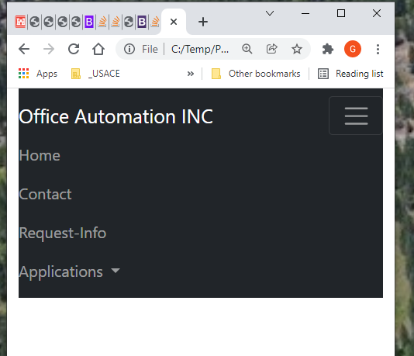

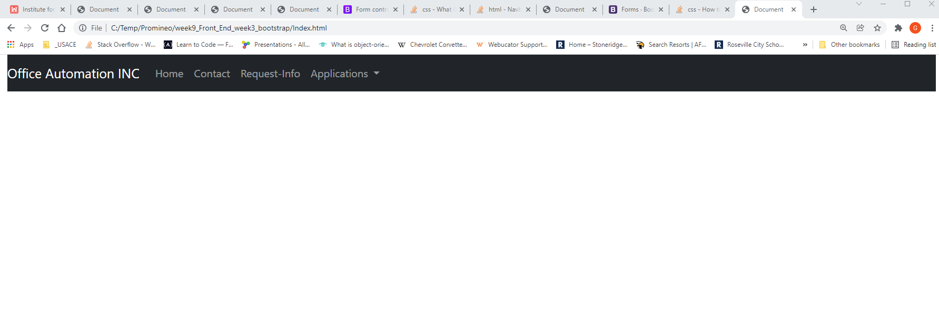

**Index_Navbar_Contact.html**

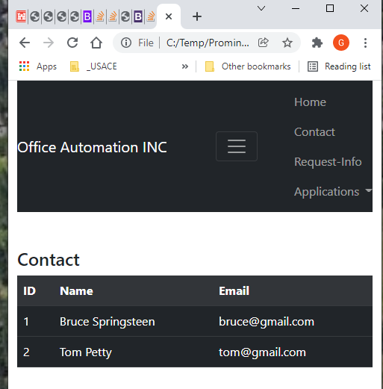

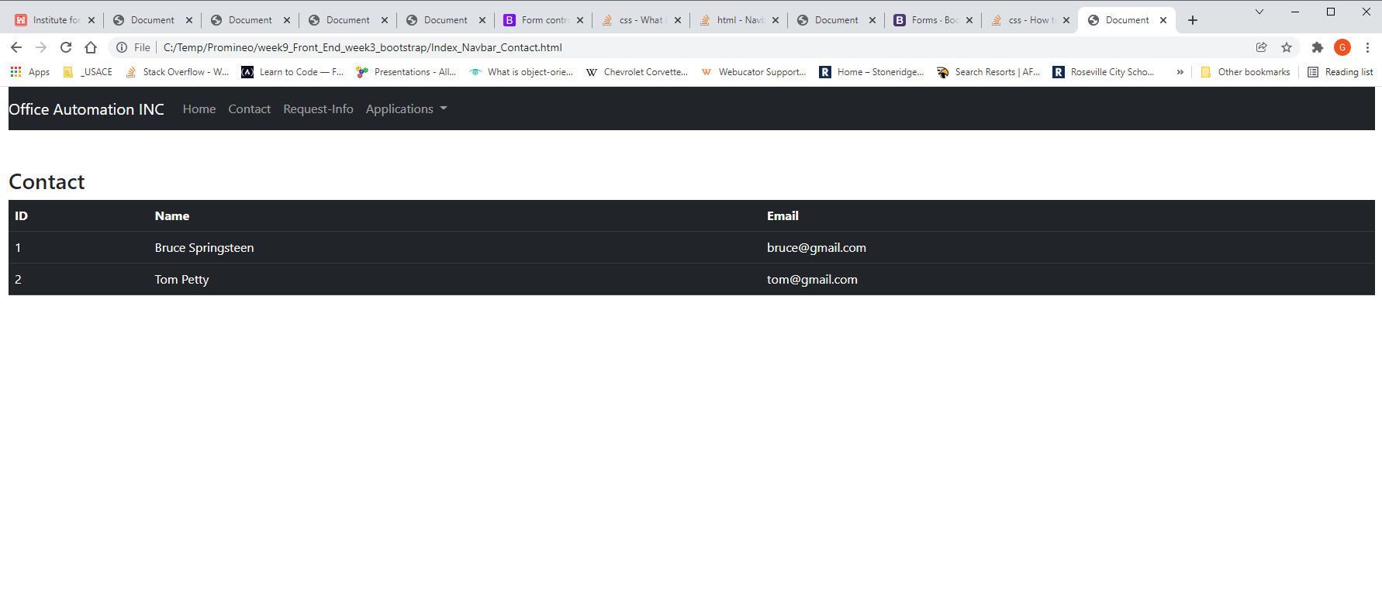

**Index_Navbar_Request.html**

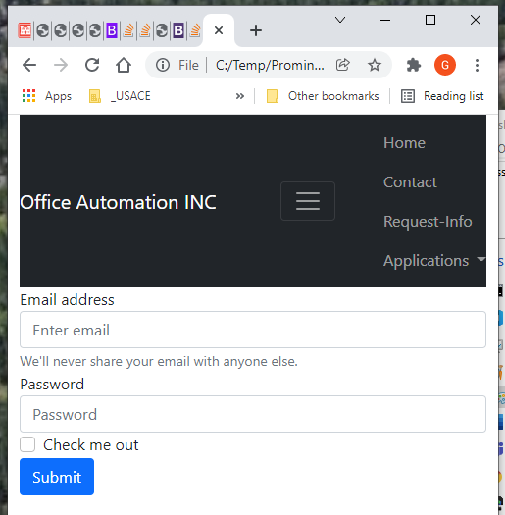

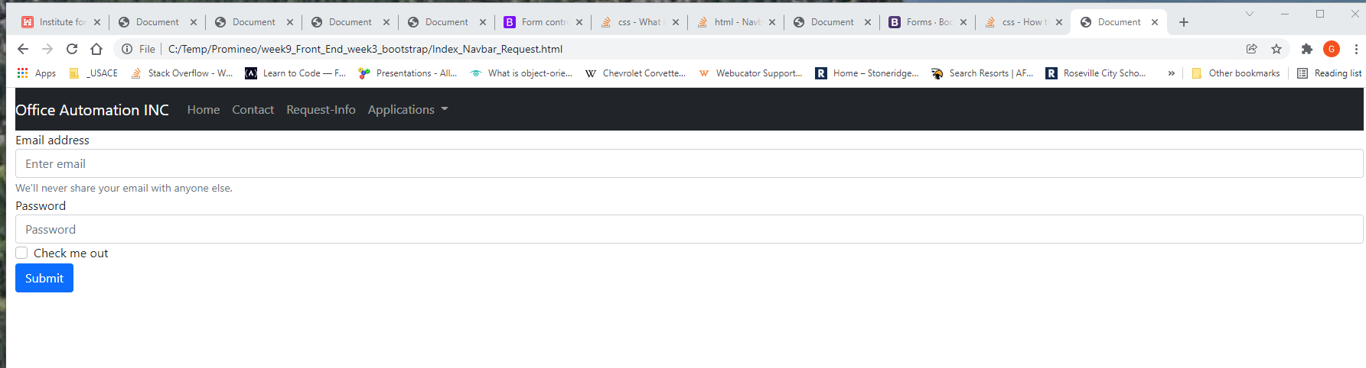

**URL to GitHub Repository:**

**https://github.com/emcis/week_9_repository.git**