Git is used to keep track of changes in the code and see who has uploaded what part and also go back to previous versions of the code 😊 very useful and it avoids messing up and problems such as losing code in your computer if it crashes because the code will be in the cloud! 😊

STEPS TO FOLLOW

**Go to a certain folder in your personal computer using: cd “folder_name” (in the terminal command line)**

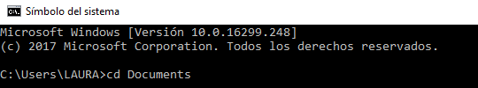

**git init***Initalize git repository in that folder*

**git clone** [**https://github.com/emclaughlin215/BMI.git**](https://github.com/emclaughlin215/BMI.gitD) *Download repository from GitHub and clone it to your personal computer*

**git add .***Add all files to git*

**git commit -m “explain_changes”***Do commit of the changes done (new file added, etc).*

**git status***See status git (changes to be committed, etc.)*

**git log***See last commits.*

**git pull***Take last version uploaded to Github (always do this before committing or doing a push)*

*.*

**git push origin master***Upload changes in the cloud from the “master” branch (we will only have this branch)*