Load Profiles: Discussing the current work.

Overview of Load Profiles and Results 1

Thoughts: 4

House 8 Discussion on Lack of Non-HVAC Data 6

Thoughts: 6

Energy Classification: Synthetic Approximations versus K-Means Clustering 7

Thoughts: 8

References 8

# Overview of Load Profiles and Results

I wanted to provide a detailed and hopefully fairly laid out explanation of my current load profile work. Currently I have been working on properly classifying load profiles to get averaged daily profiles. My current process for this is shown in Figure 1 below.

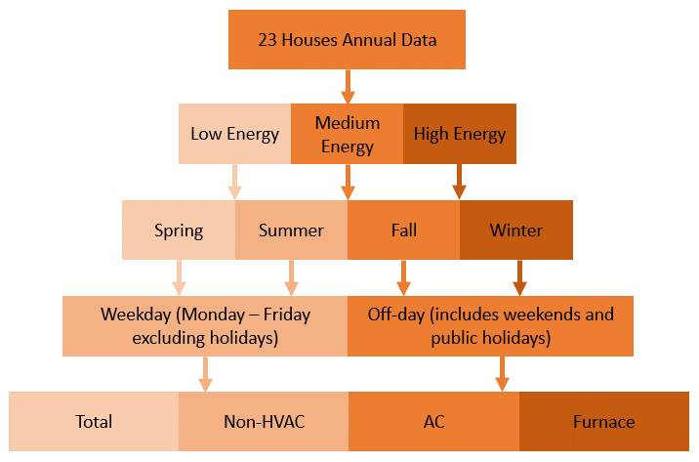

Figure : Description of how the datasets are being organized and broken down.

To go into descriptive detail of Figure 1, using the data from 23 houses in Ottawa the following process is followed [1, 2]. The energy classification is performed last, the selected house first needs to be processed using the following steps. The data is processed day-by-day, reading in one day at a time. The first step is to use the datetime of the day and determine which season that day falls under, using historical season dates [3], and the *chkseas* function designed by myself. Then the datetime is checked against the *isweekend* MATLAB function [4], which will determine if the provided datetime is a weekend. The results of the *isweekend* check are compared in an inclusive-or statement with a *chkholi* function, designed by myself, where the datetime is checked against a list of dates for public holidays [5]. This relational check will sift out all Off-days meaning that the remaining days are all Weekdays. Once the type of day is identified the data is averaged against the other data in that specific instance of the structure. This will provide the daily averages of the Total, Non-HVAC, AC, and Furnace data.

Once the house processing is complete the annual total consumption is analyzed, this value was calculated in tandem with the house processing. The Non-HVAC consumption is compared against the k-means results from a separate analysis, discussed in more detail later in this document. This then classes the house into an energy category and all the houses’ structure fields are averaged against those in that respective energy category creating a homogeneous set of seasonal load profiles for that energy class.

This provides us with the resulting daily averages that are seen in the following figures, where Low energy is seen in Figure 2, Medium Energy is seen in Figure 3, and High Energy is seen in Figure 4. The current detailed results are shown below in Table 1.

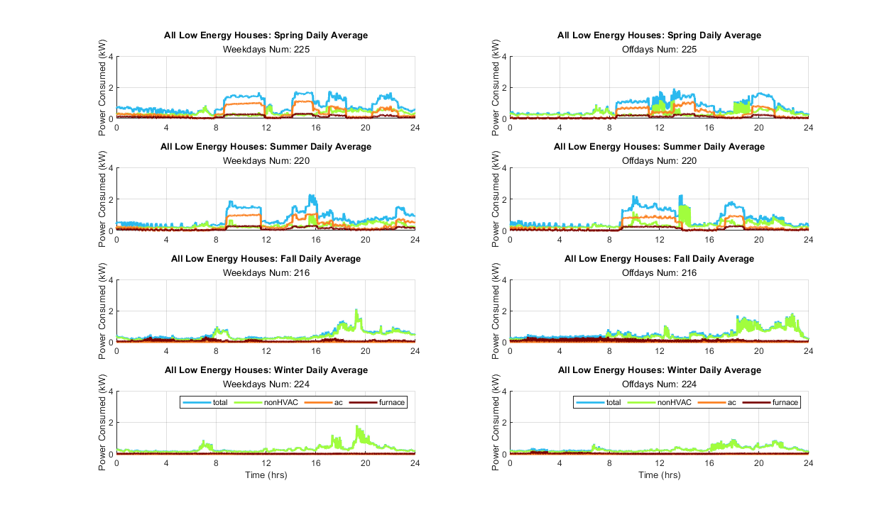

Figure : Low Energy houses outputs. The left column are the weekday data plots for the seasons, the right is the off-days, where each plot identifies the sample of days used to calculate the average.

Figure : High Energy houses outputs. The left column are the weekday data plots for the seasons, the right is the off-days, where each plot identifies the sample of days used to calculate the average.

Figure : Medium Energy houses outputs. The left column are the weekday data plots for the seasons, the right is the off-days, where each plot identifies the sample of days used to calculate the average.

### Thoughts:

The curiosity here is that while the results appear more streamlined, i.e. for a higher energy household the baseline non-HVAC power level is higher. There is a strange amount of HVAC consumption seen in the low and medium energy houses, shown by the large jump between the total and non-HVAC profiles, and the AC-furnace values rising. I am still trying to understand the reason behind why this may be occurring.

It is also important to note however that the reason behind the furnace showing power draw during spring/summer months is because the fan used to circulate the AC air throughout the house is only measurable through the furnace.

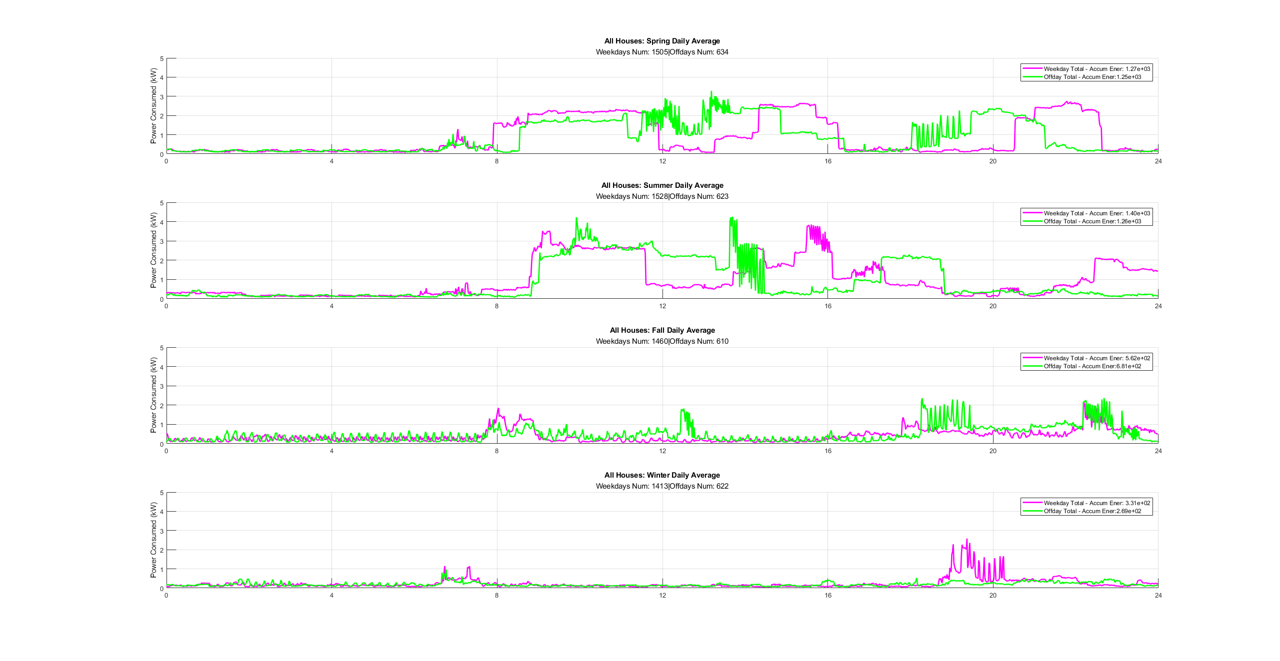My own personal note, the reason I am splitting the profiles based on energy is to try and provide more varied datasets while also making the respective data average more reasonable. When averaged together all 23 houses the resulting profile had large jumps in consumption in spring and summer, whereas the fall and winter months showed strangely minimal power consumption, Figure 5.

Figure : All houses averaged together. Plots show the total consumption for weekday and off-days for each season. X-axis is time (hours).

It is also important to note that in Table 1 there are 5 houses with over 5% of their data records that had to be filled [1, 2]. These missing data records occurred due to the inability to access the data module, due to scheduling conflicts, and manually remove the logged data, if this wasn’t achieved before the memory was filled the data would stop being recorded. There are more details on how the missing data was replaced in Saldanha and Beausoliel-Morrison, 2012.

|  |  |  |  |  |  |  |  |  |
| --- | --- | --- | --- | --- | --- | --- | --- | --- |
| TABLE 1 | | | | | | | | |
| Building Properties | | | | | | | | |
| House | Occupants | Age | Size (m2) | Building Type | Total (GJ) | Non-HVAC (GJ) | NonHVAC Energy Classification | Missing Records (%/year) |
| H1 | 3 | 1980 | 205 | Full-Detached | 18.0514 | 16.2898 | Medium | 14 |
| H2 | 1 | 1950 | 140 | Full-Detached | 11.1513 | 9.5091 | Low | 2.7 |
| H3 | 2 | 1980 | 205 | Full-Detached | 22.3728 | 16.6999 | Medium | 0.2 |
| H4 | 4 | 1950 | 170 | Full-Detached | 21.8767 | 18.2220 | Medium | 3.9 |
| H5 | 2 | 1970 | 120 | Semi-Detached Townhouse | 23.4011 | 19.5539 | Medium | 0.1 |
| H6 | 3 | 1980 | 130 | Semi-Detached | 25.3474 | 23.4340 | Medium | 0.2 |
| H7 | 2 | 1980 | 165 | Full-Detached | 32.0362 | 18.2851 | High | 2.7 |
| H8* | 3 | 1930 | 110 | Semi-Detached | 36.4372 | 33.6910 | High | 0.1 |
| H9 | 2 | 1960 | 360 | Full-Detached | 45.9344 | 35.6853 | High | 7 |
| H10** | 2 | 2000 | 195 | Full-Detached | 58.6848 | 35.1657 | High | 2.3 |
| H11 | 3 | 1960 | 100 | Semi-Detached Townhouse | 33.5085 | 30.0777 | High | 11 |
| H12 | 3 | 1950 | 140 | Full-Detached | 42.5666 | 39.4940 | High | 2.8 |
| H13 | 2 | 2010 | 180 | Row-Mid | 25.4660 | 14.9576 | Medium | 1.4 |
| H14 | 2 | 2010 | 150 | Row-Mid | 21.3151 | 15.4568 | Medium | 6.9 |
| H15 | 1 | 2000 | 185 | Row-Mid | 15.1224 | 11.3078 | Low | <0.1 |
| H16 | 2 | 2000 | 155 | Row-Mid | 27.6074 | 18.7205 | Medium | 3.6 |
| H17 | 2 | 2010 | 180 | Row-Mid | 15.3039 | 11.7459 | Low | <0.1 |
| H18 | 2 | 1990 | 130 | Row-Mid | 15.1828 | 9.5052 | Low | 1.7 |
| H19 | 1 | 1970 | 125 | Row-Mid | 12.4165 | 7.6968 | Low | 1.4 |
| H20 | 2 | 1970 | 125 | Row-End | 17.3100 | 13.6094 | Low | 5.6 |
| H21 | 3 | 1950 | 150 | Row-End | 28.2275 | 26.5263 | High | <0.1 |
| H22 | 2 | 2000 | 150 | Row-Mid | 14.1223 | 12.8103 | Low | 4.9 |
| H23 | 2 | 1990 | 180 | Row-Mid | 12.1848 | 8.5647 | Low | 0.3 |

* H8 was missing Non-HVAC data, however the Total, AC, and Furnace data was recorded so an approximation was made by subtracting the AC and Furnace data from the Total.

** H8 and H10 had a Domestic Hot Water Heater which should be noted for the analysis. Though only H10’s was monitored.

## House 8 Discussion on Lack of Non-HVAC Data

The 8th house (H8) has the shortcoming of not having non-HVAC data, while there is AC and Furnace data, there is also a domestic hot water (DHW). The fact that they were unable to measure the DHW directly means they were unable to provide exact non-HVAC data. I looked at how to overcome this and decided to subtract the AC and Furnace data from the total to infer a pseudo non-HVAC dataset.

However, I did look at other alternatives such as using data from the 10th house (H10) which does have DHW data, however the nature of the DHW is that it has short spikes of power consumption, meaning unless the total power is greater than the DHW consumption the resulting non-HVAC dataset would be negative. To illustrate this, I took a 60 second sample from H10 showing the total, non-HVAC, and DHW power draw, shown in Figure 6 below. So, to properly account for the DHW in H8, I would have to perform some sort of peak matching, or load pattern analysis.

Figure : Comparing the effect of the DHW draw from H10, in a 60 second sample. Specific time was 01-Aug-2009, 6min 0sec – 6min 59sec.

### Thoughts:

While work could be done to infer the power consumption of the DHW in the H8 profile it would require studies on the energy usage patterns of the individual house and may not be inherently useful to my work at this time, however, I believe it could be a good topic for future work.

## Energy Classification: Synthetic Approximations versus K-Means Clustering

To get distinct load profiles that would differentiate between low, medium, and high energy usage the current houses non-HVAC values are profiled. The IEA/ECBCS Annex 42 (Annex 42), profiles their synthetic loads based on detailed data on household appliances, and approximations as to floor space, and appliance cycles [6]. The Sustainable Building Energy Systems (SBES) Laboratory at Carleton University used k-means clustering to determine the centroids and which points are in proximity [2]. After performing k-means clustering on the dataset I compared the centroids to those given by the SBES and those calculated by Annex 42. It should be noted that the difference between my k-means analysis and the SBES group is my inclusion of H8, shown in Figure 7. The resulting comparison is seen in Table2.

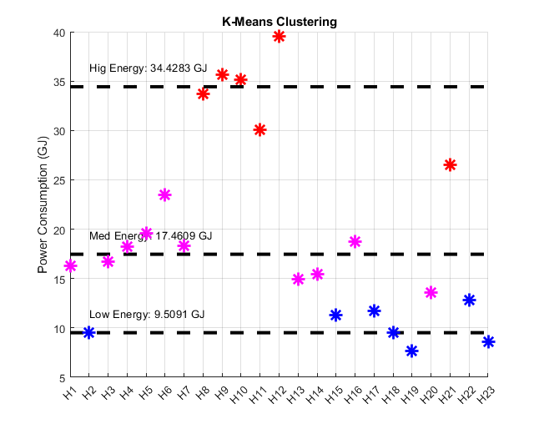

Figure : K-Means clustering of the annual consumption values for each house.

|  |  |  |  |  |  |  |  |
| --- | --- | --- | --- | --- | --- | --- | --- |
| TABLE 2 | | | | | | | |
| Power Targets and Cluster Centroid Comparison | | | | | | | |
|  |  | Low | | Med | | High | |
|  |  | GJ/year | Floor Space (m2) | GJ/year | Floor Space (m2) | GJ/year | Floor Space (m2) |
| IEA/ECBCS Annex 42 |  | 17.33 | 141.00 | 29.36 | 141.00 | 46.84 | 282.00 |
| SBES | Min | 7.6968 | 125.00 | 14.9576 | 120.00 | 26.5263 | 100.00 |
| Cluster/Ave | 10.60 | 151.88 | 18.00 | 164.44 | 33.40 | 189.00 |
| Max | 13.6094 | 185.00 | 23.434 | 205.00 | 39.494 | 360.00 |
| K-Means inc. H8 | Min | 7.69 | 125.00 | 14.95 | 120.00 | 26.52 | 100.00 |
| Cluster/Ave | 9.5091 | 155.71 | 17.4609 | 160.50 | 34.4283 | 175.83 |
| Max | 12.8103 | 185.00 | 23.434 | 205.00 | 39.494 | 360.00 |

As seen in Table 2, the Annex 42’s approximations for target annual consumption are larger than any of the reported values seen in the SBES data sets [1, 2, 6]. The floor space targets roughly in line with the averaged values seen in the SBES dataset, however the averages for both Low and Med categories are both larger than the Annex 42’s targets. Meanwhile the average floor space for the High energy households has a difference from the Annex 42 target of ~100m2. My conclusion from this is that it would be difficult to modify the Annex 42 methodology into these datasets, as not only are the target energy values ~10GJ different from the k-means cluster values, but the approximated floor space does not seem to reflect the houses that the data is extracted from.

### Thoughts:

My only main concern with this is whether to include H8, for the previously discussed issue in the k-means clustering. Regardless I could use the resulting values to determine the appropriate category for H8 in the overall energy classification section to sort the data.

# References

[1] N. Saldanha and I. Beausoleil-Morrison, "Measured end-use electric load profiles for 12 Canadian houses at high temporal resolution," *Energy and Buildings,* vol. 49, pp. 519-530, 2012/06/01/ 2012, doi: <https://doi.org/10.1016/j.enbuild.2012.02.050>.

[2] G. Johnson and I. Beausoleil-Morrison, "Electrical-end-use data from 23 houses sampled each minute for simulating micro-generation systems," *Applied Thermal Engineering,* vol. 114, pp. 1449-1456, 2017, doi: 10.1016/j.applthermaleng.2016.07.133.

[3] G. o. B. Canada, David. "When do the seasons start?" <https://nrc.canada.ca/en/certifications-evaluations-standards/canadas-official-time/3-when-do-seasons-start> (accessed 2023).

[4] MathWorks. "isweekend Documentation." <https://www.mathworks.com/help/matlab/ref/datetime.isweekend.html> (accessed 2023).

[5] W. Days. "Public Holidays for Ontario 2009-2012." <https://www.public-holidays.us/CA_EN_2009_Ontario> (accessed 2023).

[6] M. M. Armstrong, M. C. Swinton, H. Ribberink, I. Beausoleil-Morrison, and J. Millette, "Synthetically derived profiles for representing occupant-driven electric loads in Canadian housing," *Journal of Building Performance Simulation,* vol. 2, no. 1, pp. 15-30, 2009, doi: 10.1080/19401490802706653.