**Title Page**

****1.1. GLOO

FIG 1: “GLOO” GAME ICON

**Game Overview**

2.1 Game Concept

This is an Arcade Game / Platformer game open for everyone. Beware of the obstacles. The user needs to jump over obstacles and collect points to get higher score.

2.2 Genre

Arcade / Platformer game

2.3 Target Audience

Everyone

2.4 Game Flow Summary

THIS DIAGRAM SHOWS THE PLAYER MOVE THROUGH THE GAME

2.5 Look and Feel

In this game “GLOO”, it is set in a fantasy theme since our main character is a slime (Gloo). For better gaming experience, the developer used a 2d and 2.5d graphics/assets, in developing the game.

**Gameplay and Mechanics**

3.1 Gameplay

3.1.1 Game Progression

For Arcade mode, the score is calculated through distance progress, while in story mode is in level progression.

3.1.2 Mission/challenge Structure

Collect points while avoiding obstacles, game difficulty increases as you gain higher points

3.1.3 Game Structure

Have 2 different game modes, arcade mode, and story mode.

3.1.4 Objectives – What are the objectives of the game?

Get a high score, collect coins, and crystals to unlock the next level in story mode.

3.1.5 Play Flow

3.2. Mechanics

The player needs to collect points while avoiding the obstacles in the path.

3.2.1 Movement in the game

For arcade mode, the player just needs to tap the screen, to avoid being hit by obstacles.

For story mode (platformer), there’s a UI for movement wherein the player can freely move left, right, and jump to avoid obstacles or reach the next platform.

3.2.2 Objects

For objects, some objects where set to kinematic which requires the player to push the object to move it.

3.2.4 Economy

Coins, you can earn coins by playing arcade mode, it gives additional points in the game.

3.3 Game Options

Player can turn on/off the music and audio. Also, the player can freely choose what mode he/she wants to play.

**4.2 Game World**

4.2.1 General look and feel of world

* 2d game
* Fantasy-like theme

4.2.2 Characters.

Gloo, a mysterious mixture of creatures who gained sentience, which transforms him into a slime. He wants to get the legendary item “fruit of evolution” in order to gain a human form. To do that he has to face different challenges.

**5. Levels**

5.1 Levels.

ARCADE MODE, in this game levels are determined through distance travel, the longer you play, the faster it moves.

STORY MODE consists of several levels, level 1 includes the tutorial part of the game, wherein it shows the basics on how to play the game. The player needs to reach the requirements to unlock the next level.

**6.Interface**

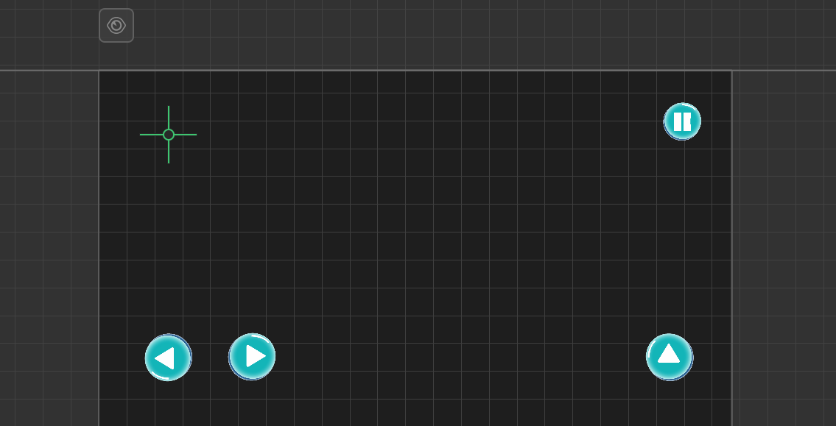6.1 Visual System.

Here are the buttons/controllers available for the user to use, a move button left, right, and jump, a pause button, and a display button for the player score.

6.2 Control System.

For Story mode, there are specific buttons for player movement, right, left or jump. While in arcade mode, the player just needs to tap the screen to control the character.

6.3 Audio, music, sound effects

Game music & sounds effects were downloaded from opengameart.org, zapsplat.com, and freesounds.org. This includes the main menu, the in-game sounds, movement sound effects and etc.

6.4 Help System

In game help system, which display an information when player pass through the object.

**7. Artificial Intelligence**

7.1 Opponent and Enemy AI

The enemies in this game are the traps and obstacles, below is the sample image.

**8. Technical**

8.1 Target Hardware

Minimum device requirement for android is Android version Jelly Bean 4.3

8.2 Development hardware and software, including Game Engine

This game is made with Buildbox, a no-code development platform focused on game creation without programming, coding, or scripting.

8.3 Network requirements

The game can be played offline, without using an internet connection.

9. Game Art

The game “Gloo” is developed using 2d assets , downloaded from sites like opengameart, and gameart2d.com, free assets in buildbox and some are custom-made.