Logan Behnke

2/6/17

CS 136L

Lab 2: Drawing Blocks

**Problem Statement:**

We needed to create classes that would draw the different types of Tetris blocks.

**Planning:**

First, we started by looking at how to draw every block. Then we created a class for draw one of the blocks. Then we looked at how to move the blocks around the screen. Finally, we worked on what layout we wanted the blocks to be in.

**Implementation and Testing:**

During the testing of this program we found out that the rotate method turns about the origin and that was an unexpected outcome.

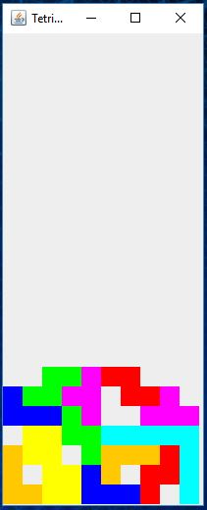

**Reflection:**

In this lab, we learned how to use java.Swing to draw Tetris blocks. We found out that that the rotate method rotates around the origin in a clockwise fashion which was unexpected. I think we could clear up some of the more redundant code by making them into methods that get called.