Logan Behnke, Eddie Dailey

2/6/17

CS 136L

Section 2

Lab 2: Drawing Blocks

**Problem Statement:**

The object of this lab was to create a window which displays an image of a “falling block” game. This was to be displayed by placing rectangle objects upon a JFrame. Our drawing was to contain seven separate and specifically shaped blocks, each type of block with its own unique and consistent color. One specification for our drawing was that it had to contain rotated versions of our blocks in a “legal” fashion.

**Planning:**

First, we started by planning how every block would be drawn with rectangle objects. We then would create separate components for each individual block which would both draw the blocks and provide the means of rotating the blocks. From there, we planned on creating the “BlocksViewer “ class which was used to place blocks in the JFrame . Once our BlocksViewer class was set up, we would work on arranging our blocks in a “legal” order.

**Implementation and Testing:**

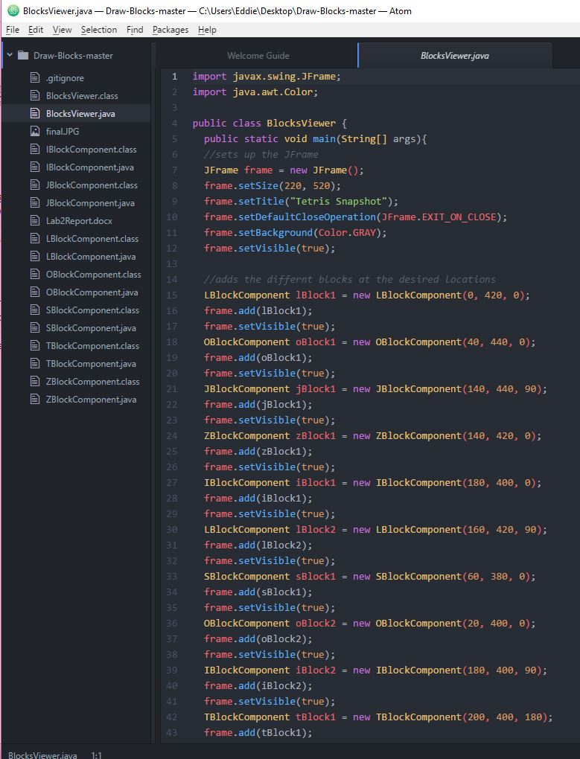 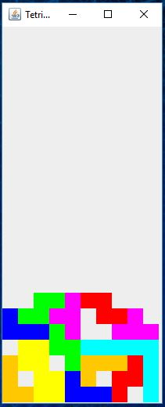

**Reflection:**

In this lab, we learned how to use java.Swing to draw Tetris blocks. We were able to successfully draw an image of the “falling block” game on our JFrame. One unexpected result we had from our code was the fact that the blocks would rotate around the origin. This made rotating them a matter of trial and error for a short while. Overall, our lab was quite successful , yet could be reworked a little by removing redundancies in placing blocks with the Viewer class.