Key outcome name: Environmental flows

Authors: Sooyeon Yi^{1*}, Lindsay Murdoch², Sarah Yarnell³, Bronwen Stanford⁴, Theodore Grantham⁵

*Corresponding author: Sooyeon Yi, syi4@csuchico.edu

¹ Department of Earth and Environmental Sciences, California State University, Chico, Chico, CA 95929, U.S.A.
² Department of Civil and Environmental Engineering, University of California, Davis, Davis, CA 95616, U.S.A.
³ Center for Watershed Sciences, University of California, Davis, Davis, CA 95616, U.S.A.
⁴ The Nature Conservancy, 830 S St, Sacramento, California 95811, U.S.A.
⁵ Department of Environmental Science, Policy, and Management, University of California, Berkeley, 130 Mulford Hall #3114, Berkeley, CA 94720, U.S.A.

Background
Flow is considered a “master variable” regulating the condition of riverine ecosystems (Poff et al. 1997). River flow is a primary driver of physical, chemical, and ecological processes, as moving water interacts with landscape features along its path from source waters to its terminus in lakes, wetlands, or the ocean. The functional flows approach (Yarnell et al., 2015), adopted by the California Environmental Flows Framework (CEWG 2021), identifies five seasonal flow components that are essential to sustaining these flow-mediated processes for rivers in California. These include the fall pulse flow, wet season peak and baseflow, spring recession flow, and dry season baseflow (Figure 1).

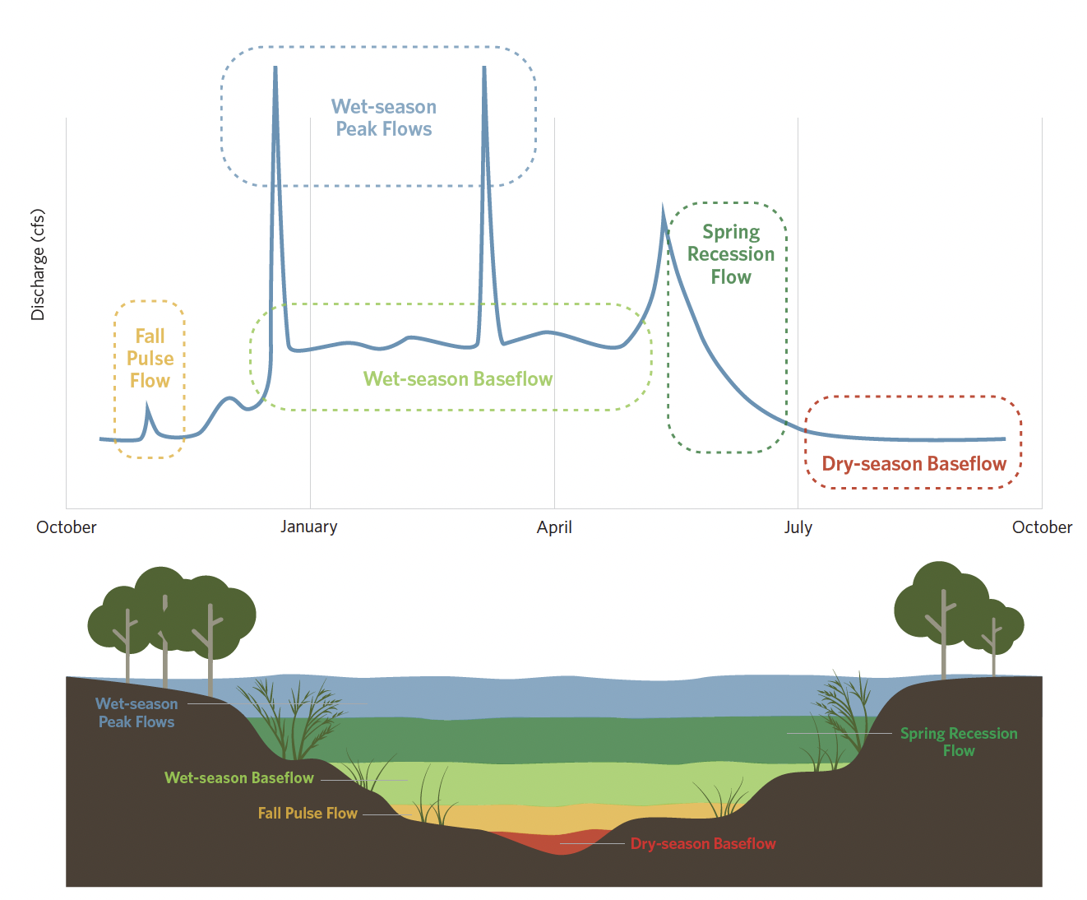
Figure 1. Functional flow components represent key aspects of seasonal flow variability (top), that create different habitat conditions within river channels for aquatic and riparian species (bottom).

Each of these components can be described by a suite of Functional Flow Metrics (FFMs) that characterize their magnitude, timing, frequency, duration, and rate of change (Yarnell et al. 2020). The specific values of these metrics vary among rivers, depending on their watershed area, annual precipitation, ratio of rainfall to snowmelt, groundwater influence, and other factors. Thus, every river has a unique signature of functional flow components across the year. In addition, seasonal flow patterns vary year-to-year. Preserving functional flow components within specific ranges, while also maintaining natural interannual variability, is critical to supporting the ecological functions that healthy rivers require.

To understand how alternative scenarios could affect the condition of river ecosystems in the Central Valley, we evaluated flows modeled in CalSim3 against functional flow needs. In brief, we first used estimates of unimpaired flows for Central Valley rivers to predict the natural range of functional flow metrics at 17 locations of interest (Table 1, Figure 2). We next used the functional flow metric values to design hydrographs representing daily flow requirements for all seasons and years within the 100-year simulation period. The timing, duration, and magnitude associated with the functional flow metrics were used to define the onset and extent of each seasonal flow component, and the individual flow components were combined sequentially to generate continuous daily hydrographs. We then aggregated the daily flows to monthly and seasonal timesteps and evaluated river flows predicted by CalSim3 scenarios against these targets. Finally, we created a ruleset to classify the degree of deviation of modeled scenario flows from the functional flow targets into four levels, corresponding to different levels of river ecosystem stress.

Locations of Interest: The analysis focuses on 17 locations of interest, distributed across major Central Valley river basins represented within the CalSim3 modeling framework (Table 1, Figure 2). Eight locations are on the Sacramento or San Joaquin river, and the remaining locations are on major tributaries. Each location corresponds to a CalSim3 model node where monthly river flows are estimated. These locations were selected to evaluate variability in environmental flow performance across hydrologically distinct regions.

Table 1. CalSim3 evaluation locations used in this study, including the corresponding CalSim3 nodes and their locations within the major Central Valley river systems. Locations are ordered approximately north to south.
River System | CalSim3 Node | Location Description
Trinity River | TRN111 | Downstream of Lewiston Dam in the upper Trinity River
Sacramento River | SAC289 | Downstream of Keswick Dam and upstream of Clear Creek
 | SAC257 | Upstream of Bend Bridge near Red Bluff
 | SAC148 | Near Colusa
 | SAC122 | At Tisdale Weir
 | SAC049 | At Freeport
 | SAC000 | At the Sacramento–San Joaquin River confluence
Feather River | FTR029 | Upstream of Yuba City
 | FTR003 | Slightly upstream of the Sacramento River confluence
Yuba River | YUB002 | Slightly upstream of the Feather River confluence
American River | AMR004 | Slightly upstream of the Sacramento River confluence
Mokelumne River | MOK028 | Slightly upstream of the Consumnes River confluence
Stanislaus River | STS011 | Slightly upstream of the San Joaquin River confluence
Tuolumne River | TUO003 | Slightly upstream of the San Joaquin River confluence
Merced River | MCD005 | Slightly upstream of the San Joaquin River confluence
San Joaquin River | SJR127 | Slightly upstream of the Merced River confluence
 | SJR070 | At the Stanislaus–San Joaquin confluence, near the southern border of the Delta

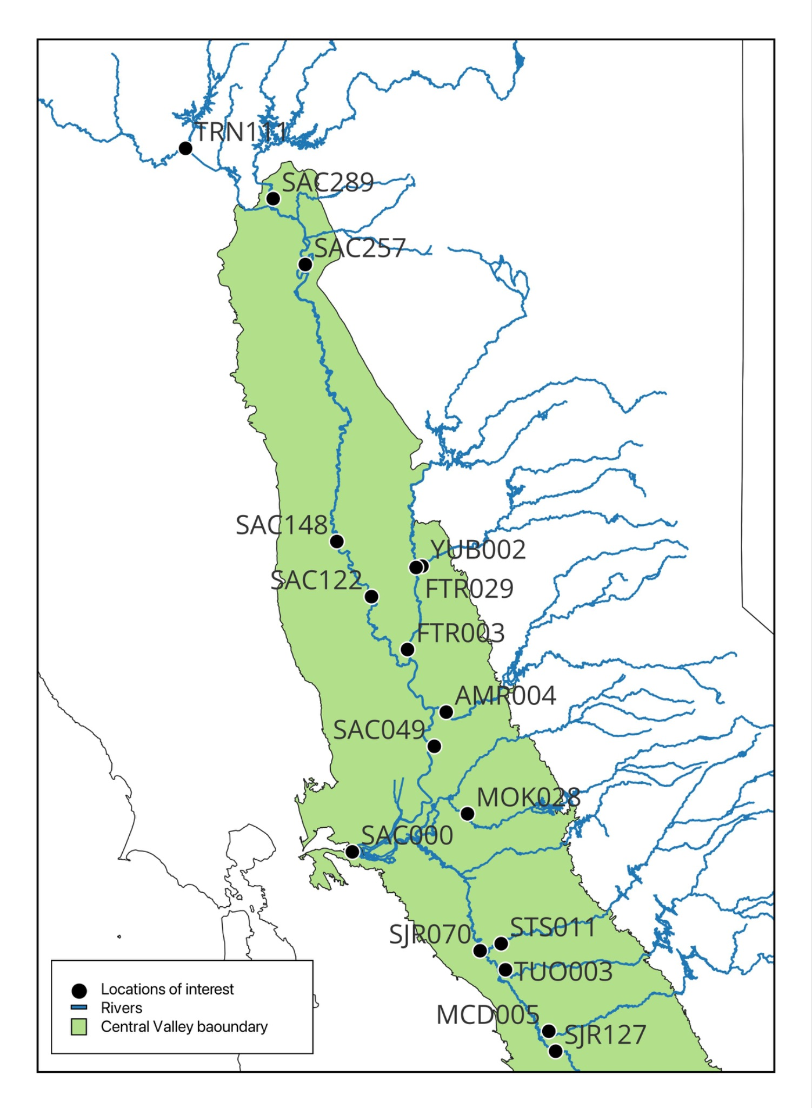
Figure 2. Locations of interest on Central Valley Rivers where modeled flows from CalSim3 scenarios were evaluated relative to functional flow requirements.

Methodology
The assessment framework evaluates river flows across multiple CalSim3 scenarios and locations by comparing simulated flow conditions against predefined, year-specific flow targets assigned using a functional flow approach. The workflow integrates CalSim3 outputs, functional flow magnitude targets, and seasonal performance criteria to generate both discrete and continuous outcome levels, corresponding to different levels of river ecosystem stress.

Functional flow targets were initially developed from daily streamflow records obtained from the California Data Exchange Center (CDEC). We specifically used the functional flows calculator with reconstructed “full natural flow” streamflow records to calculate annual functional flow metrics (e.g., the timing, duration, frequency, magnitude) of all flow components at multiple locations. Next, annual flow volumes for both the reconstructed daily streamflow data and the CalSim3 unimpaired flow data were classified into water year percentiles (WYPs) using a log normal distribution fitted to the historical hydrologic record. We then determined empirical relationships between WYP and values of each functional flow metric, calculated from the CDEC data, using simple linear regression. This made it possible to predict how functional flow metrics vary across the range of hydrologic conditions observed over the 100 years of the CalSim3 simulation period and assign a set of functional flow metric values to each year. For metrics where the linear regression was not a good fit, we developed alternate methods for assigning functional flow metric values to each year (Table 2). Peak flows were adjusted to ensure that flow targets did not exceed the maximum channel capacity reported for each river. Finally, for each of the 100 years, we aggregated annual functional flow metrics into continuous daily functional flow targets. See Murdoch 2024 for additional details.

Table 2. Summary of ruleset for translating flow metrics into daily functional flow targets for CalSim3 simulation period
Flow Component | Flow Metric | Rule type | Rule Implementation
Fall pulse | Magnitude | Constant (location-specific) | Median value for each location of interest
 | Timing | Scenario-based | 15th of October or November, in whichever month had the greater flow. If October and November have the same monthly flow, choose October.
 | Duration | Constant (all locations) | 2 days
 | Frequency | Constant (all locations) | 1 occurence
Wet season base flow | Magnitude | Scaled with WYP | Scale with water year percentile (linear regression)
 | Timing | Scenario-based | First month in water year with >3x the average of the preceding Aug-Sept flow (if none, lower the threshold until a wet timing is identified)
Spring Recession | Magnitude | Scaled with WYP | Scale with water year percentile, limiting maximum value to channel capacity
 | Timing | Scaled with WYP | Scale with water year percentile - linear relationship between the 10th percentile Sp-Tim value) and the 90th percentile Sp-Tim value. Values were rounded to the nearest integer day of the water year.
 | Rate of change | Constant (all locations) | 13% per day ramp up to peak; 7% per day ramp down
Dry Season Base Flow | Magnitude | Scaled with WYP | Scale with water year percentile (linear regression)
 | Timing | Computed | First day when spring ramp down flows reaches dry season magnitude
Peak flow (wet season) | Magnitude | Manually set | Channel capacity or 2 year peak magnitude from unimpaired dataset, whichever is lower
 | Timing | Scenario-based | Wettest month between start of the wet season and March 1 (no peak flows in March, April)
 | Duration | Scaled with WYP | Scale with WYP (greater than 10th WYP); if a peak duration is identified as zero days or less, specify a 1-day peak duration.
 | Frequency | Constant (all locations) | Once per year for WYP > 10th

Functional flow requirements included timing metrics at a daily scale (e.g., season start and event peak timings in Table 2) that define wet, spring, and dry seasons, whereas CalSim3 scenarios were available at a monthly resolution. To convert timing metrics to a monthly scale, the wet season initiation was defined as the month containing the wet season initiation date and ended in the month preceding the spring peak flow timing. The spring season extended from the month containing the spring peak flow through the month preceding the dry season start date. The dry season extended from the month in which the dry season start date occurred to the month preceding the start of the next water year’s wet season start date. Once all months were assigned to seasons, the daily functional flow targets were aggregated into monthly and total seasonal flow volumes for each year. To account for annual variation in season lengths, seasonal flow volumes were normalized by the number of months in each season to calculate the mean monthly seasonal flow required to achieve the functional flow targets in each year.

Finally, seasonal flow volumes were calculated from CalSim3 scenario modeled monthly flows (using the season timings described above) and compared against the seasonal functional flow targets in each of the 100 years for each CalSim3 scenario. For each year, we also assessed if a natural seasonal flow pattern occurred, in which the mean monthly wet season flow (including wet season and spring season flows) exceeded the mean monthly dry season flow volume.

Discrete Key Outcome Levels

Outcome levels were assigned according to the deviation in scenario (CalSim3 modeled) flows from functional flow targets, as well as the seasonality pattern of each river in each year. We specifically assessed the:
- Proportion of years in which scenario flows met or exceeded all seasonal functional flow requirements
- Proportion of years in which natural flow seasonality was preserved

To account for uncertainty in CalSim3 modeled flows, we applied a 5% buffer to our assessment of functional flow magnitudes (i.e., flow magnitude criteria were satisfied if the seasonal volume of CalSim3 modeled flows were at least 95% of the corresponding seasonal volume of functional flow targets). Outcome levels were defined as follows:
- Level 1 (Optimal): Flows meet or exceed all seasonal functional flow targets and flows are higher in the wet season than dry season in at least 95% of years.
- Level 2 (Acceptable): Flows meet or exceed all seasonal functional flow targets set for dry years in at least 90% of years and flows are higher in the wet season than dry season in at least 95% of years
- Level 3 (At-risk): Flows meet or exceed functional flow targets only for wet and dry season baseflows in at least 90% of years and flows are higher in the wet season than dry season in at least 95% of years
- Level 4 (Critical): None of the above criteria are satisfied
The specific ruleset to assign different rivers (locations of interest) to distinct outcomes levels is provided in Table 3.
Table 3. Environmental flow outcome classification ruleset
Outcome level | Criteria | Condition | Yrs Req | Description
Level 1 (Optimal) | Flow magnitude | Seasonal flows (Dry, Spring, Wet) exceed all functional flow targets (peak flow and baseflow) in all seasons in at least 95 years* | 95 | Full range of functional flows and preserved seasonality
 | Seasonal inversion check | Within each water year, Wet season flow exceeds dry season flow (Spring and Wet season mean monthly flow > Dry season mean monthly flow) in at least 95 years | 95
Level 2 (Acceptable) | Flow magnitude | Seasonal flows (Dry, Spring, Wet) exceed all dry year functional flow targets (peak flow and baseflow) in all seasons in 90 years as follows:  (1) If WYP ≥ 50 → flows must exceed WYP 33 target*  (2) If WYP < 50 → flows must exceed WYP 10 (no peak) target* | 90 | Dry year functional flows met or exceeded targets and preserved seasonality
 | Seasonal inversion check | Within each water year, Wet season flow exceeds dry season flow (Spring and wet season mean monthly flow > Dry season mean monthly flow) in at least 95 years | 95
Level 3 (At risk) | Flow magnitude | Seasonal flows exceed all dry year functional baseflow targets (wet baseflow spans wet and spring season) in all seasons in 90 years as follows:  (1) If WYP ≥ 50 → flows must exceed WYP 33 baseflow targets*  (2) If WYP < 50 → flows must exceed WYP 10 baseflow targets* | 90 | Dry year baseflow magnitudes exceeded and preserved seasonality in most years
 | Seasonal inversion check | Within each water year, Wet season flow exceeds dry season flow (Spring and wet season mean monthly flow > Dry season mean monthly flow) in at least 95 years | 95
Level 4 (Critical) |  | Assigned when conditions for Level 1–3 fail. |  | Conditions for levels 1 to 3 not satisfied.
* Note: A 5% buffer was applied to all seasonal functional flow magnitude targets

Continuous key outcome levels
After assigning each river (of each scenario) to a discrete outcome level (1 – 4), we computed continuous outcome levels over the same range. Continuous values were defined according to the number of years in which targets were satisfied, consistent with the ruleset defined for each outcome level. Overall continuous values range from:

- 1.00–1.99 for Level 1
- 2.00–2.99 for Level 2
- 3.00–3.99 for Level 3
- 4.00–4.99 for Level 4

The continuous scaling uses the number of years meeting magnitude targets as the underlying metric. The continuous score is computed using a normalized within-outcome level scaling approach:

For Levels 1 to 3, the continuous outcome level is calculated as:

CL=DL+(1/count(Yrs Required))*(100-Yrs Satisfied)

where:
CL= continuous outcome level value
DL= assigned discrete outcome level (1–4)
Count(Yrs Required) = total count of years that could satisfy flow magnitude criteria
Yrs Satisfied = number of years magnitude criteria were met

For Level 4, the continuous outcome level is calculated as:

CL=DL+(1/count(Yrs Required))*(90-Yrs Satisfied)

For example, a location that satisfies Level 1, could meet the flow magnitude criterion in 95, 96, 97, 98, 99, or 100 years (Count of Yrs Required = 6). A river that meets the flow magnitude criterion in 95 years (and meets the seasonality criterion for $≥$95 years), would therefore be assigned a continuous value of:

CL = 1 + (1/6)*(100-95) = 1.83

A river that meets the flow magnitude criterion for Level 2 in all 100 years (and also the seasonality criterion for $≥$95 years, but not $≥$95 years of the Level 1 flow magnitude criterion) would have a continuous value of:

CL = 2.0 + (1/11)*(100-100) = 2.0

Source code
All analyses and visualizations were developed in R using reproducible workflows. Scripts include preprocessing, seasonal aggregation, outcome level assignment, continuous scaling, and figure generation components. Further documentation and repository organization may be provided through a shared GitHub repository.

Guidelines for interpretation
The framework is intended as a comparative environmental flow performance assessment tool across modeled scenarios and locations. The outcome level classifications reflect the degree to which simulated flows satisfy predefined functional flow magnitude and seasonality criteria. Results should therefore be interpreted within the context of the selected functional flow targets, temporal aggregation methods, and scenario characteristics. The framework is designed to support relative comparison among scenarios rather than represent a direct ecological response model. Outcomes indicate the extent to which modeled hydrologic conditions align with functional flow objectives but do not directly quantify ecological health, species response, or habitat quality.

A key limitation of the assessment is the monthly timestep of CalSim3. A key assumption in the analysis is that seasonal flow volumes would be allocated in a manner consistent with the functional flow approach. That is, we assume that when seasonal functional flow targets are met, those flows would be distributed across the season in a pattern that tracks daily functional flows requirements. With the data available, it is not possible to specifically evaluate the occurrence or impacts to short-duration hydrologic events, including peak flows, that are known to support key ecosystem processes, including floodplain inundation, sediment transport, and movement of organisms.

References
California Environmental Flows Working Group (CEFWG). 2021. California Environmental Flows Framework Version 1.0. California Water Quality Monitoring Council Technical Report.

Murdoch, L. 2024. Adaptively Operating a Fixed-percent Environmental Flow Budget with a Functional Flows Approach. Doctoral dissertation, UC Davis.

Poff, N.L., J.D. Allan, M.B. Bain, J.R. Karr, K.L. Prestegaard, B.D. Richter, R.E. Sparks, and J.C. Stromberg. 1997. The natural flow regime. BioScience 47:769–784.

Yarnell, S.M., Petts, G.E., Schmidt, J.C., Whipple, A.A., Beller, E.E., Dahm, C.N., Goodwin, P. and Viers, J.H., 2015. Functional flows in modified riverscapes: Hydrographs, habitats and opportunities. BioScience, 65(10), pp.963-972.

Yarnell, S.M., Stein, E.D., Webb, J.A., Grantham, T., Lusardi, R.A., Zimmerman, J., Peek, R.A., Lane, B.A., Howard, J. and Sandoval‐Solis, S., 2020. A functional flows approach to selecting ecologically relevant flow metrics for environmental flow applications. River Research and Applications, 36(2), pp.318-324.

