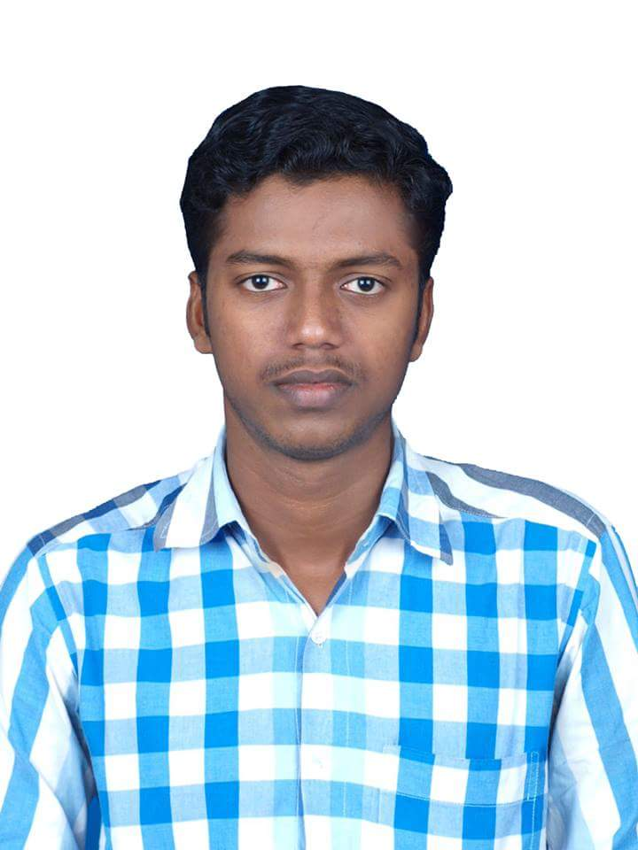
KRISHNA PRAJOD .P.P

MOB (IND): +91 9947 018 680
Email : krishnaprajod77@gmail.com

CAREER OBJECTIVE

To be associated with a progressive organization that gives me scope to update my knowledge and skills in accordance with the latest trends and be a part of a team that dynamically works towards the growth of organization.
PROFILE SUMMARY
- An enthusiastic fresher with highly motivated and leadership skills, completed Masters in Computer Applications
- Good analytical and problem solving skills.
- Expert in implementation of each step of project.
- Eager to learn new technologies and methodologies.
- Always willing to innovate the new things which can improve the existing technology.
- Easily get involve with the new people.
- Able to achieve immediate and long term goals.

PROFESSIONAL QUALIFICATION
Qualification | Institution | University | Year of Study | Academic Year | Percentage of Marks
Bsc Mathematics | Guide Collage, Tirur | Calicut University | 1st Year | 2009-2010 | 67%
Bsc Mathematics | Guide Collage, Tirur | Calicut University | 2nd Year | 2010-2011 | 67%
Bsc Mathematics | Guide Collage, Tirur | Calicut University | 3rd Year | 2011-2012 | 67%
MCA | Dr.John Matthai Centre, Trichur | Calicut University | 1st Year | 2012-2013 | 70%
MCA | Dr.John Matthai Centre, Trichur | Calicut University | 2nd Year | 2013-2014 | 72%
MCA | Dr.John Matthai Centre, Trichur | Calicut University | 3rd year | 2014-2015 | 76%

ACADEMIC QUALIFICATION
Qualification | Institution | Board | Year of Passing | Percentage of Marks
SSLC | Govt. High School , Purathur | Board of Public Examination, Kerala | 2007 | 83%
PLUS TWO | Govt. High School , Purathur | Board of Higher Secondary Examination, Kerala | 2009 | 65%

PERSONAL SKILLS

- Constant thirst for learning, Positive thinking, Self-motivated and pleasant way of speaking.
- Confident approach towards problem solving and good analytical skills.
- Highly self-improvement, cooperative
- Ability to work under pressure.
- Develop and maintain team work

COMPUTER EXPOSURE

- C, C++ & Java
- Operating Systems Known : Windows XP, Windows 7,Windows8
- Web Technology : Client Side Technologies (JAVASCRIPT & HTML)
- M.S Office (Word, Excel & PowerPoint)

PROJECTS

CPF & KRISHIBHAVAN PURATHUR (WEBSITE)
- A website for Purathur Kera Karshaka federation& krishibhavan.
- Used Jsp, MySQL, and Web Services using Java.

EXTRA CURRICULAR ACTIVITIES

- Active executive member of computer students association 2012-2013
- Treasurer of computer students association 2013-2014
- General secretary of computer students association 2014-2015
- Loves to play cricket, games, chess etc.
- Listening music and Reading books.

PERSONAL PROFILE

Address : Pathiyam Parambil House
Purathur P.O, Tirur
Malappuram ,Kerala, India
Pin - 676102
Age & Date of Birth : 23 Years, 04.01.1992
Sex : Male
Marital Status : Single
Religion : Hindu
Passport No. : N1212905
Driving Licence : LMV & 2 Wheeler
Language known : English, Hindi & Malayalam
Mob.(India) : +91 9947 018680
E-mail ID : krishnaprajod77@gmail.com
Declaration: I hereby declare that all facts above are true to the best of my knowledge and belief.

Place: Tirur Krishna Prajod Pathiyam Parambil
Date: 12.01.2016

