RESUME

SHIPRA SWAPNIL
E-Mail Id: shipra.swapnil@gmail.com
Ph no: 9791465441

- Career Objective:

To be associated with a progressive organization which can provide
me with a dynamic work sphere & appreciates
my technical acumen & ability.

- Branch: Electronics & Telecommunication Engineering
- College: Bharath University
- Avg. CGPA: 7.78

- Basic Academics.:

Standard | Board | % of marks | School
Senior Secondary Certificate | CBSE | 55 | DAV PUBLIC SCHOOL,  Gevra, KORBA
Higher Secondary Certificate | CBSE | 76 | -Do-

- COMPUTER SKILLS:
- Programming Languages known: C , c++

- TECHNICAL SKILLS :
Plc , SCADA, HMI

- TRAINING UNDERGONE:
- Organisation- SECL(coal india),
Duration- 15 days
Topic- Vocational training

- Organisation – EXCEL AUTOMATION
Duration – 45 days
Topic – AUTOMATION IN PLC(10 types)
3 HMI and 2 SCADA

- ACADEMIC PROJECT:
AUTOMATION IN MINES USING VOICE ALERT FOR THE SAFETY OF WORKERS
ABSTRACT: To avoid loss of material , human health and reduce the maual alert to have fast and reliable communication we have used automatic voice alert .

- STRENGTH:
-Adaptability to change
- Interpersonal skills
- Teamwork and collaboration
- Good communication skills

- HOBBIES:
Net surfing,
Modelling,
Cooking…

- LANGUAGES KNOWN:
English
Hindi

- PERSONAL DETAILS:

- Name: Ms. SHIPRA SWAPNIL
- Date of birth: 27th September, 1993
- Name of Guardian/Father: MR. VIJAY MISHRA
- Postal Address: B-180, shakti nagar, Gevra project,
- Distt : KORBA ( C.G)
- E-mail: shipra.swapnil@gmail.com

- Contact No. : Mob- 9791465441

- Declaration:

I hereby declare that the above-mentioned information is correct up to my knowledge and I bear the responsibility for the correctness of the above-mentioned particulars.

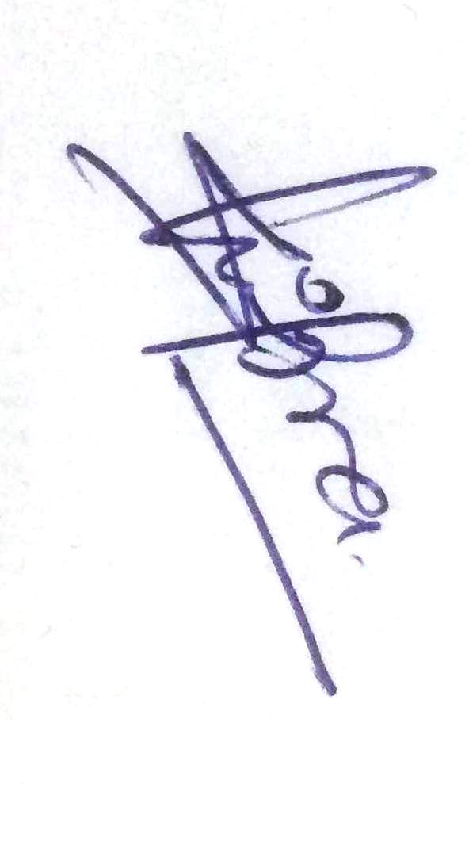
Place:
Date: (SHIPRA SWAPNIL)

