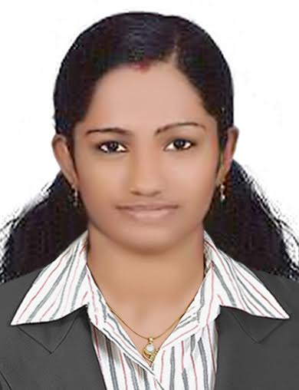
SOORYAKRISHNA S
Mobile: 09482725587,09496162918
Email-ID: sooryakrishna22@gmail.com

CAREER OBJECTIVE

To be the part of an organization where I can effectively utilize my skills and knowledge and thus contribute to the success of the organization and improve myself as a professional.

HIGHLIGHTS

- Result oriented, self starter, fast learner and able to work with minimum guidance.
- Confident in working by learning from a group and implementing the gained knowledge.
- Proven ability to work efficiently in both independent and team environment.
- Listen attentively to customer needs and concerns; demonstrate empathy.

ACADEMIC PROFILE

EXAM | UNIVERSITY/BOARD | YEAR | GRADE | PERSENTAGE
S.S.L.C | Board of Public Examination Kerala | 2009 | A+ | 94%
H.S.S  (Science) | Board of Higher Secondary Examination Kerala | 2011 | B+ | 76%
BE  (Electronics and Communication Engineering) | Anna University  Chennai | 2015 | B+ | 74%

PROJECT REPORT

- Solar Tracking System
- FM Modulation and Demodulation
- Implementation of industrial parameter control using Zigbee wireless network

TECHNICAL QUALIFICATION

- Networking
- Microsoft Office Word, Microsoft Office Excel, Microsoft Office Power Point
- C ,C++
- Windows 8,Windows 7,Windows XP,Linux
- Web designing

PERSONAL DETAILS

Sex : Female
Age & DOB : 22yrs, 09/10/1993
Marital Status : Married
Languages Known :
Read : English, Hindi and Malayalam
Write : English, Hindi and Malayalam
Speak : English, Hindi and Malayalam
Hobbies : Listening music, Driving, Travelling,Talking

DECLARATION

I hereby declare that the foregoing information is true to the best of my knowledge and belief. I haven’t held back any relevant information that will materially change the text of the information furnished here.

(Sooryakrishna)

