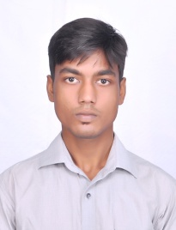
VISHAL GAURAV
B.E.( Electrical & Electronics)
Email : vishalgauravd007@gmail.com
Mobile: +919880714713

To work in a healthy, innovative and challenging environment extracting the best out of me and grow at professional as well as personal level thereby directing my future endeavours as an asset to the organization.

PROFILE SUMMARY
- Knowledge of designing, developing and maintaining electrical systems focussing on economy,safety,reliability and sustainability.
- Proficient in finding and resolving malfunctions, using technical and analytical skills.
- Ability to express technical concepts clearly to people with no technical background.
- An effective communicator with excellent interpersonal, logical & analytical abilities.
SCHOLASTIC
Qualification | Board/University | Year | Percentage
B.E. (Electrical & Electronics Engineering) | Annamalai university,T.N.(accredited ‘A’ grade by NAAC) | 2011-2015 | 7.9/10
Intermediate | St. Dominic Savio’s,Patna | 2010 | 72%
High School | Modern public School | 2008 | 74%

ACADEMIC PROJECTS
- Project Title : Anti-collision System for Railways using Microcontroller PIC 16F877.
- Platform Used : C++
- Description : This project dealt with the avoidance of Head-on, Front-end
and Rear-end collisions.

EXTRA CURRICULUM
- Awarded 1st prize in National Technical Symposium SURGE’15.
- MATLAB and AUTOCAD.
- Languages Known: C and JAVA.
SUMMARY OF SKILLS
- Troubleshooting and Testing.
- Leadership and Motivational Skills
PERSONAL SNIPPETS
Hobbies : Reading Novels, Drawing and Music.
Date of Birth : 8th Sept. 1993
Languages Known : English and Hindi.
Permanent Address : 96,Masjid Gali,Digha,Patna-800011

