Deterministic Approach for Rainfall-Induced Landslide Risk Assessment in the Philippines

**Giancarlo P. Ventura1, Elaine C. Agcaoili1, Jaime Angelo S. Victor1**

1Institute of Civil Engineering, University of the Philippines Diliman  
Quezon City 1101, Philippines

gpventura@up.edu.ph; ecagcaoili@up.edu.ph; jsvictor@up.edu.ph

***Abstract* -** Recently, the assessment of landslide hazards has been one of the main concerns in the field of disaster risk and mitigation because a multitude of areas in the country are prone to rainfall-induced landslides. By using the deterministic approach of landslide prediction involving slope stability simulation which results from the calculation of the factor of safety, the study is aimed to develop a physically-based model that consists of a methodology that combines the groundwater model for analyzing the pore-water pressure and the infinite slope stability model for computing the factor of safety. The seepage analyses were implemented using SEEP/W 2-D finite element software. The model considers the behavior of the pore-water pressures by including the hydraulic properties of the soil, the slope geometry and the physical processes relating the rainfall regime to the groundwater level fluctuations. Results of the site-specific study show that upon application of an antecedent infiltration rate of 3.82 x 10-4 m/hr and a subsequent rainfall flux contributed by the southwest monsoon in August 2013 as a function of time for 5 days, the factors of safety for various depth failures remained greater than unity signifying that the slope remained stable throughout the entire 5-day rainfall duration. The minimum rainfall intensity to cause a landslide in the site was then identified. It has been found out that at least 0.0063 m/hr of rainfall is needed for the site to fail within 48 to 72 hours of the rainfall event. Also, an extreme case of 0.01 m/hr is necessary for failure to occur within the first 24 hours. The research that has been undertaken has expound and analyzed several issues that would be beneficial to the advancement of quantitative landslide hazard assessment and prediction.

***Keywords*:** Landslide, Model, Rainfall, Risk, Silt, Slope

**1. Introduction**

Recently, the assessment of landslide hazards has been one of the main concerns in the field of geotechnical engineering because a multitude of areas in the Philippines are prone to rainfall-induced landslides. This is due to the changing weather conditions, the amount of rainfall each season brings and because of the sloping terrain and soil morphology in the country.

Landslides are one of the most damaging geo-environmental phenomena that have created considerable socio-economic losses in the past. Therefore, it is important to find out where and in what conditions will landslides take place. Rain induces a rise of the groundwater level and an increase in pore-water pressure that results in slope failures.

Rainfall-induced landslides owing to water infiltration and subsequent changes in pore pressure and shear strength of the soil generally occur as relatively shallow slope failures which are oriented parallel to the slope surface. These landslides are caused by the increase in pore-water pressures from rainfall infiltration and seepage forces during or shortly after a period of intensive rainfall. Increasing the pore-water pressure will reduce the effective stress of the soil and thus reducing the soil strength and will trigger the slope failure.

The pore-water pressure changes that develop in the soil will occur as a transient process as the infiltrating water moves downward into the soil profile. The development of seepage forces in the slope will also depend on the evolution of the pore-water pressure profile. To calculate the change of the pore water pressure profile, the equations for the flow of water through an unsaturated soil are utilized. Also, the shear strength of the soil mass depends on the degree of suction.

In previous studies concerning landslide susceptibility, water infiltration and slope stability are usually dealt with separately. Typically, the governing differential equation for rainfall infiltration within the slope is first solved using numerical techniques such as the finite element method to come up with the pore-water pressure changes. These pore-water pressure changes are then used to assess the slope stability. Using the limit equilibrium method, slope stability is determined by calculating for the factor of safety, which is defined as the ratio of the soil shear strength along a potential failure surface to that required for the equilibrium of the slope (Conte & Troncone, 2011). If the factor of safety takes a value greater than unity, the slope is stable; otherwise a slope failure occurs. To overcome this limitation, this study develops an approach for a slope stability analysis which attempts to establish a relationship among rainfall, pore-water pressures and slope failure. This approach uses an analytical solution to account for the transient rain infiltration effects on the change in pore-water pressure, and it uses a simple infinite slope model to estimate the factor of safety at certain depths.

It is vital to grasp the underlying concepts behind these dangerous landslides and analysis of such should be able to accurately predict their occurrences. It would appear advantageous to be able to derive a closed-form unsaturated flow model that more realistically considers the unsaturated soil properties. Moreover, coupling transient groundwater modeling and slope stability with physically-based GIS modeling to develop a predictive model for landslide susceptibility helps in the accuracy of site-specific situations.

In this study, an infinite slope has been developed to evaluate the influence of infiltration on the stability of slopes by using the limit equilibrium method. Having those in mind, the study aimed to predict landslide occurrences using the deterministic approach. This approach is related to the assessment of slope stability once the pore-water pressure, geological model and the soil’s geotechnical parameters were defined.

**2. Methodology**

**2.1. Seepage Analysis using SEEP /W**

The seepage analyses were implemented using SEEP/W 2-D finite element software (GEO-SLOPE, 1991-2008) version 7.10. This software was capable of simulating the real physical process of water flowing through a particulate medium by mathematical simulation of the process itself. The seepage analyses were used to investigate the effects of the different hydraulic parameters to the pore-water pressure distribution during and after rainfall events. The three major necessary steps to fully simulate numerical modeling in SEEP/W were the following: geometry definition, material designation and boundary conditions specification.

The numerical model used in the study used a total vertical depth of the of 5m. It was assumed that the slope was composed of a homogeneous and isotropic material. The horizontal length of the model is 100 m (i.e., 20 times of the vertical depth), which is long enough to reduce boundary effects and form an infinite slope.

The saturated-unsaturated type of material modeling was used in the study wherein the major input parameters were volumetric water content and hydraulic conductivity functions. For the volumetric water content, a set of functions built into the software for different soil types was utilized. The soil type of the material was selected from the various classifications available in SEEP/W. Saturated water content was specified by the user to decide how sensitive the results are to function shape. The previously specified volumetric water content function was then used for the estimation of the hydraulic conductivity function of the material. Saturated hydraulic conductivity and residual water content were indicated as well to predict the hydraulic conductivity function.

There are five different types of boundary conditions in SEEP/W namely: head (H), total flux (Q), unit flux (q), unit gradient (i) and pressure head (P). For the initial condition (i.e., steady-state analysis), the boundary conditions were pressure head and unit flux. An interval of 1m in defining points for pressure head boundary condition was used in the study. The pressure head constants for different points were also computed.

For the transient analysis, the subsequent rainfall was considered by applying unit flux boundary to the ground surface as well. The site-specific study made use of the daily rainfall data acquired, thus specifying a function of unit flux that changes according to the average rainfall intensity computed per day.

**2.2. Slope Stability Analysis**

For an infinite slope, the slope failure surface is parallel to the slope surface at a particular depth. The calculation of the factor of safety was conducted using Microsoft Excel and ArcGIS. Stability of the slope in different depths (Z=0, 0.5m, 1m and 2m) were analyzed in every time step.

The pore–water pressures and volumetric water content that were determined in the transient seepage analysis by SEEP/W were used as input data for the slope stability analysis. The shear strength of unsaturated soil can be described using the extended Mohr-Coulomb criteria discussed before. The equation utilized in the slope stability analysis was the unsaturated shear strength equation to incorporate the contribution from the negative pore-water pressure.

This time-dependent pore-water pressure distribution was used directly to compute the factor of safety over time. The effect of rainfall infiltration on the unit weight of the soil was taken into consideration, the equation used for calculating the factor of safety for unsaturated soils was:

$FS=\frac{c^{'}-u_{w}\left(Z\right)tanϕ^{b}}{[γ_{d}\left(H-Z\right)+γ_{w}\int_{Z}^{H}{Θ\left(Z\right)dZ]sinγcosγ}}+\frac{tanϕ'}{tanγ}$ (1)

Alternatively, for soils which transformed from an unsaturated to a saturated state, meaning the pore-water pressure is positive, the following formula for the factor of safety was used:

$FS=\frac{c^{'}+(γZ\cos^{2}α-u_{w}(Z))tan∅'}{γZ\cos^{2}α}$ (2)

**2.3. Design of Site Specific Study**

The slope profile used in the site-specific study is a homogeneous layer of soil underlain by a less permeable layer located in Antipolo, Rizal, Philippines.

A soil sample was obtained from the site and was analyzed in the laboratory to identify the soil type. With the use of the Unified Soil Classification System, it has been found out that the soil type in the area is primarily silt. Hence, the typical soil properties of silt were used in the study.

The shear strength parameters of silt used were: the effective cohesion, c’ = 0 kPa, effective angle of internal friction, Φ’ = 33o, angle indicating the rate of increase in shear strength relative to matric suction, Φb = 16.5o and the dry unit weight of the soil is γd = 19 kN/m3. Likewise, the unit weight of water is γw = 9.81 kN/m3.[3]

A case study was conducted in order to investigate and predict landslide occurrences in the site. On August 17, 2013, the southwest monsoon locally known as Habagat caused heavy rainfall which transpired for 5 days (August 17 - August 21).

**2.4. Rainfall Threshold**

For a landslide in the site to occur, the subsequent rainfall for which the factor of safety became less the unity was determined. This was done for different durations, in which the slope will most likely fail. From a 10-year recorded data, the antecedent rainfall applied was 375.8 mm/month or 5.05 x 10-4 m/hr. All other parameters were held the same.

**2.5. Physically-Based Modeling using ArcGIS**

Using the ArcMap built-in application in ESRI's ArcGIS software the data on a map is organized into layers which are drawn on the map in a particular order.

The layers define how a set of geographic features will be drawn when they are added to a map. They act as storage for the data. Using ArcGIS, the site's spatial and attribute information were well-defined based on the previously done seepage analysis. The spatial information describes the location and shape of the geographic features. The attribute information tells you about other characteristics of the features.

The physically-based model made use of raster layers. In a raster model, the site is represented as a surface that is divided into a regular grid of cells. Each cell contains a value that represent a measurement, or an interpreted value. These values include the attributes needed for the slope stability formula computing for the factor of safety.

Each raster layer represented a value of a certain attribute. These layers containing specific values were then combined to come up with a final model that has the factor of safety as an output value. To account for the transient seepage analysis, a model for the initial condition was done and compared with another model of the site after the subsequent rainfall has been applied.

**3. Results and Discussion**

**3.1. Effect of zero antecedent rainfall**

Examining the rainfall pattern before the actual Habagat, there was no recorded rainfall, four days (August 13-16) before the said rainfall event. Thus, it is important to examine the condition at which the soil is assumed to be dry (qa=0 m/hr). Figure 1 shows the variation of the pore-water pressure throughout the depth of the slope being considered.

A high initial negative pore-water pressure is observed (i.e., t=0 hr). Applying a constant flux equal to 0.00193 m/hr for the first 24 hours, the pore-water pressure on the ground surface reduced significantly, from -37 kPa (t=0 hr) to -11 kPa (t=24 hr). Approaching Z=0.5m, the rate at which the pore-water pressure changes decreased. Meanwhile, from Z=0.5 to 1m, the pore-water pressure is almost the same (-29.2 kPa). At depths lower than 1m, pore-water pressure does not vary considerably from the initial condition. It can be said that rainfall water accumulated in the shallow layer first and it took some time before the water can reach the lower depths.

Applying a smaller flux rate of about 0.00125 m/hr from t=24 to 48 hours compared to the first 24 hours, the pore-water pressure continues to decrease significantly especially from the ground surface up to depth equal to 1m. At Z=1 to 2 m, pore-water pressure decreased as well but not as much as the reduction in shallower depths. This can signify that rainfall water from the first 24 hours just started to be distributed to the lower depths.

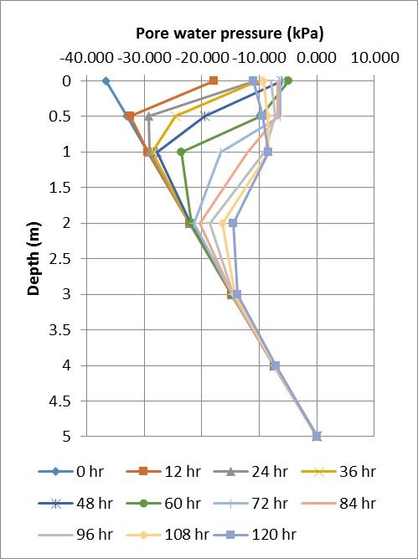Figure 1. Pore-water pressure profiles for zero antecedent rainfall

On the next day, the maximum flux rate of about 0.00468 m/hr is applied on the slope. Inspecting the distribution from t=48 to 72 hours, the pore-water pressure on the ground surface does not differ greatly. On the other hand, up to 2m depth below the ground surface, pore-water pressure varies extensively. Comparing this result from the ones obtained during the first 48 hours, it can be said that the depth of the wetting front advances downward. This can be attributed to the increase of the subsequent rainfall and further infiltration of the rainfall water accumulated on shallower depths going on. With a low negative pore-water pressure on the ground compared to its initial value, a high water coefficient of permeability is observed, which facilitates the down-flow and out-discharge of the infiltrated water.

From t=72 to 96 hours, the flux rate applied is decreased to 0.00283 m/hr, but still higher than the first two applied flux rates. On the ground surface, up to 0.5m depth, the negative pore-water pressure increased. This can be ascribed to the lowering of the applied flux rate to the slope. Conversely, at depths lower than 0.5 m, the pore-water pressure continues to diminish with Z=1m having the maximum reduction.

Finally, for the last 24 hours of the rainfall event considered, the flux rate is further decreased to 0.00125 m/hr. An increase in the negative pore-water pressure at depths 0 and 0.5 m and a decrease at depths 1 m and 2 m are still observed.

With no antecedent rainfall, a high initial pore-water pressure as well as great reduction of negative pore-water pressure is observed in the shallower soil layer on the earlier stage of the analysis.

**3.2. Effect of 3.82x10-4 m/hr antecedent rainfall**

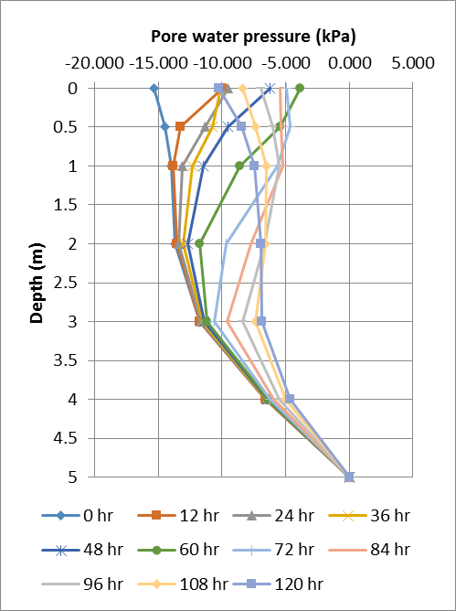The second scenario considers applying a constant flux rate of 3.82 x 10-4 m/hr, taken from the recorded rainfall from August 1-16. Figure 2 shows the variation of the pore-water pressure throughout the depth of the slope being considered.

Figure 2. Pore-water pressure profiles for a 3.82x10-4 m/hr antecedent rainfall

Applying a non-zero antecedent rainfall, a lower initial negative pore-water pressure is observed (i.e., t=0 hr) resulting to a smaller reduction of pore-water pressure in the shallow soil layer. With a constant flux equal to 0.00193 m/hr for the first 24 hours, the pore-water pressure on the ground surface reduced considerably, from -15.5 kPa (t=0 hr) to -9.5 kPa (t=24 hr), but much smaller drop than the case where zero antecedent rainfall is assumed. This is due to the higher water coefficient of permeability brought about by the low initial pore-water pressure, which facilitates the down-flow and out-discharge of the infiltrated water. A larger antecedent rainfall results to a more uniform redistribution of pore-water pressure on the entire depths as well. Up to 2m depth below the ground surface, pore-water pressure varies noticeably from the initial condition, unlike in the first scenario where pore-water pressure reduction took place until the 1m depth only.

Applying a smaller flux rate of about 0.00125 m/hr from t=24 to 48 hours compared to the first 24 hours, the pore-water pressure continues to decrease significantly reaching up to 3m depth.

The maximum flux rate of about 0.00468 m/hr is applied on the slope on the next day. Examining the pore-water distribution from t=48 to 72 hours, it can be said that the infiltrated water is more uniformly distributed on the entire depths, meaning a reduction of negative pore-water pressure occurred on almost all soil depths. Deeper wetting front advancement takes place compared to the first case due to higher soil permeability.

During the latter stage of Habagat (t=72 to 120 hrs), smaller subsequent rainfall occurred, thus, allowing soil suctions to recover (i.e., increase in negative pore-water pressure) to some extent relying on the permeability of soil. Increases from -5 kPa to -10 kPa, -4.6 kPa to -8.5 kPa and -5.6 kPa to -7.5 kPa are observed at depths 0 m, 0.5 m and 1m, respectively. Meanwhile, at 2m depth and below, pore-water pressure continues to decrease until the end of the rainfall event.

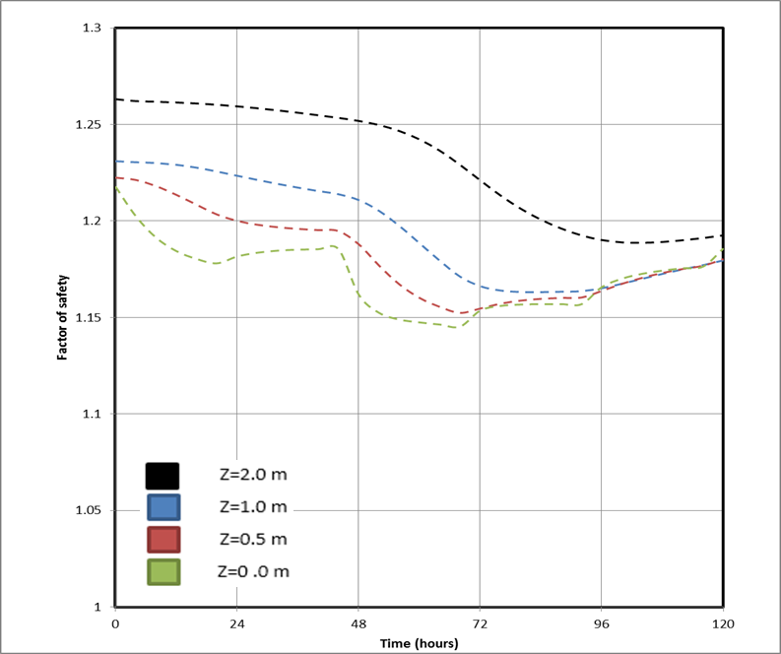With a non-zero antecedent rainfall, a low initial pore-water pressure as well as more uniform distribution and smaller reduction of negative pore-water pressure was observed on almost the entire slope depths. This pattern echoed upon the calculation of the factor of safety. Figure 3 below shows the behavior of the factor of safety assuming a non-zero antecedent rainfall.

Figure 3. Factors of safety for different slip surfaces with qa=3.82x10-4m/hr

**3.3. Rainfall Threshold**

Table 1 below summarizes the rainfall threshold that can result to a slope failure in the area. The rainfall volume is computed by multiplying the rainfall intensity to the rainfall duration.

Table 1. Summary of obtained rainfall threshold values

|  |  |  |
| --- | --- | --- |
| Rainfall Duration (hr) | Rainfall Intensity (m/hr) | Rainfall Volume (mm) |
| 0- 24 | Greater than or equal to 0.01 | Greater than 240 |
| 24 – 48 | 0.0067-less than 0.01 | 160-480 |
| 48 – 72 | 0.0063-0.0066 | 300-480 |
| 72 – 96 | 0.006-0.0062 | 430-600 |

**3.4. Physically-Based Modeling using ArcGIS**

Examining Upon numerical analysis applied with a constant slope of 30o, it has been found out that after a 5-day subsequent rainfall, a factor of safety less than unity has not occurred yet. Therefore, the minimum amount of rainfall for which the slope will fail was determined as has been discussed earlier. This is known as the rainfall threshold.

To simulate an analysis in ArcGIS of the stability of the site using the obtained rainfall threshold, a subsequent rainfall with an intensity of 0.0063 m/hr is used. Closer inspection says that before the slope fails, the soil transforms from an unsaturated to a saturated state. Also, simulation of a 3-day subsequent rainfall shows that the failure first occurs at a depth of 0.5m after 64 hours of rainfall. The result of the model is shown in Figure 4. A 3-day model was done since this is the usual rainfall duration experienced in the area of study.

Moreover, Figure 4 exposes that application of the analysis in ArcGIS generate the same trends as the conditions for Habagat 2013. The same 10m grids (below the slope) are initially critical already. But, it must be realized that after t=64 hours, the entire site fails at a depth of 0.5m.

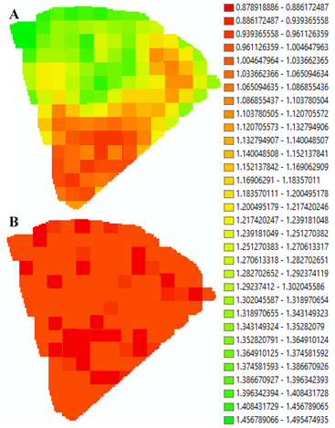

Figure 4. ArcGIS physically-based model of the rainfall threshold occurring at Z=0.5m for t=0 (A) and t=64hr (B)

**4. Conclusion**

With an antecedent rainfall of 3.82 x 10-4 m/hr prior to the amount of rainfall contributed by the Habagat that had a maximum flux rate of about 0.00468 m/hr, the factors of safety computed up to 2-m depth remained greater than unity until the end of the rainfall duration, signifying that the slope remained stable throughout the 5-day Habagat even if an antecedent rainfall had been applied. The accumulated amount of rainfall during the considered period of time was not adequate to develop a potential sliding plane on the site.

Rainfall intensity of 0.006 m/hr or greater can cause instability on the slope given the antecedent rainfall governed by the average rainfall intensity in the area during the wet season (equal to 5.05x10-4 m/hr).

Though slope failure has not been observed in the slope stability analysis for the actual case where a constant slope angle of 30o was applied, the model reveals some differences. This is primarily due to the application of the true values of the slope in the digital elevation model. The factors of safety range from approximately 1.018 to 1.45. But, numerical results show same results for portions of the model with the same slope. Hence, it can be said that the model is precise and accurate. It can be noticed that the lower portions of the slope where steeper angles can be found were the most critical during the Habagat 2013.

**References**

[1] Fredlund DG, Rahardjo H. Soil mechanics for unsaturated soils. Wiley: New York, 1993.

[2] Fredlund, D. G., & Xing, A. (1994). Equations for the soil-water characteristic curve. Canadian Geotechnical Journal, 31(4), 521-532.

[3] Kim, J., Lee, K., Jeong, S., & Kim, G. (2014). GIS-based prediction method of landslide susceptibility using a rainfall infiltration-groundwater flow model. Engineering Geology, 182, 63-78.

[4] Krahn, J. (2004). Seepage modeling with SEEP/W: An engineering methodology. GEO-SLOPE International Ltd. Calgary, Alberta, Canada.

[5] Orense, R. P. (2003). Geotechnical Hazards: Nature, Assessment, and Mitigation. University of the Philippines Press.

[6] van Genuchten, M. T. (1980). “A closed form equation for predicting the water permeability of unsaturated soils.” Soil Sci. Soc. Am. J., 44, 892–898.

[7] Zhan, T. L., Jia, G. W., Chen, Y. M., Fredlund, D. G., & Li, H. (2013). An analytical solution for rainfall infiltration into an unsaturated infinite slope and its application to slope stability analysis. International Journal for Numerical and Analytical Methods in Geomechanics, 37(12), 1737-1760.

[8] Zhan LT, Ng CWW. Analytical analysis of rainfall infiltration mechanism in unsaturated soils. International Journal of Geomechanics 2004; 4(4):273–284.