Effect of Particle shape on mechanical behaviour of unsaturated granular medium using DEM elliptical particles
Reza Asadi ¹ & Ali A. Mirghasemi ²
¹University of Tehran
School of Civil Engineering, College of Engineering, University of Tehran, Tehran, Iran
reza_asadi@ut.ac.ir;
²University of Tehran
aghasemi@ut.ac.ir
School of Civil Engineering, College of Engineering, University of Tehran, Tehran, Iran

Abstract – Due to the applied usage of the unsaturated soils study in many conditions including the behavior of earth dams during construction and operation, soil slopes and lateral earth pressure in unsaturated soils, the bearing capacity of shallow foundations, etc. some research should be done to shed light on this significant issue. On the other hand, the interaction of three distinct phases in these conditions, leads to complicated effects on microscopic, consequently, on macroscopic behavior. Since the macroscopic behavior of granular soils depends on properties of particles’ contact, the exact definition of all contact conditions (especially in the unsaturated situation due to the formation of liquid bridges or Meniscus) is important. In this research, the behavior of unsaturated granular soils is analyzed along with the impact of the suction pressure, confining stress and shape of the particles, especially elliptical particles. The main objective of this research is to study the effect of particles shape. As one of the most recent efforts, the effect of elongated or flat particles in unsaturated conditions by the means of Discrete Elements Method (DEM) is studied. The results of simulation show that strength of the assembly will increase in unsaturated condition due to increased apparent cohesion. However, friction angle remains almost constant in unsaturated soils. Moreover, it has been observed that unlike spherical particles (in the ranges of the pendular regime) which their strength increases with the increases of the saturated degree in the pendular regime span, the strength of elliptical particles increases and then decreases with the increases of saturation degree. The unsaturated strength of the particles with different shapes is always more than that of the dry condition.

Keywords: Microscopic interaction, Macroscopic behavior, Pendular regime, Apparent Cohesion, Elliptical particles.

- INTRODUCTION
Contactless micromechanical forces play an important role in the behavior of granular soil, especially in the fine-grained soils [1]. The capillary force is one of the major forces in the wet soils, which is the result of the interaction surface of water and air in the porosity of soil medium and it generates the contractile skin [3] interpreted by Laplace-Young equation. The force equation of the skin which in the technical literature is called meniscus is presented by Fisher [4].
Water in granular media, powders and fine granular soils have a widespread effect on their behavior [5]. To achieve an insight into the behavior mechanism of unsaturated soils in the different practical situation, there is a need to move towards more even experimental and modeling studies. Moreover, these macro-mechanical categories, micro-mechanical aspects need to be investigated. Efforts for determination of geometrically and constitutively performance of water presence in the powder and granular medium has been carried out in micro-dimension [6, 7] and macro-mechanical responses [8-10].
During the addition of water to a dry soil, the water absorbent layer began to form in adverse and then the liquid bridges between the particles are created under a specific condition which is called pendular state or regime. Pendular regime exists up to 30% of the degree of saturation. When the saturation process continues, the funicular state is formed that endures over high saturation degrees. Finally, when the porous areas are filled with capillary water, the capillary state is formed which exists in 90% of saturation degree. The presence of capillary water in the pores between particles creates an attractive force between them. This capillary force causes apparent cohesion and represents an additional tensile strength in the system [11].
In this paper, as one of the first attempts, the analysis of the capillary force in elliptical particles assemblies is figured out and the effect of particles shapes is analyzed. The simulations are conducted in the pendular state for three types of particle shapes and different confining pressure. It should be mentioned that most of the studies are conducted for circular and spherical shaped particles and rarely the shape of the particles in the assemblies and macro-aspect is investigated.

- Numerical simulation procedure
  - liquid bridge geometry in elliptical particles
In this study, the elliptical particles with various eccentricity are used. The geometry of liquid bridge (Meniscus) between two elliptical particles is shown in Figure 1 [12]. The major and minor radii are R₁ and R₂, respectively. The liquid bridge is defined by the interaction of the two ellipses and the air-water interface. The r₁ is the radius of air phase and r₂ is the radius of the water phase of the Meniscus around the contact point. The contact angle (w) is defined by the angle of air-water interaction with each particle. Due to symmetry, the wetting angle (φ) shown in Figure 1-b is equal in both ellipses.
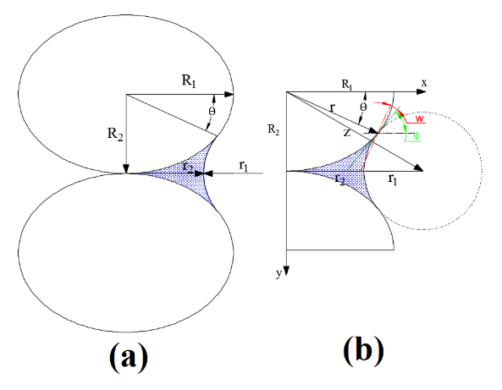 | 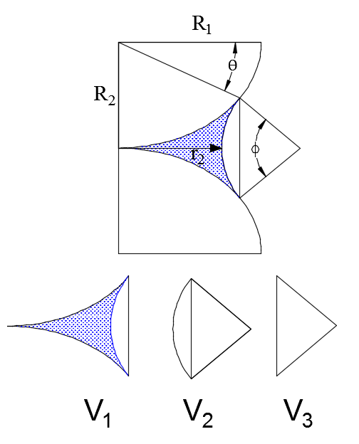
Figure 1: Geometry of liquid bridge in contact with two equal ellipses. (a) Elliptical particles in vertical contact (b) Meniscus geometric parameters. | Figure 2: Segmentation of the meniscus in order to calculate the volume[12].
Considering the above geometry, the following equation can be determined [12]:
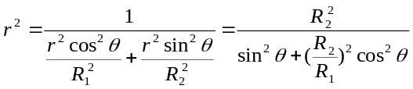 | Eq. ()
Furthermore, another geometrical equation can be determined as follows:
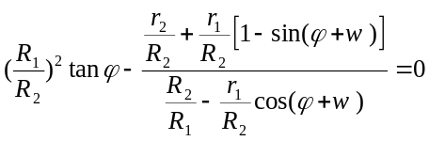 | Eq. ()
The volume of the liquid bridge can be concluded by considering Figure 2 as follows:
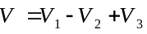 | Eq. ()
In addition, we derived the volume of the meniscus with consideration of V₃ as the area of the triangle, V₂ as the area of the sector with radius r₂ and φ angle, which are illustrated in Figure 2, the area of the meniscus can be derived as it is shown in Eq. ().
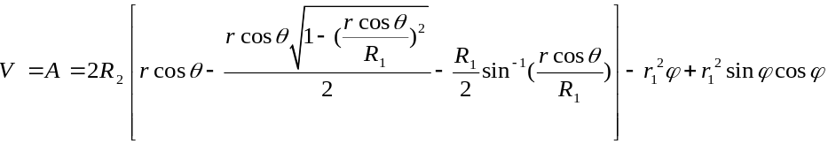 | Eq. ()
The contact of two elliptical particles according to the angle between the main axes of them (Figure 3). In this paper, it's assumed that all packings are formed vertically (Figure 1).
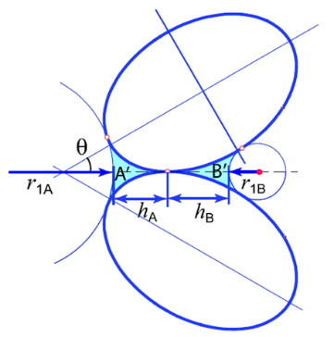 | 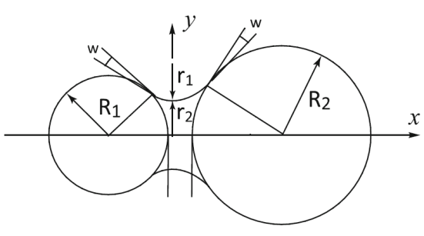
Figure 3: Inclined or rotated elliptical particles in packing. | Figure 4: Schematic figure of the formation of the liquid bridge between two ideal unequal size circular particles.
The basis of the water presence and the formation of liquid bridges phenomenon in non-circular particles are fairly similar to the circular particles, the difference is that, if the packing was made asymmetric (Figure 3), the liquid bridges would be asymmetric at both sides of the normal vector of the contact point, hence it causes unbalance capillary force. It is worth mentioning that some researches have been conducted to determine the geometry and the liquid bridge force of irregular shape particulate by power series [13], which need to be further investigated. In this regard, this paper, as one of the first attempts, significantly contributes to the assembly of elliptical shape particles.

  - Liquid bridge force
Capillary force firstly was calculated by Fisher [5], who considered liquid bridge as a saddle or toroidal curve. For determination of the liquid bridge volume, various assumptions on simulations have been taken into account. Some researchers[14] believe that water phase is transportable and menisci can form in any porous area as it’s possible. Due to the very low viscosity of the water, others [15] have ignored the liquid movement and it is assumed that water distributes uniformly among all particles. For grain particles under the pendular regime, the menisci generally are constructed around the contact points of particles[16].
In suction and liquid bridge force equations, T_{s} is the surface tension of water and r₁ and r₂ are meniscus radii respectively in the air and water phase (Figure 4). For elliptical particles, based on the Laplace-Young equation, suction Δu which is different between air and liquid pressure, and liquid bridge force F, by consideration of Figure 1is calculated as follows [12]:
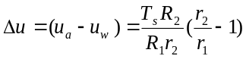 | Eq. ()
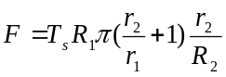 | Eq. ()

- numerical simulation
  - Generation of elliptical particle assembly
In order to study and simulate the behavior of unsaturated granular soils, in this research three types of assemblies were generated. To simulate the real behavior as well as the sensible operation simulation speed, 2031 particles were produced. To investigate the shapes of the particle on the behavior of unsaturated granular soils, three assemblies with zero, 0.15 and 0.3 eccentricities, were produced. These ranges were selected according to the results of Rothenburg and Bathurst [17] research. The purpose of various eccentricities production is to investigate the shapes of particles and convert circular particles gradually to a plate, or rather needle-like ones. According to some studies and simulations [9, 18] and also requisiteness of the appropriate particles dimension for the efficiency of liquid bridge force, the average particles diameter ascertained from 0.25 to 1 mm. Consider that the liquid bridge force is more evident in finer particles. The grading curve is shown in Figure 5.
With regard to the simulation process as: (i) Production of particles assembly in a circular shape, (ii) Converting circular particles into elliptical ones with a certain eccentricity then compacting the loose assembly, (iii) applying the confinement pressure and finally (iv) exerting deviator stress. In the initial stages of simulations, i.e. stage (i) and stage (ii), liquid bridge and capillary forces are not activated. Parameters of DEM numerical simulation are given in Table 1.
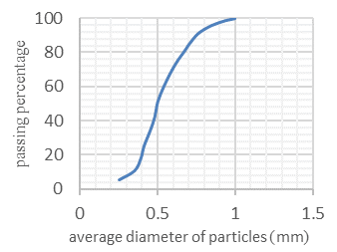 | 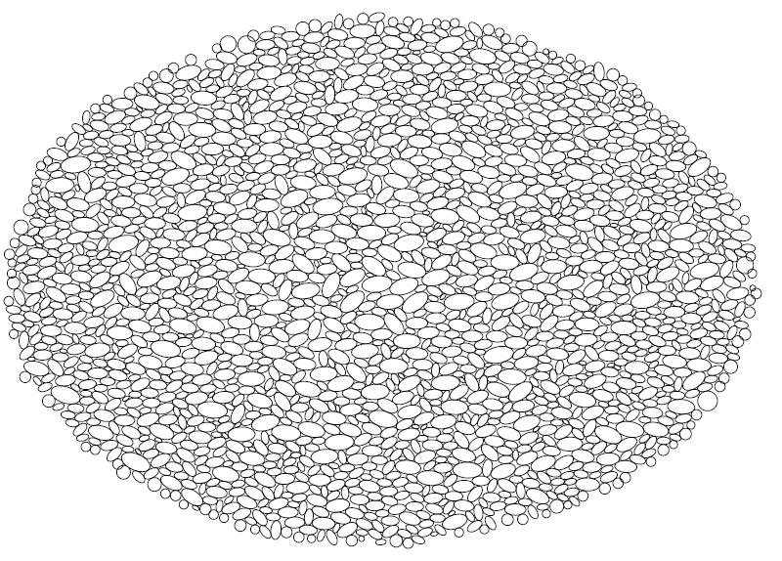
Figure 5: The grading curve of average diameter of simulated particles | Figure 6: Assembly of elliptical-shaped particles with eccentricity 0.3 at the final stage of shearing.
Each assembly with the certain particles eccentricities is sheared under three different confining pressures of 50, 100 and 200 kPa. This range of applied confining pressures is chosen in such a way that makes the capillary forces active [18, 19]. At the end of confining pressure application, for all assemblies with different confining pressures, the resultant void ratio was almost the same (0.64) Therefore, the effect of void ratio on simulation result is excluded.

  - Simulation of liquid bridge
As previously mentioned, the liquid bridge force is activated in two last stages of simulation, i.e. applying confining pressure and deviator stress. The force is employed at the centroid of the liquid bridge and its direction is perpendicular to particles surface and it pulls the particles together (Figure 7).The resultant vector of liquid bridge forces on both sides of two particles is calculated which in the case of symmetry, it would be the exerted at the contact point of two particles.
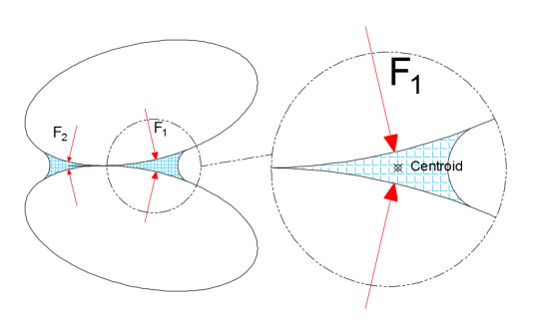  Figure 7: Exertion of liquid bridge force. | Table 1: DEM modeling parameters
  Attribute | Value | Unit
  Vertical contact stiffness (Kn) | 2 | MN/mm
  Shear contact stiffness (Ks) | 2 | MN/mm
  Contact damping coefficient (β) | 0.01 | -
  Global damping coefficient (α) | 4 | -
  Density of particles (ρ) | 2500 | kg/m3
  Friction coefficient (μ) | 0.5 | -
  - Pore water distribution
In order to model the liquid bridge between particles, the volume of the bridge must be specified. Liquid bridge volume is defined as the function of in contact particles size and the contact vector length. For pore water distribution, Eq. ()is used:
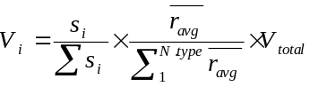 | Eq. ()
In the Eq. (), V_{i} is liquid bridge volume, V_{total} is the total volume of pore water, S_{i} is the contact vector,is the average of the mean-radius of particles which are in contact together and N type defines the number of particles types base on their mean-radius. The water contact angle during the simulation is considered as a constant angle10°. Chen et.al [20] showed that the constant contact angle10° compared to zero degree contact angle in the liquid bridge does not make considerable changes and it is a logical and rather realistic assumption. The calculations in this research are based on the 73.5 N/mm surface tension of water. It has been proposed [19] that when two adjacent particles are separated the existing liquid bridge is broken.

- simulation results
  - Shear strength of the assemblies
The variation of the sine of friction angle at the failure point for different eccentricities as a function of confining pressure for the dry assemblies is shown in Figure 8. It indicates that, when confining stress increases, the angle of internal friction decreases, which results in the emergence of apparent cohesion in linear Mohr-Coulomb failure criterion. Moreover, it is obvious that initially with a slight increase in the eccentricities, the maximum friction angle improves. The outcomes are quite similar to the results which have been presented by Rothenburg and Bathurst [17].The sine of the angle of internal friction for a non-adhesive soil (granular materials) according to the axial stress,and lateral stress σ₃ is calculated according to the following equation:

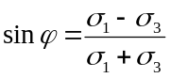 | Eq. ()
Figure 9 presents the variation of deviator stress versus axial stress for assembly of circular particles. It shows that when the saturation degree increases, deviator stress increases as well and leads to improvement of the shear strength of the assembly. These results are matched to the fact that the capillary force grows when the liquid bridge volume increases.
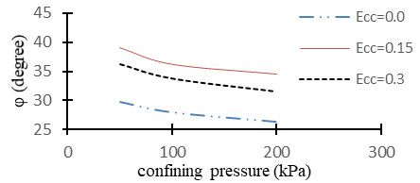 |  | 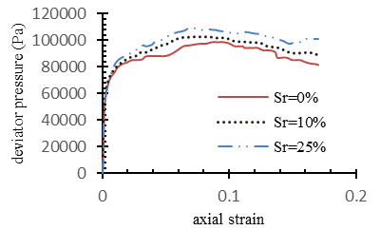  (a) σ₃ = 50 kPa | 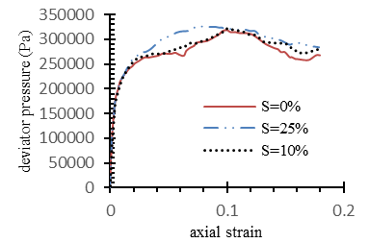  (b) σ₃ = 200 kPa
Figure 8: Internal friction angle in different confining pressures for various eccentricities |  | Figure 9: Deviator stress-axial strain relationships for assemblies with circular particles: (a) σ3 = 50 kPa and (b) σ3 = 200 kPa.
These results are matched to the fact that the capillary force grows when the liquid bridge volume increases. Liquid bridge force acts like cohesion, in other words, this force plays two roles; firstly, it attracts two particles towards each other hence the vertical force of two particles interaction increases, therefore, the shear resistance grows and prevents two particles to easily slip. The presence of water in circular particles in the technical literature is investigated extensively. As it is illustrated clearly in Figure 9, the impression of the capillary force fades in higher confining pressure. It is due to decrease of the capillary force share in comparison to the contact forces.
Figure 10 shows the increase in the deviator stress caused by the presence of water in the elliptical particles. By considering these figures, it is obvious that presence of capillary water induces the behavior of the assembly to incline toward the compacted manner in which the strength of the assembly rises to a given limit then drops a little. By comparing the Figure 10 (a) and (b), it is conceived that the effect of capillary water in the particles with larger eccentricity is more apparent. In other words, when the particles transform from circular particles to elliptical ones and by the growth of eccentricity, the shear strength of the assembly due to capillary force, increases further. These macroscopic findings harmonize with the consequences of other researchers[12]at the microscopic scale for a pair of particles. By considering these figures, it is comprehended that the effect of capillary force in a higher deviator stress, drops. Additionally, at the higher saturation degrees, due to capillary force reduction, the strength of the assembly reduces. A sensible interpretation for this phenomenon is that, when the particles eccentricities enlarge, a small amount of water satiates the resistance in accordance with capillary force and excess water only plays as lubricator role and eliminates the friction resistance between them and results in lower resistance of the assembly. These findings consistent with the outcomes of other researchers[7] at the micro scale.
In a small confining pressure, increase in the soil resistance and consequently, raise in the angle of friction between the particles is more visible. Also in a small confining pressure, more soil resistance will increase. For elliptical particles, when eccentricity grows, the stability and resistance increase first and then decrease.

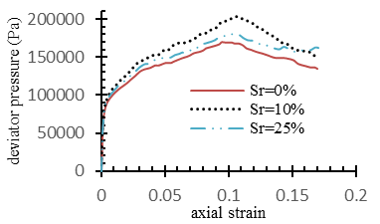  (a) σ₃ = 50 kPa , ecc=15% | 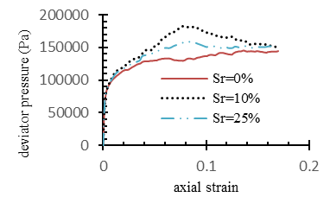  (b) σ₃ = 50 kPa , ecc=30% | 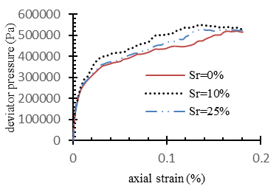  (c) σ₃ = 200 kPa , ecc=15%
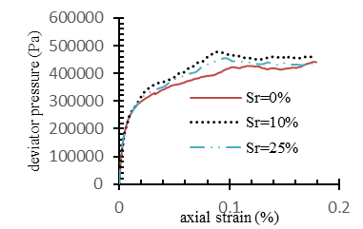  (d) σ₃ = 200 kPa , ecc=30% | Figure 10: Deviator stress-axial strain relationships for unsaturated assemblies of elliptical particles with different confining pressure and eccentricities: (a) σ3 = 50 kPa, ecc=15%; (b) σ3 = 50 kPa, ecc=30%; (c) σ3 = 200 kPa, ecc=15%; (d) σ3 = 200 kPa, ecc=30%.
  - Deformation of the assemblies
For assemblies with circular particles, Figure 11-(a) shows that the presence of water and the capillary force causes the assembly to dilate more. At the 25% of saturation, it moves toward the dry assembly behavior. Sample with the saturation of 10% presents more volume reduction comparing to the dry case but its expansion is more than the others at the end. Based on Figure 11, at higher confining stresses, the assembly behaves like a loos samples and unsaturated dilative behavior is evident in the assemblies. In the other words, the effect of capillary force emerges as a compacted behavior of assembly.
The volume change behavior of assemblies of elliptical particles is presented in Figure 12. For dry assemblies, by increasing eccentricity, the assemblies’ dilatancy develops at first and for very large eccentricities the dilatancy falls down. It has been found when the eccentricities grow, the assembly compression increases at the beginning. After the eccentricity exceeds a limit, the assembly behaves like loose granular material.
(a) σ3 = 50 kPa  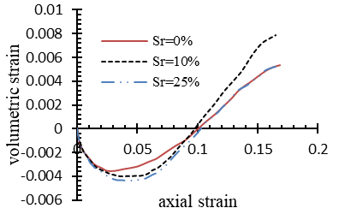 | (b) σ3 = 100 kPa  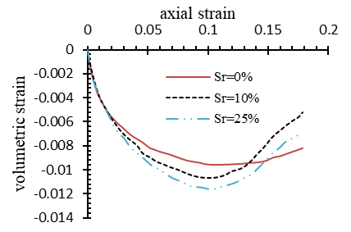 | Figure 11: Volumetric deformation in assemblies for circular particles, with different degree of saturation and confining pressure: (a) σ3 = 50 kPa and (b)σ3 = 100kPa.
Generally, by increasing the capillary force, the tendency toward dilatancy increases. When the saturation degree increases, in most cases the soil volumetric expansion enlarges and the dilatancy in comparison to dry assemblies is boosted (Figure 12). It is obvious when the confining pressure escalates, the dilatancy decreases. By increasing eccentricity, the variation of the dilatancy trend of assembly is the same as assemblies consisting particles with lower eccentricities, except that the expansion comparing to more diminutive eccentricities is slightly smaller.

(a) σ₃ = 50 kPa ,ecc=15%  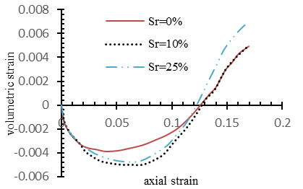 | (b) σ3 = 50 kPa , ecc=30%  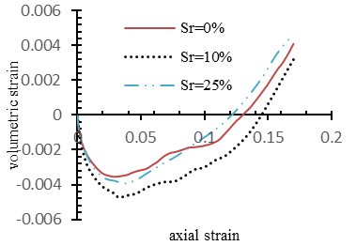 | (c) σ3 = 200 kPa , ecc=15%  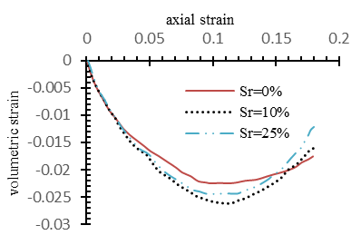
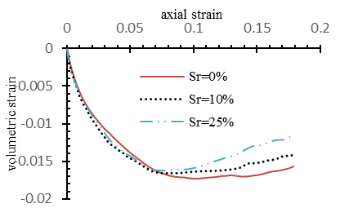  (d) σ₃ = 200 kPa , ecc=30% | Figure 12: Volumetric deformation in unsaturated assemblies of elliptical particles with different confining pressure and eccentricities: (a) σ3 = 50 kPa, ecc=15%; (b) σ3 = 50 kPa, ecc=30%; (c) σ3 = 200 kPa, ecc=15%; (d) σ3 = 200 kPa, ecc=30%.
- discuSSion and Conclusion
By considering consequences of various confining pressures using the Mohr-Coulomb criteria(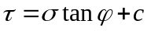), cohesion and internal friction angle parameter have been obtained, as shown in Figure 13,due to the change in anisotropy of particles during simulation, mobilized friction angle in higher confining stress decreases. In addition, because of the fact that the failure curve is estimated to a linear one, even in the dry state of assemblies, apparent cohesion is obtained.
In case of circular particles assemblies, when the saturation degree increases the apparent cohesion, due to the growth of the capillary force, improves and it acts like a glue that holds the particles together. On the other hand, it is evident that the internal friction angle of particles doesn't alter noticeably, or rather it just improves diminutive. Results are consistent with other research studies[8, 9], which indicate decent modeling in this paper (Figure 13-(a)).
In general, for elliptical particles, the increment in saturation degree leads to greater apparent cohesion while internal friction angle is kept constant. On the other hand, it can be seen that the increase in saturation initially grows the apparent cohesion but it slightly decreases then. It can also be conceived that with increasing eccentricity, internal friction angle increases and in particles which are more eccentric, the presence of water and the effect of the capillary force is more appreciable so the more shear resistance has been obtained (Figure 13-(b) & (c)).
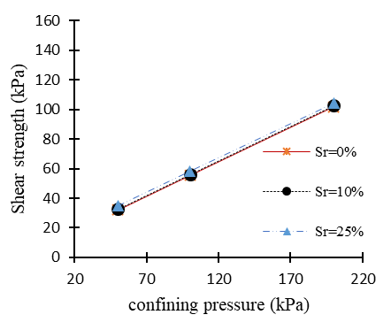  (a) circular particles (ecc=0) | 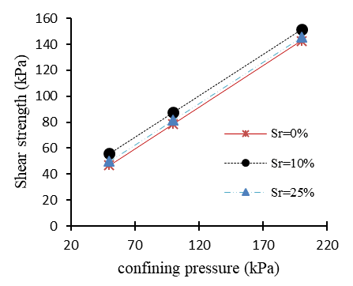  (b) ecc=15% | 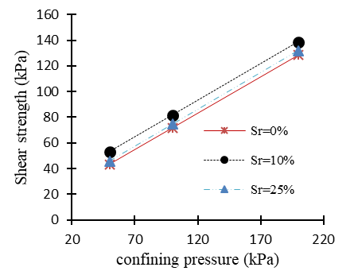  (c) ecc=30%
Figure 13: Shear stress vs confining stress for unsaturated assemblies for diverse degree of saturations in different eccentricities: (a) ecc=0%; (b) ecc=15%; (c) ecc=30%
Capillary force causes the shear strength of the soil to improve. For circular particles, it grows continuously with increasing saturation, but in elliptical particles assemblies, the strength increases at first and by enlargement of the saturation degree, it falls down. The effect of capillary force on the shear strength grows continuously with the expansion of the eccentricities.
In prevalent concluding, attendance of water in pendular regime causes the soil to behave more similar to a dense granular soil. The assembly of circular particles by increasing the saturation degree, it can be comprehended that volume reduction rises slightly and dilatancy grows. The elliptical particles the volume reduction reduces at first then increases and dilatancy tendency increases.
- RefErences
[1] H. P. Zhu, Z. Y. Zhou, R. Y. Yang, and A. B. Yu, "Discrete particle simulation of particulate systems: theoretical developments," Chemical Engineering Science, vol. 62, no. 13, pp. 3378-3396 %@ 0009-2509, 2007.
[2] J. Isrealachvili, "Intermolecular and Surface ForcesAcademic Press," San Diego, 1991.
[3] D. G. Fredlund, H. Rahardjo, and M. D. Fredlund, Unsaturated soil mechanics in engineering practice. John Wiley & Sons, 2012.
[4] R. A. Fisher, "On the capillary forces in an ideal soil; correction of formulae given by WB Haines," The Journal of Agricultural Science, vol. 16, no. 03, pp. 492-505 %@ 1469-5146, 1926.
[5] J. P. Gras, J. Y. Delenne, F. Soulié, and M. S. El Youssoufi, "DEM and experimental analysis of the water retention curve in polydisperse granular media," Powder technology, vol. 208, no. 2, pp. 296-300 %@ 0032-5910, 2011.
[6] J. A. Gili and E. E. Alonso, "Microstructural deformation mechanisms of unsaturated granular soils," International Journal for Numerical and Analytical Methods in Geomechanics, vol. 26, no. 5, pp. 433-468 %@ 1096-9853, 2002.
[7] P. Guo, "Capillary interaction-induced rolling resistance between elliptical particles and its influence on grain column length at pendular state," Acta Geotechnica, vol. 10, no. 4, pp. 435-447 %@ 1861-1125, 2015.
[8] L. Scholtès, P.-Y. Hicher, F. Nicot, B. Chareyre, and F. Darve, "On the capillary stress tensor in wet granular materials," arXiv preprint arXiv:1105.1013, 2011.
[9] U. El Shamy and T. Gröger, "Micromechanical aspects of the shear strength of wet granular soils," International journal for numerical and analytical methods in geomechanics, vol. 32, no. 14, pp. 1763-1790 %@ 1096-9853, 2008.
[10] M. J. Jiang, T. Li, H. J. Hu, and C. Thornton, "DEM analyses of one-dimensional compression and collapse behaviour of unsaturated structural loess," Computers and Geotechnics, vol. 60, pp. 47-60 %@ 0266-352X, 2014.
[11] T.-H. Kim and S. Sture, "Effect of moisture on attraction force in beach sand," Marine Georesources and Geotechnology, vol. 22, no. 1-2, pp. 33-47 %@ 1064-119X, 2004.
[12] B.-J. Mun, "Unsaturated soil behavior under monotonic and cyclic stress states," Texas A&M University, 2005.
[13] A. He, K. Nguyen, and S. Mandre, "Capillary interactions between nearby interfacial objects," EPL (Europhysics Letters), vol. 102, no. 3, pp. 38001 %@ 0295-5075, 2013.
[14] Y. Muguruma, T. Tanaka, and Y. Tsuji, "Numerical simulation of particulate flow with liquid bridge between particles (simulation of centrifugal tumbling granulator)," Powder Technology, vol. 109, no. 1, pp. 49-57 %@ 0032-5910, 2000.
[15] R. Y. Yang, R. P. Zou, and A. B. Yu, "Numerical study of the packing of wet coarse uniform spheres," AIChE journal, vol. 49, no. 7, pp. 1656-1666 %@ 1547-5905, 2003.
[16] P. Guo, "Coupled effects of capillary suction and fabric on the strength of moist granular materials," Acta Mechanica, vol. 225, no. 8, pp. 2261-2275 %@ 0001-5970, 2014.
[17] L. Rothenburg and R. J. Bathurst, "Numerical simulation of idealized granular assemblies with plane elliptical particles," Computers and geotechnics, vol. 11, no. 4, pp. 315-329 %@ 0266-352X, 1991.
[18] B. S. Kim, S. W. Park, and S. Kato, "DEM simulation of collapse behaviours of unsaturated granular materials under general stress states," Computers and Geotechnics, vol. 42, pp. 52-61 %@ 0266-352X, 2012.
[19] M. J. Jiang, S. Leroueil, and J. M. Konrad, "Insight into shear strength functions of unsaturated granulates by DEM analyses," Computers and Geotechnics, vol. 31, no. 6, pp. 473-489 %@ 0266-352X, 2004.
[20] Y. Chen, Y. Zhao, H. Gao, and J. Zheng, "Liquid bridge force between two unequal-sized spheres or a sphere and a plane," Particuology, vol. 9, no. 4, pp. 374-380 %@ 1674-2001, 2011.

